Tables and figures:
Table (1): Comparison between the two studied groups according to patient characteristics
Patient characteristics | Total  (n = 122) | P16/IHC |  | Test of sig. | p
Patient characteristics | Total  (n = 122) | Negative  (n = 24) | Positive  (n = 98) | Test of sig. | p
Age (years)
Mean ± SD. | 53.97 ± 12.39 | 58.17 ± 10.23 | 52.94 ± 12.70 | t=  1.871 | 0.064
Number of marriages
I | 101 (82.8%) | 17 (70.8%) | 84 (85.7%) |   6.969* | 0.022*
II | 19 (15.6%) | 5 (20.85%) | 14 (14.3%) |   6.969* | 0.022*
III | 2 (1.6%) | 2 (8.3%) | 0 (0%) |   6.969* | 0.022*
IV | 0 (0%) | 0 (0%) | 0 (0%) |   6.969* | 0.022*
Min – Max. | 1.0 – 3.0 | 1.0 – 3.0 | 1.0 – 2.0 | U=  987.0 | 0.063
Mean ± SD. | 1.19 ± 0.43 | 1.38 ± 0.65 | 1.14 ± 0.35 | U=  987.0 | 0.063
Median (IQR) | 1.0 (1.0 – 1.0) | 1.0 (1.0 – 2.0) | 1.0 (1.0 – 1.0) | U=  987.0 | 0.063
Age of marriage (years)
Mean ± SD. | 22.06 ± 4.85 | 22.79 ± 5.63 | 21.88 ± 4.65 | U=  1137.0 | 0.800
Duration of marriage (years)
Mean ± SD. | 28.63 ± 12.67 | 30.50 ± 12.12 | 28.17 ± 12.83 | U=  1050.5 | 0.418
Parity
Mean ± SD. | 1.53 ± 1.35 | 1.33 ± 1.34 | 1.58 ± 1.35 | U=  1005.5 | 0.130
Menstrual state
Premenopausal | 49 (40.2%) | 4 (16.7%) | 45 (45.9%) | χ²=6.864* | 0.009*
Postmenopausal | 73 (59.8%) | 20 (83.3%) | 53 (54.1%) | χ²=6.864* | 0.009*
Smoking | 13 (10.7%) | 3 (12.5%) | 10 (10.2%) | χ²=0.107 | ^{FE}p=0.718
Tumor size (cm)
Mean ± SD. | 5.09 ± 2.08 | 5.29 ± 2.16 | 5.04 ± 2.07 | U=  1114.5 | 0.688
Histopathology type
Squamous cell carcinoma | 96 (78.7%) | 12 (50.0%) | 84 (85.7%) | χ²=  14.802* | <0.001*
Adenocarcinoma | 24 (19.7%) | 12 (50.0%) | 12 (12.2%) | χ²=  14.802* | <0.001*
Neuroendocrine | 2 (1.6%) | 0 (0.0%) | 2 (2.0%) | χ²=  14.802* | <0.001*
FIGO stage
I | 34 (27.9%) | 5 (20.8%) | 29 (29.6%) | χ²=  8.145 | ^{MC}p=  0.034*
II | 55 (45.1%) | 15 (62.5%) | 40 (40.8%) | χ²=  8.145 | ^{MC}p=  0.034*
III | 18 (14.8%) | 0 (0%) | 18 (18.4%) | χ²=  8.145 | ^{MC}p=  0.034*
IV | 15 (12.3%) | 4 (16.7%) | 11 (11.2%) | χ²=  8.145 | ^{MC}p=  0.034*

IQR: Inter quartile range SD: Standard deviation χ²: Chi square test , FE: Fisher Exact test , t: Student t-test , U: Mann Whitney test
p: p value for comparing between the two studied groups *: Statistically significant at p ≤ 0.05

Table (2): Comparison between the two studied groups according to Management and survival outcomes
Management and survival outcomes | Total  (n = 122) | P16/IHC |  | Test of sig. | p
Management and survival outcomes | Total  (n = 122) | Negative  (n = 24) | Positive  (n = 98) | Test of sig. | p
Treatment
Surgical | 29 (23.8%) | 5 (20.8%) | 24 (24.5%) | χ²=0.461 | 0.862
Chemo Radiotherapy (CRT) | 85 (69.7%) | 17 (70.8%) | 68 (69.4%) | χ²=0.461 | 0.862
Combined | 8 (6.6%) | 2 (8.3%) | 6 (6.1%) | χ²=0.461 | 0.862
Overall survival (OS)
Alive | 84 (68.9%) | 14 (58.3%) | 70 (71.4%) | χ²=1.542 | 0.214
Died | 38 (31.1%) | 10 (41.7%) | 28 (28.6%) | χ²=1.542 | 0.214
Overall survival (OS) time
Mean ± SD. | 17.18 ± 11.21 | 17.04 ± 11.95 | 17.21 ± 11.08 | U=  1127.50 | 0.754
Recurrence
No | 73 (59.8%) | 18 (75%) | 55 (56.1%) | χ²=2.859 | 0.091
Yes | 49 (40.2%) | 6 (25%) | 43 (43.9%) | χ²=2.859 | 0.091
Disease free survival (DFS) time (months)
Mean ± SD. | 12.78 ± 11.14 | 13.58 ± 12.22 | 12.58 ± 10.92 | U=  1145.000 | 0.841
IQR: Inter quartile range SD: Standard deviation χ²: Chi square test , U: Mann Whitney test
p: p value for comparing between the two studied groups

Table (3): Univariate and multivariate COX regression analysis for the parameters affecting mortality for total sample (n = 122)
Mortality | Univariate |  | #Multivariate
Mortality | p | HR (95%C.I) | p | HR (95%C.I)
Age category
<45® | 1.000 | – | 1.000 | –
45-55 | 0.626 | 1.281 (0.473 – 3.473) | 0.731 | 0.756 (0.154 – 3.719)
>55 | 0.045* | 2.399 (1.018 – 5.652) | 0.860 | 1.171 (0.202 – 6.795)
Menstrual state
Premenopausal® | 1.000 | – | 1.000 | –
Postmenopausal | 0.022* | 2.400 (1.132 – 5.091) | 0.353 | 2.087 (0.442 – 9.851)
Smoking
No® | 1.000 | –
Yes | 0.081 | 0.170 (0.023 – 1.242)
Parity
Nullipara | 1.000 | –
Para 1 | 0.460 | 1.970 (0.326 – 11.92)
Para 2 – 6 | 0.455 | 1.580 (0.476 – 5.243)
Histopathology type
Squamous cell carcinoma® | 1.000 | –
Adenocarcinoma | 0.896 | 1.052 (0.495 – 2.233)
Neuroendocrine | 0.948 | 0.935 (0.126 – 6.923)
P16.IHC
Negative ® | 1.000 | –
Positive | 0.262 | 0.662 (0.321 – 1.363)
FIGO stage
I® | 1.000 | – | 1.000 | –
II | 0.631 | 0.825 (0.375 – 1.812) | 0.440 | 0.731 (0.330 – 1.619)
III | 0.849 | 0.895 (0.285 – 2.810) | 0.827 | 0.879 (0.277 – 2.794)
IV | 0.017* | 0.895 (0.285 – 2.810) | 0.046* | 2.481 (1.016 – 6.055)
Treatment
Surgical ® | 1.000 | –
Chemo Radiotherapy (CRT) | 0.719 | 1.143 (0.551 – 2.372)
>1 treatment modality | 0.370 | 0.390 (0.05 – 3.055 )
Recurrence | 0.074 | 1.800 (0.944 – 3.432)
HR: Hazard ratio, C.I: Confidence interval #: All variables with p<0.05 was included in the multivariate *: Statistically significant at p ≤ 0.05

Table (4): Univariate and multivariate COX regression analysis for the parameters affecting Recurrence for total sample (n = 122)

Recurrence | Univariate |  | #Multivariate
Recurrence | P | HR (95% CI) |  | p | HR (95% CI)
Age category
<45® | 1.000 | – |  | 1.000 | –
45-55 | 0.675 | 1.199 (0.514 – 2.796) |  | 0.680 | 1.197 (0.509 – 2.816)
>55 | 0.018* | 2.426 (1.161 – 5.054) |  | 0.023* | 2.352 (1.128 – 4.903)
Menstrual state
Premenopausal® | 1.000 | –
Postmenopausal | 0.056 | 1.820 (0.985 – 3.362)
Smoking
No® | 1.000 | –
Yes | 0.488 | 1.441 (0.512 – 4.054)
Parity
Nullipara | 1.000 | –
Para 1 | 0.951 | 1.046 (0.252 – 4.348)
Para 2 – 6 | 0.095 | 0.128 (0.011 – 1.430)
Histopathology type
Squamous cell carcinoma® | 1.000 | –
Adenocarcinoma | 0.561 | 0.553 (0.075 – 4.068)
Neuroendocrine | 0.443 | 0.444 (0.056 – 3.527)
P16.IHC
Negative ® | 1.000 | -
Positive | 0.107 | 2.030 (0.859 – 4.798)
FIGO stage
I® | 1.000 | – |  | 1.000 | –
II | 0.202 | 1.589 (0.780 – 3.239) |  | 0.289 | 1.475 (0.719 – 3.025)
III | 0.743 | 1.195 (0.411 – 3.480) |  | 0.667 | 1.267 (0.432 – 3.717)
IV | 0.011* | 3.347 (1.320 –8.489) |  | 0.014* | 3.241 (1.272 – 8.263)
Treatment
Surgical ® | 1.000 | –
CRT | 0.052 | 2.089 (0.994 – 4.390)
>1 treatment modality | 0.515 | 1.552 (0.413 – 5.828)
HR: Hazard ratio, C.I: Confidence interval #: All variables with p<0.05 was included in the multivariate *: Statistically significant at p ≤ 0.05

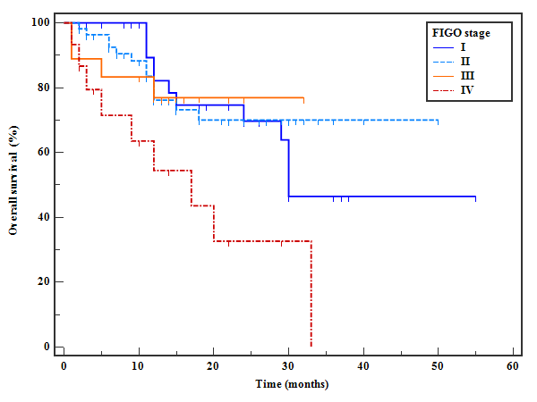
Figure (1): Kaplan-Meier survival curve for Overall Survival according to the FIGO staging

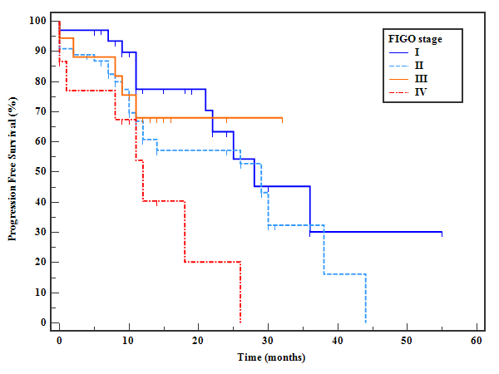
Figure (2): Kaplan-Meier survival curve for DFS according to the FIGO staging

