Supplementary Materials for

Global atlas of pesticide use

Yuyue Zhang*, Anja Gladbach, Marissa Kosnik, Ulf Norinder, Luke Settles, Daniel Glas, Peter Fantke*

*Corresponding authors: peter@substitute.dk; yuyzh@dtu.dk

The PDF file includes:

Materials and Methods
Supplementary Text
Figs. S1 to S20
Tables S14, S18
References (48-70)

Other Supplementary Materials for this manuscript include the following:

Data file 1 (Table S1)
Data file 2 (Tables S4 to S13, S15 to S17, S19 to S21)
External repository for data file 3, data file 4, and spatial data per pesticide and per crop (46)
External repository code (47)

Supplementary Tables

Table S1 Global dataset of annual average pesticide application at the level of individual pesticide active ingredients, countries/regions, crops, crop growth stages, and pesticide application methods, based on the combination of reported and imputed application data.
See data file 1

Table S2 Extensive global dataset of annual average pesticide application at the level of individual pesticide active ingredients, countries/regions, crops, crop growth stages, and pesticide application methods, based on the combination of reported and imputed application data, including specific information on all reported and imputed crop growth stage, application method and treatment target compartment categories.
See data file 3 available in external data repository (46)

Table S3 Raw reported GfK Kynetec AgroTrakTM data from year 2016 to 2020 on country/region, crop, crop growth stage, pesticide active ingredient, pesticide application method, annual pesticide mass applied, annual super-treated area (the crop area that comprises the annual treated area, and the number of individual treatments over the given year), and raw reported pesticide application rate, with an additional sheet documenting data source prioritization by year-country-crop-indication combination.
See data file 4 available in external data repository (46)

Table S4 Harmonization of country/region names reported in the raw data, and assignment to ISO 3166 country codes, and allocation to continents.
See data file 2

Table S5 Countries with assigned ISO 3166 country codes, and regions included in Central American & the Caribbean (CAC) region.
See data file 2

Table S6 Harmonization of crop names reported in the raw data, assignment to EarthStat crop codes (http://www.earthstat.org), assignment to the UN common product classification (CPC 2.1) (51) codes and FAOSTAT crop codes, mapping to mapSPAM2020 crop or crop groups, and allocation to crop classes.
See data file 2

Table S7 Harmonization of pesticide active ingredient names reported in the raw data, assignment to Chemical Abstracts Service - Registry Numbers (CAS RN), DSSTox substance identifiers (DTXSID) used in the Environmental Protection Agency CompTox Dashboard, International Chemical Identifier (InChI) Keys, and allocation to chemical class (based on the Compendium of Pesticide Common Names, http://bcpcpesticidecompendium.org), primary pesticide target class, and mode of action classification, derived from the Fungicide Resistance Action Committee (FRAC), Herbicide Resistance Action Committee (HRAC), and Insecticide Resistance Action Committee (IRAC).
See data file 2

Table S8 Harmonization of crop growth stages reported in the raw data, and assignment to the Biologische Bundesanstalt, Bundessortenamt und Chemische Industrie (BBCH) scale based on (48).
See data file 2

Table S9 Harmonization of pesticide application methods reported in the raw data, and assignment to six aggregated reference application methods, including aerial application, boom sprayer, hand-operated sprayer, soil incorporation, seed treatment, and tunnel sprayer.
See data file 2

Table S10 Adjustment of pesticide application methods and aggregation of treatment target compartments separated by crop, seed, and soil, and indication of possible mismatches between pesticide application method and related treatment target compartment.
See data file 2

Table S11 Data enrichment information, including temporal and spatial resolution, and data format on input features for data imputation techniques, in support of applying appropriate machine learning algorithms for imputing missing data.
See data file 2

Table S12 Country list for reported and imputed countries and regions, and total annual average pesticide application mass over the years 2016-2020 across all crops and pesticide active ingredients per country or region.
See data file 2

Table S13 Input parameters and scenario information for training machine learning algorithm models for different data imputation steps.
See data file 2

Table S14 Decision class labels from conformal prediction p-values (cpp-values).
See present file, section 3.1: Active ingredient imputation for no-data countries

Table S15 Tuned hyperparameter significance level and corresponding efficiency for each conformal prediction model derived from the model validation process.
See data file 2

Table S16 Error rate, “yes” accuracy, and “no” accuracy levels of conformal prediction models to impute missing data for pesticide active ingredient, pesticide application method, crop growth stage (BBCH), and treatment target compartment, and for imputed countries whether a given active ingredient is predicted or not from conformal prediction.
See data file 2

Table S17 Recursive feature elimination results of the XGBoost regression model for predicting weighted average pesticide application rate.
See data file 2

Table S18 Trained hyperparameters utilized in RandomizedSearchCV for tuning the XGBoost regression model.
See present file, section 4.1.2: Application rate prediction and aggregation where reported data were not available

Table S19 Recursive feature elimination results of the XGBoost regression model for predicting the annual load of each applied pesticide active ingredient.
See data file 2

Table S20 Crop list, and total annual average pesticide application mass over the years 2016-2020 across all countries and pesticide active ingredients per crop.
See data file 2

Table S21 Pesticide active ingredient list, and total annual average pesticide application mass over the years 2016-2020 across all countries and crops per active ingredient, including biological pesticides.
See data file 2

Parameters and indices
Parameters:
$A$ Area [ha]
$\overline{A}$: Average area across years 2016 to 2020 [ha]
${\overline{D}}_{\text{appl}}^{\text{wt}}$ Annual weighted average pesticide application rate [kg/ha]
${\overline{D}}_{\sum{\text{appl}}}^{\text{phys}}$ Annual load (annual average pesticide mass applied per physical crop unit area) [kg/ha]
${\overline{D}}_{raw}^{\text{treat}}$ Raw reported annual pesticide application rate calculated from the annual mass applied to the respective annual crop super-treated area
$M$ Pesticide mass applied in a certain year [kg]
$\overline{M}$ Average annual pesticide mass applied across years 2016 to 2020 [kg]
$r$ Area ratio [ha/ha]

Indices:
$a$ Pesticide active ingredient
$c$ Country/region
$dr$ Data row in harmonized raw dataset
$g$ Grid cell (5×5 arcminute resolution)
$n$ Count
$p$ Plant/crop
$y$ Year
$n_{dr}$ Data row count for the same country/region $c$ - crop $p_{\text{dataset}}$- pesticide active ingredient $a$scenario within the harmonized raw dataset
$n_{p}$ Crop or crop category count
$n_{y}$ Year count with available harvested area information from FAOSTAT for given country $c$ - crop $p_{\text{FAO}}$ scenario
$p_{\text{dataset}}$ Crops or crop categories in the final harmonized dataset ($n_{pdataset}=131$)
$p_{\text{FAO}}$ Primary crops from FAOSTAT ($n_{p}=160$)
$p_{\text{mapSPAM2020}}$ Primary crops or crop categories from mapSPAM2020 ($n_{p}=43$; starting from 46 total, excluding coconut, and aggregating arabica+robusta coffee and pearl millet+small millet, since these are not separated in FAOSTAT nor in the raw or harmonized raw dataset)
$\text{appl}$ Individual pesticide application
$\text{harv}$ Harvested (crop area)
$\text{phys}$ Physical (crop production area)
$\text{treat}$ Crop super-treated area, which refers to the crop area that comprises the annual treated area, and the number of individual applications over the given year

Materials and Methods

1. Overall workflow

As a starting point for building a global, internally consistent, high-resolution, and robust pesticide use dataset, data from official panel reports, industry statistics, market research and data collection programs at Bayer CropScience for the years 2016 to 2020 have been combined into a granular dataset of reported pesticide usage information. The overall analysis workflow is presented in Fig. 6 in the main text. The different data curation, harmonization, processing and visualization steps are detailed in the following sections.

2. Data cleaning and curation

2.1 Raw data on pesticide use between 2016 and 2020

The foundation of our analysis is a global dataset of raw reported pesticide use data compiled from different commercial data sources. However, for full transparency of our analysis as well as for possible reanalysis and comparison with other datasets, the sourced, complete set of data are made available in curated and harmonized format fully openly as part of our present study, including—for reference—the originally sourced reported raw dataset that is described in full technical detail in the following. Data acquisition employed structured query protocols, which we have also published alongside the dataset.
For correct query replication, the following specifications were utilized:
Years: 2016-2020
Countries: All countries
Crops: All crops
Data type: Crop protection products
Priority data: Included
Scenario: Default
Dimensions:
- Year
- Region
- Country
- Indication
- Active Indication
- Active Type
- Crop Main Group
- Crop Group
- Crop
- Active Group
- Active Ingredient
- Mode of Action
- Method
- Stage
- Stage Group
- CAS Number
- Source
- Area Active (000 ha, 3 decimal places)
- Volume Active (000 kg-li, 3 decimal places)
- Active Dose Rate (kg-li/ha, 3 decimal places)
The prioritization protocol employed a systematic source selection methodology that designated a single authoritative data source for each unique combination of year, country, crop, and indication variables. This prioritization protocol is fully documented in Table S3.
The initial raw data file (provided for reference in Table S3) was extracted from the commercial Agrowin database. The sourced dataset provides annually aggregated pesticide use data from 2016 to 2020, delineated by region (covering nations, some sub-national regions and nation clusters, e.g. Central America & the Caribbean region), crop, crop growth stage, pesticide active ingredient name, pesticide application method, annual pesticide mass applied, annual super-treated area (the crop area that comprises the annual treated area, and the number of individual treatments over the given year), and raw reported pesticide application rate (calculated from the annual mass applied to the respective super-treated area). Between 193,085 (for year 2016) and 209,065 (for year 2018) data records were provided per year, resulting in a total of 1,000,672 raw data records, reported for 1,270 distinct pesticide active ingredients and 902 crops or crop varieties, yielding 150,008 country/region-crop-active ingredient combinations that were reported in the raw dataset (see Table S3 for the full set of sourced raw data). Sources for the raw dataset were official panel data, data from industry statistics, Bayer expert judgement data, and market research data. Details on the data curation and harmonization methodology and assumptions for each data source before sourcing are provided in the following.

2.1.1 Data from Agrowin
Agrowin is a sophisticated database developed by Lexagri, designed to provide a comprehensive and harmonized view of the global crop protection and seed markets. This software is utilized by Bayer and other companies in the crop protection manufacturing and plant breeding industries to gain detailed historical insights into market trends from different sources, specifically focusing on what, where, when, why, and how farmers use various products and seeds in their fields, including plant protection products containing pesticide active ingredients. Unlike sales data, which represent the sales of seeds or crop protection products by manufacturers to the market, the data in Agrowin reflect actual consumption—meaning what farmers have effectively planted and applied on their fields.
To achieve such a detailed understanding of agricultural practices, data that are ultimately included in the Agrowin database software are meticulously collected by independent market research companies, which then offer these datasets for purchase to companies within the industry. The Agrowin database integrates multiple sources of data, which are broadly classified into two categories: panel data and non-panel data. Panel data are given the highest priority within the Agrowin data hierarchy in terms of their data quality and representativeness of agricultural practices, while non-panel data, derived from industry statistics, market research, and national market-level data collection efforts conducted by Bayer market intelligence experts, are used to fill gaps in panel data coverage in support of providing a more comprehensive picture.
The raw data utilized in the present study were filtered to include specific indications (target classes), years (2016-2020), and all pertinent countries, crop types, and crop protection products. Consistency in data retrieval was ensured by adhering to standardized procedures and selecting the same panel and industry data sources across comparable scenarios. Although minor revisions in historical data by panel providers may occur, typically confined to the most recent year, the data version used at the time of extraction for the present study remains accessible and consistent.

Panel data
Panel data constitute primary information directly collected from farmers through various interview methods, including telephone interviews, pen-and-paper personal interviews, computer-assisted web interviews, and tablet-based personal interviews, conducted after each crop season. The collection of these data involves interviewing global panels of farmers to understand their use of seeds and crop protection products in the field. These data are then sold to a broad range of customers, providing valuable insights into agricultural practices.
To ensure the data's comparability and reliability, the interview questionnaires are harmonized and aligned with the needs of the panel data customers. These panel data are externally sourced from well-established agricultural market research institutions, such as Kynetec, SPARK, branches & trends, Fera, Adquation, and Agristatis. During these interviews, farmers are asked detailed questions about their practices, for example:
- Which crop protection products did they use?
- How many hectares did they treat (treated area)?
- How many kilograms/liters of a product did they use (volume applied)?
- At which crop growth stage did they apply a product?
- Which application methods did they utilize?
- What was the reason for an application (pest, disease, etc.)?
Once collected, these panel data are transferred to Lexagri, which compiles and harmonizes them within the Agrowin database. Lexagri does not conduct the interviews themselves but focuses on compiling and standardizing the data from these original sources.
To ensure a representative sample across different countries, agricultural market research companies such as Kynetec carefully consider several attributes when conducting their sampling from selected farmers. These attributes include the need for the sample to be representative of the entire farmer population, ensuring all population elements have an equal chance to participate in the survey, conducting interviews based on farms, optimizing the coverage rate, ensuring a sufficiently high number of interviews for each segment, and maintaining neutrality in data collection.
Sampling methodologies vary between panels and countries, but generally, data scientists and country experts create sample frames that encompass various crop sizes and regions, ensuring representativeness and statistical precision. Market research companies typically use a stratified sampling approach rather than random sampling. Stratification involves dividing the population into homogeneous subgroups based on criteria such as region, crop type, and farm size, ensuring that the sample of interview participants is collectively exhaustive and mutually exclusive. This stratified sampling approach aims to improve the accuracy of the sample by reducing sampling errors.
Over time, independent market research companies like Kynetec strive to maintain continuity by interviewing the same group of farmers each year through continuous fieldwork monitoring. The number of farmers interviewed annually varies depending on the crop and market relevance. For example, in 2020, Kynetec interviewed 16,800 farms for corn/maize in Europe, of which 2,200 were in France and 2,125 were in Germany. While the number of farmers interviewed each year remains relatively stable, the sample size and resampling choices are made to ensure the continued representativeness of the data.
To extrapolate the data from these sample interviews to determine the total market, market research companies apply mathematical approaches. The basic principles for extrapolating the sample results to the total market area include:
- Interviewing a representative number of farms.
- Calculating the total area covered by summing the crop area of the interviewed farms.
- Calculating a weighting factor using the formula:
 | $$\text{Weighting factor =}\frac{\text{Total statistical area per crop \& segment}}{\text{Covered area}}$$ | (S1)
- Applying this weighting factor to each interview aspect (e.g., product area, tank mix area) to obtain a weighted estimate using the formula:
 | $$\text{Weighted estimate =Weighting factor × Interview aspect}$$ | (S2)

Non-Panel data
Non-panel data are utilized to supplement gaps where panel data are not available, often due to the low commercial relevance of certain markets or budget restrictions that lead to the allocation of resources to specific crop/country panels only. These non-panel data sources help cover the remaining global market and are used under specific conditions, such as when no panel data are available for a particular crop-country segment, when available panels do not meet the appropriate quality standards, or when budget constraints necessitate focusing on more commercially relevant regions.
The different types of non-panel data used, especially for smaller markets or regions with limited data availability, include:
- Industry Statistics: Provided by governmental bodies or industry organizations, these statistics offer data on the crop protection and seeds industry within individual countries. Examples include data from AG-DATA (https://agdata.com) for Canada (2018-2020) and CropLife (https://croplife.org) member organizations for countries like Ivory Coast and Ghana (2016-2018).
- Market Research: External data providers collect sales data from companies within the sector and report back a consolidated market dataset. This process typically involves major crop protection companies at the national level sharing their sales information with a third-party vendor, who then sends back aggregated results. These results do not disclose company-specific details but provide insights into the total sales of the participating companies at a certain level of detail. The coverage of these data depends heavily on the companies participating in the process, and the frequency of updates and level of detail (e.g., monthly, quarterly, annually) depends on agreements between the participating companies. Examples include Agromarketing data for Paraguay (2017-2019), Fera Science (formerly part of UK government) for the UK (2016-2018), and Kynetec-Sigma market research data for countries such as Egypt and Israel (2017-2020).
- Bayer expert judgement: Bayer's market intelligence experts estimate total pesticide usage market sizes (encompassing all manufacturers and products) in each relevant country based on national, market-wide knowledge from commercial teams and/or available data statistics. Bayer expert judgement data collection aims to capture total national pesticide use markets, not just Bayer products. To illustrate that the market coverage in relevant countries goes beyond products marketed by Bayer, our dataset includes, for example, Clomepro in Japan, Ambam in China and Japan, which were distributed by other manufactures during the study period 2016-2020, demonstrating that the expert judgement methodology captures products from the wider range of relevant manufacturers. The experts utilize diverse information sources and country-specific approaches to estimate total use regardless of manufacturers. These estimates are then used to develop market datasets. The data collection approach reflects country-specific market structures, regulatory frameworks, and agricultural systems. Three representative examples illustrate methodological diversity:
Japan: The dataset is predominantly derived from governmental sources, principally the Ministry of Agriculture, Forestry, and Fisheries and their underlying agencies. Regulatory requirements mandate that all crop protection product vendors report product-specific sales and volumes to government authorities. This comprehensive industry-wide dataset (https://jppaonlinestore.raku-uru.jp/item-detail/1712477) constitutes the primary data foundation. Supplementary governmental registration records (https://www.acis.famic.go.jp/ddata/index.htm) provide detailed product attributes, including active ingredient composition, crops, application rates and application method. A third governmental dataset (https://www.maff.go.jp/j/tokei/kouhyou/sakumotu/menseki/) supplies crop-specific cultivation area statistics. For products approved across multiple crops, Bayer-internal specialists estimate proportional usage distribution among approved crops. Significantly, approximately 40% of products are exclusively registered for rice cultivation, resulting in unambiguous allocation for this substantial market segment. These diverse data elements are subsequently integrated, translated, and incorporated into the Agrowin database by BCS Japan.
While based on sales metrics, the dataset closely approximates actual application patterns in Japan. Inventory accumulation is minimal due to stable pricing structures maintained for approximately 25 years until 2022, encompassing the study period. Additionally, the temporal distribution of applications (predominantly March through August) aligns with the defined harvest year reporting period (October through September, where 2019 designates October 2018 through September 2019). Consequently, inter-year product carryover is rare.
Ecuador: The dataset is fundamentally constructed from LIGIMA-sourced customs tracking data (https://ligima.ec/). This methodology documents all crop protection product imports through port authorities, an approach particularly appropriate for Ecuador given the absence of domestic manufacturing facilities. The customs documentation provides importing entity identification, product nomenclature, and corresponding commercial valuation. Bayer-internal specialists subsequently allocate these products across agricultural sectors utilizing market intelligence and sales analytics. Product price structures and recommended application rates enable conversion to physical quantities and treated area estimations. This analytical process incorporates multiple expert stakeholders across organizational divisions and undergoes iterative refinement until consensus is achieved. Higher accuracy is expected for crops constituting larger market segments (bananas, vegetables, ornamental flowers).
Italy: The dataset is constructed through Bayer-internal expertise, informed by diverse external information sources. The methodology employs a hierarchical approach wherein territory-level sales representatives quantify crop protection product utilization and corresponding cultivation area by crop type within their respective regions. These specialists then determine product-crop associations, incorporating multiple parameters including meteorological conditions, pest pressure dynamics, treatment frequency, regulatory specifications, and similar factors to estimate product distribution across crops. These assessments undergo verification against territory-specific Bayer product sales records. The analytical process includes iterative refinement to establish expert consensus. Following validation, the data undergoes national-level aggregation and standardization before integration into the Agrowin system. Generally, widely cultivated crops demonstrate higher accuracy levels in the resultant dataset.
Thailand: The dataset is developed through Bayer-internal expertise, drawing upon various external information sources, such as grower crop panels and industry-level data. The methodology considers the utilization of crop protection products for key crops across agricultural sectors within sales regions. It reflects annual changes in planted crop areas as well as weather and pest dynamics. Subsequently, the data is aggregated at the country level, where Bayer specialists evaluate it against other available intelligence, including policy and regulatory changes, agrochemical import and export data, and national shifts in crop areas, weather, pest dynamics, and crop economics. This process involves iterative refinement to establish a consensus among experts. Generally, crops that are widely cultivated exhibit higher accuracy levels in the resulting dataset.
Kenya: The dataset is accumulated from a variety of sources, including registered state-owned entities, non-governmental organizations, private companies, the Kenya National Bureau of Statistics, industry surveys conducted by associations such as the Agrochemicals Association of Kenya, and comprehensive company sales reports. Annual collections of crop area and production figures are validated against data from previous years and market off-take records. Allocation of products to specific crops is based on registered labels and sales data acquired from Agro-Dealers, while application rates are influenced by climatic conditions and official recommendations. Sales volumes are monitored through company reports and import/export data, ensuring they are validated against estimates of crop area and demand. The assessment of market value is conducted using dealer prices and sales volumes, with reconciliation performed by comparing total sales with estimated usage. Ultimately, accuracy is prioritized through the utilization of multiple sources and data triangulation, while maintaining the confidentiality of sensitive sales information through necessary data adjustments and compliance with regulatory standards.
South Africa: The dataset is primarily derived from the nine leading chemical companies, which collectively represent approximately 85% of the market, thereby providing a comprehensive dataset for analysis. Crop area and production figures are sourced from reputable organizations such as Macadamias South Africa (SAMAC), The South African Sugar Association (SASA), and the Department of Agriculture, Land Reform and Rural Development (DALRRD). Product allocation is informed by regional spray programs and sales data, with collaboration from agents and dealers to ensure accurate matching to specific crops. The determination of application rates considers dosage requirements and pest pressures, which are influenced by seasonal climatic conditions. Initial sales volumes from participating companies are distributed to the respective crops, with subsequent distribution based on regional representation and feedback from agents, all validated through company managers. Market valuation is calculated at the dealer cost level and reconciled with industry sources, with adjustments made for non-participating companies. To uphold confidentiality, the final data figures are modified to achieve an estimated accuracy of 85-95%, thereby ensuring reliable market representation while safeguarding individual company information.

2.1.2 Agrowin data quality checks

To ensure the reliability and consistency of the data in the Agrowin database, stringent quality checks are implemented. Panel data providers must meet more than 30 criteria to be included in the database. Quality assurance starts with the careful selection of representative farmers for interviews. The interview questionnaires are simplified to improve clarity and effectiveness, and interviewers are trained in data collection methodologies. They are also provided with assistance tools, such as showcards, to help farmers with lower education levels better understand the interview questions. Additionally, non-panel data undergo a thorough review before being incorporated into the Agrowin database.
The data is checked at multiple stages. Data providers perform initial checks before sharing the data. Lexagri conducts additional checks when loading the data into Agrowin. Bayer experts then perform final checks and select a single, prioritized data source for each year-country-crop-indication combination based on criteria such as coverage and reliability. This selected “priority source” is what is reflected in the extracts, ensuring there is no double counting.
Once the data are collected, incorporated, and harmonized within the Agrowin database, multiple cross-checks are carried out. These checks include requests for confirmation from country planners, who review the data using a check file to ensure that the system accurately reflects the official view of their respective markets.
To further ensure data quality, market research companies implement specific processes for data cleaning and processing. For example, Kynetec, a major provider of panel data, uses a proprietary workflow software that enables fast, consistent, and detailed data checks. This software exhaustively checks panel data against years of referential data, flagging any abnormalities for further verification, validation, and correction as needed. These data processing programs and procedures are designed to ensure a repeatable approach to data weighting and extrapolation, which is crucial for maintaining longitudinal panel continuity and delivering globally consistent data. In summary, their quality checks are ensured by:
1. Use of Trained Interviewers: Trained interviewers are used to conduct face-to-face interviews with the farmers. This ensures that the questions are asked in a consistent manner and that the responses are recorded accurately.
2. Validation Checks: validation checks are implemented in the data collection process. These checks help to identify and correct any errors or inconsistencies in the data.
3. Use of Representative Samples: A representative sample of farmers is used for the interviews. This ensures that the data collected are representative of the larger farmer population.
4. Regular Updates: Questionnaires are regularly updated to reflect changes in farming practices and technologies. This ensures that the data collected are relevant and up to date.
5. Use of Advanced Analytical Techniques: Proprietary workflow software is used for advanced analytical techniques to analyze the data. This helps to identify patterns and trends in the data.

2.1.3 Limitations in the Agrowin database

Despite the rigorous processes and quality checks in place, there are limitations to the Agrowin database, particularly regarding the frequency and comprehensiveness of the available panel interview data. These limitations largely depend on the commercial relevance of a market and the accessibility of farmers for panel interviews. In larger and more commercially significant markets, farmer panel data are typically available on an annual basis. However, in markets with lower commercial relevance, the frequency of data collection can be lower, often occurring every 2-3 years. In countries and markets where no panel data are available, data gaps are filled using national statistics, such as import and export data, or through dedicated market analysis and business intelligence based on expert knowledge of the respective markets.
Data quality in our set of reported pesticide use values varies across regions and data collection methods. Panel data (based on direct farmer interviews) generally provide the highest accuracy for actual pesticide use patterns. Quality of data collected by various Bayer experts varies by country and crop, with accuracy expected to be higher for major crops with large market shares and lower for smaller segments requiring more extrapolation steps. While some data derived from Bayer experts do extrapolate from sales information (similar to FAO approaches), these extrapolations, however, incorporate local expertise across multiple functional areas, various additional data sources, and detailed considerations of agronomic factors to approximate actual pesticide use patterns in each region considered.
Potential geographic bias may exist where data quality varies systematically by region, with higher-income countries and larger markets generally having access to better pesticide use measurement technologies compared to lower-income countries that may rely more heavily on extrapolated estimates. We acknowledge that some of our data sources face similar challenges to those we identified in FAO data regarding sales-to-use conversion. However, where extrapolation from sales occurs in our dataset, it typically involves more granular analysis incorporating local agricultural expertise and multiple validation sources, in addition to effectively linking pesticide use information to crops at the level of individual active ingredients—information that is not available in FAO or other global data sources of pesticide use.
Geographic coverage limitations exist for certain countries where data were not reported, regardless of their agricultural significance. More specifically, data availability does not correlate with the commercial presence of any pesticide manufacturer or seller, including Bayer CropScience, in any country. Instead, our data collection methodology aims to capture total national pesticide applications across relevant manufacturers. Missing countries like Nigeria represent general gaps in available data sources rather than selective coverage based on company-specific operations or market presence. These coverage gaps reflect methodological constraints across our and similar data collection efforts in accessing reliable data sources rather than systematic bias toward specific regions or company interests.
Even with these limitations, the Agrowin database set still covers approximately 90% of all crop protection products applied globally, making it an invaluable resource for agricultural market analysis. The database’s comprehensive coverage, combined with its stringent quality checks and harmonized data integration, ensures that it remains a critical tool for understanding global agricultural practices and trends. To address continuous data quality challenges in regions with limited monitoring infrastructure, we recommend that market experts across pesticide manufacturers, agricultural organizations, and international agencies collaborate to develop improved estimation methodologies and joint data collection systems for countries with current poor data availability. Such collaborative efforts could substantially enhance the robustness of global pesticide use assessments and support more informed agricultural policy decisions worldwide.

2.2 Cleaning of the raw data

Data cleaning and curation procedures were applied to the originally retrieved raw dataset, including the removal of pesticide active ingredients that are not mono-constituent chemicals, have zero application mass or treated area reported. Application rates at the upper end of the distribution (see main text Figure 2A) were systematically reviewed and checked for plausibility. The majority of high-rate applied pesticides were identified as soil fumigants, such as 1,3-dichloropropene, cyanamide and metam sodium, which are known to require high application rates according to recommended agricultural practices (49, 50). To maintain data integrity while preventing unrealistic outliers from affecting the analysis, we retained most of the reported applications. However, extreme values that were clearly erroneous, such as unspecified insecticide applications exceeding 10,000 kg/ha in Spain and glyphosate applications exceeding 30,000 kg/ha in Venezuela, were excluded from further analysis. This curation process resulted in the removal of 80 rows from the total dataset of 1,000,672 entries. The retained data were subsequently processed using weighted averages and uncertainty calculations to enhance the reliability of the final dataset.
Data were reported for 1,240 pesticides from 49 chemical and six target classes (347 herbicides, 296 insecticides, 207 fungicides, 72 plant growth regulators, 12 rodenticides, and 307 covering other classes). Reported data included 120 application methods, 99 countries and regions, 929 crops and varieties across 10 crop groups, and 406 crop growth stage ranges prior to cleaning.
- Country or region: The names of 99 countries or regions were harmonized according to ISO3166 (https://www.iso.org/iso-3166-country-codes.html), with the full list of included countries provided in data file 2, Table S4. Alpha-3 codes were provided based on ISO3166. Countries and regions located between Mexico and Ecuador/Venezuela were not separately listed in the reported dataset, but instead were allocated to the country cluster “Central America & the Caribbean”, as detailed in data file 2, Table S5.
- Crop: 907 crop names were harmonized and categorized based on EarthStat (http://www.earthstat.org) and FAOSTAT (https://www.fao.org/faostat/en/#data) crop name terminology, with some aggregations of crops not widely available, e.g. ‘citrusnes’ for citrus fruits excluding separately reported grapefruits, pomelos, tangerines, mandarins, oranges or lemons, etc. After harmonization, 131 crops and crop categories were included in the harmonized raw dataset (including one unspecific crop group). The UN common product classification (CPC 2.1) (51) code and FAOSTAT crop code for the 131 crops and crop categories are detailed in data file 2, Table S6. mapSPAM2020 provides crop areas for 46 crop categories; 45 were used in our analysis (coconut excluded due to no reported pesticide application data), which after further aggregation of closely related crop pairs (arabica and robusta coffee; pearl millet and small millet) yields 42 spatially distinct crop groups mapped to the 122 crops in our dataset (see data file 2, Table S6).
- Pesticide active ingredient: The U.S. Environmental Protection Agency (EPA) CompTox Chemicals Dashboard (https://comptox.epa.gov/dashboard) was used to harmonize the list of active ingredients, with the chemical identifier CAS Registry Number (CAS RN) assigned based on chemical names given in data file 2, Table S7. In addition to listing mono-constituents reported in the Agrowin database, the harmonization Table S7 in data file 2 also includes reported substances that were ambiguous or unspecific, such as Bacillus cereus (microorganism used as bio-pesticide), and dithiocarbamates or copper-compounds (classes of chemicals). The raw dataset consists of data for 1,240 substances to which a CAS RN could be assigned. DSSTox substance identifiers (DTXSID) from EPA CompTox Dashboard and the International Chemical Identifier (InChI) Keys are complemented to as the additional identifiers. As the focus of the present study is to provide a global pesticide use dataset for xenobiotic chemicals, no additional analysis was performed on biological pesticides and unspecific chemicals beyond reporting their raw annual average application mass in data file 1, Table S1. Following the process of harmonizing and cleaning raw data, 1,071 distinct active ingredients are included in the analysis. An additional 6 xenobiotic chemicals applied on unspecific crops or for non-agricultural use are reported separately, yielding 1,077 active ingredients in total. In addition, six target classes, namely herbicides, insecticides, fungicides, growth regulators, rodenticides and other pesticides, were associated with individual active ingredients. This categorization also encompasses those active ingredients that exhibit multiple target classes, falling within the “others” class (data file 2, Table S7). Different glyphosate formulations (glyphosate and glyphosate salts) are reported separately as they represent distinct active ingredient preparations with different solubility properties and formulation requirements. Glyphosate salts are formed through acid-base bonding between glyphosate (proton donor) and mixed ingredients (proton acceptors) to enhance delivery to plant tissues, making them functionally distinct from pure glyphosate with respect to uptake and possible effects in target crops, pests and non-target organisms.
- Crop growth stage: The Biologische Bundesanstalt, Bundessortenamt und Chemische Industrie (BBCH) scale describes phenological development stages of crops and was derived based on (48). Twelve crop growth stage ranges were defined from 402 raw reported different crop growth stages for our study, including 0009 (Germination/sprouting/bud development), 1019 (leaf development/main shoot), 2029 (side shoots formation/tillering), 3039 (stem elongation/main shoot development), 4049 (harvestable vegetative plant parts development/main shoot booting), 5059 (inflorescence emergence/heading), 6069 (flowering), 7079 (fruit development), 8089 (fruit and seed ripening or maturity), 9099 (senescence/dormancy beginning), and 9900 (post-harvest). The earlier stage is selected when the reported crop growth stage encompasses multiple stages, which is conservative in terms of related environmental emission distributions (i.e. lower crop growth yields lower crop surface coverage, leaving more applied pesticide reaching the field soil, see e.g. (52). This harmonization of crop growth stages is distinct for spring and winter crops (i.e. BBCH for winter crops with reported crop growth stage as “autumn” will be defined as 0009). In addition, a broader stage 1092 was defined and applied to data points where active ingredients were not assigned to one of the 11 narrower crop growth stages (data file 2, Table S8).
- Pesticide application method: The reported 120 pesticide application methods in the raw dataset were aggregated into six major reference application methods, including aerial application, boom sprayer, hand-operated sprayer, soil incorporation, seed treatment, and tunnel sprayer (data file 2, Table S9). The categorization was applied to capture main differences in environmental emission patterns that are driven by application method characteristics, such as application height (e.g. aerial application vs. various motorized boom and other sprayers) (53, 54). Adjustment rules were applied as additional steps, such as ‘herbicides are never be applied as seed treatment, soil incorporation or tunnel sprayer’ (data file 2, Table S10).
After data cleaning and harmonization, 22,904 data records were eliminated due to incorrectly reported application rate or mass, 61,043 data records were removed due to lack of specific chemical names (e.g. “ZZ-OTHERS”), and 5,170 data records were removed that had reported application as fertilizer instead of use in pest control (e.g. “FERTILIZER/MICRONUTRIENT (NPK-FERTILIZER)”). To further restrict the subsequent analysis to xenobiotic chemicals applied to agricultural crops with available crop allocation information, 20,517 data records for biological pesticides were removed (e.g. BIOLOGICALS-INS, application mass per specific biological agent with CAS RN reported in Table S21), and 237 records for non-agricultural use were excluded (e.g. NON-CROP-LAND). The remaining 895,971 data records were utilized in the subsequent analysis.
The trends of global pesticide mass applied from 2016-2020 and application sources summary are shown in Figure S1 and Figure S2.

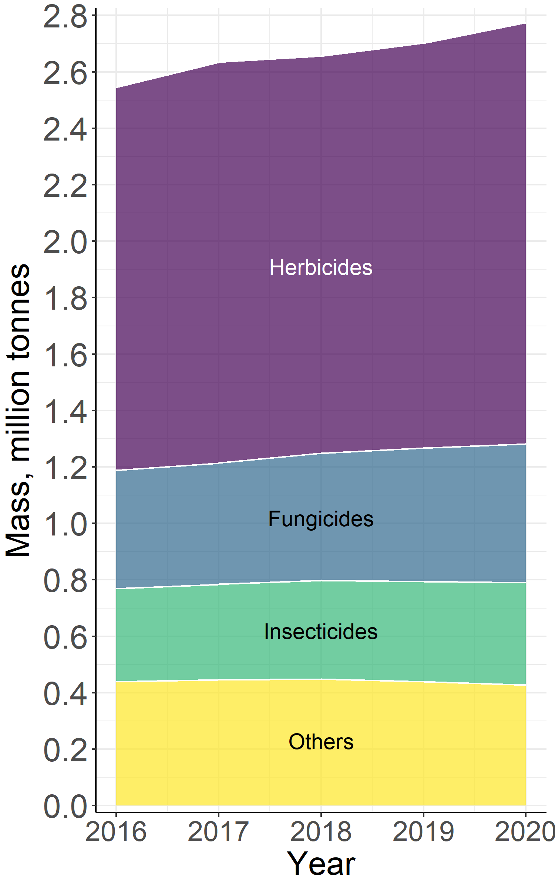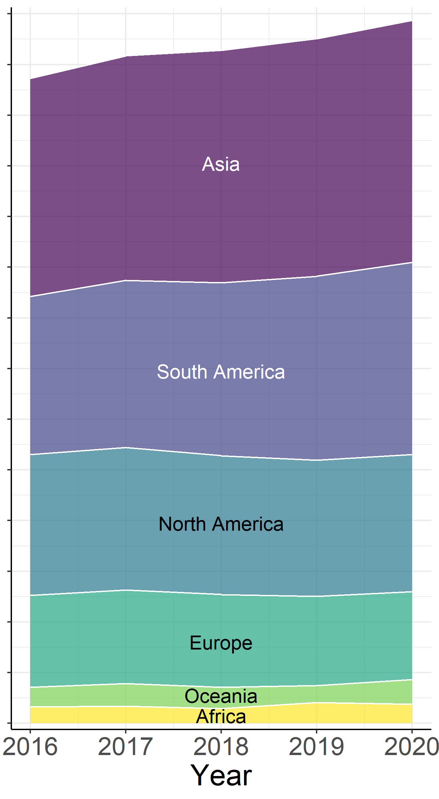
Figure S1 Trend of cumulative reported pesticide mass applied, differentiated by chemical target class and global region.

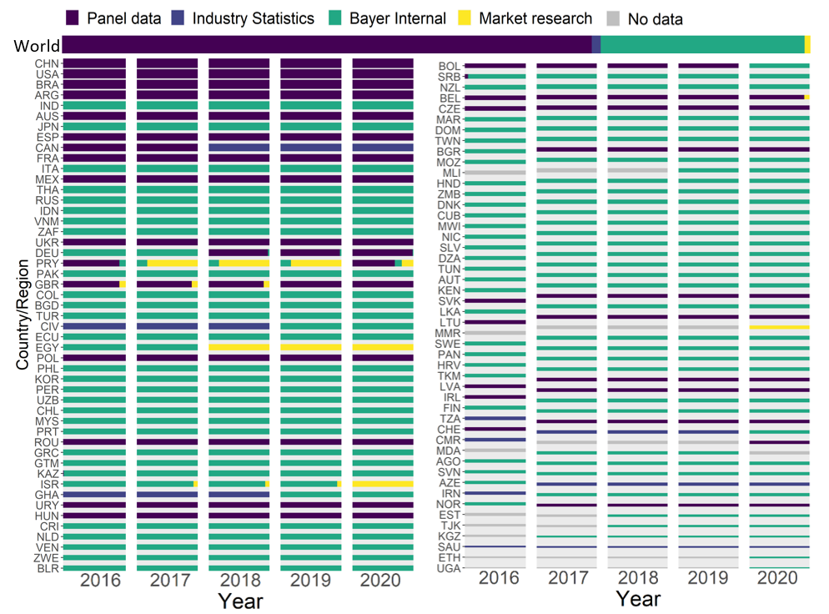
Figure S2 Overview of pesticide application data sources per country or region for reported data, with the vertical thickness of the bars capturing the difference in mass applied across countries on a logarithmic scale.

2.3 Aggregation of the harmonized data

Following the harmonization of the raw dataset, each parameter was aggregated according to respective sources and criteria. This process aimed to facilitate the comparison and clear structuring of results, to supplement data for further imputation steps, and to enable reporting results at different levels of resolution. Countries have been allocated to continents (data file 2, Table S4), and 131 individual crops have been aggregated to 10 crop groups in accordance with CPC crop classification and allocated to annual or perennial crop groups (https://www.fao.org/economic/the-statistics-division-ess/world-census-of-agriculture/programme-for-the-world-census-of-agriculture-2000/appendix-4-crop-list/en) (data file 2, Table S6). Each active ingredient was allocated to a pesticide chemical class based on the British Crop Production Council’s compendium of pesticide common names, (http://bcpcpesticidecompendium.org), supplemented by information from PubChem (https://pubchem.ncbi.nlm.nih.gov). To each active ingredient, a mode of action group (MoA group) was assigned based on Insecticides Resistance Action Committee IRAC (55), Fungicides Resistance Action Committee FRAC (https://www.frac.info), and Herbicides Resistance Action Committee HRAC (https://www.hracglobal.com) (data file 2, Table S7), if no mode of action information is given from IRAC, FRAC and HRAC, unknown is listed as mode of action.
The inclusion of treatment target compartments (crop, seed, and soil) alongside crop growth stage and application method information characterizes different pesticide application aspects (data file 2, Table S8). These aspects are crucial determinants of how pesticides are distributed during application, with direct implications for understanding actual use patterns in agricultural systems. The structured documentation of these application aspects, supported by consistency rules (e.g., herbicides as soil treatments for permanent crops, restriction of seed treatments in orchards or vineyards), ensures the dataset accurately reflects real-world agricultural practices while also providing the necessary foundation for potential environmental emissions and fate assessments. All defined rules are included in data file 2 (Table S10).

2.4 Data enrichment

Spatialized information, such as mapSPAM2020 crop production maps, and environmental and socio-economic information from various sources, as well as the regulation, was added to the harmonized data to enhance any further analysis of data imputation for application information in countries without reported data as well as for spatialization of pesticide application data.
The mapSPAM2020 v2 spatial crop production dataset (https://mapspam.info/data) was utilized as source for allocating crop production areas for 122 crops (‘unspecific’ and forage crops do not have the corresponding crop growth area) to available harmonized raw pesticide application data, based on the assumption that each active ingredient is equally applied to the entire corresponding crop area within a country for a given country-crop-chemical scenario. As the pesticide application data include information from 2016 to 2020, mapSPAM2020 crop maps from 2020 was used as the reference crop allocation information for best-possible consistency across available mapSPAM datasets. FAOSTAT ‘crop harvested area’ at country level for 160 primary crops from 2016 to 2020, and mapSPAM2020 gridded global annual crop physical area for 43 crops and crop groups at 5×5 arcmin resolution in 2020 were used to generate the final spatialized crop allocation information.
The mapSPAM2020 v2 dataset incorporates substantial improvements over version 1, including additional subnational districts and enhanced validation through disaggregated subnational statistics, satellite imagery where available, and feedback from partner research centers. However, like all global crop distribution datasets, mapSPAM2020 has inherent limitations including potential spatial inaccuracies in certain regions with complex cropping patterns or rapid land use changes. The SPAM team continuously validates and updates their dataset based on user feedback and emerging data sources. While mapSPAM2020 represents the most comprehensive global crop spatial allocation dataset currently available, users requiring higher spatial accuracy for specific regions may combine our pesticide use dataset with alternative, more detailed (e.g. higher resolution) crop-distribution maps that might be better suited to their specific study areas. Our open dataset and transparent methodology enable such customized applications for regional or national analyses where more detailed crop maps are available.
The mapSPAM2020 data already include major individual crops, such as wheat, soybean, rice, etc., which collectively cover 86% of the global crop physical area in 2020. For the remaining crop groups, such as tropical fruits or vegetables, the crop physical area from mapSPAM2020 crop categories is disaggregated into the individual crops included in our study. This manipulation is necessary because deriving globally consistent information on pesticide use patterns is the primary focus of the present study. We assumed that every crop in each crop category is cultivated in the area where the corresponding crop category has some non-zero reported area, to obtain the crop distribution map for pesticide applications for the 122 crops included in our study. The disaggregation was determined by the ratio, $r_{p_{\text{dataset}},p_{\text{mapSPAM2020}},c}$, of each crop harvested area in our final harmonized dataset, ${\overline{A}}_{p_{\text{dataset}},c}^{\text{harv}}[\text{ha}]$, to the crop or crop category related harvested area reported mapSPAM2020 data, ${\overline{A}}_{p_{\text{mapSPAM2020}},c}^{\text{harv}}\left[\text{ha}\right].$ The final crop-specific physical area used in our study’s analysis time frame from 2016 to 2020 was calculated for each crop $p_{\text{dataset}}$ in country $c$ per grid cell $g$, ${\overline{A}}_{g,p_{\text{dataset}},c}^{\text{phys}}[\text{ha}]$ ,as:

 | $${\overline{A}}_{g,p_{\text{dataset}},c}^{\text{phys}}=r_{p_{\text{dataset}},p_{\text{mapSPAM2020}},c}×{\overline{A}}_{{g,p}_{\text{mapSPAM2020}},c}^{\text{phys}}$$ | (S3)
with
 | $$r_{p_{\text{dataset}},p_{\text{mapSPAM2020}},c}=\frac{{\overline{A}}_{p_{\text{dataset}},c}^{\text{harv}}}{{\overline{A}}_{p_{\text{mapSPAM2020}},c}^{\text{harv}}},$$ | (S4)
 | $${\overline{A}}_{p_{\text{dataset}},c}^{\text{harv}}=\sum_{p_{\text{FAO}}∩p_{\text{dataset }}}{\left(\frac{\sum_{y}{A_{p_{\text{FAO}}, c,y}^{\text{harv}}}}{n_{y}}\right)}$$ | (S5)

In addition to the data harmonization and updated spatialized crop mapping steps, Table S11 in data file 2 provides information on grid-based data according to Köppen-Geiger climate zones during the period 1800-2100 (56), average temperature and precipitation during 2016 to 2020 (CPC Global Unified Temperature data and CPC Global Unified Precipitation data provided by the NOAA PSL, Boulder, Colorado, USA, https://psl.noaa.gov), field size, gross domestic products (GDP), and human development index (HDI) using year 2015 statistics (57).The field size categories were standardized by assigning representative values within each range: very large fields (>100 ha) were represented by 500 ha, large fields (16–100 ha) by 50 ha, medium fields (2.56–16 ha) by 5 ha, small fields (0.64–2.56 ha) by 1 ha, and very small fields (<0.64 ha) by 0.5 ha. The projection and resolution of the added environmental and socioeconomic data were adjusted to correspond to the adjusted crop map for the time frame 2016 to 2020, which has a 5$×$5 arcmin resolution and a WGS84 projection.

3. Data and scenario imputation

Conformal prediction was used as technique to impute the possible active ingredients applied on a given crop for countries with no reported data (‘no-data’ countries). Furthermore, conformal prediction was used to impute BBCH crop growth information during pesticide application and application methods for both countries with reported data (where this specific information was missing in the reported dataset) and for no-data countries, using the enriched harmonized dataset. Sixty-eight additional countries (data file 2, Table S12) were identified based on mapSPAM2020 crop map data, for which pesticide use information was imputed. Using the same process as described above under “Data enrichment”, the imputed dataset was enriched for countries with no reported data.

3.1 Active ingredient imputation for no-data countries

For each active ingredient, a binary inductive conformal prediction model was developed to predict whether a chemical is applied or not in one scenario, because the harmonized raw dataset contains a wide variety of chemicals and is highly unbalanced with respect to whether an active ingredient is applied or not across all region/country-crop combinations. More specifically, 600 active ingredients have less than 1% occurrence in 1,900 region/country-crop scenarios in the harmonized raw dataset.

Step 1: Data preprocessing and encoding
Considering that climatic conditions are a relevant factor influencing pesticide application, each model was constructed on a region/country-crop-climate zone basis, with spatialized information per active ingredient. The parameters included in the imputation were continent, crop, crop group, average minimum and maximum temperature, precipitation, average field size, human development index (HDI), gross domestic product (GDP), and a crop coverage score derived from the ratio of each crop to the total crop area per climate-country/region combination (19, 33). Country/region was not listed as input parameter, since the predictions were made for countries with no reported data. In addition, country crop coverage area information was supplied to indicate that different crop areas might influence the number of distinct pesticides applied (data file 2, Table S13). The binary outcome is either “yes” (i.e. an active ingredient is used), or “no” (i.e. an active ingredient is not used). To build a robust prediction model, at least 20 scenarios are needed for the prediction per chemical at an error rate of 0.15, which corresponds to a significance level in statistical hypothesis testing, calibration set at 30% and with 10-fold cross-validation ($\text{minimum number of scenarios}= \frac{n\text{-fold}}{n\text{-fold}-1}×\frac{(1/\text{significance level})-1}{x\% \text{calibration dataset}}$), while at least 70 scenarios are needed for the prediction at an error rate of 0.05. To establish an initial threshold for the predicted chemicals in the running model while retaining the maximum number of chemicals within the model, 853 active ingredients from the harmonized raw dataset were included in the analysis with at least 20 region/country-crop-climate zone scenarios. Since information on the country/region, continent, crop, crop group, and climate zone is categorical, one-hot encoding was utilized for these variables, because there is not a natural ordered relationship in the categories conducive to integer encoding.

Step 2: Imputation model design
Conformal prediction (58, 59) was used to propose active-ingredient-specific models to determine with what measure of confidence each active ingredient is applied to a certain country/region-climate zone-crop scenario. Here, an inductive conformal predictor was used as the baseline conformal predictor, which is considerably more computationally efficient for the imbalanced dataset (60). Ten-fold cross validation (CV) procedure was used to tune hyper-parameters, e.g., significance level, and evaluate the model performance. Because of the imbalanced nature of the data, the folds are created in a stratified manner, ensuring that each fold has a similar distribution of the outcomes. For each CV iteration, a validation fold was reserved for tuning the significance level, a test fold was left for final performance assessment, and the remaining 8 folds were used as training fold. The active-ingredient-specific models were built using Python nonconformist package version 2.1.0 (https://github.com/donlnz/nonconformist). Random forest was utilized as the embedding model to fit the appropriate training dataset using scikit learn package version 1.2.1 (61). Classification was applied, with default parameters and tree number set to 500. To produce nonconformity scores from the Mondrian setting, conformal prediction relies on predictions for both test and calibration data. This was considered as part of the model fitting process and thus occurred within each cross-validation iteration. With that, for a given set of training data, 70% of data were used as proper training dataset and the remaining 30% for calibration. This additional split was done randomly and repeated 20 times to obtain the median conformal prediction p-values (cpp-value, which describes the degree of nonconformity) for a given cross-validation iteration. The workflow of the conformal prediction models is summarized in Figure S3.

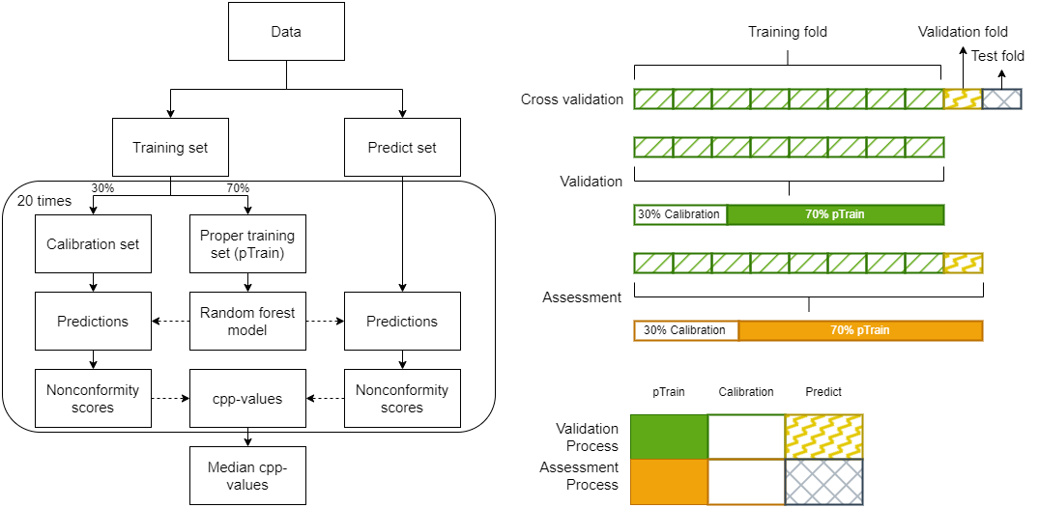
Figure S3 Schematic representation of the developed conformal prediction models. Left: Conformal prediction workflow for each iteration. The ‘Training set’ was divided into a proper training set and a calibration set. Predictions were then generated for a ‘Predict set’ using nonconformity scores. These nonconformity scores were subsequently compared with those obtained from the calibration set. This process was repeated 20 times with randomly stratified separations of the proper training set and calibration set. The resulting cpp-values were averaged to get the median to yield the final prediction. Right top: Data separation and validation steps. The data were segregated into the proper training set, calibration set and predict set. Right bottom: The sets used in the model validation process to tune the significance level for the final model and model assessment process to assess the models’ performance during cross-validation.

For each scenario, one conformal prediction p-value was calculated per class (yes present: an active ingredient is applied, or no absent: an active ingredient is not applied). The decision on whether an active ingredient is applied in one scenario was made by combining the predetermined significance level with the two cpp-values predicted from each conformal prediction model. Table S14 displays four alternative decision-class labels for binary conformal prediction. As the ‘empty’ (both cpp-values smaller than significance level) or ‘both’ (both cpp-values larger than significance level) sets were not informative to determine whether an active ingredient is applied or not in one scenario, only single-class sets (either “yes present, applied” cpp-value is larger than significance level or “no absent, not applied” cpp-value is larger than significance level) were used to make a decision.

Table S14 Decision class labels from conformal prediction p-values (cpp-values)
“Yes present, applied” cpp-values | “No absent, not applied” cpp-values | Decision
> significance level | < significance level | “Yes, applied”
> significance level | > significance level | “No” (not informative)
< significance level | > significance level | “No, not applied”
< significance level | < significance level | “No” (not informative)

EC Regulation 1107/2009 for approval on active ingredients in EU nations and the Pesticide Action Network (PAN) or PIC from the Rotterdam Convention (http://www.pic.int) international consolidated list of prohibited pesticides were used after application imputation predictive algorithms to flag those “yes, applied” predicted pesticides that are currently not permitted for use in one or more world regions.

Step 3: Model selection and assessment
Validity, accuracy and efficiency are three evaluation criteria for the developed conformal prediction models. Conformal prediction model efficiency was computed as the proportion of predictions with just one class (either “yes, applied” related cpp-value is larger than significance level, or “no, not applied” related cpp-value is larger than significance level) compared to the total number of the data points in the test dataset. This ratio should be maximized for optimal efficiency in order to obtain as many informative predictions as possible from each model. Error rate is defined as the proportion of predictions that do not have the true predicted labels divided by the size of the test dataset. The ideal error rate corresponds to the predetermined significance level. Here we use accuracy, where the “yes” accuracy and “no” accuracy were defined as the ratio of truly predicted labels, i.e. single labels, size to the size of the test dataset that was initially reported as “yes” or “no” (of applied pesticides in given scenarios). The overall accuracy (including the prediction of “yes”, “no” or both labels), i.e. the validity, should be as closely as feasible to $1-x$, with $x$ being equal to the pre-defined significance level.
During the validation phase, each model was constructed on the training fold and the significance level was tuned based on the highest observed efficiency during CV on validation fold. The calibration lines for error rate and efficiency for each active ingredient’s conformal prediction model (Figure S4) show strong correspondence between the error rate and the preset significance level (turquoise line similar to the red reference line of error rate equals to significance level). Among the 853 active ingredients, the predetermined significance levels ranged from 0.01 to 0.11, and all efficiencies exceeded 0.977, indicating that more than 97% of predictions correctly identified a single class to obtain the most informative predictions (data file 2, Table S15).

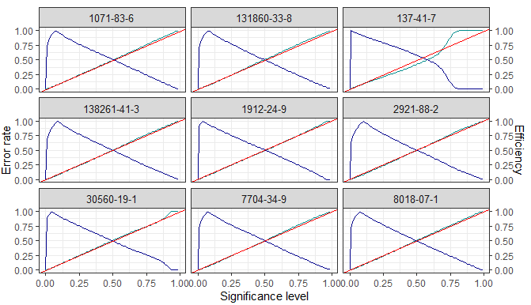
Figure S4 Calibration plots for example chemical conformal prediction models (CAS RN per plot), with x-axis showing pre-defined significance levels ranging from 0 to 1, left y-axis showing error rates ranging from 0 to 1 and right y-axis showing efficiency ranging from 0 to 1. Blue line indicates the efficiency, turquoise line indicates error rate, and red line indicates the reference line of error rate being equal to the significance level.

Following validation with hyper-parameter tuning, specifically adjusting the significance level, each assessment model was constructed using both training and validation folds, and the performance of the models was assessed during CV on the test fold, providing us with realistic estimates of its performance on unseen data. This assessment considered error rate, efficiency, “yes” accuracy and “no” accuracy (data file 2, Table S16). Out of the 853 active ingredients, 340 were predicted to be applied in sixty-eight countries despite the absence of reported data. Each final active ingredient-specific model was then fitted on the complete dataset and used the values of its tuned hyper-parameters.

3.2 BBCH, application method and treatment target compartment imputation

Crop growth stage (expressed in codes based on the BBCH classification) and pesticide application method will be informative for further emission modeling and impact estimation of pesticide use. Forty percent of BBCH and fifty percent of application methods were missing from the original reported raw dataset. The missing proportions at the level of distinct crop-country-chemical combinations are 43% for BBCH and 48% for application method. The treatment target compartment was added as an additional indicator for application information that involves soil, seed, and crop treatment. This additional indicator is captured separately, since herbicides can be sprayed to soil at any stage of crop growth using a sprayer, which is not captured by the reference application method ‘soil incorporation’ and early crop stages. Similar to active ingredient imputation, binary inductive conformal prediction models were developed for imputing BBCH, application method and treatment target compartment due to an imbalanced input dataset. More specifically, the boom sprayer reference application method is present in more than 50% of reported application scenarios, and BBCH 0009 accounts for more than 40% of the reported crop growth stages, while for instance the tunnel sprayer application method only applied on grapes in United Kingdom contributes with less than 1% occurrence over all country/region-crop-chemical scenarios in the reported dataset. For the imputed country/region-crop-chemical scenarios, the application information including BBCH, application method and treatment target compartment were likewise imputed by conformal prediction modeling.

Step 1: Data preprocessing and encoding
Crops were the primary inputs from the reported dataset that were utilized as model inputs, with crop groups and life history (annual or perennial) serving as categories for further delineating the data. To avoid problems with having too many predictors, instead of directly including more than 1000 active ingredients, chemical classes, mode of action groups, and target classes were selected as indicative of individual active ingredients for use as predictors. Additional predictors included climate zone, average air temperature, precipitation, field size, HDI, and GDP. One-hot encoding was performed to the categorical parameters due to the absence of an inherent hierarchical relationship among the categories suitable for integer encoding.

Step 2: Imputation model design
Binary conformal prediction for classification was used separately per BBCH, application method or treatment target compartment to predict whether a country/region-crop-active ingredient (represented by chemical class, mode of action and target class) scenario will be applied at modelled BBCH or application method or treatment target compartment. Identical model settings and procedures were applied to the models as for the active ingredient imputation steps (see Section 3.1, Step 2).
Class labels for evaluating models were similarly determined based on Table S14. To achieve the appropriate significance level with the best performance, only single class sets (‘yes, BBCH or application method or treatment target compartment is employed to the scenario’ or ‘no, BBCH or application method or treatment target compartment is not employed to the scenario’) were considered informative in the respective test datasets.
For a particular country/region-crop-chemical scenario, multiple crop growth stage ranges (BBCH) or application methods or treatment target compartments may be applied. For example, herbicides can be applied at both early crop growth stages and initial leaf growth stages or even during late crop growth stages. Another example is that when applied to a herbicide-tolerant crop, active ingredients can be applied by boom sprayers in one field and aerial application in another within the same country (relevant for those countries where aerial application is permitted). Therefore, different application rates were derived where multiple application methods are provided for a single country/region-crop-chemical scenario, and each probable crop growth stage BBCH was provided alongside a scenario with separate mass applications. For predicting information for no-data scenarios—both within the harmonized raw data and for the no-data country scenarios—conformal prediction p-values (cpp-values) were reported for each group (BBCH or application method or treatment target compartment). In addition, one predicted reference BBCH, application method and treatment target compartment with highest cpp-value over the pre-defined significance level with predicted single class as ‘yes’ among all groups were provided per scenario. If all cpp-values were below the significance level, the most common groups were used as reference. More specifically, in such cases, application method (i.e. boom sprayer) was used as the reference for application method, the germination crop growth stage 0009 was used as the reference BBCH for herbicides, while the broad crop growth stage BBCH 1092 was used as the reference for all other pesticides, and soil treatment target was the default for herbicide application while crop treatment target was the default for all other pesticides. Several rules were applied to both the input dataset and the prediction dataset, such as herbicide application on permanent crops always requiring soil treatment. The rules allow to spot and correct possible misallocations and are summarized in data file 2, Table S10. Because of the incompleteness of the raw dataset, there were instances where one country/region-crop-chemical scenario had both reported and predicted crop growth stage (BBCH) or application method. In such cases, the applied mass was provided individually for both the reported and predicted BBCH as well as the reported and predicted application method.
One overall reference application method was assigned across reported and imputed application methods, where the country/region-crop-chemical scenario only had one reported application method or where no application method was reported, using the predicted reference application method. Overall reference BBCH and treatment target compartment were assigned based on the same approach.

Step 3: Model selection and assessment
The evaluation steps were similar to those selected in the step describing the imputation of active ingredients for countries with no reported data. Efficiency and error rate are two important criteria to determine the significance level based on the best performance per imputation model during cross validation constructed on the training fold and validation fold. The calibration lines for error rate and efficiency are depicted in Figure S5 for treatment target compartment, in Figure S6 for crop growth stage (BBCH), and in Figure S7 for application methods. The performance figures display calibration and efficiency charts to highlight deviations from calibration values, the predefined significance level. As shown in the calibration graphs (Figure S5 to Figure S7), the model performance error rate is always near or below the predefined significance level if the predefined significance level, i.e. error rate is below 0.6, depicted by the red line, and the significance level hyperparameter was tuned based on the one with the maximum efficiency and varied across BBCH class, application method, or treatment type. The tuned significance level for each model is displayed in data file 2, Table S15.
After conducting the validation phase and fine-tuning the hyperparameters significance level, the assessment models were constructed by combining both the training fold and validation fold. The performance was evaluated during cross-validation on the test fold with metrics such as error rate, efficiency, “yes” accuracy and “no” accuracy (data file 2, Table S16).

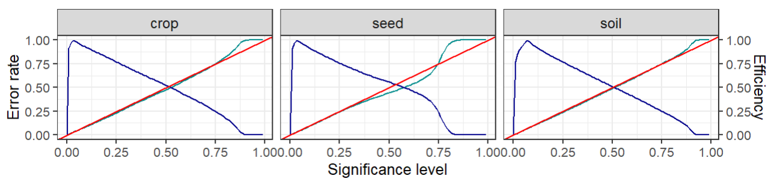
Figure S5 Calibration plots for treatment target compartment conformal prediction models (one treatment target compartment per plot), with x-axis showing pre-defined significance levels ranging from 0 to 1, left y-axis showing error rates ranging from 0 to 1 and right y-axis showing efficiency ranging from 0 to 1. Blue line indicates the efficiency, turquoise line indicates error rate, and red line indicates the reference line of error rate being equal to the significance level.

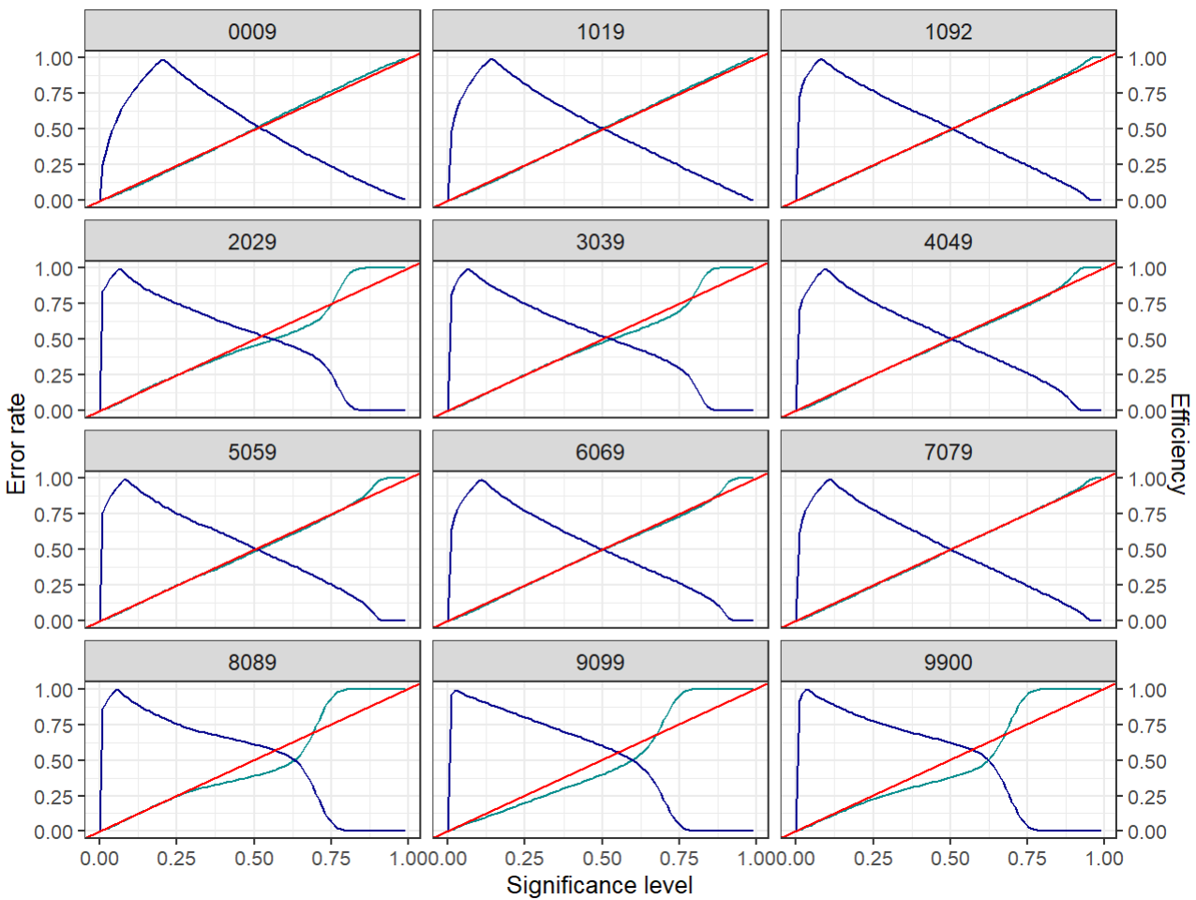
Figure S6 Calibration plots for crop growth stage conformal prediction models (one BBCH range per plot), with x-axis showing pre-defined significance levels ranging from 0 to 1, left y-axis showing error rates ranging from 0 to 1 and right y-axis showing efficiency ranging from 0 to 1. Blue line indicates the efficiency, turquoise line indicates error rate, and red line indicates the reference line of error rate being equal to the significance level.

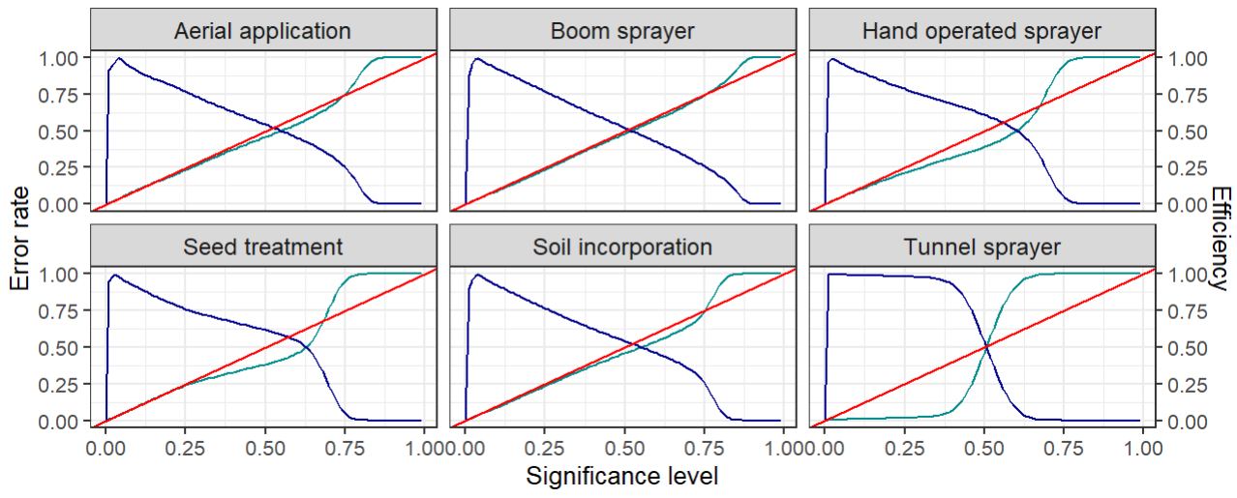
Figure S7 Calibration plots for application method conformal prediction models (one application method per plot), with x-axis showing pre-defined significance levels ranging from 0 to 1, left y-axis showing error rates ranging from 0 to 1 and right y-axis showing efficiency ranging from 0 to 1. Blue line indicates the efficiency, turquoise line indicates error rate, and red line indicates the reference line of error rate being equal to the significance level.

4. Output generation and projection

After obtaining the comprehensive set of combined reported and imputed pesticide application scenarios across country/region-crop-chemical combinations, and including a complete set of crop growth stages (BBCH), application methods, and application target compartments, three primary outputs were calculated and projected based on our analysis: annual weighted average application rate, annual applied mass per country/region-crop-chemical scenario (for reported countries per country/region-crop-chemical-application method scenario and per country/region-crop-chemical-treatment target compartment scenario) derived from annual load, and geospatial projections of pesticide application mass.

4.1 Annual weighted average application rate

A weighted average application rate for a single application was provided for each country-crop-chemical scenario. Because the raw dataset contains information on super-treated area (i.e. the area that comprises the treated area per single treatment and the number of treatments per year), a rate weighted by super-treated area was calculated to represent an average application rate per single application per scenario.

4.1.1 Application rate calculation from reported data

Step 1: Weighted average application rate
Average application rates for single applications, ${\overline{D}}_{\text{appl,}p_{\text{dataset}},c,a }^{\text{wt}}$ [kg/ha], were derived as weighted arithmetic means using super-treated area, $A_{{r,p}_{\text{dataset}},c,a}^{\text{treat}} [\text{ha}]$, as weight, averaging on rows in the harmonized raw dataset (using the ratio of reported mass applied and related super-treated area) were calculated per country $c$, crop $p_{\text{dataset}}$ and chemical combination from the reported dataset:

 | $${\overline{D}}_{\text{appl,}p_{\text{dataset}},c,a }^{\text{wt}}=\frac{\sum_{r}{\left(A_{{r,p}_{\text{dataset}},c,a}^{\text{treat}}×{\overline{D}}_{raw,{r,p}_{\text{dataset}},c,a,}^{\text{treat}}\right)}}{\sum_{r}{A_{r,p_{\text{dataset}},c,a}^{\text{treat}}}}= \frac{\sum_{r}{\left(A_{{r,p}_{\text{dataset}},c,a}^{\text{treat}}×\frac{M_{r,p_{\text{dataset}},c,a}}{A_{{r,p}_{\text{dataset}},c,a}^{\text{treat}}}\right)}}{\sum_{r}{A_{r,p_{\text{dataset}},c,a}^{\text{treat}}}}=\frac{\sum_{r}{M_{r,p_{\text{dataset}},c,a}}}{\sum_{r}{A_{r,p_{\text{dataset}},c,a}^{\text{treat}}}}$$ | (S6)

Step 2: Uncertainty quantification around weighted average application rate
Uncertainty 95% confidence interval ranges around weighted average application rates were generated from bootstrapping using the R package bcaboot (62) for each country/region-crop-chemical combination, which provides a non-parametric estimation with bias-correction on the confidence interval.
For combinations consisting of less than 5 reported raw data rows, a conservative assumption was used instead of applying the bootstrapped confidence interval, since the latter would not yield reliable uncertainty ranges. The 97.5th %-ile from the ratios between high-end bootstrapping 97.5th %-ile results and calculated weighted average application rates across scenarios with 5 reported data rows (i.e. ${ratio}_{\text{bootstrap 97.5\%}/{\overline{D}}_{\text{appl,}p_{\text{dataset}},c,a }^{\text{wt}}}^{97.5\%}=2.3$) was applied as fixed, conservative uncertainty estimate to all scenarios with less than 5 reported data rows (Figure S8, top). A similar approach was applied to calculate the conservative 97.5th %-ile ratio with 5 reported data rows from the ratios between calculated weighted average application rates and low-end bootstrapping 2.5th %-ile results across scenarios (${ratio}_{{\overline{D}}_{\text{appl,}p_{\text{dataset}},c,a}^{\text{wt}}/\text{bootstrap 97.5\%}}^{97.5\%}=5.6$) (Figure S8, bottom).

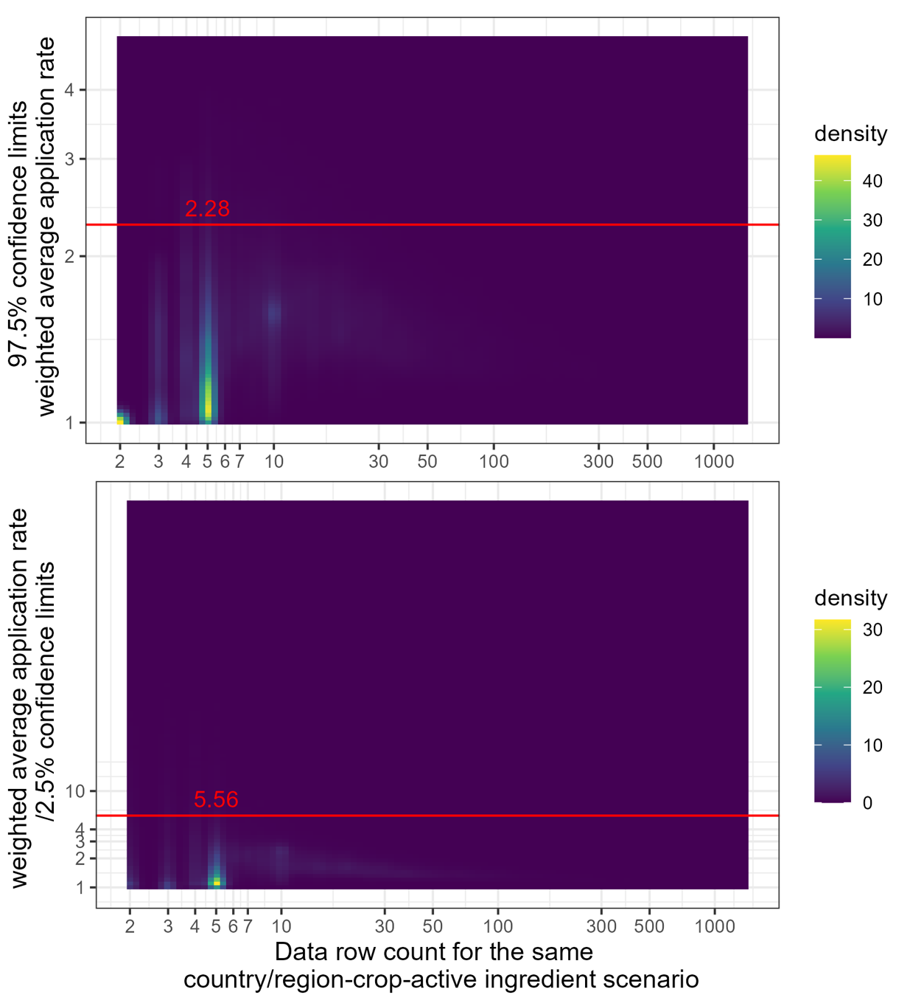
Figure S8 Density plots for weighted average application rates ratio between high-end bootstrapping 97.5th %-ile results and calculated weighted average application rates (top) and between calculated weighted average application rates and low-end bootstrapping 2.5th %-ile (bottom).

4.1.2 Application rate prediction and aggregation where reported data are not available

For no-data country scenarios, weighted average application rates were predicted through XGBoost using the Python package xgboost, version 1.7.5 (63). Since the continuous numeric weighted average application rate is the dependent variable, an XGBoost regression model was applied. The predictions were only conducted on the active ingredient “yes applied” scenarios from active ingredient imputation for no-data countries.

Step 1: Data preprocessing and encoding
Weighted average application rate was the dependent variable from model predictions. The log-transformed values were used in the prediction because of the skewed distribution of the weighted average application rate. Crops (including crop groups) and continents were utilized as model inputs. As predictions were made exclusively for countries with no reported data, the country itself was not used as an input parameter in the model. As the target of the prediction is at the level of country/region-crop-active ingredient scenario to obtain the average application rate and as our study covers almost all effectively applied chemical pesticides globally, CAS RN was included as an input categorical parameter to identify individual chemical active ingredients, along with chemical classes, target classes and mode of action groups. Environmental and socio-economic features, i.e. average minimum and maximum temperature, precipitation, field size, GDP and HDI were used as numerical input parameters to complement chemical-related inputs, since they were reported to influence differences in application rates within and across active ingredients (18, 35). Categorical variables were encoded by one-hot-encoding to avoid an inherent hierarchical relationship among the categories from ordinal integer encoding.

Step 2: Prediction model design
The XGBoost algorithm was used to predict the log-transformed weighted average application rates using the Python xgboost package, version 1.7.5 (63). Since XGBoost can counteract overfitting through sequentially creating and improving decision trees where the sample data present high similarity across data points, it is a suitable model for predicting the application rates across scenarios. The input dataset was split into 80% training data and 20% test data with stratified separation on weighted average application rate, i.e. the distribution of log-transformed weighted average application rate in the training data and test data are the same. Hyperparameter tuning was conducted using RandomSearchCV from using scikit learn package version 1.2.1 (61), with the different trained hyperparameters shown in Table S18. The model with the highest negative mean absolute error (NMSE) value was kept as the best fit and applied to the country/region-crop-chemical scenarios for countries with no reported data.

Table S18 Trained hyperparameters utilized in RandomizedSearchCV for tuning the XGBoost regression model to predict weighted average application rate and annual load.
Number of trees (n_estimator) | Maximum depth of a tree (max_depth) | Step size shrinkage used in update to prevent overfitting (learning_rate) | Minimum sum of instance weight (hessian) needed in a child (min_child_weight) | Lagrangian multiplier (gamma)
100 | 3 | 0.05 | 0.01 | 0
200 | 6 | 0.1 | 0.05 | 0.1
400 | 9 | 0.2 | 0.25 | 0.2
700 | 12 | 0.3 | 0.50 | 0.3

Permutation feature importance analysis demonstrated that while categorical features (e.g. chemical class, mode of action groups, CAS RN, crop group, target class) ranked highest in importance, all model inputs, including numerical features (e.g. field size, HDI, GDP, precipitation, temperature) were deemed necessary for the model's performance (see Figure S9). Recursive feature elimination (RFE) using the XGBoost regression model with 10-fold cross-validation (data file 2, Table S17) confirmed the relevance of these numerical inputs. Although some categories within categorical variables were not individually selected by RFE, the categorical variables as such remained integral to the predictive model, highlighting the necessity of retaining all input features to ensure comprehensive model accuracy.
To further explore feature contributions, SHAP (SHapley Additive exPlanations) analysis was employed (64). SHAP provides a unified framework for interpreting the contribution of each feature to a model's predictions, calculating the marginal impact of each feature by comparing different feature values. This method is especially useful in complex machine learning models like XGBoost, as it allows for clearer interpretation of feature influence on output predictions. The contributions of interactions between features are not assessed separately.
The SHAP analysis (Figure S10, Figure S11) revealed that chemical class had the highest mean SHAP value (>0.2) when predicting the log-transformed application rate, signifying its strong influence on model output. This was closely followed by mode of action group, with a mean SHAP value around 0.18, and CAS RN. Mode of action groups and chemical class tended to exert a negative impact on the predicted outcomes, while HDI demonstrated a distinctive pattern: higher HDI values positively affected the predictions, whereas lower HDI values had a pronounced negative effect, as illustrated in the SHAP summary plot (Figure S11). Other key features such as crop group, target class, and field also showed larger contributions, with GDP and climate features exerting comparatively less influence on the model. Despite variations in individual feature importance, SHAP analysis reinforced that all input features played a critical role in shaping model predictions, supporting the necessity of including both categorical and numerical variables.

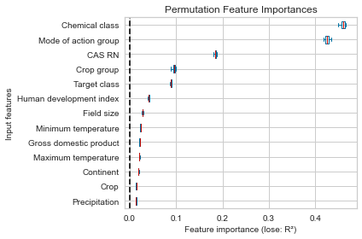

Figure S9 Permutation feature importance ranking for the XGBoost model to predict weighted average pesticide application rates.
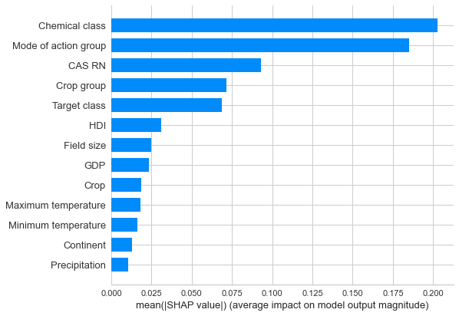

Figure S10 Bar plot illustrating the mean absolute SHAP (SHapley Additive exPlanations) values for each variable, ranked by their contribution to the XGBoost model’s predicted weighted average pesticide application rates.

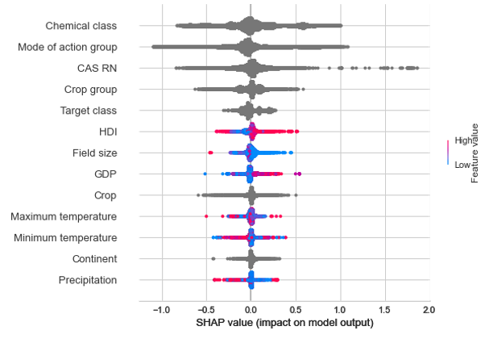
Figure S11 Beeswarm plot showing SHAP (SHapley Additive exPlanations) values for each feature across individual predictions, ranked by the feature’s importance in the XGBoost model’s predicted weighted average pesticide application rates. The x-axis reflects whether a feature contributes positively or negatively to each prediction, while color represents how the value of an individual feature compares to the population average. Categorical features are depicted in dark grey.

Step 3: Model evaluation and calibration
The prediction error plot (Figure S12) depicts an R² performance of 0.809 for the trained model on test data and a root mean square error (RMSE) of 0.31 of log-transformed weighted average pesticide application rate predictions, indicating that it explains 81% of the variance in weighted average application rates. This robust performance underscores the model's effectiveness in capturing the underlying patterns in the application rate data. While the model showed excellent predictive capability across most cases, some minor deviations were observed at extreme values, particularly for exceptionally high application rates and those approaching zero.

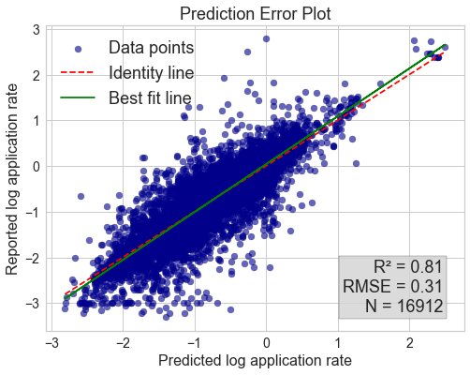
Figure S12 Prediction error plot for log-scale weighted average pesticide application rate predictions for countries with no reported data.

Step 4: Uncertainty quantification around projected weighted average application rate
Uncertainty 95% confidence interval ranges around the predicted weighted average pesticide application rates were calculated from bootstrapping steps introduced by (65) (https://github.com/saattrupdan/doubt) for the XGBoost hypermeter tuned regression model. The approach computes the confidence interval for a non-parametric approach with no specific assumptions on the sampling distribution of the model variances, sample errors or the data.

4.2 Annual average application mass per country/region-crop-chemical scenario

Annual average application mass was provided for each country/region-crop-active ingredient scenario. Figure S13 depicts the full heat map of pesticide application mass across the combination of 167 considered countries and 131 considered crops. As the average mass combines both how much pesticide is applied and the respective treated crop area, annual load was calculated using the yearly average mass per country/region-crop-active ingredient and the crop physical area per country/region-crop information to indicate the mass prevalence. The application mass applied per country/region, per crop and per pesticides are respectively provided in Table S12, Table S20, and Table S21.
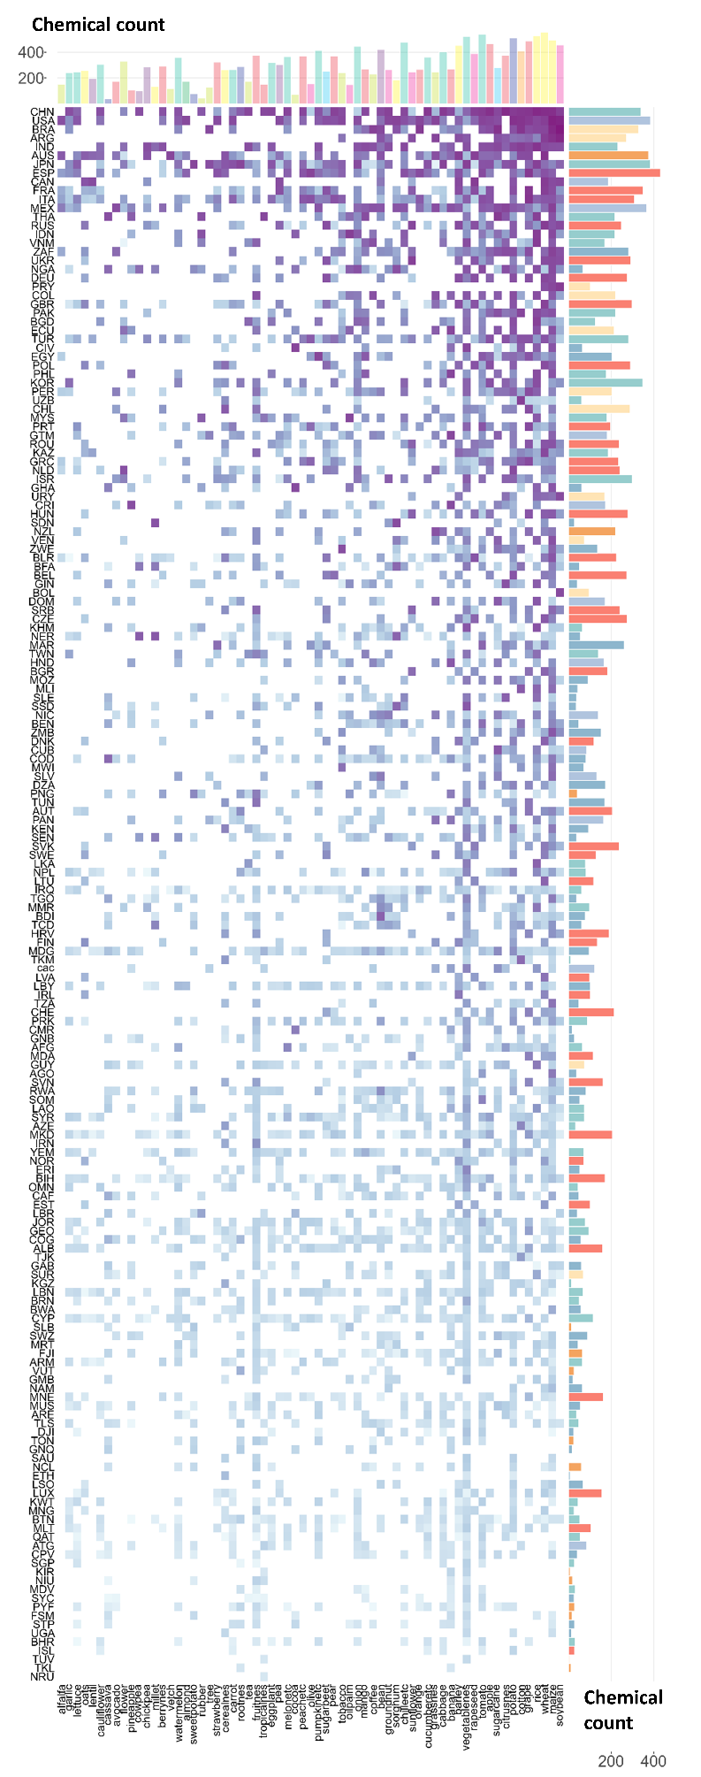
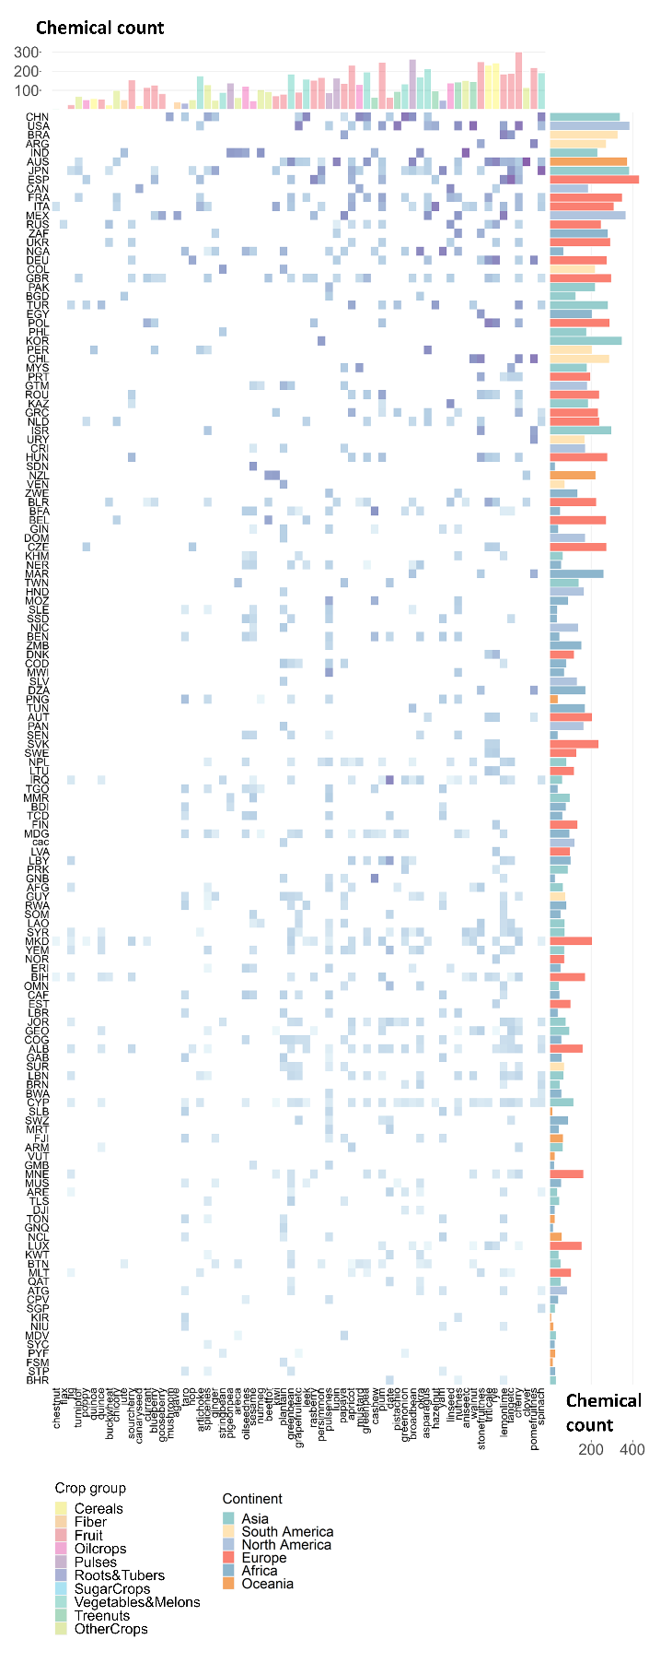
Figure S13 Full heat map (left panel for top-ranked 65 crops in terms of pesticide application mass, and right panel for the remaining 65 crops) of pesticide mass applied across countries (y-axis) and crops (x-axis) combinations in terms of annual average pesticide mass applied, with pesticide count per crop across all countries on top as bars and pesticide count per country across all crops on the right as bars.

4.2.1 Annual average application mass and annual load per scenario derived from reported data

Step 1: Annual average applied mass
Annual average applied mass, ${\overline{M}}_{p_{\text{dataset}},c,a}$ [kg], was calculated from averaging the harmonized raw applied mass with corresponding country/region-crop-active ingredient scenarios (for reported countries per country/region-crop-chemical-BBCH scenario, per country/region-crop-chemical-application method scenario and per country/region-crop-chemical-treatment target compartment) as:

 | $${\overline{M}}_{p_{\text{dataset}},c,a}=\frac{\sum_{r}{M_{{r,p}_{\text{dataset}},c,a}}}{n_{r}}$$ | (S7)

Step 2: Average annual load
We assumed that active ingredients are applied to the entire corresponding physical crop area within a country for a given country-crop-chemical scenario. With that, the annual load of pesticide application was calculated from annual average applied mass ${\overline{M}}_{p_{\text{dataset}},c,a} [\text{kg}]$ per country-crop-chemical scenario and the corresponding total physical crop area in that country ${\overline{A}}_{p_{\text{dataset}},c}^{\text{phys}} [\text{ha}]$ from the adjusted annual average spatialized crop maps for the timeframe 2016 to 2020. Several country-crop combinations within the reported dataset did not have any respective crop growth areas in the crop maps (corresponding to less than 1% of the total application mass in the reported dataset). For these cases, only annual average application mass was reported. For the remaining country-crop-active ingredient scenarios with country-crop physical area information, the average annual load, ${\overline{D}}_{\sum{\text{appl,}p_{\text{dataset}},c,a}}^{\text{phys}}$ [kg/ha], was calculated as:

 | $${\overline{D}}_{\sum{\text{appl,}p_{\text{dataset}},c,a}}^{\text{phys}}= \frac{{\overline{M}}_{p_{\text{dataset}},c,a}}{{\overline{A}}_{p_{\text{dataset}},c}^{\text{phys}}}$$ | (S8)
with
 | $${\overline{A}}_{p_{\text{dataset}},c}^{\text{phys}}=\sum_{g∩c}{{\overline{A}}_{{g,p}_{\text{dataset}},c}^{\text{phys}}}$$ | (S9)

4.2.2 Annual load prediction and application mass calculation where reported data were missing

The mass applied for country scenarios with no reported data, ${\overline{M}}_{p_{\text{dataset}},c,a}$ [kg], was calculated from the predicted annual load for each country/region-crop-chemical scenario, ${\overline{D}}_{\sum{\text{appl,}p_{\text{dataset}},c,a}}^{\text{phys}}$ [ka/ha], and the physical crop area for each country/region-crop combination, ${\overline{A}}_{p_{\text{dataset}},c}^{\text{phys}}$ [ha]:

 | $${\overline{M}}_{p_{\text{dataset}},c,a}={\overline{D}}_{\sum{\text{appl,}p_{\text{dataset}},c,a}}^{\text{phys}}×{\overline{A}}_{p_{\text{dataset}},c}^{\text{phys}}$$ | (S10)

Similar to the weighted average application rate prediction, for country scenarios that have been imputed through active ingredient imputation steps, the log-transformed annual load was predicted through XGBoost using the Python package xgboost, version 1.7.5 (63). The prediction model setup was the same as applied for the weighted average application rate prediction models (see Section 4.1.2), with the difference in the output from log-transformed annual average application rate to log-transformed annual load based on annual average application mass and crop physical area values derived from the adjusted annual average spatialized crop map over the years 2016 to 2020. Uncertainty 95% confidence interval ranges for the predicted annual load were calculated following the same approach as for the weighted average application rate (see Section 4.1.2, Step 4).
The prediction error plot (Figure S14) shows an R² performance of 0.66 for the model on test data and a root mean square error (RMSE) of 0.75 of log-transformed annual load. The feature ranking with the refined model after hyperparameter tuning is shown in Figure S15, demonstrating that categorical features such as crop group, mode of action group ranked highest in importance for predicting the annual load, followed by field size, climate features like temperature, and socio-economic features like HDI and GDP. The recursive feature elimination results are listed in data file 2, Table S19. SHAP analysis (Figure S16, Figure S17) confirmed that crop group had the highest mean absolute SHAP value, followed by mode of action group and chemical class. SHAP also reveals the directionality of feature influences on the predicted annual load, i.e. lower minimum temperature is associated with a negative impact on the prediction and higher HDI tends to exert positive influence on the annual load prediction.

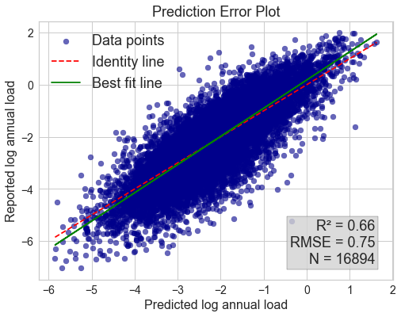
Figure S14 Prediction error plot for log-transformed pesticide annual load predictions for countries with no reported data.

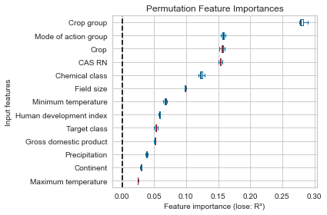

Figure S15 Permutation feature importance ranking for the XGBoost model to predict pesticide annual loads.

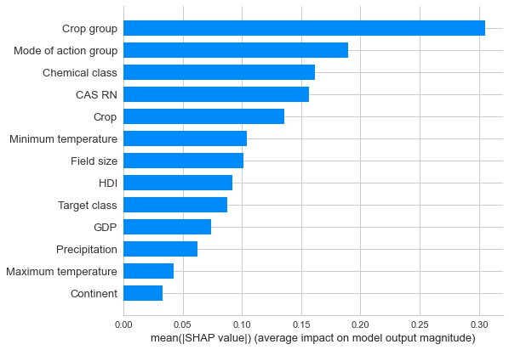

Figure S16 Bar plot illustrating the mean absolute SHAP (SHapley Additive exPlanations) values for each variable, ranked by their contribution to the XGBoost model’s predicted pesticide annual loads.

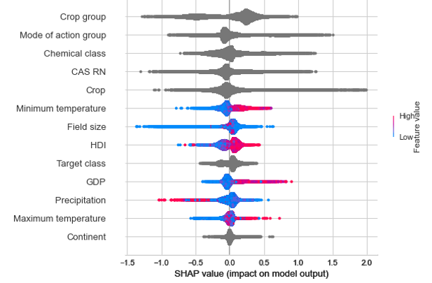
Figure S17 Bee-swarm plot showing SHAP (SHapley Additive exPlanations) values for each feature across individual predictions, ranked by the feature’s importance in the XGBoost model’s predicted pesticide annual loads. The x-axis reflects whether a feature contributes positively or negatively to each prediction, while color represents how the value of an individual feature compares to the population average. Categorical features are depicted in dark grey.

4.3 Geospatial projections of pesticide application mass

To generate global pesticide application geospatial maps, the average annual mass applied from the reported data and the predicted annual average mass applied at country/region-crop-active ingredient level were used as pesticide application information. Adjusted spatialized crop maps were utilized as the crop production area distribution reference, indicating spatial crop distribution globally as annual average across years 2016-2020. The mass applied per country-crop-chemical combination on each spatial grid cell, ${\overline{M}}_{{g,p}_{\text{dataset}},c,a} [\text{kg}]$, was calculated from the mass applied per physical crop area per country-crop-chemical scenario, ${\overline{D}}_{\sum{\text{appl,}p_{\text{dataset}},c,a}}^{\text{phys}}$ [kg/ha], and the physical crop area for the country-crop combination in the relevant spatial grid cell, ${\overline{A}}_{{g,p}_{\text{dataset}},c}^{\text{phys}} [\text{ha}]$:

 | $${\overline{M}}_{{g,p}_{\text{dataset}},c,a}={\overline{D}}_{\sum{\text{appl,}p_{\text{dataset}},c,a}}^{\text{phys}}×{\overline{A}}_{{g,p}_{\text{dataset}},c}^{\text{phys}}$$ | (S11)

The variability of applied mass per grid cell in one country for one active ingredient is derived from the related crop density from the crop maps.
Pesticide application maps were generated at the crop-active ingredient level based on a 5×5 arcminute grid using the WGS84 projection. Aggregated level maps, i.e. pesticide application maps at 5×5 arcmin grid per active ingredient across all related crops, and pesticide application maps at 5×5 arcmin grid across all active ingredients and crops, are provided in addition. With the calculation of pesticide application mass in each grid cell per active ingredient across all crops, ${\overline{M}}_{g,a}$ [kg], or overall mass across all crops and chemicals, ${\overline{M}}_{g}$ [kg], are derived as:

 | $${\overline{M}}_{g,a}=\sum_{p_{\text{dataset}}}{{\overline{M}}_{{g,p}_{\text{dataset}},c,a}}$$ | (S12)
 | $${\overline{M}}_{g}=\sum_{a}{{\overline{M}}_{g,a}}$$ | (S13)

4.3 Imputation safeguards and dominant pesticide considerations

We have implemented safeguards against disproportionate influence of dominant pesticides in our imputation procedures. For active ingredient presence prediction (Section 3.1), for each chemical a separate conformal prediction model was developed, preventing cross-chemical bias. For application rate and mass prediction (Sections 4.1-4.2), we predict annual load (mass per physical area) rather than absolute mass, which reduces the influence of widely applied pesticides (e.g. on monoculture cropping systems). Additionally, our prediction models include CAS registry numbers, chemical classes, and mode of action groups as input parameters, which further reduces potential bias from predominant pesticides by ensuring that predictions are based on chemical properties rather than just pesticide use.
The dominance of glyphosate compounds and other major herbicides reflects actual global agricultural practices, where broad-spectrum herbicide use dominates due to their effectiveness across multiple crop systems and widespread adoption of herbicide-tolerant crops. Our methodology accounts for this reality while preventing artificially skewing predictions toward more or less common pesticides.

5. Output evaluation

The evaluation of our main outputs involved the examination of pesticide application data derived from the final compiled dataset, as well as information from alternative sources, at various levels of granularity. The evaluation was conducted at the country/region level for the overall pesticide application mass comparison across all crops and active ingredients, at the country/region-active ingredient level for the pesticide application mass across all crops, at the country/region-crop-active ingredient level for pesticide application, and lastly at the geospatial county-active ingredient level for the pesticide application mass across all crops.

5.1 Comparison of pesticide application mass by Country/region

The pesticide application mass in each country/region derived from the dataset in our study was evaluated against data from the Food and Agriculture Organization of the United Nations (FAO) (https://www.fao.org/faostat/en/#data/RP; original data retrieved on 1-June-2023 and updated data retrieved on 1-November-2023) for total pesticide use in each country/region and UN COMTRADE (https://comtradeplus.un.org) trade data representing commodity code 3808 ("Insecticides, rodenticides, fungicides, herbicides, anti-sprouting products, plant growth regulators, disinfectants and the like, put up in forms or packings for retail sale or as preparations or articles") to assess consistency and identify methodological strengths across different data collection approaches (Figure S18). We compared the annual average application mass from our dataset with FAOSTAT averages for the years 2016 to 2020 using both FAOSTAT reported data in 2022 and 2023 (due to a major update of FAOSTAT data between these two years), and with COMTRADE import and net trade data converted to active ingredient equivalents using a factor of 0.36 (conversion factor from FAOSTAT for generic pesticides) for the same time period. Our dataset’s average application mass incorporates all country/region-crop-active ingredient combinations, which in some cases led to higher total values compared to yearly reported masses, as observed for Japan, due to differences in scenario coverage across years.
Our analysis reveals a generally fair alignment in total pesticide application mass between the FAO data and our dataset across most countries, with additional validation provided by COMTRADE trade data for import-dependent countries. Among the top 20 countries, which collectively represent over 80% of global pesticide use by mass applied, the median ratios are 1.13 (comparison/FAOSTAT 2022) and 0.93 (comparison/FAOSTAT 2023). This indicates reasonable alignment at the aggregated level, with our estimates exhibiting slight positive deviation relative to FAOSTAT 2022 and modest negative deviation relative to FAOSTAT 2023. For these 20 countries, all (excluding Indonesia) demonstrate agreement within a factor of two when compared to FAOSTAT 2022. When evaluated against FAOSTAT 2023, 94.7% of these major countries remain within this concordance range. Examining the complete dataset more granularly, our cross-dataset comparison reveals that 28.3% of countries fall within ±10% agreement, 41.2% within ±25%, and 68.5% within ±50% when compared with FAOSTAT 2022. Similar patterns emerge in the FAOSTAT 2023 comparison, with 25.4% of countries showing agreement within ±10%, 38.7% within ±25%, and 66.9% within ±50%.
COMTRADE import data provide an independent validation perspective, particularly valuable for import-dependent countries without domestic pesticide manufacturing. When comparing our estimates against COMTRADE import data (converted to active ingredients using a 0.36 factor), 32.1% of countries with available trade data fall within ±25% agreement, 47.8% within ±50%, and 71.3% within a factor of two. The comparison reveals variation in agreement patterns across countries based on their agricultural systems, data collection approaches, and market structures. Thailand presents a case where our dataset estimates 50.4 million kg annually, while FAO reports 29.3 million kg, and COMTRADE net trade data indicate 48.5 million kg. In this import-dependent market, the trade data fall between our estimate and FAO's lower figure. Brazil exemplifies how domestic pesticide production affects comparisons differently. Our dataset (385.6 million tonnes) falls between FAO 2023 (577 million tonnes) and COMTRADE net imports (110.7 million tonnes). Here, trade data capture only imported products, missing domestically manufactured pesticides, while differences between our estimates and FAO figures may reflect methodological revisions in FAO's 2023 reporting.
Indonesia exhibits notable divergence between our dataset and both FAOSTAT reports, with COMTRADE data providing additional perspective on this discrepancy. The FAOSTAT methodology for Indonesia appears to derive values from application patterns in Malaysia extrapolated via Indonesian production statistics (66), particularly for palm trees, rice, and rubber tree cultivation systems. Our dataset utilizes directly reported data for Indonesia, though acknowledging the persistent challenge of limited data availability for these agriculturally significant crops. The three-way comparison shows FAO 2023 estimating 275.5 million kg, our dataset estimating 38 million kg, and COMTRADE net imports of 11.1 million kg, suggesting our estimate falls intermediate between consumption estimates and trade-based proxies.
The comparisons reveal both higher and lower estimates in our dataset relative to other sources, with patterns varying by country characteristics and market structure. For some countries with domestic pesticide manufacturing capacity, such as several European countries and some Asian markets, our estimates are 10-30% higher than FAO 2022 figures, potentially reflecting more comprehensive capture of field-level applications through farmer panel surveys compared to sales-based reporting systems. For some other import-dependent countries, particularly those in sub-Saharan Africa and parts of Asia, our estimates are often 20-60% lower than COMTRADE import figures. This pattern appears most pronounced in countries where our data sources were limited, and agricultural systems are dominated by smallholder farms with informal supply chains. The discrepancies in import-dependent markets may reflect several factors: trade data capture all imported products regardless of ultimate use (including re-export, storage, or non-agricultural applications), while our estimates focus on agricultural field applications; and conversion factors from formulated products to active ingredients introduce uncertainty. These bidirectional differences illustrate how each dataset's methodology performs differently across varying agricultural and market contexts, with no single approach providing uniformly accurate estimates across all country types. Several countries (Brazil, Spain, Vietnam, and South Africa) display considerable ratio shifts between the two FAOSTAT reporting periods, potentially reflecting evolving methodological approaches in national-level data acquisition or reporting protocols. These shifts underscore the general challenge of pesticide use quantification: facing difficulties in data-poor regions (7), particularly in low-income countries where monitoring infrastructure is limited. Institutional barriers include limited capacity for tracking agricultural inputs, inadequate data collection systems, resource constraints preventing comprehensive surveys, and informal supply chains operating outside official monitoring. These challenges affect FAO statistics, trade data, and our own dataset similarly, though they manifest differently depending on each methodology's specific approach.
When uncertainty is considered, our dataset demonstrates reasonable agreement with FAO estimates. Our global estimate of 2.9 million MT comes with an uncertainty range of 2.2-3.8 million MT (derived from temporal variability for countries with reported data over the considered 5 years’ timeframe as well as 95% confidence intervals reflecting prediction model accuracy for countries with imputed data), which encompasses well the FAO 2023 estimate of 3.3 million MT. This overlap indicates that differences between point estimates are less pronounced when confidence intervals are considered. The explicit quantification of uncertainty ranges in our dataset provides more complete information about confidence levels compared to point estimates alone, highlighting the inherent challenges in global pesticide use quantification while supporting the credibility of both approaches for policy applications requiring different levels of granularity.
These comparative analyses highlight both the consistency and divergence across global pesticide datasets and the inherent methodological challenges in comprehensive pesticide use quantification. Our dataset provides fine resolution data on crop-specific and chemical-specific applications based on farmer surveys and market research. In contrast, FAOSTAT offers country/level aggregates that combine pesticides into broader chemical classes without distinguishing individual active ingredients or specific crops and may include forestry uses depending on national reporting practices. COMTRADE captures international trade flows of formulated pesticide products (commodity code 3808) converted to active ingredient equivalents. Our dataset’s fine-grained resolution at the level of individual active ingredients mapped to specific crops with spatial information complements FAOSTAT's country-level aggregated statistics and COMTRADE’s trade-flow perspectives, and enables applications such as chemical-specific risk assessments, crop protection optimization and targeted policy interventions. The complementary nature of these datasets suggests potential benefits in their integrated analysis for developing more comprehensive insights into global pesticide application patterns and informing evidence-based agricultural policy decisions.

Figure S18 Comparison between the dataset in our study and lower resolution data sources for the average total pesticide use or trade in mass for each country/region from 2016 to 2020. The comparison includes FAOSTAT data retrieved on 1-June-2023 (FAO 2022) and 1-November-2023 (FAO 2023) from https://www.fao.org/faostat/en/#data/RP, and UN COMTRADE trade data from https://comtradeplus.un.org for commodity code 3808 converted to active ingredients using a 0.36 conversion factor. Both COMTRADE import values and net trade values (import minus exports) are shown. The countries were ranked by pesticide application mass from top to bottom. Countries marked with “T” indicate where FAO relies primary on trade-based methodologies (imports, net trade proxy, or supply balance approaches). Error bars for FAOSTAT were used to represent the range of reported pesticide application mass from 2016 to 2020. Error bars for the dataset from our study for countries with reported data were used to represent the range of pesticide application mass from 2016 to 2020, and for countries imputed were used to represent the 95% confidence interval.

5.2 Comparison of pesticide application mass by country/region-active ingredient

The comparison of pesticide application mass for individual active ingredients was conducted in 5 countries across 4 continents: South Africa (Africa), India (Asia), Czechia (Europe), the United Kingdom (Europe) and the USA (North America). These countries were selected to represent countries with different levels of available reported data on pesticide consumption.
The average mass application data from our study, spanning 2016 to 2020, were utilized for this comparison. For the national data specifically, pesticide consumption data for South Africa were obtained from (67, 68), the data source was GfK Kynetec AgroTrakTM database for the year 2009. India’s pesticide consumption data for indigenous pesticides from 2016 to 2020 were sourced from the Directorate of Plant Protection, Quarantine & Storage (PPQS) under the Ministry of Agriculture & Farmers Welfare in India (https://ppqs.gov.in/statistical-database). Pesticide use data for United Kingdom were obtained from the Food and Environment Research Agency (FERA) (https://pusstats.fera.co.uk/data) for the years 2016, 2018 and 2020, covering arable, soft fruit and orchard crops. For the USA, pesticide use data were retrieved from the United States Geological Survey (USGS) under the pesticide national synthesis project (https://water.usgs.gov/nawqa/pnsp/usage/maps/), utilizing both low pesticide-use estimate (EPest-low) and high pesticide use estimate (EPest-high). Data from 2016 to 2019 were used for the final comparison. Since the list of monitored active ingredients was reduced from 420 active ingredients to 72 for the year 2019, data from 2016 to 2018 were used as proxy for the remaining active ingredients. Since seed treatment was not included and reported in USGS, crop-active ingredient combinations with seed treatment as reference application method in the USA from our dataset were excluded in the evaluation part. In cases where the USA reported at the county or state level, the active ingredient pesticide application data were aggregated to the country level. Top 30 most used active ingredients in terms of mass applied available in each country were included in the comparison.
In Figure S19 (left), the pesticide application mass data exhibited similarity and fell within the error bar ranges, especially for countries with well-refined pesticide use reporting systems, such as the USA (USGS) and the United Kingdom (FERA). However, larger discrepancies were observed in the reported data for South Africa, where the national data traced back to 2009, and India, where the national report indicated lower pesticide use compared to our dataset. The disparities in India’s national data could be attributed to reporting issues, as there was limited information available on how pesticides were applied to specific crops and how the national statistics were collected.

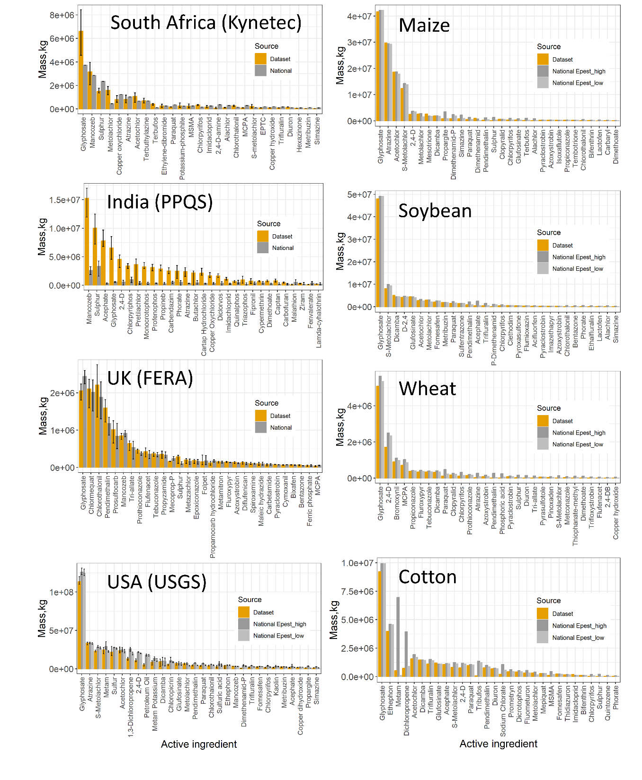
Figure S19 Left: Comparison between dataset in the present study and national statistics regarding the average total pesticide use in mass per individual active ingredient in South Africa, India, the United Kingdom and the USA. Error bars for national statistics were used to represent the range of reported pesticide application mass from corresponding years. Error bars for the dataset from our study for countries with reported data were used to represent the range of pesticide application mass from 2016 to 2020. Right: Comparison between dataset in the present study and national statistics regarding the average total pesticide use in mass per individual active ingredient in the USA on maize, soybean, wheat and cotton for the years 2016 to 2019.

5.3 Comparison of pesticide application mass by country/region-crop-active ingredient

The comparison of pesticide application mass for specific active ingredients on individual crops was limited to the USA, where crop-specific data were available. This analysis focused on four major crops: maize, soybean, wheat, and cotton. Like the approach employed in the previous section, data spanning the years 2016 to 2019 from the United States Geological Survey (USGS) were utilized to calculate averages for the comparison. For the year 2019, data were used whenever available for chemicals with relevant information. The active ingredient pesticide application data were then aggregated to the country level for a consistent comparison at national level.
In Figure S19 (right), the pesticide application mass displayed notable similarities between our dataset and USGS data for most of the active ingredients, particularly at the high end, for each of the major crops. There was a slight divergence observed in the case of glyphosate use. Significant disparities were evident for metam and diclopropene applied on cotton between the two data sources. However, the estimates for high pesticide use and low pesticide use from USGS also exhibited substantial differences for these chemicals, whereas our values closely aligned with the low pesticide use estimates.

5.4 Geospatial comparison of pesticide application mass by active ingredient in the USA

We selected the USGS EPest data for this comparison because it uses proprietary survey data from GFK Kynetec as a key input, similar to our pesticide use atlas. This shared data foundation enables us to focus our evaluation in this step on the effectiveness of our spatial disaggregation methodology, specifically how well we project national level pesticide use data onto spatial crop production areas, rather than validating the underlying pesticide use estimates themselves.
As the United States Geological Survey (USGS) primarily provides pesticide application mass data at the county level, a procedure was implemented to aggregate our pesticide spatial application maps based on geographic coordinates to facilitate a comparison at this highest level of detail. To investigate pesticide usage patterns at the county level, the following approach was adopted. Initially, county boundaries and census tracts for each state were obtained from the United States Census Bureau (available at https://www.census.gov/geographies/mapping-files/time-series/geo/carto-boundary-file.html). These boundaries were then transformed into a consistent spatial format, employing a standardized coordinate reference system (CRS), resulting in a coherent spatial representation encompassing 3,082 counties.
Subsequently, these county boundaries were effectively merged with our pesticide gridded spatial maps pesticide data, establishing crucial spatial relationships for subsequent analysis. To better align the data from 5×5 arcmin grid cells, each grid cell within the dataset was assigned a unique Federal Information Processing Standards (FIPS) code or a Geographic Identifier (GEOID) based on its geographical coordinates, enabling seamless integration with the updated mapSPAM2020 crop allocation map and pesticide spatial application map. The pesticide mass data for each county were then rigorously aggregated by summing the pesticide application on the crops on one 5×5 arcmin grid cell and then summing the values from the 5×5 arcmin grids cells falling within the corresponding county boundaries. Pesticide data from USGS were standardized for the years 2016 to 2019 for glyphosate, atrazine and imidacloprid (69), widely used herbicides and insecticides in US agriculture, at county level with no interpolation. Since USGS reports do not include seed treatment applications, we excluded seed treatment from our dataset for this comparison to ensure methodological consistency.
The calculation of pesticide mass applied in one county from our dataset encompassed all pesticide mass applied to the corresponding crops cultivated within one 5×5 arcminute grid cell, aggregating the values from all grid cells within that county. The geospatial comparison in Figure S20 demonstrates good alignment between our spatialized estimates with USGS spatial reported data for glyphosate, both in terms of counties where the pesticide was applied and the quantity applied. For atrazine, we observe moderate agreement (R² = 0.63). Concerning imidacloprid, our data show limited agreement (R² = 0.50). The comparison maps showing factors of difference reveal that rather than systematically overestimating across all counties, our estimates show both higher and lower values compared to USGS data in different counties. Given that the overall imidacloprid application mass after excluding seed treatment differed within a factor of two between our dataset (with an average of 3.9×10⁵ kg) and USGS (ranging from 4.5×10⁵ kg to 6.4×10⁵ kg with an average of 5.7×10⁵ kg), the observed differences can be attributed to certain counties in the USGS data where the reported pesticide mass is comparatively high. These disparities arise directly from our dataset’s implementation of uniform annual loads for each crop-active ingredient at the country level, which does not capture sub-national variations in application patterns that are particularly pronounced for chemicals with heterogeneous use patterns like imidacloprid.

Figure S20 Comparative analysis of county-level pesticide use in the USA, focusing on top-ranked pesticides in terms of mass applied, namely atrazine, glyphosate, and imidacloprid. Left panel: scatter plot correlating per-county pesticide application masses (in kg) as reported by USGS with those recorded in our dataset. Central and right panels: spatial distribution of pesticide application masses across counties, with data from USGS (central) and our present dataset (right), respectively. These distributions are segmented into five equal quantile classes based on USGS data.

5.5 Policy-relevant assessment of internationally regulated pesticides

Beyond validation against existing datasets, our global pesticide-use dataset enables the assessment of international regulatory compliance patterns. Analysis of pesticides banned or severely restricted under the Pesticide Action Network (PAN) and Rotterdam Convention's Prior Informed Consent (PIC) procedure reveals that 73 such chemicals are still being applied across 48 countries, representing 24.2 million kg annually (0.83% of global pesticide use).
This assessment highlights three key regulatory implementation challenges: (1) implementation gaps persist even in countries with strong institutional frameworks, as European countries account for 65% of regulated chemical use by mass, with soil fumigant 1,3-dichloropropene alone representing 9.2 million kg annually across Italy, Spain, Portugal, and Greece, despite this substance is not receiving EU approval due to its toxicity and having been repeatedly rejected since 2006 (https://ec.europa.eu/food/plant/pesticides/eu-pesticides-database/ppp/); (2) soil fumigants present unique replacement challenges due to their high application volumes and the economic interests linked to large-scale monocultures that depend on soil sterilization practices; and (3) accelerating international regulatory action is evident, with 25 chemicals regulated between 2020-2022, representing one-third of all regulated chemicals in our dataset. The case of 1,3-dichloropropene is particularly illustrative of regulatory implementation challenges. This genotoxic soil fumigant, which has been proven to cause chromosome aberrations and multiple tumor types, continues to receive emergency derogations in southern European countries primarily for intensive fruit and vegetable production (70).
These findings demonstrate how our dataset's integration of regulatory status information enables monitoring of global compliance with international chemical management frameworks, supporting evidence-based policy development and implementation assessment while revealing systematic gaps between regulatory intentions and field-level practices.

s

