Appendix A
Table S1. Chief Complaint Classification
Category | Examples
Pain/musculoskeletal/non-specific | pain, back pain, neck pain, shoulder pain, leg pain, knee pain, headache, eye pain, ear pain, joint pain, body ache, limb pain, or general pain.
Neurological / weakness / dizziness | dizziness, vertigo, general weakness, focal weakness, numbness, tingling, headache with neurological symptoms, confusion, speech difficulty, suspected cerebrovascular event, or syncope associated with neurological symptoms.
Respiratory / flu-like | cough, shortness of breath, dyspnoea, influenza-like illness, upper respiratory tract infection, sore throat, asthma exacerbation, respiratory symptoms, COVID-19-related symptoms, or chest congestion.
Abdominal/GI / urinary | abdominal pain, epigastric pain, flank pain, nausea, vomiting, diarrhoea, constipation, urinary tract infection, dysuria, renal colic, gastrointestinal upset, or urinary symptoms.
Fever/infection | fever, chills, suspected infection, febrile illness, wound infection, suspected sepsis, infected lesion, or unexplained fever.
Chronic / metabolic | diabetes-related symptoms, hyperglycaemia, hypoglycaemia, hypertension-related concerns, medication-related chronic-disease follow-up, renal-disease symptoms, electrolyte disturbance, dehydration, or fatigue attributable to chronic illness.
Chest pain/cardiac/syncope | chest pain, palpitations, suspected cardiac symptoms, elevated blood pressure with cardiac concern, presyncope, syncope, collapse, suspected acute coronary syndrome, or arrhythmia-related symptoms.
Falls/trauma | fall, injury, trauma, laceration, wound, burn, fracture-related complaint, head injury, road-traffic injury, or post-traumatic pain.
Follow-up / administrative | follow-up visit, dressing change, laboratory-test request, referral-related visit, prescription renewal, procedure review, medical report request, catheter-related review, or scheduled reassessment.
Other | complaints that were clinically interpretable but did not fit a prespecified category, such as rash, allergy, dental complaint, psychiatric concern, foreign body, or isolated skin-related symptoms.
Missing/ unclear | blank entries, non-interpretable abbreviations, typographical fragments, non-clinical entries such as “ER,” or vague terms that could not be assigned confidently to a clinical category.

Appendix B
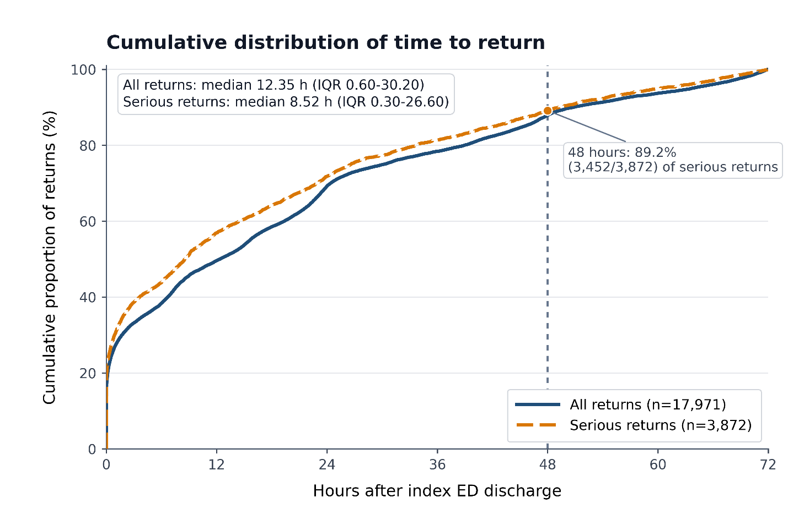
Figure S1. Cumulative distribution of time to return
Figure S2. Sensitivity-analysis plot

