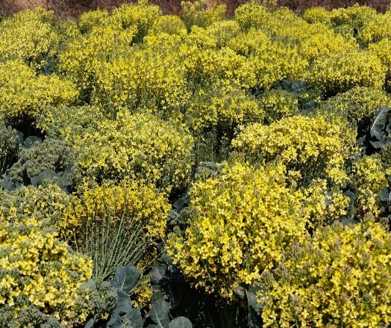
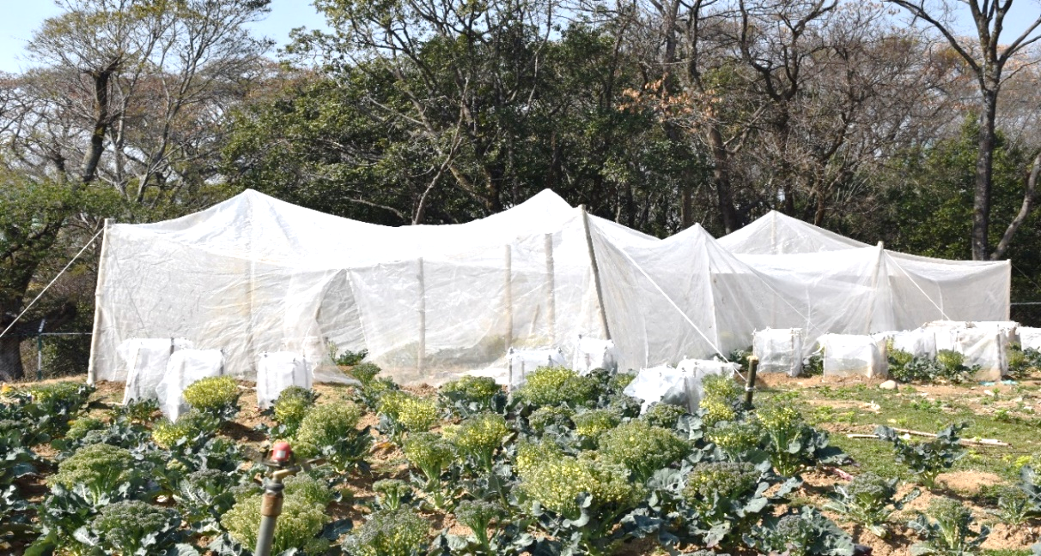
(a) Open pollination (b) Enclosed structure for A. mellifera

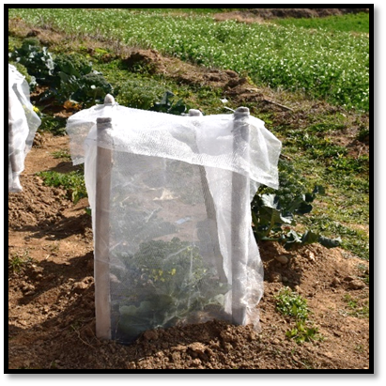
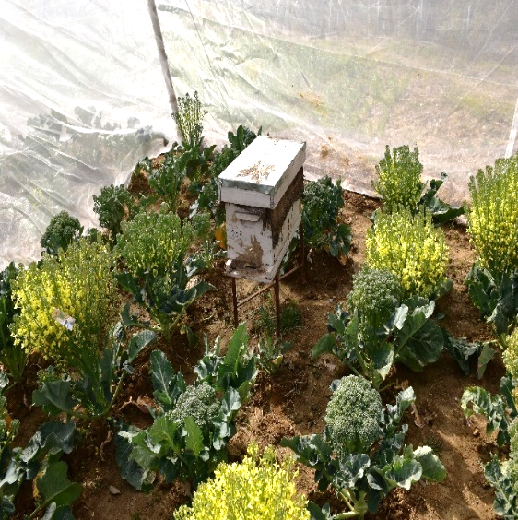

(d) Pollination by A. mellifera (e) Pollinator’s exclusion

Field trial at Seed Production Farm, Department of Seed Science and Technology, CSK HPKV, Palampur, India

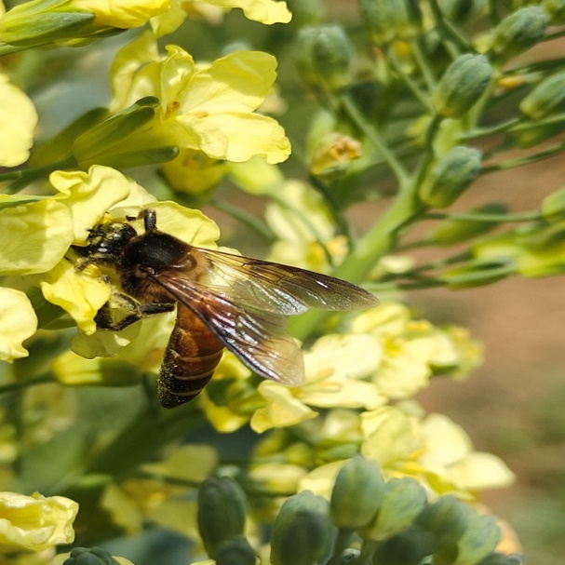
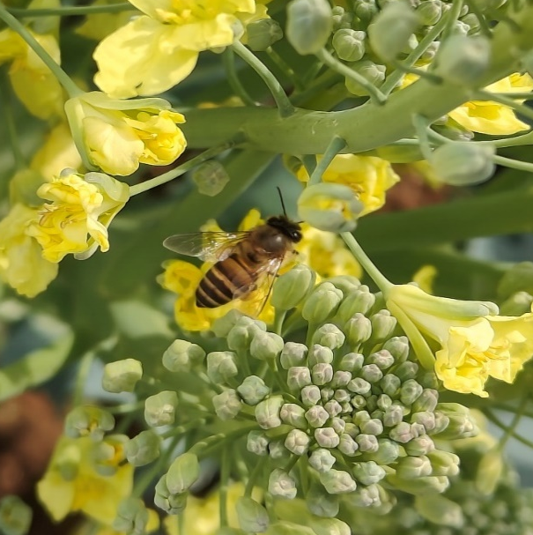

(a) Apis cerana F. (b) Apis dorsata F.

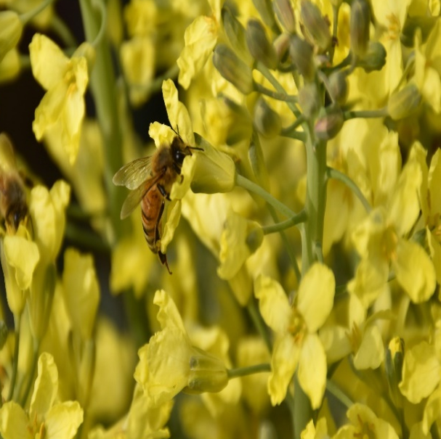
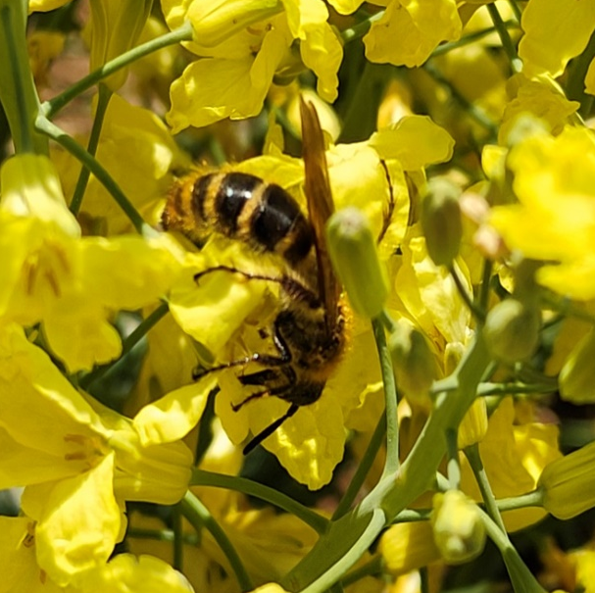

(c) Apis mellifera L. (d) Campsomeris spp.

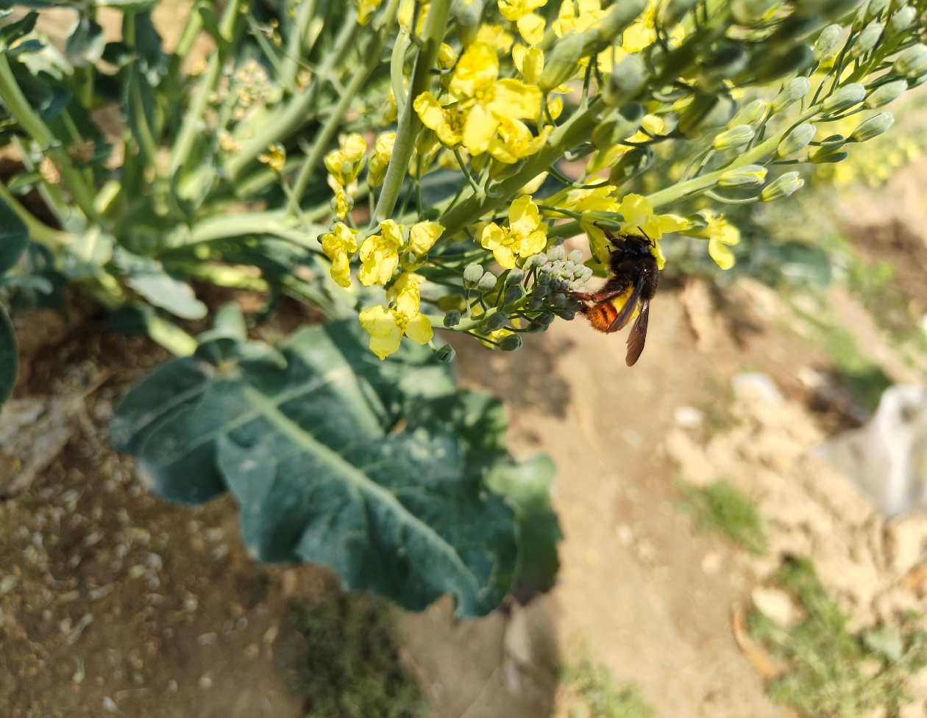
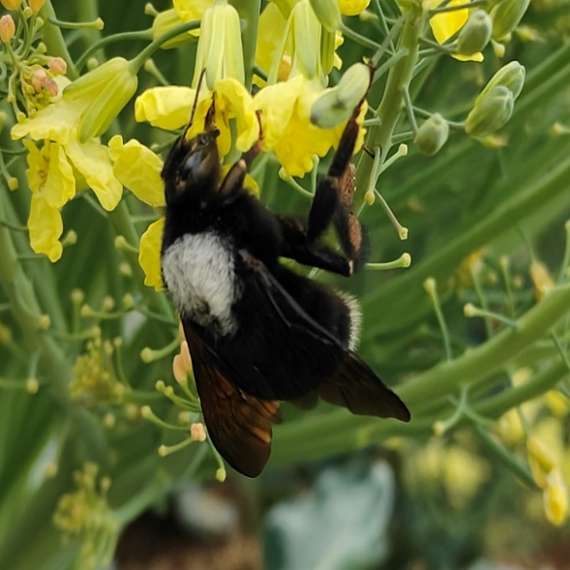

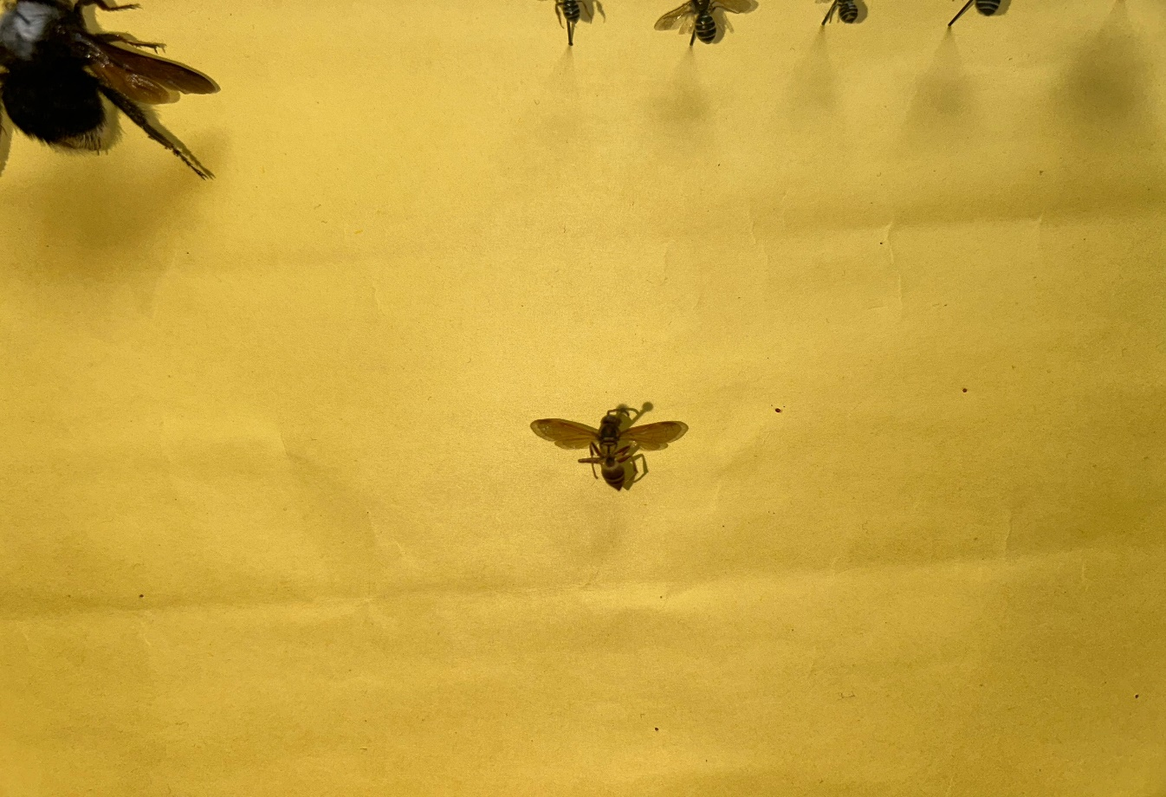
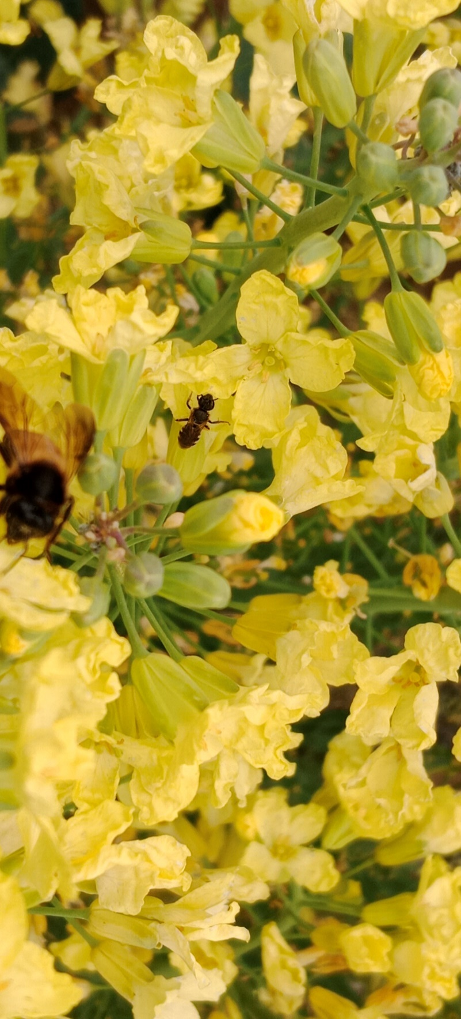
(e) Bombus haemorrhoidalis S. (f) Bombus tunicatus S.

(g) Halictus spp. (h) Polistes spp.

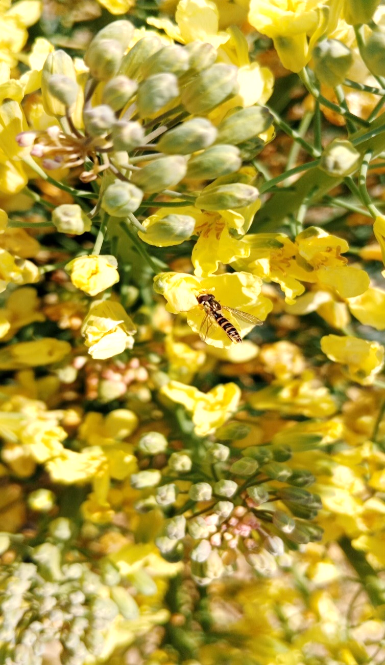
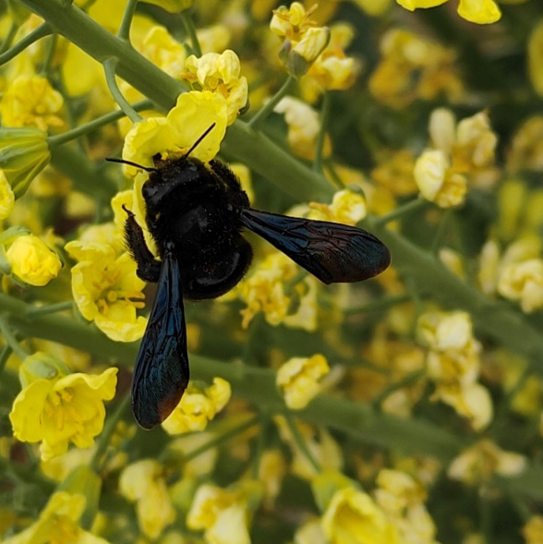
(i) Xylocopa fenestrata F. (j) Episyrphus balteatus D.

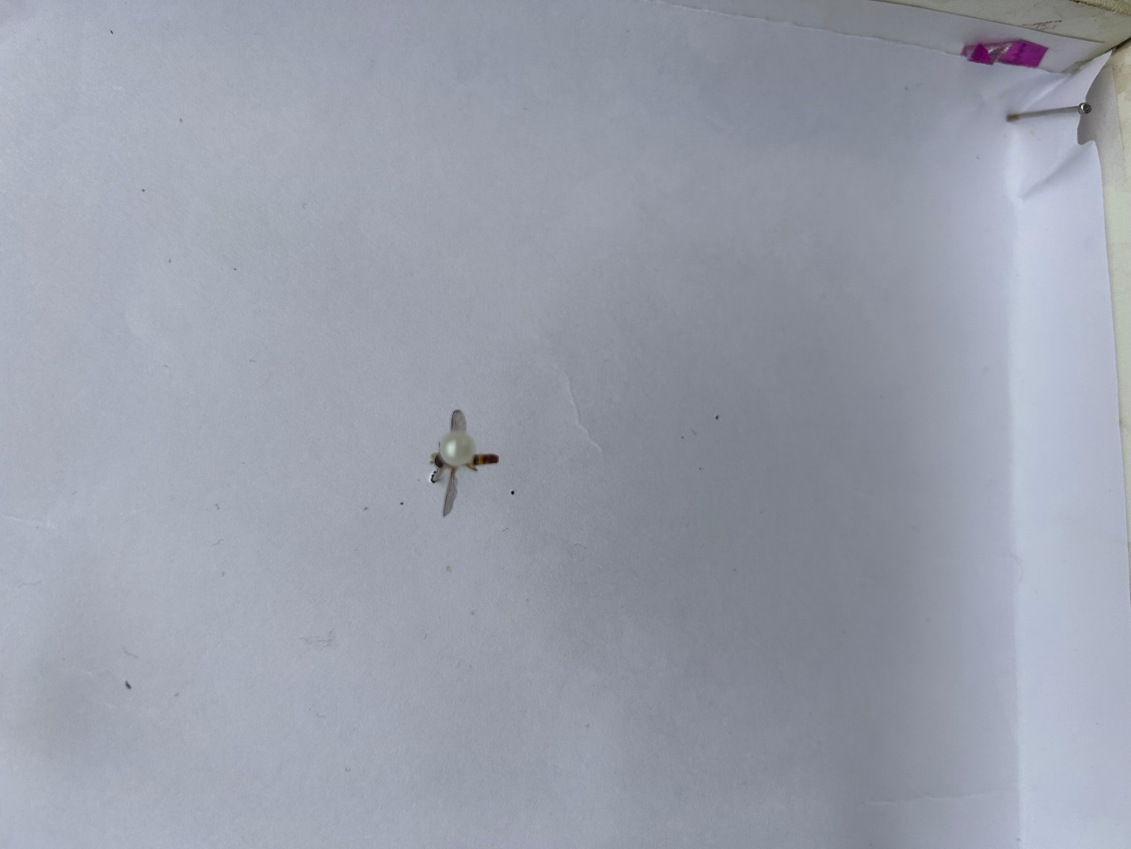
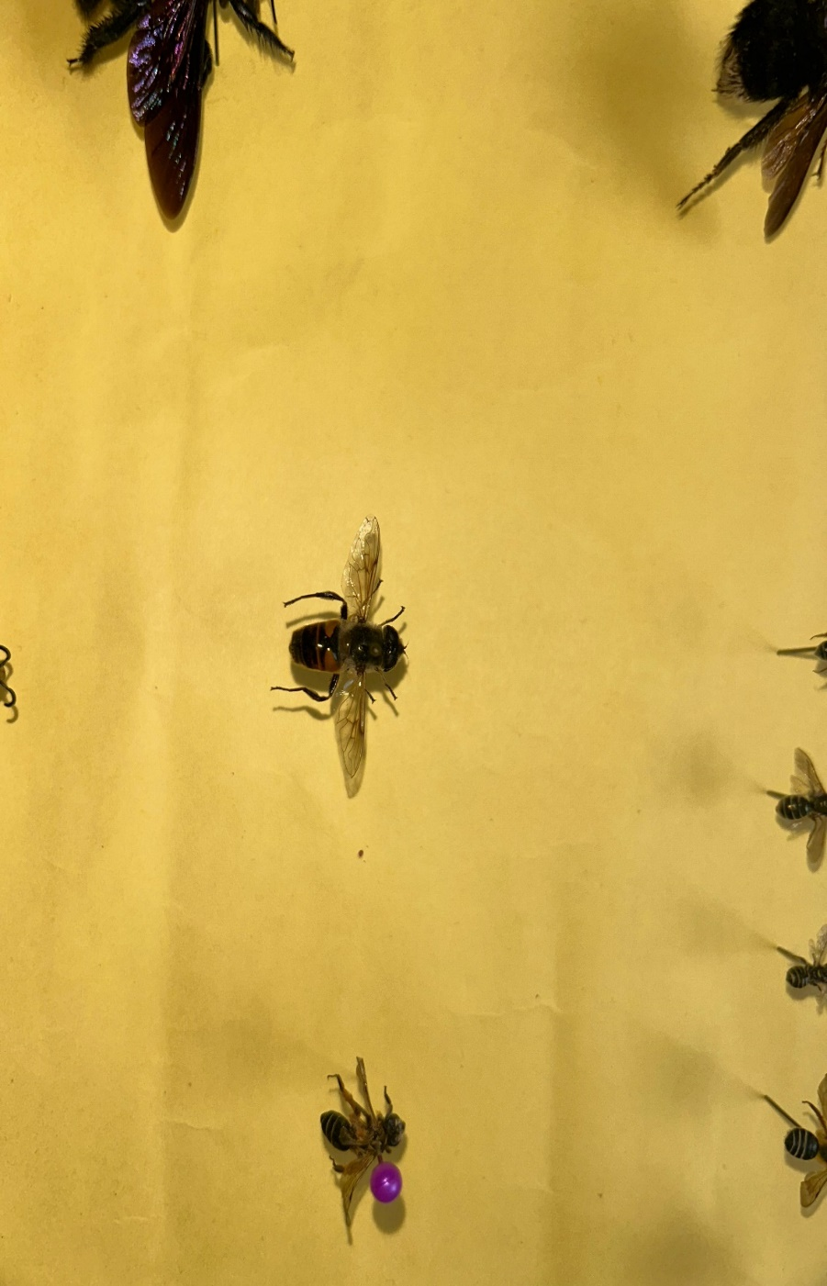
(k) Eristalis tenax L. (l) Melanostoma univittatum W.
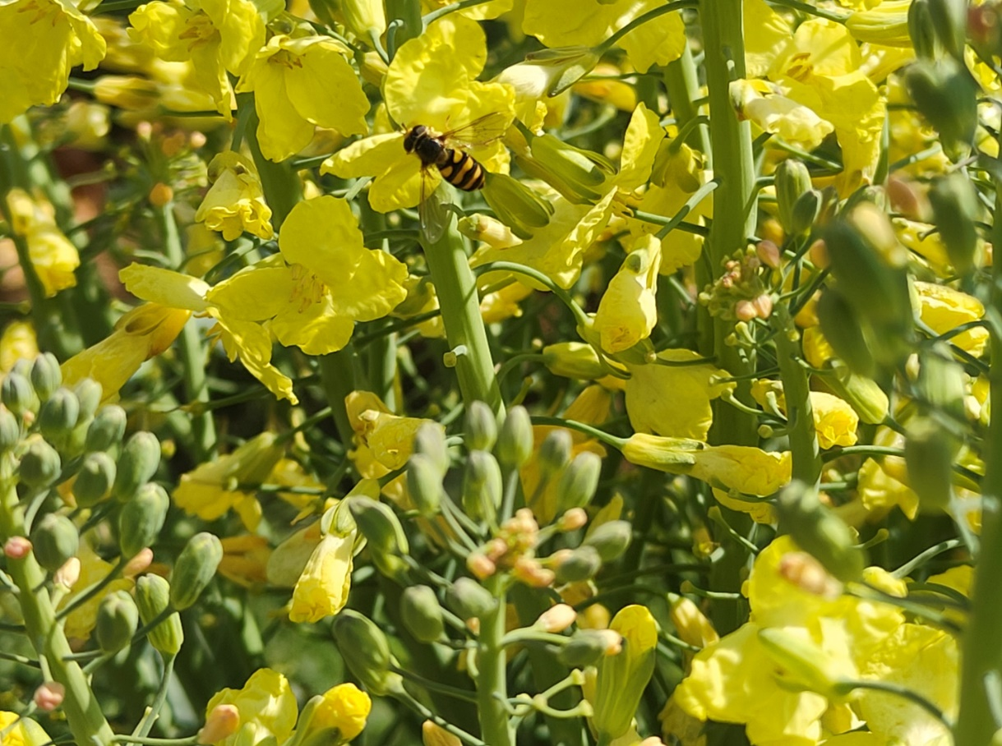
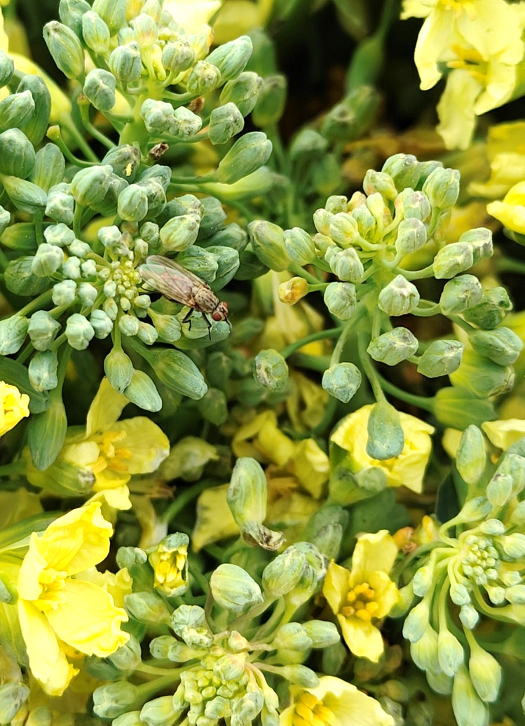

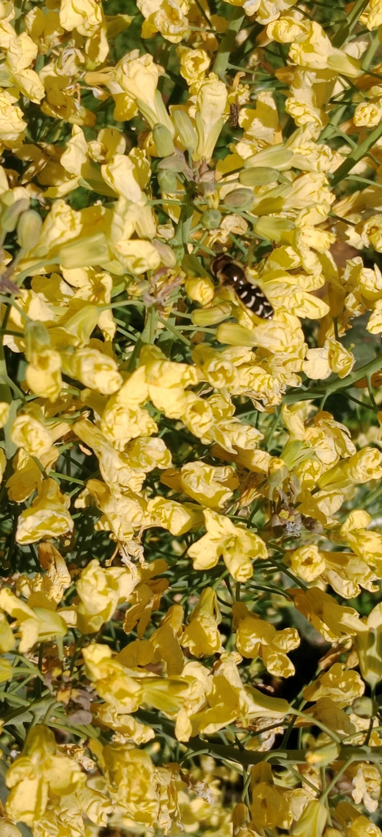
(m) Sarcophaga spp. (n) Scaeva latimaculata B.

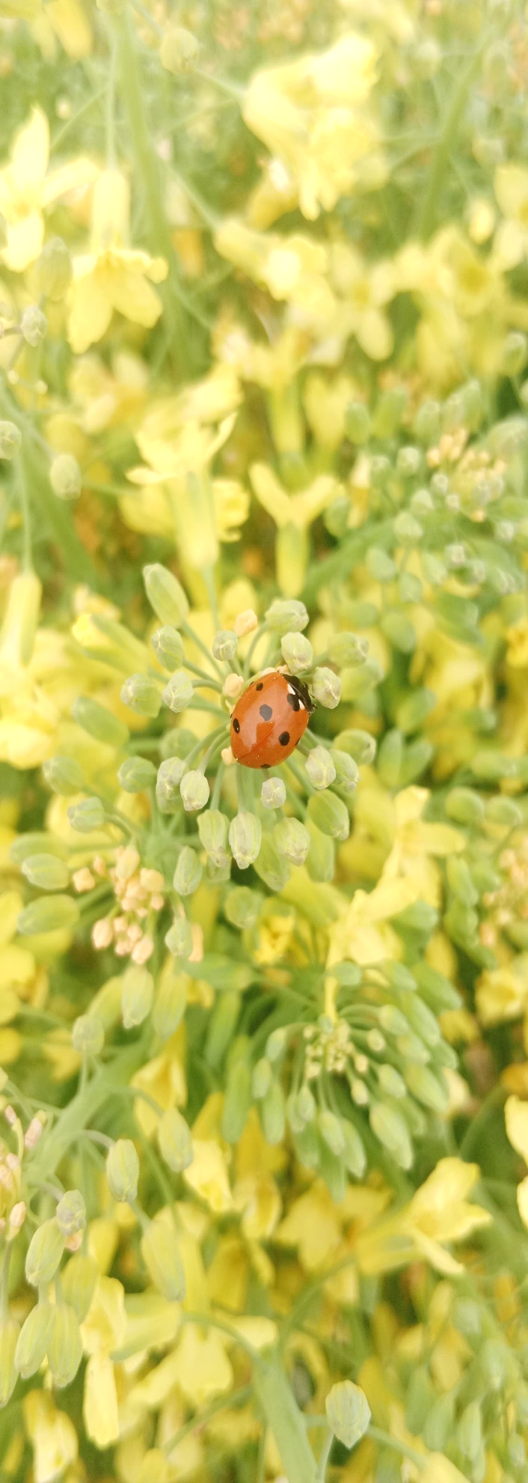

(o) Scaeva spp. (p) Coccinella septempunctata L.

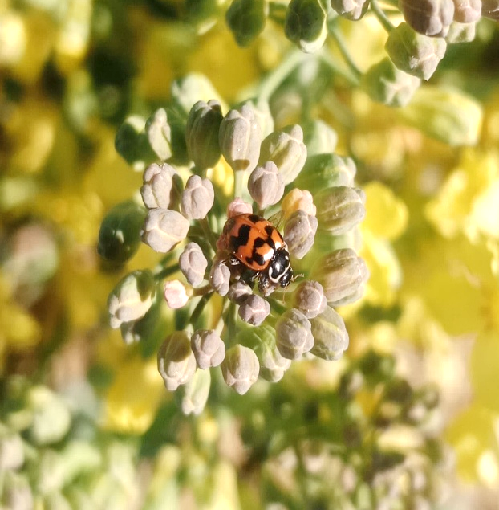
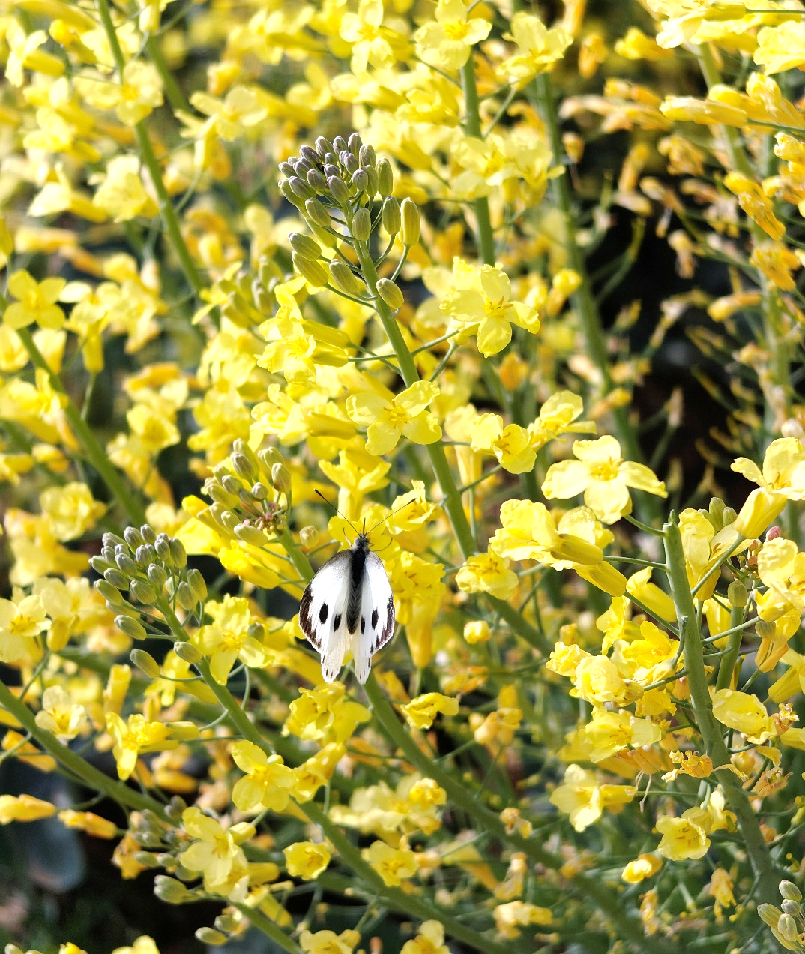
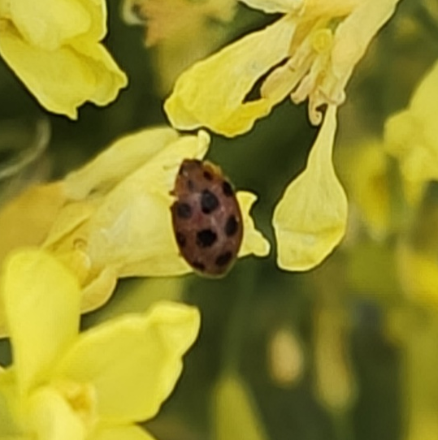
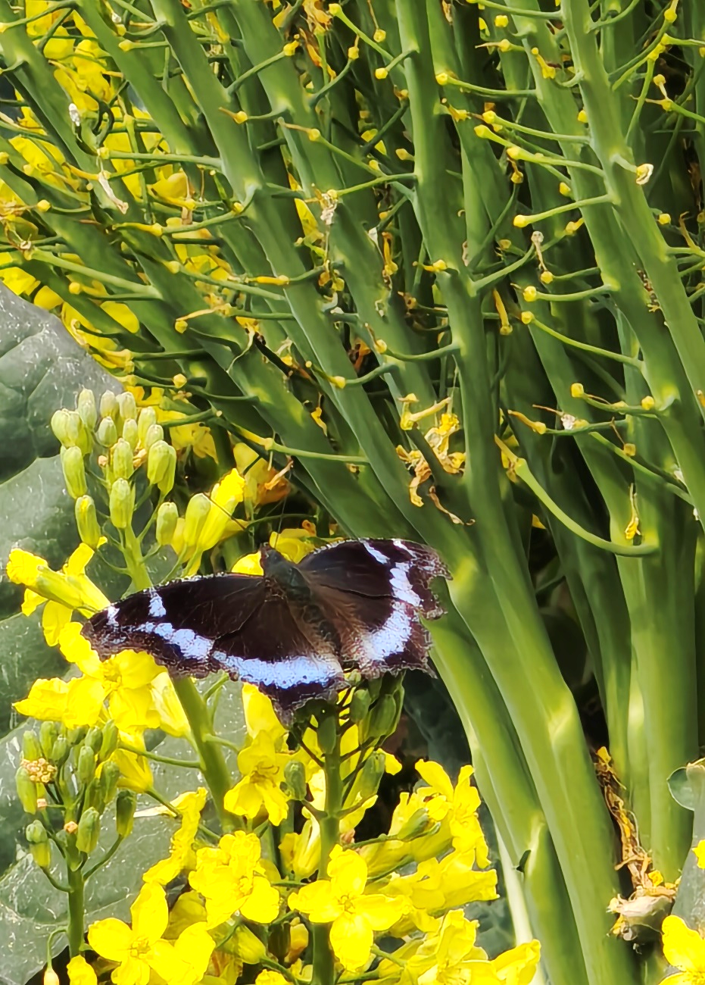

(q) Coccinella transversalis F. (r) Epilachna vigintioctopunctata F.

(s) Kaniska canace L. (t) Pieris brassicae L.
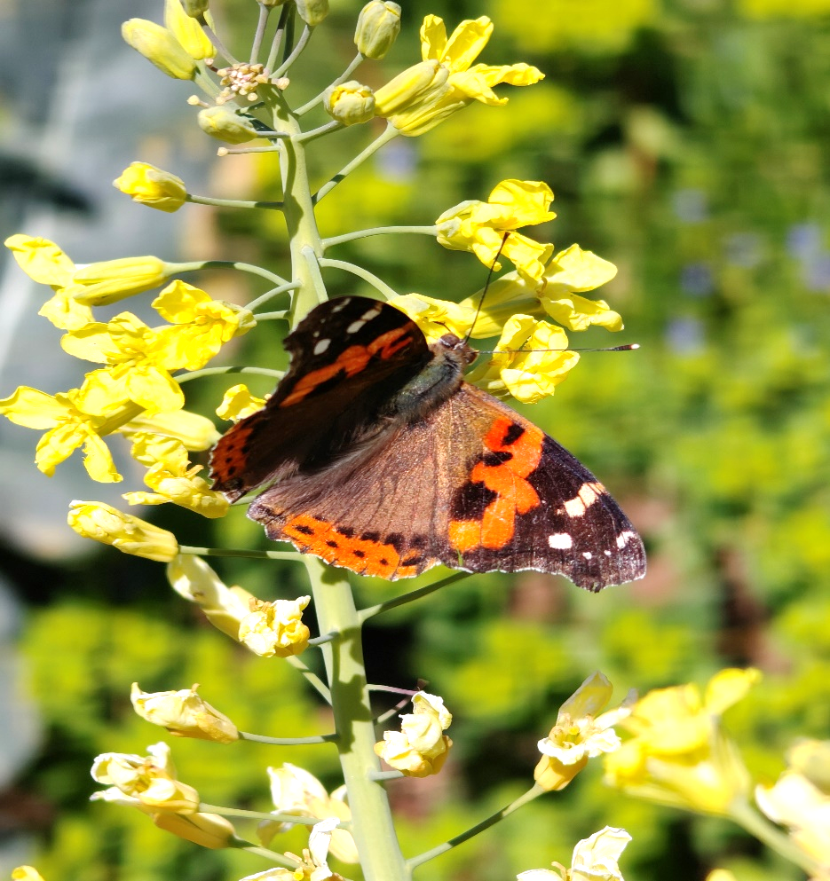

(u) Vanessa indica H.
Insect visitors/pollinators of broccoli

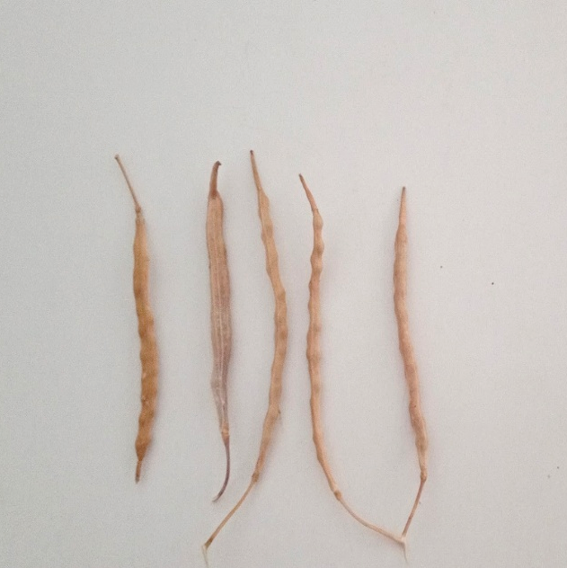
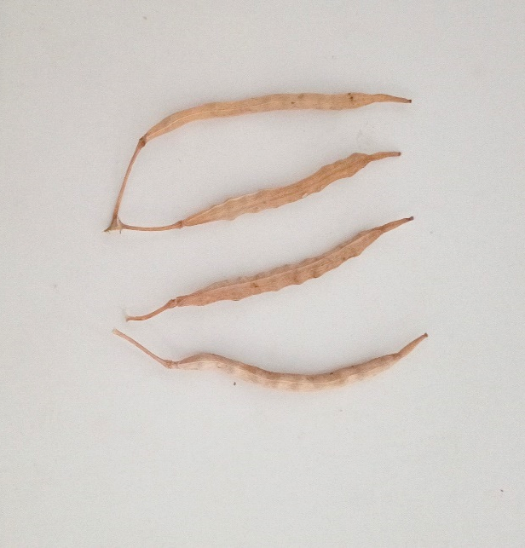

(a) Open pollination (b) Pollination by A. mellifera

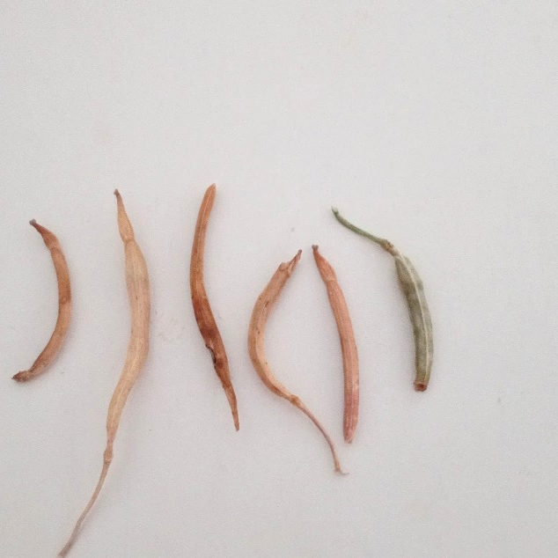

(c) Pollinator’s exclusion

Siliqua of broccoli under different pollination conditions

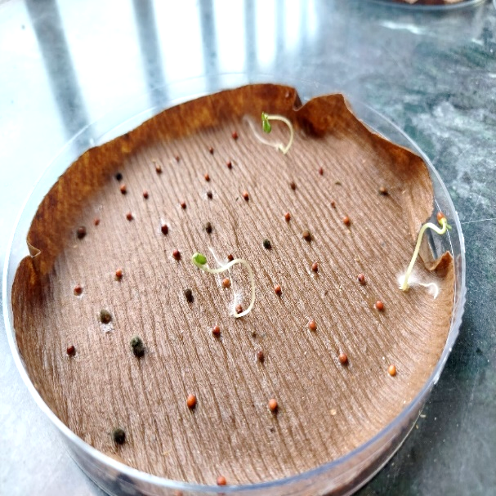
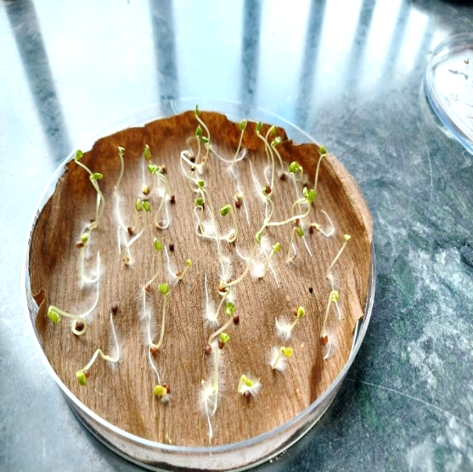
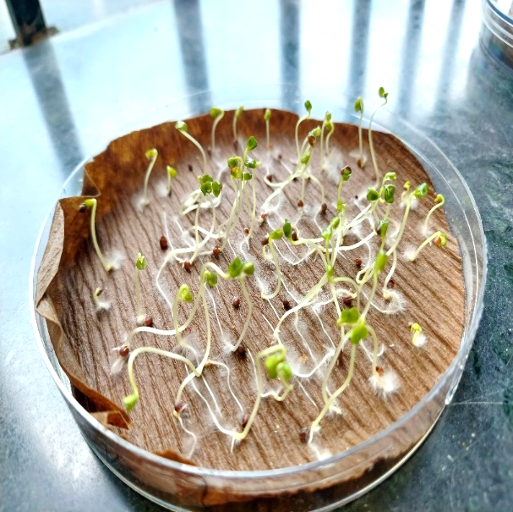

(a) Open pollination (b) Pollination by A. mellifera

(c) Pollinator’s exclusion

Germination of broccoli seeds in different pollination conditions

