Supplementary information
for
¹H, ¹³C, and ¹⁵N backbone resonance assignment of the N-terminal 280 amino acids of human NHERF1 protein

Almudena Hornero-Romera,¹ Miguel Á. Treviño,¹ David Pantoja-Uceda,¹ Jaime Millán,² M. Ángeles Jiménez¹*

1. Instituto de Química Física Blas Cabrera (IQF), CSIC, Madrid, Spain
2. Centro de Biología Molecular Severo Ochoa (CBM), CSIC-UAM, Madrid, Spain

List of tables:
Table S1. Relevant NMR acquisition parameters.
Table S2. Secondary structure elements deduced from chemical shifts for NHERF1⁽¹¹⁻²⁸⁰⁾ (this work), present in experimental 3D structures for isolated PDZ1 and PDZ2 domains, and in the AlphaFold 2 model for the full-length NHERF1 protein.
List of figures:
Figure S1. Ribbon representation of the AlphaFold (AF3) model for the 11-280 region of NHERF1.

Table S1: Relevant NMR acquisition parameters.

Experiment | TD  (points) | Spectral width  (ppm) | Center  (ppm) | FIDRES  (Hz) | Nº scans | Acquisition time
¹H–¹⁵N HSQC | (¹H) 2k  (¹⁵N) 128 | 13.6  35.0 | 4.7  119.0 | 8.0  33.26 | 4 | 10 min
HNCO | (¹H) 2k  (¹⁵N) 64  (¹³C) 90 | 13.6  26.9  14.0 | 4.7  119.547  173.5 | 8.0  25.56  46.96 | 8 | 16 h
HNcaCO | (¹H) 2k  (¹⁵N) 64  (¹³C) 90 | 13.6  26.9  14.0 | 4.7  119.547  173.5 | 8.0  25.56  46.96 | 8 | 16 h
HNCA | (¹H) 2k  (¹⁵N) 64  (¹³C) 128 | 13.6  26.9  30.0 | 4.7  119, 547  53.2 | 8.0  25.56  70.75 | 8 | 22.0 h
CBCAcoNH | (¹H) 2k  (¹⁵N) 64  (¹³C) 128 | 13.6  26.9  80.0 | 4.7  119. 547  43.0 | 8.0  25.56  188.65 | 16 | 45.0 h
HNCACB | (¹H) 2k  (¹⁵N) 64  (¹³C) 128 | 13.6  26.9  80.0 | 4.7  119.547  43.0 | 8,0  25.56  188.65 | 40 | 112 h

Table S2. Secondary structure elements deduced from chemical shifts for NHERF1⁽¹¹⁻²⁸⁰⁾ (this work), present in experimental 3D structures for isolated PDZ1 and PDZ2 domains, and in the AlphaFold 2 (AF2) model for the full-length NHERF1 protein.

 | PDZ1 |  |  | PDZ2
Secondary structure | This work | 2M0T | AF2 | This work | 2KJD | AF2
β1 | 13-17 | 13-18 | 13-18 | 153-158 | 153-158 | 153-158
β2 | 26-30 | 26-30 | 26-29 | 155-170 | 166-170 | 166-169
β3 | 37-42 | 37-42 | 37-42 | 177-182 | 177-182 | 177-182
α1 | 47-51 | 46-52 | 47-49 | 187-191 | 186-192 | 187-190
β4 | 59-62 | 58-62 | 58-62 | 200-202 | 198-202 | 198-202
β5 | --- | 65-66 | 65-66 | 205-206 | 205-206 | 205-206
α2 | 72-81 | 71-80 | 72-81 | 212-221 | 211-221 | 212-221
β6 | 86-91 | 85-91 | 85-91 | 226-231 | 225-231 | 225-231
α3 | 93-102 | 92-101 | 93-102 | 233-241 | 232-243 | 233-241
α4 | 106-112 | 108-113 | 108-112 | 248-251 | 247-252 | 248-251

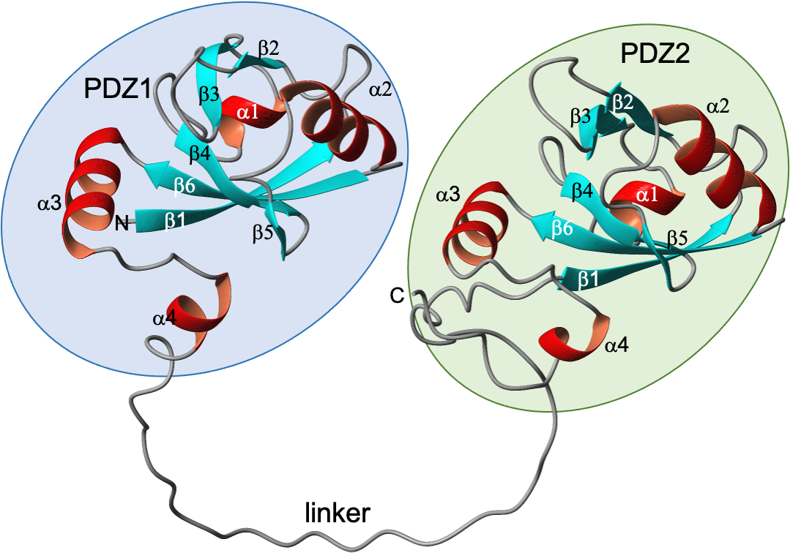
Figure S1. Ribbon representation of the AlphaFold (AF2) model for the N-terminal region of NHERF1. PDZ1 and PDZ2 domains are, respectively, in light-blue and light-green backgrounds. N- and C-terminal ends, β-strands and α-helices are labelled.

