SUPPORTING MATERIAL
Supporting Information for: Developing Facilitation Competence through Reflective Problem-Based Learning: A Qualitative Design-Based Case Study in Higher Education
Isak Rajjak Shaikh^{¹,²,³*}
¹ Swedish University of Agricultural Sciences (SLU), P.O. Box 7070, Uppsala, SE-750 07, Sweden (Facilitation of Groups in Higher Education – the pilot course coordinated by the Didaticum vid Linköpings, Linköping Universitet, Linköping, SE-581 83, in a consortium setting with SLU, Karolinska Institutet, Liu, Mälardalens Universitet, and Blekinge Tekniska Högskola, Sweden), Linköping Universitet, Linköping, SE-581 83 Sweden.
² Razaaq University Consortium, Paulsgatan 8 D, 214 46 Malmö, Sweden
³ Razak Institution of Skills, Education & Research (RISER), Nanded – 431 605, India
* Correspondence via <isak.rajjak@gmail.com> <isak@razaaq.se>

S1. Highlights
- Examines a PBL-based facilitator training model across Swedish higher education
- Reconceptualises group work challenges as learning opportunities through Educational Communication
- Demonstrates the role of reflection as both pedagogy and research data
- Shows how psychological safety supports facilitation competence and collaborative learning
- Proposes a theoretically grounded and scalable model for facilitator development

S2. Contribution of the Study
This study makes three interrelated contributions to research on higher education pedagogy, collaborative learning, and facilitator development:
(i). This study reconceptualises group work in Problem-Based Learning (PBL) not merely as a pedagogical setting for individual learning, but as a dynamic and relational process through which groups themselves evolve as learning entities. In doing so, it advances the understanding of collaborative learning as occurring both in groups and as groups, highlighting the developmental and communicative nature of collective knowledge construction (Vygotsky, 1978; Garrison et al., 2000).
(ii). The study introduces Educational Communication (EC) as an integrative analytical construct that unifies cognitive, social, affective, and structural dimensions of learning in collaborative environments. EC complements existing frameworks such as sociocultural learning theory and the Community of Inquiry by explicitly incorporating the communicative processes through which learning is co-constructed, while also foregrounding the role of inclusion, diversity, and widening participation as constitutive conditions of learning rather than external contextual factors (Fraser, 2008; hooks, 1994; OECD, 2017). In this sense, EC provides a theoretically grounded lens for understanding how meaning-making, participation, and power relations intersect in group-based learning processes.
(iii). The study contributes empirically by examining how facilitation competence develops through experiential engagement in a PBL-based professional development course for higher education educators. By focusing on educators as learners, the study demonstrates how reflective practice, lived group experience, and engagement with real-time group dynamics foster the development of facilitation capacity, particularly in relation to managing group processes, supporting psychological safety, and navigating conflict (Edmondson & Lei, 2014).
The findings therefore inform both theory and practice by identifying facilitation as a multidimensional, communicative, and developmental competence that is essential for the effective implementation of collaborative and inclusive pedagogies in higher education. Overall, the study offers a theoretically informed model with potential applicability across higher education contexts for facilitator development that bridges the gap between pedagogical theory and practice, while positioning Educational Communication as a central analytical construct for understanding learning, interaction, inclusion, and participation in contemporary higher education.
EC is proposed as an integrative analytical construct that complements existing frameworks such as sociocultural learning theory and the Community of Inquiry by explicitly incorporating the communicative mechanisms through which learning is co-implementation of collaborative and inclusive pedagogies in higher education. Overall, the study offers a theoretically informed model with potential applicability across higher education contexts for facilitator development that bridges the gap between pedagogical theory and practice, while positioning Educational Communication as a central analytical mechanism for understanding learning, interaction, and inclusion in contemporary higher education.

S3. More about the Pilot Course Context
The pilot course Facilitation of Groups in Higher Education was implemented as a collaborative Continuing Professional Development (CPD) initiative involving multiple Swedish higher education institutions. The course combined synchronous webinars, asynchronous collaborative activities, reflective journaling, rotating facilitation roles, peer feedback processes, and tutorial-group-based Problem-Based Learning (PBL). Participants engaged both as learners and facilitators throughout iterative collaborative learning cycles designed to strengthen facilitation competence, reflective practice, communication awareness, and group process management.

S4. Educational Communication (EC) as an Integrative Analytical Lens
Educational Communication (EC) is conceptualised in this study as the communicative and relational process through which participation, collaborative inquiry, reflective dialogue, facilitation development, and meaning-making are co-constructed within higher education learning environments. EC extends existing collaborative learning perspectives by positioning communication not merely as supportive of learning but as constitutive of how collaborative participation, psychological safety, facilitation competence, and reflective engagement emerge within Problem-Based Learning (PBL) contexts.
Educational Communication also includes an epistemic dimension. Communication within collaborative inquiry does not only support participation and relational meaning-making; it provides a mechanism through which learners' experiential contributions can be connected with disciplinary concepts, explanatory frameworks, and more systematic forms of knowledge. This dimension responds to social realist concerns that student-centred collaborative learning may become knowledge poor when access to disciplinary knowledge is insufficiently supported (Bernstein, 2000; Wheelahan, 2010).
The interactional relationships between teaching presence, social presence, cognitive presence, and Educational Communication (EC) are illustrated in Figure S3.

S5. Supplementary Figures
A supplementary conceptual representation of Educational Communication (EC) and facilitation competence development is presented in the Graphical Abstract Figure.

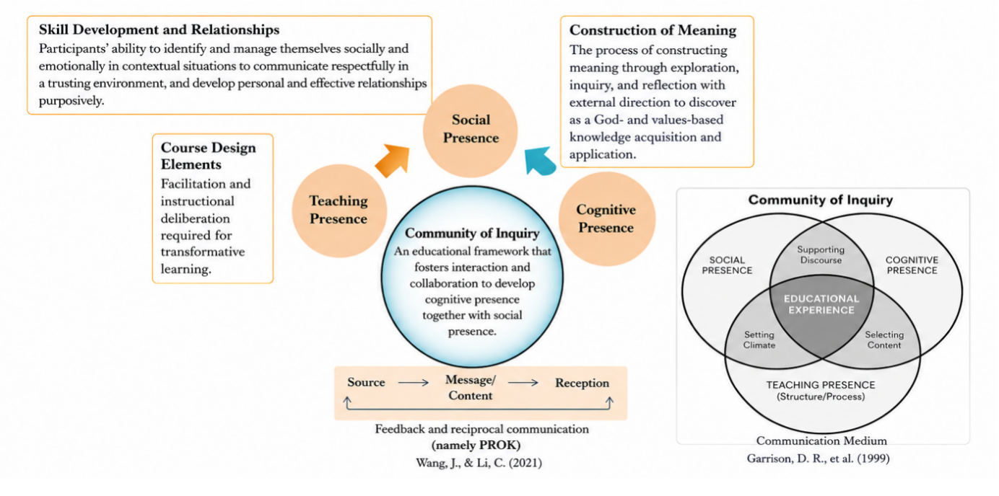
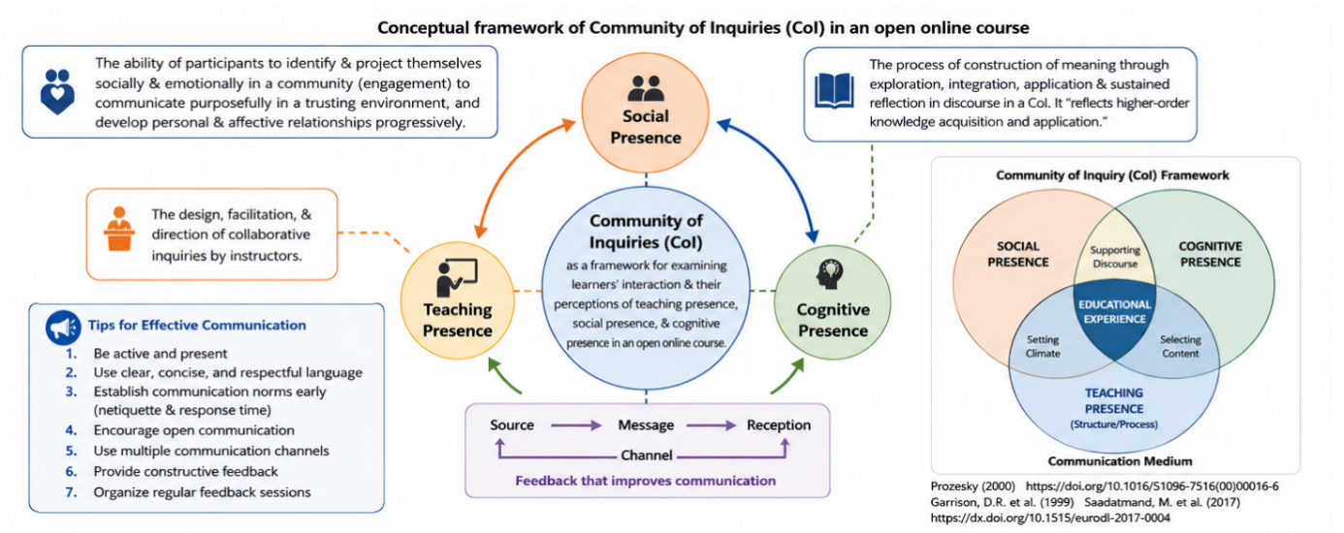
Graphical Abstract Figure. Conceptual framework of educational communication and facilitation competence development within reflective problem-based learning (PBL).
The figure illustrates how educational communication (EC) is shaped through the dynamic interaction of Problem-Based Learning (PBL), facilitation competence, psychological safety, reflective practice, and collaborative meaning-making. The framework highlights the iterative relationships among communication, participation, inquiry, and reflection in fostering transformative learning experiences. The integrated Community of Inquiry (CoI) model further demonstrates the interconnected roles of teaching presence, social presence, and cognitive presence in supporting meaningful educational experiences.
The interrelationships among communication, reflection, participation, psychological safety, and facilitation competence are conceptually illustrated in Figure S1.
The cyclical nature of facilitation learning through reflection, participation, dialogue, feedback, and experiential engagement is illustrated in Figure S2.
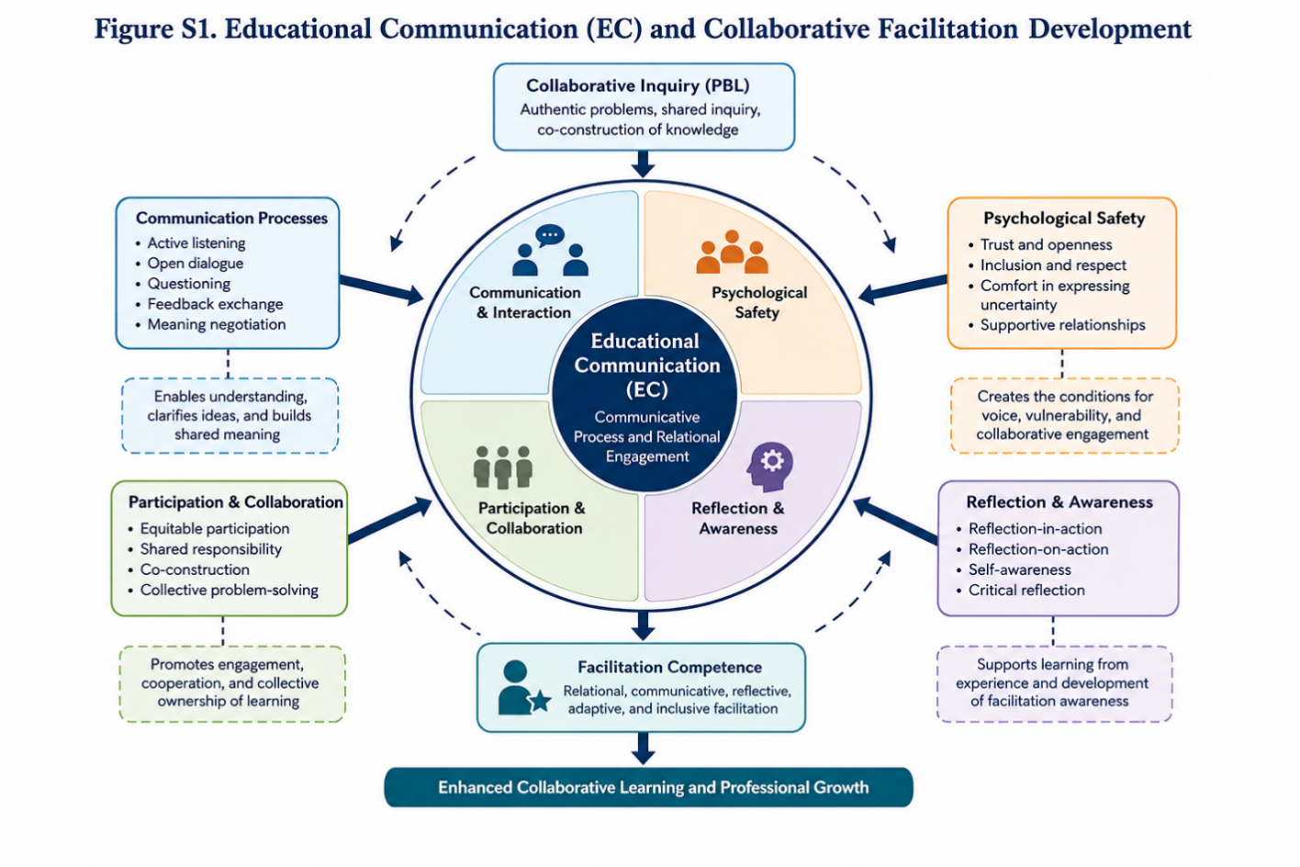
Figure S1. Educational Communication (EC) and Collaborative Facilitation Development. Conceptual illustration showing relationships between communication, reflection, psychological safety, participation, collaborative inquiry, and facilitation competence within reflective PBL environments.

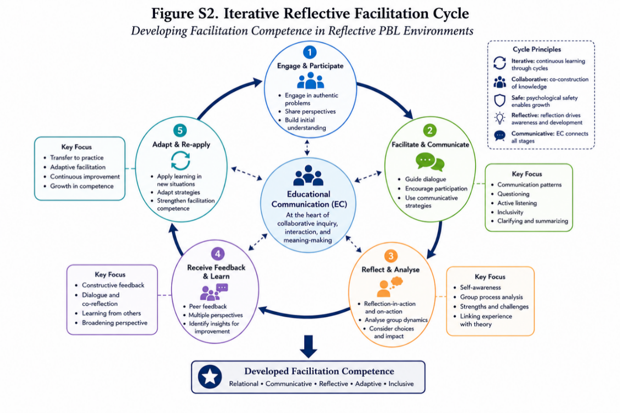
Figure S2. Iterative Reflective Facilitation Cycle. Cyclical representation of facilitation learning through participation, reflection, collaborative dialogue, feedback, and experiential engagement.

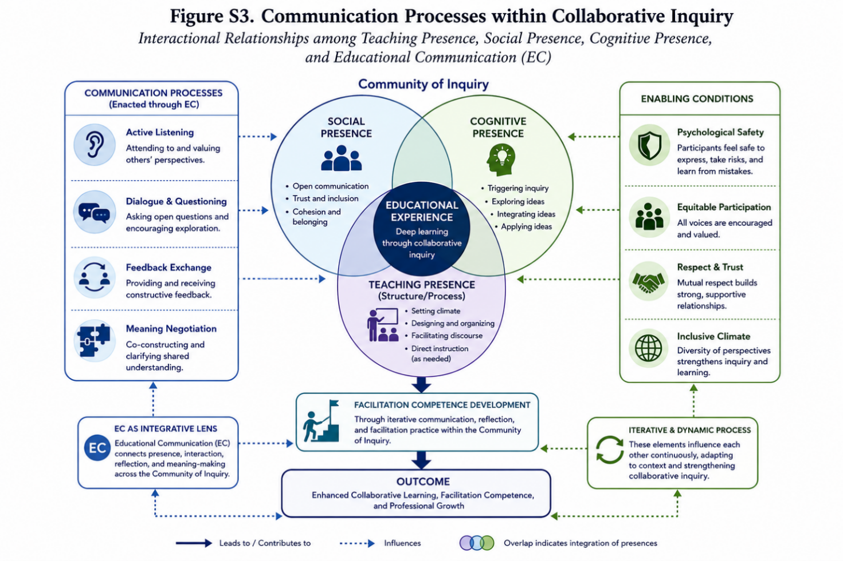
Figure S3. Communication Processes within Collaborative Inquiry. Illustration of interactional relationships between teaching presence, social presence, cognitive presence, and Educational Communication (EC).
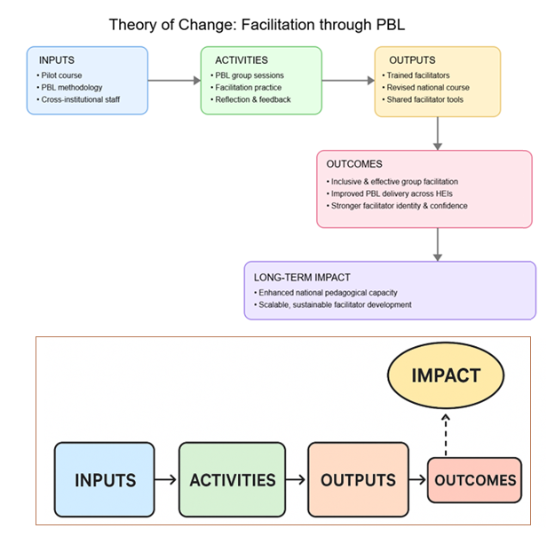
Figure S4. Theory of Change
Community of Inquiry brings about the change.
The pilot course is underpinned by a Theory of Change that conceptualises how facilitation competence in collaborative higher education develops through iterative cycles of participation, reflection, and communicative engagement. The model proposes that when learners and facilitators engage in structured collaborative inquiry within psychologically safe environments, supported by Educational Communication (EC), they progressively develop deeper awareness of group dynamics, reflective capacity, and adaptive facilitation strategies. These processes are expected to strengthen both individual and collective agency in learning situations, enabling participants to move from task-oriented participation towards more dialogic, inquiry-driven forms of collaboration. The Theory of Change further suggests that sustained exposure to reflective practice, feedback loops, and guided interaction leads to observable improvements in facilitation competence, including the ability to manage conflict, foster inclusion, and support shared meaning-making. Over time, these developmental processes are expected to contribute to more effective collaborative learning environments and enhanced pedagogical quality within problem-based learning contexts.
Figure S5 Educational Communication as a Facilitation Development Process
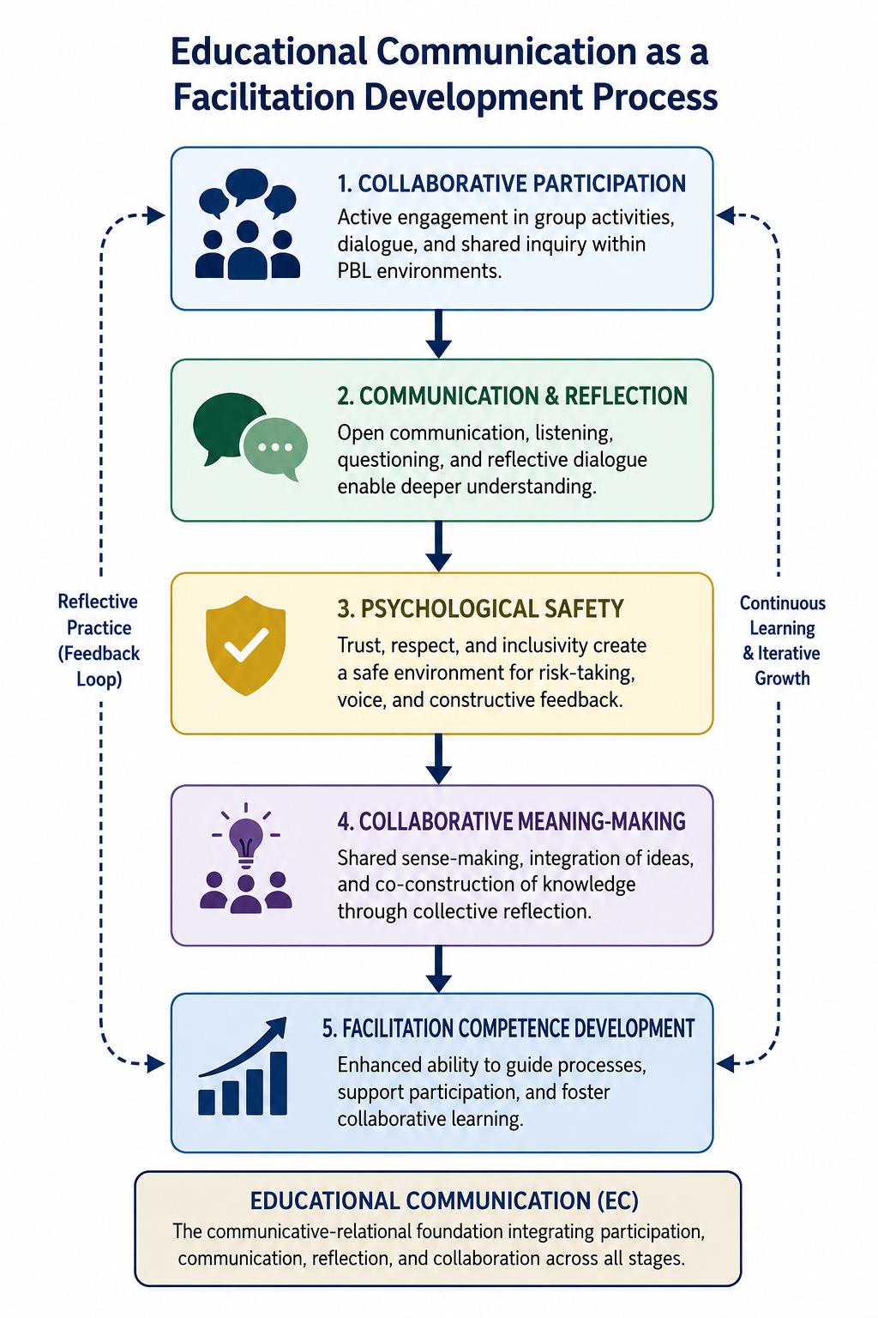

S6. Supplementary Tables
A summary of the major analytical themes and representative reflective evidence is presented in Table S1, while examples of facilitation strategies supporting collaborative learning and communicative participation are summarised in Table S2. Examples of reflective prompts used to support facilitation awareness and collaborative inquiry are presented in Table S3, and examples of structured interaction practices supporting inclusion, communication, and psychological safety are presented in Table S4. The primary analytical coding categories applied during thematic analysis are summarised in Table S5, and indicators supporting the pilot course Theory of Change framework are summarised in Table S6. Table S7 gives overview of analytical procedure (cf. methodology).
Table S1. Summary of Themes and Representative Evidence
Theme | Representative Focus in Participant Reflections
Facilitation identity development | Participants questioning facilitator role, neutrality, leadership, and process support
Communication as collaborative meaning-making | Active listening, open interaction, group dialogue, communication structures
Psychological safety | Vulnerability, inclusion, trust, “high ceiling,” mistakes as learning
Uncertainty, conflict, and group dynamics | Disagreement, group development, conflict handling, uncertainty in collaboration
Reflection as professional learning | Reflective logs, metaperspectives, self-awareness, theory–practice integration

Table S2. Facilitation Strategies Supporting Collaborative Learning in PBL Environments
Facilitation Strategy | Purpose | Contribution to Collaborative Learning
Reflective questioning | Encourages critical reflection and dialogue | Supports collaborative inquiry and meaning-making
Structured turn-taking | Promotes equitable participation | Reduces dominance and increases inclusion
Group agreements/contracts | Establishes communication norms | Strengthens psychological safety
Rotating facilitation roles | Develops facilitation awareness | Encourages shared responsibility
Peer feedback activities | Supports reflective learning | Enhances communicative awareness
Active listening practices | Improves responsiveness and inclusion | Strengthens relational engagement
Reflective journaling | Connects experience with theory | Supports facilitation identity development
Epistemic questioning and knowledge checking | Identifies conceptual gaps, misconceptions, assumptions, and connections to disciplinary knowledge | Supports movement from experiential contributions toward systematic disciplinary understanding

Table S3. Example Reflective Questions Used in Facilitation Journals
Reflective Focus | Example Prompt
Communication | How did communication patterns influence participation in the group?
Facilitation | What facilitation strategies supported or constrained collaboration?
Psychological safety | When did participants appear comfortable expressing uncertainty?
Group dynamics | How did the group respond to disagreement or silence?
Reflection | What did I learn about my own facilitation approach?

Table S4. Examples of Structured Interaction Practices
Practice | Purpose
Group agreements | Establish collaborative norms and expectations
Rotating facilitator roles | Encourage experiential facilitation learning
Reflective turn-taking | Support equitable participation
Peer feedback sessions | Strengthen collaborative reflection
Check-ins and check-outs | Promote relational awareness and psychological safety

Table S5. Analytical Coding Categories
Analytical Category | Focus of Analysis
Facilitation identity | Development of facilitator awareness and role understanding
Communication patterns | Dialogue, listening, participation, interaction
Collaborative meaning-making | Shared inquiry and negotiation of understanding
Psychological safety | Trust, openness, inclusion, vulnerability
Reflection | Reflexive learning and theory–practice integration
Group development | Conflict, uncertainty, cohesion, negotiation
Epistemic facilitation — Conceptual extension concerning how facilitators attend to knowledge quality, disciplinary concepts, misconceptions, and progression beyond experiential understanding; proposed for future empirical investigation.
Table S6. Theory of Change Indicators
Level | Indicator | Data Source
Inputs | Staff participation rate | Registration logs
Activities | Number of PBL sessions | Course schedule
Outputs | Facilitators certified | Course completion
Outcomes | Improved facilitation competence | Self/peer assessment
Impact | Pedagogical innovation across HEIs | Follow-up surveys

Table S7. Overview of Analytical Procedure
Phase | Analytical Activity
Phase 1 | Familiarisation with reflective journals and collaborative documentation
Phase 2 | Initial coding of facilitation, communication, and reflective processes
Phase 3 | Development of preliminary themes
Phase 4 | Iterative thematic refinement
Phase 5 | Theoretical interpretation through Educational Communication (EC)

S7. Example Reflective Prompts and Facilitation Activities
Participants engaged in recurring reflective and collaborative activities throughout the course. These activities included facilitation observations, reflective journaling, collaborative feedback discussions, rotating facilitation exercises, and structured dialogue activities intended to support awareness of communication, participation, group dynamics, and facilitation processes.
Example reflective prompts included:
- How did the group negotiate participation and communication?
- What communicative practices contributed to psychological safety?
- How did facilitation influence collaborative inquiry?
- What challenges emerged during moments of uncertainty or disagreement?
- How did reflection influence facilitation awareness?

S8. Additional Thematic Evidence
The qualitative dataset contained extensive reflective material related to facilitation identity, communication practices, psychological safety, collaborative inquiry, uncertainty management, and reflective professional learning. Themes frequently overlapped because participants described facilitation development as relational, communicative, and iterative rather than linear or technique-based.
Representative thematic areas included:
- negotiation of facilitator neutrality,
- communication and participation structures,
- reflective engagement with group conflict,
- development of communicative awareness,
- experiences of collaborative uncertainty,
- and evolving understanding of facilitation as relational practice.

S9. Reflexive and Methodological Notes
The study adopted a reflexive qualitative approach recognising that facilitation learning, collaborative inquiry, and reflective interpretation were relationally situated within the educational environment itself. Reflection therefore functioned simultaneously as pedagogical process, participant learning mechanism, and analytical resource. The researcher maintained ongoing reflexive awareness regarding interpretation, participation, and analytical positioning throughout the research process.

S10. Purpose of the Piolot Course and Impact Thereof
S10.1 Objectives
The pilot course was designed to explore:
- How educators experience learning through PBL when positioned as learners.
- How these experiences shape their understanding of facilitation practice.
- What competencies facilitators need to support effective group learning.
- How a facilitator training programme can be structured to be inclusive, scalable, and aligned with national pedagogical standards.
- What revisions and improvements are needed to form a full, nationally offered course.
The broader pedagogical logic and intended developmental outcomes of the pilot course are summarised in the Theory of Change model presented in Figure S4.
S10.2 Impact at Multiple Levels
Individual Level
- Enhanced facilitation competence
- Stronger reflective and communication skills
- Greater confidence in PBL and collaborative learning models
Institutional Level
- Increased pedagogical capacity
- Better alignment between educational practice and institutional strategies
- Formation of a facilitator community of practice
National Level
- Scalable model for facilitator preparation
- Strengthened national collaboration in higher education pedagogy
- A harmonised approach to group facilitation training across institutions
Thus, the pilot course at Linköping University served as an essential foundation for the development of a robust, evidence-based national course on group facilitation through PBL. The experiences of participants offered meaningful insights into how educators learn to facilitate, what competencies they require, and how training environments can be optimally designed. The new course reflects a pedagogically refined, strategically aligned, and sustainably structured facilitator training programme that advances UNESCO’s goals for quality, equity, and learner-centred higher education.¹
¹ See United Nations Educational, Scientific and Cultural Organisation (UNESCO), Beyond Limits: New Ways to Reinvent Higher Education (Paris: UNESCO, 2022), which emphasizes quality, equity, inclusion, and learner-centred approaches as core goals of higher education reform.

References (for Supporting Information):
Bernstein, B. (2000). Pedagogy, symbolic control, and identity: Theory, research, critique. Rowman & Littlefield. https://doi.org/10.5040/9798216401735
Wheelahan, L. (2010). Why knowledge matters in curriculum: A social realist argument. Routledge. https://doi.org/10.4324/9780203860236 DOI 10.4324/9780203860236
Fraser, N. (2008). Scales of justice: Reimagining political space in a globalizing world. Columbia University Press.
Hooks, B. (1994). Teaching to transgress: Education as the practice of freedom. Routledge.
OECD. (2017). Education at a glance 2017: OECD indicators. OECD Publishing. https://doi.org/10.1787/eag-2017-en

