Reference compounds

To validate the docking protocol and provide a comparative framework for evaluating the phytochemical compounds, two reference inhibitors, Allopurinol and Quercetin, were docked into the catalytic pocket of xanthine oxidase. Allopurinol is a clinically approved xanthine oxidase inhibitor widely used in the treatment of gout and hyperuricemia, while quercetin is a naturally occurring flavonoid previously reported to exhibit inhibitory activity against xanthine oxidase. The binding profiles of these compounds served as important benchmarks for comparison with the screened phytochemicals.
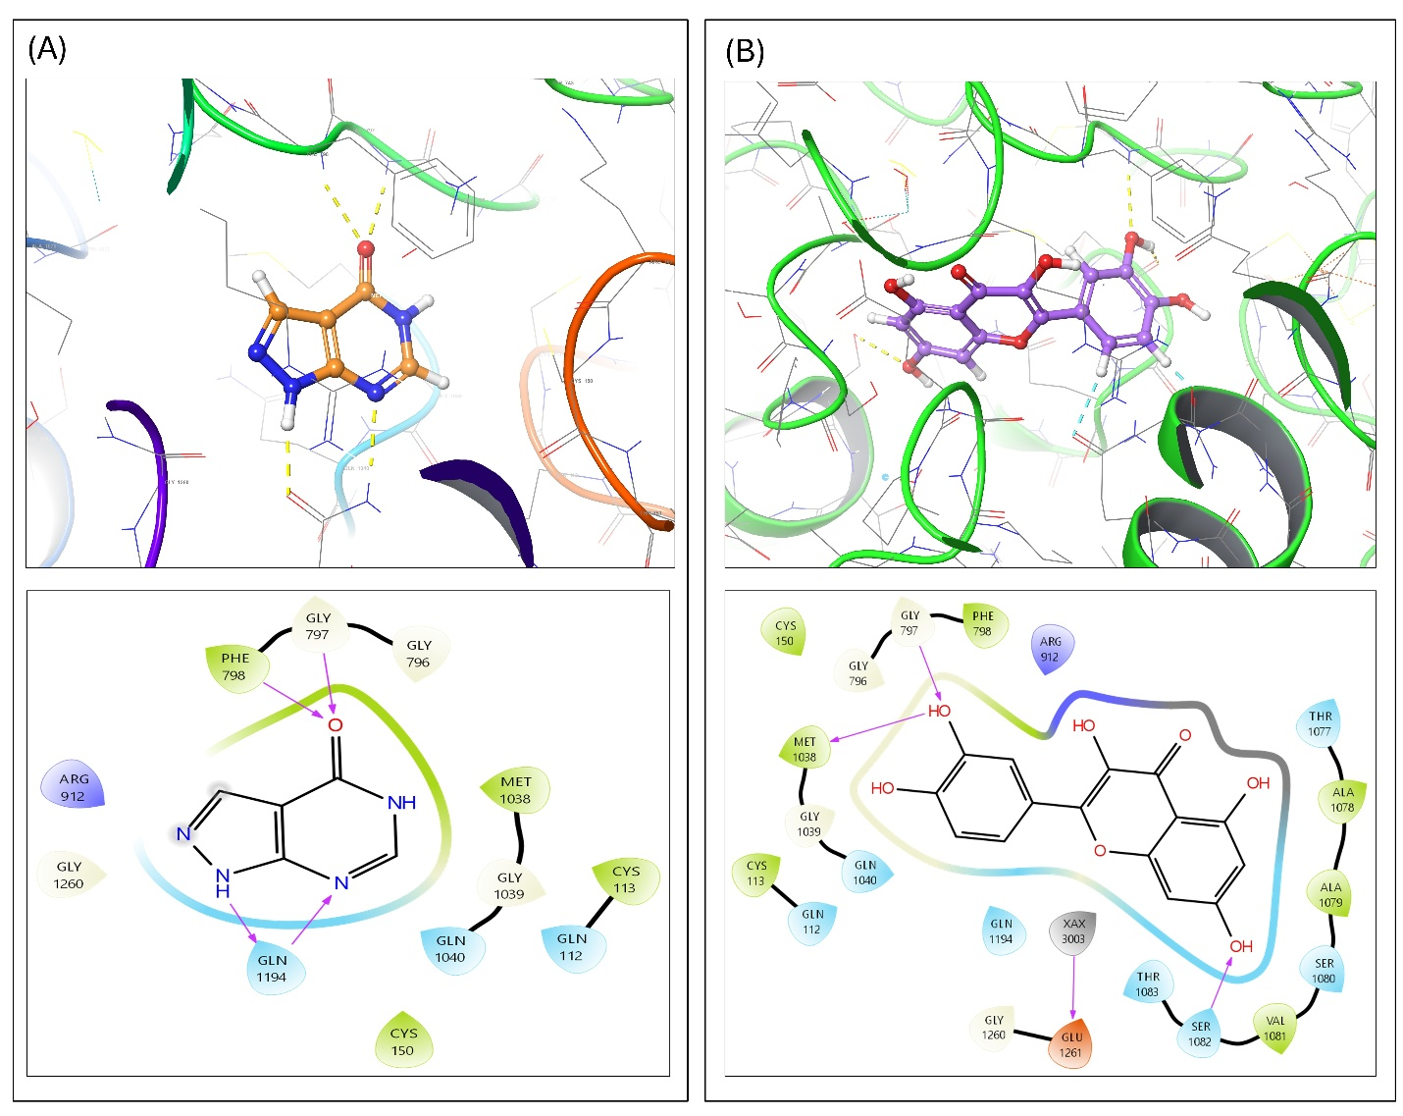
Figure S1 Binding interactions of reference compounds within the catalytic pocket of xanthine oxidase. (A) Allopurinol and (B) Quercetin
Allopurinol (Figure S1A) exhibited a Glide XP docking score of −6.782 kcal/mol and an MM-GBSA binding energy of −35.73 kcal/mol. The compound occupied the catalytic cavity near the molybdenum cofactor region and formed stabilizing interactions with several residues involved in substrate recognition and catalysis. Despite exhibiting a comparatively moderate docking score, the highly favorable MM-GBSA value suggests stable energetic accommodation within the active site under solvent-corrected conditions. The relatively small purine-like scaffold of allopurinol enables efficient positioning within the catalytic pocket, allowing interactions with residues surrounding the molybdenum center that are essential for inhibition of xanthine oxidase activity. The discrepancy between docking score and MM-GBSA value further highlights the importance of complementary energetic analyses beyond docking alone when evaluating inhibitor binding stability.

Quercetin (Figure S1B) demonstrated a substantially stronger docking score of −9.647 kcal/mol together with an MM-GBSA binding energy of −31.67 kcal/mol. The flavonoid scaffold adopted a stable orientation within the elongated substrate-binding channel and established multiple hydrogen bonding interactions with catalytic residues near the molybdenum cofactor region. In addition, the polyphenolic aromatic rings of quercetin occupied hydrophobic regions within the active site, allowing stabilization through π-related and van der Waals interactions. The presence of multiple hydroxyl groups facilitated extensive hydrogen bonding with polar residues, contributing to favorable binding affinity. The stronger docking performance of quercetin relative to allopurinol suggests that larger polyphenolic scaffolds may achieve improved geometric complementarity with the catalytic cavity of xanthine oxidase. Comparison of the phytochemical compounds with the reference inhibitors revealed that several screened ligands exhibited docking scores and MM-GBSA values comparable to or more favorable than those of allopurinol and quercetin. In particular, flavonoids, phenolic acids, and certain alkaloid derivatives demonstrated strong interaction patterns with catalytic residues such as Glu1261, Gln1040, Gln112, and residues surrounding the molybdenum cofactor region. These findings suggest that naturally occurring phytochemicals possessing polyphenolic and conjugated aromatic scaffolds may serve as promising structural templates for the development of novel xanthine oxidase inhibitors.

Statistical Analysis
Welch's t-test was applied to assess statistically significant differences between the IC₅₀ values of the screened phytochemical compounds and the reference inhibitors, allopurinol and quercetin. Welch's t-test was selected over Student's t-test due to its robustness under conditions of unequal variances and sample sizes. A p-value threshold of < 0.05 was considered statistically significant. Results are presented as mean ± standard deviation from triplicate independent experiments.

Table S1: Statistical analyses of IC50 values using Welch's t-test method.
Compound | P-value | Significance
Morin | 0.006173 | Significant
Oxyresveratrol | 0.000040 | Significant
Digallic Acid | 0.006343 | Significant
Scopolin | 0.000079 | Significant

