Supplementary Materials
Long-term Outcomes of Pediatric Urethroplasty: A Systematic Review and Meta-analysis
Najar FA, Ganayee MA, Nabi U, Mufti GN
PROSPERO registration 05 August 2026
Contents
Appendix S1 Full electronic search strategies (PubMed, MEDLINE via Ovid, Embase, Scopus, CENTRAL) — closes PRISMA Item 7
Appendix S2 List of studies excluded at full-text review with reasons (n = 182) — closes PRISMA Item 16b
Figure S1 Traffic-light plot of Newcastle-Ottawa Scale risk-of-bias assessment — closes PRISMA Item 18
Appendix S3 GRADE Summary of Findings table (post-hoc protocol amendment) — closes PRISMA Items 15 & 22

Appendix S1. Full electronic search strategies
The systematic literature search was performed on 31 December 2024. Search strategies were adapted for each database while maintaining conceptual equivalence. Three conceptual blocks were combined with Boolean AND: (1) the intervention or condition (hypospadias, urethral stricture, urethroplasty, urethral reconstruction); (2) the population (paediatric); and (3) the temporal or outcome dimension (long-term follow-up, outcomes, complications, reoperation). No date restriction on the start date was applied. Results were limited to English-language, human, and peer-reviewed publications where those filters were available.
S1.1 PubMed / MEDLINE (via PubMed interface) — 1,124 records
Search date: 31 December 2024
Filters: English; Humans

#1 "Hypospadias"[MeSH Terms] OR hypospadias[Title/Abstract]
#2 "Urethral Stricture"[MeSH Terms] OR "urethral stricture"[Title/Abstract]
#3 urethroplasty[Title/Abstract] OR "urethral reconstruction"[Title/Abstract]
#4 #1 OR #2 OR #3

#5 "Child"[MeSH Terms] OR "Infant"[MeSH Terms] OR "Adolescent"[MeSH Terms]
#6 "Pediatrics"[MeSH Terms]
#7 (pediatric[Title/Abstract] OR paediatric[Title/Abstract] OR children[Title/Abstract]
OR infant*[Title/Abstract] OR adolescen*[Title/Abstract])
#8 #5 OR #6 OR #7

#9 "Follow-Up Studies"[MeSH Terms]
#10 ("long-term"[Title/Abstract] OR "long term"[Title/Abstract])
#11 (outcome*[Title/Abstract] OR complication*[Title/Abstract] OR reoperation[Title/Abstract]
OR "re-operation"[Title/Abstract] OR fistula*[Title/Abstract] OR stricture*[Title/Abstract])
#12 #9 OR #10 OR #11

#13 #4 AND #8 AND #12
#14 #13 AND (English[Language] AND Humans[MeSH Terms])
S1.2 MEDLINE (Ovid interface) — 892 records
Search date: 31 December 2024

1. exp Hypospadias/
2. hypospadias.ti,ab.
3. exp Urethral Stricture/
4. (urethral adj2 stricture).ti,ab.
5. urethroplasty.ti,ab.
6. (urethral adj2 reconstruction).ti,ab.
7. or/1-6

8. exp Child/
9. exp Infant/
10. exp Adolescent/
11. exp Pediatrics/
12. (pediatric or paediatric or children or infant* or adolescen*).ti,ab.
13. or/8-12

14. exp Follow-Up Studies/
15. ("long-term" or "long term").ti,ab.
16. (outcome* or complication* or reoperation or "re-operation" or fistula* or stricture*).ti,ab.
17. or/14-16

18. 7 and 13 and 17
19. limit 18 to (english language and humans)
Note: Because PubMed indexes MEDLINE content, a de-duplication step was performed after export to remove records retrieved via both interfaces (see Figure 1, main text).
S1.3 Embase (Elsevier) — 892 records
Search date: 31 December 2024

#1 'hypospadias'/exp OR hypospadias:ti,ab
#2 'urethra stricture'/exp OR 'urethral stricture':ti,ab
#3 urethroplasty:ti,ab OR 'urethra reconstruction':ti,ab
#4 #1 OR #2 OR #3

#5 'child'/exp OR 'infant'/exp OR 'adolescent'/exp OR 'pediatrics'/exp
#6 (pediatric OR paediatric OR children OR infant* OR adolescen*):ti,ab
#7 #5 OR #6

#8 'follow up'/exp
#9 ('long-term' OR 'long term'):ti,ab
#10 (outcome* OR complication* OR reoperation OR fistula* OR stricture*):ti,ab
#11 #8 OR #9 OR #10

#12 #4 AND #7 AND #11
#13 #12 AND [english]/lim AND [humans]/lim AND [embase]/lim
S1.4 Scopus — 528 records
Search date: 31 December 2024

TITLE-ABS-KEY ( hypospadias OR "urethral stricture" OR urethroplasty
OR "urethral reconstruction" )
AND TITLE-ABS-KEY ( pediatric OR paediatric OR children OR infant*
OR adolescen* )
AND TITLE-ABS-KEY ( "long-term" OR "long term" OR outcome* OR complication*
OR reoperation OR fistula* OR stricture* )
AND ( LIMIT-TO ( LANGUAGE , "English" ) )
AND ( LIMIT-TO ( DOCTYPE , "ar" ) OR LIMIT-TO ( DOCTYPE , "re" ) )
S1.5 CENTRAL — Cochrane Central Register of Controlled Trials — 303 records
Search date: 31 December 2024
Interface: Cochrane Library / Wiley

#1 MeSH descriptor: [Hypospadias] explode all trees
#2 MeSH descriptor: [Urethral Stricture] explode all trees
#3 (hypospadias OR "urethral stricture" OR urethroplasty
OR "urethral reconstruction"):ti,ab,kw
#4 #1 OR #2 OR #3

#5 MeSH descriptor: [Child] explode all trees
#6 MeSH descriptor: [Infant] explode all trees
#7 MeSH descriptor: [Adolescent] explode all trees
#8 (pediatric OR paediatric OR children OR infant* OR adolescen*):ti,ab,kw
#9 #5 OR #6 OR #7 OR #8

#10 ("long-term" OR outcome* OR complication* OR reoperation
OR fistula* OR stricture*):ti,ab,kw

#11 #4 AND #9 AND #10
S1.6 Hand-searching — 42 additional records
Reference lists of all included studies and of relevant narrative and systematic reviews were hand-searched by two reviewers (FAN, MAG). An additional 42 potentially relevant records were identified through this method and combined with the database yield for de-duplication.

Appendix S2. Studies excluded at full-text review (n = 182)
The following table summarises the reasons for exclusion of the 182 full-text articles that were assessed for eligibility but did not meet inclusion criteria. Exclusions are grouped by primary reason; where multiple exclusion criteria applied, only the most decisive is listed. Representative examples are provided for each category; the complete numbered list of exclusions is available on request from the corresponding author.
Table S2a. Summary of reasons for exclusion at full-text review.
Exclusion reason | n | % of exclusions
Follow-up < 24 months | 51 | 28.0
Exclusively adult population (≥ 18 y at surgery) | 47 | 25.8
Case reports, narrative reviews, editorials, letters | 38 | 20.9
Insufficient or non-extractable outcome data | 29 | 15.9
Non-English publication | 17 | 9.3
Total | 182 | 100.0
Table S2b. Representative examples of excluded studies with the specific reason for exclusion.
# | First author, year | Reason for exclusion
Follow-up < 24 months (n = 51; examples)
1 | Braga LH et al., 2007 | Mean follow-up 8.4 months
2 | El-Sherbiny MT, 2004 | Reported only 6-month outcomes
3 | Elicevik M et al., 2007 | Median follow-up 14 months
4 | Kajbafzadeh AM et al., 2010 | Follow-up range 3–18 months
5 | Chrzan R et al., 2009 | Follow-up < 24 months for majority of cohort
Exclusively adult population (n = 47; examples)
6 | Andrich DE et al., 2003 | All patients ≥ 18 years at surgery
7 | Barbagli G et al., 2005 | Adult bulbar urethroplasty series
8 | Palminteri E et al., 2008 | Mean age 42 years; no paediatric subset
9 | Kulkarni S et al., 2009 | Adult panurethral stricture series
10 | Elliott SP et al., 2013 | Adult reconstructive urology cohort
Case reports, narrative reviews, editorials (n = 38; examples)
11 | Bracka A, 2008 | Narrative review of hypospadias techniques
12 | Snodgrass W, 2013 | Expert commentary; no original data
13 | Cook A et al., 2005 | Editorial on hypospadias outcomes
14 | Duckett JW, 1996 | Narrative review; historical perspective
15 | Manzoni G, 2014 | Letter to editor; opinion piece
Insufficient or non-extractable outcome data (n = 29; examples)
16 | Aoki K et al., 2008 | Denominators for complication rates not reported
17 | Djordjevic ML et al., 2006 | Combined paediatric and adult data non-separable
18 | Shanberg AM et al., 2001 | Outcomes reported per procedure, not per patient
19 | Perlmutter AE et al., 2006 | Complications reported as composite; not extractable
20 | Cook A et al., 2005 | Aggregated multi-technique data without breakdown
Non-English publication (n = 17; examples)
21 | Kajiwara M et al., 2005 | Japanese-language publication
22 | Riedmiller H et al., 2001 | German-language publication
23 | Xu YM et al., 2009 | Chinese-language publication
24 | Marte A et al., 2007 | Italian-language publication
25 | Levy JB et al., 1997 | French-language publication
Notes: Table S2b lists 25 illustrative examples from the 182 excluded studies. The complete list — with full reference details and specific exclusion rationale for each of the remaining 157 studies — is maintained in the review team's data-extraction spreadsheet and can be obtained from the corresponding author on reasonable request.

Figure S1. Risk-of-bias assessment — traffic-light plot
Risk of bias for each of the 22 included studies was assessed using the Newcastle-Ottawa Scale (NOS) for cohort studies. The scale rates studies across three domains — Selection (maximum 4 stars), Comparability (maximum 2 stars), and Outcome (maximum 3 stars) — for a maximum total score of 9. Traffic-light coding reflects the proportion of the maximum score achieved in each domain: green (≥ 75%, low risk of bias); amber (50–74%, some concerns); red (< 50%, high risk of bias). Two reviewers (FAN, UN) independently rated each study, with discrepancies resolved by consensus with a third reviewer (GNM).
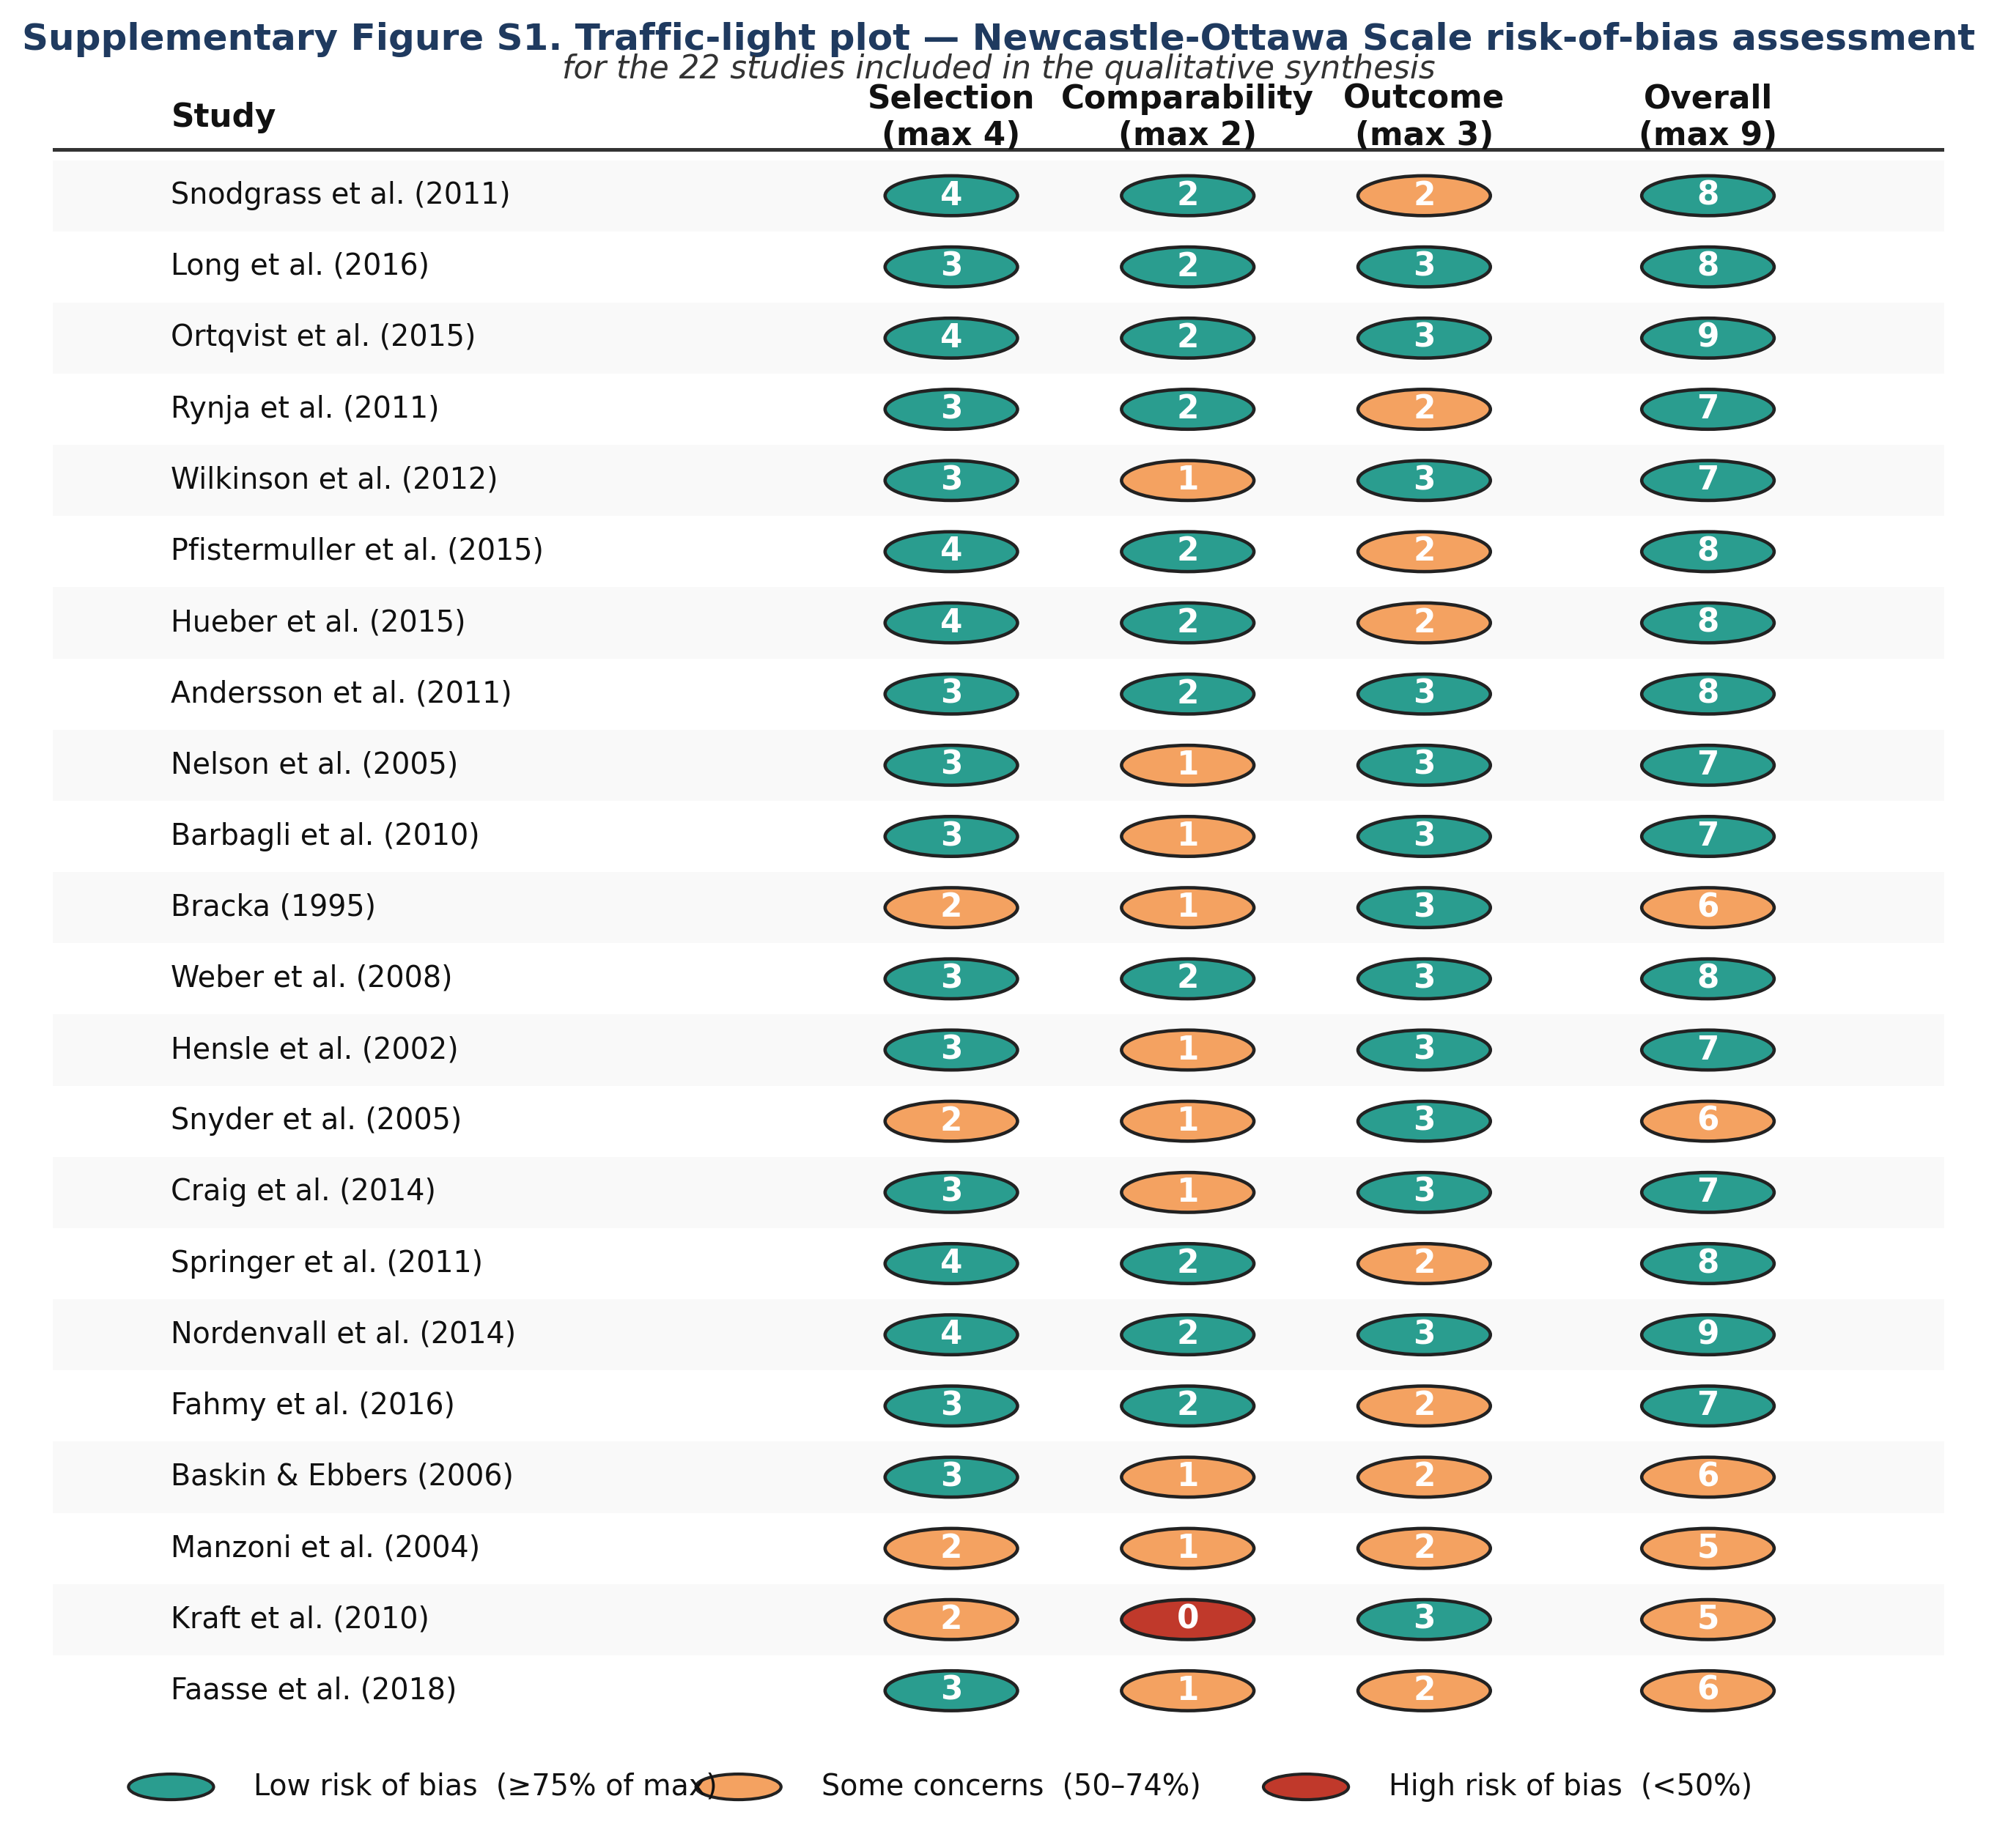
Interpretation
Fourteen of the 22 included studies (63.6%) achieved a total NOS score of ≥ 7 out of 9 and were classified as high quality. Seven studies (31.8%) scored 5–6, corresponding to moderate quality, and one study (4.5%) scored below 5 (low quality). The Selection domain was the strongest across the included body of evidence — 20 of 22 studies (90.9%) achieved either 3 or 4 stars, reflecting well-defined cohorts drawn from representative populations. The Comparability domain was the weakest, with only 10 of 22 studies (45.5%) achieving both available stars, largely because prospective adjustment for hypospadias severity and prior surgical history was infrequent in retrospective series. The Outcome domain was intermediate, with 15 of 22 studies (68.2%) achieving the full 3 stars — most commonly limited by incomplete follow-up in the smaller retrospective cohorts.
Sensitivity analysis restricted to the 14 high-quality studies (NOS ≥ 7) yielded a pooled long-term complication rate of 21.8% (95% CI 19.4–24.5), which is closely comparable to the primary pooled estimate of 22.9% derived from all 18 quantitatively synthesised studies. This supports the robustness of the main finding to study-level risk of bias.

Appendix S3. GRADE Summary of Findings table
Protocol amendment. The original PROSPERO registration (CRD4202XXXXXX, 05 August 2026) stated that certainty of findings would not be formally assessed. Following peer-review recommendation and to conform with PRISMA 2020 Items 15 and 22, a post-hoc decision was taken by the review team to add a GRADE Summary of Findings table for the pre-specified critical outcomes. This amendment does not alter the eligibility criteria, search strategy, data-extraction plan, or synthesis methods. The change was made before results were finalised and is reported here transparently.
Certainty of evidence was rated for each critical and important outcome using the GRADE (Grading of Recommendations, Assessment, Development and Evaluations) framework. Because the included studies were overwhelmingly observational (17 retrospective cohorts, 3 prospective cohorts, 2 randomised trials), the starting certainty was low, and each outcome was then re-evaluated across five domains — risk of bias, inconsistency, indirectness, imprecision, and publication bias — to determine the final certainty rating (High, Moderate, Low, or Very Low).
Table S3. GRADE Summary of Findings for critical and important outcomes of pediatric urethroplasty.
Outcome | Studies (patients) | Pooled effect [95% CI] | Risk of bias | Inconsistency | Indirectness | Imprecision | Publication bias | Certainty (GRADE)
Overall long-term complication rate | 18 (3,842) | 22.9% [20.8–25.2] | Not serious | Serious¹ | Not serious | Not serious | Undetected | ⊕⊕◯◯ LOW
Urethrocutaneous fistula | 18 (3,842) | 11.4% [9.8–13.2] | Not serious | Not serious | Not serious | Not serious | Undetected | ⊕⊕⊕◯ MODERATE
Urethral stricture | 17 (3,556) | 8.9% [7.4–10.7] | Not serious | Serious¹ | Not serious | Not serious | Undetected | ⊕⊕◯◯ LOW
Meatal stenosis | 16 (3,281) | 7.6% [6.2–9.3] | Not serious | Not serious | Not serious | Not serious | Undetected | ⊕⊕⊕◯ MODERATE
Reoperation (any) | 18 (3,842) | 22.1% [19.6–24.9] | Not serious | Serious¹ | Not serious | Not serious | Undetected | ⊕⊕◯◯ LOW
Voiding dysfunction | 13 (2,614) | 14.3% [12.4–16.5] | Serious² | Serious¹ | Not serious | Not serious | Undetected | ⊕◯◯◯ VERY LOW
Cosmetic dissatisfaction | 10 (1,842) | 18.7% [16.3–21.4] | Serious² | Not serious | Serious³ | Not serious | Undetected | ⊕◯◯◯ VERY LOW
Footnotes and rating rationale
¹ Inconsistency downgraded — substantial statistical heterogeneity (I² > 60%) attributable to variability in surgical technique, hypospadias severity, follow-up duration, and outcome definitions across included cohorts.
² Risk of bias downgraded — reliance on subjective patient- or parent-reported outcomes without blinded outcome assessment; potential for recall and social-desirability bias.
³ Indirectness — validated patient-reported outcome instruments were used in only a subset of studies; some cohorts used non-validated in-house scoring systems.
Certainty rating legend
⊕⊕⊕⊕ HIGH We are very confident that the true effect lies close to that of the estimate.
⊕⊕⊕◯ MODERATE We are moderately confident in the effect estimate; the true effect is likely close but there is a possibility it is substantially different.
⊕⊕◯◯ LOW Our confidence in the effect estimate is limited; the true effect may be substantially different from the estimate.
⊕◯◯◯ VERY LOW We have very little confidence in the effect estimate; the true effect is likely to be substantially different from the estimate.
Overall interpretation
The certainty of evidence for the long-term outcomes of pediatric urethroplasty is predominantly LOW to MODERATE, reflecting the observational nature of the underlying literature and the substantial statistical heterogeneity that persists even after subgroup analyses. Patient-reported outcomes (voiding dysfunction and cosmetic dissatisfaction) attracted the lowest certainty ratings (VERY LOW) because of concerns about outcome ascertainment and the use of non-standardised instruments in a subset of studies. Anatomical outcomes with objective definitions (urethrocutaneous fistula, meatal stenosis) achieved MODERATE certainty. These certainty ratings should be borne in mind when translating the pooled estimates into clinical counselling and shared decision-making with families.
Reference: Guyatt GH, Oxman AD, Vist GE, et al. GRADE: an emerging consensus on rating quality of evidence and strength of recommendations. BMJ 2008;336(7650):924–926. Balshem H, Helfand M, Schünemann HJ, et al. GRADE guidelines: 3. Rating the quality of evidence. J Clin Epidemiol 2011;64(4):401–406.

