Supplementary Data
Observation of Protonation-Assisted Contrary Aggregate Emission with Strong and Weak Electron Donor Substituents in Barbituric Acid-Pyran Conjugate Triads

Ajayakumar Aswathyª, Kurisingal B. Daisymolª, Pookalavan K. Vineethaª, Aluparambil R. Biju^{b}, Narayanapillai Manoj^{a,c*}
ªDepartment of Applied Chemistry, Cochin University of Science and Technology, Kochi, Kerala, India
^{b}Department of Chemistry, Kannur University, Kannur, Kerala, India
^{c}Interuniversity Center for Nanomaterials and Devices, Cochin University of Science and Technology, Kochi, Kerala, India
*corresponding author: manoj.n@cusat.ac.in
Tel: +91 9447712268

Materials and Instrumentation
The chemicals and reagents necessary for the synthesis were purchased from Sigma Aldrich and used as received. Spectroscopic grade solvents from Merck were used for photophysical studies, while solvents for the synthesis procedures were obtained from Spectrochem Ltd. and distilled before use. The melting points were recorded in an open capillary tube on a JSGW melting point apparatus. ¹H (400 MHz) and ¹³C NMR (100 MHz) spectra were recorded on a Bruker Avance III FT-NMR spectrometer in deuterated dimethyl sulfoxide (DMSO-d6) with tetramethylsilane (TMS) as an internal reference. Chemical shift values are reported in parts per million (ppm) with respect to reference. A Bruker Autoflex max LRF mass spectrometer was used to obtain the MALDI-TOF mass spectra. An Evolution 201 UV-Vis spectrophotometer was used to record the absorption spectra with a quartz cuvette of 1 cm path length. Horiba Fluorolog 3 spectrofluorometer was used to record fluorescence spectra with both excitation and emission slit widths set to 3 nm. All the measurements were carried out at the room temperature.
Acidochromism Experiments
The acidochromism experiments were carried out by performing UV−vis absorption and fluorescence titrations with a dilute solution of PHPBA and ANPBA (2 x 10⁻⁵ M) in chloroform) against standard solutions of TFA in chloroform at 298 K. After each addition of the acid to the solution of PHPBA and ANPBA , the reaction mixture contained in a 3 mL quartz cuvette was allowed to equilibrate for ca. 30 s prior to spectral acquisition throughout the titration experiments. For ¹H NMR titration, the solution (0.5 mL) of samples in CHCl₃ (0.03 M) was treated with 1-2 equivalents of TFA, and the NMR spectra were recorded at 298 K.

Synthesis of 5-(2,6-di((E)-styryl)-4H-pyran-4-ylidene)pyrimidine-2,4,6(1H,3H,5H)-trione (PHPBA)
PHPBA was synthesized according to literature procedure[5-7]. A mixture of 5-(2,6-dimethyl-4H-pyran-4-ylidene) pyrimidine-2,4,6(1H,3H,5H)-trione ( 0.936g, 4 mmol), benzaldehyde 1.36g, 8 mmol) and 0.5mL piperidine, in 20 mL Toluene, was refluxed under N2 atmosphere for 24h (Scheme1). Upon cooling the reaction mixture the orange coloured residue obtained was filtered, washed with cold water, and dried under vacuum. The crude product was purified by recrystallization from methanol to afford compound 1 as a orange solid in 80% yield. The compound was characterized by FT-IR, ¹H NMR, ¹³C NMR and MALDI-TOF techniques, m.p. > 260 °C. FT-IR (KBr, ν_{max}cm⁻¹): 3370, 3177, 2367,1737, 1617, 1455, 1337, 1132, 947, 754, 627, 575.¹H NMR (400 MHz, DMSO-d6) δ (ppm): 10.63 (1H, S), 8.85 (1H, S),7.83(1H, d, J=16Hz-vinylic), 7.35(1H d, J=16Hz-vinylic), 7.463 (3H, m), 7.498 (2H, S). 13C NMR (100MHz, DMSO- d6)δ(ppm):110.69,111.77,127.73,128.31,129.08,134.15,136.60 148.50, 159.04, 164.40,164.40. MALDI-TOF MS (ESI MS) m/z: [M+H]+ calcd for C25H18N2O4 = 411.134, found 411.760.

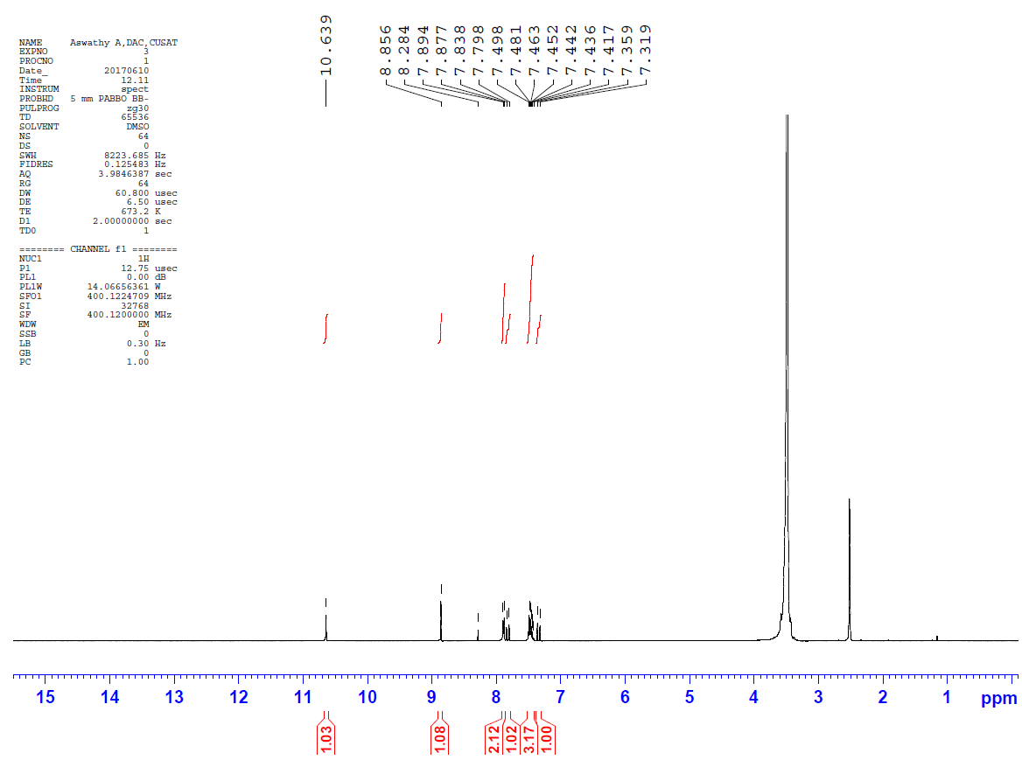
Fig.S1 ¹H NMR Spectra of PHPBA DMSO-d₆

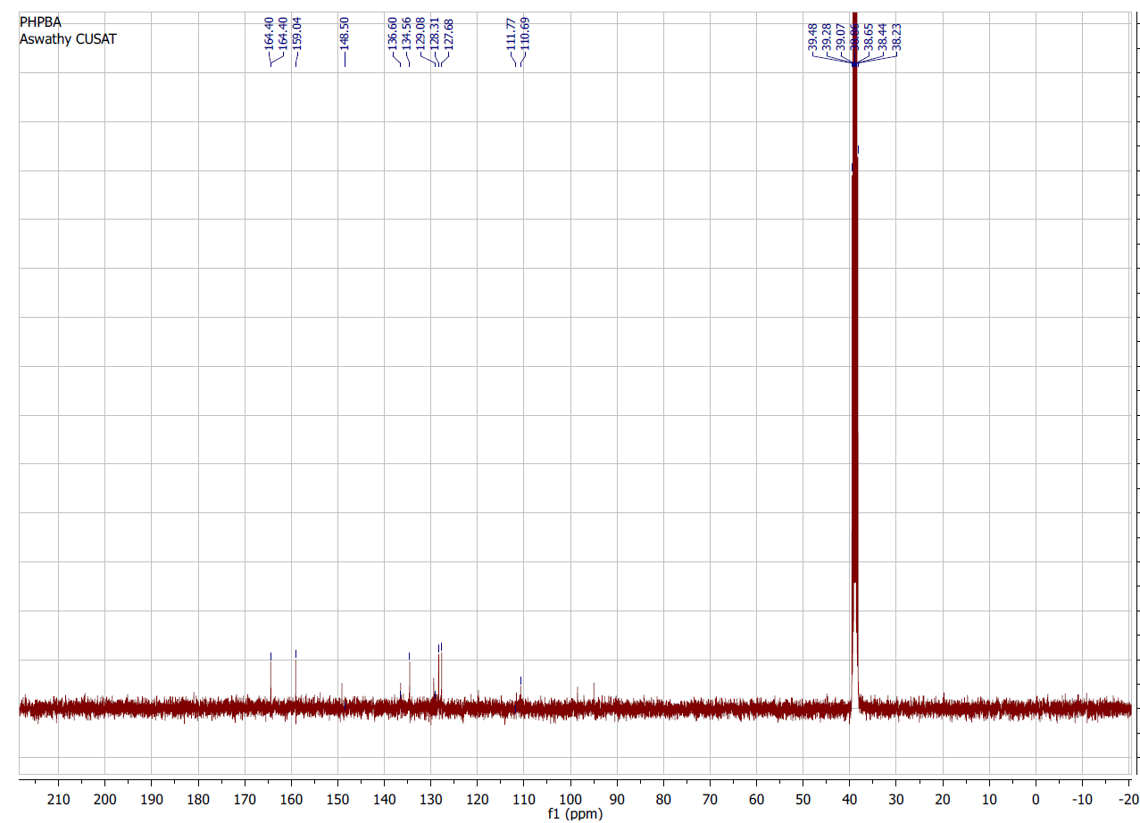

Fig.S2 ¹³C NMR Spectra of PHPBA DMSO-d₆

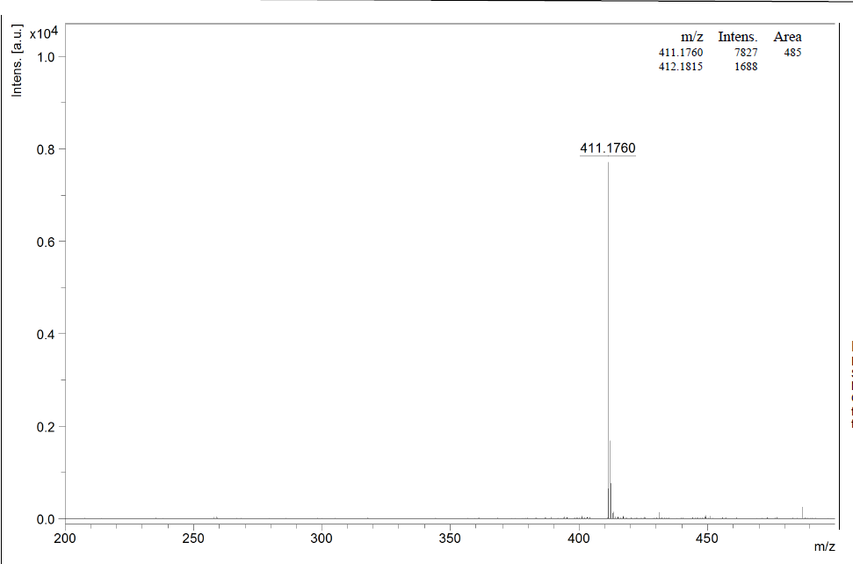

Fig.S3 MALDI-TOF Mass Spectra of PHPBA

Synthesis of 5-(2,6-bis((E)-4-methoxystyryl)-4H-pyran-4-ylidene)pyrimidine-2,4,6(1H,3H,5H)-trione (ANPBA)
ANPBA was synthesized according to literature procedure[5-7]. A mixture of 5-(2,6-dimethyl-4H-pyran-4-ylidene)pyrimidine-2,4,6(1H,3H,5H)-trione (1, 0.936g, 4 mmol), anisaldehyde (2, 1.36g, 8 mmol) and 0.5mL piperidine, in 20 mL Toluene, was refluxed under N2 atmosphere for 24h (Scheme1). After cooling the reaction mixture the orange coloured residue was filtered, washed with cold water, and dried under vacuum. The crude product was purified by recrystallization from methanol to afford compound 2 as a orange solid in 80% yield. The compound was characterized by FT-IR, ¹H NMR, ¹³C NMR and MALDI-TOF techniques, m.p. > 260 °C. FT-IR (KBr, ν_{max}cm⁻¹): 3370, 3177, 2367,1737, 1617, 1455, 1337, 1132, 947, 754, 627, 575. ¹H NMR (400MHz, DMSO) δ (ppm): 10.563 (1H, S), 8.79 (1H, S), 7.80 (2H, S), 7.77 (1H, d, J=16Hz-vinylic), 7.19 (1H d, J=16Hz-vinylic), 7.04 (2H, S), 3.385 (3H, S). 13C NMR (100MHz, DMSO) δ (ppm): 55.85, 95.20,111.02, 114.88, 118.30, 128.32, 130.53, 137.41, 150.20, 160.59, 161.35, 165.50. MALDI-TOF MS (ESI MS) m/z: [M+H]⁺ calcd for C27H22N2O6 471.156, found 471.044

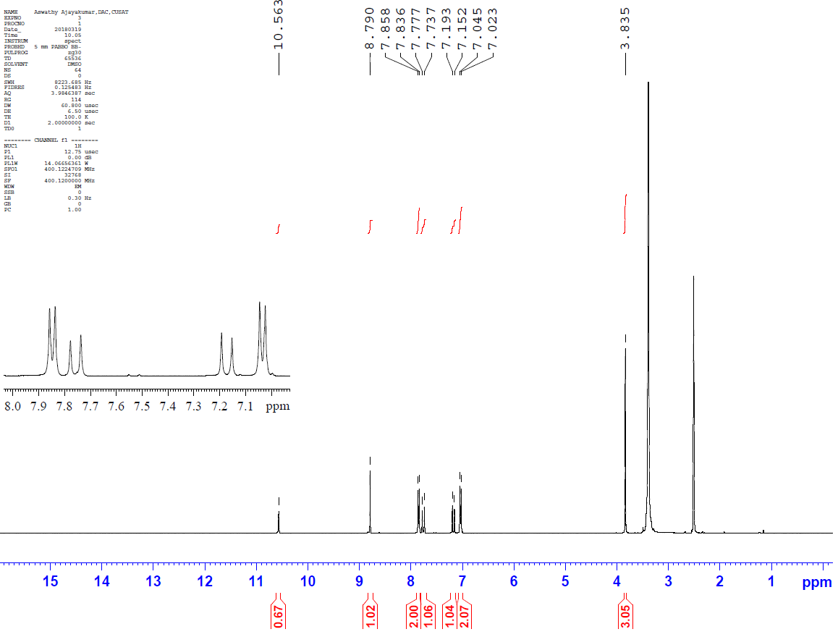
Fig.S4 ¹H NMR Spectra of ANPBA in DMSO-d₆
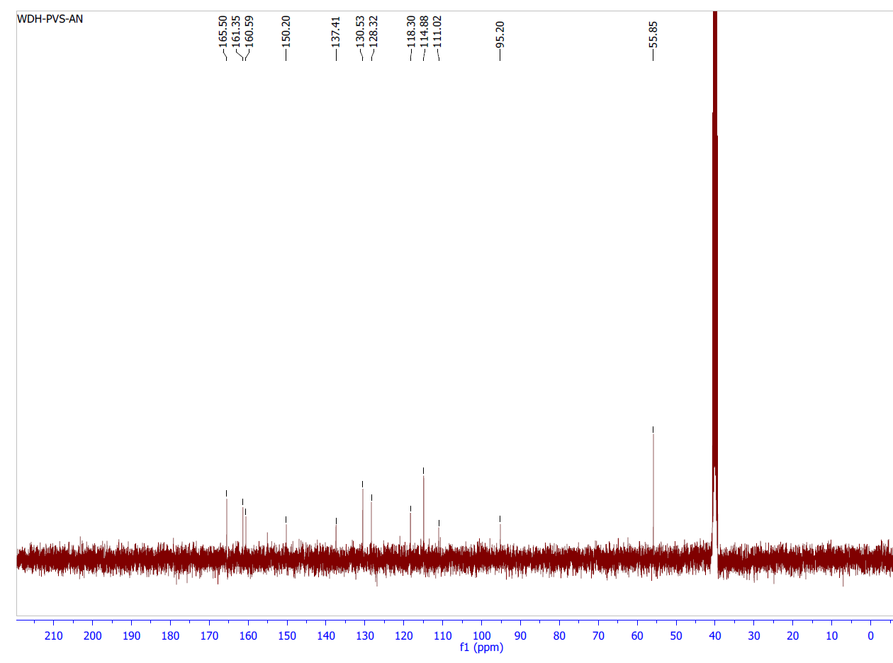

Fig.S5 ¹³C NMR Spectra of PHPBA DMSO-d₆
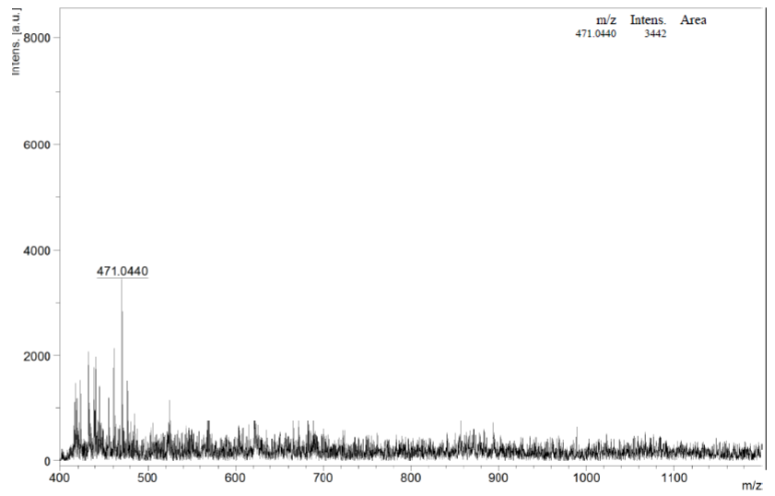
Fig.S6 MALDI-TOF Mass Spectra of ANPBA

