Supplementary Information

Supplementary Results
This section provides detailed information on all candidate variants identified through the second-level prioritization strategy targeting genes from the kinin-kallikrein (KKS) and complement pathways. Within the complement cascade, a splice-site variant in C5 (c.3151_3154+2del) affecting the junction of exon 24 was identified in four unrelated sporadic HAE-nC1INH cases from the Canary Islands (families 12, 17, 18, and 19). This variant was absent from population databases and was predicted to cause loss-of-function impact on protein. While familial segregation could not be assessed due to lack of family members in the study, the variant met PVS1 (very strong) and PM2 (moderate) ACMG criteria, supporting a likely pathogenic classification. Additionally, a frameshift variant in C9 (c.1042del; p.Ser348AlafsTer5) was identified in the index case of family 30 and is predicted to trigger nonsense-mediated decay, with two independent entries in DECIPHER annotating this variant as loss-of-function, although further clinical correlation is required to confirm its pathogenicity. Two variants were prioritized in C3, including the synonymous variant c.606C>T (p.Gly202=) identified in family 80, which was classified as deleterious by usDSM (score = 0.704) and reclassified as likely pathogenic, and a canonical splice-site variant (c.2583+1G>A) identified in family 95 and classified as likely pathogenic based on PVS1 criteria. The C1S:c.1198G>C (p.Glu400Gln) variant identified in family 41 showed conflicting interpretations among pathogenicity predictors and in ClinVar submissions, leading to a classification of uncertain significance. Similarly, the C1QBP:c.401A>G (p.Asn134Ser) variant was identified in families 57 (Spain) and 69 (insular Portugal), and despite a moderate CADD score, this variant remained classified as a variant of uncertain significance, although C1QBP has recently been implicated in KKS-mediated bradykinin production [1], suggesting its potential as a therapeutic target for HAE.

Regarding the KKS and related genes, the TEK:c.2404G>A (p.Ala802Thr) missense variant was identified in family 50 and demonstrated complete co-segregation with the disease, being present in all affected individuals (patients 1, 3, and 4) and in one asymptomatic relative (patient 2), who may represent a pre-symptomatic case or exhibit incomplete penetrance, although the variant was classified as VUS due to insufficient functional evidence. The ANGPT2:c.1342C>T (p.Asp448Asn) variant was identified in the affected members of family 66, and computational predictors consistently indicated a high functional impact on the protein, but available evidence was insufficient for definitive classification, with literature supporting that ANGPT2 dysfunction leads to Tie2 receptor inactivation, enhancing endothelial permeability [2]. The KRT1:c.1865G>T (p.Gly622Val) variant in exon 9 was identified in all members of family 51, and computational tools strongly predicted functional impact, with this gene having been previously reported in HAE patients with normal C1-INH levels [3] and forming a complex with C1QBP that functions as a high-affinity receptor for kininogen 1. The F11:c.1858G>C (p.Glu620Gln) variant identified in the index case of family 68 showed a CADD score significantly exceeding the estimated MSC 95% threshold for F11 gene, and although ClinVar currently classifies this variant as VUS, its low allele frequency in gnomAD enhances its potential clinical relevance. The VEGFA:c.617C>T (p.Thr206Ile) variant was identified in a female proband with clinical suspicion of HAE type 2 (family 75), and these findings gain biological plausibility from recent studies linking VEGFA to BK-mediated angiogenesis in HAE patients without C1-INH deficiency [4, 5], while elevated plasma VEGFA levels during attacks [6] suggest that this variant might disrupt the BK-VEGFA feedback loop. The KDR:c.241G>A (p.Asp81Asn) variant affects a critical residue in the VEGFR2 extracellular Ig-like domain 1 structure (family 78), with molecular modeling suggesting disruption of the hydrophobic core, and although the variant meets several ACMG criteria (PM2, PP3, PP4), it was ultimately classified as VUS due to insufficient functional evidence and lack of segregation data. Two missense variants were prioritized in SYTL2, including the c.6401G>T (p.Arg2134Leu) variant in family 54 and the c.5802A>C (p.Lys1934Asn) variant in family 67, both of which had CADD scores exceeding the gene-specific MSC 95%, and while SYTL2 has been recently associated with clinically suspected HAE [6], the available evidence for these specific variants remains limited, and both were classified as VUS. The XPNPEP2 c.623A>G (p.Gln208Arg) variant in the proband of family 42 showed conflicting evidence from in silico prediction tools, and although its CADD score (18.0) exceeds the estimated pathogenic threshold MSC 95% (11.8), the lack of functional or segregation evidence limited its classification to VUS. Finally, the TLR4 c.842G>A (p.Cys281Tyr) missense mutation identified in the index case from family 40 has been previously associated with HAE-C1INH in recent literature [7], although discordant pathogenicity predictions hampered definitive classification, and the variant was categorized as VUS following ACMG guidelines.

Supplementary References
[1] Ghebrehiwet B, Geisbrecht BV, Xu X, Savitt AG, Peerschke EIB. The C1q receptors: Focus on gC1qR/p33 (C1qBP, p32, HABP-1). Semin Immunol. 2019;45:101338. https://doi.org/10.1016/j.smim.2019.1013381. Wu MA, Bova M, Berra S, Senter R, Parolin D, Caccia S, et al. The central role of endothelium in hereditary angioedema due to C1 inhibitor deficiency. Int Immunopharmacol. 2020;82:106304. doi: 10.1016/j.intimp.2020.106304
[2] Loules G, Parsopoulou F, Zamanakou M, Csuka D, Bova M, González-Quevedo T, et al. Deciphering the Genetics of Primary Angioedema with Normal Levels of C1 Inhibitor. J Clin Med. 2020;9(11):3402. doi: 10.3390/jcm9113402
[3] Giavina-Bianchi P, Aun MV, Kalil J. Vascular endothelial growth factor (VEGF) emerging as a mediator of hereditary angioedema (HAE). World Allergy Organ J. 2024;17:100942. doi: 10.1016/j.waojou.2024.100942
[4] D'Apolito M, Santacroce R, Vazquez DO, Cordisco G, Fantini CA, D'Andrea G, et al. DAB2IP associates with hereditary angioedema: insights into the role of VEGF signaling in HAE pathophysiology. J Allergy Clin Immunol. 2024. doi: 10.1016/j.jaci.2024.05.017
[5] Bork K, Wulff K, Möhl BS, Steinmüller-Magin L, Witzke G, Hardt J, et al. Novel hereditary angioedema linked with a heparan sulfate 3-O-sulfotransferase 6 gene mutation. J Allergy Clin Immunol. 2021;148(4):1046-53. doi: 10.1016/j.jaci.2021.01.011
[6] Burns S, Lewis E. Transition to lanadelumab-flyo from three medications for a hereditary angioedema patient with a variant in the SYTL2 gene: A case report. Clin Case Rep. 2021;9(4):2438-41. doi: 10.1002/ccr3.4060
[7] Grymova T, Vlkova M, Soucek P, Hakl R, Nechvatalova J, Slanina P, et al. Neutrophils Are Dysregulated in Patients with Hereditary Angioedema Types I and II in a Symptom-Free Period. Mediators Inflamm. 2019:5648257. doi: 10.1155/2019/9515628

Supplementary Figures and Tables

Supplementary Figures

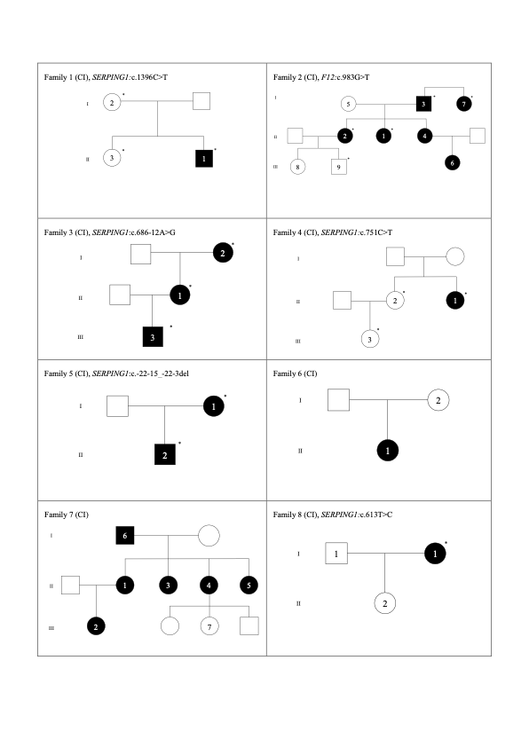
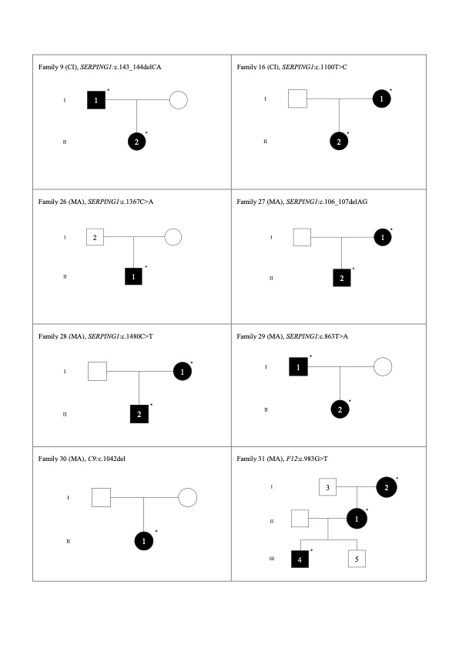
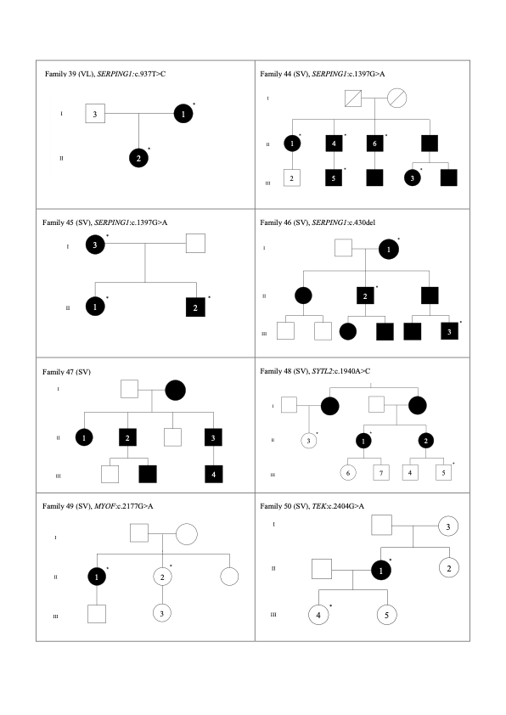
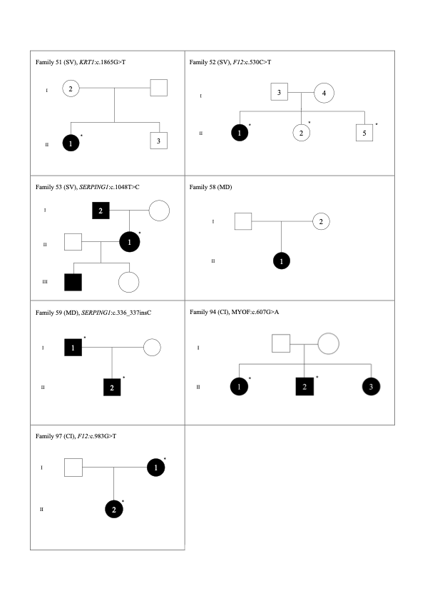
*: detected mutation for NGS-based diagnosis. Recruitment place is indicated in parenthesis (in Spain, CI: Canary Islands; SV: Sevilla; MA: Málaga; VL: Valencia; in Portugal, MD: Madeira). All declared “patient 1” for each family is the index case. Empty box indicates non recruited individuals.
Supplementary Figure 1. Pedigree charts of the HAE affected families included in the study.

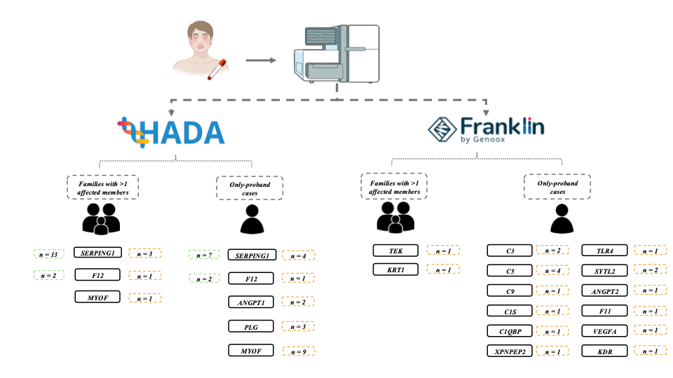
Supplementary Figure 2. Filtering steps for HAE causal and novel candidate variants prioritization combining HADA (http://hada.hpc.iter.es) and Franklin (https://franklin.genoox.com). The number of variants circled in green represents previously reported causal variants and orange circles for novel candidate variants prioritized in KKS genes.

Supplementary Tables
Supplementary Table 1. Summary of the Illumina platforms and kit combinations used for HAE sample sequencing.
DNA library preparation kit | Sequencing platform | Read setup
Nextera DNA Exome | HiSeq 4000 | PE75
Agilent SureSelectXT HS2 | NovaSeq 6000 | PE100
Nextera Flex for Enrichment | HiSeq 4000 | PE75
Illumina DNA Prep With Enrichment | NovaSeq 6000 | PE100
Illumina DNA Prep With Enrichment | HiSeq 4000 | PE75
Illumina DNA Prep With Exome 2.0 Plus Enrichment | NovaSeq 6000 | PE100
Illumina DNA Prep with Exome 2.5 Enrichment | NovaSeq 6000 | PE100
Illumina DNA Prep with Exome 2.5 Enrichment | NextSeq 550 | PE75
PE75 and PE100: 75 or 100-base paired-end reads, respectively.

Supplementary Table 2. Primer sequences and PCR conditions for amplifications and Sanger sequencing to validate prioritized candidate variants in this study.
GENE | HGVS VARIANT | PRIMER SEQUENCES (5' - 3') | AMPLICON LENGHT (bp) | Tm (ºC) | MgCl₂ CONCENTRATION (mM)
SERPING1 | NM_001032295.2:c.336_337insC | AGTTTGCAAGACAGAGGCGA | 373 | 60 | 1.5
SERPING1 | NM_001032295.2:c.336_337insC | TTGCTGAGAAGGCGTGGTAG | 373 | 60 | 1.5
SERPING1 | NM_001032295.2:c.551-48C>G | TGTGATCCCCTCCAAAGCAG | 340 | 60 | 2.0
SERPING1 | NM_001032295.2:c.551-48C>G | TGTCCTTTCTTTCCCCAGCG | 340 | 60 | 2.0
SERPING1 | NM_001032295.2:c.731dup | ACGACGTGTTCAGGACTCAT | 432 | 60 | 1.5
SERPING1 | NM_001032295.2:c.731dup | GGTGGGAGGGTTGCTCTAAT | 432 | 60 | 1.5
SERPING1 | NM_001032295.2:c.863T>A | ACGACGTGTTCAGGACTCAT | 432 | 60 | 1.5
SERPING1 | NM_001032295.2:c.863T>A | GGTGGGAGGGTTGCTCTAAT | 432 | 60 | 1.5
SERPING1 | NM_001032295.2:c.889+3A>C | TTGTGAATGCCTCTCGGACC | 378 | 60 | 1.5
SERPING1 | NM_001032295.2:c.889+3A>C | GCTAGAGGGAAGAGGTGGGA | 378 | 60 | 1.5
SERPING1 | NM_001032295.2:c.1455_1459dup | ATGCTGGCTTCTGACTCT | 417 | 60 | 2.0
SERPING1 | NM_001032295.2:c.1455_1459dup | GTGGATAGCGGACACCTGAG | 417 | 60 | 2.0
F12 | NM_000505.4:c.230C>G | GGTCCAGAATCCCAGGTGTG | 400 | 60 | 1.5
F12 | NM_000505.4:c.230C>G | GCCACTTCCCCTTCCAGTAC | 400 | 60 | 1.5
F12 | NM_000505.4:c.530C>T | CTCTCCTGCCTCCCTCTCAT | 351 | 60 | 1.5
F12 | NM_000505.4:c.530C>T | GGTGAGCAGATGGTTGGGAA | 351 | 60 | 1.5
F11 | NM_000128.4:c.1858G>C | GCTGAAGATGGGAAGCGTCT | 560 | 60 | 1.5
F11 | NM_000128.4:c.1858G>C | CTTCTGCCTGATCCCCACTG | 560 | 60 | 1.5
PLG | NM_000301.5:c.296A>T | CCCCTGCCTGATTCCACTAG | 493 | 60 | 1.5
PLG | NM_000301.5:c.296A>T | ACCAATCCCTCACAGACACAG | 493 | 60 | 1.5
PLG | NM_000301.5:c.112A>G | TGCTCCCTCTCTCCCTTCTC | 536 | 60 | 2.0
PLG | NM_000301.5:c.112A>G | AGCTGTTAGTATGGCTTCACA | 536 | 60 | 2.0
ANGPT1 | NM_001146.5:c.809-1G>T | AAAGGTGTGTGGATTGGGGA | 636 | 60 | 1.5
ANGPT1 | NM_001146.5:c.809-1G>T | TGCCCAGGTCATTTGTTCCT | 636 | 60 | 1.5
ANGPT2 | NM_024596.5:c.1342C>T | GGATCATCATGGTTGTGGCC | 392 | 60 | 1.5
ANGPT2 | NM_024596.5:c.1342C>T | CCACACAGCACAAGGGAAAA | 392 | 60 | 1.5
MYOF | NM_013451.4:c.508C>A | TAAACCCACTTGTGCCTGCA | 485 | 60 | 1.5
MYOF | NM_013451.4:c.508C>A | GGATCTCCTTCACCTGCCAC | 485 | 60 | 1.5
MYOF | NM_013451.4:c.607G>A | AGCCAAGATCGTACCACTGC | 584 | 60 | 1.5
MYOF | NM_013451.4:c.607G>A | TTTCTGCACTCTGACCCCAC | 584 | 60 | 1.5
MYOF | NM_013451.4:c.2177G>A | CCTATTCTTGGTGCCATTTCGC | 382 | 60 | 1.5
MYOF | NM_013451.4:c.2177G>A | AGGAGGTTGATGTGGTTTGCA | 382 | 60 | 1.5
MYOF | NM_013451.4:c.3403A>G | GCCCTCTCAACCCCTTTACC | 434 | 60 | 1.5
MYOF | NM_013451.4:c.3403A>G | ACTGGAGTCTGAGCAGTGAC | 434 | 60 | 1.5
MYOF | NM_013451.4:c.4015G>A | TTGTGTGTGTGTGTGTGAGG | 410 | 60 | 1.5
MYOF | NM_013451.4:c.4015G>A | GCAGGAGAAAGAAAGGGGCA | 410 | 60 | 1.5
MYOF | NM_013451.4:c.4208T>C | TTGTGTGTGTGTGTGTGAGG | 410 | 60 | 1.5
MYOF | NM_013451.4:c.4208T>C | GCAGGAGAAAGAAAGGGGCA | 410 | 60 | 1.5
MYOF | NM_013451.4:c.5599-7delC | AAGGGATGGCACTCACTGTC | 409 | 60 | 1.5
MYOF | NM_013451.4:c.5599-7delC | CAAGGGAGTGTCAGGGTGG | 409 | 60 | 1.5
MYOF | NM_013451.4:c.5697G>C | AAGGGATGGCACTCACTGTC | 549 | 60 | 1.5
MYOF | NM_013451.4:c.5697G>C | CAGCGGGAAGTCACACTGAT | 549 | 60 | 1.5
MYOF | NM_013451.4:c.5881G>A | CTCACAGCATCTCCCACCTT | 483 | 60 | 1.5
MYOF | NM_013451.4:c.5881G>A | CACTGTGTGCCTCTCTCCTG | 483 | 60 | 1.5
C1QBP | NM_001212.4:c.401A>G | CATGCGACTGGACTTAGAGGA | 397 | 60 | 1.5
C1QBP | NM_001212.4:c.401A>G | GGATTGGATGTAGGCACCCA | 397 | 60 | 1.5
C1S | NM_001734.5:c.1198G>C | CCACTTTCCCGATGCCTTCT | 354 | 60 | 1.5
C1S | NM_001734.5:c.1198G>C | TCATCTCTCCCCAAGCCTCA | 354 | 60 | 1.5
C3 | NM_000064.4:c.606C>T | AGGCTCCACTATGACCTCGA | 455 | 60 | 1.5
C3 | NM_000064.4:c.606C>T | CTAAGCCCAGCCTCCGAAG | 455 | 60 | 1.5
C3 | NM_000064.4:c.2583+1G>A | AAGCACTCACCACGACCTTC | 382 | 60 | 1.5
C3 | NM_000064.4:c.2583+1G>A | TCGAAACGAGCAGGTGGAAA | 382 | 60 | 1.5
C5 | NM_001735.3:c.3151_3154+2delGAAGGT | AGGTGCCTTGCCTCTCATTC | 563 | 60 | 1.5
C5 | NM_001735.3:c.3151_3154+2delGAAGGT | TCACCCCGTTTCTGAGAAGC | 563 | 60 | 1.5
C9 | NM_001737.5:c.1042del | AAAGGAGCAGGTTACAGGGC | 480 | 60 | 1.5
C9 | NM_001737.5:c.1042del | GGTATCTCATGGTCACTGCT | 480 | 60 | 1.5
KDR | NM_002253.4:c.241G>A | CAGCCTTTAGAGCAAGCCCT | 534 | 60 | 1.5
KDR | NM_002253.4:c.241G>A | TTTACCATGTTGCCCAGCCT | 534 | 60 | 1.5
KRT1 | NM_006121.4:c.1865G>T | GCAGAAAAGAAAGAGCTGGGG | 575 | 60 | 1.5
KRT1 | NM_006121.4:c.1865G>T | CAAGCCACACCACCATCAGT | 575 | 60 | 1.5
TEK | NM_001375476.1:c.2404G>A | GGGCAGTCCTGTGTGATGAA | 351 | 60 | 1.5
TEK | NM_001375476.1:c.2404G>A | CAGCATCCATCCGTAACCCA | 351 | 60 | 1.5
TLR4 | NM_138554.5:c.842G>A | AGACCTGTCCCTGAACCCTA | 475 | 60 | 2.0
TLR4 | NM_138554.5:c.842G>A | AGCATTCCCACCTTTGTTGGA | 475 | 60 | 2.0
SYTL2 | NM_206927.4:c.5802A>C | ACACATACCCTCCCTCCTCT | 530 | 60 | 1.5
SYTL2 | NM_206927.4:c.5802A>C | TGAGCCGAGATCAAGCCA | 530 | 60 | 1.5
SYTL2 | NM_206927.4:c.6401G>T | TCCTTGAGAACACTGTAGGA | 552 | 60 | 2.0
SYTL2 | NM_206927.4:c.6401G>T | ACGTTCTGGTCCATATGCCA | 552 | 60 | 2.0
XPNPEP2 | NM_003399.6:c.623A>G | TTCCTGGGGTGTAAATGGGC | 473 | 60 | 1.5
XPNPEP2 | NM_003399.6:c.623A>G | TTCCTCCCTTCCTGCTCCAT | 473 | 60 | 1.5
VEGFA | NM_001317010.1:c.617C>T | GTTGGTGGGAGGGAAGTGAG | 342 | 60 | 1.5
VEGFA | NM_001317010.1:c.617C>T | GACCTGAACAGCGGAGAGTC | 342 | 60 | 1.5

Supplementary Table 3. Protein levels and clinical metadata of participants in the study.
FAMILY ID | INDIVIDUAL ID | SEX | HAE SUBTYPE | C1-INH PROTEIN LEVELS (mg/dL) | C1-INH ACTIVITY LEVELS (%) | C4 PROTEIN LEVELS (mg/dL)
001 | 1 | M | HAE-C1INH type 2 | 47 | 10 | 1.8
001 | 2 | F | HAE-C1INH type 2 | 58 | 37 | 7.4
001 | 3 | F | HAE-C1INH type 2 | 65 | <10 | 7.6
002 | 3 | F | HAE-nC1INH | 27 | 79 | 17.2
002 | 4 | F | HAE-nC1INH | 25 | 99 | 27.9
002 | 5 | F | HAE-nC1INH | 26 | 93 | 21.7
002 | 6 | F | HAE-C1INH type 2 | 24 | 12 | 22.4
002 | 1 | M | HAE-nC1INH | 29 | 99 | 29.8
002 | 2 | F | HAE-C1INH type 1 | 16 | <10 | 10.9
002 | 7 | F | HAE-nC1INH | . | . | .
002 | 8 | M | HAE-nC1INH | . | . | .
002 | 9 | M | HAE-nC1INH | . | . | .
003 | 2 | F | HAE-C1INH type 1 | 8 | <10 | 2.4
003 | 1 | M | HAE-C1INH type 1 | 14 | 46 | 10.5
003 | 3 | F | HAE-C1INH type 1 | 4 | <10 | <1.5
004 | 1 | F | HAE-C1INH type 1 | 14 | 13 | <1.5
004 | 2 | F | Asymptomatic | . | . | 19.2
004 | 3 | F | HAE-nC1INH | 30 | 70 | 28.1
005 | 1 | M | HAE-C1INH type 1 | 6 | 14 | 5.6
005 | 2 | F | HAE-C1INH type 1 | 7 | 28 | 16.7
006 | 3 | F | HAE-nC1INH | 27 | 74 | 26.2
006 | 4 | F | Asymptomatic | . | . | .
007 | 1 | F | HAE-C1INH type 1 | 4 | <10 | 5.8
007 | 2 | F | HAE-C1INH type 1 | 11 | 13 | 4.6
007 | 3 | F | HAE-C1INH type 1 | 5 | <10 | 4.2
007 | 4 | F | HAE-C1INH type 1 | 5 | <10 | 4
007 | 5 | F | HAE-C1INH type 1 | 5 | 16 | 2.7
007 | 6 | F | HAE-nC1INH | . | . | 17
007 | 7 | M | HAE-C1INH type 1 | 9 | . | .
008 | 1 | F | HAE-C1INH type 1 | 10.50 | 39 | 6.8
008 | 2 | F | Asymptomatic | . | . | .
009 | 1 | M | HAE-C1INH type 1 | 11 | 25 | 6
009 | 2 | F | HAE-C1INH type 1 | 11 | 27 | 14,40
010 | 1 | F | HAE-C1INH type 2 | 21 | 18 | 21.1
011 | 1 | F | HAE-nC1INH | 26 | 112 | 21.8
012 | 1 | F | HAE-C1INH type 2 | 31 | 41 | 31.5
013 | 1 | F | HAE-C1INH type 1 | 20 | 18 | 30
014 | 1 | F | HAE-C1INH type 1 | 30 | 17 | 36
015 | 1 | F | HAE-C1INH type 1 | 17 | 39 | 25.3
016 | 2 | F | HAE-C1INH type 1 | . | . | .
016 | 1 | M | HAE-C1INH type 1 | 11 | 30 | 9
017 | 1 | F | HAE-nC1INH | 25 | 94 | 39.4
018 | 1 | F | HAE-nC1INH | 29 | 90 | 35
019 | 1 | F | HAE-nC1INH | 32 | 95 | 36.4
020 | 1 | F | HAE-nC1INH | 30 | 109 | 28,2
021 | 1 | F | HAE-C1INH type 1 | 14 | 57 | 13.4
022 | 1 | F | HAE-nC1INH | 18 | 20 | 31
023 | 1 | F | HAE-C1INH type 2 | 24 | 58 | 29
024 | 1 | F | HAE-C1INH type 2 | 33 | 10 | 38
025 | 1 | F | HAE-C1INH type 2 | 42 | 10 | 42
026 | 1 | M | HAE-C1INH type 1 | . | . | .
026 | 2 | M | HAE-C1INH type 1 | . | . | .
027 | 1 | F | HAE-C1INH type 1 | . | . | .
027 | 2 | M | HAE-C1INH type 1 | . | . | .
028 | 1 | M | HAE-C1INH type 1 | . | . | .
028 | 2 | M | HAE-C1INH type 1 | . | . | .
029 | 1 | M | HAE-C1INH type 1 | . | . | .
029 | 2 | F | HAE-C1INH type 1 | . | . | .
030 | 1 | F | HAE-UNK | 16113 | 9900 | 14
030 | 2 | F | HAE-UNK | . | . | .
031 | 1 | M | HAE-UNK | . | . | .
031 | 2 | M | HAE-UNK | . | . | .
031 | 3 | F | HAE-UNK | . | . | .
031 | 4 | M | HAE-UNK | . | . | .
031 | 5 | F | HAE-UNK | 27715 | 10200 | 24
032 | 1 | F | HAE-C1INH type 1 | . | . | .
033 | 1 | M | HAE-C1INH type 1 | . | . | .
034 | 1 | M | HAE-C1INH type 1 | . | . | .
035 | 1 | M | HAE-C1INH type 1 | . | . | .
036 | 1 | F | HAE-C1INH type 1 | . | . | .
037 | 1 | M | HAE-C1INH type 1 | . | . | .
038 | 1 | M | HAE-C1INH type 1 | 12471 | 3300 | 6
039 | 1 | M | HAE-C1INH type 2 | . | 3.2 | 4.5
039 | 2 | M | Asymptomatic | . | . | .
039 | 3 | F | HAE-C1INH type 1 | . | . | .
040 | 1 | F | HAE-nC1INH | . | . | .
041 | 1 | F | HAE-nC1INH | . | . | .
042 | 1 | F | HAE-nC1INH | . | . | .
043 | 1 | F | HAE-nC1INH | . | . | .
044 | 1 | F | HAE-C1INH type 2 | 22.70 | 10.2 | 1.64
044 | 2 | M | HAE-C1INH type 2 | 22.40 | 96.56 | 40.91
044 | 3 | M | HAE-C1INH type 2 | . | 25.6 | .
044 | 4 | F | HAE-C1INH type 2 | 25.10 | 25.3 | 2.46
044 | 5 | M | HAE-C1INH type 2 | 35.20 | 33.61 | 9.90
044 | 6 | M | HAE-C1INH type 2 | 19.20 | 5.10 | 0.00
045 | 1 | F | HAE-C1INH type 2 | 23.8 | 38.5 | 2.9
045 | 2 | M | HAE-C1INH type 2 | 30.10 | 31.93 | 6.20
045 | 3 | F | HAE-C1INH type 2 | 30.0 | 34.2 | 18.50
046 | 1 | F | HAE-C1INH type 1 | 10.80 | 19.0 | 12.98
046 | 2 | M | HAE-C1INH type 1 | 11.20 | 17.2 | 14.20
047 | 1 | M | HAE-C1INH type 1 | 31.40 | 48.6 | 22.70
047 | 2 | F | HAE-C1INH type 1 | 6.10 | 8.39 | 18.73
047 | 3 | M | HAE-C1INH type 1 | 7.61 | 17.7 | 19.02
047 | 4 | M | HAE-C1INH type 1 | 10.10 | 45.37 | 23.62
047 | 5 | M | HAE-C1INH type 1 | 7.61 | 57.06 | 8.42
048 | 1 | F | HAE-C1INH type 1 | 30.40 | 100.1 | 28.38
048 | 2 | F | HAE-C1INH type 1 | 24.30 | 114.1 | 30.02
048 | 3 | F | Asymptomatic | . | 111.66 | .
048 | 4 | M | Asymptomatic | . | 93.79 | .
048 | 5 | M | Asymptomatic | . | 123.4 | .
048 | 6 | F | Asymptomatic | . | 104.59 | .
048 | 7 | M | Asymptomatic | . | 113.33 | .
049 | 1 | F | HAE-nC1INH | 29.80 | 114.8 | 33.40
049 | 2 | F | Asymptomatic | . | . | .
049 | 3 | F | Asymptomatic | . | . | .
050 | 1 | F | HAE-nC1INH | 22.70 | 96.2 | 16.30
050 | 2 | F | Asymptomatic | . | . | .
050 | 3 | F | HAE-nC1INH | 40.10 | . | 44.90
050 | 4 | F | Asymptomatic | 28.70 | . | 26.34
050 | 5 | F | Asymptomatic | 30.10 | . | 17.67
051 | 1 | F | HAE-nC1INH | 26.10 | 125.25 | 28.18
051 | 2 | F | Asymptomatic | . | . | .
051 | 3 | M | Asymptomatic | . | . | .
052 | 1 | F | HAE-nC1INH | 20.60 | 99.3 | 22.24
052 | 2 | F | Asymptomatic | . | . | .
052 | 3 | M | Asymptomatic | . | . | .
052 | 4 | M | Asymptomatic | . | . | .
053 | 1 | F | HAE-C1INH type 1 | 11.60 | 26.5 | 11.70
053 | 2 | M | HAE-C1INH type 1 | 9.6 | 32.7 | 10.0
054 | 1 | F | HAE-C1INH type 1 | 19.5 | 109.8 | 26.0
055 | 1 | F | HAE-C1INH type 1 | 18.70 | 73.9 | 24.74
056 | 1 | F | HAE-C1INH type 1 | < 10.9 | 0 | <6
057 | 1 | M | HAE-C1INH type 1 | 6.58 | 42.6 | 7.74
058 | 1 | F | Asymptomatic | 89 | . | 35
058 | 2 | F | HAE-nC1INH | 75 | . | 21.5
059 | 1 | M | HAE-C1INH type 1 | <3 | <25 | 3.2
059 | 2 | M | Asymptomatic | 11 | <25 | .
060 | 1 | F | HAE-C1INH type 2 | 34 | 23 | 17.6
061 | 1 | M | HAE-C1INH type 1 | 26 | 96 | 17.4
062 | 1 | F | HAE-C1INH type 1 | <10 | 3 | 4.7
063 | 1 | F | HAE-C1INH type 1 | 30 | 87 | 22.6
064 | 1 | F | HAE-C1INH type 2 | 26 | 3 | 17.6
065 | 1 | F | HAE-C1INH type 1 | 22 | 80 | 22.3
066 | 1 | F | HAE-nC1INH | . | . | .
067 | 1 | M | HAE-C1INH type 2 | 28 | 29 | 20.8
068 | 1 | M | HAE-nC1INH | . | . | .
069 | 1 | M | HAE-UNK | . | . | .
070 | 1 | F | HAE-UNK | . | . | .
071 | 1 | M | HAE-C1INH type 2 | 28 | <25 | 157
072 | 1 | F | HAE-C1INH type 2 | 34 | 32 | 53.4
073 | 1 | F | HAE-C1INH type 2 | . | . | .
074 | 1 | F | HAE-nC1INH | . | . | .
075 | 1 | F | HAE-C1INH type 2 | 41 | 52 | 26
076 | 1 | F | HAE-UNK | . | . | .
077 | 1 | M | HAE-nC1INH | . | . | .
078 | 1 | F | HAE-nC1INH | . | . | .
079 | 1 | M | HAE-UNK | . | . | .
080 | 1 | M | HAE-nC1INH | 41 | 88 | 25
081 | 1 | F | HAE-nC1INH | 42 | 131 | 42
082 | 1 | M | HAE-C1INH type 1 | 42 | . | 24
083 | 1 | M | HAE-UNK | 30 | 94 | 22,7
084 | 1 | M | HAE-C1INH type 2 | 36 | 36 | 22
085 | 1 | F | HAE-C1INH type 1 | 12 | 40 | 19
086 | 1 | F | HAE-UNK | . | . | .
087 | 1 | F | HAE-UNK | . | . | .
088 | 1 | F | HAE-UNK | . | . | .
089 | 1 | F | HAE-UNK | . | . | .
090 | 1 | F | HAE-UNK | . | . | .
091 | 1 | F | HAE-UNK
092 | 1 | F | HAE-C1INH type 1
093 | 1 | M | HAE-C1INH type 2 | . | . | .
094 | 1 | F | HAE-nC1INH | . | . | .
095 | 1 | M | HAE-nC1INH | . | . | .
096 | 1 | F | HAE-C1INH type 1 | 0 | 0 | 2
097 | 1 | F | HAE-nC1INH | . | . | .
098 | 1 | M | HAE-C1INH type 1 | . | . | .
099 | 1 | M | HAE-C1INH type 1 | . | . | .
100 | 1 | F | HAE-C1INH type 2 | . | . | .
97 | 2 | F | HAE-C1INH type 1 | . | . | .
101 | 1 | F | HAE-nC1INH | . | . | .
HAE-UNK: HAE due to unknown mutation
Supplementary Table 4. Pathogenic scores information and ACMG criteria applied for novel candidate variants detected in affected HAE patients.
Family ID | Patient ID | Gene | Position start-end | HGVS | Aminoacid change | HAE type | ACMG class | ACMG criteria | Functional effect | CADD phred score | gnomAD NFE exome AF | Allele coverage/ coverage depth | HPO terms
5 | 1 | SERPING1 | chr11:57365705- 57365705 | NM_001032295.2:c.-22-15_-22-3del | p.Leu459fs | HAE-C1INH type 1 | Likely pathogenic† | PM2 (supporting), PP4 (supporting), BP4 (supporting) | non coding | . | not found | 3 / 4 | 0010783; 0000172; 0040315; 0000282; 0005225; 0007514; 0012027; 0100665; 0002027; 0000969; 0011855; 0000006; 0001600
10 | 1 | PLG | chr6:161132112-161132112 | NM_000301.5:c.296A>T | p.Tyr99Phe | HAE-nC1INH | Uncertain significance† | PM2 (moderate), PP4 (supporting); BP4 (supporting) | missense | 20.4 | not found | 29 / 60 | 0010783; 0000282; 0012027; 0100665; 0000969; 0000006; 0001600
12 | 1 | C5 | chr9:123751844-123751844 | NM_001735.3:c.3151_3154+2delGAAGGT | p.Glu1051fs | HAE-nC1INH | Likely pathogenic† | PVS1 (very strong), PM2 (moderate) | splice junction loss | . | not found | 5 / 40 | 0010783; 0000172; 0000282; 0005225; 0007514; 0100665; 0002027; 0000969; 0011855; 0000006; 0001600
17 |  |  |  |  |  |  |  |  |  |  |  | 6 / 59
18 |  |  |  |  |  |  |  |  |  |  |  | 11 / 48
19 |  |  |  |  |  |  |  |  |  |  |  | 8 / 37
14 | 1 | MYOF | chr10:95109633-95109633 | NM_013451.4:c.4015G>A | p.Glu1339Lys | HAE-nC1INH | Uncertain significance† | PM2 (moderate); PP4 (supporting) | missense | 24.5 | 0.00112 | 28 / 55 | 0000282; 0100665; 0000006; 0000969
15 | 1 | MYOF | chr10:95076472-95076472 | NM_013451.4:c.5697G>C | p.Leu1899Phe | HAE-nC1INH | Uncertain significance† | PM2 (supporting); PP3 (supporting); PP4 (supporting) | missense | 22.4 | 0.000247 | 15 / 35 | 0000282; 0100665; 0000006; 0000969
21 | 1 | ANGPT1 | chr8:108315596-108315596 | NM_001146.5:c.809-1G>T | . | HAE-nC1INH | Likely pathogenic† | PM2 (moderate); PP4 (supporting) | non coding | . | not found | 5 / 19 | 0000282; 0007514; 0100665; 0000969; 0000006
43 | 1 |  |  |  |  |  |  |  |  |  |  | 2 / 11 | 0000282; 0007514; 0100665; 0000969; 0000006
29 | 1, 2 | SERPING1 | chr11:57373660-57373660 | NM_001032295.2:c.863T>A | p.Val288Asp | HAE-C1INH type 1 | Likely pathogenic† | PM2 (moderate); PP3 (moderate); PP4 (moderate) | missense | 26.2 | not found | 14 / 112; 65 / 138 | 0010783; 0000172; 0040315; 0000282; 0005225; 0007514; 0012027; 0100665; 0002027; 0000969; 0011855; 0000006; 0001600
30 | 1 | C9 | chr5:39311308-39311308 | NM_001737.5:c.1042del | p.Ser348AlafsTer5 | HAE-nC1INH | Likely pathogenic† | PVS1 (very strong), PM2 (moderate) | non coding | . | not found | 76 / 220 | 6
35 | 1 | SERPING1 | chr11:57373528-57373528 | NM_001032295.2:c.731dup | p.Tyr244Ter | HAE-C1INH type 1 | Likely pathogenic† | PVS1 (very strong), PM2 (moderate), PP4 (supporting) | frameshift | . | not found | 60 / 109 | 0010783; 0000172; 0040315; 0000282; 0005225; 0007514; 0012027; 0100665; 0002027; 0000969; 0011855; 0000006; 0001600
37 | 1 | SERPING1 | chr11:57382004-57382004 | NM_001032295.2:c.1455_1459dup | p.Lys487SerfsTer91 | HAE-C1INH type 1 | Likely pathogenic† | PVS1 (very strong), PM2 (moderate), PP4 (supporting) | frameshift | . | not found | 27 / 58 | 0010783; 0000172; 0040315; 0000282; 0005225; 0007514; 0012027; 0100665; 0002027; 0000969; 0011855; 0000006; 0001600
38 | 1 | SERPING1 | chr11:57373689-57373689 | NM_001032295.2:c.889+3A>C | . | HAE-C1INH type 1 | Likely pathogenic† | PM2 (moderate); PP3 (moderate) PP4 (moderate) | non coding | 14.9 | not found | 96 / 215 | 0010783; 0000172; 0040315; 0000282; 0005225; 0007514; 0012027; 0100665; 0002027; 0000969; 0011855; 0000006; 0001600
40 | 1 | TLR4 | chr9:120475248-120475248 | NM_138554.5:c.842G>A | p.Cys281Tyr | HAE-nC1INH | Uncertain significance† | PM2 (supporting), BP1 (supporting), BP6 (supporting) | missense | 23.0 | 0.00317 | 55 / 103 | 0000969; 0000006
41 | 1 | C1S | chr12:7175762-7175762 | NM_001734.5:c.1198G>C | p.Glu400Gln | HAE-nC1INH | Conflicting interpretations of pathogenicity† | PM2 (moderate), BP4 (supporting) | missense | 7.6 | 0.000545 | 43 / 83 | 6
42 | 1 | XPNPEP2 | chrX:128881715-128881715 | NM_003399.6:c.623A>G | p.Gln208Arg | HAE-nC1INH | Uncertain significance† | PM2 (supporting), BP1 (supporting), BP4 (supporting) | missense | 18.0 | not found | 24 / 52 | 0010783; 0040315; 0000282; 0012027; 0100665; 0000969; 0011855; 0001600
49 | 1, 2 | MYOF | chr10:95134644-95134644 | NM_013451.4:c.2177G>A | p.Arg726Gln | HAE-nC1INH | Uncertain significance† | PM2 (moderate), PP3 (supporting), PP4 (supporting) | missense | 25.6 | 0.000115 | 22 / 41; 18 / 34 | 0000282; 0100665; 0000006; 0000969
50 | 1, 3, 4 | TEK | chr9:27206619-27206619 | NM_001375476.1:c.2404G>A | p.Ala802Thr | HAE-nC1INH | Uncertain significance† | PP1 (supporting), | missense | 22.4 | not found | 23 / 51; 24 / 44; 28 / 53 | 0010783; 0000172; 0040315; 0000282; 0005225; 0007514; 0012027; 0100665; 0000969; 0011855; 0000006
 |  |  |  |  |  |  |  | PM2 (moderate) | missense | 22.4 | not found | 40 / 81; 37 / 77; 30 / 76
51 | 1, 2, 3 | KRT1 | chr12:53069047-53069047 | NM_006121.4:c.1865G>T | p.Gly622Val | HAE-nC1INH | Uncertain significance† | PM2 (moderate), PP1 (supporting) | missense | 24.1 | not found | 22 / 45; 24 / 40; 21 / 46; 30 / 48 | 0000006; 0010783
52 | 1, 2, 3, 4 | F12 | chr5:176831915-176831915 | NM_000505.4:c.530C>T | p.Ala177Val | HAE-nC1INH | Likely pathogenic† | PM2 (moderate), PP4 (moderate), BP6 (supporting) | missense | 11.4 | 0.0000596 | 19 / 31 | 0000282; 0005225; 0100665; 0002027; 0000969; 0011855; 0000006
54 | 1 | SYTL2 | chr11:85407399-85407399 | NM_206927.4:c.6401G>T | p.Arg2134Leu | HAE-C1INH type 1 | Uncertain significance† | PM2 (moderate), PP3 (supporting) | missense | 31.0 | not found | 5 / 5 | 0000969; 0000282; 0040315, 0012027
57 | 1 | C1QBP | chr17:5338269-5338269 | NM_001212.4:c.401A>G | p.Asn134Ser | HAE-C1INH type 1 | Uncertain significance† | PM2 (supporting), BP4 (supporting) | missense | 12.0 | 0.0000615 | 57 /135 | 969
69 |  |  |  |  |  |  |  |  |  |  |  | 58 / 112; 60 / 125 | 969
59 | 1, 2 | SERPING1 | chr11:57367637-57367637 | NM_001032295.2:c.336_337insC | p.Ser113LeufsTer20 | HAE-C1INH type 1 | Pathogenic† | PVS1 (very strong), PM2 (supporting), PP4 (supporting), PP1 (supporting) | frameshift | . | not found | 36 / 73 | 0010783; 0000172; 0040315; 0000282; 0005225; 0007514; 0012027; 0100665; 0002027; 0000969; 0011855; 0000006; 0001600
60 | 1 | SERPING1 | chr11:57369460-57369460 | NM_001032295.2:c.551-48C>G | . | HAE-C1INH type 1 | Uncertain significance† | PP4 (moderate), PM2 (supporting), PP2 (supporting) | non coding | 0.6 | not found | 40 / 82 | 0010783; 0000172; 0040315; 0000282; 0005225; 0007514; 0012027; 0100665; 0002027; 0000969; 0011855; 0000006; 0001600
63 | 1 | MYOF | chr10:95169422-95169422 | NM_013451.4:c.508C>A | p.Val170Phe | HAE-nC1INH | Uncertain significance† | PM2 (moderate), PP4 (supporting) | missense | 13.0 | not found | 52 / 105 | 0000282; 0100665; 0000006; 0000969
66 | 1 | ANGPT2 | chr8:6360771-6360771 | NM_024596.5:c.1342C>T | p.Asp448Asn | HAE-nC1INH | Uncertain significance† | PM2 (moderate), PP3 (supporting) | missense | 13.6 | not found | 49 / 132 | 0001541; 0040315; 0000282; 0005225; 0007514; 0012027; 0100665; 0000969; 0011855; 0000006
67 | 1 | SYTL2 | chr11:85420487-85420487 | NM_206927.4:c.5802A>C | p.Lys1934Asn | HAE-nC1INH | Uncertain significance† | PM2 (moderate), PP3 (supporting) | missense | 23.5 | not found | 131 / 277 | 0000969; 0000282; 0040315, 0012027
68 | 1 | F11 | chr4:187209748-187209748 | NM_000128.4:c.1858G>C | p.Glu620Gln | HAE-nC1INH | Uncertain significance† | PM2 (moderate), PP2 (supporting), BP4 (supporting) | missense | 21.3 | 0.000141 | 174 / 351 | 6
70 | 1 | F12 | chr5:176832792-176832792 | NM_000505.4:c.230C>G | p.Pro77Arg | HAE-nC1INH | Uncertain significance† | PM2 (moderate), PP4 (supporting), BP4 (supporting) | missense | 21.2 | 0.00000879 | 25 / 54 | 0000282; 0005225; 0100665; 0002027; 0000969; 0011855; 0000006
73 | 1 | MYOF | chr10:95072785-95072785 | NM_013451.4:c.5881G>A | p.Val1961Ile | HAE-nC1INH | Uncertain significance † | PM2 (moderate), | missense | 18.8 | 0.000367 | 25 / 54 | 0000282; 0100665; 0000006; 0000969
 |  |  |  |  |  |  |  | PP3 (supporting)
 |  |  |  |  |  |  |  | PP4 (supporting)
74 | 1, 2 | MYOF | chr10:95076577-95076577 | NM_013451.4:c.5599-7delC | . | HAE-nC1INH | Uncertain significance† | PM2 (moderate), PP4 (supporting), | non coding | . | not found | 42 / 100 | 0000282; 0100665; 0000006; 0000969
 |  |  |  |  |  |  |  | BP4 (supporting)
75 | 1 | VEGFA | chr6:43752340-43752340 | NM_001317010.1:c.617C>T | p.Thr206Ile | HAE-nC1INH | Uncertain significance† | PM2 (moderate), | missense | 30.0 | not found | 168 / 338 | 0100665; 0002027; 0000969
 |  |  |  |  |  |  |  | PP3 (supporting),
 |  |  |  |  |  |  |  | BP1 (supporting)
76 | 1 | PLG | chr6:161127501-161127501 | NM_000301.5:c.112A>G | p.Lys38Glu | HAE-nC1INH | Pathogenic† | PM2 (strong), | missense | 17.5 | 0.00513 | 60 / 150 | 0010783; 0000282; 0012027; 0100665; 0000969; 0000006; 0001600
77 |  |  |  |  |  |  |  | PS3 (very strong), | missense | 17.5 | 0.00513 | 56 / 129
78 | 1 | KDR | chr4:55984888-55984888 | NM_002253.4:c.241G>A | p.Asp81Asn | HAE-nC1INH | Uncertain significance† | PM1 (supporting), PM2 (moderate), BP4 (supporting) | missense | 23.9 | 0.000185 | 101 / 210 | 6
80 | 1 | C3 | chr19:6714253-6714253 | NM_000064.4:c.606C>T | p.Gly202= | HAE-nC1INH | Uncertain significance† | PM2 (moderate), BP7 (supporting) | synonymous | 8.2 | 0.0000264 | 149 / 336 | 6
83 | 1 | MYOF | chr10:95107415-95107415 | NM_013451.4:c.4208T>C | p.Asp1403Ala | HAE-nC1INH | Uncertain significance† | PP4 (supporting), PM2 (moderate), PP3 (supporting), BP1 (supporting) | missense | 25.7 | not found | 48 / 104 | 0000282; 0100665; 0000006; 0000969
91 | 1 | MYOF | chr10:95115385-95115385 | NM_013451.4:c.3403A>G | p.Arg1135Gly | HAE-nC1INH | Uncertain significance | PM2 (moderate), PP3 (supporting) | missense | 18.8 | not found | 40 / 82 | 0000282; 0100665; 0000006; 0000969
94 | 1, 2 | MYOF | chr10:95168666-95168666 | NM_013451.4:c.607G>A | p.Val203Ile | HAE-nC1INH | Uncertain significance | PM2 (supporting), PP3 (supporting) | missense | 20.2 | 0.000115 | 53 / 98 | 0000282; 0100665; 0000006; 0000969
98 | 1 |  |  |  |  |  |  |  |  |  |  | 44 / 108 | 0000282; 0100665; 0000006; 0000969
95 | 1 | C3 | chr19:6697662-6697662 | NM_000064.4:c.2583+1G>A | . | HAE-nC1INH | Likely pathogenic | PVS1 (very strong), | non coding | 34.0 | not found | 13 / 63 | 0000006; 0010783
 |  |  |  |  |  |  |  | PP4 (moderate),
 |  |  |  |  |  |  |  | PM2 (moderate)
NFE: Non-Finish Europeans; AF = Allele Frequency.

