Supplementary Materials
The Arrhythmic Brain: Atrial Fibrillation as a Model of Interoceptive Overload
Aslı Akdeniz^{1,2,3}, Dimitra Kiakou^{4,5}, Karsten Mueller^{4,5}, Sofie Valk^{2,6,7,8}, Arno Villringer^{1,2,3,9}

Supplementary Figures
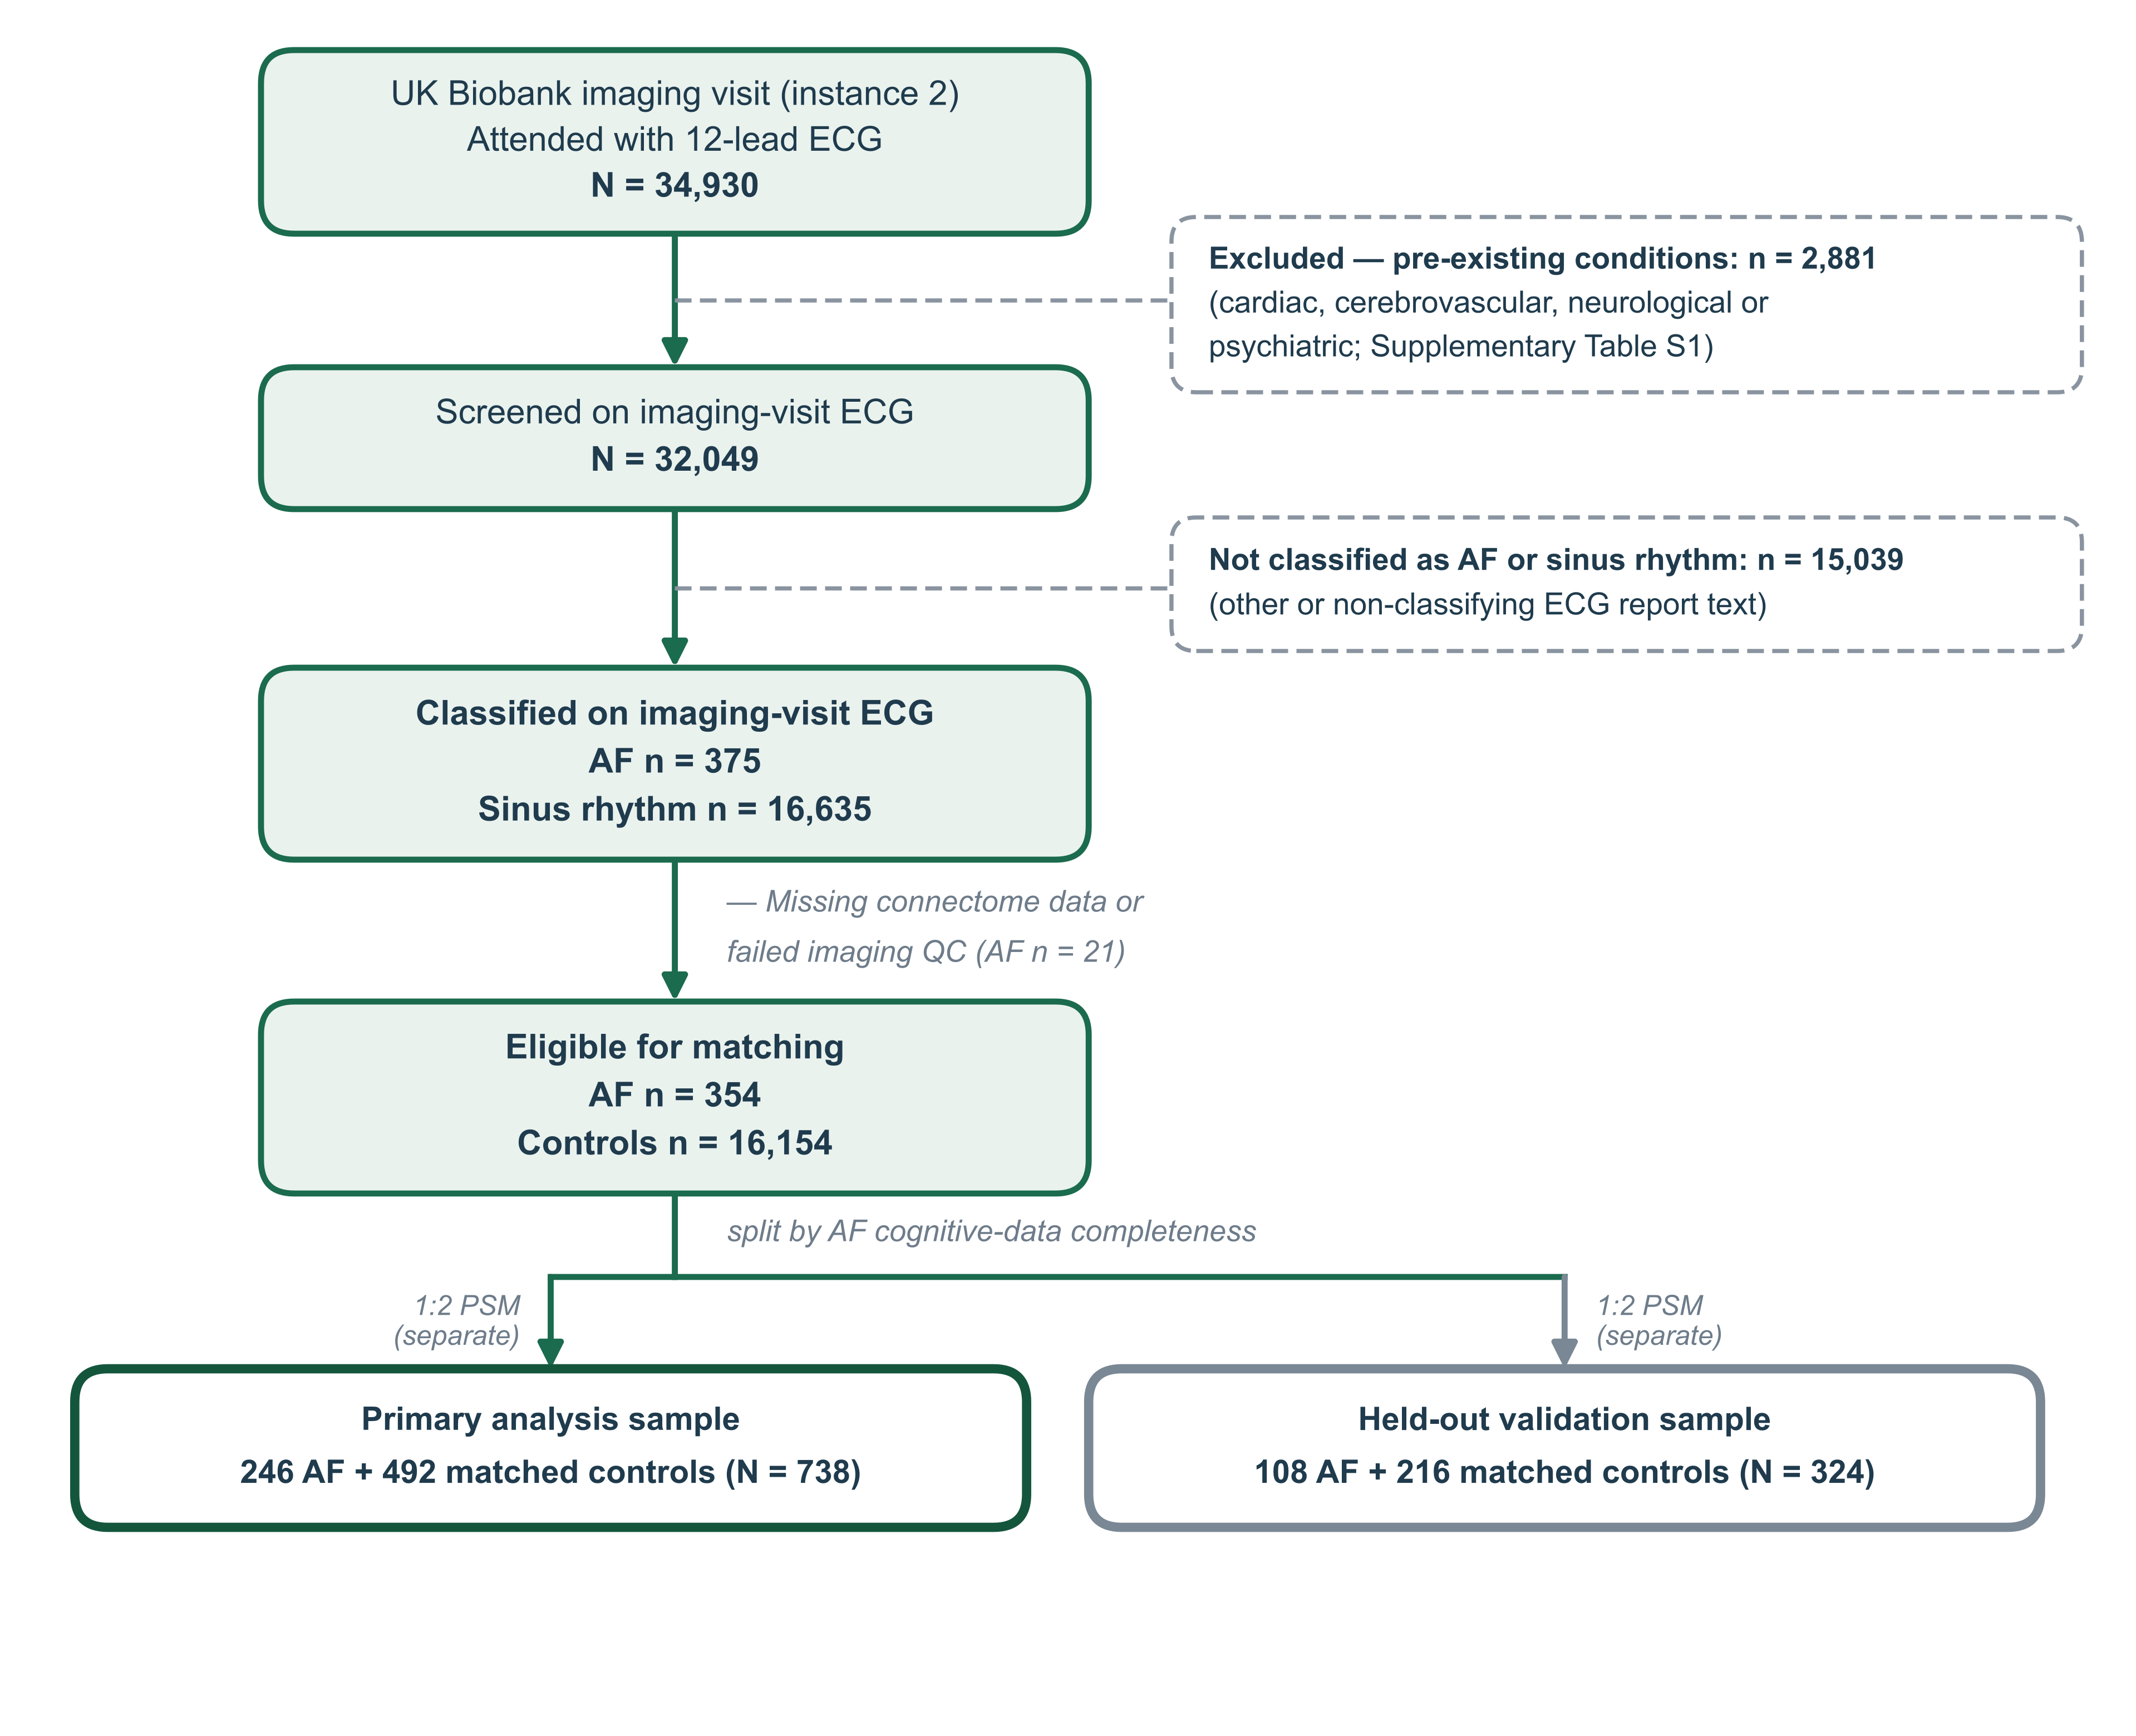

Supplementary Figure S1. Participant flow. Ascertainment of the primary and held-out analysis samples from the UK Biobank imaging cohort. AF cases and sinus-rhythm controls were classified from the imaging-visit 12-lead ECG report text. Exclusions for pre-existing conditions were applied sequentially, each participant counted once at the first criterion met; full code lists are given in Supplementary Table S1. Participants without complete connectome data or failing imaging quality control were excluded before matching. Matching was performed separately within each branch. AF, atrial fibrillation; ECG, electrocardiogram.
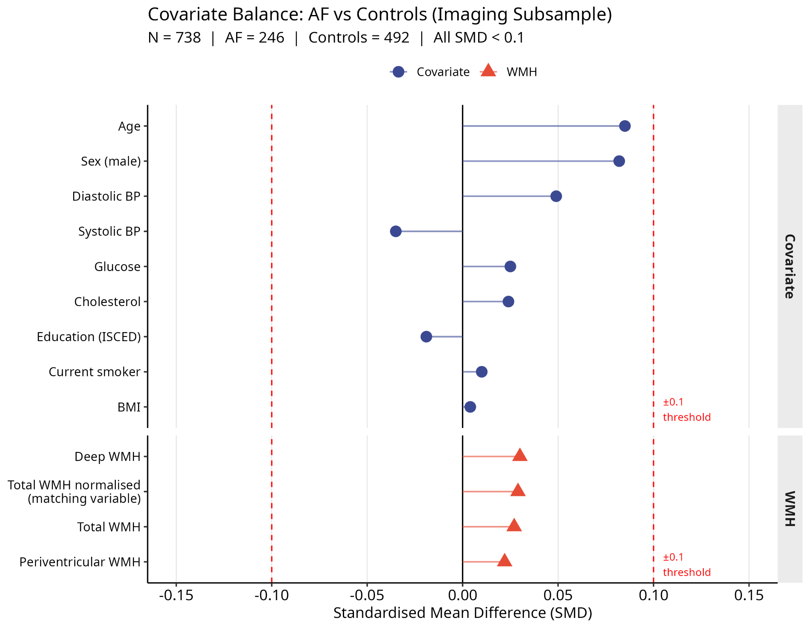

Supplementary Figure S2. Propensity score matching balance. Standardised mean differences (SMDs) for all matching covariates after 1:2 nearest-neighbour propensity score matching. Circles denote the non-WMH matching covariates (age, sex, education, BMI, systolic and diastolic blood pressure, total cholesterol, blood glucose, and current smoking status); triangles denote white matter hyperintensity (WMH) measures. TIV-normalised total WMH load was the matching variable; deep, periventricular, and unnormalised total WMH are shown for reference. Dashed lines indicate the conventional balance threshold of |SMD| < 0.10. All covariates fall well within this threshold, confirming successful balance between AF cases (n = 246) and controls (n = 492). TIV, total intracranial volume.

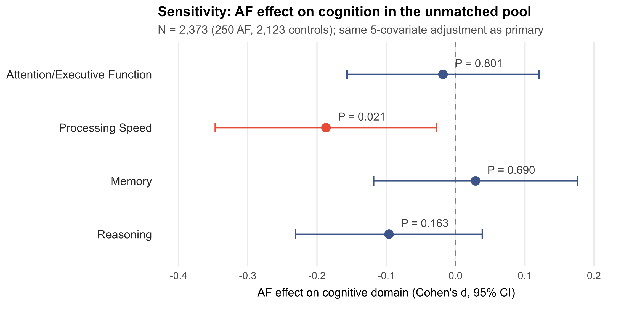
Supplementary Figure S3. Sensitivity analysis. AF effect (Cohen's d, 95% CI) on each cognitive domain in the full pool (N = 2,373; 250 AF, 2,123 controls), without propensity score matching, using the same 5-covariate adjustment as the primary analysis.
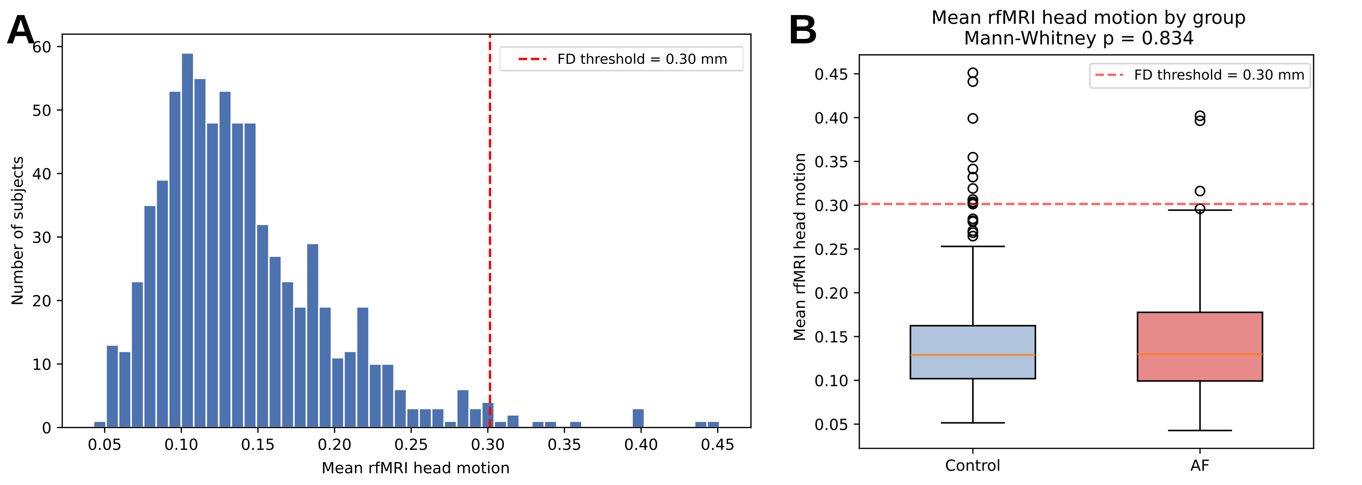
Supplementary Figure S4. Mean rfMRI head motion in the main cohort (N = 738). (A) Distribution across all participants; the 0.30 mm threshold (red dashed line) is exceeded by 14 participants (3 AF, 11 control; 1.9% of the cohort), who were retained in the main analysis and excluded in the sensitivity cohort. (B) Mean rfMRI head motion by group (AF vs Control); the groups did not differ (Mann–Whitney p = 0.83).
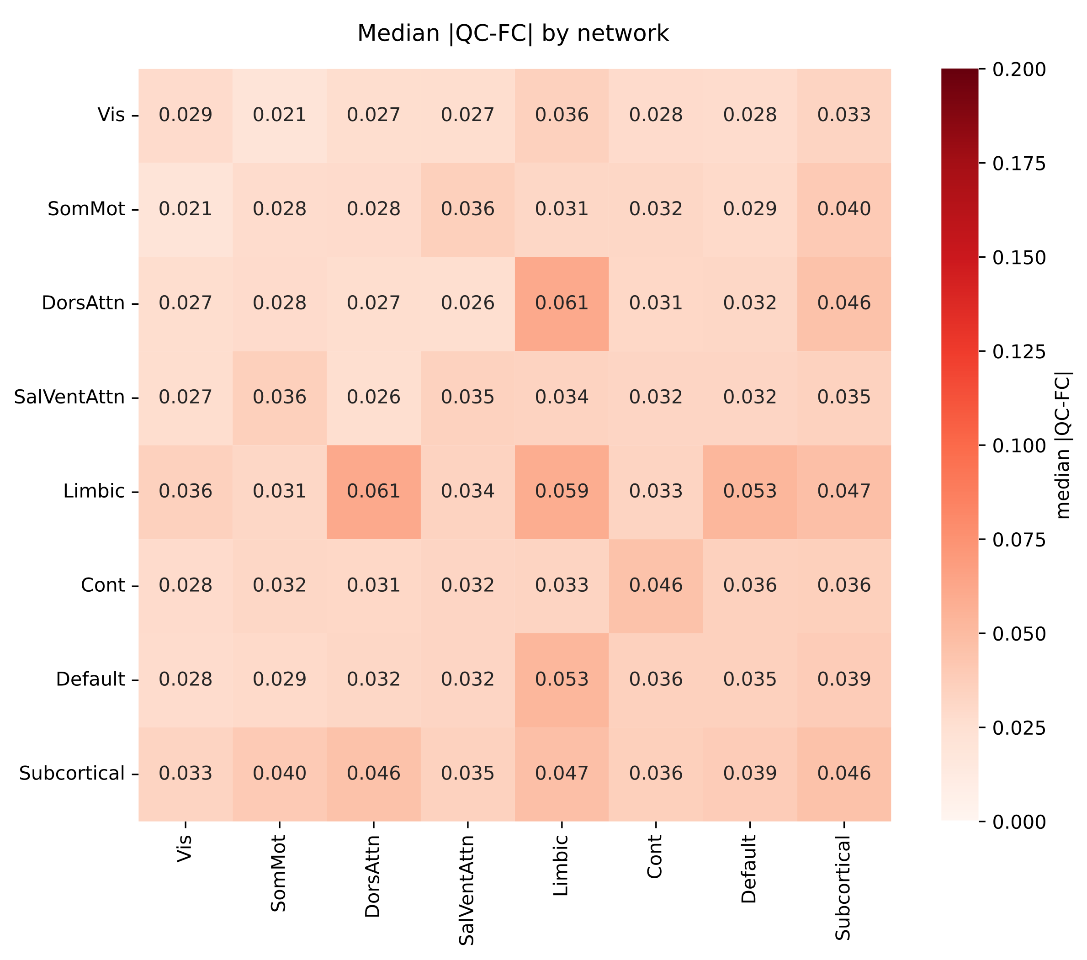
Supplementary Figure S5. Network-level motion contamination in the main cohort (N = 738). Median absolute QC–FC correlation aggregated across the seven Yeo cortical networks and the subcortical block (Tian S1). All 64 within- and between-network blocks fall well below the Parkes et al. (2018) 0.10 clean threshold (range 0.021–0.061).
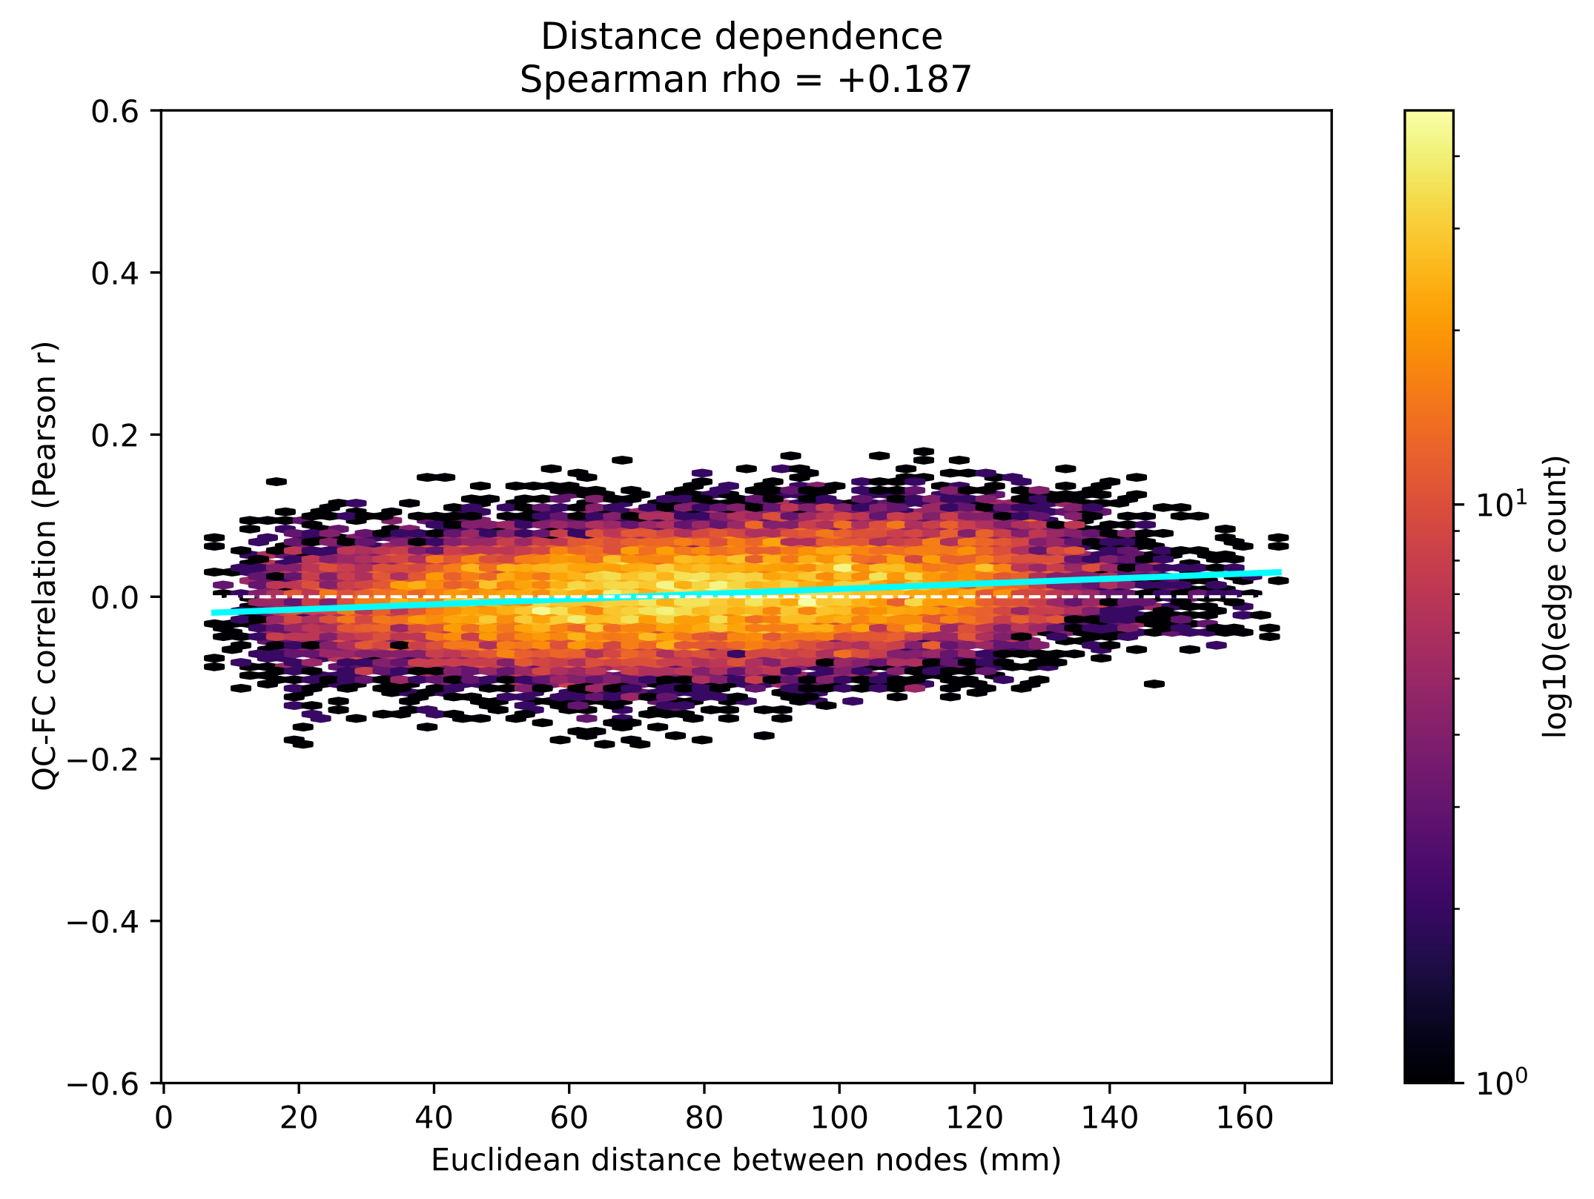
Supplementary Figure S6. Distance dependence of QC–FC in the main cohort (N = 738). Spearman ρ = +0.19 between Euclidean inter-node distance and edge-wise QC–FC. The mildly positive slope is opposite to the canonical short-range motion artefact (Power et al., 2014), indicating no residual distance-structured motion contamination.
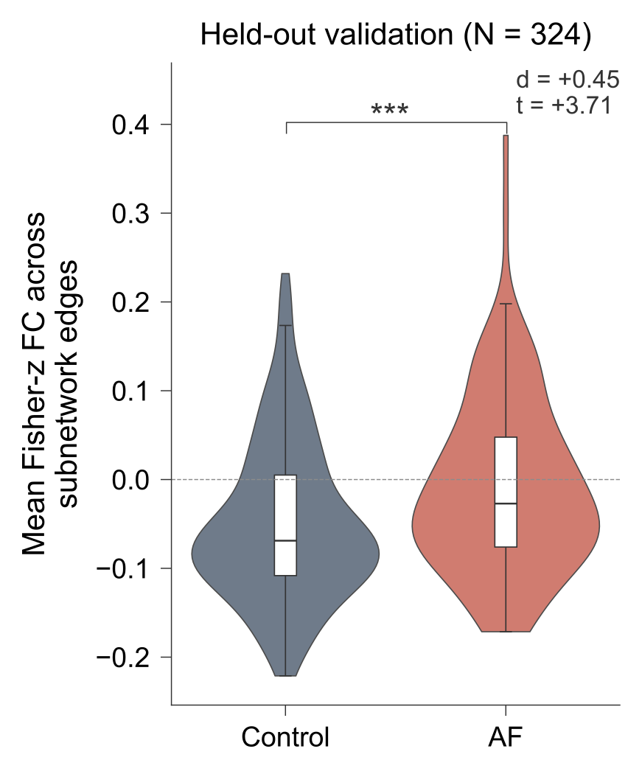
Supplementary Figure S7. Internal held-out validation of the AF > Control subnetwork. Mean Fisher-z connectivity across the 264 NBS-identified subnetwork edges (defined in the primary N = 738 cohort) in an internal held-out sample of 324 propensity-matched individuals (108 AF, 216 controls), excluded from the primary analysis because of incomplete cognitive testing and therefore not contributing to defining the subnetwork. AF participants showed significantly higher within-subnetwork connectivity than controls (β = 0.043, SE = 0.012, t = 3.71, p = 2 × 10⁻⁴; Cohen's d = 0.45), using OLS with HC3 robust standard errors and the same covariate set as the primary analysis. Violins show the full distribution; boxes show median and IQR; the dashed line marks zero. ***p < 0.001. AF, atrial fibrillation.

Supplementary Tables

Supplementary Table S1. Excluded diagnoses.
Diagnoses excluded prior to AF/control selection. Both ICD-10 (UK Biobank field 41270 / 41202) and self-reported (UK Biobank field 20002) sources were used. Participants meeting any criterion were excluded.
Category | ICD-10 codes | Self-reported codes
Stroke (any subtype) | I60, I61, I63, I64 | 1081, 1082, 1083, 1086, 1491, 1583
Transient ischaemic attack | G45 | 1082
Other cerebrovascular disease | I65, I66, I67, I68, I69 | 1086, 1583
Subarachnoid / intracerebral haemorrhage | I60, I61, I62 | 1086, 1491
Dementia (all causes) | F00, F01, F02, F03, G30 | 1263
Mild cognitive impairment | F06.7 | —
Parkinson's disease | G20 | 1262
Other extrapyramidal disease | G21–G25 | —
Multiple sclerosis | G35 | 1261
Other demyelinating disease | G36, G37 | —
Motor neuron disease | G12 | 1259
Epilepsy | G40, G41 | 1264
Migraine | G43 | 1265
Brain tumour (any) | C71, D33, D43 | 1031, 1032, 1437, 1438
Encephalitis | G04, G05 | 1247
Meningitis | G00–G03 | 1246
Traumatic brain injury | S06, S07 | 1266
Hydrocephalus | G91 | —
Schizophrenia | F20–F29 | 1289
Bipolar disorder | F30, F31 | 1291
Major depressive disorder (recurrent severe) | F33.2, F33.3 | —
Substance use disorders (other than alcohol) | F11–F19 | 1408–1411
Severe psychiatric disorders — other | F00–F09 (organic), F22–F29 | —
Cardiac arrest / sudden cardiac death | I46 | —
Severe valvular heart disease | I05–I08, I34–I39 | 1490, 1586, 1587
Cardiomyopathy (severe) | I42, I43 | 1079
Implanted cardiac device (pacemaker / ICD) | Z95.0 | —
Active malignancy (within 5 years, brain-affecting) | Various C-codes | —
End-stage renal / hepatic disease | N18.5–6, K72, K74 | —
MRI contraindication / withdrawal of consent | — | —

Supplementary Table S2. Cognitive domain results across WMH model specifications.
Cohen's d is computed as (AF − controls)/pooled SD, the same direction used for all imaging contrasts (positive β = higher in AF). All cognitive measures are oriented so that higher scores indicate better performance; negative d therefore indicates poorer performance in AF. Confidence intervals for d are large-sample approximations based on group sizes and are unadjusted for multiplicity.

Model A. log(1+x)-transformed Deep WMH.
Domain | Cohen's d | 95% CI | p (raw) | p_FDR
Processing speed | −0.21 | [−0.36, −0.06] | 0.008 | 0.032
Attention / executive function | +0.02 | [−0.13, +0.17] | 0.805 | 0.969
Memory | 0.00 | [−0.15, +0.15] | 0.969 | 0.969
Reasoning | −0.06 | [−0.21, +0.09] | 0.444 | 0.888

Model B. log(1+x)-transformed Periventricular WMH.
Domain | Cohen's d | 95% CI | p (raw) | p_FDR
Processing speed | −0.21 | [−0.36, −0.06] | 0.008 | 0.031
Attention / executive function | +0.02 | [−0.13, +0.17] | 0.822 | 0.982
Memory | 0.00 | [−0.15, +0.15] | 0.982 | 0.982
Reasoning | −0.06 | [−0.21, +0.09] | 0.445 | 0.889

Model C. log(1+x)-transformed Periventricular + Deep WMH (entered simultaneously).
Domain | Cohen's d | 95% CI | p (raw) | p_FDR
Processing speed | −0.21 | [−0.36, −0.06] | 0.008 | 0.032
Attention / executive function | +0.02 | [−0.13, +0.17] | 0.815 | 0.986
Memory | 0.00 | [−0.15, +0.15] | 0.986 | 0.986
Reasoning | −0.06 | [−0.21, +0.09] | 0.453 | 0.905

Supplementary Table S3. Individual cognitive test results.
Adjusted Cohen's d, raw p-values, and FDR-corrected p-values (across 10 tests) for individual cognitive tasks, using the same five-covariate adjustment set as Table 3 (age, sex, education, diastolic BP, log-transformed total WMH). Time-based measures (Trail Making, Reaction Time) were sign-reversed so that higher z-scores indicate better performance. Cohen's d is computed as (AF − controls)/pooled SD, the same direction used for all imaging contrasts (positive β = higher in AF); negative d therefore indicates poorer performance in AF.
Test | Domain | Cohen's d | p (raw) | p_FDR
Reaction Time | Processing speed | −0.06 | 0.415 | 0.898
Symbol Digit Substitution | Processing speed | −0.08 | 0.294 | 0.898
Trail Making Test A | Processing speed | −0.21 | 0.007 | 0.068
Tower Rearranging | Attention / exec. | −0.04 | 0.609 | 0.898
Trail Making Test B | Attention / exec. | +0.07 | 0.389 | 0.898
Numeric Memory | Memory | −0.01 | 0.882 | 0.955
Paired Associate Learning | Memory | +0.01 | 0.947 | 0.955
Prospective Memory | Memory | 0.00 | 0.955 | 0.955
Fluid Intelligence | Reasoning | −0.06 | 0.480 | 0.898
Matrix Pattern Completion | Reasoning | −0.04 | 0.628 | 0.898

Supplementary Table S4. Magnitude of AF > Control connectivity: within versus outside the NBS subnetwork.
Mean Fisher-z connectivity across edges in each set, computed for each subject. Group differences shown both unadjusted (Cohen's d, Mann–Whitney) and after OLS adjustment for age, sex, education, diastolic blood pressure, log-total-WMH, and mean framewise displacement. The AF > Control effect is present across the connectome and larger within the identified subnetwork. A per-edge specificity test in the held-out sample is reported in the main text.

Edge set | N edges | AF median | Control median | Cohen’s d | MW p | AF β (adj.) | t (adj.) | p (adj.)
Within subnetwork | 264 | 0.0223 | −0.0794 | +1.27 | 3 × 10⁻⁴³ | +0.104 | +16.28 | 5 × 10⁻⁵¹
Outside subnetwork | 22,956 | 0.0444 | 0.0310 | +0.79 | 8 × 10⁻¹⁹ | +0.018 | +10.04 | 3 × 10⁻²²

Supplementary Table S5a. Functional NBS subnetwork sensitivity to WMH specification.
Primary t-threshold | WMH specification | Edges | p_FWER
4.5 | Total WMH (primary) | 264 | 0.0002
4.5 | Periventricular WMH | 264 | 0.0002
4.5 | Deep WMH | 262 | 0.0002
5.0 | Total WMH (primary) | 100 | 0.0002
5.0 | Periventricular WMH | 100 | 0.0002
5.0 | Deep WMH | 100 | 0.0002
5.5 | Total WMH (primary) | 34 | 0.0002
5.5 | Periventricular WMH | 34 | 0.0002
5.5 | Deep WMH | 34 | 0.0002
6.0 | Total WMH (primary) | 6 | 0.0002
6.0 | Periventricular WMH | 6 | 0.0002
6.0 | Deep WMH | 4 | 0.0002

Functional NBS analyses for the AF > Control contrast repeated under alternative WMH covariate specifications, across the four primary thresholds (t = 4.5, 5.0, 5.5, 6.0). All other covariates (age, sex, education, diastolic BP, mean framewise displacement) held constant.
Supplementary Table S5b. Stability of the AF > Control subnetwork across primary thresholds.

Comparison | Edge Jaccard | Edge containment | Node Jaccard | Hub-rank ρ
t = 4.5 vs 5.0 | 0.38 | 1.00 | 0.50 | +0.93
t = 4.5 vs 5.5 | 0.13 | 1.00 | 0.24 | +0.82
t = 4.5 vs 6.0 | 0.02 | 1.00 | 0.06 | +0.68

Overlap between the component identified at the primary threshold (t = 4.5) and those at higher thresholds. Jaccard = |A ∩ B| / |A ∪ B|; containment = |A ∩ B| / min(|A|,|B|), where 1.00 indicates that the smaller component is entirely nested within the larger. Hub-rank ρ is the Spearman correlation of eigenvector-centrality ranks across nodes shared between solutions. Jaccard values decline at higher thresholds as an arithmetic consequence of the disparity in component size, not of topological reorganisation: containment is 1.00 at every comparison, indicating strictly nested components. The t = 4.5 vs 6.0 hub-rank correlation is based on 7 shared nodes (p = 0.094).

Supplementary Table S6. Functional NBS subnetwork sensitivity to high-motion exclusion.
Functional NBS analyses for the AF > Control contrast in the main cohort (N = 738) and in a sensitivity cohort excluding participants with mean rfMRI head motion (UK Biobank Field 25741) > 0.30 mm (n = 14 excluded; N = 724). All other covariates (age, sex, education, diastolic BP, log-transformed total WMH, mean rfMRI head motion) and the primary t-threshold range were held constant. The AF > Control subnetwork remained significant at every primary threshold tested, with subnetwork size at the primary t = 4.5 threshold reduced by less than 5% (264 → 251 edges) following high-motion exclusion.

Primary t-threshold | Cohort | Edges | p_FWER
4.5 | Main (N = 738) | 264 | 0.0002
4.5 | Sensitivity (N = 724) | 251 | 0.0002
5.0 | Main (N = 738) | 100 | 0.0002
5.0 | Sensitivity (N = 724) | 100 | 0.0002
5.5 | Main (N = 738) | 34 | 0.0002
5.5 | Sensitivity (N = 724) | 33 | 0.001
6.0 | Main (N = 738) | 6 | 0.0002
6.0 | Sensitivity (N = 724) | 5 | 0.0002

Supplementary Table S7. Edge-wise QC–FC summary across cohorts.
Edge-wise QC–FC analysis using the 216-node connectivity matrices. Mean rfMRI head motion was used from UK Biobank Field 25741. Median |QC–FC| and 95th percentile fall well below the Parkes et al. (2018) clean benchmarks (< 0.10 and < 0.20 respectively). Distance dependence is mildly positive, opposite in direction to the canonical short-range motion artefact described by Power et al. (2014), indicating no residual distance-structured motion contamination.
Cohort | N | Median |QC–FC| | 95th pct |QC–FC| | Prop p<0.05 | Median signed QC-FC | Distance ρ
Main | 738 | 0.032 | 0.096 | 0.136 | +0.003 | +0.187
Sensitivity | 724 | 0.029 | 0.085 | 0.093 | +0.001 | +0.153

Supplementary Table S8. Small Control > AF subnetwork (primary threshold t = 4.5).
Edges comprising the small Control > AF subnetwork identified at the primary threshold t = 4.5 (4 nodes, 3 edges; p_FWER = 0.005). The subnetwork did not survive at higher thresholds (t ≥ 5.0) and was not pursued in subsequent analyses; it is reported here for completeness.

Edge | Region 1 | Region 2 | t-value
1 | 7Networks_LH_SomMot_6 | aTHA-lh | 4.72
2 | 7Networks_RH_SomMot_7 | aTHA-lh | 4.72
3 | 7Networks_RH_SomMot_19 | aTHA-lh | 4.57

Supplementary Table S9. Top 30 hub nodes of the NBS-identified functional hyperconnectivity subnetwork.
Nodes ranked by weighted eigenvector centrality (EC), computed using absolute t-statistics as edge weights (see Methods, "Functional NBS and hub analysis"). Anatomical labels assigned via Harvard-Oxford atlas spatial overlap. Network = Schaefer/Tian network assignment.
Rank | Node label | Hemisphere | Network | EC
1 | Anterior insular cortex | R | Frontoparietal Control | 0.323
2 | Middle frontal gyrus (dlPFC) | R | Frontoparietal Control | 0.283
3 | Heschl's gyrus (primary auditory) | R | Somatomotor | 0.263
4 | Middle frontal gyrus (dlPFC) | R | Frontoparietal Control | 0.255
5 | Parietal opercular cortex | R | Somatomotor | 0.238
6 | Precuneus cortex | R | Frontoparietal Control | 0.230
7 | Planum temporale | L | Somatomotor | 0.213
8 | Paracingulate gyrus | R | Frontoparietal Control | 0.212
9 | Central opercular cortex | L | Somatomotor | 0.199
10 | Planum polare | L | Somatomotor | 0.198
11 | Cingulate Gyrus, posterior division | R | Frontoparietal Control | 0.193
12 | Insular Cortex | L | Salience/Ventral Attn | 0.186
13 | Putamen | L | Subcortical | 0.166
14 | Superior Frontal Gyrus | L | Default Mode | 0.160
15 | Insular Cortex | R | Somatomotor | 0.148
16 | Cingulate Gyrus, anterior division | L | Salience/Ventral Attn | 0.146
17 | Frontal Opercular Cortex | R | Salience/Ventral Attn | 0.145
18 | Cingulate Gyrus, anterior division | R | Salience/Ventral Attn | 0.142
19 | Precuneous Cortex | L | Frontoparietal Control | 0.139
20 | Cingulate Gyrus, anterior division | L | Default Mode | 0.114
21 | Paracingulate Gyrus | L | Default Mode | 0.109
22 | Superior Frontal Gyrus | R | Frontoparietal Control | 0.103
23 | Frontal Orbital Cortex | L | Default Mode | 0.089
24 | Inferior Frontal Gyrus, pars triangularis | R | Default Mode | 0.088
25 | Inferior Frontal Gyrus, pars opercularis | R | Dorsal Attention | 0.086
26 | Parahippocampal Gyrus, posterior division | R | Visual | 0.086
27 | Middle Frontal Gyrus | L | Frontoparietal Control | 0.086
28 | Cingulate Gyrus, posterior division | R | Somatomotor | 0.083
29 | Supramarginal Gyrus, anterior division | R | Salience/Ventral Attn | 0.080
30 | Supramarginal Gyrus, posterior division | L | Salience/Ventral Attn | 0.072

Supplementary Table S10. System segregation and participation: sensitivity to WMH specification.
Between-group differences (AF vs Controls) in whole-brain system segregation and mean participation coefficient, for the functional (FC) and structural (SC) connectomes, under each of the three alternative WMH specifications. Each metric was z-scored, so β is the AF effect in SD units (matching the main text). Models adjusted for age, sex, education, diastolic BP, mean framewise displacement (functional only), and the indicated WMH covariate; HC3 robust SEs. FDR correction applied across the two measures within each modality separately, within each WMH specification. Full matched sample (N = 738). The functional dedifferentiation effect (reduced segregation, increased participation) and the structural null are both stable across all three specifications.

Modality | Measure | WMH specification | β (SD) | SE | t | Cohen's d | p_FDR
FC | System segregation | Deep WMH | −0.522 | 0.079 | −6.62 | −0.55 | < 0.001
FC | System segregation | Periventricular WMH | −0.520 | 0.079 | −6.61 | −0.55 | < 0.001
FC | System segregation | Peri + Deep | −0.528 | 0.079 | −6.67 | −0.56 | < 0.001
FC | Participation coefficient | Deep WMH | 0.495 | 0.076 | 6.49 | 0.52 | < 0.001
FC | Participation coefficient | Periventricular WMH | 0.491 | 0.076 | 6.44 | 0.51 | < 0.001
FC | Participation coefficient | Peri + Deep | 0.497 | 0.077 | 6.47 | 0.52 | < 0.001
SC | System segregation | Deep WMH | 0.012 | 0.073 | 0.17 | 0.01 | 0.865
SC | System segregation | Periventricular WMH | −0.012 | 0.070 | −0.17 | −0.01 | 0.865
SC | System segregation | Peri + Deep | −0.028 | 0.070 | −0.40 | −0.03 | 0.817
SC | Participation coefficient | Deep WMH | −0.058 | 0.074 | −0.79 | −0.06 | 0.864
SC | Participation coefficient | Periventricular WMH | −0.022 | 0.071 | −0.31 | −0.02 | 0.865
SC | Participation coefficient | Peri + Deep | −0.017 | 0.071 | −0.23 | −0.02 | 0.817

Supplementary Table S11. Brain–behaviour interaction sensitivity to WMH specification.
WMH specification | Interaction model | β | SE | t | p
Total WMH (primary) | FC Deviation × AF | 0.914 | 0.337 | 2.71 | 0.007
Periventricular WMH | FC Deviation × AF | 0.909 | 0.337 | 2.69 | 0.007
Deep WMH | FC Deviation × AF | 0.933 | 0.339 | 2.75 | 0.006
Peri + Deep | FC Deviation × AF | 0.918 | 0.339 | 2.71 | 0.007
Total WMH (primary) | System segregation × AF | −0.045 | 0.065 | −0.69 | 0.487
Periventricular WMH | System segregation × AF | −0.045 | 0.065 | −0.69 | 0.491
Deep WMH | System segregation × AF | −0.045 | 0.065 | −0.69 | 0.489
Peri + Deep | System segregation × AF | −0.045 | 0.065 | −0.69 | 0.488
Total WMH (primary) | Participation × AF | 0.002 | 0.065 | 0.03 | 0.978
Periventricular WMH | Participation × AF | 0.001 | 0.065 | 0.02 | 0.983
Deep WMH | Participation × AF | 0.002 | 0.065 | 0.04 | 0.971
Peri + Deep | Participation × AF | 0.002 | 0.065 | 0.03 | 0.978

Interaction models predicting processing speed, repeated under total WMH (primary) and three WMH subtype specifications: (i) the primary FC deviation × AF interaction; (ii) system segregation × AF; and (iii) participation × AF, testing whether whole-brain dedifferentiation measures moderate the effect. Models adjusted for age, sex, education, diastolic BP, mean framewise displacement, and the indicated WMH covariate; HC3 robust standard errors (N = 738). The FC deviation × AF interaction is robust across all specifications, whereas neither system segregation nor participation interacts with AF, confirming specificity to subnetwork connectivity magnitude.

Supplementary Table S12. Hierarchical regression: WMH specification sensitivity and within-group results.
Hierarchical regression predicting processing speed. The upper panel repeats the analysis in the full matched sample (N = 738) under each WMH specification; the lower panel repeats it separately within AF patients and controls, using total WMH. Baseline model includes age, sex, education, mean framewise displacement, diastolic blood pressure, and the indicated WMH covariate. Step 2 adds the functional deviation score. ΔR² is the change in adjusted R² on adding the functional deviation score and is an in-sample estimate; leakage-controlled out-of-fold estimates are given in Supplementary Table S13.
Model | Baseline R² | Full R² | ΔR² | p
Full matched sample (N = 738)
Total WMH (primary) | 0.215 | 0.214 | −0.001 | 0.781
Periventricular WMH | 0.214 | 0.213 | −0.001 | 0.779
Deep WMH | 0.213 | 0.212 | −0.001 | 0.794
Peri + Deep | 0.213 | 0.212 | −0.001 | 0.779
By group (total WMH)
AF patients (n = 246) | 0.254 | 0.272 | +0.018 | 0.009
Controls (n = 492) | 0.198 | 0.202 | +0.004 | 0.075

Supplementary Table S13. Fully nested cross-validation of the connectivity–processing speed association.
Out-of-fold results from a fully nested cross-validation in which edge selection (t = 4.5, largest connected component), per-edge normative modelling in training controls only, and outcome modelling were all refitted within each training fold, with no test data used at any stage. Values are medians across 100 repeats of 10-fold cross-validation stratified by AF status. Baseline covariates: age, sex, education, mean framewise displacement, log total WMH, and diastolic blood pressure. Significance was assessed by repeating the complete nested procedure with the outcome permuted within group (1,000 permutations); the permuted-outcome median increment was −0.005 (within AF) and −0.003 (interaction model). The reported interval is the 2.5th–97.5th percentile of ΔR²_cv across repeats and reflects variability across fold splits rather than sampling uncertainty. Mean fold-specific mask size was 208 edges; fold-mask stability was median pairwise Dice = 0.63 (minimum 0.55).
Model | Population | R²_cv baseline | R²_cv augmented | Median ΔR²_cv | 2.5–97.5th pctile | Permutation p
Baseline + deviation score | AF (n = 246) | +0.218 | +0.231 | +0.013 | −0.001 to +0.023 | 0.024
Baseline + score + score × AF | Full sample (N = 738) | +0.205 | +0.209 | +0.005 | −0.002 to +0.009 | 0.025

Supplementary Table S14. Structure–function moderation within AF patients only.
Two exploratory moderation models testing whether structural network organisation modulates the FC deviation → processing speed relationship within the AF group (n = 246), following the Gabusi et al. (2022) approach. Predictors z-scored; models adjusted for age, sex, education, log total WMH, diastolic BP, and mean framewise displacement; HC3 robust SEs. Neither structural system segregation nor structural participation moderated the effect, indicating that the within-AF magnitude–speed association does not depend on structural network organisation.

Model 1. FC deviation × structural system segregation.
Predictor | β | SE | t | p
FC deviation | 0.161 | 0.073 | 2.19 | 0.029
Structural system segregation (z) | 0.035 | 0.072 | 0.49 | 0.626
FC deviation × structural system segregation | −0.048 | 0.060 | −0.81 | 0.421

Model 2. FC deviation × structural participation.
Predictor | β | SE | t | p
FC deviation | 0.147 | 0.069 | 2.13 | 0.034
Structural participation (z) | 0.018 | 0.069 | 0.26 | 0.794
FC deviation × structural participation | −0.032 | 0.057 | −0.57 | 0.571

Motion-related Quality Control
To ensure that the reported functional connectivity findings were not driven by residual head motion, we conducted five complementary motion-related quality control analyses on the 216-node connectivity matrices used in the primary analysis (Schaefer 200 + Tian S1 16, global signal regression applied). Mean rfMRI head motion was operationalised throughout as UK Biobank Field 25741 ("Mean rfMRI head motion, averaged across space and time points"). Analyses were performed in the main cohort (N = 738) and repeated in a sensitivity cohort excluding participants with mean rfMRI head motion > 0.30 mm (n = 14 excluded; N = 724).
(i) Group rfMRI head motion. AF participants and matched controls did not differ in mean rfMRI head motion in either cohort (main: AF median = 0.130 mm, Control median = 0.129 mm, Mann–Whitney p = 0.83; sensitivity: AF median = 0.128 mm, Control median = 0.128 mm, Mann–Whitney p = 0.97; Supplementary Figure S4). The 14 participants exceeding the 0.30 mm threshold (3 AF, 11 control; top 1.9% of the cohort) were retained in the main analysis and excluded in the sensitivity cohort.
(ii) Edge-wise QC–FC. For each of the 23,220 upper-triangular edges, the Pearson correlation between edge weight and subject-level mean rfMRI head motion was computed. In the main cohort, median |QC–FC| was 0.032 (Parkes 2018 clean threshold < 0.10), the 95th percentile was 0.096 (Parkes threshold < 0.20), the proportion of edges with p < 0.05 was 0.136, and the median signed QC–FC was +0.003 (Supplementary Table S7). All metrics improved marginally in the sensitivity cohort (median |QC–FC| = 0.029, 95th percentile = 0.085, prop p<0.05 = 0.093), indicating that the 14 high-motion participants did not bias edge-level connectivity.
(iii) Network-level motion contamination. Median |QC–FC| was aggregated across the seven Yeo cortical networks and the subcortical block (Supplementary Figure S5). All 64 within- and between-network blocks fell well below the 0.10 threshold (range 0.021–0.061). Mildly elevated values were concentrated in the Limbic network (OFC, temporal pole — regions of known susceptibility-induced signal dropout) and subcortical block (proximal to ventricles and major arteries), consistent with expected MR physics rather than motion-related contamination.
(iv) Distance dependence. The Spearman correlation between Euclidean inter-node distance and edge-wise QC–FC was +0.19 in the main cohort and +0.15 in the sensitivity cohort (Supplementary Figure S6). The direction is opposite to the canonical short-range motion artefact described by Power et al. (2014), in which motion inflates short-range connectivity and yields a negative distance–QC–FC slope. The absence of that signature indicates no residual distance-structured motion contamination. Benchmarking studies report global signal regression to increase, rather than reverse, negative distance dependence (Ciric et al., 2017; Parkes et al., 2018), so the positive slope observed here is reported descriptively and is not attributed to a specific denoising step.
(v) NBS sensitivity to high-motion exclusion. All NBS analyses were repeated in the sensitivity cohort (N = 724). The AF > Control hyperconnectivity subnetwork remained significant at every primary threshold tested, with subnetwork size at the primary t = 4.5 threshold reduced by less than 2% (114 → 112 nodes) and less than 5% (264 → 251 edges) compared to the main cohort; edge counts across thresholds are reported in Supplementary Table S6, confirming that the reported network-level findings are not attributable to the 14 high-motion participants.

References
Ciric R, Wolf DH, Power JD, Roalf DR, Baum GL, Ruparel K, Shinohara RT, Elliott MA, Eickhoff SB, Davatzikos C, Gur RC, Gur RE, Bassett DS, Satterthwaite TD (2017): Benchmarking of participant-level confound regression strategies for the control of motion artifact in studies of functional connectivity. NeuroImage 154:174–187.
Gabusi I, Pontillo G, Petracca M, Battocchio M, Bosticardo S, Costabile T, Daducci A, Pane C, Riccio E, Pisani A, Brunetti A, Schiavi S, Cocozza S (2022): Structural disconnection and functional reorganization in Fabry disease: a multimodal MRI study. Brain Commun 4:fcac187.
Parkes L, Fulcher B, Yücel M, Fornito A (2018): An evaluation of the efficacy, reliability, and sensitivity of motion correction strategies for resting-state functional MRI. NeuroImage 171:415–436.
Power JD, Mitra A, Laumann TO, Snyder AZ, Schlaggar BL, Petersen SE (2014): Methods to detect, characterize, and remove motion artifact in resting state fMRI. NeuroImage 84:320–341.

