Supplementary Material

Unusual removal of T-DNA in T₁ progenies of rice after Agrobacterium-mediated CRISPR/Cas9 editing

Yang Qin^{1, 2}, Tae-Sung Park¹, Bumkyu Lee², Myung-Ho Lim¹*

¹Biosafety Division, National Academy of Agricultural Science, Rural Development Administration, Jeonju 54874, Korea
²Department of Environmental Science & Biotechnology, Medical Science, Jeonju University, Jeonju 55069, Republic of Korea

*Corresponding author
Myung-Ho Lim
E-mail: mhlim312@korea.kr, Tel: +82-63-238-4705

Materials and methods
In vitro DNA cleavage assay of sgRNAs
Transcribed sgRNA was synthesized using a Guide-it sgRNA In vitro Transcription Kit (Takara Bio. Inc., Shiga, Japan). In brief, sgRNA template was respectively amplified by using 10 pm of specific primer (Supplementary Table S2) followed the manual description. The sgRNA transcription reaction was performed for 4h at 37℃ with a total of 20 µl reaction buffer, including 5 µl of sgRNA template, 7 µl of in vitro transcription buffer, 3 µl of T7 polymerase mix and 5 µl of RNase free water. The synthesized sgRNA were purified using Guide-it IVT RNA clean-up kit (Takara Bio. Inc., Shiga, Japan) and confirmed sgRNA concentrations with 500 ng/µl by Nano Drop spectrophotometer. After then, three target DNAs including bar expression cassette (1,692bp), rbc promoter (1,613bp) and mcry1Ac1 gene (1,857bp) were respectively amplified from plasmid DNA (PZRT3) by using primers listed in Supplementary Table S2. In vitro cleavage was performed according to the Guide-it sgRNA Screening kit (Takara Bio. Inc., Shiga, Japan). A total of 15 µl of reaction mix containing 250 ng of Guide-it Recombinant Cas9 Nuclease (Takara Bio. Inc., Shiga, Japan), 500 ng of synthesized sgRNA, 200 ng of linear target DNA, 15ⅹ cas9 reaction buffer, and 15ⅹ BSA were prepared. After 1hr incubation at 37℃, the reaction was stopped by incubating for 5min at 80℃, followed separation of reaction buffers on 2% agarose gel, respectively.
PCR analysis for genomic DNA deletion and genotype confirmation
Primer sets 10,688,843-F/10,689,431-R and 10,688,640-F2/10,689,620-R2 were respectively designed to confirm genomic DNA deletion on chromosome 4 and genotype segregations of T₁ population. Furthermore, a 5′-UTR of a TE-related gene Os04g19250 was contained in the deletion region. To prove this deletion, we design a primer set Os04g19250-F/Os04g19250-R, as shown on Supplementary Table S6.
Off-target analysis
Cas-OFFinder (www.rgenome.net/cas-offinder/) was carried out to identify potential off-target sites of selected sgRNAs with 5′-NGG-3′ PAM type in target Oryza sative rice genome. The parameters setting provides three options including 1 to 3 (allowing up to nine mismatches) of mismatch nucleotides and 0 to 2 of DNA or RNA bulge size. The detected potential off-target sites based on 1 or 2 of mismatch and 0 to 2 of DNA/RNA bulge size were extracted to search potential off-target sites in the whole genome. Furthermore, off-target sites involved in functional elements of genes containing exon, intron, 5′-UTR and 3′-UTR were identified based on rice database (ensemble.gramene.org/Oryza_Sativa/Location/Genome). In addition, eight potential off-target sites were further analyzed by using WGS data, which were created from four materials including CRISPR-Cas9 mediated editing rice T₁ lines 130-4-36 and 130-4-42, their recipient transgenic rice line BT-T07, and their donor variety Dongjin. Eight gene sequences were extracted from Oryza Sativa japonica variety Nipponbare and defined to mapping references. After then, ‘De novo assembly’ for all four lines were performed, and the output tracks were mapped to eight gene references on CLC genomic workbench platform. Sequence alignment of each gene was compared to identify nucleotide mutations potentially mediated by CRISPR-cas9 editing.

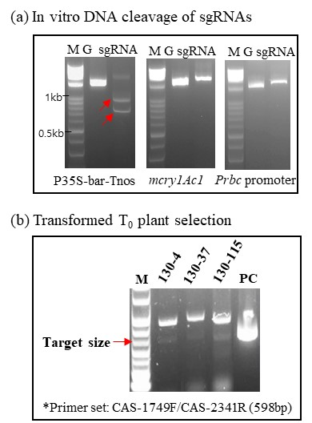
Supplementary Fig.1 (a) In vitro DNA cleavage efficiency test for sgRNA targeting on bar by using three DNA fragments amplified from pre-existing vector (pZRT3) including a bar expression cassette P35S::bar::Tnos, a Bt-resistant gene mcry1Ac1 and its expression promoter Prbc promoter; (b) PCR-based CRISPR/Cas9 editing vector transformed rice plants selections by using a Cas9-specific primer set of CAS-1749F/CAS-2341R with a predicted size of 598bp.

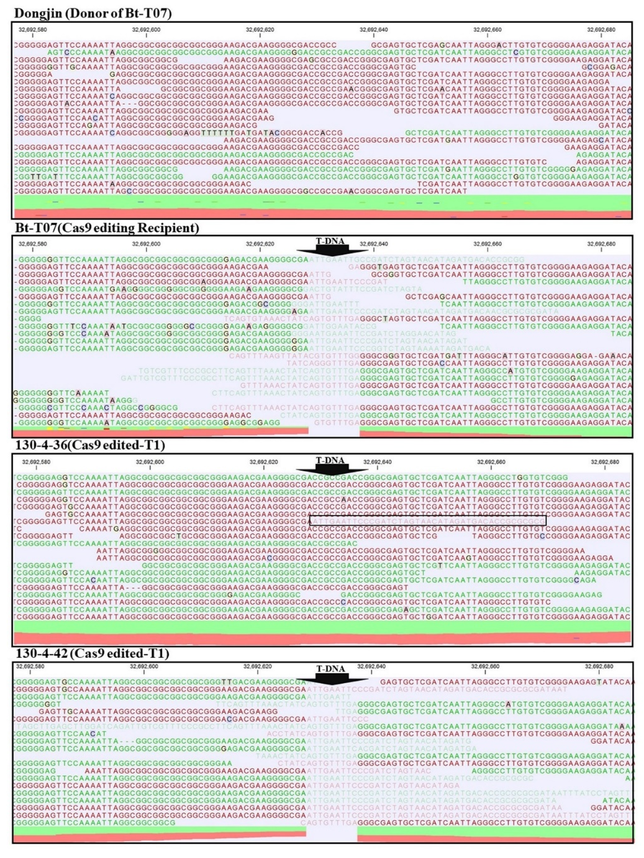
Supplementary Fig.2 The chromosome view of pre-existing T-DNA integration sites on rice chromosome 4, by reference mapping of two T1 plants 130-4-36 and 130-4-42, their recipient line BT-T07 and their donor rice variety Dongjin. The black box indicates a T-DNA sequence observed on 130-4-36 line.

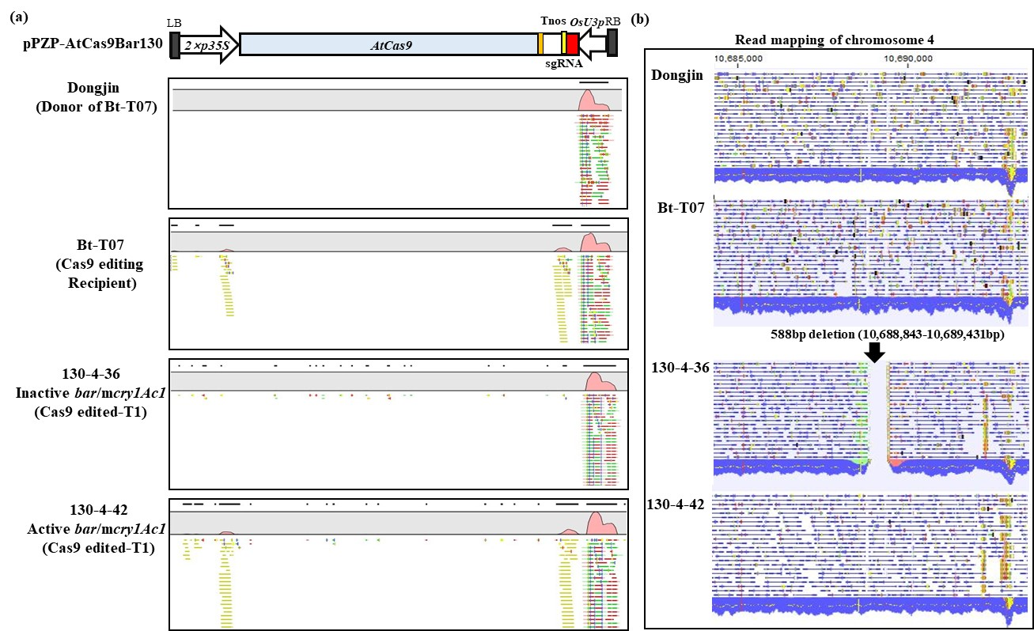
Supplementary Fig.3 (a) CRISPR/Cas9 editing vector (pPZP-AtCas9Bar130)-based reference mapping for two T1 plants 130-4-36 (inactive bar/cry1ac expression) and 130-4-42 (active bar/mcry1Ac1 expression), their recipient line BT-T07 and their donor rice line Dongjin; (b) An addition 588-nt sequence deletion at 10,688,843-10,689,431bp on chromosome 4 of 130-4-36, comparing to the other three lines.

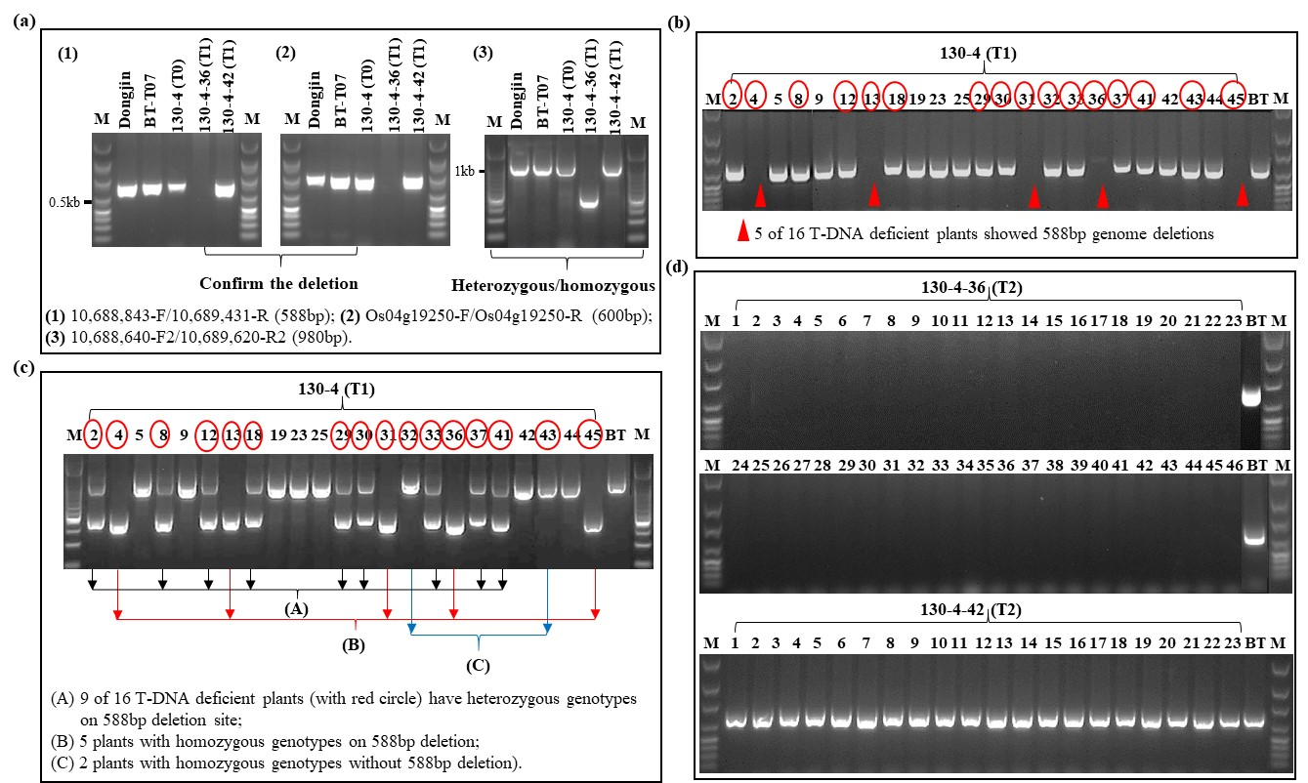
Supplementary Fig.4 (a) PCR confirmation for the additional 588bp deletion of T1 plant 130-4-36 and genotypes by using three primer set (1), (2) and (3); (b) PCR analysis to confirm the deletion for all of 23 T1 plants by using primer set (1); The line number with red circles indicated they were bar-knockout lines; Red triangle indicated the lines with 588bp deletion; (c) PCR analysis to confirm homozygous or heterozygous genotypes of the deletion by using primer set (3); (d) PCR analysis to confirm the 588bp deletions for all of T2 plants from both T1 plants 130-4-36 and 130-4-42.

Supplementary Table S1 Primers information for vector construction
Primer name | Primer sequence (5′- 3′) | Applications
BAR130-cas9-F | ggcaGCGGTTCCTGCGGCTCGGTA | Construction of sgRNA (cloning into psgRNA-bar130)
BAR130-cas9-R | aaacTACCGAGCCGCAGGAACCGC | Construction of sgRNA (cloning into psgRNA-bar130)
AtCAS_F_SpeI | ccACTAGTCATGGATAAGAAGTACTCTA | Atcas9 PCR amplified for pPZP-P35Atcas9 vector construction
AtCAS_R_KpnI | aaGGTACCTCAAACCTTCCTCTTCTTCT | Atcas9 PCR amplified for pPZP-P35Atcas9 vector construction
AtCAS_597F | AGCTCGTGCAGACCTACAAC | Sequence confirmation for Atcas9 gene
AtCAS_1269F | GAGTTGCACGCTATCCTT | Sequence confirmation for Atcas9 gene
AtCAS_1924F | TCAAGACCTACGCTCATC | Sequence confirmation for Atcas9 gene
AtCAS_2662F | ATTGGAGGCAGCTCCTCA | Sequence confirmation for Atcas9 gene
U3p_F_RI | gggaattcAAGGAATCTTTAAACATACGA | Amplified OsU3-gRNA scaffold-Poly T (cloning into pENTR vector to synthesize pOsU3sgRNA vector)
Pol3t_R_RI | gggaattcAAAACAAAAAAGCACCGACT

Supplementary Table S2 Primers information for in vitro DNA cleavage assay of sgRNA
Target region | Name | Primer sequence (5′- 3′) | Size (bp) | Applications
bar expression cassette | 35S-F1 | CCTGCAGGTCCCCAGATTAGCCTTT | 1,692 | Target DNA production for in vitro DNA cleavage
bar expression cassette | Tnos-R | TATCGCGCGCGGTGTCATCTATGT | 1,692 | Target DNA production for in vitro DNA cleavage
rbc promoter (Prbc) | Prbc-F | tcgagcctccatatttagccccggtt | 1,613 | Target DNA production for in vitro DNA cleavage
rbc promoter (Prbc) | Prbc-R | acggtggaaggatcagctgtatg | 1,613 | Target DNA production for in vitro DNA cleavage
mcry1Ac1 gene | Cry-F | ATGGACAACAACCCAAACATCAACGA | 1,857 | Target DNA production for in vitro DNA cleavage
mcry1Ac1 gene | Cry-R | TTGAGGCTGAGTACAATCTTTAA | 1,857 | Target DNA production for in vitro DNA cleavage
108-130bp of bar | sgRNA | CCTCTAATACGACTCACTATAGGCGGTTGCTGCGGCTCGGTAGTTTAAGAGCTATGC | 130 | Primer for in vitro transcription of sgRNA
*Letters underline means selected sgRNA sequence.

Supplementary Table S3 Primer information for cas9 confirmation and mutation analysis of target gene bar
Confirmation region | Name | Primer sequence (5′ - 3′) | Predict size (bp) | Applications
Atcas9 confirmation | CAS-2341R | gaggtggtggataagggtgctag | 598 | Transformed rice line selection
Atcas9 confirmation | CAS-1749F | ttcctcgctgctaagaacctctc | 598 | Transformed rice line selection
bar gene | Bar-F | ATGAGCCCAGAACGACGCCCG | 552 | Sequence amplify for cloning
bar gene | Bar-R | GGTCCTGCCCGTCACCGAGATCTGA | 552 | Sequence amplify for cloning
bar gene | Bar-F3 | GAGTCGACCGTGTACGTCT | 146 | PCR for T1 progenies of 130-4
bar gene | Bar-R3 | ATGCGCACGCTCGGGTCG | 146 | PCR for T1 progenies of 130-4
T-DNA confirmation (PZRT3) | Q1CR4-F02 | GCCGATGTGGAAACTGCGGCAGCGGA | 7,000 | Genomic sequence of T-DNA insertion site on Chromosome 4
T-DNA confirmation (PZRT3) | Q1CR4-R01 | ATTCATGACTGCCGAGCGATCTACA | 7,000 | Genomic sequence of T-DNA insertion site on Chromosome 4

Supplementary Table S4 Reference assembly of two T₁ plants from 130-4 with their donor and recipient varieties onto the Nipponbare genome (Oryza sativa Japonica).
Donors / Transformants | Total read length (bp) | Average coverage | Total read count | Reads in aligned pairs | Mapping reads percentage (%) | Total reference length (bp)
Dongjin | 57,629,045,508 | 149.8 | 381,649,308 | 363,346,758 | 99.47 | 374,424,240
BT-T07 | 58,856,230,662 | 136.7 | 389,776,362 | 331,198,032 | 87.95 | 374,424,240
130-4-36 (T₁) | 54,829,817,723 | 129.8 | 383,491,932 | 332,976,286 | 89.03 | 374,424,240
130-4-42 (T₁) | 49,974,656,543 | 117.7 | 349,628,072 | 301,924,890 | 88.93 | 374,424,240

Supplementary Table S5 PCR primer information to confirm genome nucleotide deletion (588 bp) on chromosome 4 of T-DNA deficient T₁ plant 130-4-36
Primer name | Primer target | Predicted product size (bp) | Primer sequence (forward) | Primer sequence  (reverse)
10,688,843F/ 10,689,431R | Deletion on Chr.4 | 588 | 5’-TGGGACCAAGGTGATATACGAA-3’ | 5’-ATGCAATGCTGGAGAAGAATGTG-3’
Os04g19250F/ Os04g19250R | Os04g19250 (nearby deletion) | 600 | 5’-TATCGATCTGCAATATGATACGG-3’ | 5’-GGTGAGTGGTGTCCACCG-3’
10,688,640F2/ 10,689,620R2 | Deletion on Chr.4 (for genotype confirmation) | 980 | 5’-GAAGCCCATAGCTGACATCAC-3’ | 5’-TACCGTGCCATCCTATCATAGA-3’

Supplementary Table S6 Structural variants analysis for 130-4-36, 130-4-42 and their recipient variety BT-T07 compared to the donor variety Dongjin
Transgenic lines/variant number | Variants vs. Dongjin | Filtering against control (mapping to Dongjin) | Variants vs. BT-T07 | Line specific variants
BT-T07 | 106,942 | 12,873 | - | -
130-4-42 (T₁) | 102,463 | 16,675 | 12,423 | 2,667
130-4-36 (T₁) | 110,763 | 24,300 | 21,599 | 11,852

Supplementary Table S7 Predicted potential off-target gene sequence variations on T₁ lines of 130-4-36 and 130-4-42 and their transformation recipient line BT-T07, comparing to their donor rice variety Dongjin by using CLC genomic workbench.
Predicted off-target genes | 130-4-36 vs. Dongjin | 130-4-42 vs. Dongjin | BT-T07 vs. Dongjin
Os01g0180300 | T/G (350); G/C (373); T/C (388); G/A (426); A/C (4201) | A-deletion (51-52), A-Insertion (57); G/A (119) | A-deletion (51-52), A-Insertion (57); G/C (166); A/G (178); G/T (570); G/A (576); A/T (577); C/T (588)
Os02g0637900 | NO change | NO change | NO change
Os02g0637800 | NO change | T/A (879) | NO change
Os02g0326500 | C/G (140); C/T (145); A/G (151); C/T (1880); A/T (1941); T/A (1953); C/A (1966); G/A (2016); C/T (2032); C/A (2488); C/T (2494); A/T (2501); T/G (2687); A/T (2692); T/A (2710); A/C (2722); T/A (2724); C/T (2736); C/T (2748); A/T (2753); T/C (2761); C/T (2784); T/G (2786); T/C (3060); T/C (3290); C/A (3305) | C/T (145); A/G (151); C/T (1880); A/T(1941); T/A (1953); C/A (1966); G/A (2016); C/T (2032); T/G (2192); C/A (2488); C/T (2494); A/T (2501); G/A (2520); T/G (2687); A/T (2692); T/A (2710); A/C (2722); G/A (2850); C/T (2955); T/C (3060); T/C (3290); C/A (3305); T/C (3364) | T/C (87); T/G (90); C/T (145); A/G (151); G/C (763); C/T (778); G/C (1154); G/A (1823); C/T (1840); C/T (1872); C/T (1880); A/T (1941); T/A (1953); C/A (1966); C/T (2032); C/A (2488); C/T (2494); A/T (2501); G/A (2520); T/C (2579); C/T (2598); C/A (2636); C/T (2748); A/T (2753); G/A (2850); G-deletion (2859-2860); T/C (3290); C/A (3305)
Os04g0652900 | NO change | NO change | A/G (763); G/C (800)
Os04g0585900 | NO change | NO change | NO change
Os08g0276000 | C-deletion (3260-3261) | C-deletion (3260-3261) | T/A (618); C-deletion (3260-3261)
Os12g0570075 | C/T (4388); G/C (4404) | C/T (4388); G/C (4404) | T/C (4272); A/G (4279); A/G (4281); CA-insertion (4284-4285); C/T (4388)
*The value in brackets mean single nucleotide polymorphism (SNP), insertion and deletion occurred locations on each target gene.

