Supplementary materials.
Supplementary table 1. Pathological outcomes by f-BN / i-BN concordance group (unifocal subgroup; n=368 who underwent ePLND).
Concordance group (n=368 ePLND) | n | pN1 (%) | pT3 (%) | SM+ (%) | ECE (%) | SVI (%)
Both below threshold (both omit ePLND) | 108 | 2.8 | 22.2 | 17.6 | 17.2 | 9.4
Both above threshold (both recommend ePLND) | 250 | 15.6 | 40.8 | 34.3 | 43.5 | 20.9
Only f-BN above threshold | 5 | 40 | 60.0 | 66.7 | 0 | 0
Only i-BN above threshold | 5 | 0 | 0 | 0 | 0 | 0
SM+ = positive surgical margin; ECE = extracapsular extension, SVI – seminal vesicle invasion. pN1 rates in the two discordant groups are based on small denominators (both n=5) and should be interpreted with caution.
Pathological outcomes (pN1, pT3, positive surgical margins, ECE, SVI) stratified by full-bilateral (f-BN) versus ipsilateral-only (i-BN) Briganti nomogram concordance group in the unifocal subgroup (n=368 who underwent ePLND). Discordant groups are based on small denominators (n=5 each)

Supplementary table 2. Diagnostic performance of f-BN and i-BN for LNI prediction (multifocal subgroup n=57; ePLND performed n=27; pN1=6).
Metrics | f-BN | i-BN
True positives (pN1) | 6/27 | 6/27
True negatives (pN0) | 4/27 | 4/27
False positive (pN0 above threshold) | 17/27 | 17/27
False negative (pN1 below threshold) | 0/27 | 0/27
Accuracy | 37.0% | 37.0%
Sensitivity | 100% | 100%
Specificity | 19% | 19%
PPV | 26.1% | 26.1%
NPV | 100% | 100%
AUC (95% CI)  p = 0.9 | 0.71 (95% CI: 0.47–0.95) | 0.71 (95% CI: 0.49–0.94)
Performance metrics calculated among patients who underwent ePLND. PPV = positive predictive value; NPV = negative predictive value; AUC = area under the receiver operating characteristic curve.

Diagnostic performance of full-bilateral (f-BN) and ipsilateral-only (i-BN) Briganti nomograms for lymph node invasion prediction in the multifocal ipsilateral subgroup (n=57; ePLND performed in 27; pN1=6), reporting sensitivity, specificity, PPV, NPV, accuracy, and AUC.

Supplementary table 3. Diagnostic performance comparison performance of f-BN and i-BN for LNI prediction in the bilateral subgroup (n=137; ePLND performed in 73; pN1=6).
Metrics | f-BN | i-BN
True positives (pN1) | 6/73 | 5/73
True negatives (pN0) | 31/73 | 29/73
False positive (pN0 above threshold) | 36/73 | 38/73
False negative (pN1 below threshold) | 0/73 | 1/73
Accuracy (p value= 0.4) | 50.7% | 46.6%
Sensitivity | 100% | 83.3%
Specificity (p value = 0.6) | 46.3% | 43.3%
PPV | 14.3% | 11.6%
NPV | 100% | 96.7%
AUC (95% CI)  (p value= 0.9) | 0.80 (95% CI: 0.63–0.98) | 0.81 (95% CI: 0.61–1.00)
Performance metrics calculated among patients who underwent ePLND. PPV = positive predictive value; NPV = negative predictive value; AUC = area under the receiver operating characteristic curve.

Diagnostic performance of full-bilateral (f-BN) and ipsilateral-only (i-BN) Briganti nomograms for lymph node invasion prediction in the bilateral subgroup (n=137; ePLND performed in 73; pN1=6), reporting sensitivity, specificity, PPV, NPV, accuracy, and AUC with DeLong comparison.

Supplementary table 4. Diagnostic performance of f-GN and i-GN for ECE and SVI prediction (unifocal cohort; final pathology available n=481; pECE+ = 109, pSVI+ = 40).
Metrics | ECE f-GN | ECE i-GN | SVI f-GN | SVI i-GN
Upgraded the risk, n(%) | - | 57 (11.8%) | - | 112 (23.3%)
Downgraded the risk, n(%) | - | 19 (3.9%) | - | 16 (3.3%)
True positive | 60 | 65 | 29 | 32
True negative | 295 | 264 | 355 | 284
False positive | 77 | 108 | 86 | 157
False negative | 49 | 44 | 11 | 8
Sensitivity | 55.0% | 59.6% | 72.5% | 80.0%
Specificity | 79.3% | 71.0% | 80.5% | 64.4%
Accuracy | 73.8% | 68.4% | 79.9% | 65.7%
PPV | 43.8% | 37.6% | 25.2% | 16.9%
NPV | 85.8% | 85.7% | 97.0% | 97.3%
AUC (95% CI) | 0.72 (95% CI: 0.66–0.77) | 0.72 (95% CI: 0.66–0.77) | 0.84 (95% CI: 0.78–0.90) | 0.82 (95% CI: 0.75–0.89)
Performance metrics calculated among patients who have final pathology at RP. f-GN – full Gandaglia nomogram, i-GN – ipsilateral Gandaglia nomogram, ECE – extracapsular extension, SVI – seminal vesicle invasion, PPV = positive predictive value; NPV = negative predictive value; Accuracy: p value for ECE f-GN vs i-GN p<0.01, p value for SVI f-GN vs i-GN p<0.01. AUC DeLong p value: ECE f-GN vs i-GN p=0.95, SVI f-GN vs t-GN p=0.16
Diagnostic performance of full (f-GN) and ipsilateral-only (i-GN) Gandaglia nomograms for extracapsular extension and seminal vesicle invasion prediction (unifocal cohort; final pathology n=481), showing risk reclassification, sensitivity, specificity, accuracy, PPV, NPV, and AUC with DeLong comparison.

Supplementary figure 1.
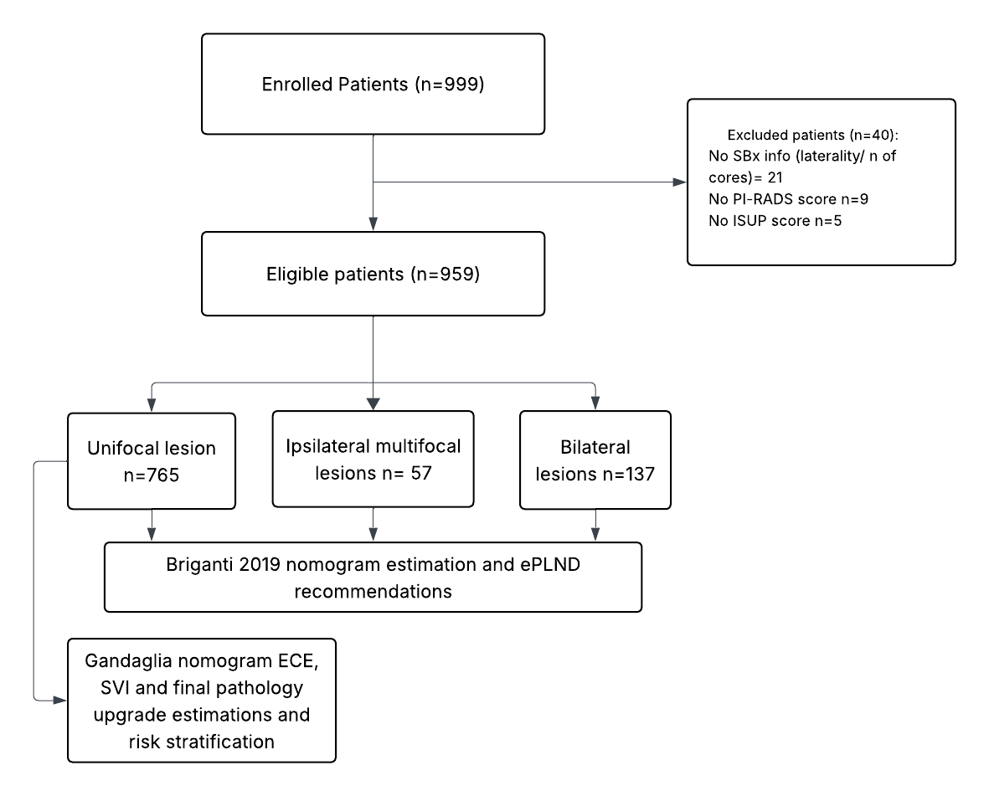
Supplementary figure 1. Consort diagram of the COBRA study

CONSORT flow diagram of the COBRA study, showing patient identification, stratification by MRI lesion pattern (unifocal, multifocal ipsilateral, bilateral), and inclusion in nomogram analyses.

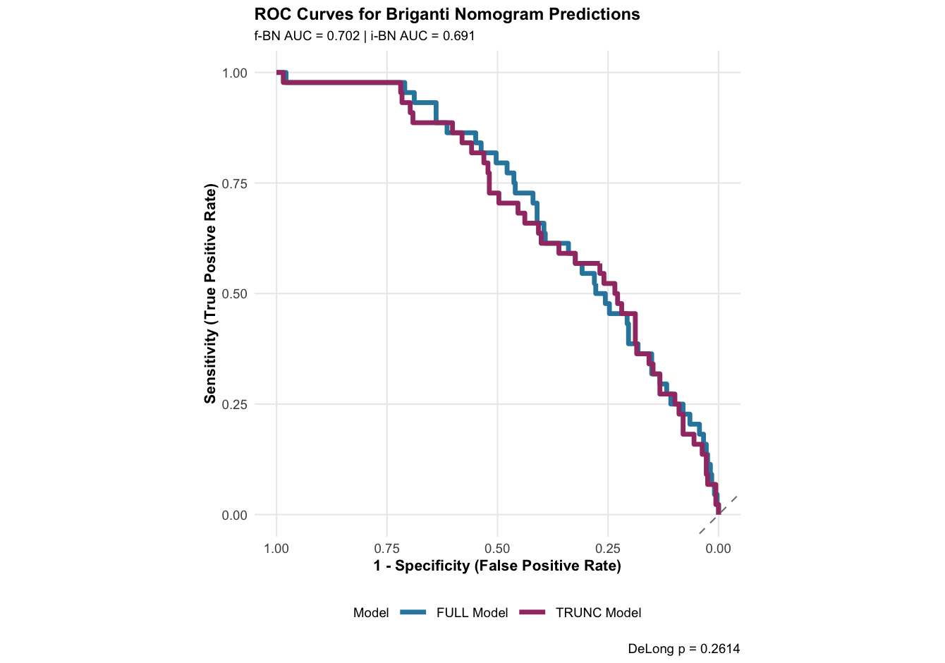
Supplementary figure 2. ROC Curves for Briganti nomogram predictions using f-BN and i-BN
Receiver operating characteristic (ROC) curves comparing full-bilateral (f-BN) and ipsilateral-only (i-BN) Briganti nomogram predictions of lymph node invasion in the unifocal cohort.

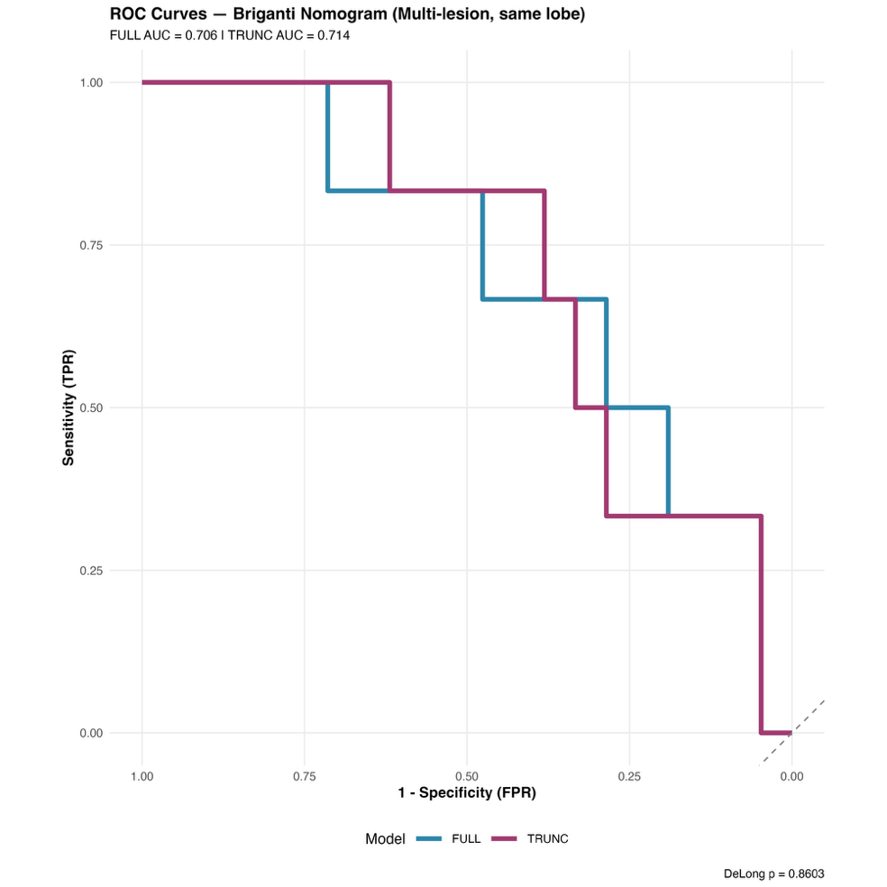
Supplementary figure 3. ROC-curves for Briganti nomogram estimation (ipsilateral multiple lesions)
Receiver operating characteristic (ROC) curves for full-bilateral (f-BN) and ipsilateral-only (i-BN) Briganti nomogram estimations in the multifocal ipsilateral (multiple-lesion) subgroup.

