Supplementary Information
A Novel Benzimidazole-π-Bridge-Dicyanoisophorone-Type Near-Infrared Fluorescent Probe for Rapid Monitoring of Hydrogen Sulfide Based on a Cascade Thiolysis Strategy
Jiali Zhao, Ruyu Liu, Minqi Xie, Shuang Wang, Shumin Jiang, Hua Zhang* and Chuanxiang Liu*
Faculty of Chemical Engineering and Energy Technology, Shanghai Institute of Technology, Shanghai 201418, China
* Emails: cxliu@sit.edu.cn

Table of contents
¹H NMR and ¹³C NMR Data of N-Bu-B 1
¹H NMR, ¹³C NMR and HRMS Data of N-Bu-DCIB 2
¹H NMR, ¹³C NMR and HRMS Data of N-Bu-DCIB-2DNP 3
pH-dependent absorbance profiles of N-Bu-DCIB-2DNP 5
LC-MS analysis of the reaction of probe N-Bu-DCIB-2DNP with H₂S 5

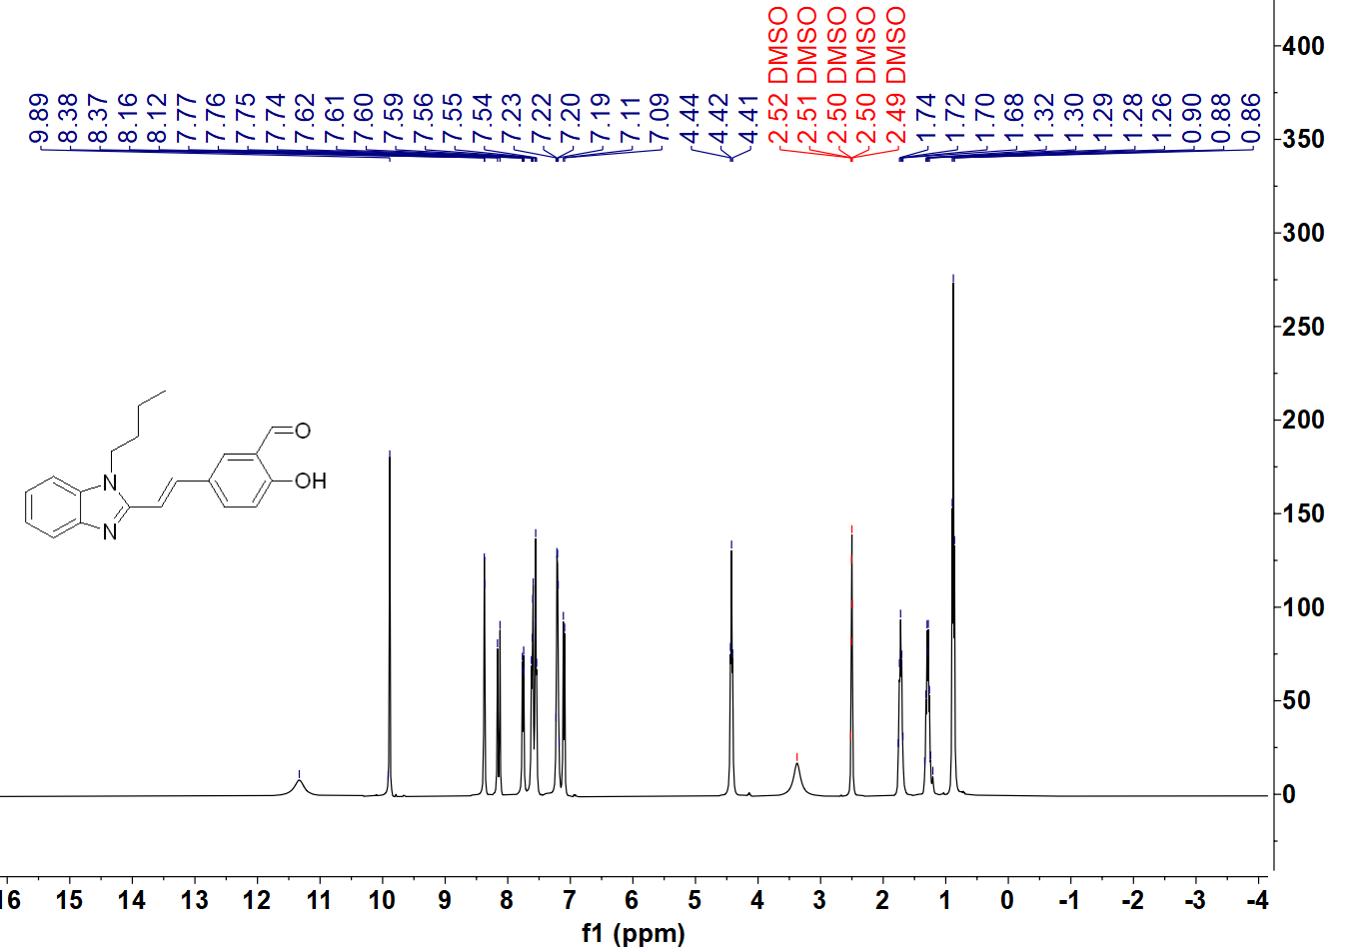Figure S1 ¹H NMR (DMSO-d₆) spectrum of N-Bu-B
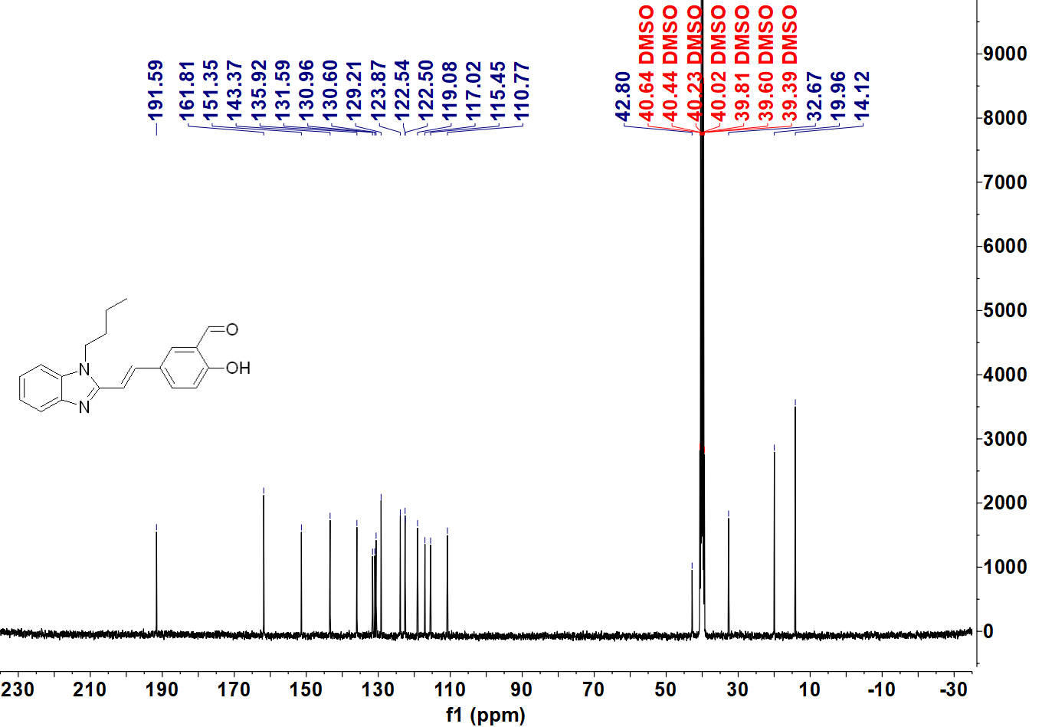
Figure S2 ¹³C NMR (DMSO-d₆) spectrum of N-Bu-B

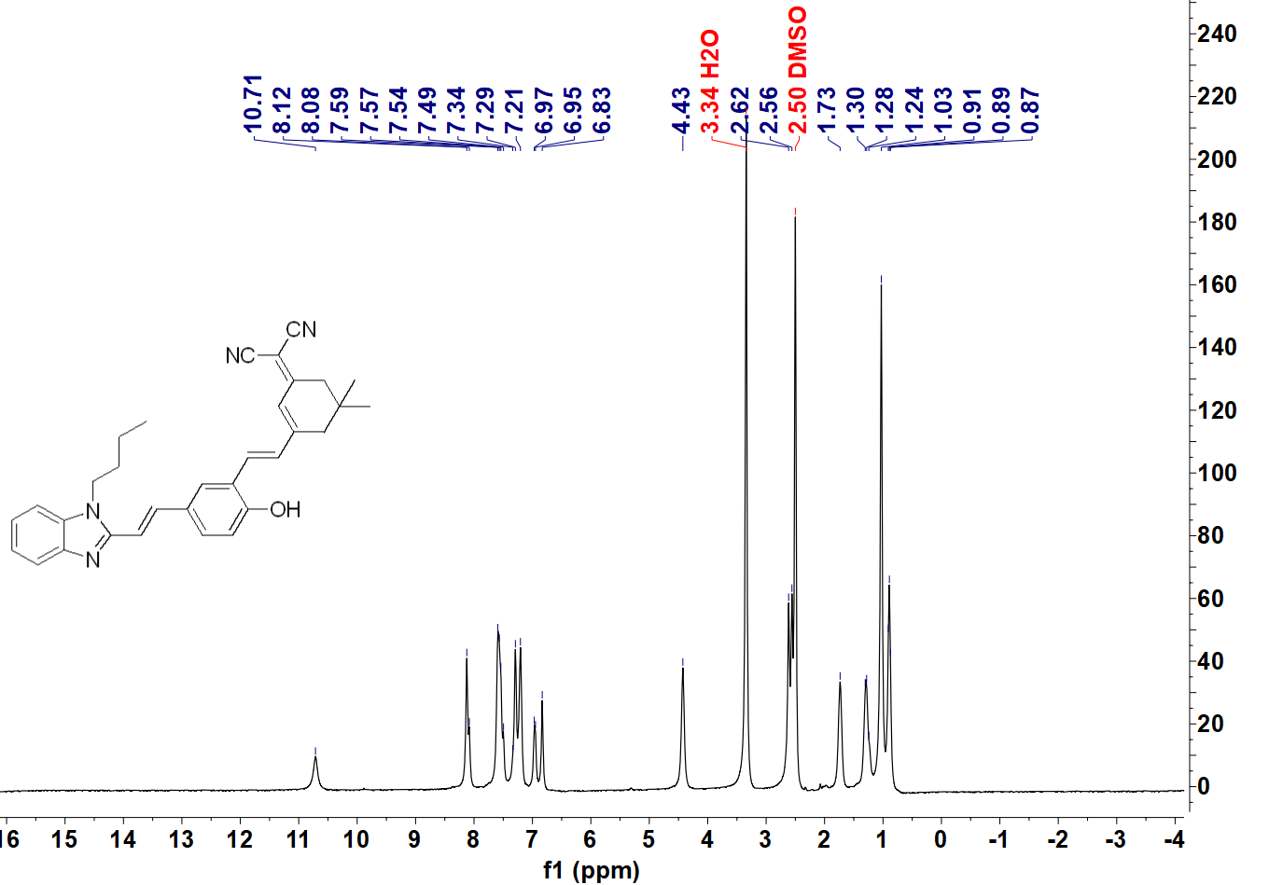
Figure S3 ¹H NMR (DMSO-d₆) spectrum of N-Bu-DCIB
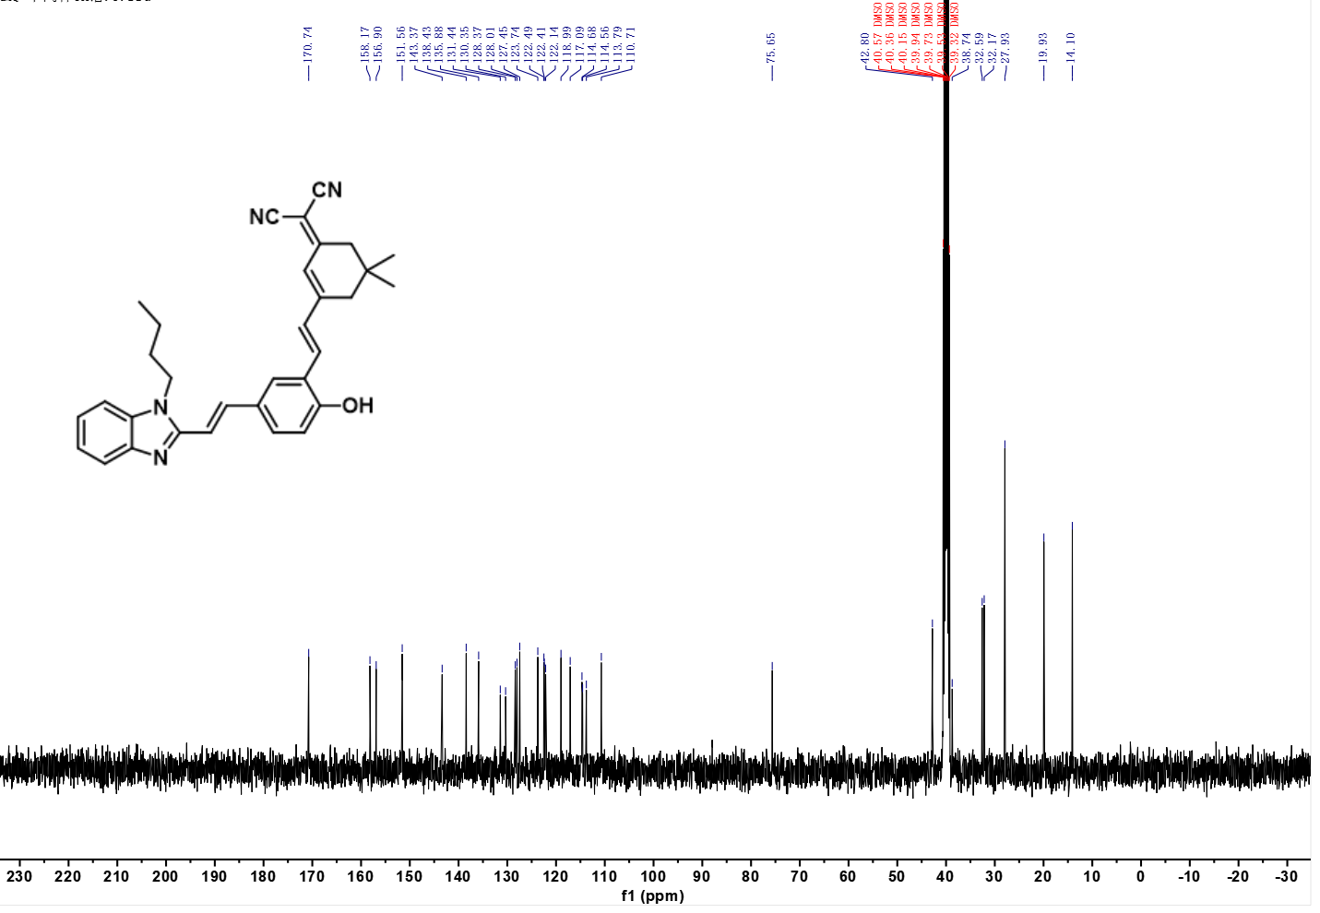
Figure S4 ¹³C NMR (DMSO-d₆) spectrum of N-Bu-DCIB
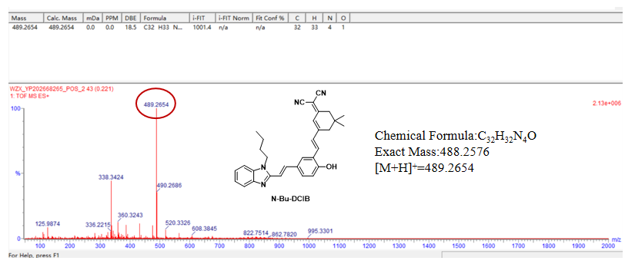
Figure S5 HRMS-ESI mass spectra of N-Bu-DCIB
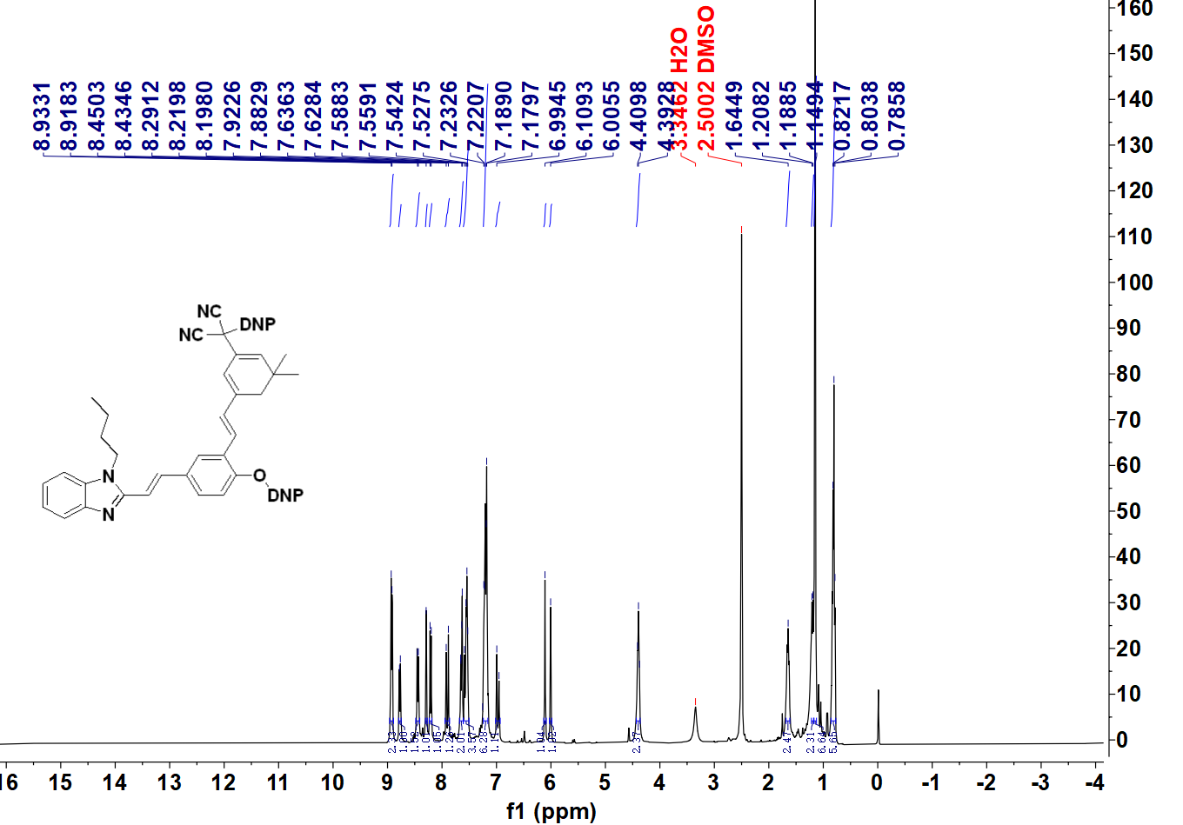
Figure S6 ¹H NMR (DMSO-d₆) spectrum of N-Bu-DCIB-2DNP
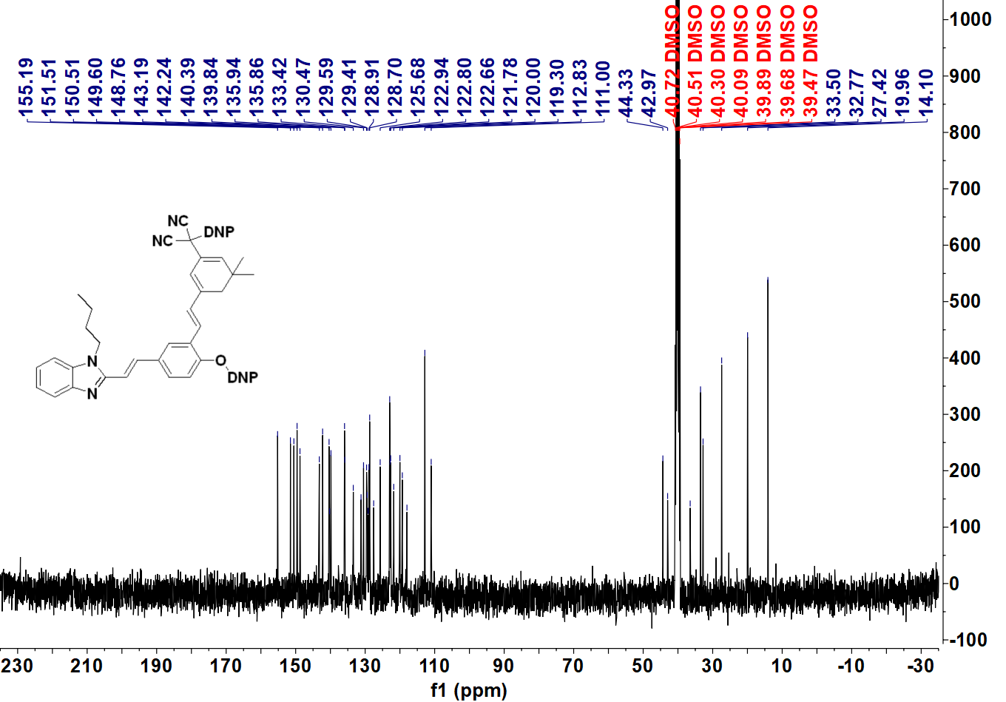Figure S7 ¹³C NMR (DMSO-d₆) spectrum of N-Bu-DCIB-2DNP
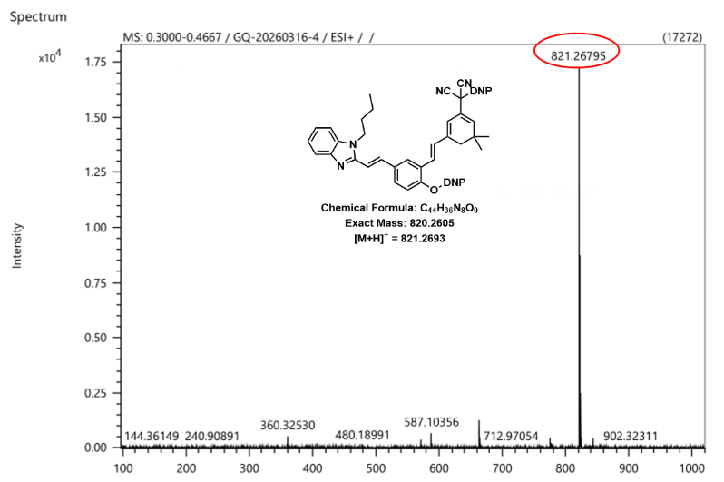
Figure S8 HRMS-ESI mass spectra of N-Bu-DCIB-2DNP
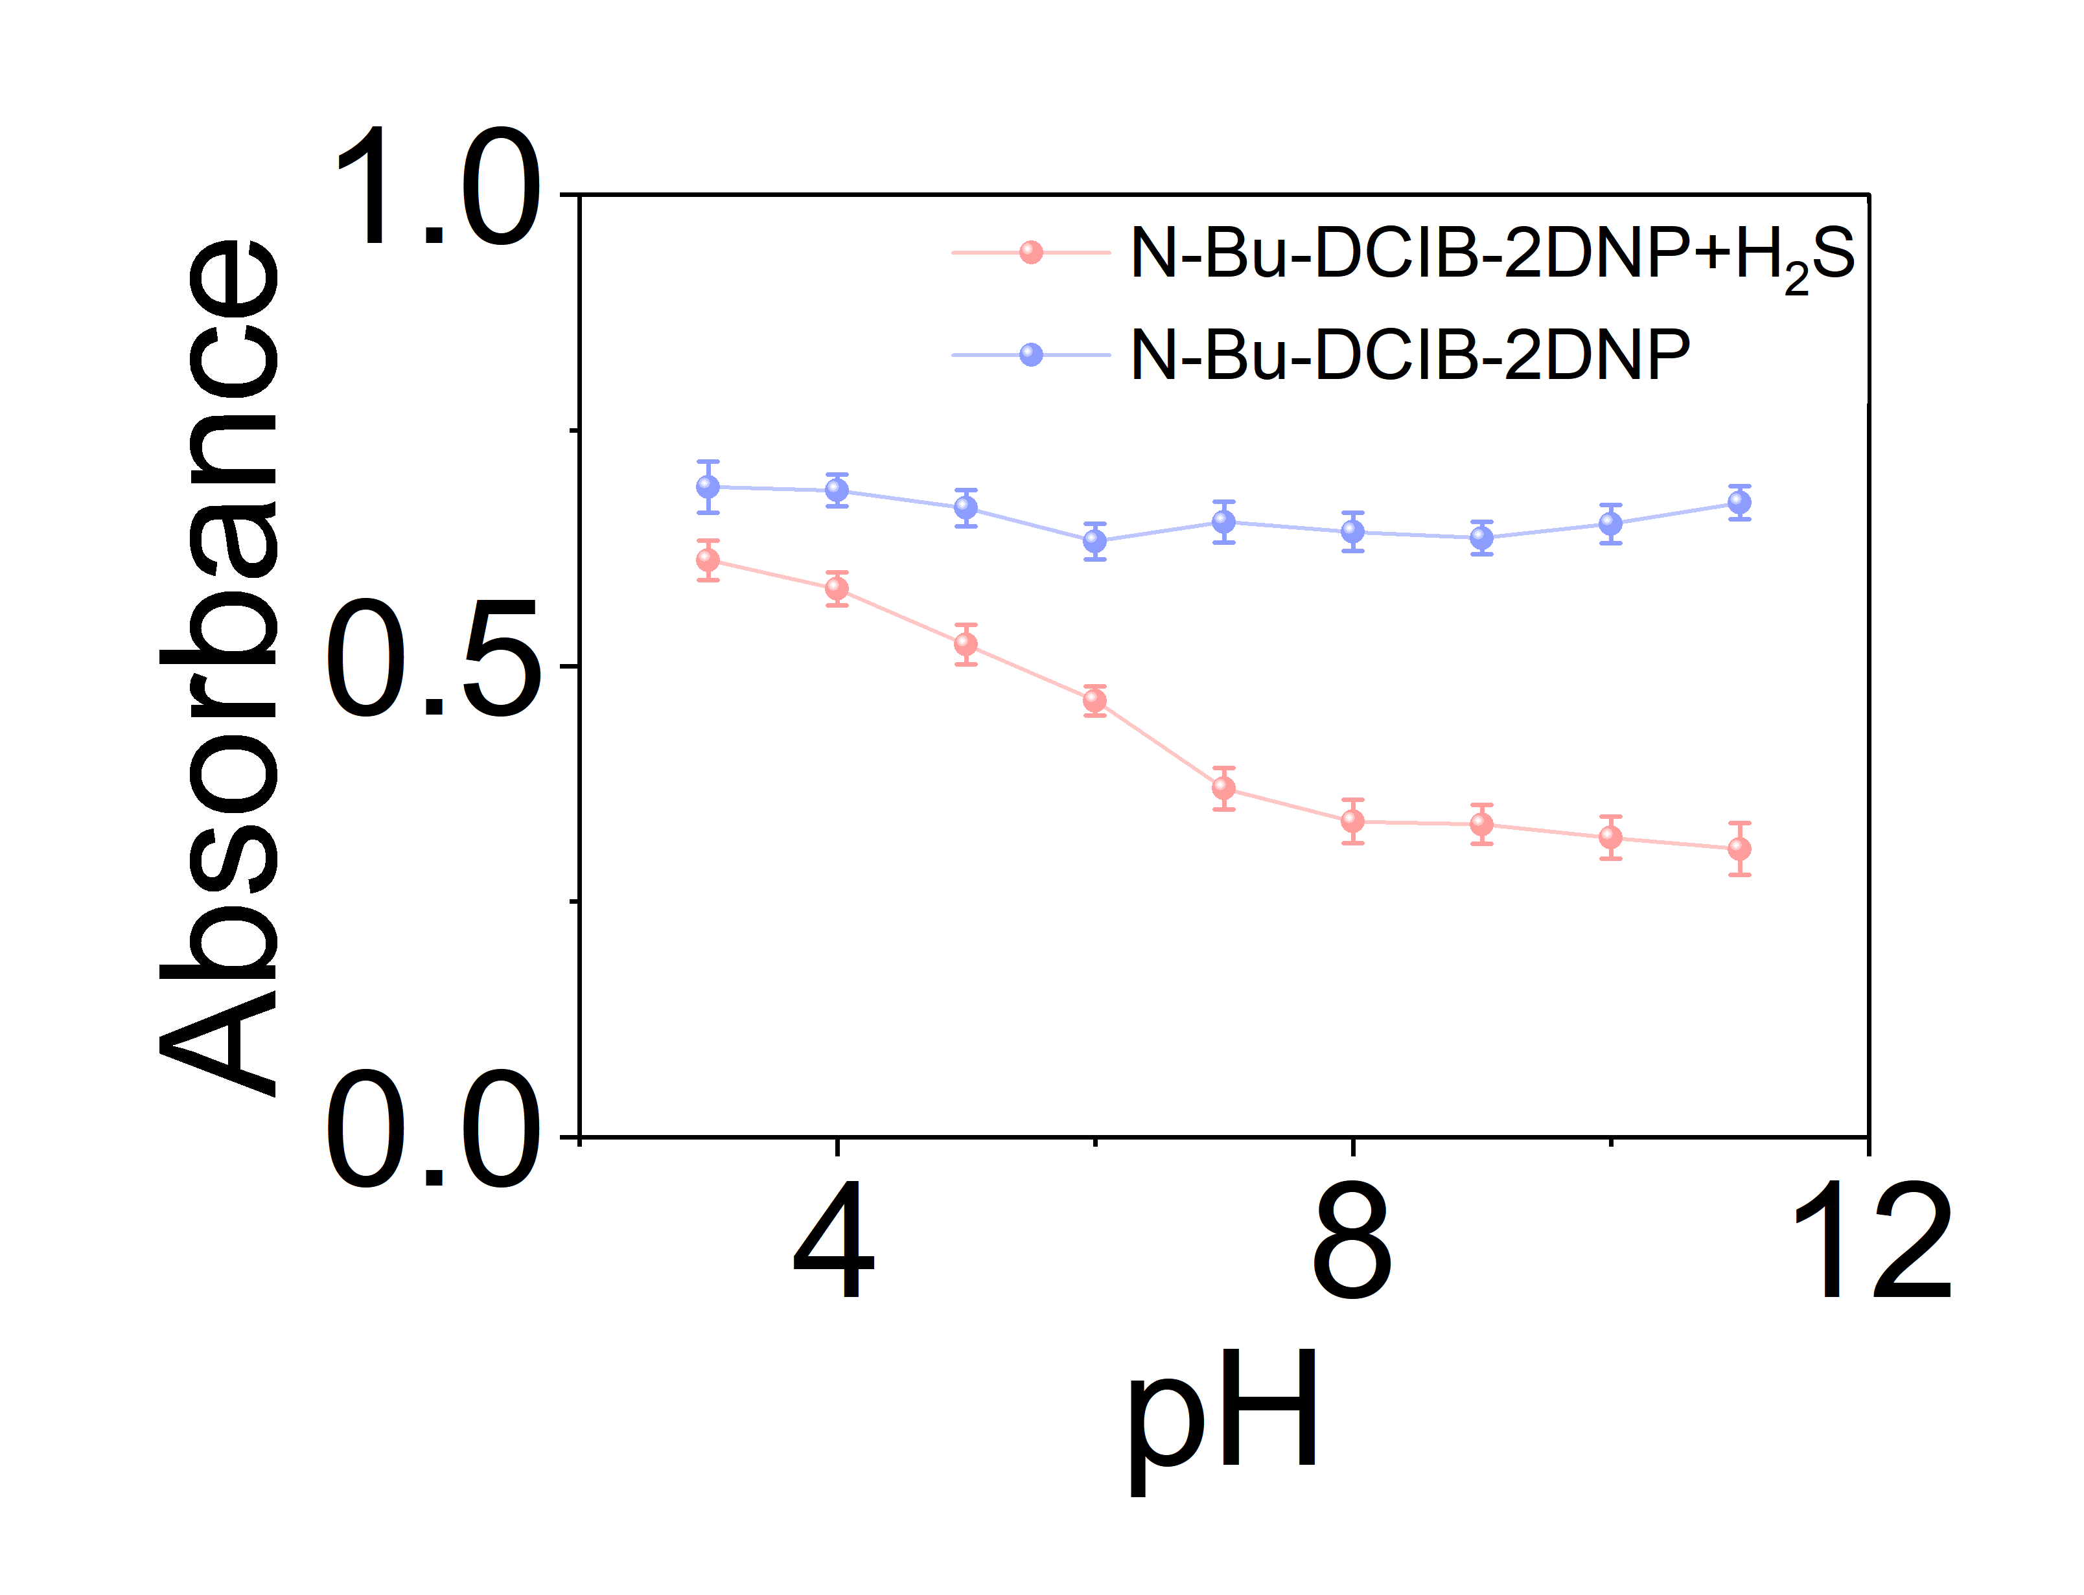
Figure S9 pH-dependent absorbance profiles of N-Bu-DCIB-2DNP at 690 nm before and after treatment with H₂S (60 equiv)
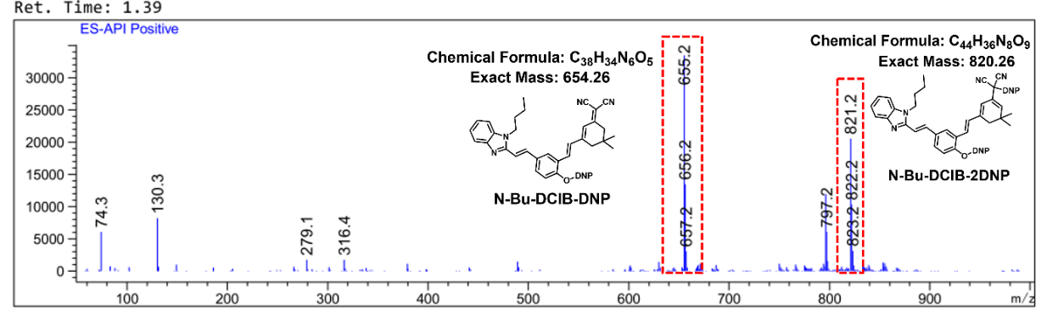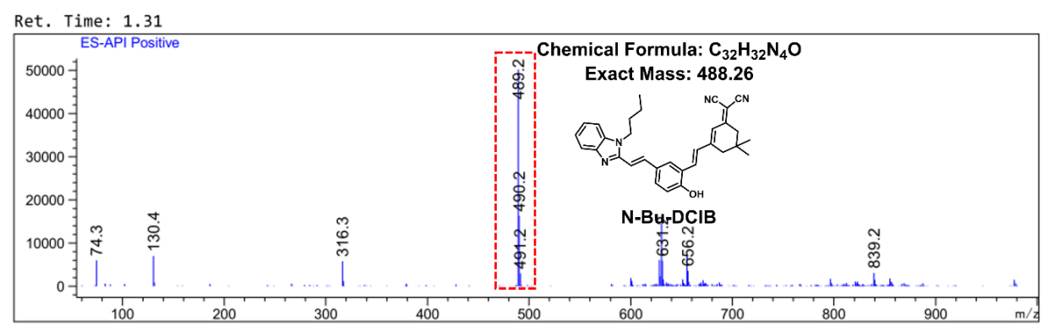
Figure S10 LC-MS analysis of the reaction of probe N-Bu-DCIB-2DNP with H₂S

