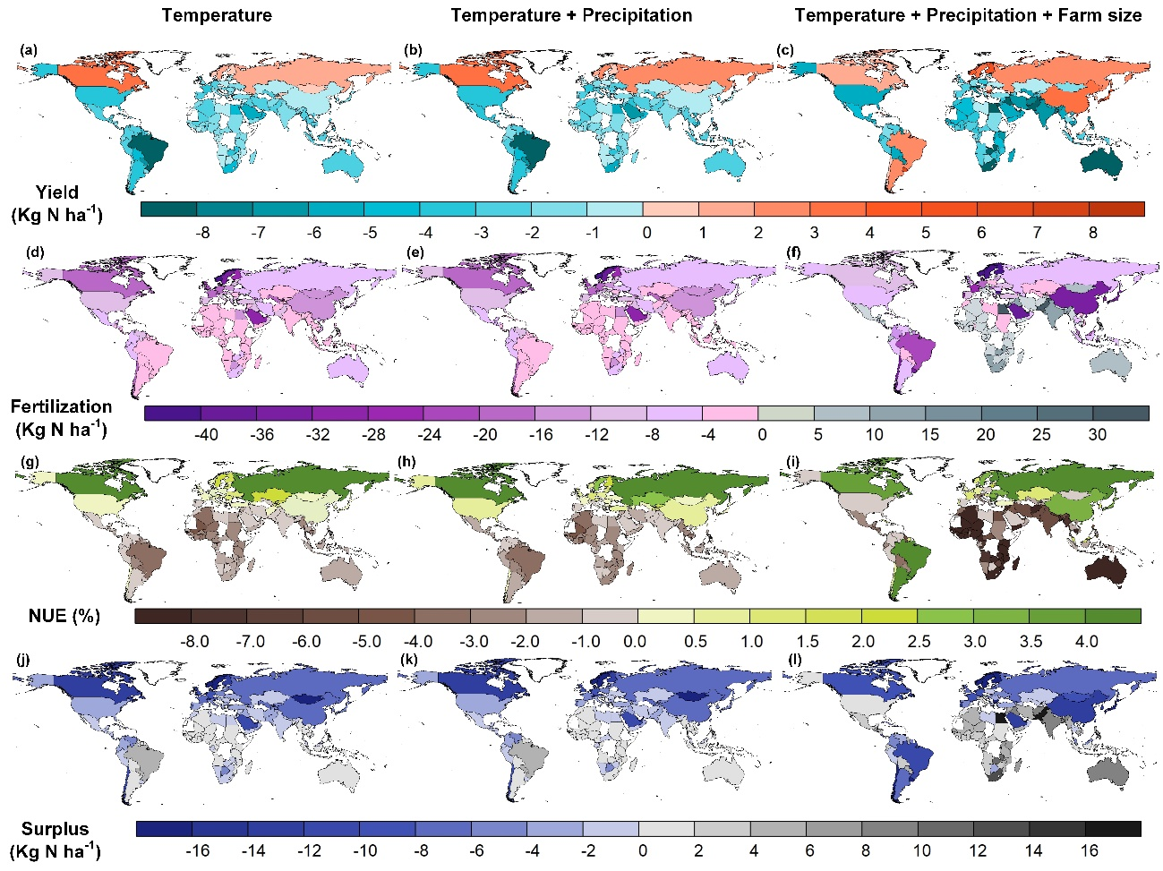
Extended Data Fig. 1 | Physical impacts of climate change and farm size on yield, fertilization, NUE and N surplus in 2018. (a), (d), (g), and (j) present the impacts of temperature changes on yield, fertilization, NUE, and N surplus, respectively. The impacts of climate change are shown in panels (b), (e), (h), and (k). Combined impacts of temperature, precipitation, and farm size are depicted in panels (c), (f), (i), and (l). The impact of climate change on each country refers to the physical change to the observed value in 2018. It is the difference between the value predicted under the climate with and without temperature and precipitation changes. And we calculate the combined impacts without climate and farm size changes, assuming the farm size remains unchanged from 1961. The base map is applied without endorsement from GADM data (https://gadm.org/).

Extended Data Fig. 2 | Yield, fertilization, NUE and N surplus changes under climate change. In this figure, we selected data of the world average and Angola to depict temperature and precipitation effects, respectively.

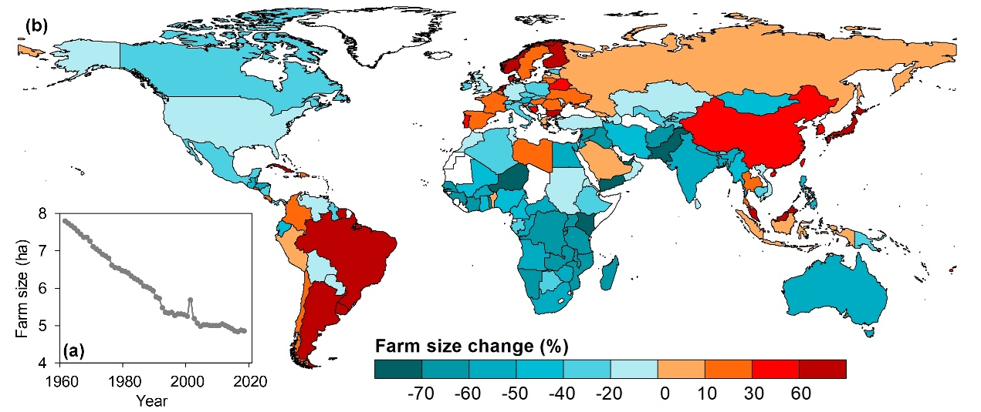
Extended Data Fig. 3 | Farm size changes from 1961 to 2018. Panel (a) depicts the global average changes of farm size from 1961 to 2018. Panel (b) shows the spatial relative change (%) in 2018 compared to that in 1961. The base map is applied without endorsement from GADM data (https://gadm.org/).

Extended Data Fig. 4 | Relative effects of climate change and farm size to NUE, fertilization, yield and N surplus changes across different regions. In each panel, the three bars on the left refer to the effect of the average farm size less than 2 ha. Accordingly, the three on the right represent the effect of more than 2 ha. The effects were derived from the ratio of the standardization coefficient of the explanatory variable to the standard deviation of the explained variable according to Eq. (7). The total effects from temperature and precipitation depicted in panel (c) were summed the effects from themselves and their quadratic items in each farm size group. Note that for the USA and Canada, and Oceania, the average farm size on country-level are all over 2 ha.

Extended Data Fig. 5 | Yield, fertilization, NUE and N surplus trends under SSP scenarios. NUE in panels (a), (c), (e) and (g) shows yield, fertilization, NUE and N surplus trends only considering temperature, respectively. And panel (b), (d), (f) and (h) represents yield, fertilization, NUE and N surplus trends under both temperature and farm size changes. The historical observations are taken as a three-year moving average. All global means in this figure are weighted average.

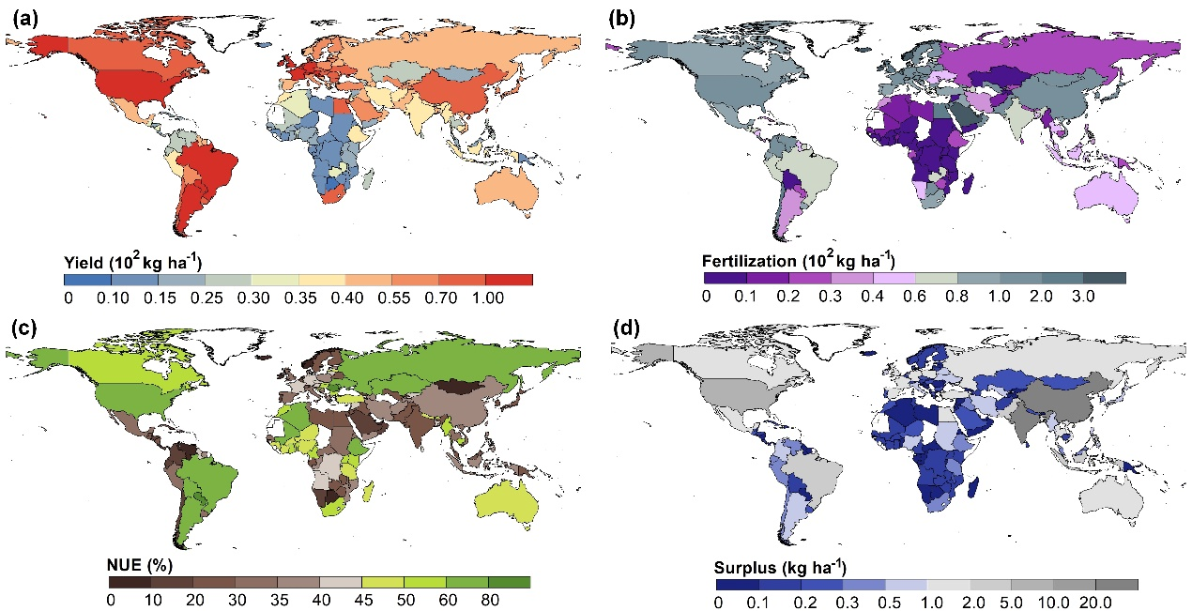
Extended Data Fig. 6 | Spatial patterns of N yield, fertilization, NUE and N surplus in 2018. The base map is applied without endorsement from GADM data (https://gadm.org/).

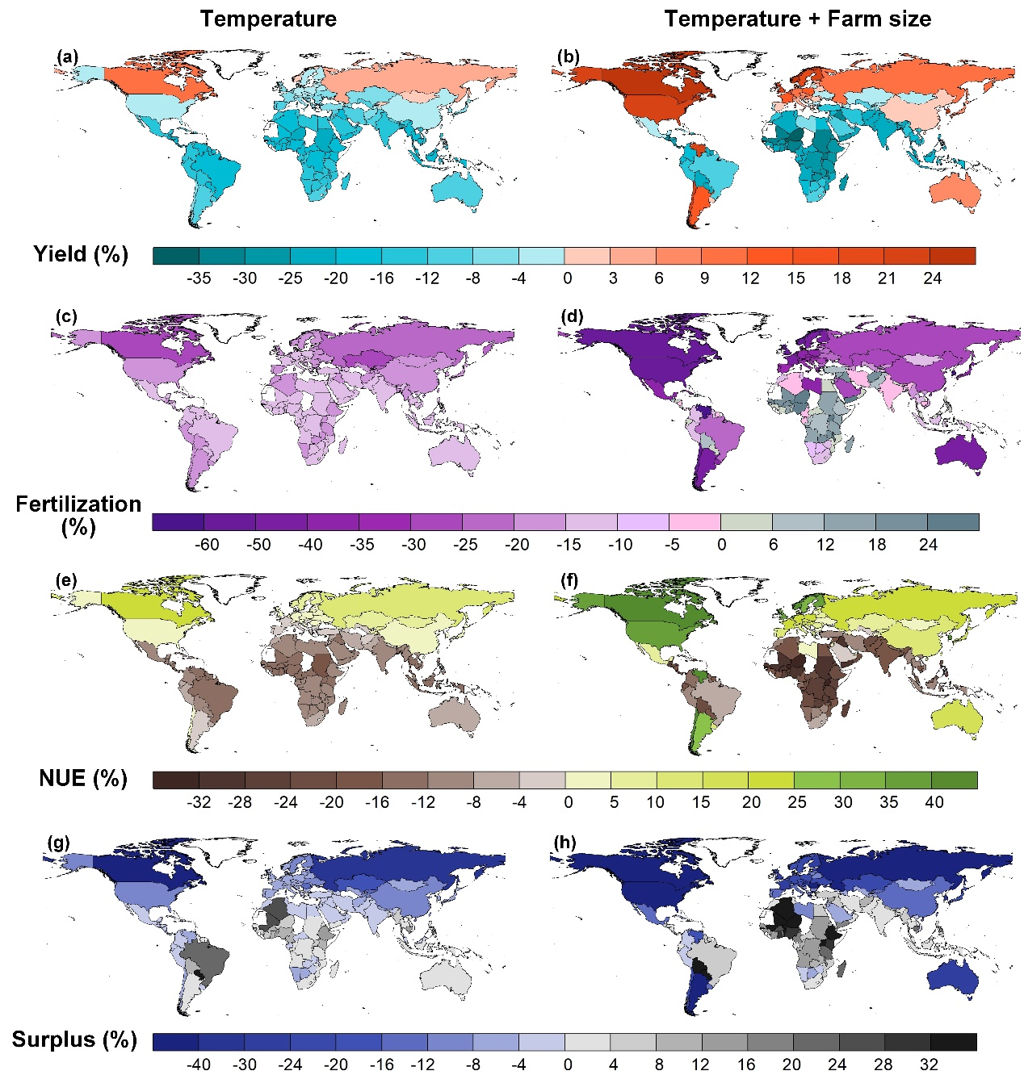 Extended Data Fig. 7 | Yield, fertilization, NUE and N surplus changes in 2100 under the high challenge SSP scenario (SSP3). Value changes refer to the relative change (%) in this figure. It is calculated by the value difference subtracting the observed value in 2018 from the simulated value in 2100 under the SSP3 scenario divided by the observed value in 2018 and the result is carried out in percentage terms. The left panel shows changes under the SSP3 scenario only considering the temperature. The right panel represents changes further considering the role of farm size. The base map is applied without endorsement from GADM data (https://gadm.org/).

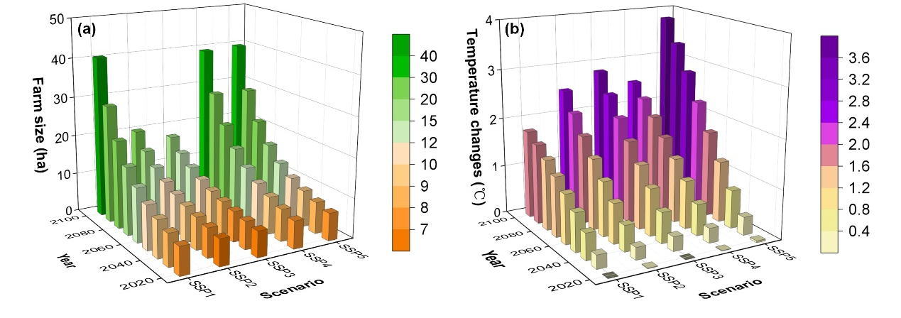
Extended Data Fig. 8 | Farm size and temperature changes under SSP scenarios. Farm size is the global average agricultural land area per rural population under different scenarios. Temperature changes refer to the temperature rise since the pre-industrial period.

Extended Data Table 1 | The turning point of climate change to yield, fertilization, NUE and N surplus
 | Temperature (℃) |  |  | Precipitation (10² mm)
 | U shape | Turning Point |  | U shape | Turning Point
Yield | Inverted-U | 6.6 |  | Inverted-U | 25.1
Fertilization | U | 58.9 |  | Insignificant | Insignificant
NUE | Inverted-U | 10.1 |  | Inverted-U | 25.5
Surplus | U | 14.4 |  | U | 24.0
The turning point is calculated based on regression results in Table S3 using panel model from 1961 to 2018.
Extended Data Table 2 | Yield, fertilization and NUE changes without interaction effect under climate change
 | Ln Yield |  |  | Ln Fer |  |  | Ln NUE |  |  | Ln Surplus
 | Regression | Effects |  | Regression | Effects |  | Regression | Effects |  | Regression | Effects
Ln Farm size (ha) | 0.15*** | 44% |  | -0.29*** | -11% |  | 0.13*** | 84% |  | -0.07*** | -9%
TEM | 1.80** | 30% |  | -8.78*** | -31% |  | 2.94*** | 72% |  | -3.30*** | -25%
TEM² | -13.74*** | -71% |  | 7.45 | 8% |  | -14.51*** | -111% |  | 11.46*** | 27%
PRE | 2.79*** | 45% |  | -0.61 | -2% |  | 2.71*** | 65% |  | -1.78** | -13%
PRE² | -5.56*** | -27% |  | 1.19 | 1% |  | -5.31*** | -39% |  | 3.71** | 8%
Ln Fer | 0.09*** | 34% |  |  |  |  | -0.12*** | -72% |  | 0.25*** | 45%
N | 7106 |  |  | 7106 |  |  | 7106 |  |  | 7097
Adjust R² | 0.92 |  |  | 0.86 |  |  | 0.84 |  |  | 0.90
Within R² | 0.13 |  |  | 0.02 |  |  | 0.25 |  |  | 0.30
*p < 0.05, **p < 0.01, and ***p< 0.001. TEM and PRE are the average temperature (10² ℃) and accumulated precipitation (10⁴ mm) across the year, respectively. Yield is all crop harvest N (kg ha⁻¹). Fer refers to fertilization (kg N ha⁻¹). NUE is an abbreviation of nitrogen use efficiency of the agricultural cropland system. Surplus is the difference between the harvest nitrogen and the total input nitrogen (kg ha⁻¹). And cash crop ratio, irrigation, country code, and year effect have been controlled. The effects of each item were derived from the ratio of the standardization coefficient of each explanatory variable to the standard deviation of the explained variable.

