Supplementary Materials for
Inequality of nitrogen use and loss in global croplands caused by climate change
Robust checks. We developed multiple econometric models to assess the robustness of our findings. We firstly introduced monthly temperature and precipitation anomalies which are normal distribution referring to Holtermann, 2020 ¹ to test the robustness of quadratic terms of average temperature and precipitation. Taking precipitation as an example, the closer the precipitation anomaly is to -1, the less precipitation it is, the closer it is to 1, the more precipitation it is, and the closer it is to 0, the more normal it is. We also used a fixed-effect model to do the analysis. We estimated the following equation using country-level data from 1961 to 2018:
$$Ln Y_{it}=α+β∙Ln {Farmsize}_{it}+γ_{1}{∙TA}_{it}+γ_{2}∙{TA}_{it}^{2}+δ_{1}{∙PA}_{it}+δ_{2}∙{PA}_{it}^{2}+θ_{1}∙Ln {Farmsize}_{it}∙{TA}_{it}+θ_{2}∙Ln {Farmsize}_{it}∙{TA}_{it}^{2}+θ_{3}∙Ln {Farmsize}_{it}∙ {PA}_{it}+θ_{4}∙Ln {Farmsize}_{it}∙{PA}_{it}^{2}+\sum_{n}{φ_{n}q_{nit}}+σ_{i}+μ_{it}$$ (1)
where the subscript i and t denotes country and year, respectively. $Y_{it}$ stands for explained variables, namely, yield, fertilization, NUE, and N surplus. $Ln Farmsize$ is the logarithm of the agricultural land area per rural population. $TA$ and $PA$ are the abbreviations of the temperature and precipitation anomalies across the year, respectively. ${TA}^{2}$ and ${PA}^{2}$ represent their quadratic terms. We also introduced the interaction items of $TA$, $PA$, ${TA}^{2}$ and ${PA}^{2}$ with $Ln Farmsize$ to explore the role of farm size under climate anomalies. $q_{n}$ is control variable, including the average temperature, accumulative precipitation, cash crop ratio, irrigation, country code, and year. In the equations whose explained variable is yield, NUE and N surplus, fertilization is further controlled. $α$ is a constant, $σ_{i}$ and $μ_{it}$ are error items. $β, γ, δ, θ$ and $φ$ are coefficients that need to be estimated. Interaction items have been centered by each year group when doing regression analysis. The results are detailed in Table S3 and summary statistics are in Table S2.

Since carbon dioxide (CO₂) concentration is also a common indicator describing global warming. We further took annual CO₂ concentration (ppm) into consideration for a robust check. As CO₂ and temperature are highly correlated (Table S4), only precipitation is controlled in this analysis. We estimated the following equation using country-level data from 2002 to 2018:
$${Ln Y}_{it}=α+β∙{Ln Farmsize}_{it}+γ_{1}{∙CO}_{2,it}+γ_{2}∙{CO}_{2,it}^{2}+\sum_{n}{φ_{n}q_{nit}}+σ_{i}+μ_{it}$$ (2)
where the subscript i and t denotes country and year, respectively. $Y_{it}$ stands for explained variables, namely, yield, fertilization, NUE, and N surplus. $Ln Farmsize$ is the logarithm of the agricultural land area per rural population. ${CO}_{2}$ is the abbreviations of carbon dioxide (averaged by monthly CO₂ concentration data) and ${CO}_{2}^{2}$ represents its quadratic term. We didn’t introduce their interaction items with $Ln Farmsize$. Because we consider CO₂ concentration changes are long-term and not fierce, which is not easy to be noticed by farmers. Thus, farmers would not change their management to deal with CO₂ concentration changes, leading to no interaction effects with farm size. $q_{n}$ is control variable, including the accumulative precipitation and its quadratic term, cash crop ratio, irrigation, country code, and year. In the equations whose explained variable is yield, NUE, and N surplus, fertilization is further controlled. $α$ is a constant, $σ_{i}$ and $μ_{it}$ are error items. $γ$ and $φ$ are coefficients that need to be estimated. The results are detailed in Table S3 and summary statistics are in Table S2.

Besides, based on formula (4) in the main manuscript, formula (1) and (2) in this Supplementary Materials, we further added the country-level PGDP and its quadratic term to control the effect of economic development (results in Table S5), and removed the interaction terms with farm size (results in Extended Data Table 1) test the robustness of our main findings. All of these have no significant change to our core results, which proves the robustness.

References:
1. Holtermann, L., Precipitation anomalies, economic production, and the role of “first-nature” and “second-nature” geographies: A disaggregated analysis in high-income countries. Glob. Environ. Change 65 102167 (2020).
2. Lowder, S. K., Skoet, J. & Singh, S., What do we really know about the number and distribution of farms and family farms worldwide? Background paper for The State of Food and Agriculture 2014. ESA Working Paper No. 14-02. Rome, FAO. (2014).

Table S1 High correlation between agricultural land area per rural population and average farm size
 | Average farm size | Average farm size
Agricultural land area per rural population | 3.21*** | 3.09***
Country | YES | YES
Year |  | YES
N | 351 | 351
Adjust R² | 0.95 | 0.95
Within R² | 0.17 | 0.16
*p < 0.05, **p < 0.01, and ***p< 0.001. Data of average farm size are from Lowder et al. ². This table indicates a high correlation between agricultural land area per rural population and average farm size. Specifically, agricultural land area per rural population can explain 95% fluctuations of average farm size. Thus, agricultural land area per rural population can be considered as a proxy indicator for average farm size.

Table S2 Summary Statistics for regression analysis
 | Obs | Mean | SD | Min | Max
Ln Yield (kg N ha⁻¹) | 7106 | 3.35 | 0.69 | 1.03 | 5.32
Ln Fertilization (kg N ha⁻¹) | 7106 | 3.11 | 1.91 | -9.39 | 7.50
Ln NUE | 7106 | -1.22 | 0.57 | -4.29 | 0.15
Ln Surplus (kg N ha⁻¹) | 7097 | 4.11 | 1.03 | -3.06 | 8.00
Ln Farm size (ha) | 7106 | 0.51 | 1.37 | -2.70 | 5.55
Temperature (10² ℃) | 7106 | 0.19 | 0.08 | -0.15 | 0.29
Precipitation (10⁴ mm) | 7106 | 0.11 | 0.08 | 0.001 | 0.50
CO₂ (ppm) | 2177 | 389 | 9.76 | 371 | 406
Cash crop ratio | 7106 | 0.11 | 0.13 | 0.001 | 0.99
Irrigation | 7106 | 1.27 | 0.45 | 1 | 2
Temperature anomaly | 7106 | 0.05 | 0.99 | -3.25 | 3.29
Precipitation anomaly | 7106 | -0.01 | 0.99 | -4.07 | 4.17
Ln PGDP (US dollars captia⁻¹) | 6197 | 7.75 | 1.59 | 3.52 | 11.54

Table S3 Regression results of yield, fertilization, NUE and N surplus with climate anomalies and CO₂
 | TEM and PRE anomalies |  |  |  |  | CO₂ with average TEM and accumulated PRE
 | Ln Yield | Ln Fer | Ln NUE | Ln Surplus |  | Ln Yield | Ln Fer | Ln NUE | Ln Surplus
Ln Farm size (ha) | 0.16*** | -0.29*** | 0.14*** | -0.08*** |  | -0.14*** | -0.49** | 0.21*** | -0.57***
TEM | -0.03*** | 0.003 | -0.02*** | 0.01
TEM² | 0.001 | -0.007 | -0.004 | 0.01***
PRE | 0.03*** | -0.01 | 0.03*** | -0.03*** |  | 2.83*** | 0.46 | 2.64*** | -1.42
PRE² | -0.01*** | -0.003 | -0.007** | 0.002 |  | -5.36*** | -0.07 | -4.57** | 2.07
CO₂ |  |  |  |  |  | -0.83*** | 3.16*** | -0.01 | -0.84**
CO₂² |  |  |  |  |  | 0.001*** | -0.004*** | 0.00001 | 0.001**
TEM×Ln Farm size | -0.01*** | -0.01 | -0.002 | -0.002
TEM²×Ln Farm size | -0.0004 | -0.002 | -0.001 | 0.003
PRE×Ln Farm size | 0.004 | -0.001 | 0.006** | -0.005
PRE²×Ln Farm size | -0.0001 | -0.004 | -0.0001 | -0.001
Ln Fer | 0.09*** |  | -0.12*** | 0.25*** |  | 0.04*** |  | -0.12*** | 0.22***
N | 7106 | 7106 | 7106 | 7097 |  | 2177 | 2177 | 2177 | 2170
Adjust R² | 0.92 | 0.86 | 0.84 | 0.90 |  | 0.96 | 0.91 | 0.93 | 0.94
Within R² | 0.14 | 0.02 | 0.25 | 0.30 |  | 0.07 | 0.03 | 0.21 | 0.23
*p < 0.05, **p < 0.01, and ***p< 0.001. TEM, and PRE mean temperature and precipitation, respectively. CO₂ refers to the average carbon dioxide (ppm). “ha” refers to the unit “hectare”. Yield is all crop harvest nitrogen (N) (kg ha⁻¹). Fer refers to fertilization (kg N ha⁻¹). NUE is an abbreviation of nitrogen use efficiency of the agricultural cropland system. Surplus is the difference between the harvest nitrogen and the total input nitrogen (kg ha⁻¹). Cash crop ratio, irrigation, country code, and year effect have been controlled. When we tested the effects of temperature and precipitation anomalies, average temperature and accumulated precipitation were further controlled.

Table S4 The role of PGDP and CO₂ on temperature changes
 | TEM | TEM | TEM | TEM
CO₂ | 0.08** |  | 0.08** | 0.07
Ln PGDP |  | 0.09*** | 0.19** | 0.29***
CO₂ ×Ln PGDP |  |  |  | 0.04***
N | 2292 | 6660 | 2292 | 2292
Adjust R² | 0.996 | 0.996 | 0.996 | 0.996
Within R² | 0.004 | 0.005 | 0.01 | 0.02
*p < 0.05, **p < 0.01, and ***p< 0.001. CO₂ and TEM are the average carbon dioxide (ppm) and temperature (℃) across the year, respectively. PGDP means gross domestic product per capita (US dollars). Country code and year effect have been controlled in all regression.
Table S5 Roust tests of yield, fertilization, NUE and N surplus under climate change
 | Average TEM and accumulated PRE |  |  |  |  | TEM and PRE anomalies |  |  |  |  | CO₂ with average TEM and accumulated PRE
 | Ln Yield | Ln Fer | Ln NUE | Ln Surplus |  | Ln Yield | Ln Fer | Ln NUE | Ln Surplus |  | Ln Yield | Ln Fer | Ln NUE | Ln Surplus
Ln Farm size (ha) | 0.07*** | -0.31*** | 0.19*** | -0.22*** |  | 0.10*** | -0.21*** | 0.18*** | -0.18*** |  | -0.15*** | -0.42** | 0.23*** | -0.57***
TEM | 0.61 | -11.63*** | 5.77*** | -6.85*** |  | -0.02*** | -0.03 | -0.02*** | 0.02**
TEM² | -9.01*** | 18.63* | -21.27*** | 21.26*** |  | 0.0002 | -0.004 | -0.003 | 0.01**
PRE | 3.20*** | -0.27 | 4.22*** | -3.60*** |  | 0.02*** | -0.01 | 0.04*** | -0.04*** |  | 2.82*** | 0.46 | 2.64*** | -1.41
PRE² | -7.94*** | 0.48 | -10.30*** | 8.69*** |  | -0.007*** | -0.007 | -0.005* | 0.003 |  | -5.03*** | 0.10 | -4.61*** | 2.11
CO₂ |  |  |  |  |  |  |  |  |  |  | -0.91*** | 2.05** | -0.05 | -0.98**
CO₂² |  |  |  |  |  |  |  |  |  |  | 0.001*** | -0.003** | 0.00005 | 0.001***
TEM×Ln Farm size | 1.20* | 7.77*** | -2.21*** | 2.13*** |  | -0.01*** | -0.008 | -0.001 | -0.005
TEM²×Ln Farm size | -0.02 | -11.81* | 6.14*** | -2.74 |  | 0.001 | 0.003 | -0.0001 | 0.003
PRE×Ln Farm size | 0.55* | -1.15 | 1.82*** | -2.20*** |  | 0.001 | -0.003 | 0.06* | -0.01*
PRE²×Ln Farm size | -2.83*** | 1.52 | -5.62*** | 5.61*** |  | -0.0002 | -0.004 | -0.001 | 0.001
Ln Fer | 0.08*** |  | -0.14*** | 0.26*** |  | 0.08*** |  | -0.14*** | 0.27*** |  | 0.03*** |  | -0.12*** | 0.22***
Ln PGDP | 0.11*** | 1.00*** | 0.13*** | -0.04 |  | 0.10*** | 1.05*** | 0.10*** | -0.02 |  | 0.06 | 1.51*** | -0.13 | 0.18
Ln PGDP² | -0.004** | -0.05*** | -0.01*** | 0.01*** |  | -0.003* | -0.05*** | -0.01*** | 0.005* |  | -0.003 | -0.08*** | -0.01* | -0.01*
N | 6197 | 6197 | 6197 | 6189 |  | 6197 | 6197 | 6197 | 6189 |  | 2177 | 2177 | 2177 | 2170
Adjust R² | 0.93 | 0.88 | 0.86 | 0.92 |  | 0.93 | 0.87 | 0.86 | 0.91 |  | 0.96 | 0.91 | 0.93 | 0.94
Within R² | 0.14 | 0.06 | 0.27 | 0.32 |  | 0.13 | 0.05 | 0.26 | 0.32 |  | 0.08 | 0.06 | 0.22 | 0.24
*p < 0.05, **p < 0.01, and ***p< 0.001. TEM, and PRE mean temperature and precipitation, respectively. CO₂ refers to the average carbon dioxide (ppm). Yield is all crop harvest N (kg ha⁻¹). Fer refers to fertilization (kg N ha⁻¹). NUE is an abbreviation of nitrogen use efficiency of the agricultural cropland system. Surplus is the difference between the harvest nitrogen and the total input nitrogen (kg ha⁻¹). PGDP means gross domestic product per capita (US dollars). And cash crop ratio, irrigation, country code, and year effect have been controlled. When we tested the effects of temperature and precipitation anomalies, average temperature and accumulated precipitation were further controlled.
Table S6 Data of each group used in Fig. 3 (a) and (b)
Latin America (Fig. 3a) |  |  |  |  | Afica (Fig. 3b)
Num | Farm size (ha) | Temperature (℃) | Ln NUE |  | Num | Farm size (ha) | Precipitation (10² mm) | Ln NUE
27 | 0.10 | 26.46 | -2.22 |  | 67 | 1.36 | 11.45 | -0.90
44 | 0.17 | 25.27 | -1.71 |  | 50 | 1.47 | 11.76 | -0.91
54 | 0.22 | 25.41 | -1.31 |  | 39 | 1.49 | 12.37 | -0.91
5 | 0.29 | 25.56 | -0.95 |  | 49 | 1.51 | 11.14 | -0.92
35 | 0.37 | 25.01 | -1.07 |  | 47 | 1.52 | 7.38 | -0.90
35 | 0.44 | 25.19 | -1.18 |  | 57 | 1.60 | 12.05 | -0.94
36 | 0.50 | 24.82 | -1.31 |  | 44 | 1.74 | 12.64 | -1.01
32 | 0.57 | 25.25 | -1.22 |  | 57 | 1.78 | 8.02 | -0.82
25 | 0.63 | 25.27 | -1.14 |  | 51 | 1.86 | 12.96 | -0.92
59 | 0.74 | 23.97 | -1.19 |  | 39 | 1.99 | 6.16 | -1.05
80 | 0.86 | 24.09 | -1.15 |  | 39 | 2.00 | 10.56 | -0.82
15 | 0.99 | 24.36 | -1.21 |  | 79 | 2.21 | 13.44 | -0.80
26 | 1.14 | 24.63 | -1.11 |  | 53 | 2.29 | 10.26 | -0.76
49 | 1.28 | 24.30 | -1.06 |  | 58 | 2.36 | 10.85 | -0.68
43 | 1.40 | 23.25 | -1.38 |  | 63 | 2.44 | 14.10 | -0.85
29 | 1.53 | 23.40 | -1.39 |  | 54 | 2.55 | 6.79 | -0.78
20 | 1.63 | 23.16 | -1.48 |  | 107 | 2.59 | 9.82 | -0.78
26 | 1.70 | 23.34 | -1.29 |  | 68 | 2.61 | 8.63 | -0.87
15 | 1.77 | 24.45 | -1.49 |  | 93 | 2.83 | 9.22 | -0.80
51 | 1.88 | 24.92 | -1.46 |  | 74 | 2.83 | 14.84 | -0.69
47 | 2.07 | 25.46 | -1.08 |  | 71 | 3.01 | 15.53 | -0.62
55 | 2.28 | 25.39 | -1.15 |  | 24 | 3.31 | 22.98 | -0.76
23 | 2.48 | 25.24 | -0.79 |  | 69 | 3.81 | 16.23 | -0.68
20 | 2.82 | 23.68 | -0.98 |  | 100 | 5.39 | 0.35 | -1.29
47 | 3.10 | 21.77 | -0.78 |  | 52 | 5.42 | 16.94 | -0.65
30 | 3.32 | 20.96 | -0.58 |  | 25 | 6.43 | 19.66 | -0.80
59 | 4.13 | 22.42 | -0.83 |  | 97 | 6.79 | 0.92 | -0.89
62 | 4.49 | 23.61 | -0.86 |  | 44 | 7.09 | 17.62 | -0.74
13 | 5.04 | 22.79 | -0.80 |  | 29 | 7.22 | 18.52 | -0.82
16 | 5.66 | 19.00 | -0.85 |  | 32 | 7.69 | 4.98 | -0.61
35 | 6.09 | 23.89 | -0.97 |  | 44 | 8.91 | 1.76 | -1.05
25 | 6.58 | 23.06 | -0.89 |  | 27 | 9.09 | 5.61 | -0.71
68 | 7.05 | 18.82 | -0.59 |  | 44 | 10.00 | 3.34 | -0.72
28 | 7.49 | 17.45 | -0.33 |  | 50 | 12.11 | 3.04 | -0.82
28 | 7.97 | 19.13 | -0.33 |  | 59 | 13.74 | 4.40 | -0.79
14 | 8.32 | 24.06 | -0.16 |  | 40 | 13.83 | 2.15 | -1.04
58 | 11.43 | 20.91 | -0.25 |  | 24 | 14.79 | 3.94 | -0.77
20 | 25.65 | 14.16 | -0.31 |  | 39 | 16.70 | 2.45 | -1.01
58 | 32.84 | 15.80 | -0.59 |  | 55 | 16.71 | 2.75 | -0.83
38 | 59.22 | 17.37 | -0.67 |  | 32 | 17.00 | 3.66 | -0.90

Fig. S1 Global average temperature and cumulative precipitation changes from 1961 to 2018 Values for precipitation and temperature are shown on the primary and secondary axis, respectively.

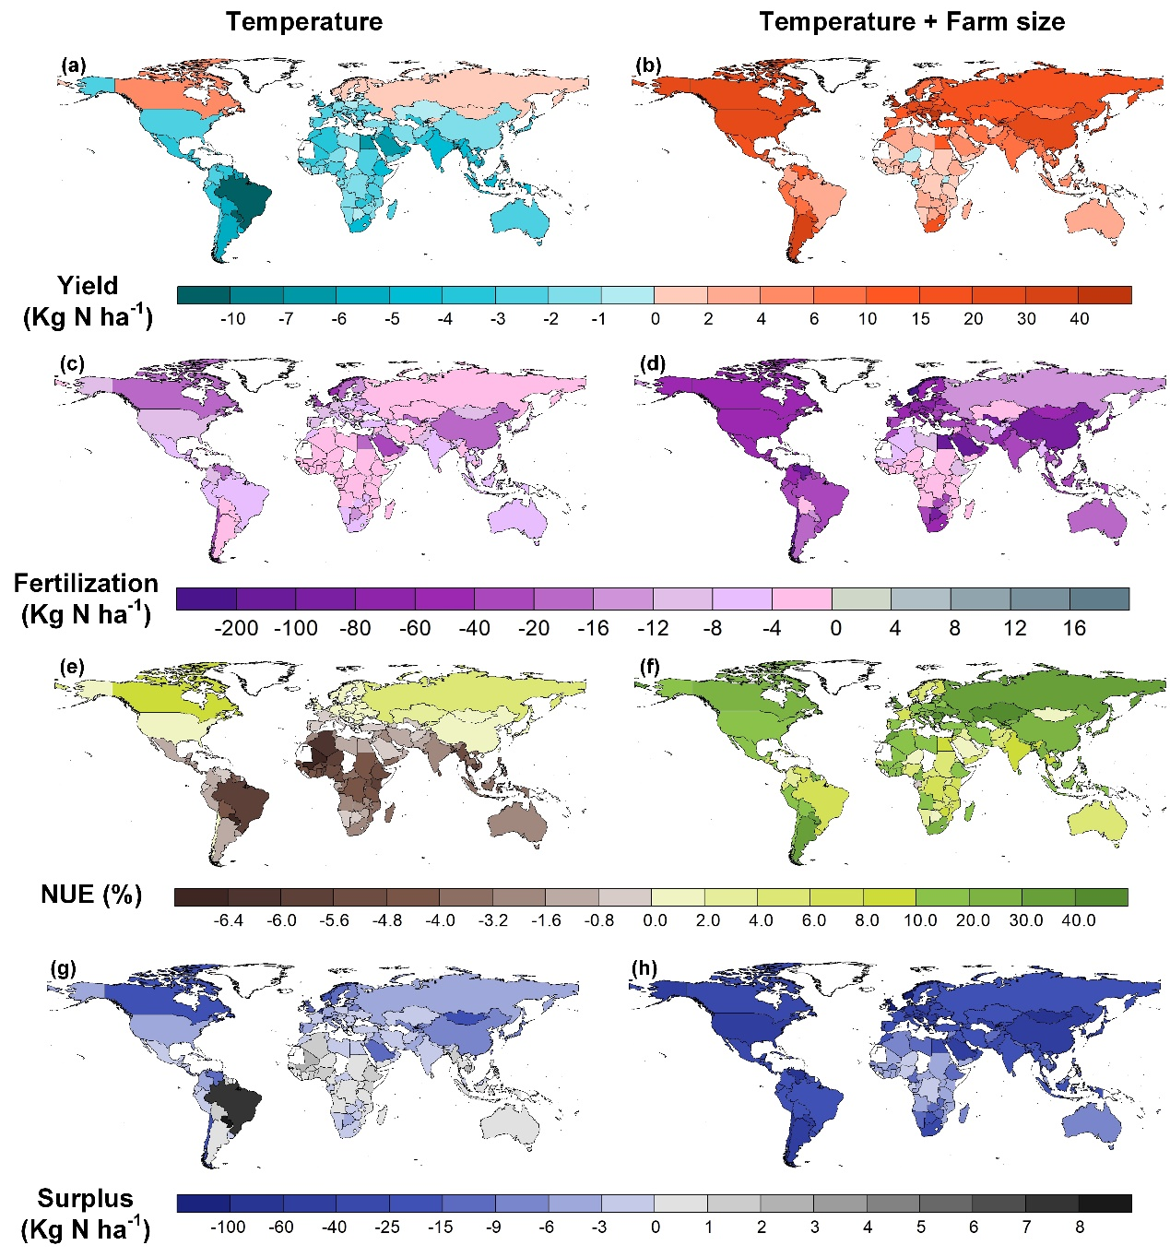
Fig. S2 Physical changes of yield, fertilization, NUE and N surplus in 2100 under the SSP1 scenario. Value changes refer to the physical change in this figure. It is calculated by the value difference subtracting the observed value in 2018 from the simulated value in 2100 under the SSP1 scenario. The left panel shows changes under the SSP1 scenario only considering the temperature. The right panel represents changes further considering the role of farm size. The base map is applied without endorsement from GADM data (https://gadm.org/).
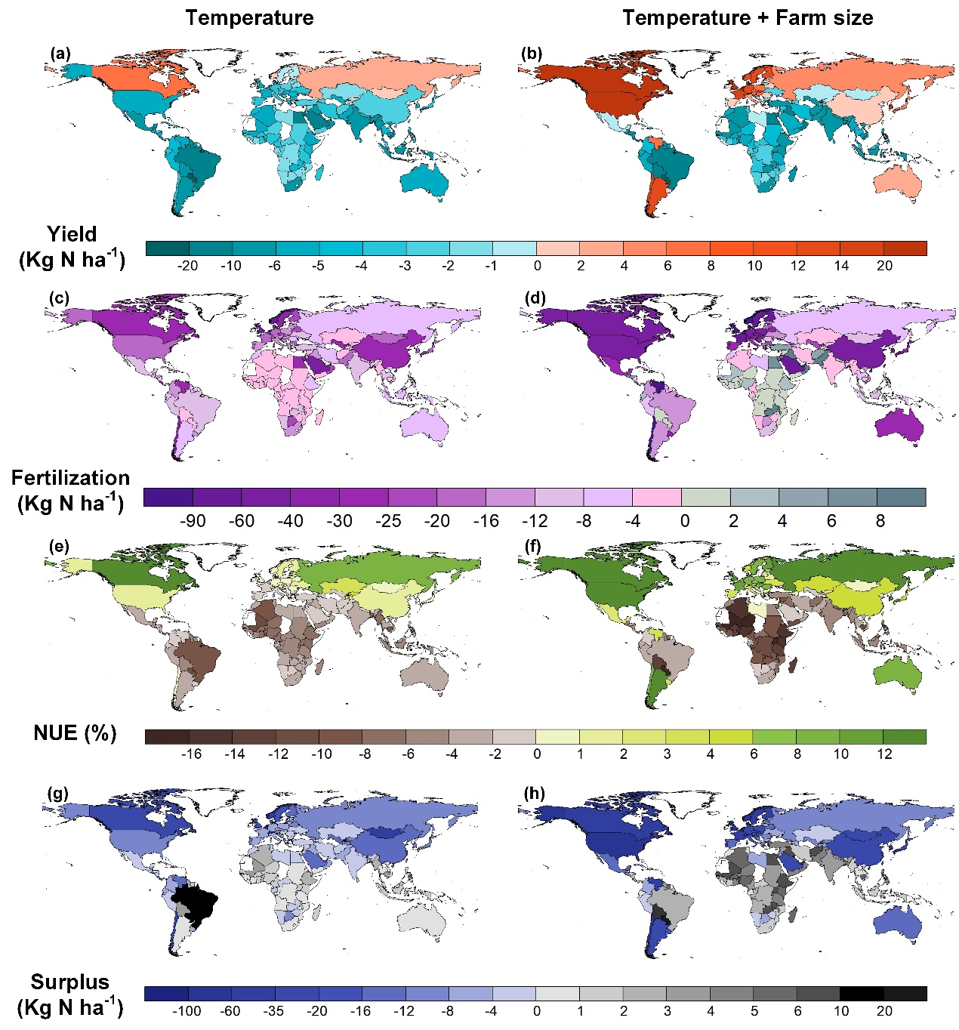
Fig. S3 Physical changes of yield, fertilization, NUE and N surplus in 2100 under the SSP3 scenario. Value changes refer to the physical change in this figure. It is calculated by the value difference subtracting the observed value in 2018 from the simulated value in 2100 under the SSP3 scenario. The left panel shows changes under the SSP3 scenario only considering the temperature. The right panel represents changes further considering the role of farm size. The base map is applied without endorsement from GADM data (https://gadm.org/).
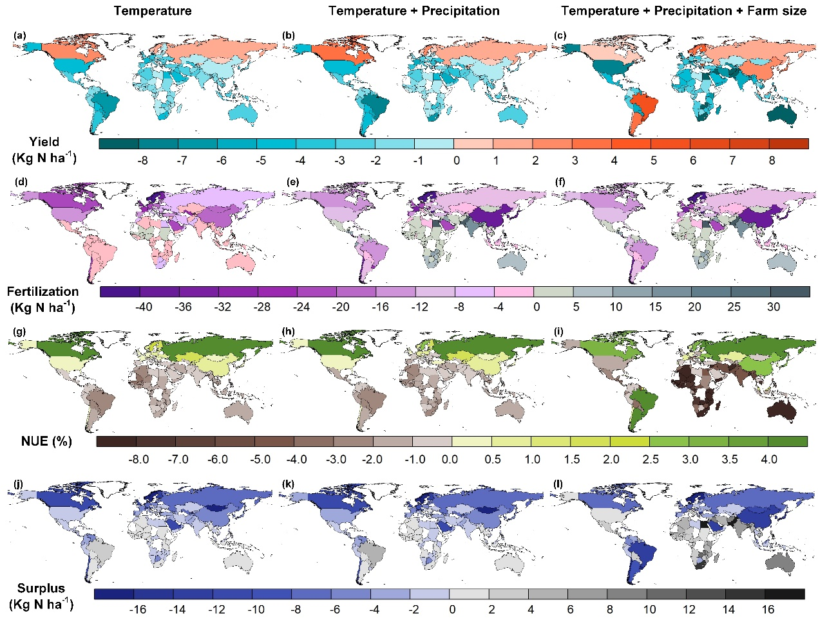
Fig. S4 Upper limit of impacts of climate and farm size change on yield, fertilization, NUE, and N surplus in 2018. (a), (d), (g), and (j) present the upper limit of impacts of temperature changes on yield, fertilization, NUE, and N surplus, respectively. The upper limits of impacts of climate change are shown in panels (b), (e), (h), and (k). The upper limit of compound impacts of temperature, precipitation, and farm size are depicted in panels (c), (f), (i), and (l). This figure shows the upper limit of physical change to the observed value in 2018. The base map is applied without endorsement from GADM data (https://gadm.org/).
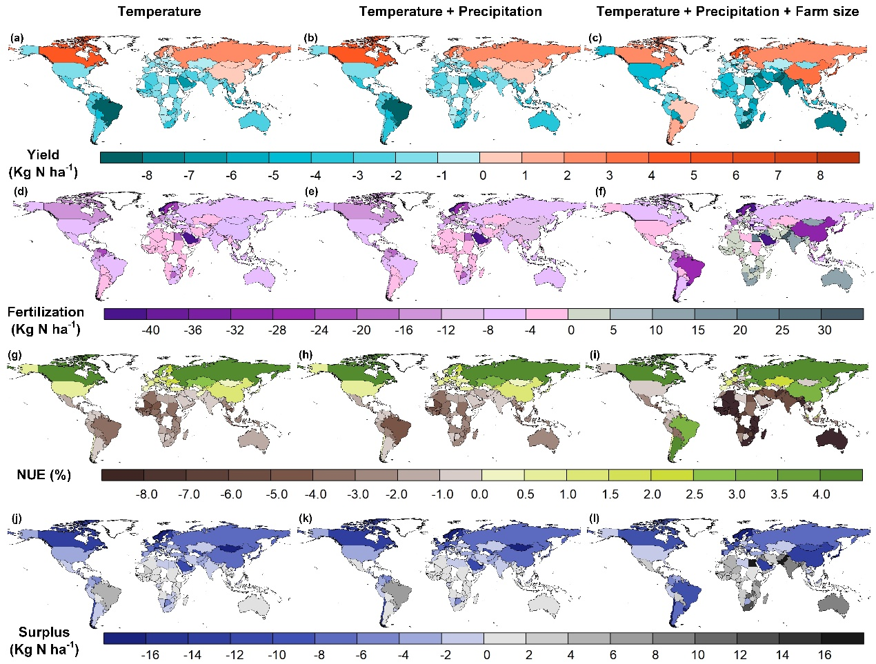
Fig. S5 Lower limit of impacts of climate and farm size change on yield, fertilization, NUE, and N surplus in 2018. (a), (d), (g), and (j) present the lower limit of impacts of temperature changes on yield, fertilization, NUE, and N surplus, respectively. The lower limits of impacts of climate change are shown in panels (b), (e), (h), and (k). The lower limit of compound impacts of temperature, precipitation, and farm size are depicted in panels (c), (f), (i), and (l). This figure shows the lower limit of physical change to the observed value in 2018. The base map is applied without endorsement from GADM data (https://gadm.org/).
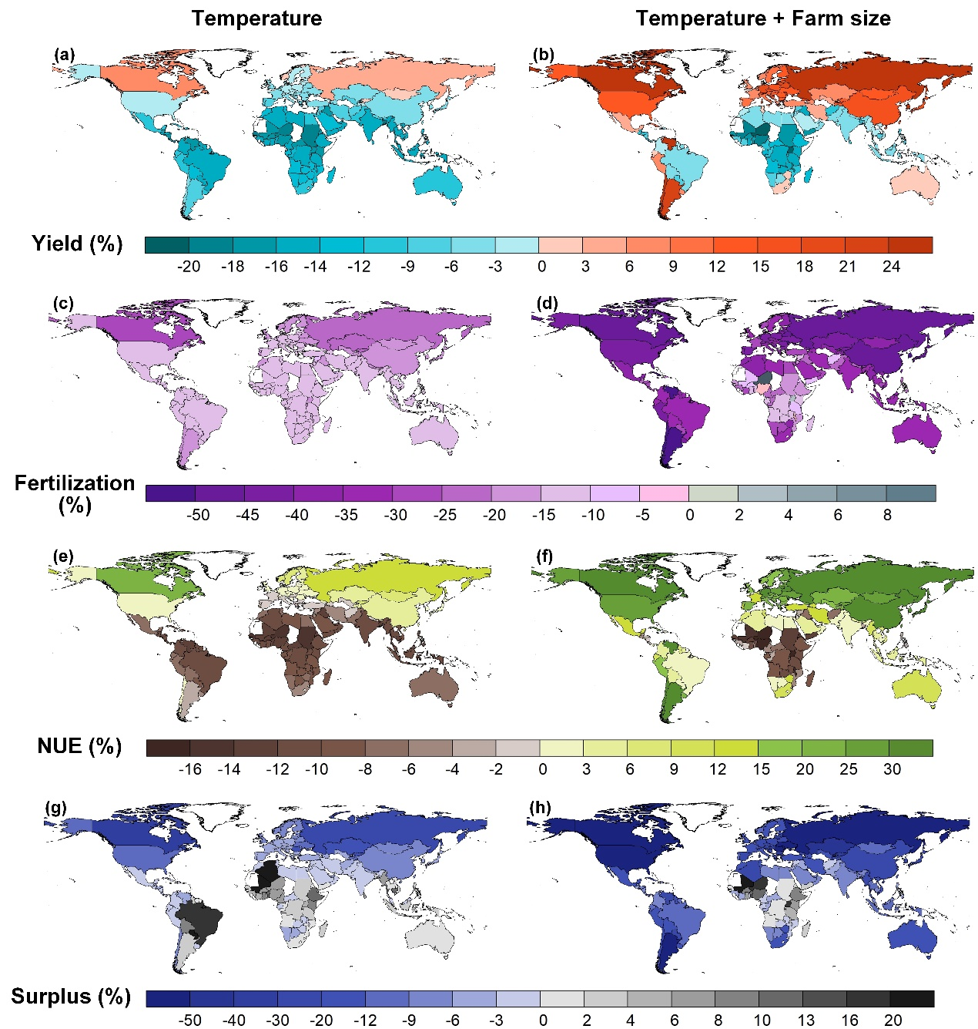 Fig. S6 Yield, fertilization, NUE and N surplus changes in 2100 under the medium challenge SSP scenario (SSP2). Value changes refer to the relative change (%) in this figure. It is calculated by the value difference subtracting the observed value in 2018 from the simulated value in 2100 under the SSP2 scenario divided by the observed value in 2018 and the result is carried out in percentage terms. The left panel shows changes under the SSP2 scenario only considering the temperature. The right panel represents changes further considering the role of farm size. The base map is applied without endorsement from GADM data (https://gadm.org/).
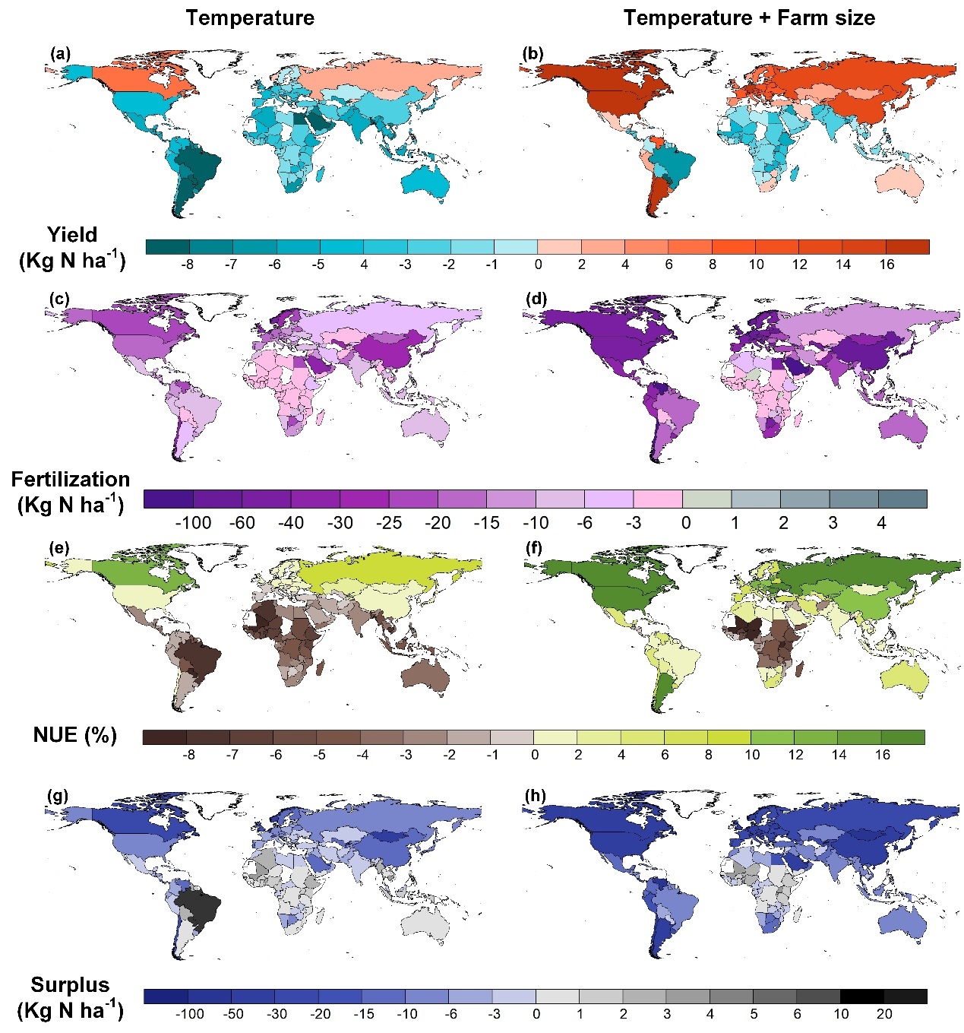
Fig. S7 Physical changes of yield, fertilization, NUE and N surplus in 2100 under the SSP2 scenario. Value changes refer to the physical change in this figure. It is calculated by the value difference subtracting the observed value in 2018 from the simulated value in 2100 under the SSP2 scenario. The left panel shows changes under the SSP2 scenario only considering the temperature. The right panel represents changes further considering the role of farm size. The base map is applied without endorsement from GADM data (https://gadm.org/).

