Supplementary Files
Fig. S1Osmotic Pump-Mediated Intrahypothalamic Delivery of 2-Arachidonoylglycerol
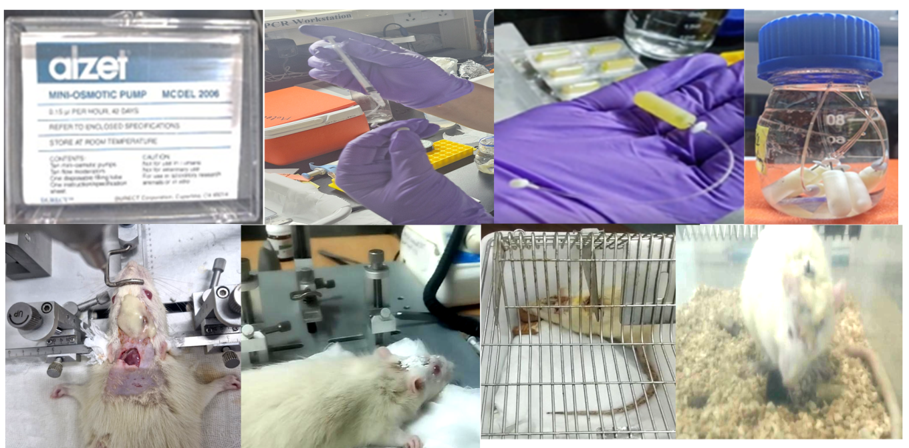
Fig. S2 Experimental Timeline of the study
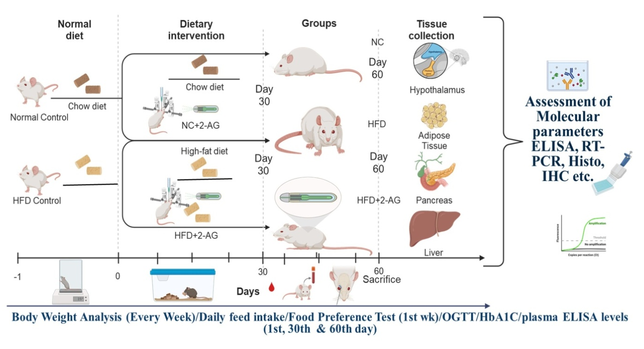

Fig. S3: Oil Red O staining or neutral lipids for Liver and Adipose Tissue
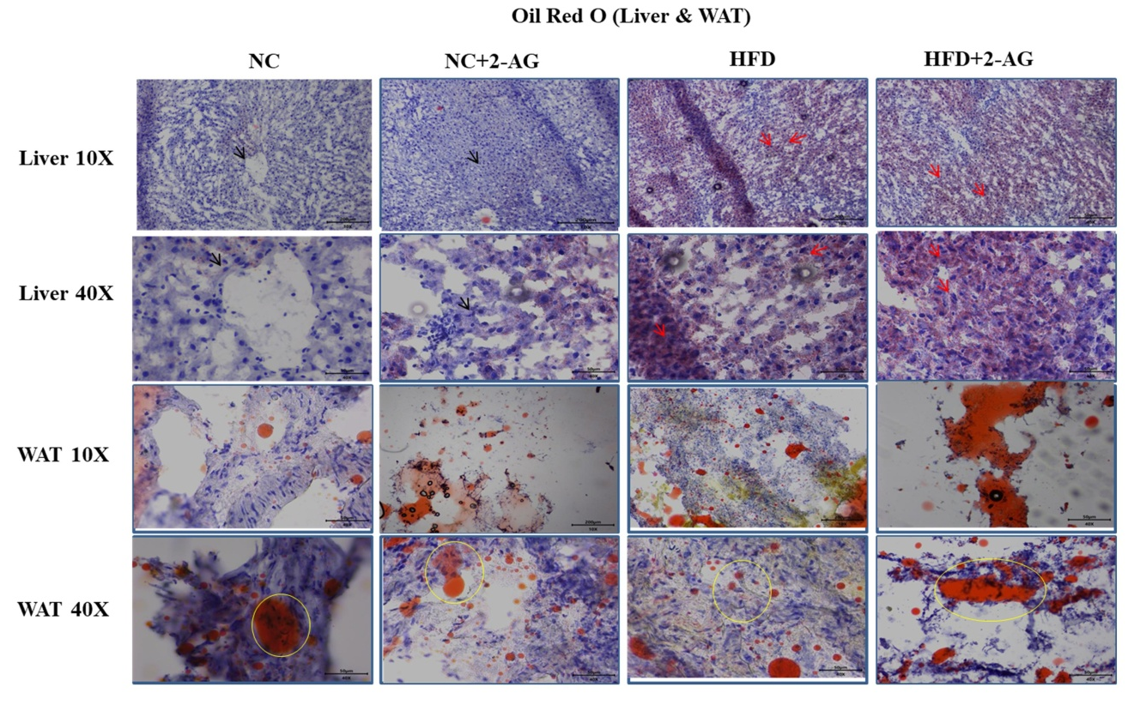
Fig. S3 Representative Oil Red O staining of liver and white adipose tissue (WAT) showing neutral lipid accumulation following chronic intrahypothalamic 2-AG infusion in normal chow (NC) and high-fat diet (HFD) fed rats. Liver sections are shown at 10× and 40× magnification, while WAT sections are presented at 10× and 40× magnification. Oil Red O-positive neutral lipid droplets appear as red/orange staining (indicated by arrows and circles), whereas nuclei are counterstained blue. The NC and NC + 2-AG groups exhibited minimal lipid deposition. HFD feeding induced marked hepatic steatosis and increased adipose lipid accumulation, which were further exacerbated by central 2-AG infusion. The HFD + 2-AG group demonstrated the most extensive lipid deposition, characterized by diffuse hepatic lipid accumulation and enlarged lipid droplets in WAT, indicating enhanced lipogenesis and triglyceride storage under combined HFD and endocannabinoid activation. Data are representative of n = 6 animals per group.

Fig. S4 Immunostaining for CB1 and CB2 across different tissues and groups
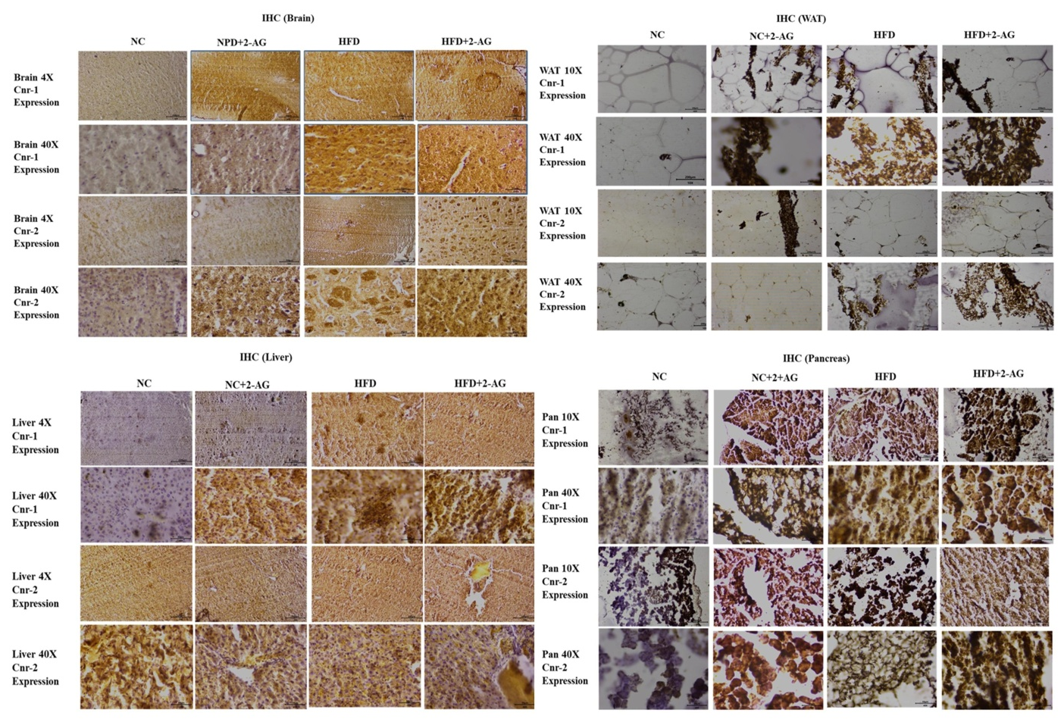

Fig. S4 Representative immunohistochemical (IHC) staining of cannabinoid receptor type 1 (Cnr-1/CB1) and cannabinoid receptor type 2 (Cnr-2/CB2) in pancreatic sections from normal chow (NC), NC + 2-AG, high-fat diet (HFD), and HFD + 2-AG rats. Pancreatic tissues were immunostained using antibodies against Cnr-1 and Cnr-2 and examined at 10× and 40× magnification. Positive immunoreactivity is visualized as brown DAB staining, indicating receptor expression within pancreatic acinar cells and islets of Langerhans. The NC group exhibited weak basal CB1 and CB2 expression, whereas central 2-AG administration moderately increased receptor immunoreactivity. HFD feeding markedly enhanced pancreatic Cnr-1 and Cnr-2 expression, and chronic central 2-AG infusion further intensified staining, with the HFD + 2-AG group displaying the strongest and most extensive immunoreactivity. These findings corroborate the qRT-PCR data and demonstrate enhanced pancreatic endocannabinoid signaling associated with islet remodeling, impaired insulin homeostasis, and obesity-induced metabolic dysfunction.

