Supplementary Information
Recombinant Allergen-Based Quantum Dot Lateral Flow Immunoassays for
Component-Specific IgE Detection in House Dust Mite Allergy
Applied Biochemistry and Biotechnology
Yun-Zhi Liª, Zi-Xin Wangª, Xiao-Ya Wangª, Yan-Yan Sun^{c*}, Xin-lei Chu^{b*}, Chun-Ming Dong^{a*}
ª College of Marine and Environmental Sciences, Tianjin University of Science and Technology, Tianjin 300457, China
^{b} Department of Epidemiology and Biostatistics, Tianjin Medical University Cancer Institute and Hospital, Tianjin Medical University, Tianjin 300060, China
^{c} Jinan Deheng Medical Technology Co., Ltd., Jinan 250031, Shandong Province, China
*Corresponding authors: Chun-Ming Dong (mingchundongjy@tust.edu.cn), Xin-lei Chu (chuxinlei2014@163.com), and Yan-Yan Sun (sunyanyanggg@163.com)
Supplementary Material 1 This file contains Supplementary Tables S1-S10 and Supplementary Figs. S1-S7 supporting the bioinformatics analyses, QD-LFIA accelerated storage assessment, MBP-control testing, and comparison with ImmunoCAP

Table S1 ProtParam-predicted physicochemical properties of Der p 1, Der p 2, Der p 10, and Der p 23
Parameter | Der p 1 | Der p 2 | Der p 10 | Der p 23
Number of amino acids | 300 | 130 | 284 | 70
Molecular weight (Da) | 34,033.92 | 14,252.52 | 32,900.74 | 8,112.66
Theoretical pI | 5.40 | 6.50 | 4.78 | 4.32
Charged residues (negative/positive) | 36/27 | 17/16 | 74/50 | 16/6
Instability index | 36.94 | 35.71 | 46.78 | 61.56
Aliphatic index | 74.87 | 89.92 | 79.15 | 18.14
GRAVY | −0.453 | −0.205 | −1.060 | −1.344
Note. GRAVY, grand average of hydropathicity. Values were calculated using the ExPASy ProtParam tool.

Table S2 PSIPRED-predicted secondary-structure composition of Der p 1, Der p 2, Der p 10, and Der p 23
Allergen | α-Helix | β-Strand | Random coil
Der p 1 | 98 (32.67%) | 43 (14.33%) | 159 (53.00%)
Der p 2 | 0 (0.00%) | 69 (53.08%) | 61 (46.92%)
Der p 10 | 281 (98.94%) | 0 (0.00%) | 3 (1.06%)
Der p 23 | 2 (2.86%) | 12 (17.14%) | 56 (80.00%)
Note. Values are shown as the number of residues (percentage of the amino acid sequence).

Table S3 Linear B-cell epitope regions predicted using the IEDB Analysis Resource
Allergen | Predicted region(s)
Der p 1 | 6–25: FEEYKKAFNK SYATFEDEEA  35–36: KY  38–102: QSNGGAINHL SDLSLDEFKN RFLMSAEAFE HLKTQFDLNA ETNACSINGN APAEIDLRQM RTVTP  104: R  128–135: YRNQSLDL  147–148: HG  161–176: IQHNGVVQES YYRYVA  178–179: EQ  181–194: CRRPNAQRFG ISNY  227: A  229–245: RHYDGRTIIQ RDNGYQP  256–263: SNAQGVDY  272–276: TNWGD  278: G
Der p 2 | 5–17: DVKDCANHEI KKV  22–25: CHGS  64–76: VDVPGIDPNA CHY  78–90: KCPLVKGQQY DIK  93–101: WNVPKIAPK
Der p 10 | 5–171: KNKMQAMKLE KDNAIDRAEI AEQKARDANL RAEKSEEEVR ALQKKIQQIE NELDQVQEQL SAANTKLEEK EKALQTAEGD VAALNRRIQL IEEDLERSEE RLKIATAKLE EASQSADESE RMRKMLEHRS ITDEERMEGL ENQLKEARMM AEDADRKYDE VARKLAM  174–279: ADLERAEERA ETGESKIVEL EEELRVGNNL KSLEVSEEKA QQREEAHEQQ IRIMTTKLKE AEARAEFAER SVQLQKEVGR LEDELVHEKE KYKSISDELD QTFA
Der p 23 | 5–30: NDDDPTTTVH PTTTEQPDDK FECPSR  34–39: FADPKD  50–67: EAVHKDCPGN TRWNEDEE
Note. Residue positions are one-based. Spaces within amino acid sequences are included only to improve readability.

Table S4 Linear B-cell epitope regions predicted using BepiPred 2.0
Allergen | Predicted region(s)
Der p 1 | 7–20: EEYKKAFNKS YATF  33–53: SVKYVQSNGG AINHLSDLSL D  55: F  57–151: NRFLMSAEAF EHLKTQFDLN AETNACSING NAPAEIDLRQ MRTVTPIRMQ GGCGSAWAFS GVAATESAYL AYRNQSLDLA EQELVDCASQ HGCHG  178–192: EQSCRRPNAQ RFGIS  207–217: EALAQTHSAI A  236–244: IIQRDNGYQ  253–281: VGYSNAQGVD YWIVRNSWDT NWGDNGYGY  283: A  285: N  295–296: PY
Der p 2 | 5–14: DVKDCANHEI  24–31: GSEPCIIH  35: P  39–64: EAVFEANQNT KTAKIEIKAS IDGLEV  74–76: CHY  78–79: KC  81–93: LVKGQQYDIK YTW  98–127: IAPKSENVVV TVKVMGDDGV LACAIATHAK
Der p 10 | 5–42: KNKMQAMKLE KDNAIDRAEI AEQKARDANL RAEKSEEE  48–91: KKIQQIENEL DQVQEQLSAA NTKLEEKEKA LQTAEGDVAA LNRR  93–144: QLIEEDLERS EERLKIATAK LEEASQSADE SERMRKMLEH RSITDEERME GL  146–280: NQLKEARMMA EDADRKYDEV ARKLAMVEAD LERAEERAET GESKIVELEE ELRVVGNNLK SLEVSEEKAQ QREEAHEQQI RIMTTKLKEA EARAEFAERS VQKLQKEVGR LEDELVHEKE KYKSISDELD QTFAE
Der p 23 | 6: D  62–66: WNEDE
Note. Residue positions are one-based. Spaces within amino acid sequences are included only to improve readability.

Table S5 Potential linear B-cell epitope regions identified from DNAStar Protean profiles
Allergen | Predicted region(s)
Der p 1 | 14: N  27–28: RK  55–56: FK  131: Q  153–154: TI  157: G  170: S  179–187: QSCRRPNAQ  201: N  203–205: NKI  232–233: DG  239–244: RDNGYQ  268–271: NSWD  274: W
Der p 2 | 32–34: RGK  45–48: NQNT  85: Q  98–102: IAPKS
Der p 10 | 14–17: EKDN  69–71: TKL  117–120: SQSA  157–160: DADR  203–204: NL
Der p 23 | 5–10: NDDDPT  17–24: TTEQPDDK  30: R  36–41: DPKDPH  59–67: NTRWNEDEE
Note. Residue positions are one-based. Spaces within amino acid sequences are included only to improve readability.

Table S6 Sixteen-residue linear B-cell epitope windows predicted using ABCpred
Allergen | Predicted region(s)
Der p 1 | 4–19; 15–30; 24–39; 34–49; 46–61; 62–77  69–84; 87–102; 96–111; 107–122; 116–131; 127–142  138–153; 148–163; 155–170; 165–180; 178–193; 189–204  204–219; 219–234; 230–245; 236–251; 242–257; 258–273  266–281; 273–288; 284–299
Der p 2 | 5–20; 11–26; 21–36; 31–46; 38–53; 56–71  65–80; 73–88; 82–97; 88–103; 94–109; 110–125
Der p 10 | 1–16; 12–27; 21–36; 32–47; 38–53; 48–63  64–79; 75–90; 82–97; 92–107; 99–114; 106–121  117–132; 123–138; 132–147; 142–157; 149–164; 155–170  162–177; 169–184; 179–194; 191–206; 215–230; 224–239  232–247; 243–258; 254–269; 262–277; 268–283
Der p 23 | 6–21; 12–27; 22–37; 32–47; 42–57; 48–63  55–70
Note. Each predicted window contains 16 residues; residue positions are one-based.

Table S7 Results of the 10-day accelerated storage comparison for the Der p 1 QD-LFIA
Sample | ImmunoCAP-assigned concentration (IU/mL) | QD-LFIA result after 10 days at 4 °C (IU/mL) | QD-LFIA result after 10 days at 37 °C (IU/mL) | Relative deviation (%)
1 | 94.92 | 98.72 | 94.27 | −4.50%
2 | 61.97 | 62.59 | 58.92 | −5.87%
3 | 29.52 | 30.11 | 31.32 | 4.01%
4 | 79.87 | 83.06 | 76.22 | −8.24%
5 | 7.05 | 6.77 | 6.89 | 1.86%
6 | 3.83 | 3.91 | 4.00 | 2.28%
7 | 0.98 | 0.96 | 0.93 | −3.48%
8 | 0.47 | 0.46 | 0.48 | 4.25%
Note. Relative deviation (%) = [(C_{37 °C}/C_{4 °C}) − 1] × 100. Deviations were calculated using the unrounded mean assay values.

Table S8 Results of the 10-day accelerated storage comparison for the Der p 2 QD-LFIA
Sample | ImmunoCAP-assigned concentration (IU/mL) | QD-LFIA result after 10 days at 4 °C (IU/mL) | QD-LFIA result after 10 days at 37 °C (IU/mL) | Relative deviation (%)
1 | 85.48 | 88.04 | 82.46 | −6.34%
2 | 61.20 | 61.20 | 59.82 | −2.25%
3 | 30.31 | 29.40 | 29.86 | 1.57%
4 | 115.32 | 118.78 | 111.42 | −6.20%
5 | 5.12 | 5.02 | 5.14 | 2.39%
6 | 3.38 | 3.21 | 3.29 | 2.60%
7 | 1.45 | 1.45 | 1.37 | −5.50%
8 | 0.48 | 0.47 | 0.43 | −7.64%
Note. Relative deviation (%) = [(C_{37 °C}/C_{4 °C}) − 1] × 100. Deviations were calculated using the unrounded mean assay values.

Table S9 Results of the 10-day accelerated storage comparison for the Der p 10 QD-LFIA
Sample | ImmunoCAP-assigned concentration (IU/mL) | QD-LFIA result after 10 days at 4 °C (IU/mL) | QD-LFIA result after 10 days at 37 °C (IU/mL) | Relative deviation (%)
1 | 92.61 | 95.39 | 92.22 | −3.32%
2 | 66.25 | 64.93 | 62.22 | −4.16%
3 | 39.56 | 39.56 | 36.05 | −8.88%
4 | 37.36 | 36.24 | 33.00 | −8.94%
5 | 7.08 | 7.08 | 7.11 | 0.37%
6 | 3.21 | 3.21 | 3.18 | −0.94%
7 | 1.96 | 1.86 | 1.91 | 2.34%
8 | 0.38 | 0.37 | 0.34 | −7.49%
Note. Relative deviation (%) = [(C_{37 °C}/C_{4 °C}) − 1] × 100. Deviations were calculated using the unrounded mean assay values.

Table S10 Results of the 10-day accelerated storage comparison for the Der p 23 QD-LFIA
Sample | ImmunoCAP-assigned concentration (IU/mL) | QD-LFIA result after 10 days at 4 °C (IU/mL) | QD-LFIA result after 10 days at 37 °C (IU/mL) | Relative deviation (%)
1 | 86.27 | 81.96 | 78.63 | −4.06%
2 | 59.45 | 60.04 | 61.29 | 2.08%
3 | 25.84 | 25.06 | 25.70 | 2.55%
4 | 114.04 | 111.76 | 112.49 | 0.65%
5 | 5.37 | 5.16 | 4.87 | −5.45%
6 | 3.01 | 2.95 | 2.83 | −4.20%
7 | 1.61 | 1.61 | 1.60 | −0.41%
8 | 0.49 | 0.51 | 0.47 | −7.94%
Note. Relative deviation (%) = [(C_{37 °C}/C_{4 °C}) − 1] × 100. Deviations were calculated using the unrounded mean assay values.

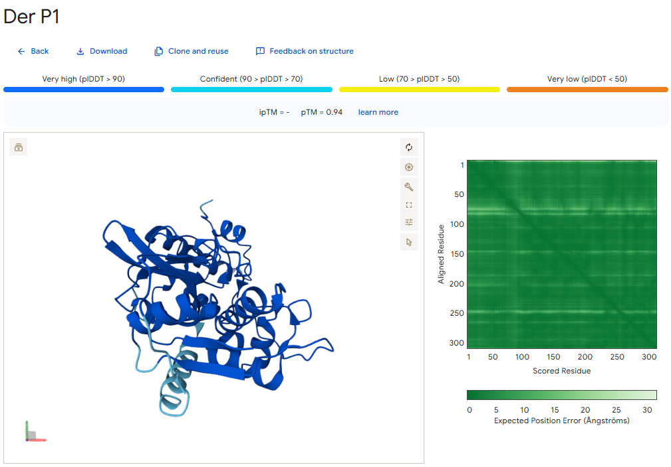
Fig. S1 AlphaFold 3-predicted tertiary structure of Der p 1 (pTM = 0.94). The predicted structure and predicted aligned error plot are shown

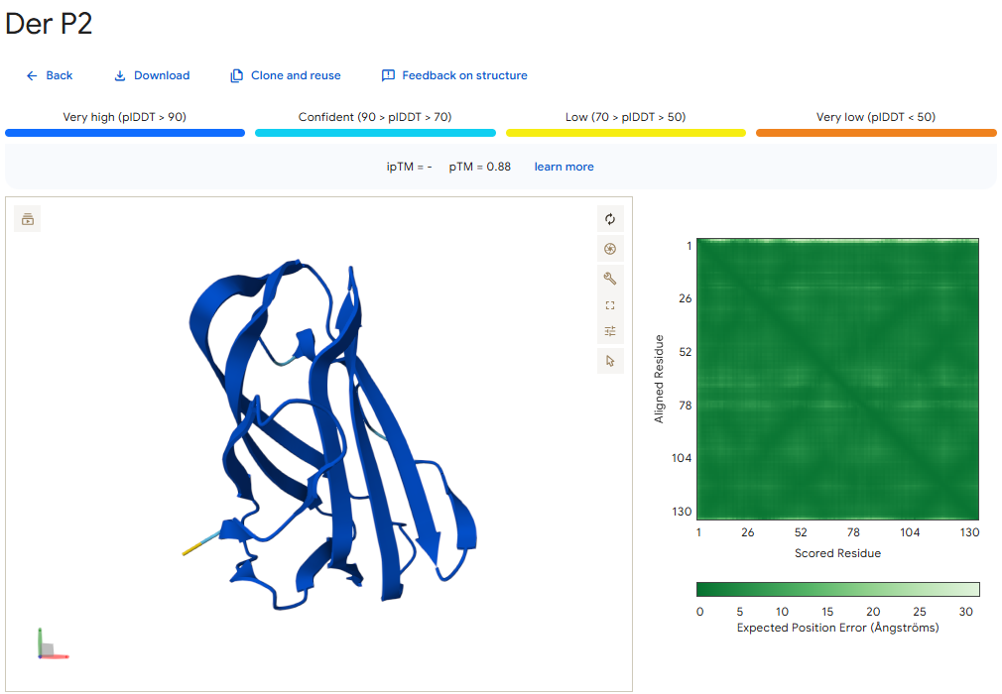
Fig. S2 AlphaFold 3-predicted tertiary structure of Der p 2 (pTM = 0.88). The predicted structure and predicted aligned error plot are shown

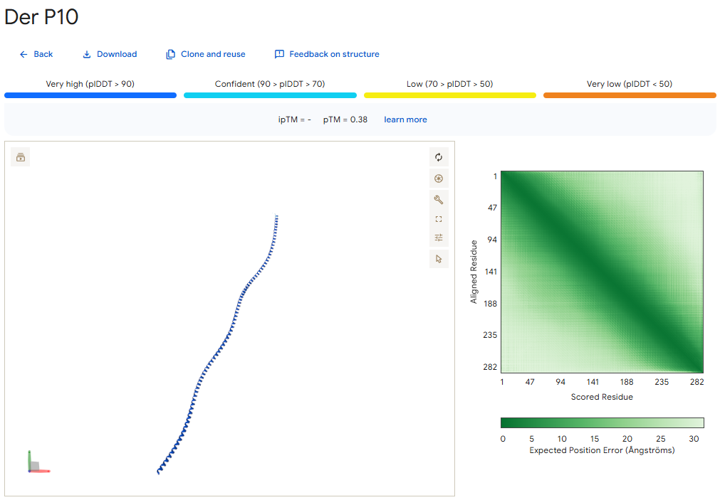
Fig. S3 AlphaFold 3-predicted tertiary structure of Der p 10 (pTM = 0.38). The predicted structure and predicted aligned error plot are shown; the low pTM value indicates limited confidence in the global model

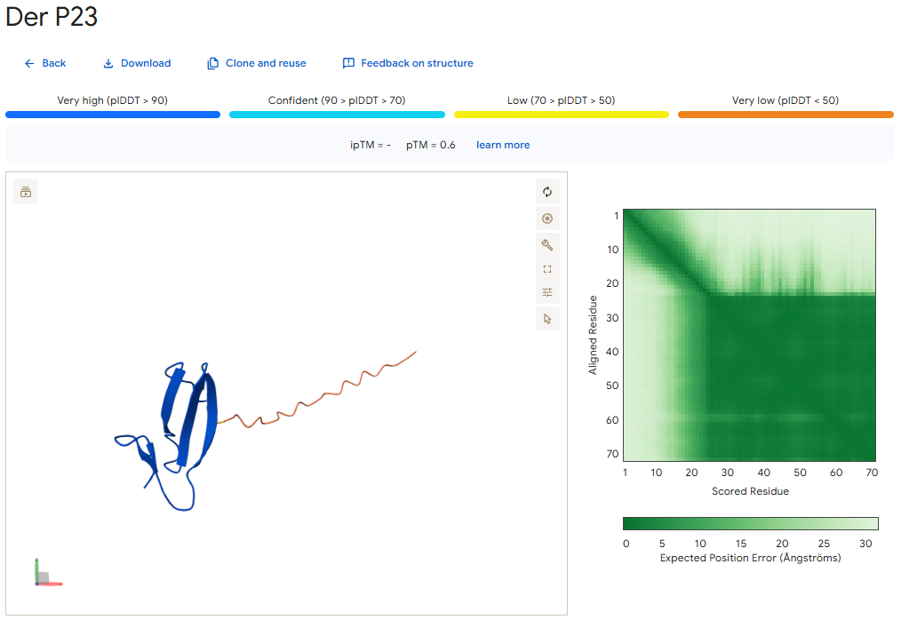
Fig. S4 AlphaFold 3-predicted tertiary structure of Der p 23 (pTM = 0.60). The predicted structure and predicted aligned error plot are shown; structural interpretation should account for the modest model confidence

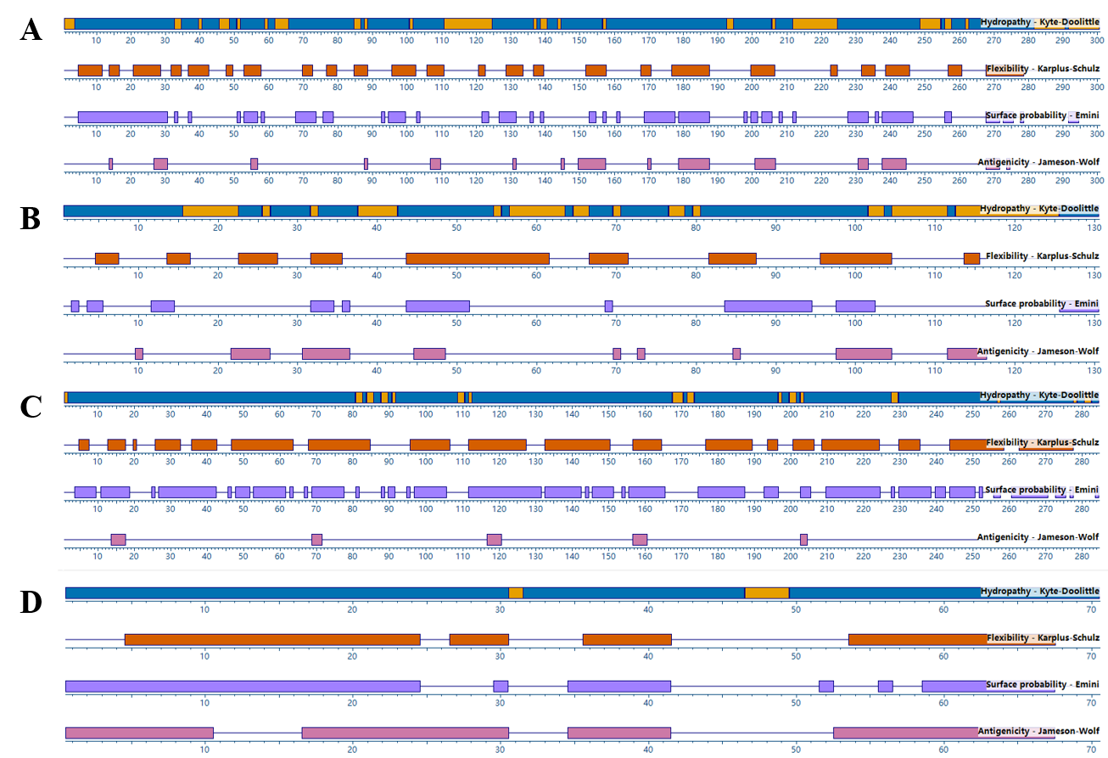
Fig. S5 DNAStar Protean profiles used to identify candidate linear B-cell epitope regions in (A) Der p 1, (B) Der p 2, (C) Der p 10, and (D) Der p 23. The displayed tracks include hydrophilicity, flexibility, surface probability, and antigenicity profiles

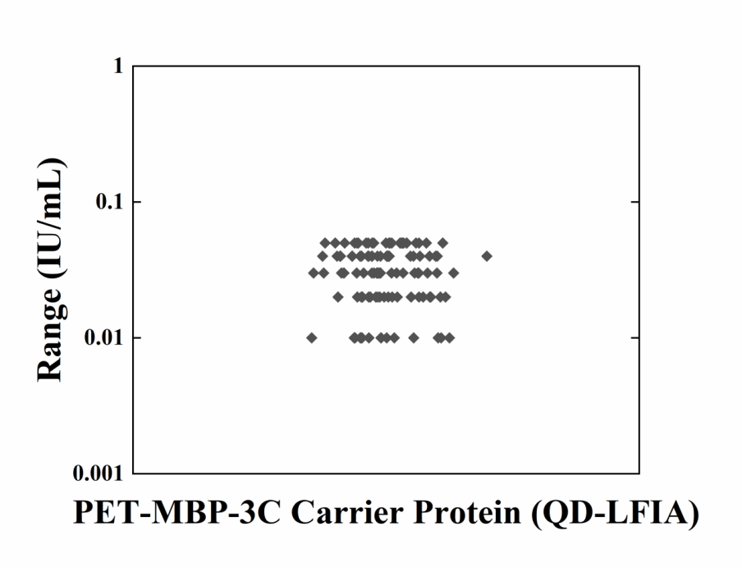
Fig. S6 Distribution of apparent IgE concentrations obtained with the MBP-control QD-LFIA in 112 residual serum samples

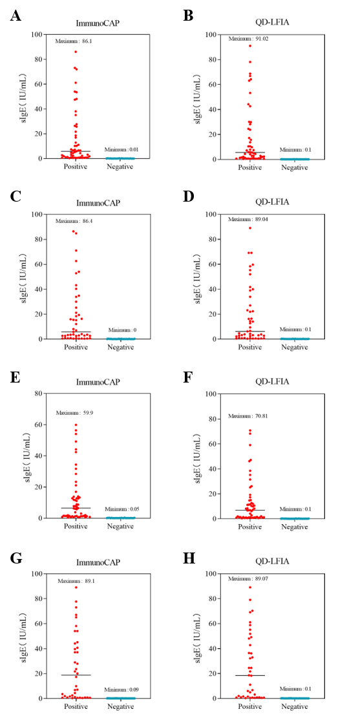
Fig. S7 Distribution of component-specific IgE concentrations measured using ImmunoCAP (A, C, E, G) and QD-LFIA (B, D, F, H): Der p 1 (A, B; n = 84), Der p 2 (C, D; n = 81), Der p 10 (E, F; n = 82), and Der p 23 (G, H; n = 91). The cutoff for a positive result was 0.35 IU/mL

