Supplementary Material

Spleen stiffness-based algorithm for predicting decompensation in treatment-naive HBV-HCC patients

Xiaofeng Zhang, Haoning Shen, Yin Peng, Hui Li, Qinjun He, Jing Huang, Junying Li, Wenfan Luo, Yali Ji, Xiaoqin Lan, Ling Zhou, Changze Hong, Xiaoqin Luo, Zheng Chen, Jinjun Chen, Xiao Cheng

Supplementary Table 1. Univariate and multivariate competing risk analysis for factors associated with liver-related death.
Variable | Univariable analysis |  | Multivariable analysis
Variable |  |  | Death_model 1 |  | Death_model 2
Variable | sHR (95% CI) | P value | sHR (95% CI) | P value | sHR (95% CI) | P value
Age | 0.98 (0.96-1.01) | 0.173
Male gender | 1.45 (0.66-3.19) | 0.349
Body mass index | 0.93 (0.86-0.99) | 0.032
Diabetes Mellitus | 0.63 (0.26-1.52) | 0.305 |  |  | 0.35 (0.09-1.35) | 0.130
HBV control baseline | 0.27 (0.14-0.51) | <0.001
BCLC classification
A | Reference | - | Reference | - | Reference | -
B | 4.12 (1.84-9.24) | 0.001 | 1.69 (0.76-3.75) | 0.200 | 1.83 (0.85-3.98) | 0.120
C | 11.08 (5.83-21.07) | <0.001 | 2.79 (1.29-6.04) | 0.009 | 3.12 (1.37-7.09) | 0.007
Laboratory tests
Platelet count | 1.00 (1.00-1.01) | <0.001
Total bilirubin | 1.02 (0.99-1.04) | 0.144 | 0.98 (0.95-1.01) | 0.140 | 0.97 (0.94-0.99) | 0.015
Albumin | 0.94 (0.91-0.98) | 0.001
Creatinine | 1.00 (0.98-1.02) | 0.913
INR | 3.22 (0.81-12.75) | 0.096 | 8.95 (2.34-34.28) | 0.001 | 7.61(1.86-31.21) | 0.005
HBV control follow up | 0.18 (0.10-0.30) | <0.001 | 0.26 (0.14-0.50) | <0.001 | 0.28 (0.14-0.58) | <0.001
CR of HCC treatment | 0.06 (0.02-0.14) | <0.001 | 0.11 (0.04-0.30) | <0.001 | 0.11 (0.04-0.33) | <0.001
LSM | 1.03 (1.02-1.04) | <0.001 | 1.01 (1.00-1.02) | 0.004
SSM | 1.02 (1.01-1.03) | <0.001 |  |  | 1.02 (1.00-1.03) | 0.007
BCLC, Barcelona Clinic Liver Cancer; CR, complete response; HBV, hepatitis B virus; HCC, hepatocellular carcinoma; INR, international normalized ratio; LSM, liver stiffness measurement; sHR, subdistribution hazard ratio; SSM, spleen stiffness measurement.

Supplementary Table 2. Time-dependent AUC with 95% confidence intervals and average C-index for hepatic decompensation (considering competing events) of the models.
Model | Apparent  AUC for  decompensation  at 1 year | Cross-validated  AUC for  decompensation  at 1 year | Apparent  AUC for  decompensation  at 2 years | Cross-validated  AUC for  decompensation  at 2 years | Apparent  C-index | Cross-  validated  C-index
Decom_model 1 | 0.868 | 0.833 | 0.815 | 0.789 | 0.788 | 0.784
Decom_model 2 | 0.878 | 0.852 | 0.836 | 0.810 | 0.809 | 0.808
MELD | 0.717 | 0.676 | 0.731 | 0.710 | 0.654 | 0.650
CTP | 0.673 | 0.611 | 0.709 | 0.631 | 0.599 | 0.600
ALBI | 0.718 | 0.676 | 0.766 | 0.722 | 0.689 | 0.684
AUC, areas under the curve; ALBI, Albumin-Bilirubin; CTP, Child-Turcotte-Pugh; MELD, Model for End-Stage Liver disease.

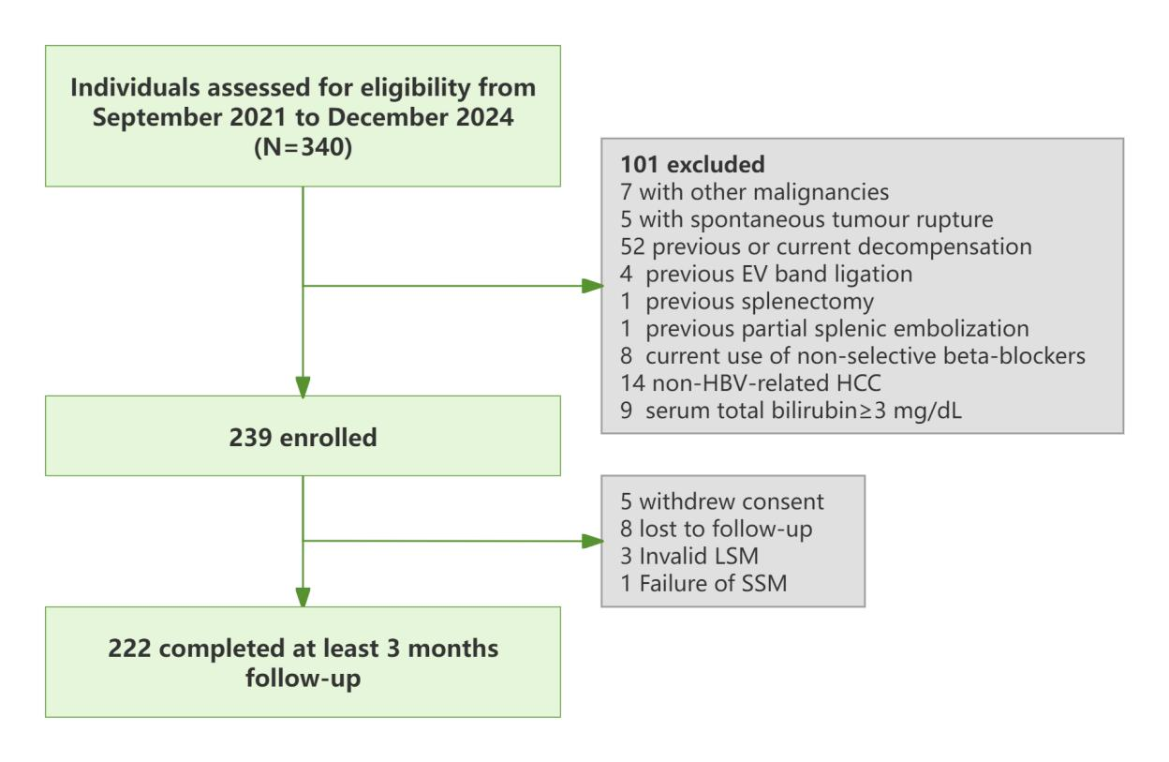
Figure S1. Flowchart of the enrollment. EV, esophageal varices; HCC, hepatocellular carcinoma; LSM, liver stiffness measurement; SSM, spleen stiffness measurement.

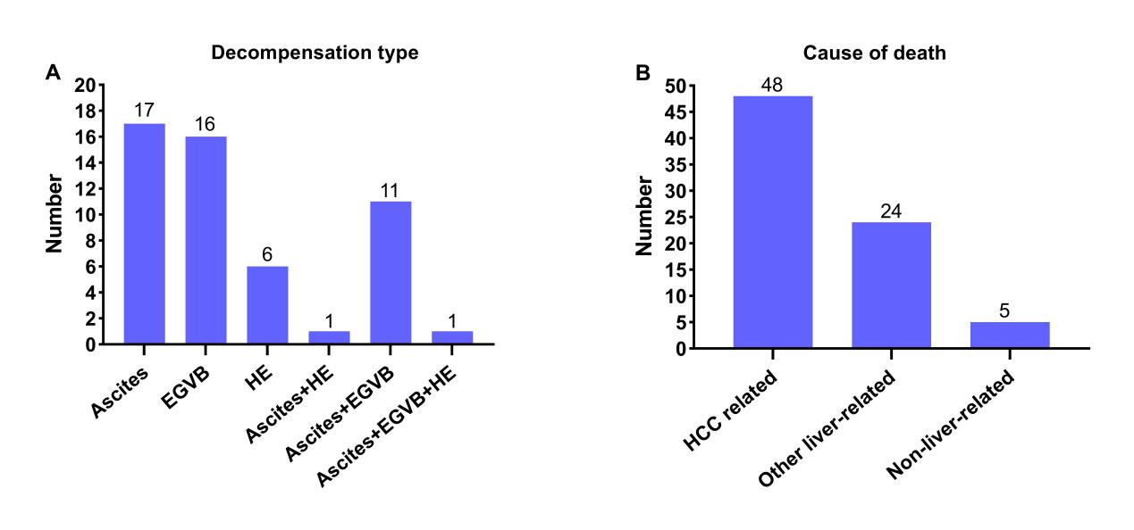
Figure S2. Types of first decompensation events (A) and causes of liver-related mortality (B).
EGVB, esophagogastric variceal bleeding; HE, hepatic encephalopathy; HCC, hepatocellular carcinoma.

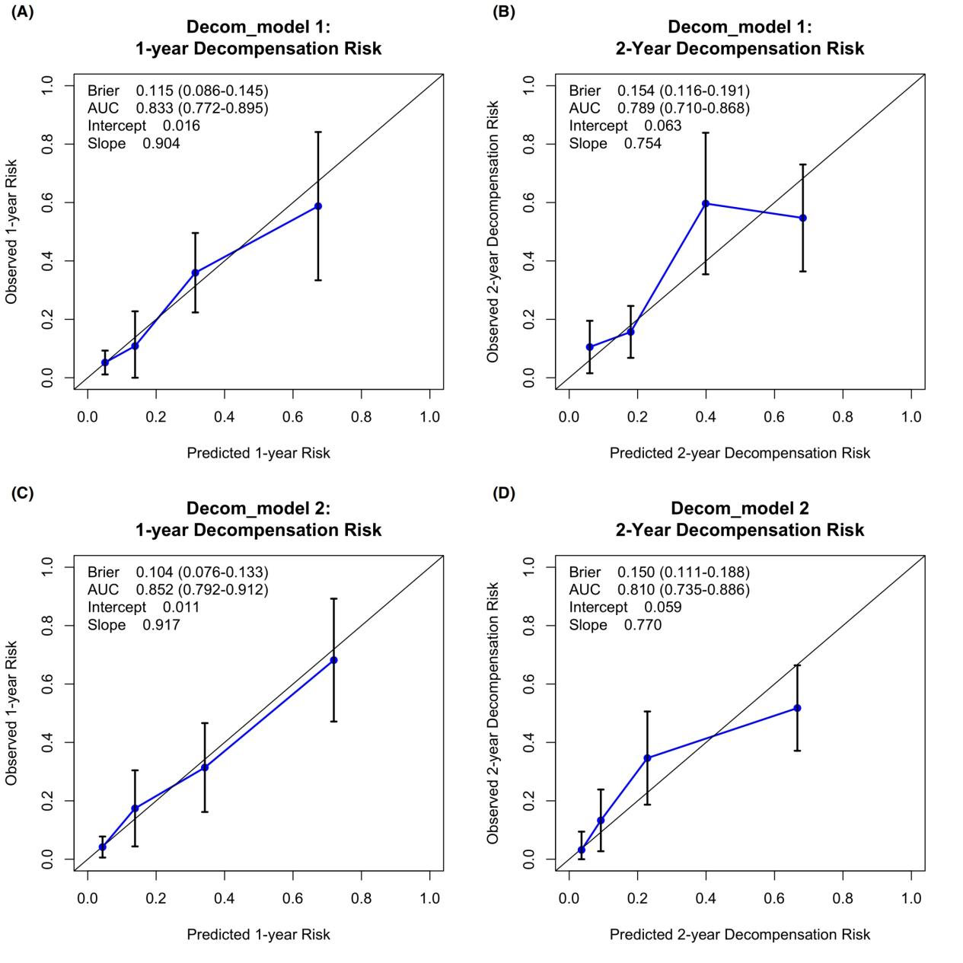
Figure S3. Calibration of decom_model 1 and decom_model 2 for predicting 1-year (A, C) and 2-year (B, D) decompensation risk. Plots compare the predicted probability (x-axis) against the observed proportion of events (y-axis). Perfect calibration corresponds to an intercept of 0 and a slope of 1; deviations indicate overestimation/underestimation or overfitting/underfitting, respectively.

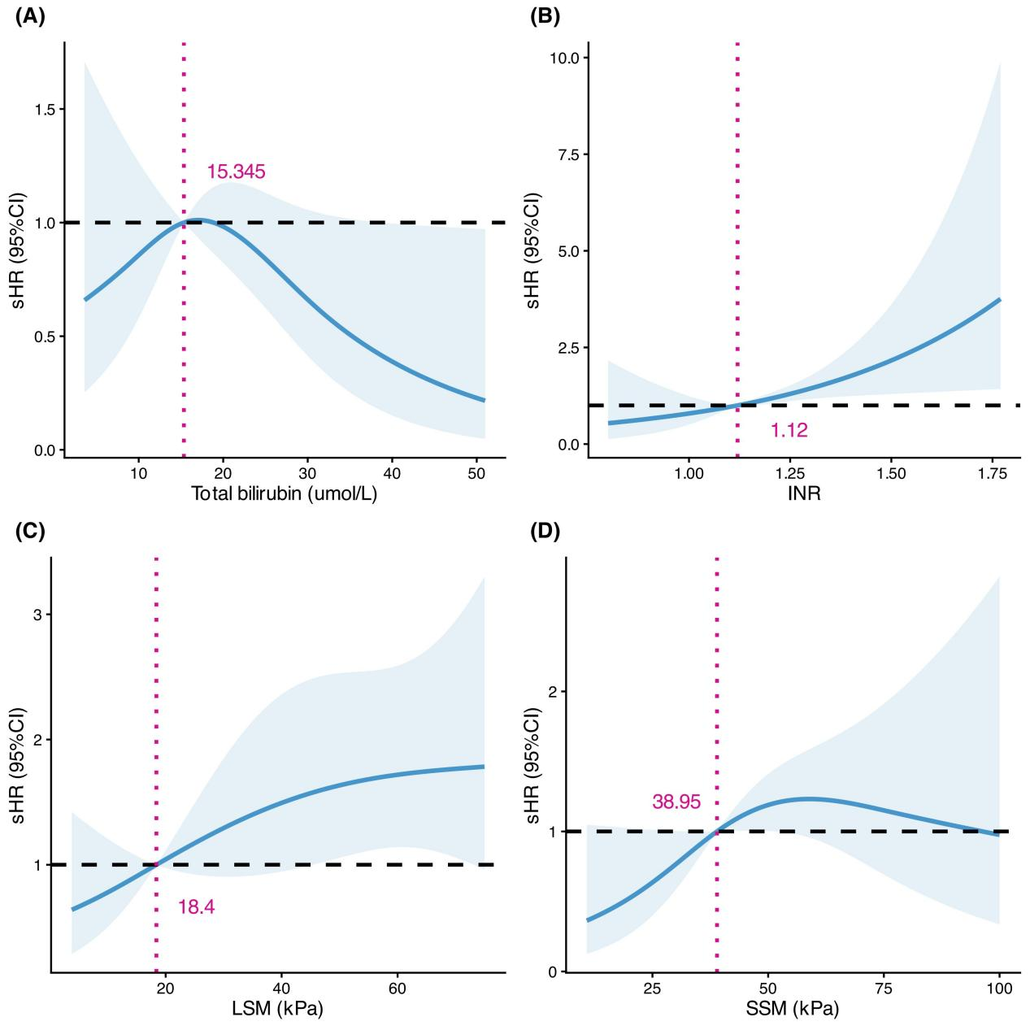

Figure S4. Relationship between the individual liver-related mortality risk predictors investigated in the study, i.e., (A) Total bilirubin, (B) INR, (C) LSM by VCTE, and the sHR for liver-related mortality. Models allowed non-linear terms with restricted cubic splines (three knots).
INR, international normalized ratio; LSM, liver stiffness measurement; sHR, subdistribution hazard ratio; VCTE, vibration-controlled transient elastography.

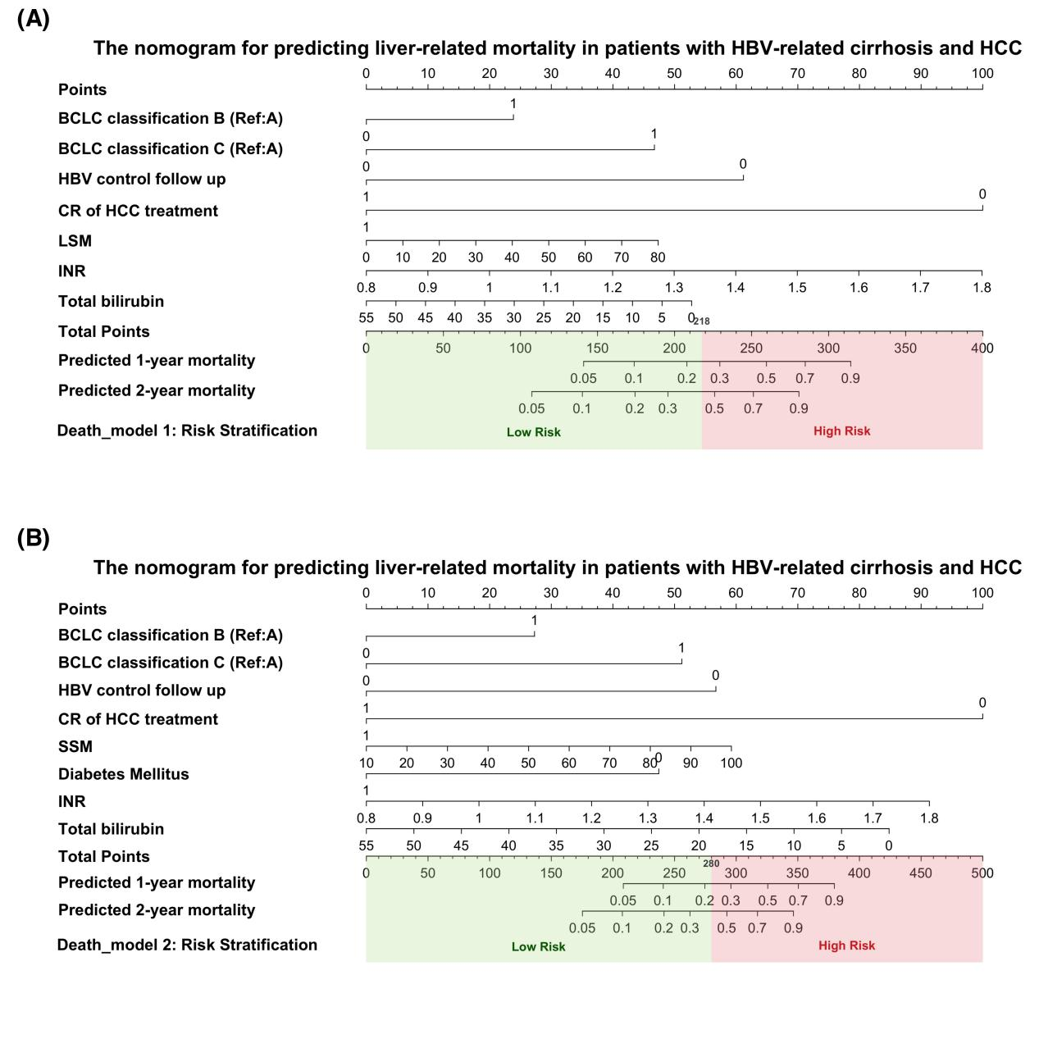
Figure S5. Nomograms based on LSM (A) and SSM (B) for predicting liver-related mortality in patients with HBV-related cirrhosis and HCC at 1 and 2 years.
BCLC, Barcelona Clinic Liver Cancer; CR, complete response; HBV, hepatitis B virus; HCC, hepatocellular carcinoma; INR, international normalized ratio; LSM, liver stiffness measurement; SSM, spleen stiffness measurement.

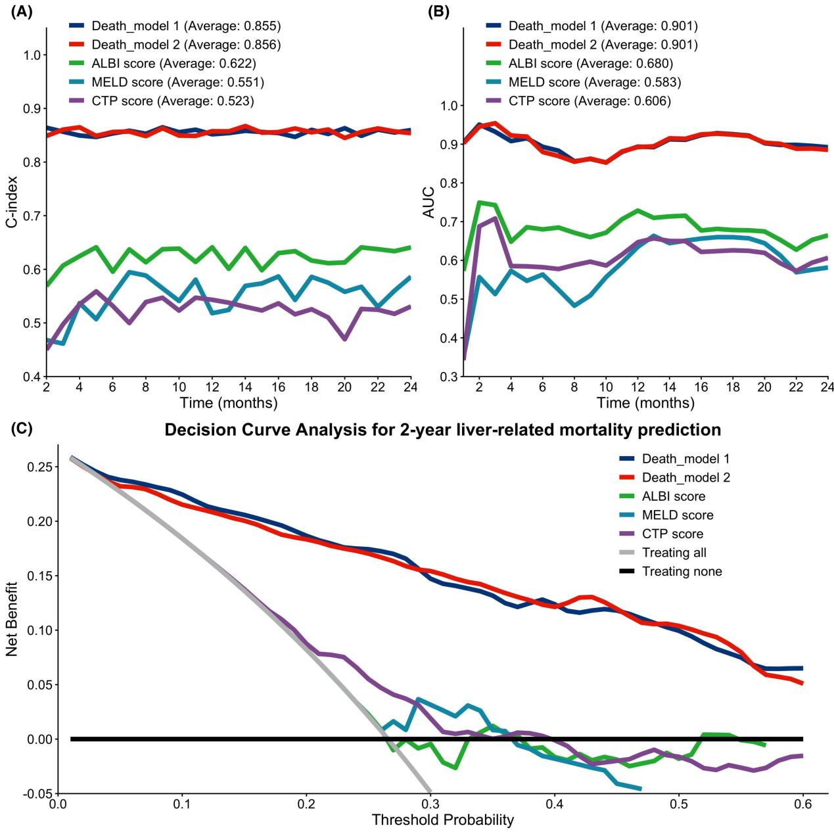
Figure S6. Time-dependent concordance index (A), AUC curves (B), and decision curve analysis (C) comparing death_model 1 and death_model 2 with MELD, Child-Turcotte-Pugh, and ALBI scores for predicting liver-related mortality in the same patient population.
AUC, area under curve; ALBI, Albumin-Bilirubin; HBV, hepatitis B virus; HCC, hepatocellular carcinoma; MELD, Model for End-Stage Liver disease.

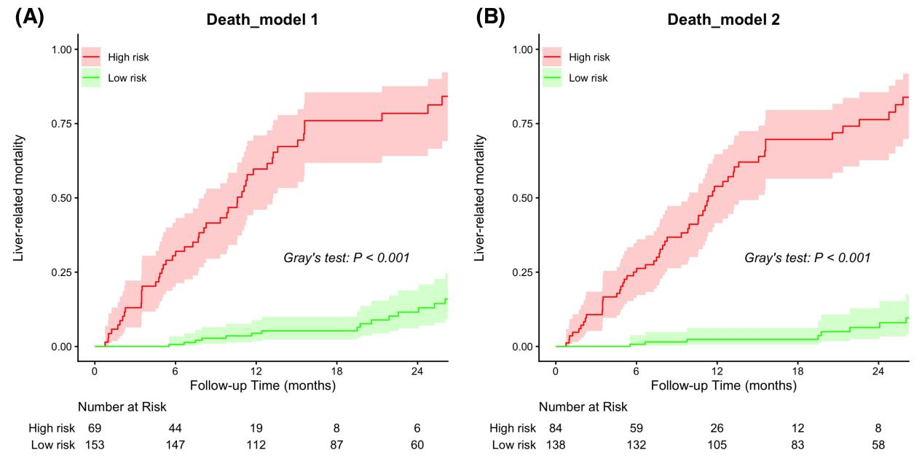
Figure S7. Cumulative liver-related death incidence in the low-risk and high-risk groups stratified according to (A) Death_model 1, (B) Death_model 2.

