Supplementary Material

Table A1 Overall MorFi data
 | Sugargraze |  |  |  |  |  |  |  |  |  |  |  | Yemen |  |  |  |  |  |  |  |  |  |  |  | GreenleafBMR |  |  |  |  |  |  |  |  |  | Graingrass
 | Leaf |  |  | Sheath |  |  | Stem(<1m) |  |  | Stem(>1m) |  |  | Leaf |  |  | Sheath |  |  | Stem(<1m) |  |  | Stem(>1m) |  |  | Leaf |  |  | Sheath |  |  | Stem |  |  |  | Leaf |  | Sheath |  |  |  | Stem
MorFi Output Variable | L | M | H | L | M | H | L | M | H | L | M | H | L | M | H | L | M | H | L | M | H | L | M | H | L | M | H | L | M | H |  | L | M | H | L | M | H | L | M | H | L | M | H
Number of analysed fibres | 50121 | 48924 | 34282 | 50104 | 50054 | 50073 | 50117 | 50046 | 50051 | 50111 | 50119 | 50121 | 50111 | 45143 | 27367 | 50099 | 50099 | 50079 | 50050 | 50133 | 34615 | 50153 | 50112 | 50101 | 50136 | 50134 | 39150 | 50151 | 50062 | 50089 |  | 50098 | 50090 | 50123 | 50081 | 50054 | 29131 | 50121 | 50136 | 50102 | 50158 | 50078 | 50112
Fibre content. millions/g of pulp | 34.7 | 26.5 | 64.2 | 36.6 | 40.2 | 51.9 | 30.6 | 35.7 | 44.8 | 44.2 | 49.7 | 59.3 | 44.2 | 41.9 | 70.9 | 33.8 | 35.9 | 46.6 | 27.3 | 31.4 | 41.4 | 38.2 | 42.9 | 54.2 | 48.8 | 54.7 | 79.2 | 53.3 | 61.0 | 84.1 |  | 46.2 | 47.5 | 63.5 | 39.0 | 47.2 | 79.7 | 60.6 | 64.3 | 82.9 | 61.3 | 66.8 | 79.4
Mean arithmetic length (µm) | 248.0 | 243.8 | 277.8 | 262.5 | 272.5 | 268.3 | 241.8 | 249.0 | 246.0 | 238.0 | 242.0 | 241.8 | 238.0 | 260.0 | 286.8 | 265.5 | 278.5 | 268.5 | 243.5 | 240.5 | 236.3 | 244.5 | 245.0 | 237.0 | 228.0 | 239.0 | 246.3 | 263.0 | 265.3 | 254.3 |  | 273.8 | 269.3 | 257.8 | 223.5 | 241.5 | 261.5 | 244.8 | 246.5 | 242.5 | 250.5 | 254.8 | 246.8
Mean length-weighted length (µm) | 354.0 | 355.5 | 369.0 | 373.8 | 379.3 | 361.5 | 342.5 | 349.8 | 337.3 | 324.3 | 325.8 | 320.8 | 324.3 | 378.8 | 386.0 | 398.5 | 405.5 | 374.3 | 342.3 | 333.8 | 320.5 | 343.8 | 341.0 | 320.5 | 321.8 | 329.8 | 324.8 | 359.5 | 356.5 | 327.3 |  | 391.8 | 381.0 | 354.5 | 332.8 | 350.0 | 344.8 | 327.5 | 325.5 | 312.0 | 347.3 | 351.5 | 331.0
Mean cubic-length-weigh. length (µm) | 485.5 | 497.0 | 472.0 | 515.3 | 508.5 | 474.3 | 494.3 | 493.5 | 461.5 | 449.0 | 440.8 | 427.5 | 449.0 | 524.3 | 499.8 | 575.0 | 564.8 | 506.3 | 488.3 | 470.5 | 436.3 | 491.3 | 480.8 | 436.5 | 454.0 | 449.5 | 425.5 | 483.0 | 471.8 | 417.8 |  | 555.0 | 534.0 | 485.0 | 496.3 | 493.5 | 444.0 | 437.5 | 429.5 | 402.0 | 483.3 | 486.0 | 444.8
Mean area-weighted length (µm) | 328.8 | 325.3 | 357.3 | 368.8 | 381.0 | 362.5 | 362.0 | 356.0 | 349.8 | 326.5 | 325.8 | 324.3 | 326.5 | 362.0 | 380.3 | 396.3 | 403.5 | 377.3 | 346.5 | 338.5 | 332.3 | 352.0 | 347.0 | 326.8 | 306.0 | 319.5 | 317.3 | 356.0 | 358.8 | 326.3 |  | 388.0 | 382.8 | 365.5 | 299.8 | 326.5 | 331.8 | 316.8 | 316.0 | 304.3 | 350.8 | 352.8 | 332.8
Mean fibre width (µm) | 17.85 | 18.43 | 13.75 | 17.65 | 16.70 | 15.60 | 23.25 | 21.35 | 18.90 | 18.23 | 17.10 | 16.08 | 18.23 | 15.88 | 13.08 | 18.60 | 17.95 | 16.73 | 25.13 | 23.08 | 19.38 | 20.80 | 19.18 | 17.30 | 16.20 | 14.85 | 13.05 | 15.35 | 14.43 | 13.13 |  | 17.88 | 17.80 | 15.85 | 18.55 | 16.13 | 12.33 | 14.95 | 14.53 | 13.10 | 16.03 | 15.05 | 13.90
Mean fibre coarseness (mg/m) | 0.098 | 0.127 | 0.046 | 0.086 | 0.078 | 0.061 | 0.118 | 0.100 | 0.079 | 0.079 | 0.069 | 0.058 | 0.079 | 0.075 | 0.040 | 0.093 | 0.086 | 0.069 | 0.135 | 0.118 | 0.088 | 0.092 | 0.083 | 0.067 | 0.071 | 0.061 | 0.041 | 0.056 | 0.049 | 0.037 |  | 0.066 | 0.067 | 0.051 | 0.092 | 0.070 | 0.036 | 0.052 | 0.050 | 0.038 | 0.051 | 0.046 | 0.040
Average kink number | 1.050 | 1.034 | 1.051 | 1.043 | 1.052 | 1.064 | 1.044 | 1.049 | 1.089 | 1.041 | 1.050 | 1.063 | 1.041 | 1.071 | 1.088 | 1.043 | 1.051 | 1.078 | 1.045 | 1.059 | 1.073 | 1.043 | 1.057 | 1.069 | 1.050 | 1.043 | 1.043 | 1.035 | 1.044 | 1.057 |  | 1.051 | 1.070 | 1.091 | 1.049 | 1.050 | 1.046 | 1.030 | 1.043 | 1.053 | 1.037 | 1.052 | 1.064
Average kink angle (°) | 132.3 | 123.1 | 135.5 | 115.9 | 130.1 | 132.8 | 110.1 | 122.2 | 129.1 | 115.3 | 124.6 | 130.3 | 115.3 | 133.7 | 134.1 | 112.4 | 128.2 | 133.0 | 108.9 | 125.8 | 131.1 | 108.3 | 124.9 | 130.9 | 119.6 | 130.0 | 133.9 | 113.7 | 123.2 | 131.3 |  | 115.1 | 126.8 | 130.0 | 118.0 | 129.4 | 134.9 | 114.1 | 123.1 | 130.4 | 108.7 | 121.1 | 129.0
Kinked fibre content (%) | 4.08 | 1.81 | 8.33 | 2.10 | 4.39 | 8.38 | 2.49 | 3.18 | 5.95 | 2.28 | 3.32 | 5.70 | 2.28 | 5.87 | 12.64 | 1.95 | 3.94 | 7.75 | 2.81 | 4.14 | 5.75 | 2.41 | 3.84 | 5.70 | 2.06 | 3.34 | 5.15 | 2.17 | 3.20 | 6.89 |  | 2.78 | 4.72 | 7.15 | 1.90 | 3.27 | 5.94 | 2.22 | 3.32 | 5.51 | 2.35 | 3.38 | 5.94
Mean fibre curl index (%) | 4.74 | 4.43 | 4.12 | 4.50 | 4.31 | 4.85 | 5.75 | 5.46 | 5.45 | 4.45 | 4.37 | 4.64 | 4.45 | 4.26 | 4.65 | 5.04 | 4.67 | 4.97 | 6.70 | 6.17 | 5.40 | 5.14 | 4.93 | 4.87 | 4.02 | 3.66 | 3.37 | 3.65 | 3.49 | 3.94 |  | 4.25 | 4.65 | 4.76 | 4.78 | 4.24 | 3.28 | 3.55 | 3.64 | 3.71 | 3.80 | 3.84 | 4.11
MacroFibrillation index (%) | 1.33 | 1.03 | 0.61 | 1.02 | 1.03 | 1.22 | 1.37 | 1.74 | 1.93 | 1.32 | 1.39 | 1.40 | 1.32 | 0.75 | 0.47 | 1.09 | 1.21 | 1.24 | 1.42 | 1.91 | 1.84 | 1.29 | 1.46 | 1.55 | 1.15 | 1.01 | 0.59 | 0.92 | 0.84 | 0.73 |  | 0.88 | 1.16 | 1.27 | 1.44 | 1.36 | 0.48 | 1.01 | 1.04 | 0.90 | 1.10 | 1.14 | 1.13
Broken fibre content (%) | 35.38 | 32.58 | 20.87 | 27.75 | 26.36 | 26.97 | 37.24 | 38.56 | 35.86 | 29.28 | 27.89 | 28.75 | 29.28 | 25.97 | 18.53 | 29.42 | 29.22 | 29.15 | 40.55 | 41.64 | 36.12 | 32.39 | 32.86 | 33.21 | 26.74 | 24.38 | 17.87 | 20.36 | 18.24 | 17.91 |  | 23.56 | 26.63 | 25.38 | 34.97 | 30.64 | 16.15 | 20.66 | 20.11 | 17.81 | 20.85 | 20.86 | 20.43
Number of analysed fines | 992819 | 1080922 | 563570 | 529012 | 540454 | 522690 | 273447 | 307595 | 615380 | 340176 | 324578 | 399984 | 340176 | 855617 | 260584 | 615747 | 541232 | 545758 | 267623 | 380588 | 575182 | 288068 | 315843 | 546162 | 676683 | 727133 | 429633 | 406109 | 402137 | 288818 |  | 194529 | 211407 | 298604 | 671564 | 786373 | 386837 | 365275 | 339271 | 297046 | 221539 | 223320 | 289482
Fines content. millions/g of pulp | 664.6 | 565.2 | 1012.0 | 370.5 | 416.7 | 521.0 | 159.9 | 210.1 | 531.5 | 289.4 | 310.1 | 455.8 | 289.4 | 764.2 | 641.2 | 398.6 | 372.3 | 488.3 | 140.2 | 229.8 | 665.6 | 211.1 | 260.0 | 571.6 | 636.9 | 767.3 | 778.2 | 414.6 | 469.1 | 463.6 |  | 171.8 | 192.0 | 363.9 | 506.1 | 717.8 | 1016.7 | 425.4 | 418.6 | 473.0 | 259.9 | 286.6 | 441.6
Fine content. % in area | 52.01 | 60.36 | 40.40 | 41.44 | 36.95 | 30.01 | 19.44 | 20.89 | 27.80 | 28.70 | 26.50 | 27.10 | 28.70 | 50.10 | 29.64 | 41.94 | 35.89 | 31.79 | 22.29 | 24.07 | 35.56 | 23.21 | 24.52 | 31.28 | 47.99 | 47.67 | 37.61 | 35.30 | 31.88 | 24.96 |  | 19.61 | 17.87 | 20.39 | 48.81 | 48.47 | 39.19 | 35.34 | 31.90 | 28.00 | 22.35 | 21.35 | 24.01
Fine content. % in length | 75.59 | 78.36 | 65.83 | 63.76 | 61.19 | 58.76 | 49.98 | 51.27 | 64.29 | 56.09 | 53.76 | 57.09 | 56.09 | 72.54 | 54.74 | 66.10 | 61.05 | 60.01 | 49.45 | 56.06 | 70.44 | 51.08 | 52.19 | 63.02 | 71.12 | 70.81 | 61.65 | 58.28 | 56.07 | 50.18 |  | 42.07 | 42.51 | 49.42 | 72.59 | 73.02 | 63.68 | 58.05 | 55.91 | 52.89 | 48.48 | 47.56 | 52.17
Fine content. % in length weighted in length | 67.94 | 71.02 | 58.36 | 54.32 | 52.23 | 50.26 | 39.71 | 41.06 | 56.32 | 45.41 | 43.49 | 47.72 | 45.41 | 64.37 | 44.63 | 56.05 | 50.79 | 51.06 | 39.56 | 46.89 | 63.68 | 40.51 | 42.18 | 54.99 | 62.61 | 62.53 | 52.31 | 47.51 | 45.70 | 38.81 |  | 29.07 | 30.65 | 38.44 | 62.03 | 62.93 | 54.92 | 47.90 | 45.10 | 41.55 | 34.99 | 34.08 | 39.92
Mean fine area (µm²) | 809.5 | 900.8 | 523.5 | 959.8 | 791.0 | 642.5 | 881.0 | 813.0 | 634.0 | 806.0 | 752.8 | 678.0 | 806.0 | 711.5 | 555.3 | 939.3 | 818.8 | 686.5 | 939.5 | 797.5 | 593.3 | 853.0 | 800.3 | 663.3 | 841.8 | 748.5 | 608.3 | 820.0 | 696.8 | 623.5 |  | 837.8 | 790.0 | 677.0 | 911.5 | 758.0 | 512.0 | 870.5 | 785.8 | 675.5 | 842.0 | 780.5 | 691.8
Mean fine length (µm) | 38.0 | 39.5 | 32.0 | 42.0 | 38.0 | 35.0 | 41.8 | 40.0 | 35.3 | 40.0 | 39.0 | 37.0 | 40.0 | 36.0 | 33.0 | 41.5 | 39.0 | 36.0 | 42.0 | 39.0 | 34.0 | 41.0 | 39.8 | 36.0 | 40.0 | 38.0 | 35.0 | 40.0 | 37.0 | 36.0 |  | 41.0 | 40.0 | 37.0 | 41.0 | 38.0 | 32.0 | 41.5 | 39.5 | 37.0 | 42.0 | 41.0 | 38.0

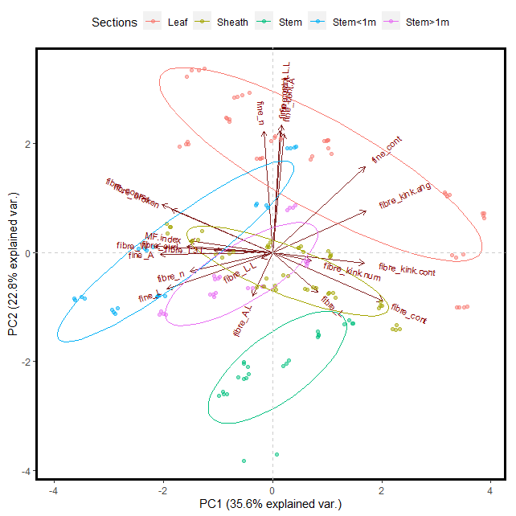
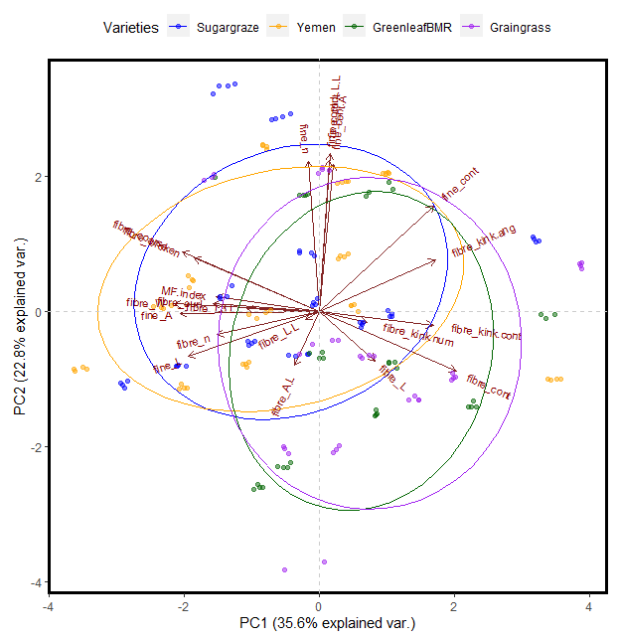
Figure A1 Principal Component Analyses for the relationships between MorFi parameters, grouped by: (a) Plant section, and (b) Sorghum variety

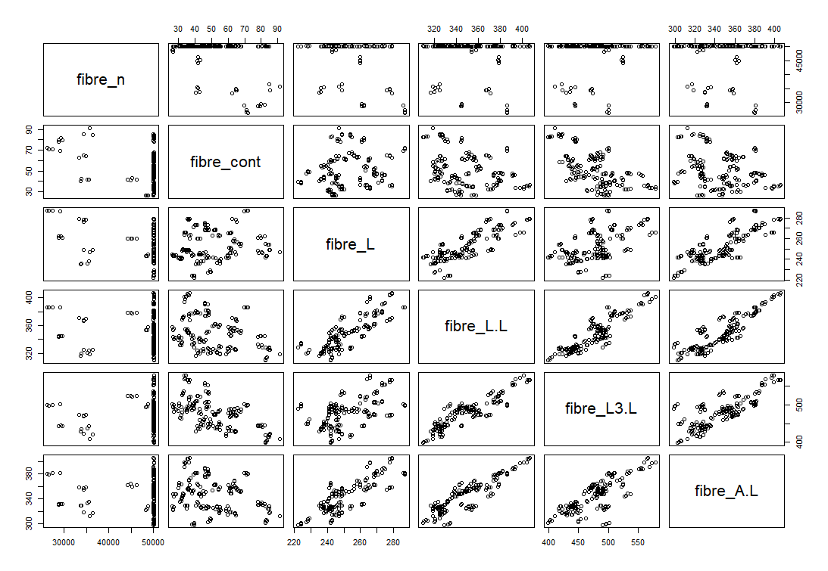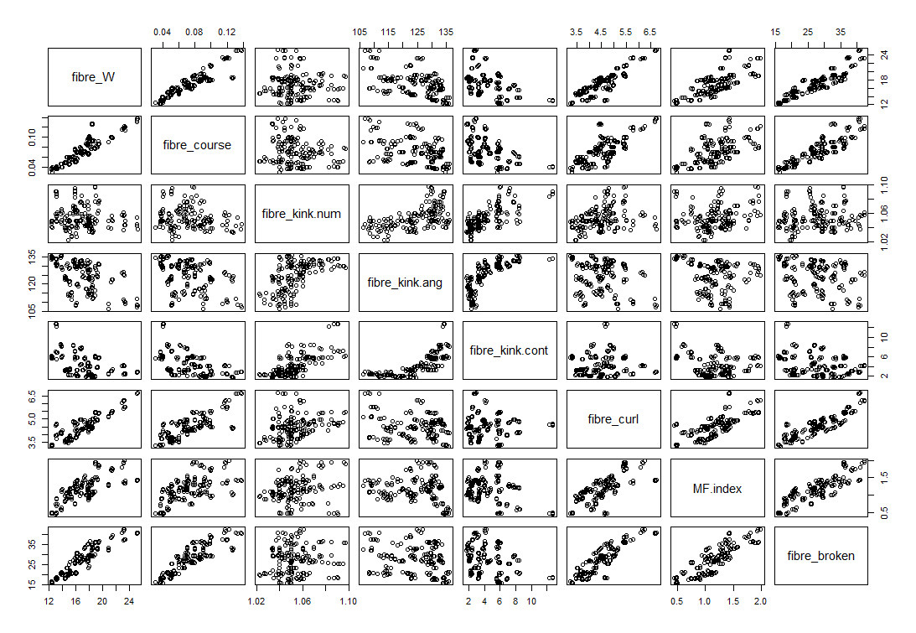
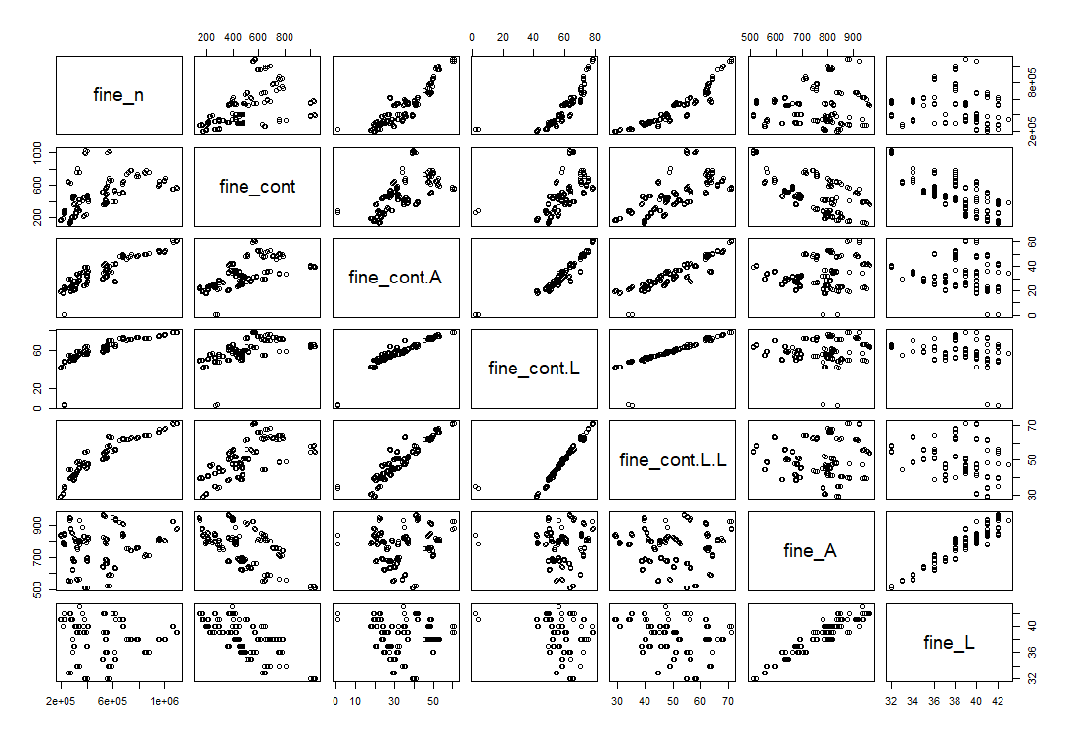
Figure A2 Pairwise correlation scatterplots for all MorFi parameter

Table A2 Overview of multiple linear regression parameters and coefficients
Multiple Linear Regression
 | Young's Modulus |  |  |  |  | Strain at break |  |  |  |  | Tensile Index |  |  |  |  | Toughness
MorFi Parameter | Estimate | SE | tStat | pValue | Signif. | Estimate | SE | tStat | pValue | Signif. | Estimate | SE | tStat | pValue | Signif. | Estimate | SE | tStat | pValue | Signif.
Intercept | -0.02 | 0.02 | -0.97 | 3.4E-01 |  | -0.01 | 0.04 | -0.26 | 8.0E-01 |  | -0.02 | 0.03 | -0.58 | 5.6E-01 |  | 0.00 | 0.03 | -0.11 | 9.1E-01
fibre_n | 0.38 | 0.08 | 4.55 | 1.1E-05 | ** | 0.36 | 0.14 | 2.57 | 1.1E-02 | * | 0.23 | 0.10 | 2.19 | 3.0E-02 | * | 0.49 | 0.11 | 4.56 | 1.1E-05 | **
fibre_cont | 1.61 | 0.20 | 8.08 | 2.4E-13 | ** | 0.99 | 0.34 | 2.93 | 4.0E-03 | ** | 0.99 | 0.25 | 3.98 | 1.1E-04 | ** | 1.17 | 0.26 | 4.55 | 1.1E-05 | **
fibre_L | 0.28 | 0.39 | 0.71 | 4.8E-01 |  | -1.83 | 0.65 | -2.80 | 5.9E-03 | ** | -0.71 | 0.48 | -1.48 | 1.4E-01 |  | -1.54 | 0.50 | -3.08 | 2.5E-03 | **
fibre_L.L | -0.51 | 0.74 | -0.70 | 4.9E-01 |  | 1.70 | 1.24 | 1.37 | 1.7E-01 |  | -0.13 | 0.91 | -0.15 | 8.8E-01 |  | 0.90 | 0.95 | 0.95 | 3.4E-01
fibre_L3.L | 0.99 | 0.43 | 2.29 | 2.3E-02 | * | -1.02 | 0.73 | -1.40 | 1.6E-01 |  | -0.07 | 0.54 | -0.14 | 8.9E-01 |  | -0.64 | 0.56 | -1.15 | 2.5E-01
fibre_A.L | 0.02 | 0.19 | 0.10 | 9.2E-01 |  | 1.53 | 0.32 | 4.76 | 4.8E-06 | ** | 1.49 | 0.24 | 6.29 | 3.6E-09 | ** | 1.68 | 0.25 | 6.79 | 2.7E-10 | **
fibre_W | 0.13 | 0.35 | 0.38 | 7.1E-01 |  | 1.35 | 0.60 | 2.27 | 2.5E-02 | * | -0.63 | 0.44 | -1.44 | 1.5E-01 |  | 0.70 | 0.45 | 1.53 | 1.3E-01
fibre_course | 0.07 | 0.23 | 0.30 | 7.6E-01 |  | -1.09 | 0.39 | -2.78 | 6.1E-03 | ** | -0.40 | 0.29 | -1.40 | 1.6E-01 |  | -0.44 | 0.30 | -1.46 | 1.5E-01
fibre_kink.num | 0.13 | 0.05 | 2.53 | 1.3E-02 | * | -0.14 | 0.09 | -1.65 | 1.0E-01 |  | -0.06 | 0.06 | -0.89 | 3.8E-01 |  | -0.07 | 0.07 | -0.98 | 3.3E-01
fibre_kink.ang | -0.25 | 0.10 | -2.66 | 8.6E-03 | ** | 0.11 | 0.16 | 0.71 | 4.8E-01 |  | -0.26 | 0.12 | -2.17 | 3.2E-02 | * | -0.07 | 0.12 | -0.59 | 5.5E-01
fibre_kink.cont | 0.25 | 0.15 | 1.72 | 8.8E-02 |  | 0.98 | 0.25 | 3.93 | 1.3E-04 | ** | 0.41 | 0.18 | 2.23 | 2.7E-02 | * | 1.07 | 0.19 | 5.63 | 9.4E-08 | **
fibre_curl | -0.04 | 0.21 | -0.19 | 8.5E-01 |  | 0.35 | 0.35 | 0.99 | 3.3E-01 |  | 0.21 | 0.26 | 0.82 | 4.1E-01 |  | 0.18 | 0.27 | 0.65 | 5.2E-01
MF.index | 0.88 | 0.14 | 6.35 | 2.7E-09 | ** | 0.74 | 0.24 | 3.14 | 2.1E-03 | ** | 1.27 | 0.17 | 7.34 | 1.5E-11 | ** | 0.90 | 0.18 | 5.02 | 1.5E-06 | **
fibre_broken | 0.09 | 0.22 | 0.42 | 6.8E-01 |  | -0.68 | 0.38 | -1.81 | 7.3E-02 |  | 0.21 | 0.28 | 0.74 | 4.6E-01 |  | -0.39 | 0.29 | -1.34 | 1.8E-01
fine_n | -1.34 | 0.20 | -6.55 | 9.5E-10 | ** | -0.91 | 0.34 | -2.64 | 9.2E-03 | ** | -0.89 | 0.25 | -3.50 | 6.1E-04 | ** | -1.12 | 0.26 | -4.27 | 3.6E-05 | **
fine_cont | -0.92 | 0.17 | -5.44 | 2.3E-07 | ** | -1.73 | 0.29 | -6.04 | 1.3E-08 | ** | -1.04 | 0.21 | -4.93 | 2.3E-06 | ** | -1.20 | 0.22 | -5.46 | 2.0E-07 | **
fine_cont.A | 3.51 | 0.47 | 7.40 | 1.1E-11 | ** | 4.26 | 0.80 | 5.32 | 4.0E-07 | ** | 4.56 | 0.59 | 7.73 | 1.8E-12 | ** | 4.55 | 0.61 | 7.43 | 9.0E-12 | **
fine_cont.L | -4.66 | 0.72 | -6.47 | 1.5E-09 | ** | -4.33 | 1.22 | -3.56 | 5.0E-04 | ** | -5.11 | 0.90 | -5.71 | 6.2E-08 | ** | -4.21 | 0.93 | -4.53 | 1.2E-05 | **
fine_cont.L.L | 4.34 | 0.73 | 5.98 | 1.7E-08 | ** | 3.76 | 1.22 | 3.07 | 2.6E-03 | ** | 3.19 | 0.90 | 3.54 | 5.3E-04 | ** | 3.09 | 0.94 | 3.31 | 1.2E-03 | **
fine_A | -1.83 | 0.34 | -5.33 | 3.7E-07 | ** | -2.24 | 0.58 | -3.88 | 1.6E-04 | ** | -1.73 | 0.43 | -4.06 | 8.0E-05 | ** | -2.06 | 0.44 | -4.66 | 7.2E-06 | **
fine_L | 0.70 | 0.28 | 2.49 | 1.4E-02 | * | 1.38 | 0.47 | 2.93 | 4.0E-03 | ** | 0.85 | 0.35 | 2.45 | 1.5E-02 | * | 1.17 | 0.36 | 3.24 | 1.5E-03 | **

Table A3 Overview of support vector regression parameters and coefficients
Support Vector Regression
Parameters | Toughness | Tensile Index | Strain at break | Young's modulus
Kernel function | 2nd degree polynomial | 2nd degree polynomial | 2nd degree polynomial | 2nd degree polynomial
Box constraint | 0.776 | 13.536 | 0.61 | 0.864
ε | 0.078 | 1.354 | 0.061 | 0.086
R² | 0.98 | 0.99 | 0.98 | 0.99
NRMSE | 0.28 | 0.23 | 0.33 | 0.13

