Supplementary material: Normative values and cut-points for online administration of the Personal Wellbeing Index: A nationally representative study of Australian adults

Title: Normative values and cut-points for online administration of the Personal Wellbeing Index: A nationally representative study of Australian adults
Journal name: Quality of Life Research

Sarah P H Khor^{1,2,*}, Georgie Frykberg^{1,3}, Tanja Capic¹, Andrew C. Ward⁴, Matthew Fuller-Tyszkiewicz¹, Matthew Iasiello^{5,6}, Robert A Cummins¹, Rebecca Davey¹, Melissa Kennedy¹, Delyse Hutchinson^{1,8,9,10}, Craig A Olsson^{1,7}, Kate Lycett^{1,3}

¹Deakin Lifespan Institute, School of Psychology, Faculty of Health, Deakin University, Burwood, Australia
²School of Psychology, Faculty of Medicine, Monash University, Clayton, Australia
³Centre for Community Child Health, Murdoch Children’s Research Institute, Melbourne, Australia
⁴Social Research Centre, Australian National University, Canberra, Australia
⁵School of Pharmacy and Biomedical Science, Adelaide University, Adelaide, South Australia, Australia
⁶Be Well Co, North Sydney, New South Wales, Australia
⁷LifeCourse, Murdoch Children’s Research Institute, Melbourne, Australia
⁸The University of New South Wales, National Drug and Alcohol Research Centre, Sydney, Australia
⁹Centre for Adolescent Health, Murdoch Children’s Research Institute, Melbourne, Australia
¹⁰University of Melbourne, Department of Paediatrics, Royal Children's Hospital, Melbourne, Australia

*Corresponding author: 221 Burwood Highway, Burwood. Email: sarah.khor@deakin.edu.au

Table of contents

1 Supplementary Material A: PWI scale validation by Item Response Theory 3
2 Supplementary Material B: Bootstrapped sampling normative ranges for PWI and scale items. 9
3 Supplementary Material C: ROC analysis of the DASS-21 with PWI with and without sample weights 17
4 Supplementary Material D: Descriptive statistics for the PWI and individual items. 21
5 Supplementary Material E: Classification performance for PWI against the DASS-21. 22
References 26

Supplementary Material A: PWI scale validation by Item Response Theory

Methods

Scale validation by Item Response Theory
Analyses were run utilising weighted data in Stata 16.[1] [1] Preliminary analysis was conducted to understand the sample characteristics and descriptive statistics for the scale items. PWI items were treated as ordinal variables. Polychoric correlations and confirmatory factor analysis were conducted to establish reliability and internal consistency and to confirm that items were explained by a single latent factor.
A weighted item response theory graded response model[2] was run to evaluate the psychometric properties of the scale composed of polytomous items. Discrimination (a) were examined for their ability to differentiate individuals at different trait levels while difficulty parameters (b) determined the consistency in which respondents select items’ categories to provide a directionality for the scale that is ordered and incremental. Residual correlations were examined for local dependency. To demonstrate suitability for the scale to measure group and individual-level differences, measurement precision was determined using the marginal and separation reliability, along with the test information characteristics.
To demonstrate convergent validity, a single-stepped robust multiple regression model was fitted using the individual subjective wellbeing items and Global Life Satisfaction (GLS; satisfaction with life as a whole) as independent and dependent variables respectively.

Results

Reliability and internal consistency
Polychoric correlations (Table 1.1) between all items greater than 0.30, indicating that these were measuring the same construct. Bartlett’s test of sphericity was significant for item- intercorrelation (χ²(21) = 42023, p < .001). The Kaiser-Meyer-Olkin measure for sampling adequacy was excellent (0.92) for factor analysis and subsequent principal components factor analysis utilising Kaiser’s criterion (Figure 1.1) showed items were explained best by a single latent factor. Ordinal reliability[3] of 0.93 indicated excellent internal consistency.

Table 1.1 Polychoric correlations and factor analysis between items forming the PWI.
 | 1. | 2. | 3. | 4. | 5. | 6. | Factor loading | Uniqueness
1. Standard of living | - |  |  |  |  |  | .80 | .36
2. Health | 0.60 | - |  |  |  |  | .71 | .49
3. Achieving in life | 0.69 | 0.67 | - |  |  |  | .85 | .28
4. Relationships | 0.54 | 0.48 | 0.64 | - |  |  | .71 | .49
5. Safety | 0.60 | 0.50 | 0.55 | 0.54 | - |  | .73 | .46
6. Community connectedness | 0.58 | 0.53 | 0.65 | 0.58 | 0.60 | - | .78 | .39
7. Future security | 0.70 | 0.56 | 0.70 | 0.58 | 0.65 | 0.68 | .84 | .29

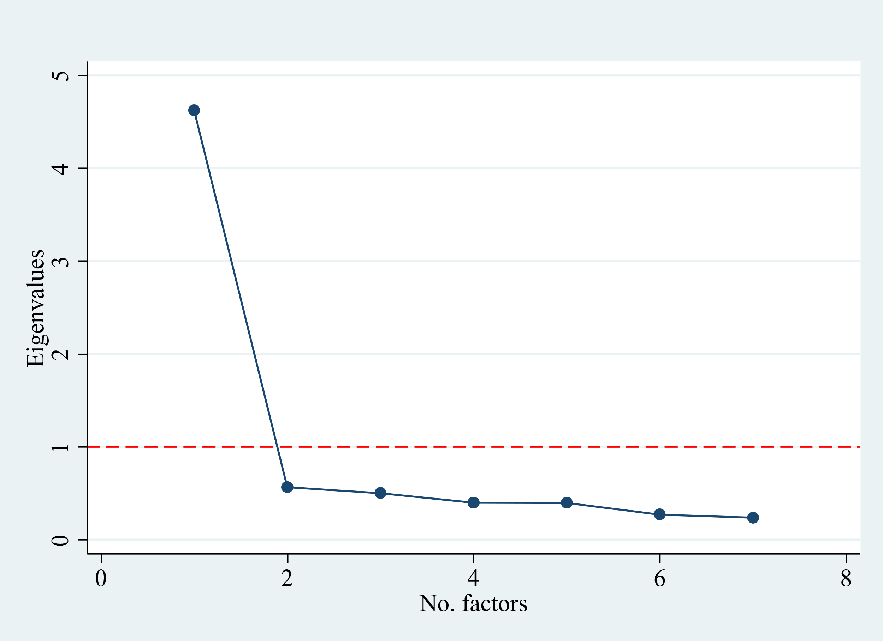
Figure 1.1 Screeplot for PWI following confirmatory factor analysis.

Item Response Theory model
Item parameters were estimated using the graded response model and residual correlations revealed local dependencies between the following items: Standard of living and Community connectedness (r_{p} = .26), Health and Future security (r_{p} = .22), Levels of achieving and Personal safety (r_{p} = .27).
Discrimination parameters are high (a = 1.96 to 3.06), indicating that items were effective at differentiating between individuals across the construct levels (Table 1.2). Difficulty thresholds (β) for all items were ordered from lowest to highest, indicating that response categories functioned as expected, where higher categories corresponded to higher levels of wellbeing. Category characteristic curve peaks across all PWI items (see exemplar in Figure 1.2) were consistent with difficulty threshold patterns and showed that the scale increases monotonically along the latent trait level (θ).
Marginal reliability (.93) and separation reliability (.92) were high and indicated that the scale on average provides precise estimates and differentiates individuals across levels of personal wellbeing. Examination of the test information criteria showed measurement precision held (Information > 10) for individuals spanning across the ±2 θ range (Figure 1.3). This indicates that the PWI is most reliable between the scores of 29 and 95, corresponding to the ±2 θ range.

Table 1.2 Discrimination parameters and difficulty thresholds for the PWI domains following analysis by item response theory graded response model.
Domain | Discrimination, a (SE) | Threshold parameters, β (SE)
Domain | Discrimination, a (SE) | ≥10 | ≥20 | ≥30 | ≥40 | ≥50 | ≥60 | ≥70 | ≥80 | ≥90 | =100
1. Standard of living | 2.67  (0.06) | −3.15 (0.08) | −2.72 (0.06) | −2.34 (0.05) | −1.87 (0.04) | −1.49 (0.03) | −1.03 (0.02) | −0.54 (0.02) | 0.12 (0.02) | 0.92 (0.02) | 1.61 (0.03)
2. Health | 1.93  (0.04) | −3.45 (0.09) | −2.90 (0.07) | −2.41 (0.05) | −1.84 (0.04) | −1.37 (0.03) | −0.86 (0.03) | −0.28 (0.02) | 0.45 (0.02) | 1.37 (0.03) | 2.38 (0.05)
3. Achieving in life | 3.05  (0.07) | −2.59 (0.06) | −2.20 (0.04) | −1.80 (0.04) | −1.43 (0.03) | −1.10 (0.02) | −0.66 (0.02) | −0.19 (0.02) | 0.42 (0.02) | 1.14 (0.02) | 1.91 (0.03)
4. Relationships | 1.96  (0.04) | −3.07 (0.08) | −2.64 (0.06) | −2.64 (0.06) | −1.81 (0.04) | −1.49 (0.03) | −0.98 (0.03) | −0.57 (0.02) | 0.00 (0.02) | 0.71 (0.02) | 1.48 (0.03)
5. Safety | 2.06  (0.05) | −3.60 (0.10) | −3.07 (0.08) | −2.67 (0.06) | −2.27 (0.05) | −1.92 (0.04) | −1.38 (0.03) | −0.97 (0.03) | −0.32 (0.02) | 0.49 (0.02) | 1.38 (0.03)
6. Community connectedness | 2.42  (0.05) | −2.67 (0.06) | −2.25 (0.04) | −1.87 (0.04) | −1.49 (0.03) | −1.19 (0.03) | −0.63 (0.02) | −0.16 (0.02) | 0.42 (0.02) | 1.10 (0.02) | 1.83 (0.03)
7. Future security | 3.04  (0.07) | −2.37 (0.05) | −1.96 (0.04) | −1.65 (0.03) | −1.30 (0.03) | −1.00 (0.02) | −0.54 (0.02) | −0.12 (0.02) | 0.42 (0.02) | 1.07 (0.02) | 1.76 (0.03)

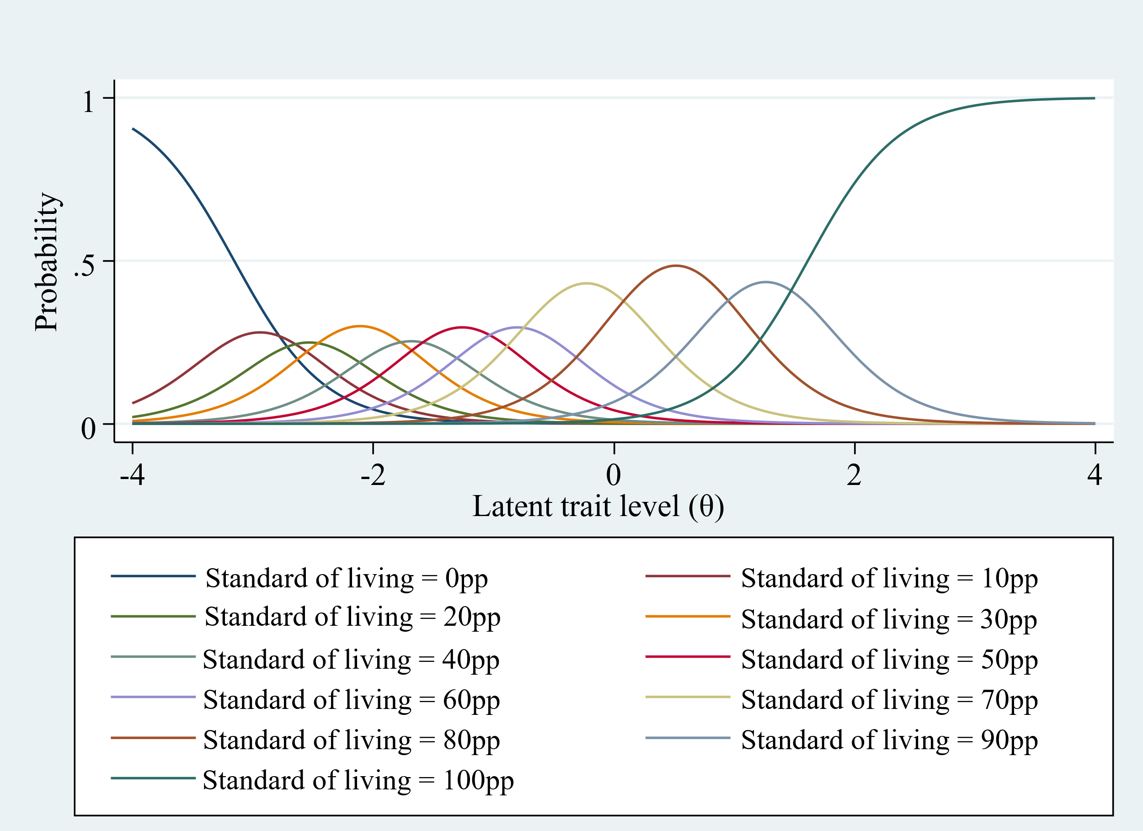
Figure 1.2 Exemplar category characteristic curve for satisfaction with standard of living item in the PWI.

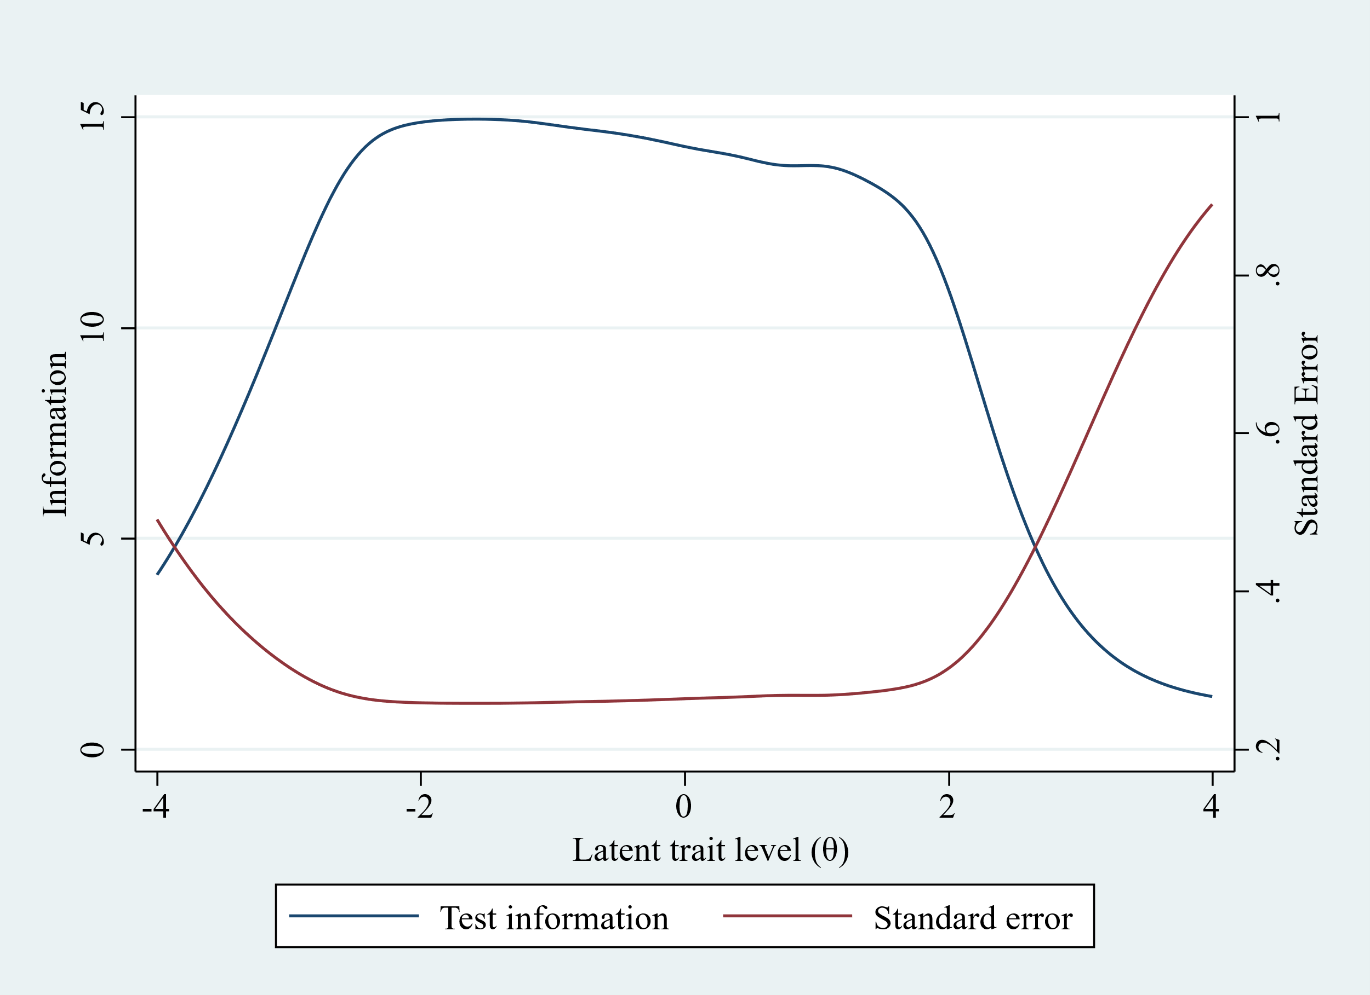
Figure 1.3 The test information function is the inverse of the standard error and shows the measurement precision of the scale across the trait level. High information = high measurement reliability.

Convergent validity
Multicollinearity was not detected (VIF<5) for individual wellbeing items when fitted against an overall GLS in multiple regression analysis. All individual items were significant contributors to GLS (Table 2) except for satisfaction with safety, however, this was retained for comparability with other countries that show a relationship between safety and PWI. Consistent with previous results,[4] standard of living (b = .23), levels of achieving (b = .31) and interpersonal relationships (b = .15) were the largest contributors to GLS and the total variance explained by the model is 72.1%.

Table 1.2 Weighted linear regression analysis for subjective wellbeing items on to global life satisfaction (GLS)
 | b | SE | T-statistic
Standard of living | 0.230*** | 0.015 | 15.66
Personal health | 0.101*** | 0.011 | 9.01
Levels of achieving | 0.314*** | 0.015 | 21.55
Interpersonal relations | 0.149*** | 0.010 | 14.19
Personal safety | -0.008 | 0.012 | -0.68
Community connectedness | 0.047*** | 0.010 | 4.65
Future security | 0.069*** | 0.012 | 5.85
Note. Weighted analysis was applied and robust standard errors used. N = 9946. F(7, 9938) = 1629.92. *** p < 0.001

Supplementary Material B: Bootstrapped sampling normative ranges for PWI and scale items
Weighted bootstrapped sampling provided in Tables 2.1 to 2.8 for overall PWI and items were stable across a range of replications (20 000 to 100 000) and sample sizes (1000 to 7000).
Table 2.1 Bootstrapped sampling results for PWI.
Replications | Sample size | M | SE | 95% CI (LL, UL)
20000 | 1000 | 67.1 | 0.7 | 65.8, 68.4
20000 | 2000 | 67.1 | 0.5 | 66.2, 68.0
20000 | 3000 | 67.1 | 0.4 | 66.4, 67.9
20000 | 4000 | 67.1 | 0.3 | 66.5, 67.8
20000 | 5000 | 67.1 | 0.3 | 66.6, 67.7
20000 | 6000 | 67.1 | 0.3 | 66.6, 67.7
20000 | 7000 | 67.1 | 0.2 | 66.6, 67.6
50000 | 1000 | 67.1 | 0.7 | 65.8, 68.4
50000 | 2000 | 67.1 | 0.5 | 66.2, 68.0
50000 | 3000 | 67.1 | 0.4 | 66.4, 67.9
50000 | 4000 | 67.1 | 0.3 | 66.5, 67.8
50000 | 5000 | 67.1 | 0.3 | 66.6, 67.7
50000 | 6000 | 67.1 | 0.3 | 66.6, 67.6
50000 | 7000 | 67.1 | 0.2 | 66.6, 67.6
100000 | 1000 | 67.1 | 0.7 | 65.8, 68.4
100000 | 2000 | 67.1 | 0.5 | 66.2, 68.0
100000 | 3000 | 67.1 | 0.4 | 66.4, 67.9
100000 | 4000 | 67.1 | 0.3 | 66.5, 67.8
100000 | 5000 | 67.1 | 0.3 | 66.6, 67.7
100000 | 6000 | 67.1 | 0.3 | 66.6, 67.7
100000 | 7000 | 67.2 | 0.3 | 66.6, 67.6
Note. Replications = total number of draws. Sample size = total sample per replication. SE = standard error. 95%CI = 95% confidence interval. LL = lower limit. UL = upper limit.

Table 2.2 Bootstrapped sampling results for satisfaction with standard of living.
Replications | Sample size | M | SE | 95% CI (LL, UL)
20000 | 1000 | 69.5 | 0.7 | 68.0, 70.9
20000 | 2000 | 69.5 | 0.5 | 68.4, 70.5
20000 | 3000 | 69.5 | 0.4 | 68.6, 70.3
20000 | 4000 | 69.5 | 0.4 | 68.7, 70.2
20000 | 5000 | 69.5 | 0.3 | 68.8, 70.1
20000 | 6000 | 69.5 | 0.3 | 68.9, 70.1
20000 | 7000 | 69.5 | 0.3 | 68.9, 70.0
50000 | 1000 | 69.5 | 0.7 | 68.0, 70.9
50000 | 2000 | 69.5 | 0.5 | 68.4, 70.5
50000 | 3000 | 69.5 | 0.4 | 68.6, 70.3
50000 | 4000 | 69.5 | 0.4 | 68.7, 70.2
50000 | 5000 | 69.5 | 0.3 | 68.8, 70.1
50000 | 6000 | 69.5 | 0.3 | 68.9, 70.1
50000 | 7000 | 69.5 | 0.3 | 68.9, 70.0
100000 | 1000 | 69.5 | 0.7 | 68.0, 70.9
100000 | 2000 | 69.5 | 0.5 | 68.4, 70.5
100000 | 3000 | 69.5 | 0.4 | 68.6, 70.3
100000 | 4000 | 69.5 | 0.4 | 68.7, 70.2
100000 | 5000 | 69.5 | 0.3 | 68.8, 70.1
100000 | 6000 | 69.5 | 0.3 | 68.9, 70.1
100000 | 7000 | 69.5 | 0.3 | 68.9, 70.0
Note. Replications = total number of draws. Sample size = total sample per replication. SE = standard error. 95%CI = 95% confidence interval. LL = lower limit. UL = upper limit.

Table 2.3 Bootstrapped sampling results for satisfaction with health.
Replications | Sample size | M | SE | 95% CI (LL, UL)
20000 | 1000 | 64.7 | 0.7 | 63.2, 66.1
20000 | 2000 | 64.7 | 0.5 | 63.6, 65.7
20000 | 3000 | 64.7 | 0.4 | 63.8, 65.5
20000 | 4000 | 64.7 | 0.4 | 64.0, 65.4
20000 | 5000 | 64.7 | 0.3 | 64.0, 65.3
20000 | 6000 | 64.7 | 0.3 | 64.1, 65.2
20000 | 7000 | 64.7 | 0.3 | 64.1, 65.2
50000 | 1000 | 64.7 | 0.7 | 63.2, 66.1
50000 | 2000 | 64.7 | 0.5 | 63.6, 65.7
50000 | 3000 | 64.7 | 0.4 | 63.8, 65.5
50000 | 4000 | 64.7 | 0.4 | 63.9, 65.4
50000 | 5000 | 64.7 | 0.3 | 64.0, 65.3
50000 | 6000 | 64.7 | 0.3 | 64.1, 65.3
50000 | 7000 | 64.7 | 0.3 | 64.1, 65.2
100000 | 1000 | 64.7 | 0.7 | 63.2, 66.1
100000 | 2000 | 64.7 | 0.5 | 63.6, 65.7
100000 | 3000 | 64.7 | 0.4 | 63.8, 65.5
100000 | 4000 | 64.7 | 0.4 | 63.9, 65.4
100000 | 5000 | 64.7 | 0.3 | 64.0, 65.3
100000 | 6000 | 64.7 | 0.3 | 64.1, 65.3
100000 | 7000 | 64.7 | 0.3 | 64.1, 65.2
Note. Replications = total number of draws. Sample size = total sample per replication. SE = standard error. 95%CI = 95% confidence interval. LL = lower limit. UL = upper limit.

Table 2.4. Bootstrapped sampling results for satisfaction with achieving in life.
Replications | Sample size | M | SE | 95% CI (LL, UL)
20000 | 1000 | 63.5 | 0.8 | 61.8, 65.1
20000 | 2000 | 63.5 | 0.6 | 62.3, 64.6
20000 | 3000 | 63.5 | 0.5 | 62.5, 64.4
20000 | 4000 | 63.5 | 0.4 | 62.6, 64.3
20000 | 5000 | 63.5 | 0.4 | 62.7, 64.2
20000 | 6000 | 63.5 | 0.3 | 62.8, 64.1
20000 | 7000 | 63.5 | 0.3 | 62.8, 64.1
50000 | 1000 | 63.5 | 0.8 | 61.8, 65.1
50000 | 2000 | 63.5 | 0.6 | 62.3, 64.6
50000 | 3000 | 63.5 | 0.5 | 62.5, 64.4
50000 | 4000 | 63.5 | 0.4 | 62.6, 64.3
50000 | 5000 | 63.5 | 0.4 | 62.7, 64.2
50000 | 6000 | 63.5 | 0.3 | 62.8, 64.1
50000 | 7000 | 63.5 | 0.3 | 62.8, 64.1
100000 | 1000 | 63.5 | 0.8 | 61.8, 65.1
100000 | 2000 | 63.5 | 0.6 | 62.3, 64.6
100000 | 3000 | 63.5 | 0.5 | 62.5, 64.4
100000 | 4000 | 63.5 | 0.4 | 62.6, 64.3
100000 | 5000 | 63.5 | 0.4 | 62.7, 64.2
100000 | 6000 | 63.5 | 0.3 | 62.8, 64.1
100000 | 7000 | 63.5 | 0.3 | 62.8, 64.1
Note. Replications = total number of draws. Sample size = total sample per replication. SE = standard error. 95%CI = 95% confidence interval. LL = lower limit. UL = upper limit.

Table 2.5. Bootstrapped sampling results for satisfaction with personal relationships
Replications | Sample size | M | SE | 95% CI (LL, UL)
20000 | 1000 | 70.8 | 0.9 | 69.1, 72.4
20000 | 2000 | 70.8 | 0.6 | 69.5, 71.9
20000 | 3000 | 70.8 | 0.5 | 69.8, 71.7
20000 | 4000 | 70.8 | 0.4 | 69.9, 71.6
20000 | 5000 | 70.8 | 0.4 | 70.0, 71.5
20000 | 6000 | 70.8 | 0.3 | 70.1, 71.4
20000 | 7000 | 70.8 | 0.3 | 70.1, 71.4
50000 | 1000 | 70.8 | 0.9 | 69.0, 72.4
50000 | 2000 | 70.8 | 0.6 | 69.5, 71.9
50000 | 3000 | 70.8 | 0.5 | 69.8, 71.7
50000 | 4000 | 70.8 | 0.4 | 69.9, 71.6
50000 | 5000 | 70.8 | 0.4 | 70.0, 71.5
50000 | 6000 | 70.8 | 0.3 | 70.1, 71.4
50000 | 7000 | 70.8 | 0.3 | 70.1, 71.4
100000 | 1000 | 70.8 | 0.9 | 69.1, 72.4
100000 | 2000 | 70.8 | 0.6 | 69.6, 71.9
100000 | 3000 | 70.8 | 0.5 | 69.8, 71.7
100000 | 4000 | 70.8 | 0.4 | 69.9, 71.6
100000 | 5000 | 70.8 | 0.4 | 70.0, 71.5
100000 | 6000 | 70.8 | 0.4 | 70.1, 71.4
100000 | 7000 | 70.8 | 0.3 | 70.1, 71.4
Note. Replications = total number of draws. Sample size = total sample per replication. SE = standard error. 95%CI = 95% confidence interval. LL = lower limit. UL = upper limit.

Table 2.6. Bootstrapped sampling results for satisfaction with personal safety
Replications | Sample size | M | SE | 95% CI (LL, UL)
20000 | 1000 | 75.7 | 0.7 | 74.2, 77.1
20000 | 2000 | 75.7 | 0.5 | 74.7, 76.7
20000 | 3000 | 75.7 | 0.4 | 74.9, 76.5
20000 | 4000 | 75.7 | 0.4 | 75.0, 76.4
20000 | 5000 | 75.7 | 0.3 | 75.0, 76.3
20000 | 6000 | 75.7 | 0.3 | 75.1, 76.2
20000 | 7000 | 75.7 | 0.3 | 75.1, 76.2
50000 | 1000 | 75.7 | 0.7 | 74.2, 77.0
50000 | 2000 | 75.7 | 0.5 | 74.7, 76.7
50000 | 3000 | 75.7 | 0.4 | 74.9, 76.5
50000 | 4000 | 75.7 | 0.4 | 75.0, 76.4
50000 | 5000 | 75.7 | 0.3 | 75.0, 76.3
50000 | 6000 | 75.7 | 0.3 | 75.1, 76.2
50000 | 7000 | 75.7 | 0.3 | 75.1, 76.2
100000 | 1000 | 75.7 | 0.7 | 74.3, 77.1
100000 | 2000 | 75.7 | 0.5 | 74.7, 76.7
100000 | 3000 | 75.7 | 0.4 | 74.9, 76.5
100000 | 4000 | 75.7 | 0.4 | 75.0, 76.4
100000 | 5000 | 75.7 | 0.3 | 75.0, 76.3
100000 | 6000 | 75.7 | 0.3 | 75.1, 76.2
100000 | 7000 | 75.7 | 0.3 | 75.1, 76.2
Note. Replications = total number of draws. Sample size = total sample per replication. SE = standard error. 95%CI = 95% confidence interval. LL = lower limit. UL = upper limit.

Table 2.7. Bootstrapped sampling results for satisfaction with community connectedness
Replications | Sample size | M | SE | 95% CI (LL, UL)
20000 | 1000 | 63.7 | 0.9 | 62.1, 65.4
20000 | 2000 | 63.7 | 0.6 | 62.5, 64.9
20000 | 3000 | 63.7 | 0.5 | 62.8, 64.7
20000 | 4000 | 63.7 | 0.4 | 62.9, 64.6
20000 | 5000 | 63.7 | 0.4 | 63.0, 64.5
20000 | 6000 | 63.7 | 0.3 | 63.1, 64.4
20000 | 7000 | 63.7 | 0.3 | 63.1, 64.4
50000 | 1000 | 63.7 | 0.8 | 62.1, 65.4
50000 | 2000 | 63.7 | 0.6 | 62.6, 64.9
50000 | 3000 | 63.7 | 0.5 | 62.8, 64.7
50000 | 4000 | 63.7 | 0.4 | 62.9, 64.6
50000 | 5000 | 63.7 | 0.4 | 63.0, 64.5
50000 | 6000 | 63.7 | 0.3 | 63.1, 64.4
50000 | 7000 | 63.7 | 0.3 | 63.1, 64.4
100000 | 1000 | 63.7 | 0.8 | 62.1, 65.4
100000 | 2000 | 63.7 | 0.6 | 62.6, 64.9
100000 | 3000 | 63.7 | 0.5 | 62.8, 64.7
100000 | 4000 | 63.7 | 0.4 | 62.9, 64.6
100000 | 5000 | 63.7 | 0.4 | 63.0, 64.5
100000 | 6000 | 63.7 | 0.3 | 63.0, 64.4
100000 | 7000 | 63.7 | 0.3 | 63.1, 64.4
Note. Replications = total number of draws. Sample size = total sample per replication. SE = standard error. 95%CI = 95% confidence interval. LL = lower limit. UL = upper limit.

Table 2.8. Bootstrapped sampling results for satisfaction with future security
Replications | Sample size | M | SE | 95% CI (LL, UL)
20000 | 1000 | 62.2 | 0.9 | 60.4, 63.9
20000 | 2000 | 62.2 | 0.6 | 60.9, 63.4
20000 | 3000 | 62.2 | 0.5 | 61.2, 63.1
20000 | 4000 | 62.2 | 0.4 | 61.3, 63.0
20000 | 5000 | 62.2 | 0.4 | 61.4, 62.9
20000 | 6000 | 62.2 | 0.4 | 61.5, 62.9
20000 | 7000 | 62.2 | 0.3 | 61.5, 62.8
50000 | 1000 | 62.2 | 0.9 | 60.4, 63.9
50000 | 2000 | 62.2 | 0.6 | 61.0, 63.4
50000 | 3000 | 62.2 | 0.5 | 61.2, 63.2
50000 | 4000 | 62.2 | 0.4 | 61.3, 63.0
50000 | 5000 | 62.2 | 0.4 | 61.4, 62.9
50000 | 6000 | 62.2 | 0.4 | 61.5, 62.9
50000 | 7000 | 62.2 | 0.3 | 61.5, 62.8
100000 | 1000 | 62.2 | 0.9 | 60.5, 63.9
100000 | 2000 | 62.2 | 0.6 | 61.0, 63.4
100000 | 3000 | 62.2 | 0.5 | 61.2, 63.1
100000 | 4000 | 62.2 | 0.4 | 61.3, 63.0
100000 | 5000 | 62.2 | 0.4 | 61.4, 62.9
100000 | 6000 | 62.2 | 0.4 | 61.5, 62.9
100000 | 7000 | 62.2 | 0.3 | 61.5, 62.8
Note. Replications = total number of draws. Sample size = total sample per replication. SE = standard error. 95%CI = 95% confidence interval. LL = lower limit. UL = upper limit.

Supplementary Material C: ROC analysis of the DASS-21 with PWI with and without sample weights
ROC sensitivity analysis for the three subscales and total score of the 21-item Depression, Anxiety and Stress Scale (DASS-21) with (Table 3.1) and without (Table 3.2) sample weights showed small differences in the area under the curve (AUC) values but did not meaningfully affect our results.
ROC analyses with AUC values revealed differences in the discriminative ability among the four DASS-21 scales at all PWI cut-points examined (χ² range: 134.67–1586.50, all p < .001). As PWI cut-points decreased (i.e. lower subjective wellbeing), discriminative ability with the DASS-21 improved, indicated by the increasing AUC values (range: .70-.95). The depression subscale consistently achieved the highest AUC values (see Figure 3.1 for exemplar ROC curve). It ranged between acceptable ratings (AUC range .79–.80) for PWI cut-points of 70 and 75, and good ratings (AUC .80–.90) for PWI cut-points of 30 and 65. It also had excellent ratings (AUC ≥ .90) at PWI cut-point of 25.[5]

Table 3.1 Area under the curve (AUC) values for DASS-21 measures by PWI cut-points using weighted samples.
PWI cut-point | Depression | Anxiety | Stress | Total | χ²(3)
75 | .79  (.78–.79) | .71  (.70–.72) | .74  (.73–.75) | .78  (.77–0.79) | 1559.3
70 | .80  (.79–.81) | .73  (.72–.74) | .74  (.73–.75) | .79  (.78–.80) | 1578.7
65 | .82  (.81–.83) | .74  (.73–.75) | .76  (.75–.77) | .80  (.79–.81) | 1392.9
60 | .83  (.82–.84) | .75  (.74–.76) | 0.76  (.75–.77) | .81  (.80–.82) | 1205.8
55 | .84  (.83–.85) | .76  (.75–.77) | .77  (.76–.78) | .83  (.82–.84) | 1054.6
50 | .86  (.85–.87) | .78  (.76–.79) | .79  (.78–.80) | .84  (.83–.85) | 964.8
45 | .87  (.86–.89) | .79  (.78–.81) | .80  (.78–.81) | .86  (.85–.87) | 677.3
40 | .88  (.86–.89) | .79  (.77–.81) | .80  (.78–.81) | .86  (.85–.88) | 522.6
35 | .89  (.87–.90) | .79  (.77–.81) | .81  (.79–.83) | .87  (.85–.88) | 308.9
30 | .90  (.88–.91) | .81  (.78–.83) | .81  (.79–.84) | .88  (.86–.89) | 246.1
25 | .92  (.90–.94) | .81  (.79–.84) | .84  (.81–.87) | .90  (.88–.92) | 181.0
Note: PWI thresholds refer to participants dichotomised into a low and high wellbeing group at the specific PWI cut-point. Values are AUC (95% confidence interval). DASS-21 = Depression Anxiety and Stress Scale,[6] a validated screening measure for symptoms of depression, anxiety, stress. N = 9,923 for all analyses. P < .001 for all χ² analyses.

Table 3.2. Area under the curve (AUC) values for DASS-21 measures by PWI cut-points using unweighted samples.
PWI cut-point | Depression | Anxiety | Stress | Total | χ²(3)
75 | .79  (.78–.79) | .71  (.70–.72) | .73  (.72–.74) | .78  (.77–0.79) | 1586.9
70 | .80  (.79–.81) | .73  (.72–.74) | .74  (.73–.75) | .79  (.78–.80) | 1553.6
65 | .82  (.81–.83) | .74  (.73–.75) | .75  (.74–.76) | .81  (.80–.82) | 1391.4
60 | .83  (.82–.84) | .75  (.74–.76) | 0.76  (.74–.77) | .81  (.80–.82) | 1161.7
55 | .85  (.84–.86) | .77  (.76–.78) | .77  (.76–.78) | .83  (.82–.84) | 948.6
50 | .86  (.85–.87) | .78  (.77–.79) | .78  (.77–.79) | .85  (.83–.86) | 818.9
45 | .88  (.87–.89) | .80  (.78–.81) | .79  (.78–.81) | .86  (.85–.87) | 549.2
40 | .88  (.87–.90) | .80  (.78–.82) | .79  (.78–.81) | .86  (.85–.88) | 425.7
35 | .89  (.88–.91) | .81  (.79–.83) | .81  (.78–.82) | .87  (.86–.89) | 247.1
30 | .90  (.88–.92) | .82  (.79–.84) | .81  (.78–.83) | .88  (.86–.90) | 185.6
25 | .93  (.91–.95) | .84  (.81–.87) | .84  (.81–.87) | .91  (.89–.93) | 134.7
Note: Cut-points refer to participants dichotomised into a low and high wellbeing group at the specific PWI value. Values are AUC (95% confidence interval). DASS-21 = Depression Anxiety and Stress Scale,[6] a validated screening measure for symptoms of depression, anxiety, stress. N = 9,923 for all analyses. P < .001 for all χ² analyses.

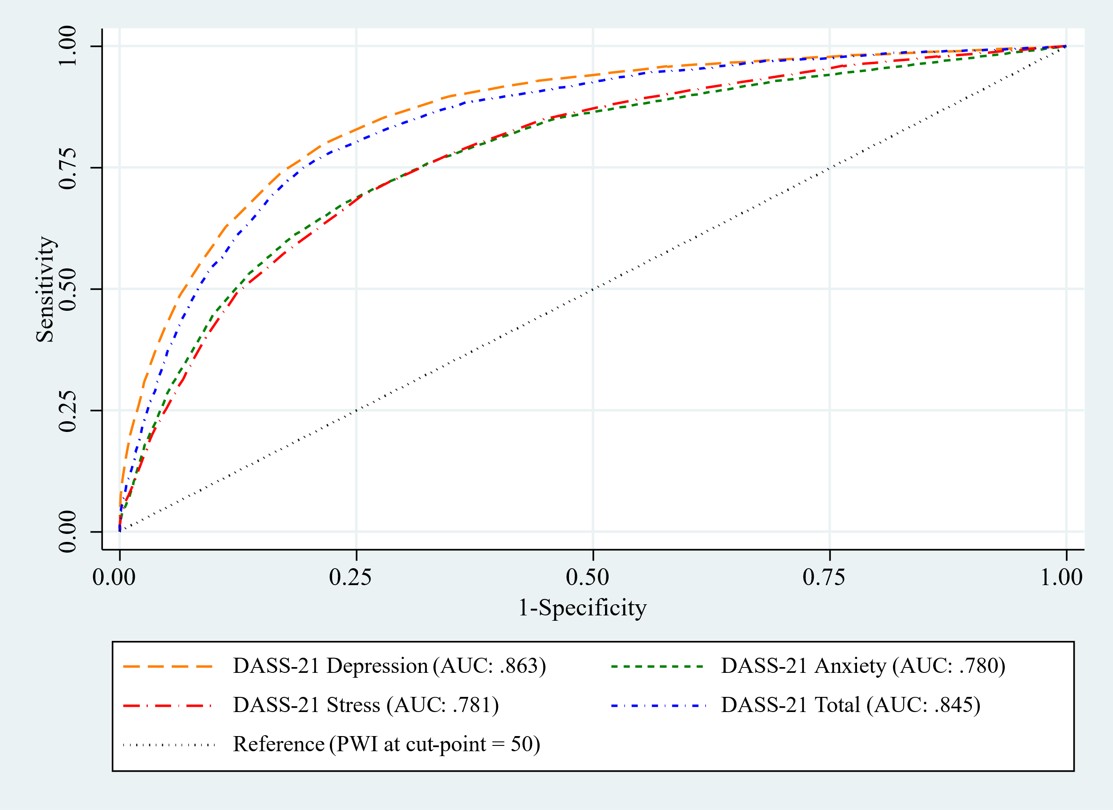
Figure 3.1 Exemplar ROC plot for PWI at the cut-point of 50 against the DASS-21 total scores and the depression, stress and anxiety subscales (unweighted).

Supplementary Material D: Descriptive statistics for the PWI and individual items

Descriptive statistics for the Personal Wellbeing Index and domain items are shown in Table 4.1. The means and standard deviations in this table show how an individual would likely respond to the PWI against the whole sample of respondents. All PWI items were negatively skewed and in the acceptable lower range limit (> -1), except for satisfaction with ‘safety’ (skewness = -1.2). All seven items demonstrated significant leptokurtic behaviour (range 3.1 to 4.7) indicating high concentration around the mean but unusually frequent extreme values.

Table 4.1 Descriptive statistics for the Personal Wellbeing Index.
 | Unweighted M (SD) | Weighted M (SD) | n | Skewness | Kurtosis
PWI | 69.42 (17.08) | 68.06 (17.53) | 9948 | -0.86 | 3.69
Standard of living | 72.72 (19.43) | 70.70 (19.79) | 9965 | -0.92 | 3.94
Health | 67.07 (19.77) | 65.79 (20.22) | 9965 | -0.78 | 3.45
Achieving in life | 66.36 (21.22) | 64.64 (21.94) | 9965 | -0.82 | 3.41
Personal relationships | 71.24 (22.56) | 70.97 (23.04) | 9960 | -0.95 | 3.56
Personal safety | 77.32 (18.95) | 76.25 (19.40) | 9964 | -1.20 | 4.69
Community connectedness | 65.89 (22.43) | 64.60 (22.93) | 9957 | -0.74 | 3.26
Future security | 65.33 (23.26) | 63.48 (23.71) | 9958 | -0.75 | 3.12
Note: PWI = Personal Wellbeing Index

Supplementary Material E: Classification performance for PWI against the DASS-21.
Tables 5.1 to 5.4 show the classification performance of the PWI against the DASS-21 depression, anxiety and stress subscales and total scores. The trajectories of the predictive values for anxiety, stress and total scores were consistent with the results for the depression subscale, supporting the dual-continua framework of mental health.
Table 5.1. Classification performance characteristics across PWI wellbeing thresholds against the DASS-21 Depression subscale.
PWI cut- point | N at or below PWI cut-point (%) | Equivalent DASS-21 depression score | Youden Index (SE) | AUC at cut-point | PPV (%)  [95%CI] | NPV (%)  [95%CI]
75 | 56.8 | 7  (Normal) | 0.44 (0.01) | .72 | 82.2  [81.1, 83.4] | 62.1  [60.8, 63.4]
70 | 45.2 | 7  (Normal) | 0.47 (0.01) | .74 | 72.8  [71.4, 74.1] | 75.2  [74.0, 76.3]
65 | 32.6 | 7  (Normal) | 0.51 (0.01) | .76 | 59.1  [57.6, 60.5] | 86.9  [86.0, 87.8]
60 | 25.4 | 9  (Normal) | 0.53 (0.01) | .76 | 53.3  [51.7, 55.0] | 90.2  [89.4, 90.9]
55 | 18.1 | 9  (Normal) | 0.57 (0.01) | .78 | 41.6  [40.0, 43.2] | 94.9  [94.4, 95.5]
50 | 14.0 | 11  (Mild) | 0.58 (0.01) | .79 | 37.6  [35.9, 39.4] | 96.0  [95.5, 96.5]
45 | 9.3 | 13  (Mild) | 0.60 (0.01) | .80 | 29.4  [27.7, 31.3] | 97.5  [97.1, 97.8]
40 | 7.1 | 13  (Mild) | 0.61 (0.02) | .81 | 23.4  [21.7, 25.1] | 98.3  [98.0, 98.6]
35 | 4.4 | 13  (Mild) | 0.63 (0.02) | .81 | 15.1  [13.7, 16.5] | 99.1  [98.9, 99.3]
30 | 3.3 | 17  (Moderate) | 0.65 (0.02) | .82 | 17.0  [15.2, 19.0] | 99.1  [98.9, 99.3]
25 | 2.1 | 19  (Moderate) | 0.72 (0.03) | .86 | 14.1  [12.2, 16.1] | 99.6  [99.4, 99.7]
Note: DASS-21 depression subscale scores determined by Youden's Index (J = sensitivity + specificity − 1), which maximizes the sum of sensitivity and specificity for each PWI cut-point. DASS-21 depression subscale scores range from 0–42, with higher scores indicating greater symptom severity; classification: Normal (0 to 9), Mild (10 to 13), Moderate, (14 to 20), Severe (21 to 27), Extremely Severe (28 and above).[7] Total N = 9934. 95%CI = 95% confidence interval; PPV = Positive predictive value; NPV = Negative predictive value; SE = Standard error of Youden Index; AUC = Area under the receiver operating characteristic curve at the optimal cut-point.

Table 5.1. Classification performance characteristics across PWI wellbeing thresholds against the DASS-21 Anxiety subscale
PWI cut point | N Low wellbeing (%) | Youden Index (SE) | Equivalent DASS-21 anxiety score | AUC at cut-point | PPV [95%CI] | NPV [95%CI]
75 | 5648 (56.8) | 0.33 (0.01) | 3  (Normal) | .66 | 72.4  [71.2, 73.6] | 59.8  [58.4, 61.2]
70 | 4501 (45.3) | 0.35 (0.01) | 5  (Normal) | .68 | 67.5  [66.0, 69.0] | 68.9  [67.8, 70.1]
65 | 3251 (32.7) | 0.38 (0.01) | 5  (Normal) | .69 | 54.2  [52.7, 55.8] | 81.1  [80.1, 82.0]
60 | 2525 (25.4) | 0.39 (0.01) | 5  (Normal) | .70 | 44.5  [43.0, 46.1] | 86.8  [86.0, 87.7]
55 | 1806 (18.2) | 0.42 (0.01) | 7  (Normal) | .71 | 38.5  [36.8, 40.3] | 90.7  [90.0, 91.4]
50 | 1396 (14.0) | 0.44 (0.01) | 7  (Normal) | .72 | 31.5  [29.9, 33.2] | 93.6  [93.0, 94.1]
45 | 920 (9.3) | 0.46 (0.02) | 7  (Normal) | .73 | 22.0  [20.5, 23.5] | 96.3  [95.8, 96.7]
40 | 707 (7.1) | 0.46 (0.02) | 7  (Normal) | .73 | 17.1  [15.8, 18.4] | 97.2  [96.8, 97.6]
35 | 439 (4.4) | 0.47 (0.02) | 7  (Normal) | .74 | 11.0  [9.9, 12.2] | 98.5  [98.1, 98.7]
30 | 325 (3.3) | 0.49 (0.02) | 7  (Normal) | .74 | 8.4  [7.4, 9.4] | 98.9  [98.7, 99.2]
25 | 211 (2.1) | 0.53 (0.03) | 9  (Mild) | .77 | 6.7  [5.8, 7.8] | 99.3  [99.1, 99.5]
Note: DASS-21 anxiety subscale scores determined by Youden's Index (J = sensitivity + specificity − 1), which maximizes the sum of sensitivity and specificity for each PWI cut-point. DASS-21 anxiety subscale scores range from 0–42, with higher scores indicating greater symptom severity; classification: Normal (0 to 3), Mild (4), Moderate, (5 to 7), Severe (8 to 9), Extremely Severe (10 and above).[7] PPV = Positive predictive value; NPV = Negative predictive value; SE = Standard error of Youden Index; AUC = Area under the receiver operating characteristic curve at the optimal cut-point. Total N = 9942. 95%CI = 95% confidence interval.

Table 5.2. Classification performance characteristics across PWI wellbeing thresholds against the DASS-21 Stress subscale
PWI cut-point | N Low wellbeing (%) | Youden Index (SE) | Equivalent DASS-21 stress score | AUC at cut-point | PPV (%) [95%CI] | NPV (%) [95%CI]
75 | 5648 (56.8) | 0.347 (0.010) | 9  (Normal) | 0.67 | 73.7  [72.5, 74.9] | 60.3  [59.0, 61.7]
70 | 4501 (45.3) | 0.361 (0.009) | 11  (Normal) | 0.68 | 67.2  [65.7, 68.6] | 69.9  [68.7, 71.0]
65 | 3251 (32.7) | 0.384 (0.010) | 13  (Normal) | 0.69 | 59.1  [57.4, 60.8] | 79.7  [78.7, 80.6]
60 | 2525 (25.4) | 0.394 (0.011) | 11  (Normal) | 0.70 | 48.7  [47.0, 50.4] | 85.6  [84.7, 86.4]
55 | 1805 (18.2) | 0.417 (0.012) | 13  (Normal) | 0.71 | 33.1  [31.7, 34.6] | 92.2  [91.5, 92.9]
50 | 1395 (14.0) | 0.437 (0.013) | 13  (Normal) | 0.72 | 30.5  [28.9, 32.1] | 93.7  [93.1, 94.3]
45 | 919 (9.2) | 0.447 (0.016) | 15  (Mild) | 0.72 | 21.0  [19.6, 22.4] | 96.3  [95.8, 96.7]
40 | 707 (7.1) | 0.447 (0.017) | 13  (Normal) | 0.72 | 20.0  [18.4, 21.6] | 96.7  [96.3, 97.1]
35 | 439 (4.4) | 0.468 (0.023) | 15  (Mild) | 0.73 | 10.5  [9.4, 11.6] | 98.4  [98.1, 98.7]
30 | 326 (3.3) | 0.468 (0.027) | 17  (Mild) | 0.73 | 11.7  [10.3, 13.3] | 98.5  [98.2, 98.8]
25 | 212 (2.1) | 0.553 (0.031) | 17  (Mild) | 0.78 | 8.7  [7.5, 10.1] | 99.3  [99.1, 99.4]
Note: DASS-21 stress subscale scores determined by Youden's Index (J = sensitivity + specificity − 1), which maximizes the sum of sensitivity and specificity for each PWI cut-point. DASS-21 stress subscale scores range from 0–42, with higher scores indicating greater symptom severity; classification: Normal (0 to 7), Mild (8 to 9), Moderate, (10 to 12), Severe (13 to 16), Extremely Severe (17 and above).[7] PPV = Positive predictive value; NPV = Negative predictive value; SE = Standard error of Youden Index; AUC = Area under the receiver operating characteristic curve at the optimal cut-point. Total N = 9938. 95%CI = 95% confidence interval.

Table 5.2. Classification performance characteristics across PWI wellbeing thresholds against the DASS-21 total score.
PWI cut-point | N Low wellbeing (%) | Youden Index (SE) | Equivalent DASS-21 total score | AUC at cut-point | PPV (%) [95%CI] | NPV (%) [95%CI]
75 | 5633 (56.8) | 0.43 (0.01) | 19  (Normal) | 0.67 | 79.0  [77.8, 80.1] | 63.7  [62.3, 65.0]
70 | 4487 (45.2) | 0.45 (0.01) | 19  (Normal) | 0.68 | 68.4  [67.0, 69.7] | 76.1  [74.9, 77.2]
65 | 3238 (32.6) | 0.48 (0.01) | 23  (Normal) | 0.69 | 58.6  [57.0, 60.1] | 85.0  [84.1, 85.9]
60 | 2518 (25.3) | 0.50 (0.01) | 25  (Normal) | 0.70 | 50.6  [49.0, 52.2] | 89.8  [89.0, 90.5]
55 | 1799 (18.1) | 0.417 (0.012) | 31  (Normal) | 0.71 | 44.6  [42.8, 46.4] | 93.1  [92.5, 93.7]
50 | 1391 (14.0) | 0.437 (0.013) | 31  (Normal) | 0.72 | 36.6  [34.9, 38.4] | 95.6  [95.1, 96.0]
45 | 915 (9.2) | 0.447 (0.016) | 33  (Mild) | 0.72 | 27.0  [25.4, 28.7] | 97.5  [97.1, 97.9]
40 | 704 (7.1) | 0.447 (0.017) | 33  (Mild) | 0.72 | 21.2  [19.7, 22.8] | 98.2  [97.9, 98.5]
35 | 437 (4.4) | 0.468 (0.023) | 33  (Mild) | 0.73 | 13.6  [12.4, 15.0] | 99.1  [98.9, 99.3]
30 | 324 (3.3) | 0.468 (0.027) | 33  (Mild) | 0.73 | 10.2  [9.1, 11.4] | 99.4  [99.2, 99.5]
25 | 210 (2.1) | 0.553 (0.031) | 43  (Moderate) | 0.78 | 10.2  [8.8, 11.7] | 99.6  [99.4, 99.7]
Note: DASS-21 stress subscale scores determined by Youden's Index (J = sensitivity + specificity − 1), which maximizes the sum of sensitivity and specificity for each PWI cut-point. DASS-21 total scores range from 0–126, with higher scores indicating greater symptom severity; classification: Normal (0 to 32), Mild (33 to 39), Moderate, (40 to 49), Severe (50 to 57), Extremely Severe (58 and above).[7] PPV = Positive predictive value; NPV = Negative predictive value; SE = Standard error of Youden Index; AUC = Area under the receiver operating characteristic curve at the optimal cut-point. Total N = 9923. 95%CI = 95% confidence interval.

References
[1] StataCorp. (2020). Stata statistical software: Release 16. (Version: 16.1). StataCorp LLC.
[2] Samejima, F. (1997). Graded response model. In: W. J. van der Linden, R. K. Hambleton (Eds.) Handbook of Modern Item Response Theory (1st ed., pp. 85–100). Springer New York.
[3] Gadermann, A. M., Guhn, M., Zumbo, B. D. (2012). Estimating ordinal reliability for Likert-type and ordinal item response data: A conceptual, empirical, and practical guide. Practical assessment, research & evaluation, 17(3), n3. 10.7275/n560-j767
[4] Richardson, B., Fuller Tyszkiewicz, M. D., Tomyn, A. J., Cummins, R. A. (2016). The psychometric equivalence of the Personal Wellbeing Index for normally functioning and homeostatically defeated Australian adults. Journal of Happiness Studies, 17(2), 627–641. https://doi.org/10.1007/s10902-015-9613-0
[5] Hosmer Jr, D. W., Lemeshow, S., Sturdivant, R. X. (2013). Applied Logistic Regression. John Wiley & Sons.
[6] Lovibond, P. F., Lovibond, S. H. (1995). The structure of negative emotional states: Comparison of the Depression Anxiety Stress Scales (DASS) with the Beck Depression and Anxiety Inventories. Behaviour Research and Therapy, 33(3), 335–343. https://doi.org/10.1016/0005-7967(94)00075-U
[7] Lovibond, S. H., Lovibond, P. F. (1995). Manual for the Depression Anxiety Stress Scales.(2nd ed.). Psychology Foundation, University of New South Wales.

