CHROMATOGRAMS OF THE EFFECTS OF DIFFERENT PROCESSING METHODS ON THE CAROTENOID
PROFILES OF VERNONIA AMYGDALINA LEAVES

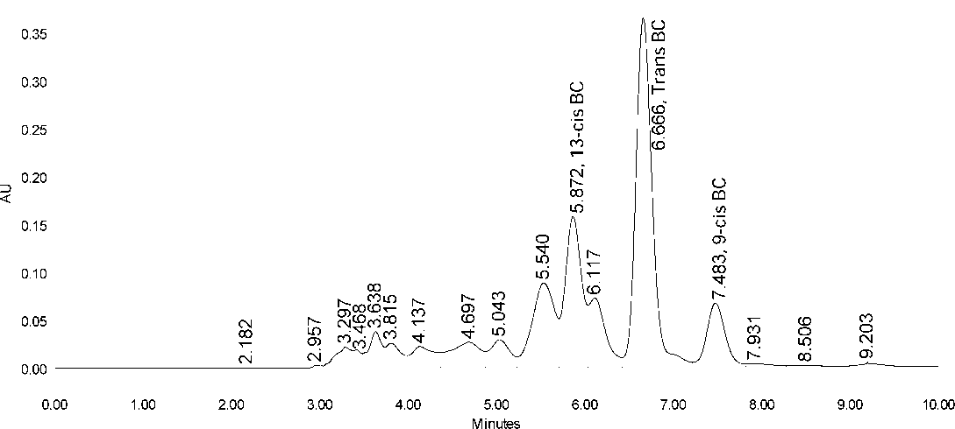

De-bittered with water alone

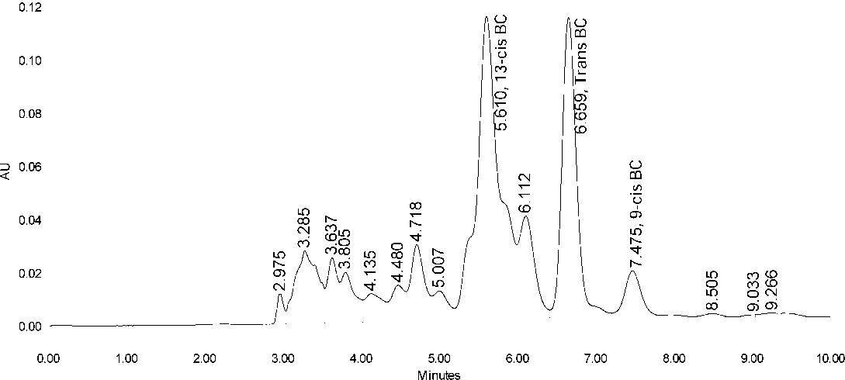

DE-BITTERED WITH WATER AND SALT

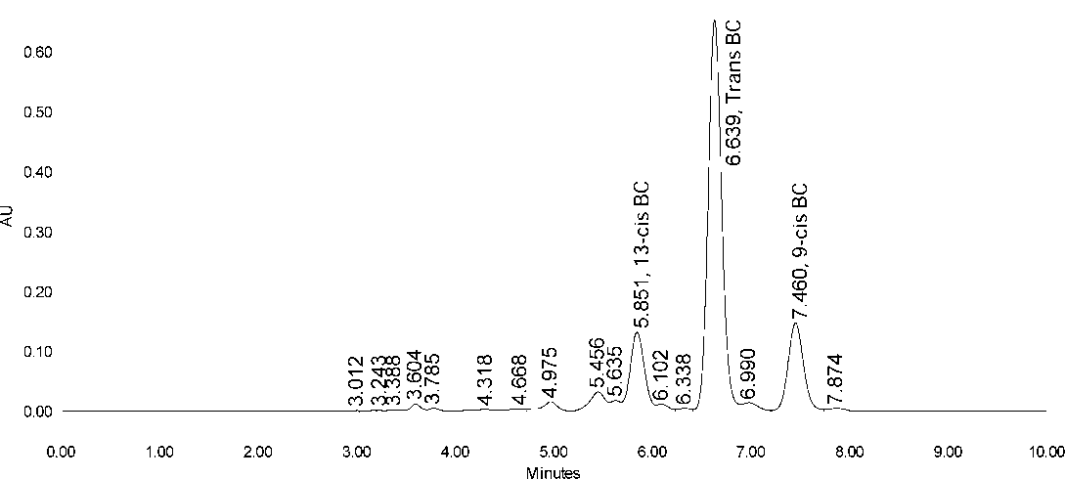

DE-BITTERED BY BOILING

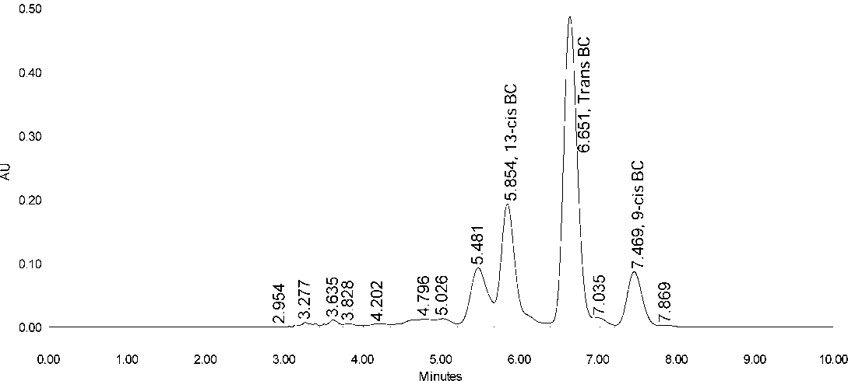

CUT AND SUNDRIED VERNONIA AMYGDALINA

