Supplementary Table S1
Exploratory Linear Regressions Predicting Pleasure from Schizotypy Dimensions
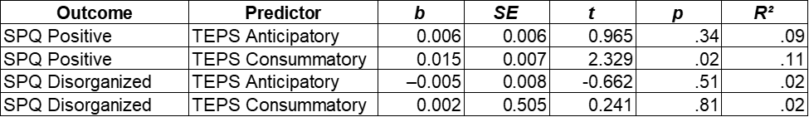
Note. b = unstandardized regression coefficient. SE = standard error. p values are two-tailed. TEPS = Temporal Experience of Pleasure Scale. SPQ = Schizotypal Personality Questionnaire.
Supplementary Table S2
Final Step Coefficients from Hierarchical Regression Predicting Sleep Quality (PSQI)
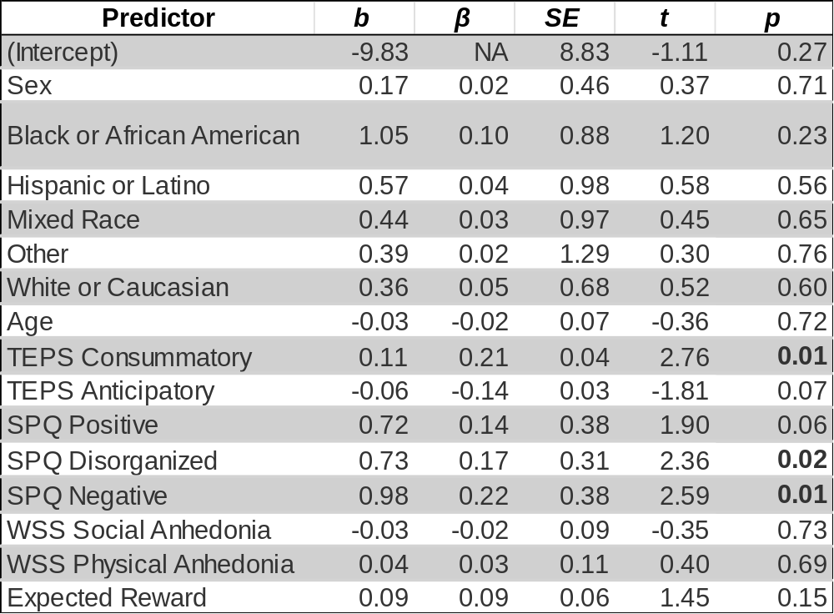
Note. PSQI = Pittsburgh Sleep Quality Index. Unstandardized coefficients (b), standardized coefficients (β), standard errors (SE), t values, and p values (bolded) are shown for each predictor in the final model (Step 6). Gender was coded as 1 = Female, 0 = Male.
Supplementary Table S3
Final Step Coefficients from Hierarchical Regression Predicting Health Behavior (LHQ HEA)
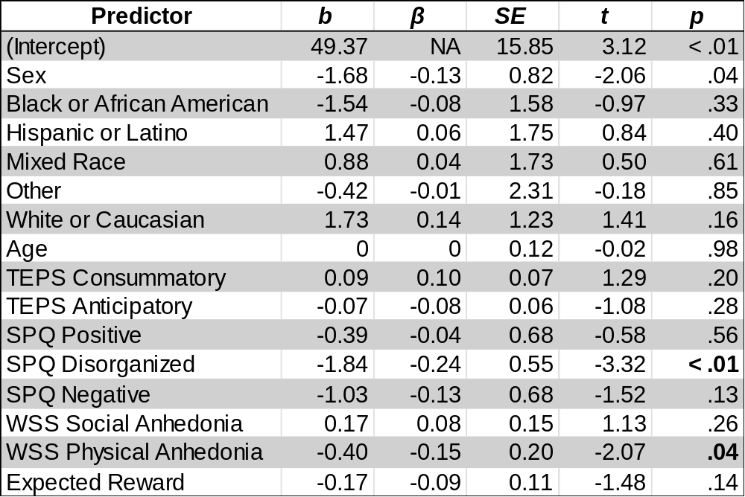
Note. LHQ HEA = Lifestyle and Habits Questionnaire Health and Exercise subscale. Unstandardized coefficients (b), standardized coefficients (β), standard errors (SE), t values, and p values (bolded) are shown for each predictor in the final model (Step 6). Gender was coded as 1 = Female, 0 = Male.
Supplementary Figure S1
Predicted Hard‑Task Choices by Negative Schizotypy Across Expected Value Levels (Full vs. Reduced Models)
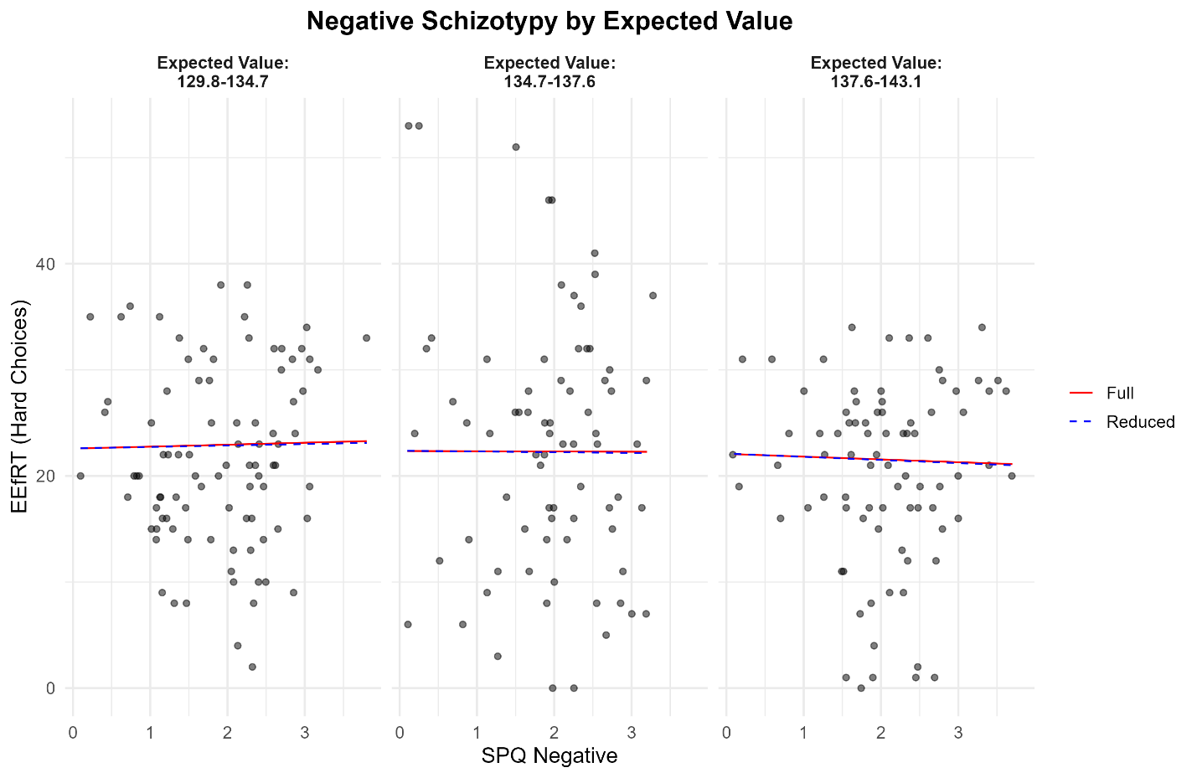
Note. Full model includes SPQ Negative, TEPS Consummatory, TEPS Anticipatory, and covariates. Reduced model omits TEPS Anticipatory. Predicted differences were minimal across levels of SPQ Negative.
Supplementary Figure S2
Predicted Hard‑Task Choices by Social Anhedonia Across Expected Value Levels (Full vs. Reduced Models)
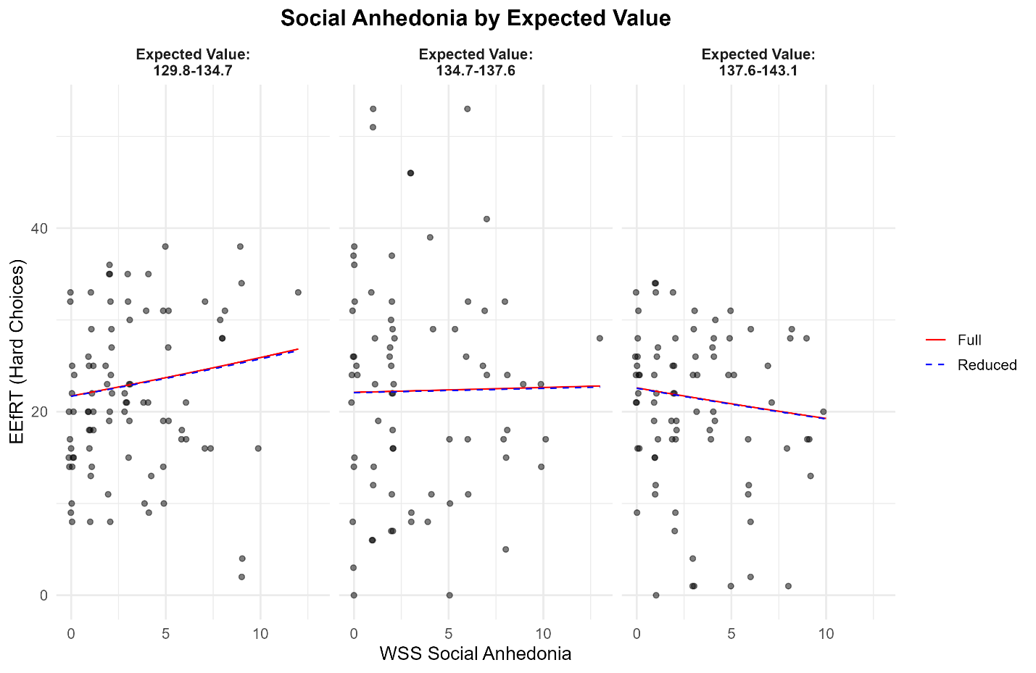
Note. The full model includes WSS Social Anhedonia, TEPS Consummatory, TEPS Anticipatory, and covariates. The reduced model excludes TEPS Anticipatory.
Supplementary Figure S3
Predicted Hard‑Task Choices by Physical Anhedonia Across Expected Value Levels (Full vs. Reduced Models)
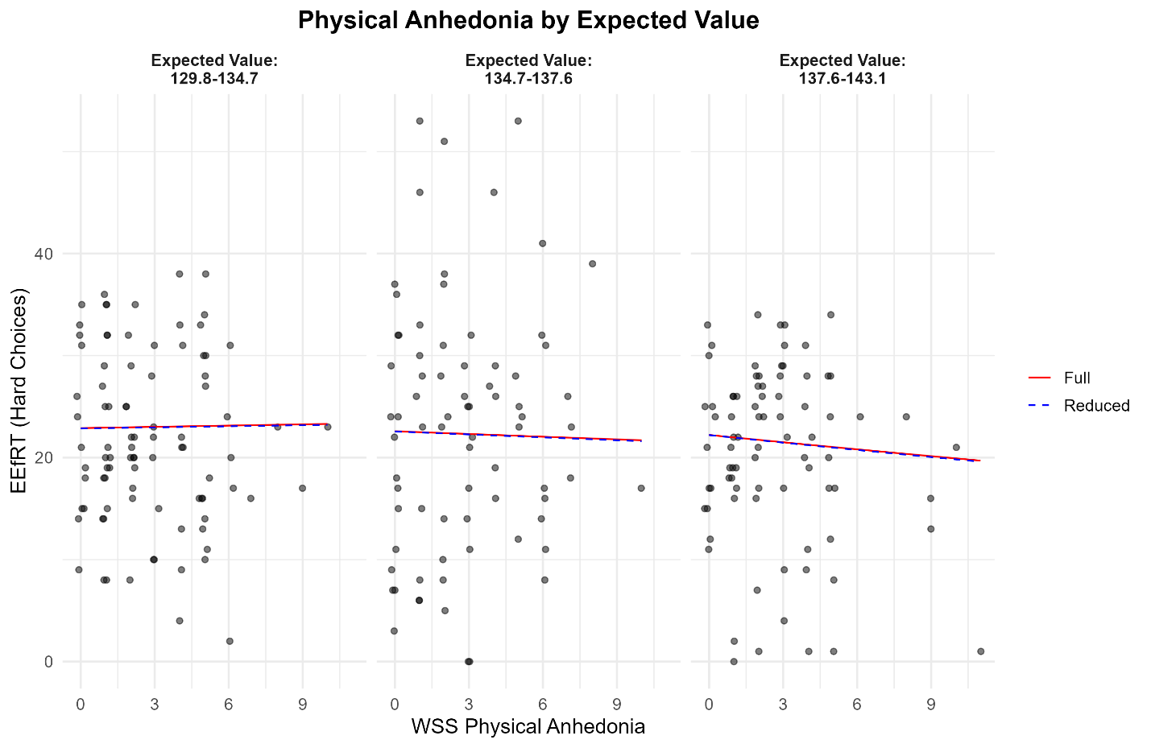
Note. The full model includes WSS Physical Anhedonia, TEPS Consummatory, TEPS Anticipatory, and covariates. The reduced model excludes TEPS Anticipatory.

