Supplementary Information

A Universal Urbach Rule for Organic Semiconductors
Christina Kaiser, Oskar J. Sandberg*, Nasim Zarrabi, Wei Li, Paul Meredith, Ardalan Armin*
Sustainable Advanced Materials (Sêr-SAM), Department of Physics, Swansea University, Singleton Park, Swansea SA2 8PP, United Kingdom
*Email: ardalan.armin@swansea.ac.uk; o.j.sandberg@swansea.ac.uk

Table of Contents
- Theoretical framework
  - Density of states
  - Marcus theory
    - Rate constant
    - Single-mode absorption coefficient
    - Multimode absorption coefficient
      - Gaussian DOS
      - Exponential DOS
  - Miller-Abrahams-type rate
    - Rate constant
    - Single-mode absorption coefficient
    - Multimode absorption coefficient
      - Gaussian DOS
      - Exponential DOS
  - Generalized Marcus theory
- Gaussian fit parameters
- Thickness dependence of the EQE tail
  - Simulating the thickness dependence
  - Experimental EQE spectra
- Temperature-dependent EQE measurements
- Simulating the absorption coefficient
- Materials and device fabrication

- Theoretical framework
  - Density of states
The energy difference between the ground state and excited state of a chromophore (single mode) is denoted by $E_{j}^{'}$. In a system, containing a large number of chromophores (multimode), the density of states will follow a distribution with a maximum at the energy difference $E_{j,0}$. For a monoenergetic distribution of states we then have:
$$g_{DOS}\left(E_{j}^{'}\right)=n_{j}δ\left(E_{j}^{'}-E_{j,0}\right), (S1)$$
where $g_{DOS}\left(E_{j}^{'}\right)$ is the density of states (DOS) and $n_{j}$ is the number density of sites with $δ$ being Dirac Delta function. In disordered organic semiconductors, the energetic distribution of $E_{j}^{'}$ is often assumed to be Gaussian (centred around $E_{j}$), with a width (Gaussian energetic disorder) $σ_{s}$, taking the form
$$g_{DOS}\left(E_{j}^{'}\right)=\frac{n_{j}}{\sqrt{2πσ^{2}}}\exp\left(-\frac{{\left[E_{j}^{'}-E_{j,0} \right]}^{2}}{2{σ_{s}}^{2}}\right). (S2)$$
In contrast, in (banded) crystalline semiconductors the so-called tail states below the bands, caused by static disorder, are often modelled based upon an exponentially distributed density of states according to
$$g_{DOS}\left(E_{j}^{'}\right)=\frac{n_{j}}{W}\exp\left(\frac{E_{j}^{'}-E_{j,0} }{W}\right), (S3)$$
for $E_{j}^{'}≤E_{j,0}$, where $W$ describes the width of the exponential distribution in analogy to $σ_{s}$ of the Gaussian DOS.
  - Marcus theory
    - Rate constant
Marcus theory was originally derived to describe the electron transfer in electrochemical reactions. Herein, the energy of the ground state and excited state are approximated by parabolic potential energy surfaces that depend on the nuclear coordinates. Apart from describing the electron transport in disordered semiconductors, the Marcus theory, in the limit of weak coupling, has been successfully used in literature to describe optical transition rates. The rate constant between ground state and excited state can be expressed as
$$κ=\frac{2π}{ℏ}{\left|v\right|}^{2}\frac{1}{\sqrt{4πλ_{j,0}kT}}\exp\left\{-\frac{{\left(E_{j}^{'}-E\right)}^{2}}{4λ_{j,0}kT}\right\}, (S4)$$
where $E$ is the photon energy, ${\left|v\right|}^{2}$ is the interstate coupling (or transfer integral) that is related to the transition dipole moment $μ$, and $λ_{j,0}$ is the reorganization energy that takes the polaronic effects into account.
    - Single-mode absorption coefficient
From the literature-known relationship between the absorption coefficient and rate constant,^{1,2} the single-mode absorption coefficient from Marcus theory can be obtained as
$$α_{0}\left(E,E_{j}^{'}\right)=\frac{f}{E\sqrt{4πk_{B}Tλ_{j,0}}}\exp\left\{-\frac{{\left(E_{j}^{'}+λ_{j,0}-E\right)}^{2}}{4λ_{j,0}kT}\right\}, (S5)$$
where $f$ is the oscillator strength that includes the interstate coupling and other energy-independent parameters.
    - Multimode absorption coefficient
      - Gaussian DOS
After integrating over all Gaussian distributed energy states (DOS from eq. S2) via
$$α\left(E\right)=\int_{0}^{∞}{α_{0}\left(E, E_{j}^{'}\right)g\left(E_{j}^{'}\right)}dE_{j}^{'}≈\int_{-∞}^{∞}{α_{0}\left(E, E_{j}^{'}\right)g\left(E_{j}^{'}\right)}dE_{j}^{'}, (S6)$$
the multimode absorption coefficient can be written as
$$α\left(E\right)=\frac{f_{j}}{E\sqrt{4πk_{B}Tλ_{j}}}\exp\left\{-\frac{{\left(E_{j}+λ_{j}-E\right)}^{2}}{4λ_{j}^{'}kT}\right\} . (S7)$$
where $f_{j}=n_{j}f$. The Gaussian spectral shape of the single mode expression from eq. S5 is reobtained in eq. S7, however, with the parameters $E_{j}^{'}$ and $λ_{j,0}$ from the single mode absorption now replaced by
$$E_{j}=E_{j,0}-\frac{{σ_{s}}^{2}}{2kT}, (S8)$$
$$λ_{j}=λ_{j,0}+\frac{{σ_{s}}^{2}}{2kT}. (S9)$$
Note that the result for a monoenergetic DOS, eq. S1, is obtained by setting $σ_{s}=0$. For $σ_{s}≠0$, the multimode absorption coefficient is redshifted with respect to the single-mode absorption coefficient depending on $σ_{s}.$This additional linewidth broadening contribution is sometimes also referred to as the inhomogeneous broadening. Eq. S7 is often applied to the experimental absorption coefficient or external quantum efficiency (EQE) in the spectral range of charge transfer (CT) absorption to extract the material-specific parameters $E_{j}$ and $λ_{j}$, which are then called $E_{CT}$ and $λ_{CT}$ ($j=CT$). The origin of linewidth broadness hence can be twofold. Recent studies have shown evidence that the linewidth broadening is mainly due to $E_{j,0}$ and $λ_{j,0}$, which stem from the coupling of vibrational and electronic states described by Marcus theory.^{3,4}
      - Exponential DOS
Under the assumption of an exponential tail distribution of energy states and a Marcus derived expression for the optical rate constant, the corresponding multimode absorption coefficient for tail state absorption (i.e. $E_{j}^{'}<E_{j,0}$) is obtained from
$$α\left(E\right)=\int_{-∞}^{E_{j,0}}{α_{0}\left(E, E_{j}^{'}\right)g_{DOS}\left(E_{j}^{'}\right)}dE_{j}^{'}, (S10)$$
and thus
$$α\left(E\right)=\frac{f_{j}}{2EW}\exp\left(\frac{E-{(E}_{j,0}+λ_{j,0}-\frac{λ_{j}kT}{W}) }{W}\right)×\left[erf\left(\frac{E_{j,0}+λ_{j}-E-\frac{{2λ}_{j,0}kT}{W}}{\sqrt{4λ_{j,0}kT}}\right)+1\right]. (S11)$$
where $\operatorname{erf}\left(x\right)$ is the error function. Importantly, unlike for the integration over the Gaussian distributed states, exponential tail states are only defined for energies below the gap. Hence, the upper integration bound is given by $E_{j,0}$.
For photon energies $E≪E_{j,0}$, the factor comprising the error functions converges to 1 and $α\left(E\right)$ reduces to
$$α\left(E\right)=\frac{f_{j}}{EW}\exp\left(\frac{E-E_{j}^{*}}{W}\right), (S12)$$
where $E_{j}^{*}=E_{j,0}+λ_{j,0}-\frac{λ_{j,0}kT}{W}$. In the spectral range, where absorption of organic photodiodes can be detected experimentally, eq. S12 is dominated by the exponent and hence $α\left(E\right)$ follows an Urbach decay, where the width of the DOS is the Urbach energy.
  - Miller-Abrahams-type rate
    - Rate constant
The Miller-Abrahams (MA) rate constant is commonly employed to describe the charge-transfer rate from site $m$ to $n$ in disordered semiconductors. This rate is usually of the form:
$$κ_{mn}={\tilde{v}}_{0}×\left\{\begin{matrix}\exp\left(-\frac{ΔE_{mn}}{kT}\right) :ΔE_{mn}≥0 \\ 1 :ΔE_{mn}≤0\end{matrix}\right. (S13)$$
where and ${\tilde{v}}_{0}$ is a prefactor that is related to the electronic coupling between the sites and depends on the inverse localization length, the distance between the localized states and the phonon frequency. Here, $ΔE_{mn}$ is the energy difference between the two sites. The exponential term is a Boltzmann factor describing the thermal activation of the hopping process. Note that two cases are distinguished: (i) for $ΔE_{mn}>0$, the rate is thermally activated; and (ii) for $ΔE_{mn}<0$, the rate is not impeded by the additional term.
As is shown below, under certain conditions Marcus theory can be extended with an energy dependence which may be approximated by a MA-type energy dependence. Similar to Marcus theory, the MA formalism can then be used to express an absorption rate constant. From this perspective, the absorption rate can be expressed as a function of $E_{j}^{'}$ and the photon energy $E$ according to
$$κ∝A\exp\left(-\frac{E_{j}^{'}-E}{kT}\right). ( S14)$$
for $E<E_{j}^{'}$, while $κ∝A$ for $E>E_{j}^{'}$. As for Marcus theory, $E_{j}^{'}$ describes the energy required for an optical transition from the ground state to the excited state. For $E_{j}^{'}=E$, the maximum rate is obtained. In analogy to the oscillator strength form Marcus theory, $A$ is assumed to be only weakly dependent on the photon energy.
    - Single-mode absorption coefficient
Based on the transfer rate described by eq. S14, we expect for $E_{j}^{'}>E$
$$α_{0}\left(E,E_{j}^{'}\right)=α_{sat}\exp\left(-\frac{E_{j}^{'}-E}{kT}\right), (S15)$$
where $α_{sat}$ determines the maximum absorption coefficient in the spectral range where $E_{j}^{'}<E$. $α_{sat}$ further contains a $1/E$-dependence which has negligible effect at energies below the gap and above the experimental limit ($E>0.5$ eV).
    - Multimode absorption coefficient
      - Gaussian DOS
Considering a Gaussian DOS and the single mode absorption coefficient from eq. S15, the multimode absorption coefficient is calculated via
$$α\left(E\right)=\frac{α_{sat}}{\sqrt{2π{σ_{s}}^{2}}}\left[\int_{-∞}^{E}{\exp\left(-\frac{{\left[E_{j}^{'}-E_{j,0}\right]}^{2}}{2{σ_{s}}^{2}}\right)dE_{j}^{'} +}\int_{E}^{∞}{\exp\left(\frac{E-E_{j}^{'}}{kT}\right)\exp\left(-\frac{{\left[E_{j}^{'}-E_{j,0}\right]}^{2}}{2{σ_{s}}^{2}}\right)dE_{j}^{'}}\right] (S16)$$
The integration over all sites with the energy $E_{j}^{'}$ is split into two parts: (i) ${-∞<E}_{j}^{'}<E$, where the optical transition is not impeded by the Boltzmann term (hence $α_{0}$ $=$ $α_{sat}$) and (ii) for ${E<E}_{j}^{'}<∞$ where $α_{0}$ $<$ $α_{sat}$. Note that the lower integration bound for (i) was taken to be $-∞$instead of 0 (this is valid for $E_{j,0}≫kT$). After solving the integral, one obtains
$$α\left(E\right)=\frac{α_{sat}}{2}\left\{\exp\left(\frac{E-E_{j,0}+\frac{{σ_{s}}^{2}}{2kT}}{kT}\right)\left[1-\operatorname{erf}\left(\frac{E-E_{j,0}+\frac{{σ_{s}}^{2}}{kT}}{σ_{s}\sqrt{2}}\right)\right]+\operatorname{erf}\left(\frac{E-E_{j,0}}{σ_{s}\sqrt{2}}\right)+1\right\}. (S17)$$
Noting that $E_{j}=E_{j,0}-\frac{{σ_{s}}^{2}}{2kT}$ and that the error functions of eq. 17 approach -1 for $E≪E_{j}$, we find
$$α\left(E\right)≈α_{sat}\exp\left(\frac{E-E_{j}}{kT}\right). ( S18)$$
The energy dependence of $α\left(E\right)$ is dominated by the exponential term in the relevant spectral range of sub-gap absorption and therefore ${\left[d\ln\left(α(E)\right)/dE\right]}^{-1}=$ $kT$. For $E≫E_{j}$, on the other hand, both error functions in eq. S17 approach 1 and $α\left(E\right)→α_{sat}$.
      - Exponential DOS
Considering an exponential DOS and eq. S16 for the single mode absorption, the multimode absorption coefficient associated with tail state absorption is calculated according to eq. S5. One finds
$$α\left(E\right)=α_{sat}\int_{-∞}^{E}{\exp\left(\frac{E_{j}^{'}-E_{j,0}}{W}\right)dE_{j}^{'}}+\int_{E}^{E_{j,0}}{\exp\left(\frac{E-E_{j}^{'}}{kT}\right)\exp\left(\frac{E_{j}^{'}-E_{j,0}}{W}\right)dE_{j}^{'}} (S19)$$
Similar to eq. S17, the integration over all sites with the energy $E_{j}^{'}$ is split into two parts: (i) ${-∞<E}_{j}^{'}<E$, where the optical transition is not impeded by the Boltzmann term (hence $α_{0}$ $=$ $α_{sat}$) and (ii) for ${E<E}_{j}^{'}<E_{j,0}$ where $α_{0}$ $<$ $α_{sat}$. Again, for an exponential DOS, it is assumed that there are no tail states for $E_{j}^{'}>E_{j,0}$ and hence the upper bound is $E_{j,0}$ (instead of $∞$ as for the Gaussian DOS). Solving the integral of eq. S19 leads to
$$α\left(E\right)=α_{sat}\exp\left(\frac{E-E_{j,0}}{W}\right)\left\{\frac{1-\exp\left(\frac{E-E_{j,0}}{kT}-\frac{E-E_{j,0}}{W}\right)}{\frac{W}{kT}-1}+1\right\}. (S20)$$
From eq. S20, it is clear that ${\left[d\ln\left(α(E)\right)/dE\right]}^{-1}$ will be dominated by $W$, i.e. the width of the exponential distribution, as expected.
  - Generalized Marcus Theory
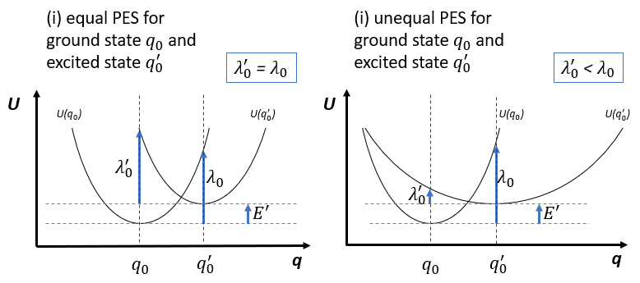
In Marcus theory, the curvature of the PES describes the vibrational frequency of the modes and is directly related to the reorganization energy. Figure S1 illustrates the potential energy surfaces (PES) as a function of the nuclear coordinate $q$, where $U(q_{0})$ and $U(q_{0}^{'})$ denote the ground state and the excited state, respectively. Two cases can be distinguished: a) for the standard Marcus theory, the curvatures of the PESs are equal and so are the reorganization energies of the ground state $λ_{0}$ and the excited states $λ_{0}^{'}$. b) In the general case, the curvatures of the PESs are different resulting in different reorganization energies for the ground state and the excited state.
b

a

Figure S1 Profile of the potential energy surfaces (PESs) of the ground state and the excited state, $U(q_{0})$ and $U(q_{0}^{'})$, respectively. a) Equal curvature of the PESs lead to equal reorganization energies. b) Broadening of one PES with respect to the other leads to unequal reorganization energies.
Case b) can be viewed as an extension to the standard Marcus theory with the generalized Marcus transfer rate now reading ^{5,6}
$$κ=\frac{2π}{ℏ}\frac{{\left|v\right|}^{2}\left({\tilde{k}}_{+}+{\tilde{k}}_{-}\right)}{\sqrt{4\left[λ_{0}^{'}+\left(1-\frac{λ_{0}^{'}}{λ_{0}}\right)\left(E^{'}-E\right)\right]πkT}}. (S21)$$
Here, $E^{'}$ is the energy difference between the ground state and excited state, while
$${\tilde{k}}_{+}=\exp\left(-\frac{λ_{0}}{kT}{\left[\frac{E^{'}-E+λ_{0}^{'}}{λ_{0}^{'}+\sqrt{{λ_{0}^{'}}^{2}+\left(λ_{0}-λ_{0}^{'}\right)\left(E^{'}-E+λ_{0}^{'}\right)}}\right]}^{2}\right) (S22)$$
$${\tilde{k}}_{-}=\exp\left(-\frac{λ_{0}}{kT}{\left[\frac{E^{'}-E+λ_{0}^{'}}{λ_{0}^{'}-\sqrt{{λ_{0}^{'}}^{2}+\left(λ_{0}-λ_{0}^{'}\right)\left(E^{'}-E+λ_{0}^{'}\right)}}\right]}^{2}\right) (S23)$$
for $E<E^{'}+\frac{λ_{0}λ_{0}^{'}}{\left(λ_{0}-λ_{0}^{'}\right)}$. Note that the rate reduces back to the standard Marcus charge-transfer rate (i.e. eq. S4) for $λ_{0}^{'}→λ_{0}$, as expected. This is demonstrated in Figure S2, where the full expression of $κ$ from eq. S21 is simulated for different ratios of $λ_{0}^{'}/λ_{0}$. Figure S2a shows that the spectral lineshape of $κ$ resembles a Gaussian function for $λ_{0}^{'}/λ_{0}$ close to 1, while for $λ_{0}^{'}/λ_{0}→0$, it converges to an exponential function with an inverse logarithmic slope of $kT$. As a result, the apparent Urbach energy $E_{U}^{app}$ approaches $kT$ for $λ_{0}^{'}/λ_{0}→0$, as illustrated in Figure S2b.
Figure S2a Generalized Marcus transfer rate simulated for different $λ_{0}^{'}$ at room temperature assuming $λ_{0}$ = 200 meV and $E^{'}$ = 1.7 eV. $κ$ approaching a Gaussian spectral line-shape for $λ_{0}^{'}/λ_{0}→1$ and an exponential line-shape for $λ_{0}^{'}/λ_{0}→0$. b) Apparent Urbach energy $E_{U}^{app}$ approaching $kT$ for $λ_{0}^{'}/λ_{0}→0$.
a

b

In the case of distribution for $E^{'}$ (e.g. Gaussian or exponential DOS), we need to simplify the generalized Marcus rate since a direct integration of eq. S21 for a given DOS is in general analytically intractable. However, for $λ_{0}>λ_{0}^{'}$, the transfer rate at low photon energies, corresponding to the absorption tail, can be approximated by
$$κ≈\frac{2π}{ℏ}\frac{{\left|v\right|}^{2}}{\sqrt{\left[λ_{0}^{'}+\left(1-\frac{λ_{0}^{'}}{λ_{0}}\right)\left(E^{'}-E\right)\right]πkT}}\exp\left(-\frac{\left[E^{'}-E+λ_{0}^{'}\right]}{kT}\frac{λ_{0}}{\left(λ_{0}-λ_{0}^{'}\right)}\right) ( S24)$$
If $λ_{0}≫λ_{0}^{'}$ (i.e. a more localized ground state and a more diffuse exited state), the dominant photon energy dependence of the absorption tail is of the form
$$κ∝\exp\left(\frac{E-E^{'}}{kT}\right) (S25)$$
becoming governed by a simple Boltzmann factor. Under such conditions, we may approximate the generalized Marcus rate with a simple MA-type expression.

- Gaussian fit parameters
From the experimental EQE spectra presented in the main text, the CT state and the mid-gap trap state parameters are extracted using a Gaussian fit function according to eq. S7. The parameters are presented in Table 1. Eq. S7 describes the spectral shape accounting for both molecular vibrations (temperature-dependent dynamic disorder), as well as static disorder arising from the non-zero variance of the density of CT states (or trap states). A separation of static and dynamic disorder can be achieved via temperature-dependent EQE or electroluminescence measurements using equations S8-S9. In literature, such measurements in the spectral range of CT absorption have led to the conclusion that dynamic disorder dominates the spectral line-shape.
DA blend | $E_{CT}$  (in eV) | $λ_{CT}$  (in meV) | $$f_{CT}$$  (in eV²) | $$E_{t}$$  (in eV) | $$λ_{t}$$  (in meV) | $$f_{t}$$  (in eV²)
BQR:PC₇₀BM | 1.42 | 233 | 9.1e-4 | 0.68 | 866 | 1.8e-6
PCDTBT:PC₇₀BM | 1.48 | 350 | 5.4e-3 | 0.74 | 560 | 1.2e-7
PBDB-T:PC₇₀BM | 1.40 | 355 | 3.0e-3 | 0.70 | 610 | 6.3e-7
PTB-Th:ITIC | 1.43 | 451 | 4.5e-2 | 0.71 | 947 | 1.9e-6
PBDB-T:ITIC | 1.50 | 287 | 1.9e-3 | 0.87 | 458 | 2.6e-7
PBDB-T:IT-4F | 1.42 | 461 | 2.0e-3 | -- | -- | --
PM6:Y6 | -- | -- | -- | 0.86 | 280 | 2.8e-8
PM6:ITIC | -- | -- | -- | 0.86 | 464 | 8.3e-7
PBDB-T:EH-IDTBR | -- | -- | -- | 0.86 | 583 | 1.5e-7

Table S1 Parameters extracted from Gaussian fits to the experimental sub-gap EQE in the spectral range of CT absorption and mid-gap state absorption spectra for 9 different DA blends. Empty cells indicate the absence of spectral features related to CT or trap state absorption.

- Thickness dependence of the EQE tail
  - Experimental EQE spectra
Optical interference (or cavity) effects modify the EQE of a solar cell, which can be regarded as a low finesse cavity with a fully reflective top electrode (for example Ag) and a semi-transparent bottom electrode (often ITO). The resonance wavelength $λ_{res}$ depends on the effective thickness $t_{cav}$ of the cavity with $λ_{res}= 2nt_{cav}j^{-1}$, with $j$ being a natural number and $n$ is the refractive index. Figure S3a and S3b demonstrate the thickness dependence of the photovoltaic EQE above and below gap for PM6:ITIC and PM6:Y6 respectively. Note that the effective bandgap for both blends corresponds to the energy gap of the neat acceptor and hence the interference effects will strongly depend on the refractive index of the acceptor.
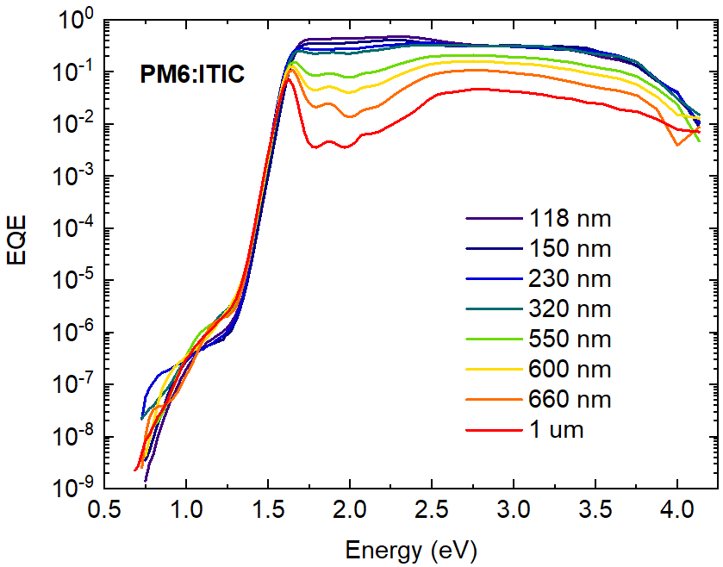
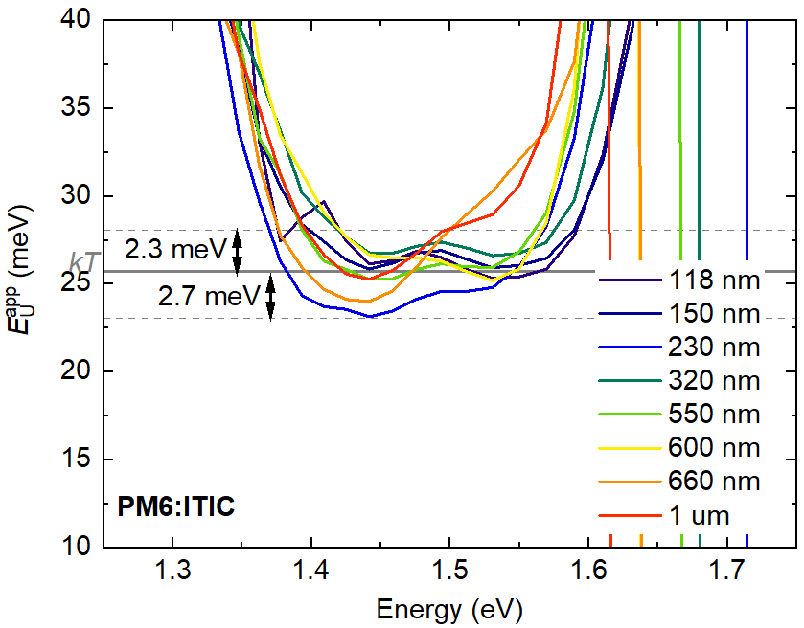
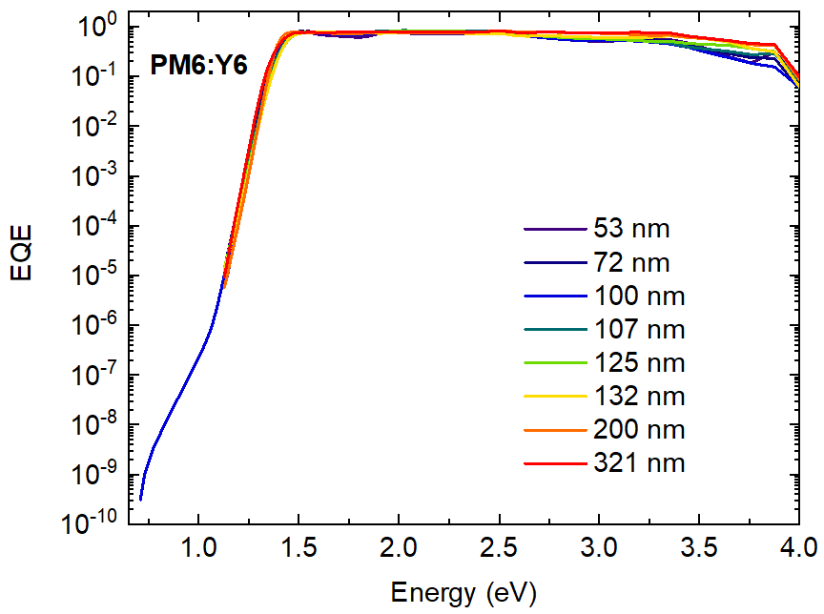
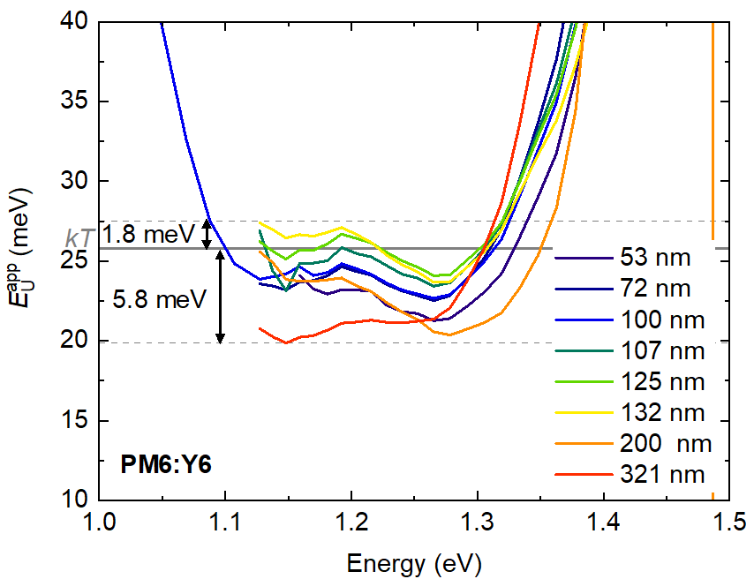
Moreover, the effect of imbalanced charge collection in “thick” organic semiconductor junctions ($t_{cav}>$ 500 nm) is visible as a decrease in the absolute EQE in the visible part of the EQE spectrum of PM6:ITIC as reported earlier for other DA blends.⁷ While the sub-gap slope above the spectral range seems to be unaffected on a logarithmic scale, the detailed analysis via the inverse slope of the logarithmic EQE ($E_{U}^{app}$) reveals thickness-dependent resonance modes. Around the steepest point of the sub-gap EQE, $E_{U}^{app}$ deviates from the thermal energy $kT$ by no more than 3 meV for PM6:ITIC and by maximally 6 meV for PM6:Y6. Such deviations are expected to increase with higher dispersion in the refractive index and extinction coefficient.
a

b

c

d

Figure S3 Nearly exponential EQE tails observed for the PM6:ITIC (a) and PM6:Y6 (b) BHJs of different thicknesses in the spectral range below the gap and above the trap state absorption (1.4 eV $<E<$ 1.6 eV for PM6:ITIC and 1.1 eV $<E<$ 1.3 eV for PM6:Y6). In this spectral range, $E_{U}^{app}$ is close to $kT$ for all thicknesses for both PM6:ITIC (c) and PM6:Y6 (d), while small deviations from $kT$ can be attributed to weak optical cavity effects.

  - Simulating the thickness dependence
The effect of optical interference can be simulated using the well-established transfer-matrix model, which requires knowledge of the optical constants of the solar cell stack of interest. As the experimental absorption coefficient cannot be determined with sufficient sensitivity, we assume a perfectly exponential sub-gap slope with $E_{U}^{app}=kT$ for $E<$1.55 eV. For $E>$1.55 eV, the experimental above-gap absorption coefficient of a 200 nm thick PM6:ITIC film on silicon is used and its refractive index as determined from spectroscopic ellipsometry over the entire wavelength range. This fictional absorption coefficient normalized to its maximum in the above-gap spectral range is shown in Figure S4a. In the absence of any spectral dependence of the Internal Quantum Efficiency, the absorptance calculated by the transfer-matrix model equals the EQE of the device. By changing the layer thickness of PM6:ITIC in the simulation, the spectral line-shape of the absorptance changes as demonstrated by the spectrum of $E_{U}^{app}$ in Figure S4b. In the experiment, $E_{U}^{app}≈ kT$ is observed between 1.6 and 1.3 eV. In this spectral range, the simulated $E_{U}^{app}$ shows deviations of +1 to -2 meV around $kT$, while discontinuities around 1.55 eV are due to the manual stitching of the experimental and fictional sub-gap absorption coefficient. As shown earlier, the fluctuation in the experimental $E_{U}^{app}$ for PM6:ITIC devices lies in between +3 to -3 meV and are therefore very close to the simulated deviations.
a

b

Figure S4 a) Absorption coefficient (α) used in transfer-matrix simulations to calculate the absorptance of an active layer (device architecture ITO (100 nm)/ZnO (30 nm)/active layer/MoO₃ (8 nm)/Ag (100 nm)). b) Sub-gap $E_{U}^{app}$ for 5 different active layer thicknesses (50 to 300 nm) showing energy and thickness dependence within +1/-2 meV range around $kT$ for 1.3 eV$<E<$ 1.6 eV. Optical cavity effects, included in the transfer-matrix simulation, are thus expected to cause spectral dependence of $E_{U}^{app}$ in a real device.

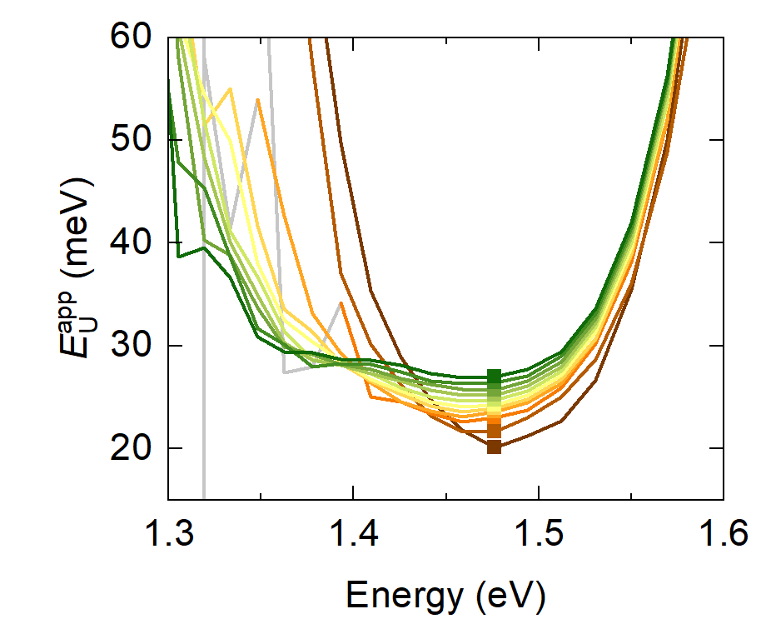
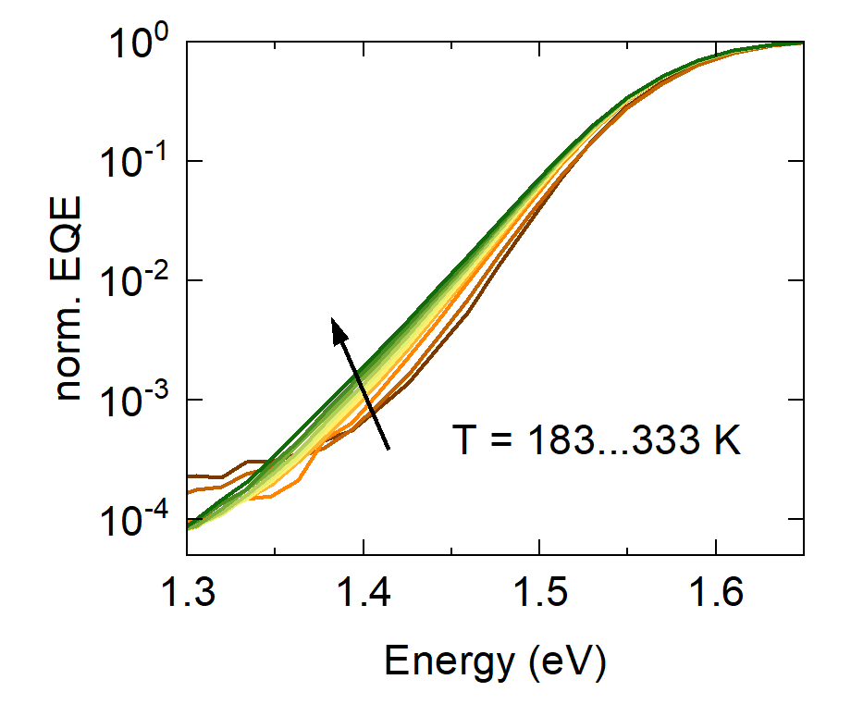
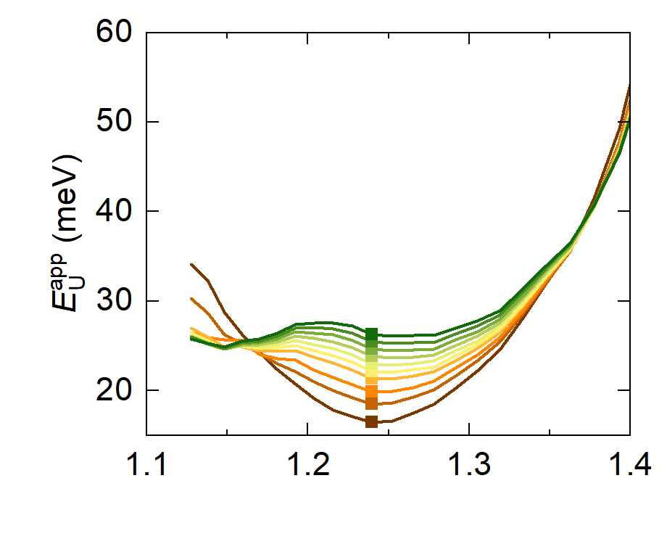
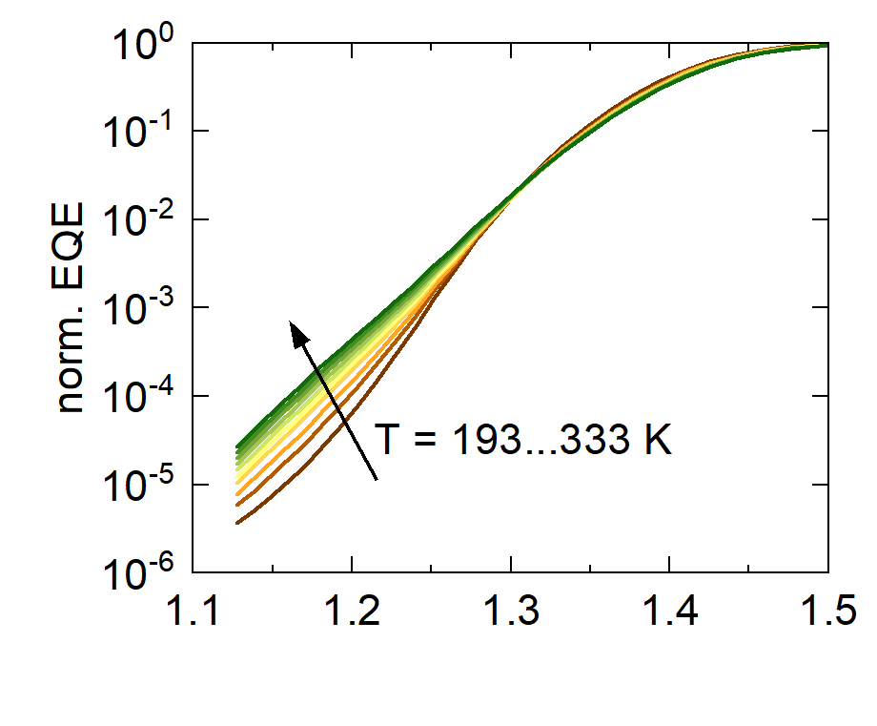
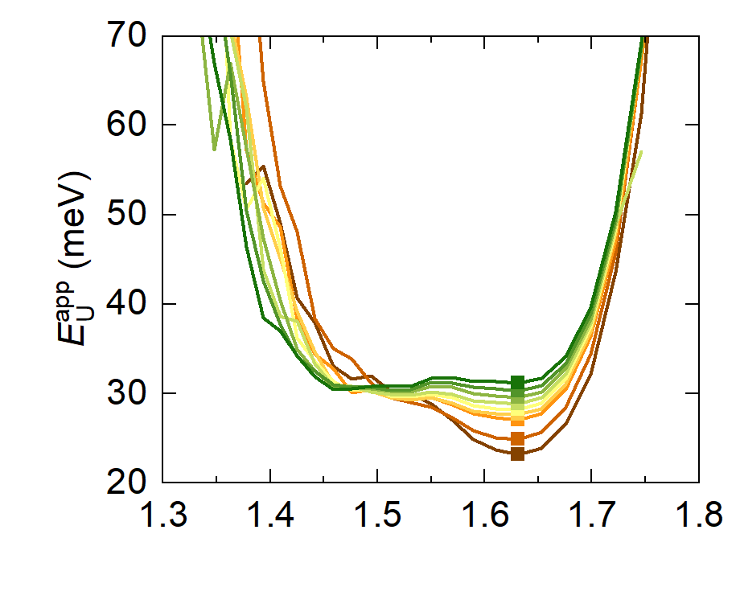
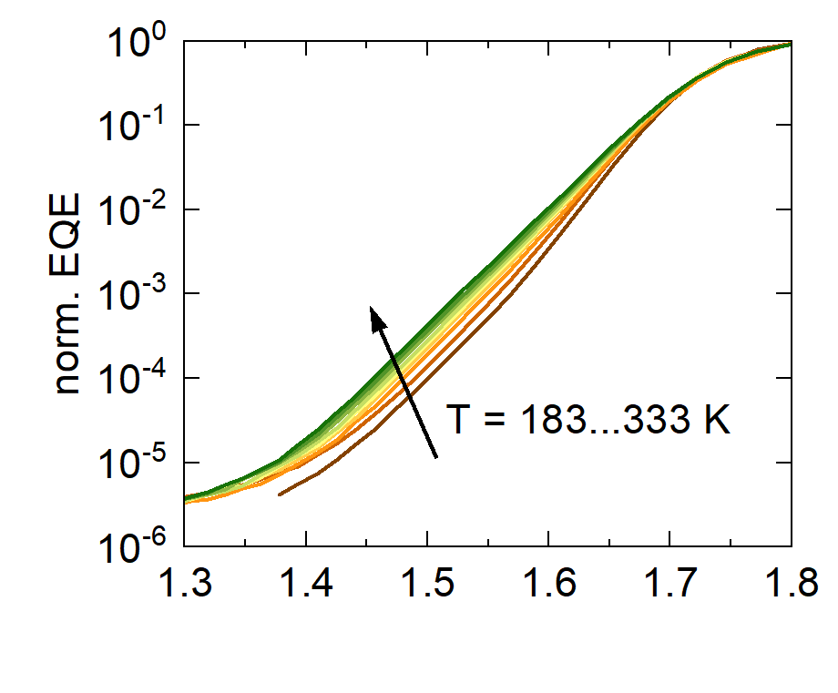
- Temperature-dependent EQE measurements
PM6:ITIC
Y6
Figure SX a) …
Figure S5 Temperature-dependent EQE and respective apparent Urbach energy spectra of neat and blend material systems.
c
a
b
PM6:Y6
PBDB-T:EH-IDTBR
IT-4F
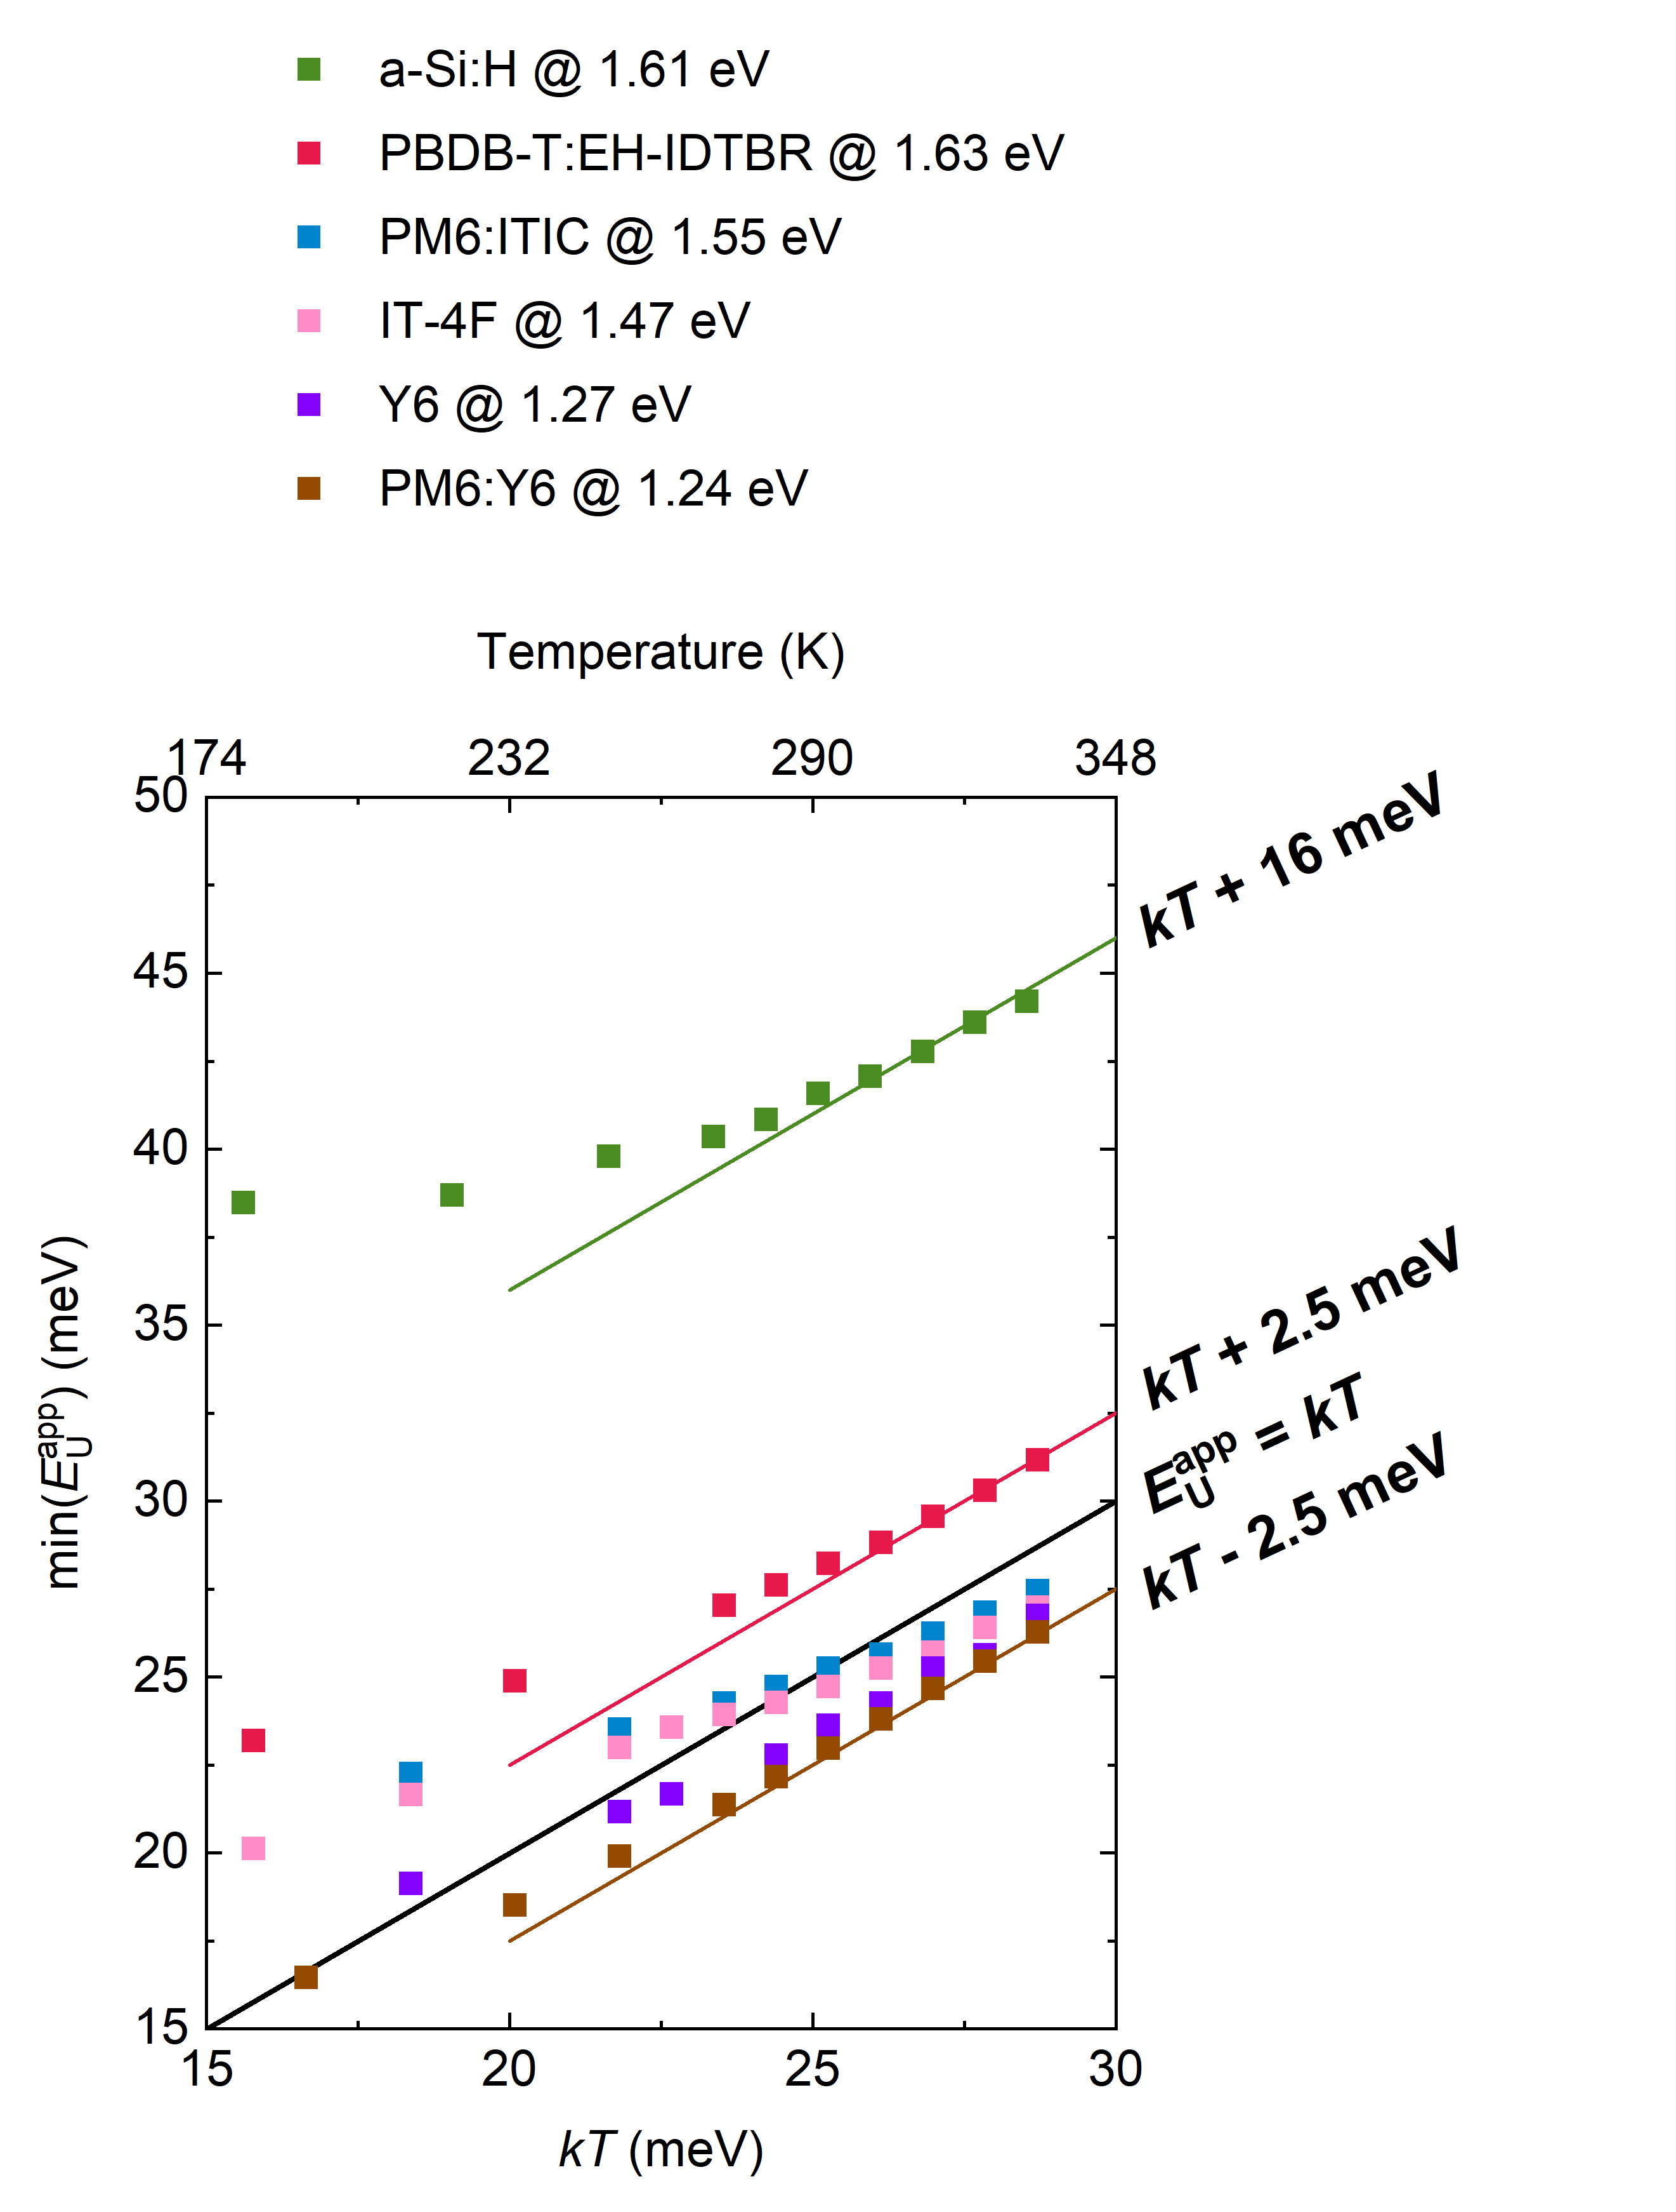
At room temperature, the excitonic absorption coefficient tails of low-offset material systems can be approximated with an Urbach energy given by $E_{U}^{app}≈kT$. To prove the generality of this statement, EQE spectra were recorded at different temperatures between 183 to 333 K for three low-offset BHJs solar cells and two neat (acceptor-only) material systems. Figure S5 shows EQE spectra normalized to the above-gap absorption and the respective $E_{U}^{app}$. The $E_{U}^{app}$ spectra are commonly characterized by a local minimum at a constant energy independent of temperature, as indicated in Figure S5 by solid markers or a dashed line for each material system. The slope of the EQE at this energy decreases as the temperature increases, i.e. ${min(E}_{U}^{app})$ increases with temperature. Figure S6a illustrates ${min(E}_{U}^{app})$ as a function of $kT$ (and $T$). For all tested material systems at temperatures above room temperature, ${min(E}_{U}^{app})$ converges to a linear function that equals $min(E_{U}^{app})=kT$ + constant. The constant, i.e. the intercept of the linear function, is no more than $±$2.5 meV and can be attributed to optical interference as shown earlier.
b

c

a

Figure S6 a) $E_{U}^{app}$ at constant energy for a commercial a-Si:H solar cell and organic BHJs and neat layer solar cells as a function of temperature. b) Normalized sub-gap EQE of a commercial a-Si:H solar cell at different temperatures. c) Apparent Urbach energy $E_{U}^{app}$ as calculated from the sub-gap EQE. The dashed line indicates the energy at which energy $E_{U}^{app}$ was evaluated.
Next, temperature-dependent EQE spectra were recorded for a commercial a-Si:H thin-film solar cell, as shown in Figure S6b. Note that due to the junction thickness of 200 to 400 nm, interference effects are expected⁸ to affect $E_{U}^{app}.$ Reported Urbach energies are usually 40 meV and above depending on the degree of hydrogenation⁹ and the energy range considered^{10,11}. In literature, $E_{U}^{app}$ of a-Si:H is believed to be a combination of temperature-independent static disorder $σ_{s}$ and temperature-dependent dynamic disorder $σ_{D}\left(T\right)$ (which increases with temperature), hence $E_{U}^{app}=σ_{s}+σ_{D}(T)$. $σ_{s}$ is hereby the result of imperfections in the band structure of Si due to the presence of defects, while the direct excitation of defect states is usually reported at energies below 1.5 eV.^{9,12} According to the sub-gap $E_{U}^{app}$ of a-Si:H shown in Figure S6c, the spectral broadening close to the band gap edge shows stronger temperature dependence in comparison to organic semiconductors as well as no apparent energy-independent $E_{U}^{app}$ minimum. At the same time, $E_{U}^{app}$ reaches a plateau at 38 meV independent of temperature which is 2-3 orders of magnitude below the absorption band edge; see Figure S6b. For a consistent analysis in comparison to organic BHJs, $E_{U}^{app}$ is evaluated at a constant energy above the direct defect absorption, here corresponding to 1.61 eV. As displayed in Figure S6a, $E_{U}^{app}$ saturates for low temperatures to roughly 38 meV, while the thermal activation at higher temperatures at 1.61 eV seems to follow $E_{U}^{app}$(1.61 eV) $=kT+$ 16 meV, which is marked by a line as guide to the eye in Figure S6a.

- Simulating the absorption coefficient
To model the experimental observation of $E_{U}^{app}≈kT$ in the spectral range of sub-gap SE absorption, it is reasonable to assume a thermally activated rate constant similar to a Miller-Abrahams (MA) type charge-transfer. This is also supported by the generalized Marcus theory assuming unequal potentials for the ground state and excited state as was shown in Chapter 1.4 of the Supplementary Information. For the macroscopic description of the absorption in a material, one needs to account for the distribution of states which, in the case of organic semiconductors, is often considered to be Gaussian (see eq. S17) and sometimes exponential (see eq. S20). Hereby, the spectral line-shape of the distribution is determined by $E_{j,0}$, i.e. the energy corresponding to the peak value of the distribution, and $W$ or $σ_{s}$, corresponding to the broadening of the exponential or Gaussian distribution, respectively.
To simulate the sub-gap absorption coefficients, $W$ and $σ_{s}$ are both assumed to be 70 meV, being within the range of previously reported values for static energetic disorder.^{13–16} Moreover, $E_{j,0}=$1.7 eV which roughly equals the energy gap of a typical BHJ solar cells. Figure S7 shows the calculated absorption coefficient $α$ normalized to $α_{sat}$ based on equations S17 and S20 for an exponential (red lines) and Gaussian (black lines) DOS at different temperatures. Note that for the exponential tail DOS, $α$ has a maximum at $E_{j,0}$ and is not defined for $E>E_{j,0}$. In the case of a Gaussian DOS, the spectral range around $E_{j,0}$ is dominated by an error function which converges to a constant $α_{sat}$. Figure S7a illustrates that the temperature-dependent sub-gap slope with $E_{U}^{app}=kT$ can only be reproduced by a MA-type rate function derived for a Gaussian DOS at $E≪E_{j,0}$. In contrast, an exponential DOS is independent of the temperature resulting in $E_{U}^{app}=W$ (cf. Figure S7b) and can therefore not explain the experimental findings. To conclude, only the results for a Gaussian DOS is consistent with the experimental results.
Figure S7. Calculated absorption coefficient based on MA-type rate constants normalized to $α_{sat}$. a) $α$ derived for exponential DOS (red lines; normalized at $E=E_{j,0}$) and for Gaussian DOS (black lines) at $kT$ between 13 - 30 meV. Green line: Guideline for the eye illustrating a function that is proportional to $\exp{(E/kT)}$. b) $α$ derived from the MA-type rate constant using an exponential DOS showing that $E_{U}^{app}=W$ in the limit $E≪E_{j,0}$.
Figure S8. a) Absorption coefficient derived for MA-type rate and Gaussian DOS. Purple and green colours indicate $α$ in the limit of $E≪E_{j,0}$ and $E≫E_{j,0}$ respectively. Normalized $α$ for a Gaussian DOS characterized by $E_{j,0}=1.7 eV$ and b) $σ_{s}=0.07 eV$ and c) $σ_{s}=0.1 eV$ at room temperature. For $E≪E_{j,0}$, $α$ converges to an exponential function with a slope described by $E_{U}^{app}=kT$. For $E≫E_{j,0}$, $α$ converges to 1 if normalized to $α_{sat}$. The larger $σ_{s}$, the more sensitive the EQE measurement must be to show that $E_{U}^{app}=kT$ at low energies. Roughly 6 – 7 orders of magnitude below $α_{sat}$, trap state absorption typically dominates the spectrum as shown experimentally. Hence, $E_{U}^{app}=kT$ cannot observed experimentally for $σ_{s}≥0.1 eV$.
$$\frac{α\left(E\right)}{α_{sat}}=\exp\left(\frac{E-E_{j,0}+\frac{{σ_{s}}^{2}}{2kT}}{kT}\right)\left[1-\operatorname{erf}\left(\frac{\frac{{σ_{s}}^{2}}{kT}+E-E_{j,0}}{σ_{s}\sqrt{2}}\right)\right]+\operatorname{erf}\left(\frac{E-E_{j,0}}{σ_{s}\sqrt{2}}\right)+1$$
a

In the next step, the influence of $σ_{s}$ on the sub-gap slope is examined in Figure S8 by considering the dominant contributions to eq. S17 in the high-energy regime (highlighted in blue) and the low-energy regime (highlighted in purple) separately. Importantly, the spectral shape of eq. S17 in the high-energy limit is determined by $σ_{s}$, which redshifts the effective bandgap by ${σ_{s}}^{2}/2kT$, causing an overall broadening of the sub-gap absorption coefficient. Therefore, the upper limit of the spectral range where $E_{U}^{app}=kT$ is determined by $σ_{s}$. The purple part of the equation dominates the spectral range where $E≪E_{j,0}$ and is independent of $σ_{s}$. Measured EQE spectra show that the trap state absorption is typically 6 orders of magnitude weaker than above-gap absorption and poses a lower limit to the spectral range where $E_{U}^{app}=kT$. Apart from the experimental limitation of measuring small EQE signals, it is hence possible that for some organic semiconductors $E_{U}^{app}=kT$ cannot be observed at room temperature due to large $σ_{s}$.

Figure S9 shows the corresponding absorption coefficients from Figure S8, but for different temperatures (at $σ_{s}=$ 70 meV and $σ_{s}=$ 100 meV). The comparison of Figure S9a and S9b shows that the spectral range where $E_{U}^{app}=kT$ increases with temperature but decreases for higher $σ_{S}$. This may partly also explain the deviation from $E_{U}^{app}=kT$ observed for PBDB-T:EHIDTBR and PM6:Y6 at low temperatures. In the simulation, a rather high degree of static disorder, e.g. $σ_{s}=$ 100 meV, leads to the plateau of $E_{U}^{app}=kT$ only being reached at $kT> 25.7$ meV and $E<$ 1.2 eV. As shown in the experimental EQE spectra, this energy regime is typically dominated by mid-gap trap absorption or the low energy tail of the CT absorption at low temperatures. Therefore, in the framework of this theory, it is unlikely to observe $E_{U}^{app}=kT$ for a material with a density of SE states characterized by $σ_{s}=$ 100 meV when $E_{j,0}=$ 1.7 eV.
Figure S9. Simulation of the absorption coefficient derived for MA-type rate and Gaussian DOS at different temperatures for a) $σ_{s}=0.07 eV$ and b) $σ_{s}=0.1 eV$ and the respective $E_{U}^{app}$ for c) $σ_{s}=0.07 eV$ and d) $σ_{s}=0.1 eV$. Smaller $σ$ and higher temperature increase the spectral range where $E_{U}^{app}=kT$ and therefore increase the likelihood to observe $E_{U}^{app}=kT$ in the spectral range of SE absorption.
To further validate our model (eq. S17 in the Supplementary Information), $σ_{s}$ and $E_{j,0}$ are extracted as fit parameters for neat IT-4F and Y6 from experimental EQE spectra recorded at different temperatures as shown in Figure 10. Herein, the same energy range was chosen for all temperatures when fitting for one material system to exclude low energy contributions from the trap state absorption. An advantage of neat material systems is that charge-transfer absorption is absent. The results for IT-4F and Y6 are shown for a few temperatures in Figure S10a, while the fit parameters $σ_{s}$ and $E_{j,0}$ are displayed for all temperatures in Figure S10b. $E_{j,0}$ shows negligible temperature dependence for both materials as well as $σ_{s}$ for Y6. The standard deviations of the experimentally-extracted $σ_{s}$over all temperatures are indicated by error bars in Figure S9b. For IT-4F, $σ_{s}$ decreases with temperature resulting in a standard deviation of 2.7 meV. The origin of this apparent trend is beyond the scope of this study.
Figure S10. a) Black lines: Sub-gap EQE of a neat IT-4F solar cells at 183, 213, 263, 303 and 333 K, and sub-gap EQE of a neat Y6 solar cell at 213, 263, 303 and 333 K. Green lines: Simulated sub-gap EQE at different temperatures. b) Static disorder $σ_{s}$ and the exciton band gap energy $E_{j,0}$ obtain as fit parameters of the simulated sub-gap absorption coefficient in a).
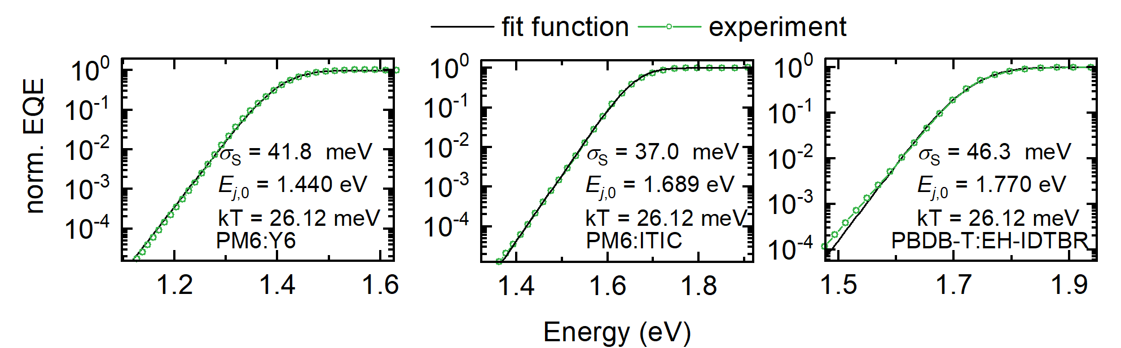
Finally, $σ_{s}$ and $E_{j,0}$ are extracted from EQE measurements at 303 K for three exemplary low-offset DA systems PM6:Y6, PM6:ITIC and PBCB-T:EH-IDTBR. For above gap, the EQE spectra are normalized to 1.
Figure S11. Green lines: Normalized experimental EQE spectra measured at 303 K for the low-offset system DA systems PM6:Y6 , PM6:ITIC and PBDB-T:EH-IDTBR. Black lines: The corresponding simulated sub-gap EQE spectra. Static disorder $σ_{s}$ and the exciton band gap energy $E_{j,0}$ are obtained as fit parameters.
- Experimental
Device Fabrication
Materials
PEDOT:PSS was purchased from Heraeus. Zinc acetate dehydrate and PCDTBT (Poly[N-9'-heptadecanyl-2,7-carbazole-alt-5,5-(4',7'-di-2-thienyl-2',1',3'-benzothiadiazole)]) were purchased from Sigma Aldrich. PC₇₀BM ([6,6]-Phenyl-C71-butyric acid methyl ester) and EH-IDTBR were purchased from Solarmer (Beijing). BQR (benzodithiophene-quaterthiophene-rhodanine) was provided by Prof. David. J Jones (University of Melbourne). m-MTDATA (4,4',4''-Tris[(3-methylphenyl) phenylamino]triphenylamine) was purchased from Ossila. IT-4F (3,9-bis(2-methylene-((3-(1,1-dicyanomethylene)-6,7-difluoro)-indanone))-5,5,11,11-tetrakis(4-hexylphenyl)-dithieno[2,3-d:2',3'-d']-s-indaceno[1,2-b:5,6-b']dithiophene), PM6 (Poly[(2,6-(4,8-bis(5-(2-ethylhexyl-3-fluoro)thiophen-2-yl)-benzo[1,2-b:4,5-b']dithiophene))-alt-(5,5-(1',3'-di-2-thienyl-5',7'-bis(2-ethylhexyl)benzo[1',2'-c:4',5'-c']dithiophene-4,8-dione)]), Y6 (2,2'-((2Z,2'Z)-((12,13-bis(2-ethylhexyl)-3,9-diundecyl-12,13-dihydro-[1,2,5]thiadiazolo[3,4-e]thieno[2",3'':4',5']thieno[2',3':4,5]pyrrolo[3,2-g]thieno[2',3':4,5]thieno[3,2-b]indole-2,10-diyl)bis(methanylylidene))bis(5,6-difluoro-3-oxo-2,3-dihydro-1H-indene-2,1-diylidene))dimalononitrile), ITIC (3,9-bis(2-methylene-(3-(1,1-dicyanomethylene)-indanone))-5,5,11,11-tetrakis(4-hexylphenyl)-dithieno[2,3-d:2',3'-d']-s-indaceno[1,2-b:5,6-b']dithiophene), PBDB-T (Poly[(2,6-(4,8-bis(5-(2-ethylhexyl)thiophen-2-yl)-benzo[1,2-b:4,5-b']dithiophene))-alt-(5,5-(1',3'-di-2-thienyl-5',7'-bis(2-ethylhexyl)benzo[1',2'-c:4',5'-c']dithiophene-4,8-dione)]) and PTB7-Th (Poly[4,8-bis(5-(2-ethylhexyl)thiophen-2-yl)benzo[1,2-b;4,5-b']dithiophene-2,6-diyl-alt-(4-(2-ethylhexyl)-3-fluorothieno[3,4-b]thiophene-)-2-carboxylate-2-6-diyl)]) were purchased from Zhi-yan (Nanjing) Inc.

Substrate preparation
Commercial patterned ITO coated glass substrates from Ossila were cleaned in an Alconox (detergent) aqueous solution bath at 60 °C, followed by sequential sonication in deionize (DI) water, acetone and isopropanol for 10 minutes each. The cleaned substrates were dried with nitrogen followed by a UV/O₃ treatment for 10 min (Ossila, L2002A2-UK).

Electron/Hole transport layer (ETL/HTL) deposition
Solar cells were fabricated with either a conventional or inverted architecture. For a conventional device architecture, 30 nm of PEDOT:PSS was spin-coated at 6000 rpm for 30 s onto precleaned ITO substrates and annealed at 155 °C for 15 minutes. For an inverted device architecture with 30 nm of ZnO, a solution of 200 mg of zinc acetate dehydrate in 2-methoxyethanol (2 ml) and ethanolamine (56 µl) was prepared and stirred overnight under ambient conditions. The ZnO layer formed upon spin-coating the solution at 4000 rpm followed by thermal annealing at 200 °C for 60 minutes.

BQR:PC₇₀BM devices were prepared using with the conventional architecture (ITO/PEDOT:PSS/BQR:PC₇₀BM/Ca/Al). BQR and PC₇₀BM were dissolved in toluene (24 mg/ml with the donor:acceptor ratio of 1:1) and stirred at 60 °C for 3 hours. Next, the BQR:PC₇₀BM solution was spin-coated at 1000 rpm on the PEDOT:PSS layer to form of film of 100 nm. As top electrode, 20 nm of calcium (Ca) and 100 nm of Aluminium (Al) were vacuum deposited at 10⁻⁶ Tor defining an active area of 4 mm².

m-MTDATA:PC₇₀BM devices were prepared using with the conventional architecture (ITO/ZnO/m-MTDATA:PC₇₀BM/MoO₃/Ag). Equimolar solutions of PC₇₀BM and m-MTDATA in dichloromethane (DCM) with a concentration of 19.4 mmol/l were prepared. To obtain a series of solutions with different molar ratios of m-MTDATA:PC₇₀BM (5 mol%, 1 mol%, 0.1 mol% and 0 mol% of m-MTDATA), 50 ul, 10 ul, 1 ul and 0 ul of m-MTDATA in DCM were added to 1 ml of PC₇₀BM in DCM. The solutions were spin-coated at a spin rate of 800 rpm to get an active layer thickness of around 90 nm. Afterwards, 7 nm of MoO₃ and 100 nm of Ag were vacuum deposited at 10⁻⁶ Tor defining an active area of 4 mm².

PM6:Y6 devices were prepared using an inverted architecture (ITO/ZnO/PM6:Y6/MoO₃/Ag). PM6:Y6 was dissolved in CF solution (14 mg ml⁻¹ with 0.5 vol.% CN) with a donor:acceptor ratio of 1:1.2, and spin-coated (3000 rpm) on ZnO to form a 100 nm thick film. The casted active layers were thermally annealed at 110 ºC for 10 min. As top electrode, 7 nm of MoO₃ and 100 nm of Ag were vacuum deposited at 10⁻⁶ Tor defining an active area of 4 mm².

PM6:ITIC devices were prepared using an inverted architecture (ITO/ZnO/PM6:ITIC/MoO₃/Ag). PM6:ITIC was dissolved in CB solution (18 mg ml⁻¹ with 0.5 vol.% DIO) with a donor:acceptor ratio of 1:1, and spin-coated (1000 rpm) on ZnO to form 100 nm film. The active layers were further treated with thermal annealing at 100 ºC for 10 min. As top electrode, 7 nm of MoO₃ and 100 nm of Ag were vacuum deposited at 10⁻⁶ Tor defining an active area of 4 mm².

PBDB-T:EH-IDTBR devices were prepared using an inverted architecture (ITO/ZnO/PBDB-T:EH-IDTBR/MoO₃/Ag). PBDB-T:EH-IDTBR was dissolved in CB solution (14 mg ml⁻¹) with a donor:acceptor ratio of 1:1, and spin-coated (800 rpm) on ZnO to form a 100 nm thick film. As top electrode, 7 nm of MoO₃ and 100 nm of Ag were vacuum deposited at 10⁻⁶ Tor defining an active area of 4 mm².

PBDB-T:ITIC devices were prepared using an inverted architecture (ITO/ZnO/PBDB-T:ITIC/MoO₃/Ag). PBDB-T:ITIC was dissolved in CB solution (14 mg ml⁻¹ with 0.5 vol.% DIO) with a donor:acceptor ratio of 1:1, and spin-coated (800 rpm) on ZnO to form 100 nm film. The active layers were further treated with thermal annealing at 100 ºC for 10 min. As top electrode, 7 nm of MoO₃ and 100 nm of Ag were vacuum deposited at 10⁻⁶ Tor defining an active area of 4 mm².

PTB7-Th:ITIC devices were prepared using an inverted architecture (ITO/ZnO/ PTB-TH:ITIC/MoO₃/Ag). PTB-TH:ITIC was dissolved in CB solution (14 mg ml⁻¹ with 1 vol.% DIO) with a donor:acceptor ratio of 1:1.4, and spin-coated (1000 rpm) on ZnO to form 100 nm film. As top electrode, 7 nm of MoO₃ and 100 nm of Ag were vacuum deposited at 10⁻⁶ Tor defining an active area of 4 mm².

PBDB-T:PC₇₀BM devices were prepared using an inverted architecture (ITO/ZnO/PBDB-T:PC₇₀BM/MoO₃/Ag). PBDB-T:PC₇₀BM was dissolved in CB solution (14 mg ml⁻¹ with 3 vol.% DIO) with a donor:acceptor ratio of 1:1.4, and spin-coated (1000 rpm) on ZnO to form 100 nm film. Then the as-cast ﬁlms were rinsed with 80 μL of methanol at 4000 rpm for 20 s to remove the residual DIO. As top electrode, 7 nm of MoO₃ and 100 nm of Ag were vacuum deposited at 10⁻⁶ Tor defining an active area of 4 mm².

PBDB-T:IT-4F devices were prepared using an inverted architecture (ITO/ZnO/PBDB-T:IT-4F/MoO₃/Ag). PBDB-T:IT-4F was dissolved in CB solution (14 mg ml⁻¹ with 0.5 vol.% DIO) with a donor:acceptor ratio of 1:1, and spin-coated (800 rpm) on ZnO to form 100 nm film. The active layers were further treated with thermal annealing at 100 ºC for 10 min. As top electrode, 7 nm of MoO₃ and 100 nm of Ag were vacuum deposited at 10⁻⁶ Tor defining an active area of 4 mm².
Neat ITIC devices were prepared using an inverted architecture (ITO/ZnO/ITIC/MoO₃/Ag). ITIC was dissolved in chloroform solution (10 mg ml⁻¹) and spin-coated on ZnO (2000 rpm) to form 70 nm film. As top electrode, 7 nm of MoO₃ and 100 nm of Ag were vacuum deposited at 10⁻⁶ Tor defining an active area of 4 mm².

Neat IT-4F devices were prepared using an inverted architecture (ITO/ZnO/IT-4F/MoO₃/Ag). IT-4F was dissolved in chloroform solution (10 mg ml⁻¹) and spin-coated on ZnO (2000 rpm) to form 70 nm film. As top electrode, 7 nm of MoO₃ and 100 nm of Ag were vacuum deposited at 10⁻⁶ Tor defining an active area of 4 mm².

Neat PBDB-T devices were prepared using an inverted architecture (ITO/ZnO/PBDB-T/MoO₃/Ag). PBDB-T was dissolved in chloroform solution (10 mg ml⁻¹) and spin-coated on ZnO (3000 rpm) to form 70 nm film. As top electrode, 7 nm of MoO₃ and 100 nm of Ag were vacuum deposited at 10⁻⁶ Tor defining an active area of 4 mm².

Literature
(1) Nelson, J. The Physics of Solar Cells; Imperial College Press, 2003. https://doi.org/10.1142/p276.
(2) May, V.; Kühn, O. Charge and Energy Transfer Dynamics in Molecular Systems; Wiley-VCH Verlag GmbH & Co. KGaA: Weinheim, Germany, 2011. https://doi.org/10.1002/9783527633791.
(3) Tvingstedt, K.; Benduhn, J.; Vandewal, K. Temperature Dependence of the Spectral Line-Width of Charge-Transfer State Emission in Organic Solar Cells; Static vs. Dynamic Disorder. Mater. Horizons 2020. https://doi.org/10.1039/D0MH00385A.
(4) Panhans, M.; Hutsch, S.; Benduhn, J.; Nikolis, V. C.; Vangerven, T.; Vandewal, K.; Schellhammer, K. S.; Ortmann, F. Molecular Vibrations Reduce the Maximum Achievable Photovoltage in Organic Solar Cells. Nat. Commun. 2020, No. 2020, 1–10. https://doi.org/10.1038/s41467-020-15215-x.
(5) Casado-pascual, J.; Morillo, M.; Goychuk, I.; Hänggi, P.; Morillo, M. The Role of Different Reorganization Energies within the Zusman Theory of Electron Transfer The Role of Different Reorganization Energies within the Zusman Theory of Electron Transfer. J. Chem. Phys. 2003, 118 (1), 291. https://doi.org/10.1063/1.1525799.
(6) Tang, J. Electron-Transfer Reactions Involving Non-Linear Spin-Boson Interactions. Chem. Phys. 1994, 188 (2–3), 143–160. https://doi.org/10.1016/0301-0104(94)00254-1.
(7) Lin, Q.; Armin, A.; Burn, P. L.; Meredith, P. Filterless Narrowband Visible Photodetectors. Nat. Photonics 2015, 9 (10), 687–694. https://doi.org/10.1038/nphoton.2015.175.
(8) Leblanc, F. Related Content Accurate Determination of the Urbach Energy of A- Si : H Thin Films by Correction for the Interference Effect. Japanese J. Appl. Phys. Jpn. J. Appl. Phys 1994, 33, 1755–1758. https://doi.org/10.1143/jjap.33.l1755.
(9) Cody, G. D.; Tiedje, T.; Abeles, B.; Brooks, B.; Goldstein, Y. Disorder and the Optical-Absorption Edge of Hydrogenated Amorphous Silicon. Phys. Rev. Lett. 1981, 47 (20), 1480–1483. https://doi.org/10.1103/PhysRevLett.47.1480.
(10) Searle, T. M.; Jackson, W. A. Static versus Electron-Phonon Disorder in Amorphous Si: H and Its Alloys. Philos. Mag. B Phys. Condens. Matter; Stat. Mech. Electron. Opt. Magn. Prop. 1989, 60 (2), 237–255. https://doi.org/10.1080/13642818908211192.
(11) Cody, G. D. Urbach Edge of Crystalline and Amorphous Silicon: A Personal Review. J. Non. Cryst. Solids 1992, 141 (C), 3–15. https://doi.org/10.1016/S0022-3093(05)80513-7.
(12) Smith, Z. E.; Chu, V.; Shepard, K.; Aljishi, S.; Slobodin, D.; Kolodzey, J.; Wagner, S.; Chu, T. L. Photothermal and Photoconductive Determination of Surface and Bulk Defect Densities in Amorphous Silicon Films. Appl. Phys. Lett. 1987, 50 (21), 1521–1523. https://doi.org/10.1063/1.97819.
(13) Hood, S.; Zarrabi, N.; Meredith, P.; Kassal, I.; Armin, A. Measuring Energetic Disorder in Organic Semiconductors Using the Photogenerated Charge-Separation Efficiency. J. Phys. Chem. Lett. 2019, 10 (14), 3863–3870. https://doi.org/10.1021/acs.jpclett.9b01304.
(14) Burke, T. M.; Sweetnam, S.; Vandewal, K.; Mcgehee, M. D. Beyond Langevin Recombination : How Equilibrium Between Free Carriers and Charge Transfer States Determines the Open-Circuit Voltage of Organic Solar Cells. Adv. Energy Mater. 2015, 1500123, 1–12. https://doi.org/10.1002/aenm.201500123.
(15) Arkhipov, V. I.; Emelianova, E. V.; Tak, Y. H.; Bässler, H. Charge Injection into Light-Emitting Diodes: Theory and Experiment. J. Appl. Phys. 1998, 84 (2), 848–856. https://doi.org/10.1063/1.368146.
(16) Noriega, R.; Rivnay, J.; Vandewal, K.; Koch, F. P. V.; Stingelin, N.; Smith, P.; Toney, M. F.; Salleo, A. A General Relationship between Disorder, Aggregation and Charge Transport in Conjugated Polymers. Nat. Mater. 2013, 12 (11), 1038–1044. https://doi.org/10.1038/nmat3722.

