Supplementary Table S1. Association Between Clinical Cluster and All-Cause Mortality Poisson regression models with robust variance (Relative Risk and 95% CI)
Explanatory Variable | Model 1 RR (95% CI) P Value | Model 2 RR (95% CI) P Value | Model 3 RR (95% CI) P Value | Model 4 RR (95% CI) P Value | Model 5 RR (95% CI) P Value
Cluster
Cluster 2 | 1.50 (1.21-1.89) P<.001 | 1.53 (1.19-1.95) P<.001 | - | 1.39 (1.09-1.79) P=.009 | 1.39 (1.08-1.81) P=.010
Cluster 3 | 1.12 (0.83-1.49) P=.469 | 1.07 (0.79-1.43) P=.654 | - | 1.52 (1.11-2.08) P=.009 | 1.52 (1.10-2.09) P=.009
Anticoagulant (Ref: 1 = Warfarin)
2 = LMWH | - | 0.98 (0.72-1.33) P=.895 | 1.02 (0.75-1.39) P=.889 | 1.07 (0.78-1.45) P=.688 | 1.07 (0.78-1.45) P=.689
3 = DOACs | - | 0.73 (0.57-0.95) P=.018 | 0.74 (0.57-0.95) P=.019 | 0.73 (0.56-0.94) P=.014 | 0.73 (0.56-0.94) P=.014
Age Category (Ref: <65)
2 = 65-74 | - | - | - | 1.50 (0.93-2.45) P=.100 | 1.50 (0.93-2.45) P=.100
3 ≥ 75 | - | - | - | 3.40 (2.27-5.28) P<.001 | 3.40 (2.27-5.30) P<.001
Sex (Ref: 0 = Female)
1 = Male | - | - | - | - | 1.01 (0.90-1.28) P=.911
Model Fit Statistics
AIC | 1229.5 | 1226.3 | 1234.0 | 1172.7 | 1174.7
n | 812 | 812 | 812 | 812 | 812
Overdispersion Goodness-of-Fit P | 1.000 | 1.000 | 1.000 | 1.000 | 1.000
Poisson Goodness-of-Fit P | 1.000 | 1.000 | 1.000 | 1.000 | 1.000
Log-Likelihood (LL) | -611.7 | -608.1 | -614.0 | -579.4 | -579.4
P Value \chi^2 vs LL (Model Comparison) | - | 0.028 | 0.033 | < .001 | 0.911
Notes: RR indicates Risk Ratio; CI, Confidence Interval; DOACs, Direct Oral Anticoagulants; AIC, Akaike Information Criterion; n, sample size; LL, Log-Likelihood. Bold values indicate statistical significance at P < .05.
Model comparisons are based on the likelihood-ratio \chi^2 test.
Model 2 is not rejected vs. Model 1 (P=.028), but Model 1 fits better.
Model 3 is rejected vs. Model 1 (P=.033).
Model 4 is rejected vs. Model 3, but Model 4 fits better (P<.001).
Model 5 is not rejected vs. Model 4 (P=.911); the two models have similar fit.

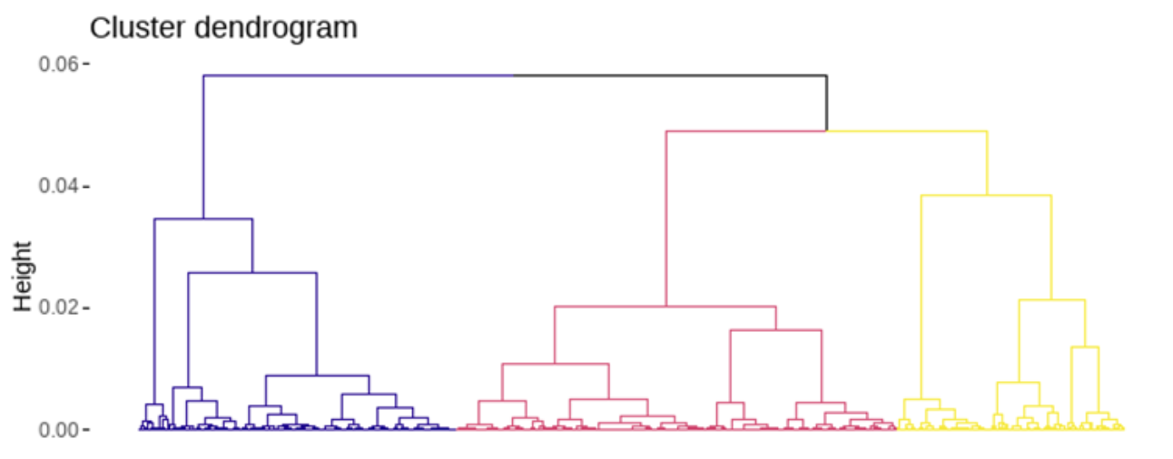
Supplementary Figure S1. Hierarchical clustering dendrogram. Dendrogram illustrating the hierarchical clustering process used to classify patients into three distinct clusters. This dendrogram served as the basis for cluster definition and subsequent visualization using radar plots in Figure 1.

