APPENDICES
Table S1. Transition probability matrix between behavioral categories associated with shelters (OUT, INS, VIS, TAC) and the tank (JET, CRL, ARE) for juvenile O. maya ≤ 17 g.
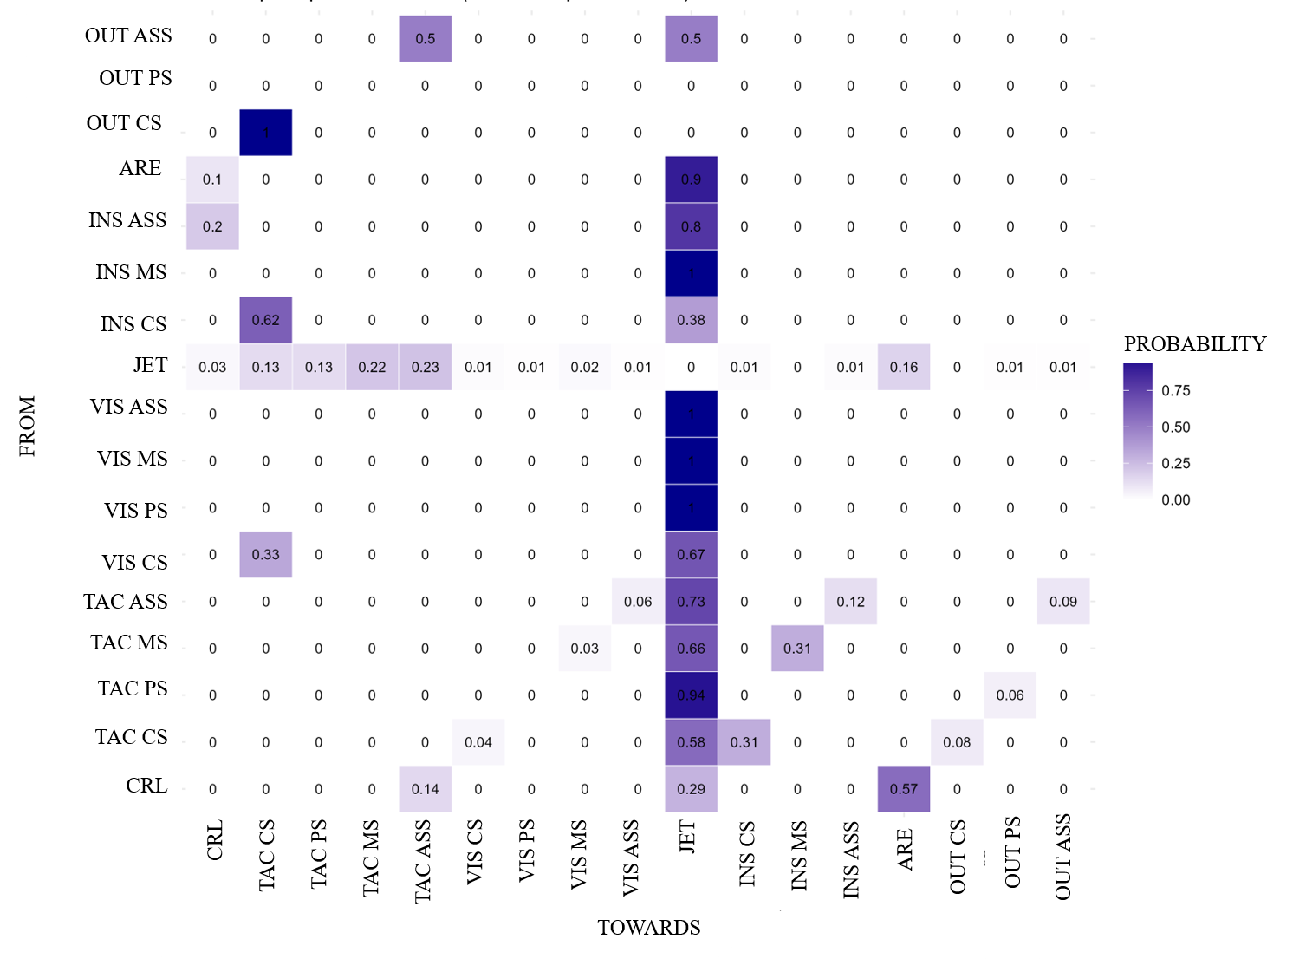

Table S2. Transition probability matrix between behavioral categories associated with shelters (OUT, INS, VIS, TAC) and the tank (JET, CRL, ARE) for juvenile O. maya 17.1-30.8 g.
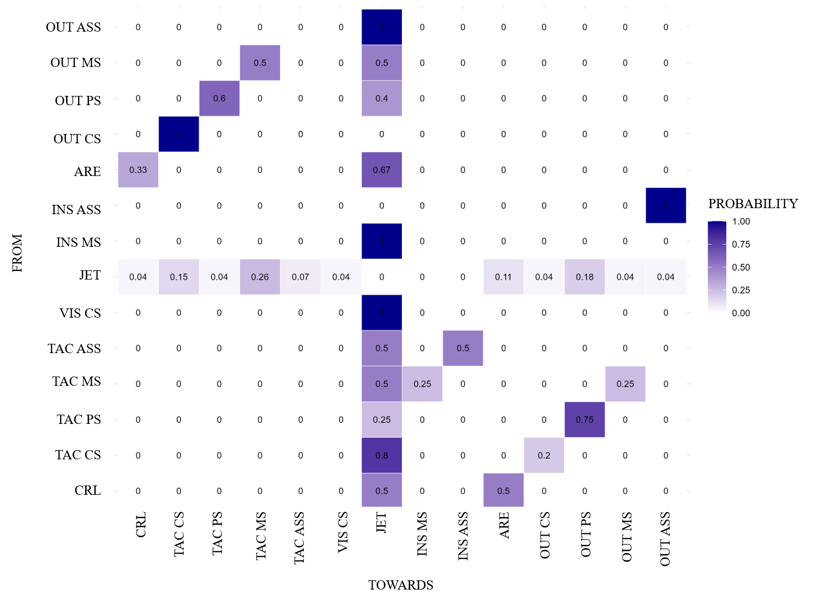

Table S3. Transition probability matrix between behavioral categories associated with shelters (OUT, INS, VIS, TAC) and the tank (JET, CRL, ARE) for juvenile O. maya > 30.8 g.
