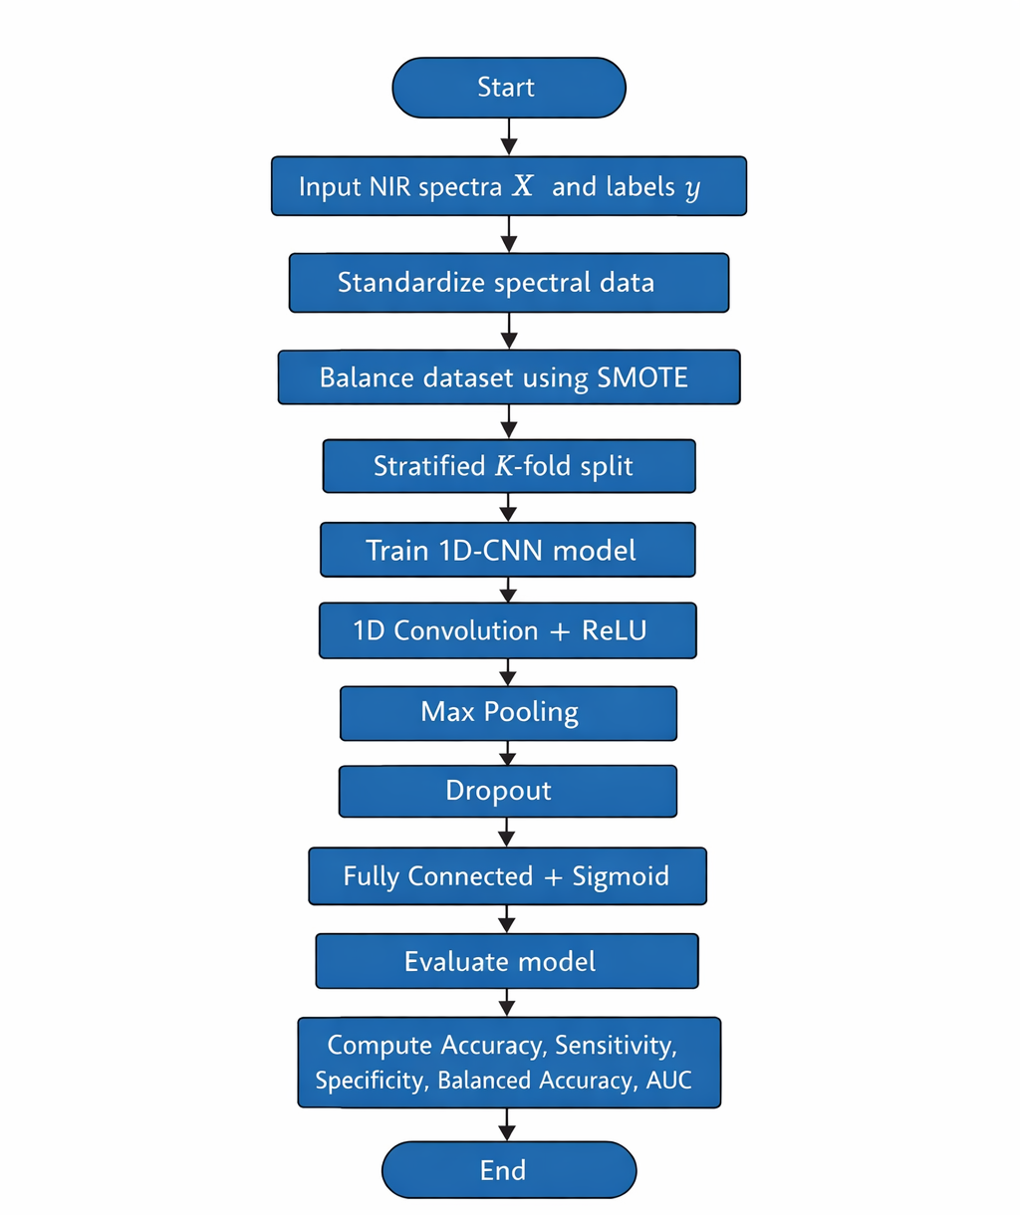

Figure A1: A SMOTE-Augmented 1D-CNN Framework for Binary Classification of Soil Fertility from NIR Spectra

