Supplementary Materials

Supplementary Table 1. Recording, communication, and device specifications of the Brain Interchange (BIC) system.
Parameter | Specification
Recording capabilities
Recording channels | 32
Sampling rate | 1 kHz
ADC resolution | 16 bits (≈ 74 nV/LSB)
Internal band-pass filter | ≈ 2–325 Hz
Amplification gains | 750× (57.5 dB), 375× (51.5 dB), 188× (45.5 dB), 95× (39.5 dB)
Max. input voltage | 4 mv peak to peak (at 57.5 dB), and 30 mv peak to peak (at 39.5 dB), gain dependent
Communication & power
Communication | Bi-directional radio frequency (2.45 GHz), 5 Mbit/s
Powering | Inductive (120–140 kHz), regulated on implant demand
Power supply | Wireless
General properties
Implant dimensions | 67 × 38 × 7 mm³
Reference configuration | Any electrode contacts or group of contacts
ADC, Analog-to-digital converter; LSB, least significant bit; PP, peak-to-peak; RF, radio frequency. The internal band-pass filter and amplification gain were configured for low-noise wideband neural recording; the maximum input voltage scales inversely with the selected gain.

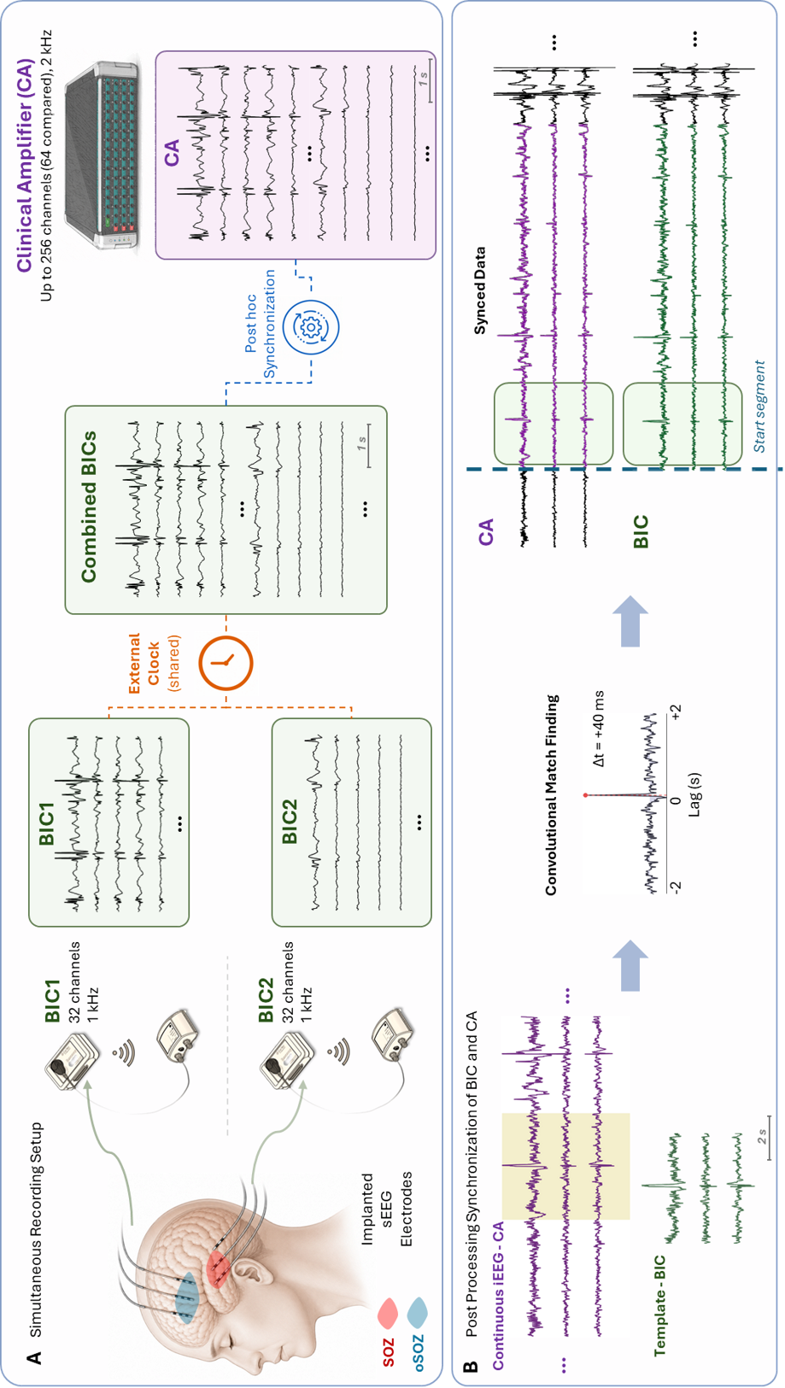
Supplementary Fig. S1 Simultaneous recording and post hoc synchronization framework for continuous iEEG acquisition using a clinical amplifier (CA) and combined Brain Interchange devices (BICs). (A) Simultaneous recording setup showing concurrent acquisition of iEEG signals from implanted sEEG electrodes using a clinical amplifier (CA; up to 256 channels, 2 kHz sampling rate) and two synchronized Brain Interchange devices (BIC1 and BIC2; 32 channels each, 1 kHz sampling rate). The two BIC systems shared a common external clock to generate a combined 64-channel BIC recording. Following acquisition, CA and combined BIC recordings were temporally aligned using a post hoc synchronization procedure. (B) Post processing synchronization pipeline between continuous CA and BIC recordings. A short BIC signal segment was used as a template and convolved across the continuous CA recording to identify the optimal temporal alignment between systems. The lag corresponding to the maximum convolution match defined the synchronization offset ($Δt$). After alignment, synchronized CA and BIC recordings were segmented using common start points for downstream comparative analyses. Colored traces highlight corresponding synchronized neural activity across both recording systems.

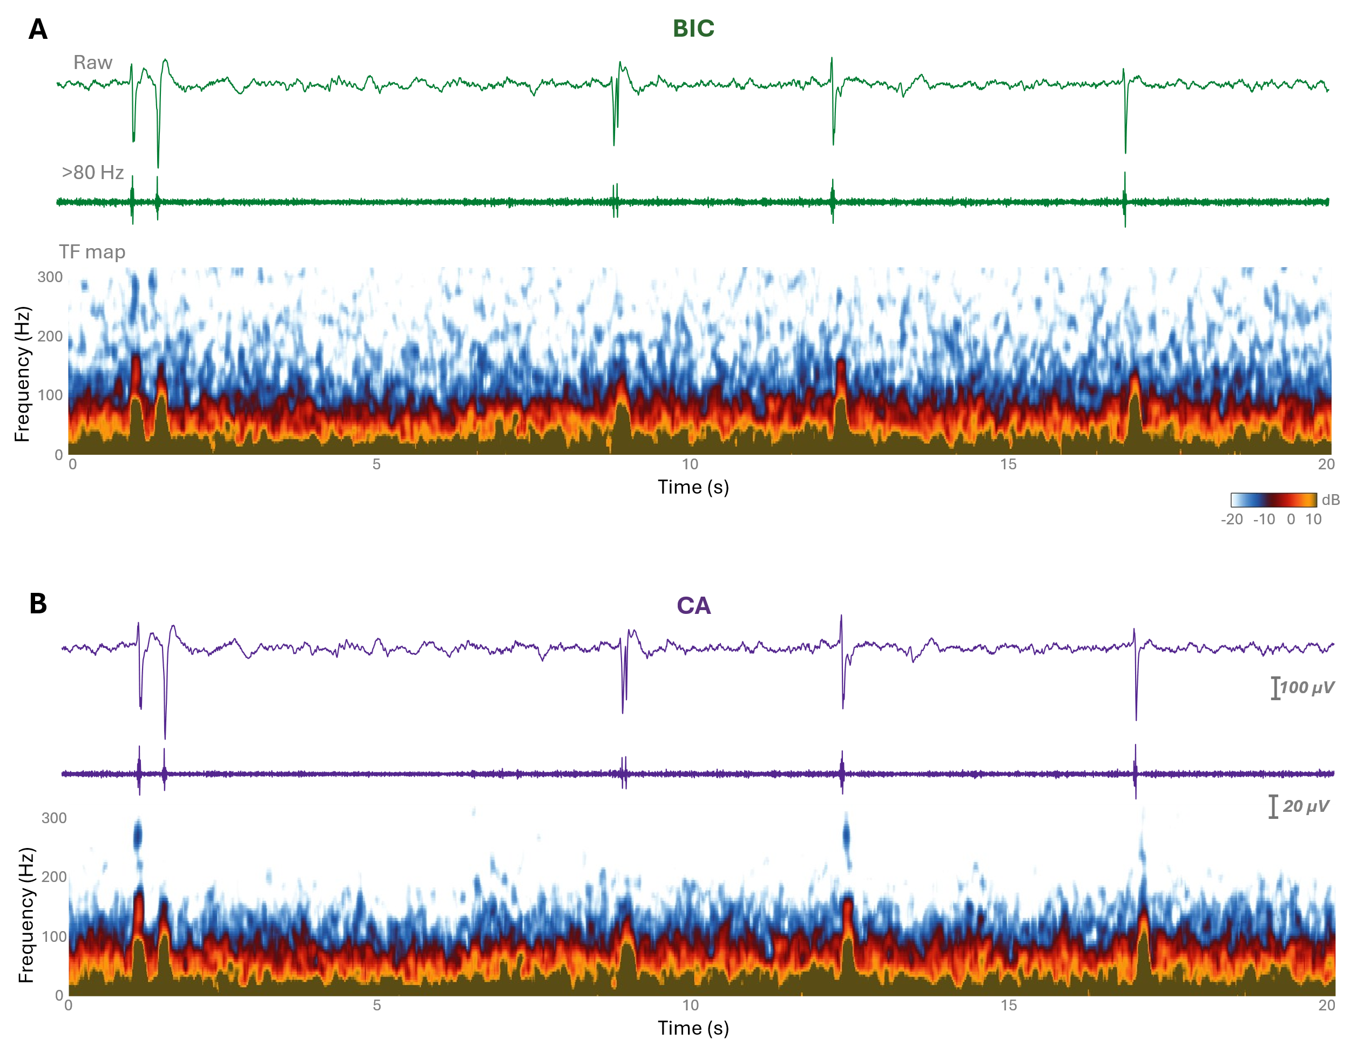
Supplementary Fig. S2 Raw and filtered iEEG with time-frequency representation. (A) Twenty seconds of raw iEEG from a hippocampal SOZ channel. Filtered signals in the HFO band (>80 Hz) are shown below the raw trace. The corresponding STFT-based time-frequency map is displayed for the BIC recording, illustrating the spectral power distribution over time. High-frequency ripple activity is partially masked by background noise. (B) Corresponding data from CA. The HFO-filtered signal highlights ripple and fast ripple activity, which is captured more clearly compared with BIC. The time-frequency map shows isolated FR events that are evident as bright localized blobs, demonstrating that CA better resolves fast ripple events in this segment.
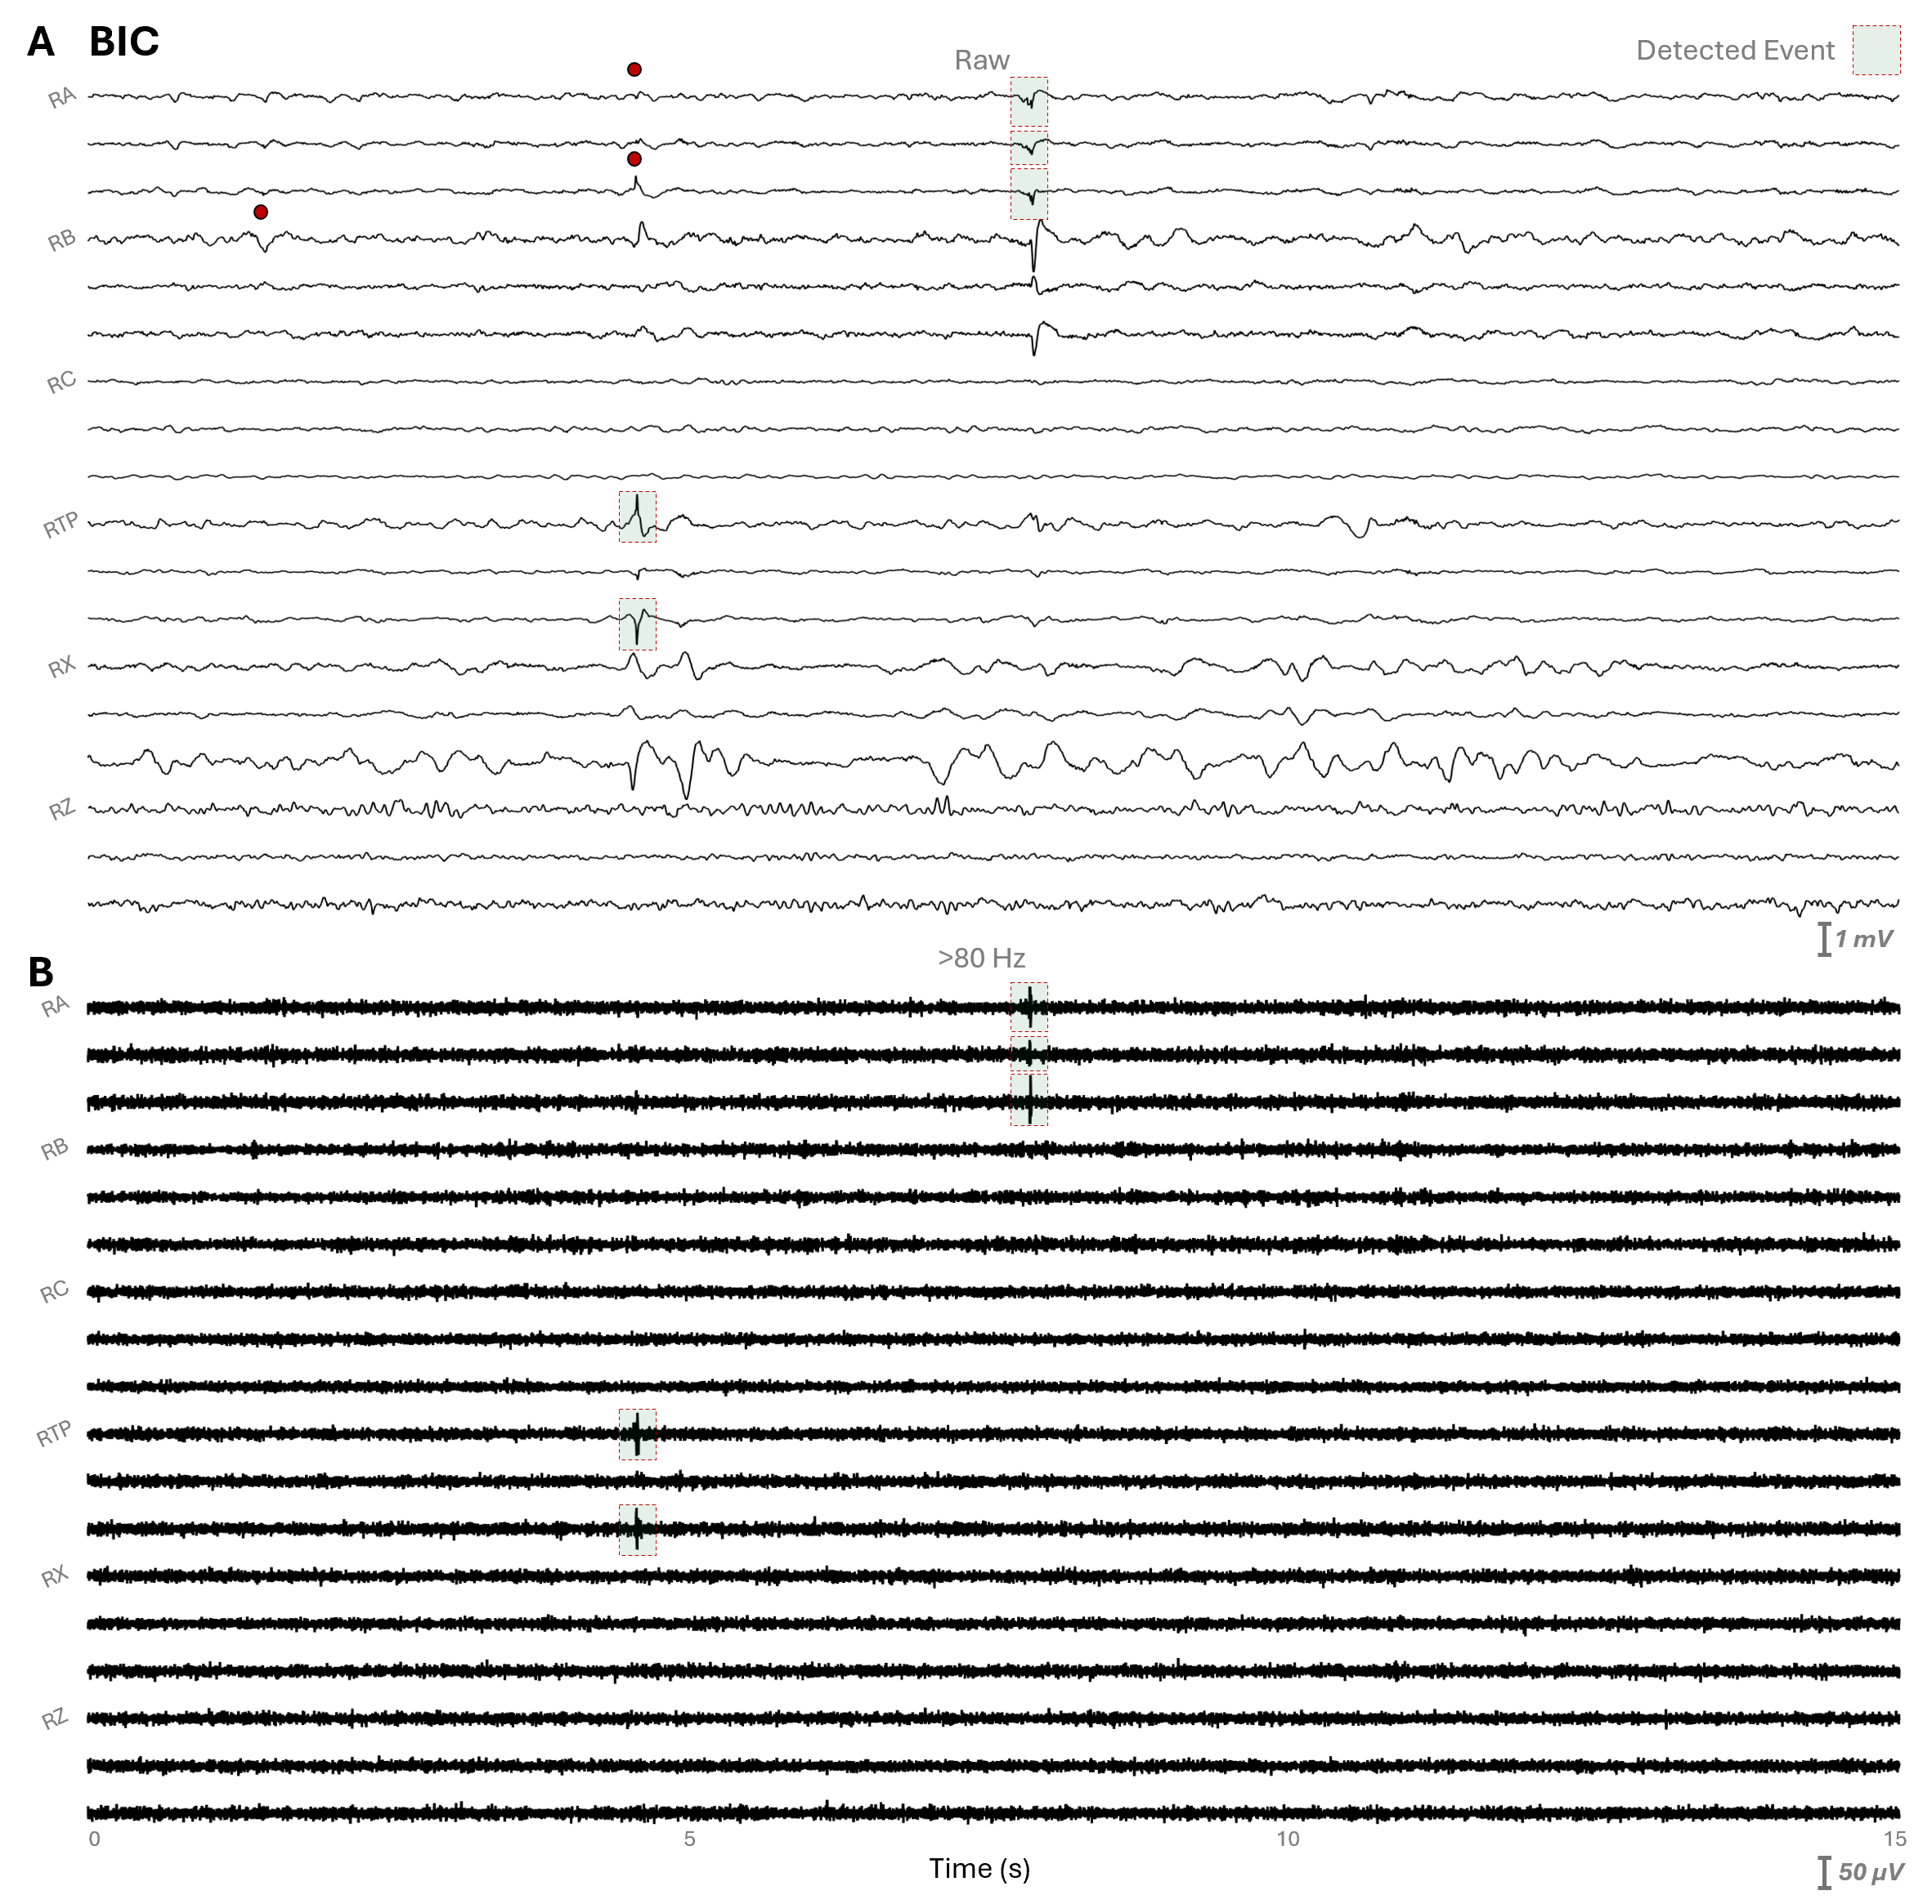
Supplementary Fig. S3 Multi-channel iEEG HFO detection in BIC recordings. (A) Fifteen seconds of multi-channel iEEG recorded with BIC. (B) HFO-filtered data in the >80 Hz band, with detected HFOs marked using red dashed green transparent boxes. Several HFO events were masked by background noise and were not captured in the BIC recording, illustrating the limitations in detecting fast events under high-noise conditions. Red circles indicate HFO events detected in the clinical amplifier recordings but not captured in the corresponding BIC recordings, due to the elevated background noise floor and reduced sensitivity of the implantable system to low-amplitude fast events.

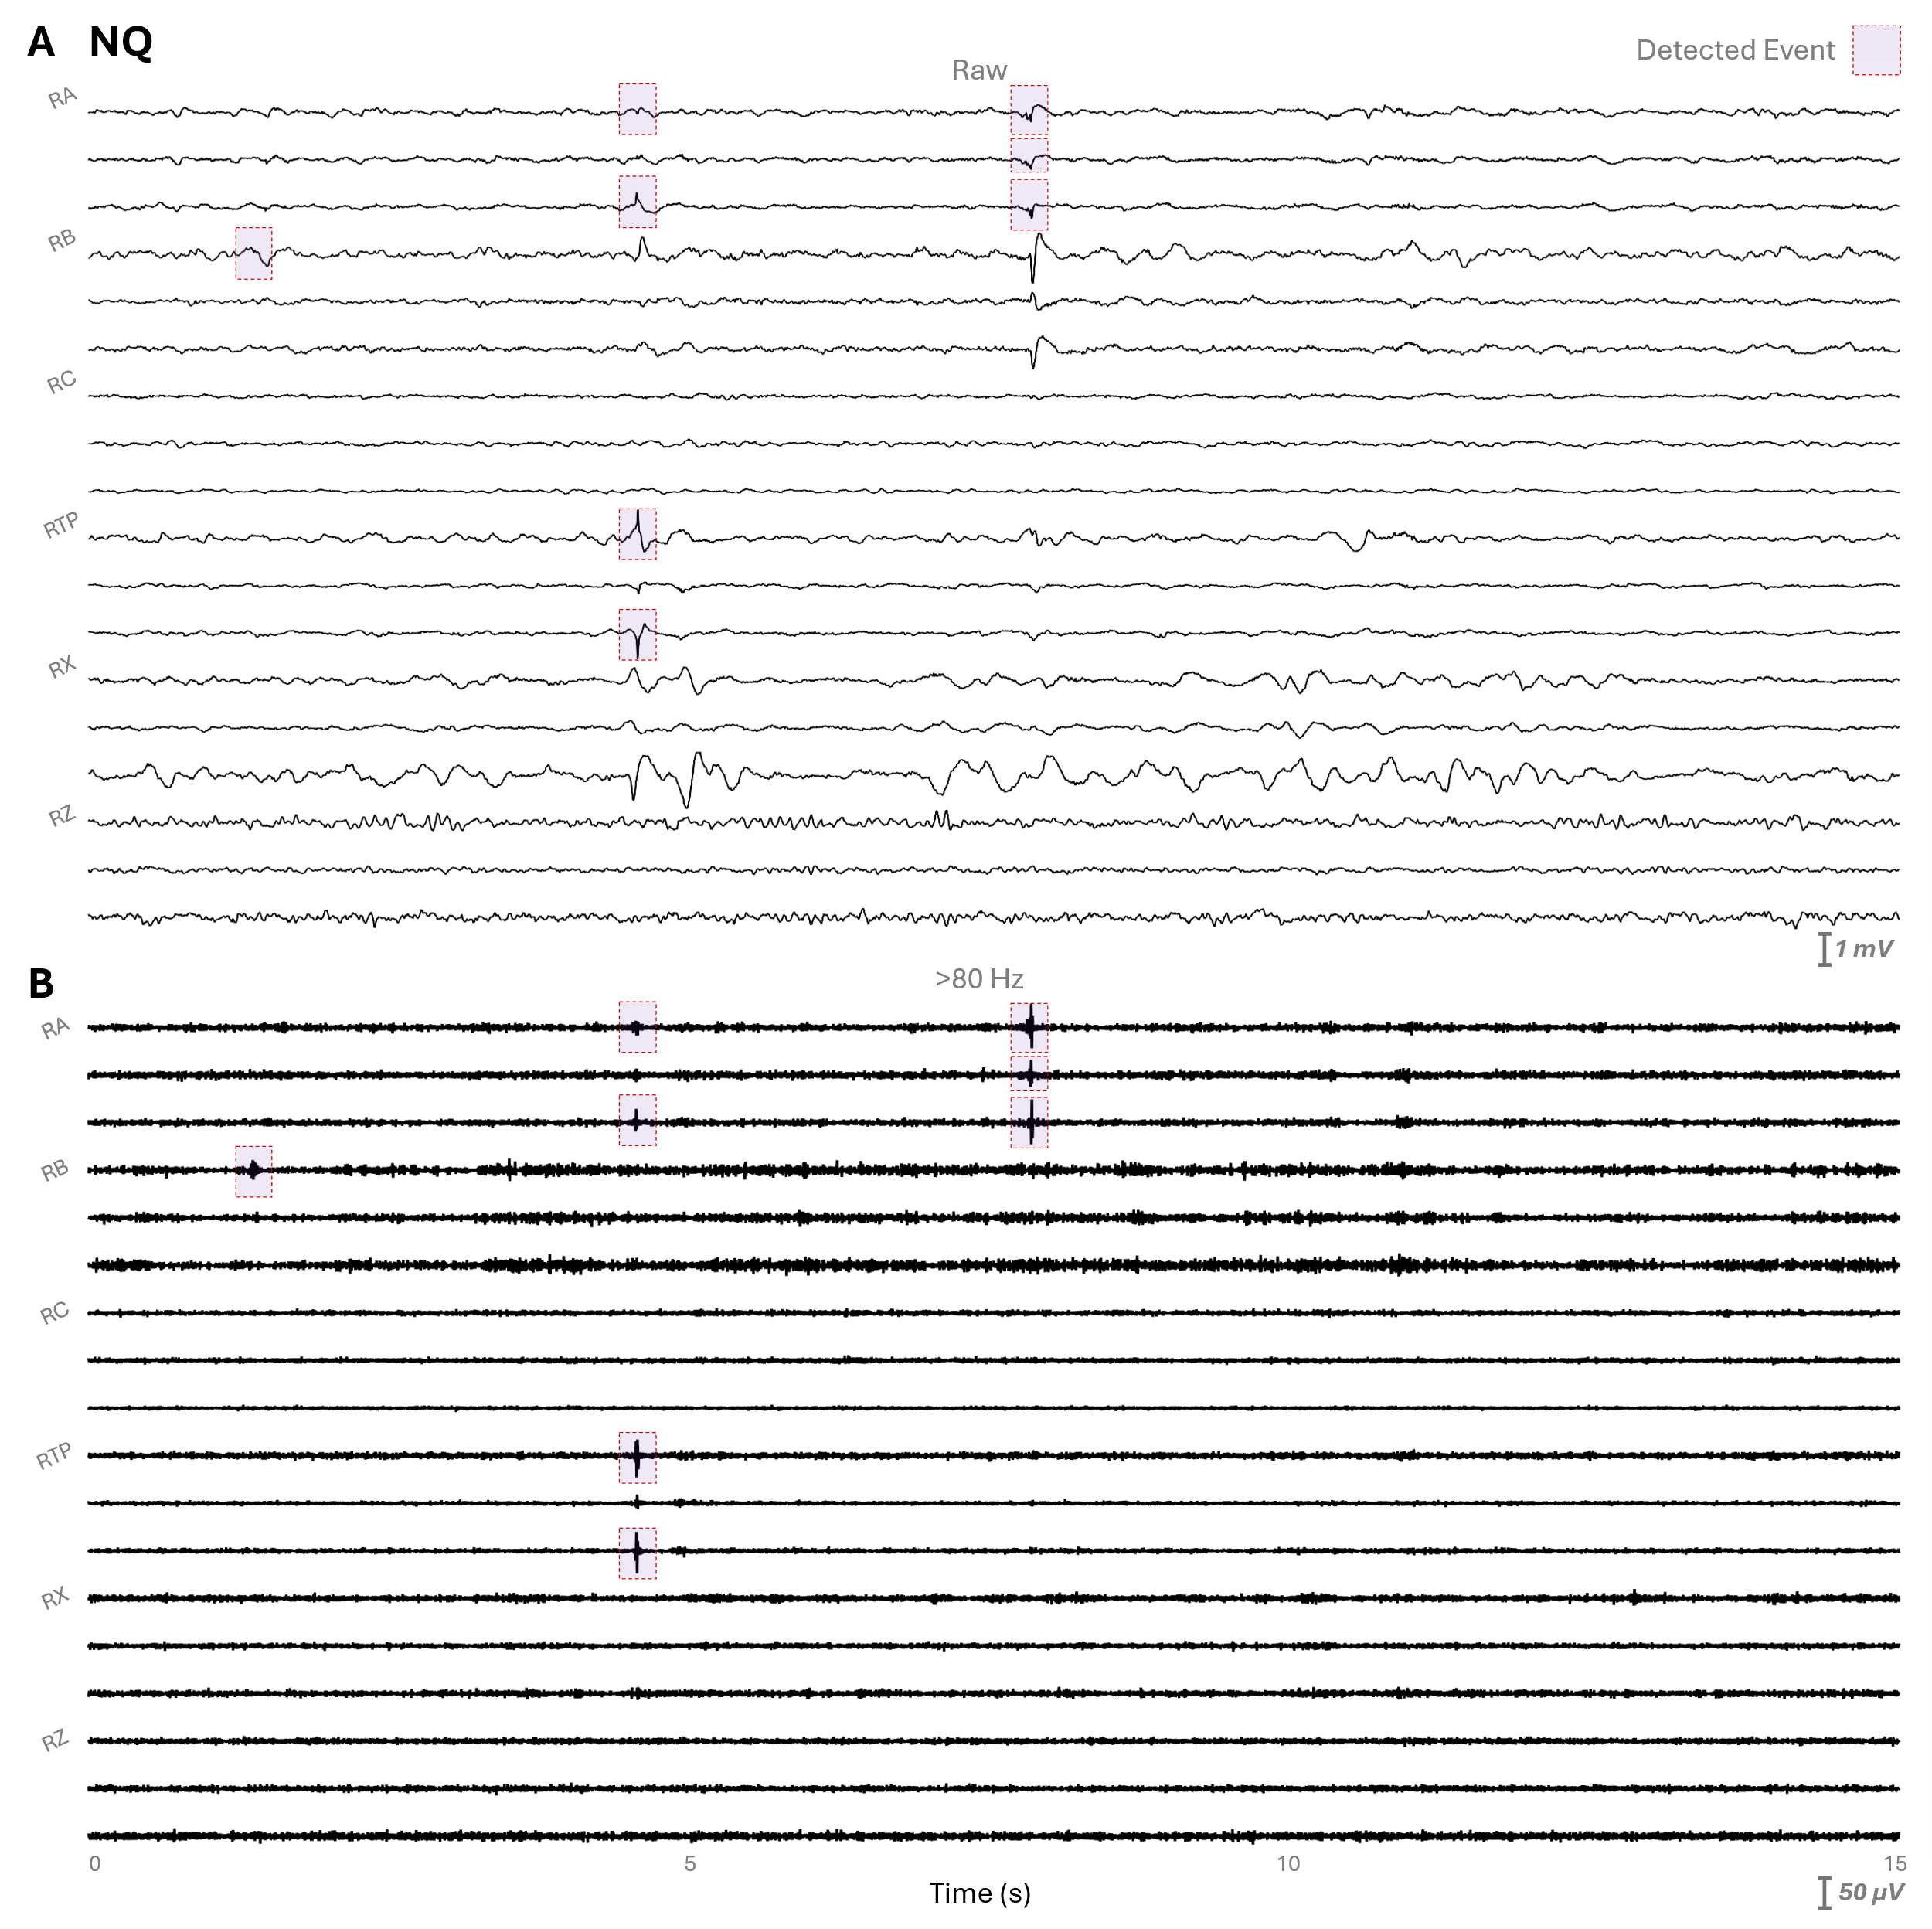
Supplementary Fig. S4 Multi-channel iEEG HFO detection in CA recordings. (A) Fifteen seconds of multi-channel iEEG recorded with CA. (B) HFO-filtered data in the >80 Hz band, with detected HFOs marked using red dashed purple transparent boxes. HFO events are clearly captured in the filtered data, demonstrating effective detection across channels with minimal masking from background activity.

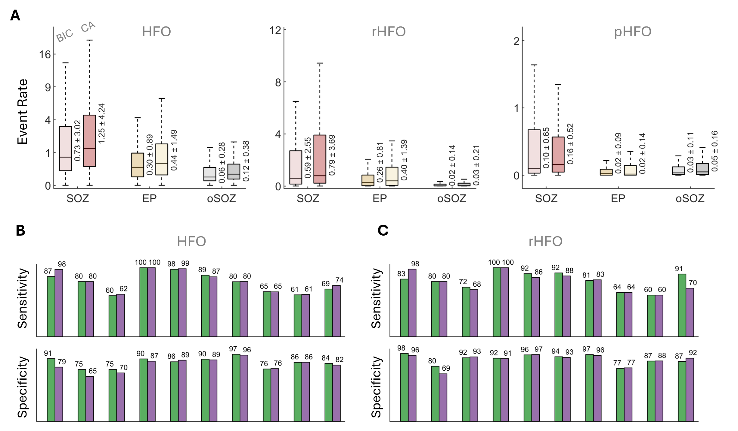
Supplementary Fig. S5 HFO rates and detection performance across anatomical regions. (A) Boxplots of normalized HFO rates across SOZ, EP, and oSOZ contacts for initial HFOs, rHFOs, and eliminated pHFOs, shown separately for BIC and CA recordings. Rates were normalized by the total number of channels within each anatomical category, allowing direct comparison across recording systems. (B) Mean sensitivity and specificity for initial HFO detection, with BIC in green and CA in purple, summarizing detection performance across all subjects. (C) Mean sensitivity and specificity for rHFO detection after denoising, with BIC in green and CA in purple, illustrating improved detection performance for high-frequency events post-denoising.

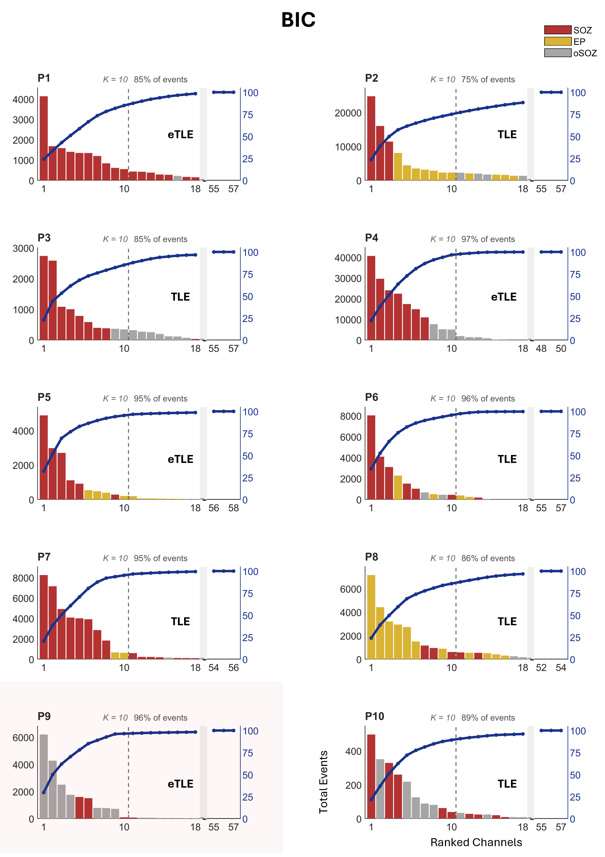
Supplementary Fig. S6 Channel-wise total event counts ranked by HFO - BIC recordings. Bar plots show the total number of detected events over 24 hours for each channel, ranked from highest to lowest rate, for all 10 subjects (P1–P10) recorded with the BIC system. Bars are color-coded by anatomical category: SOZ contacts in red, EP contacts in yellow, and oSOZ contacts in gray. The dashed vertical line at K = 10 indicates the cutoff. The top-ranked channels are consistently dominated by SOZ and EP contacts across subjects (except P9, which was an uncertain-localization case), supporting the spatial concordance between rHFO-rich channels and clinically defined epileptogenic regions. Panel labels (P1–P10) identify individual subjects.
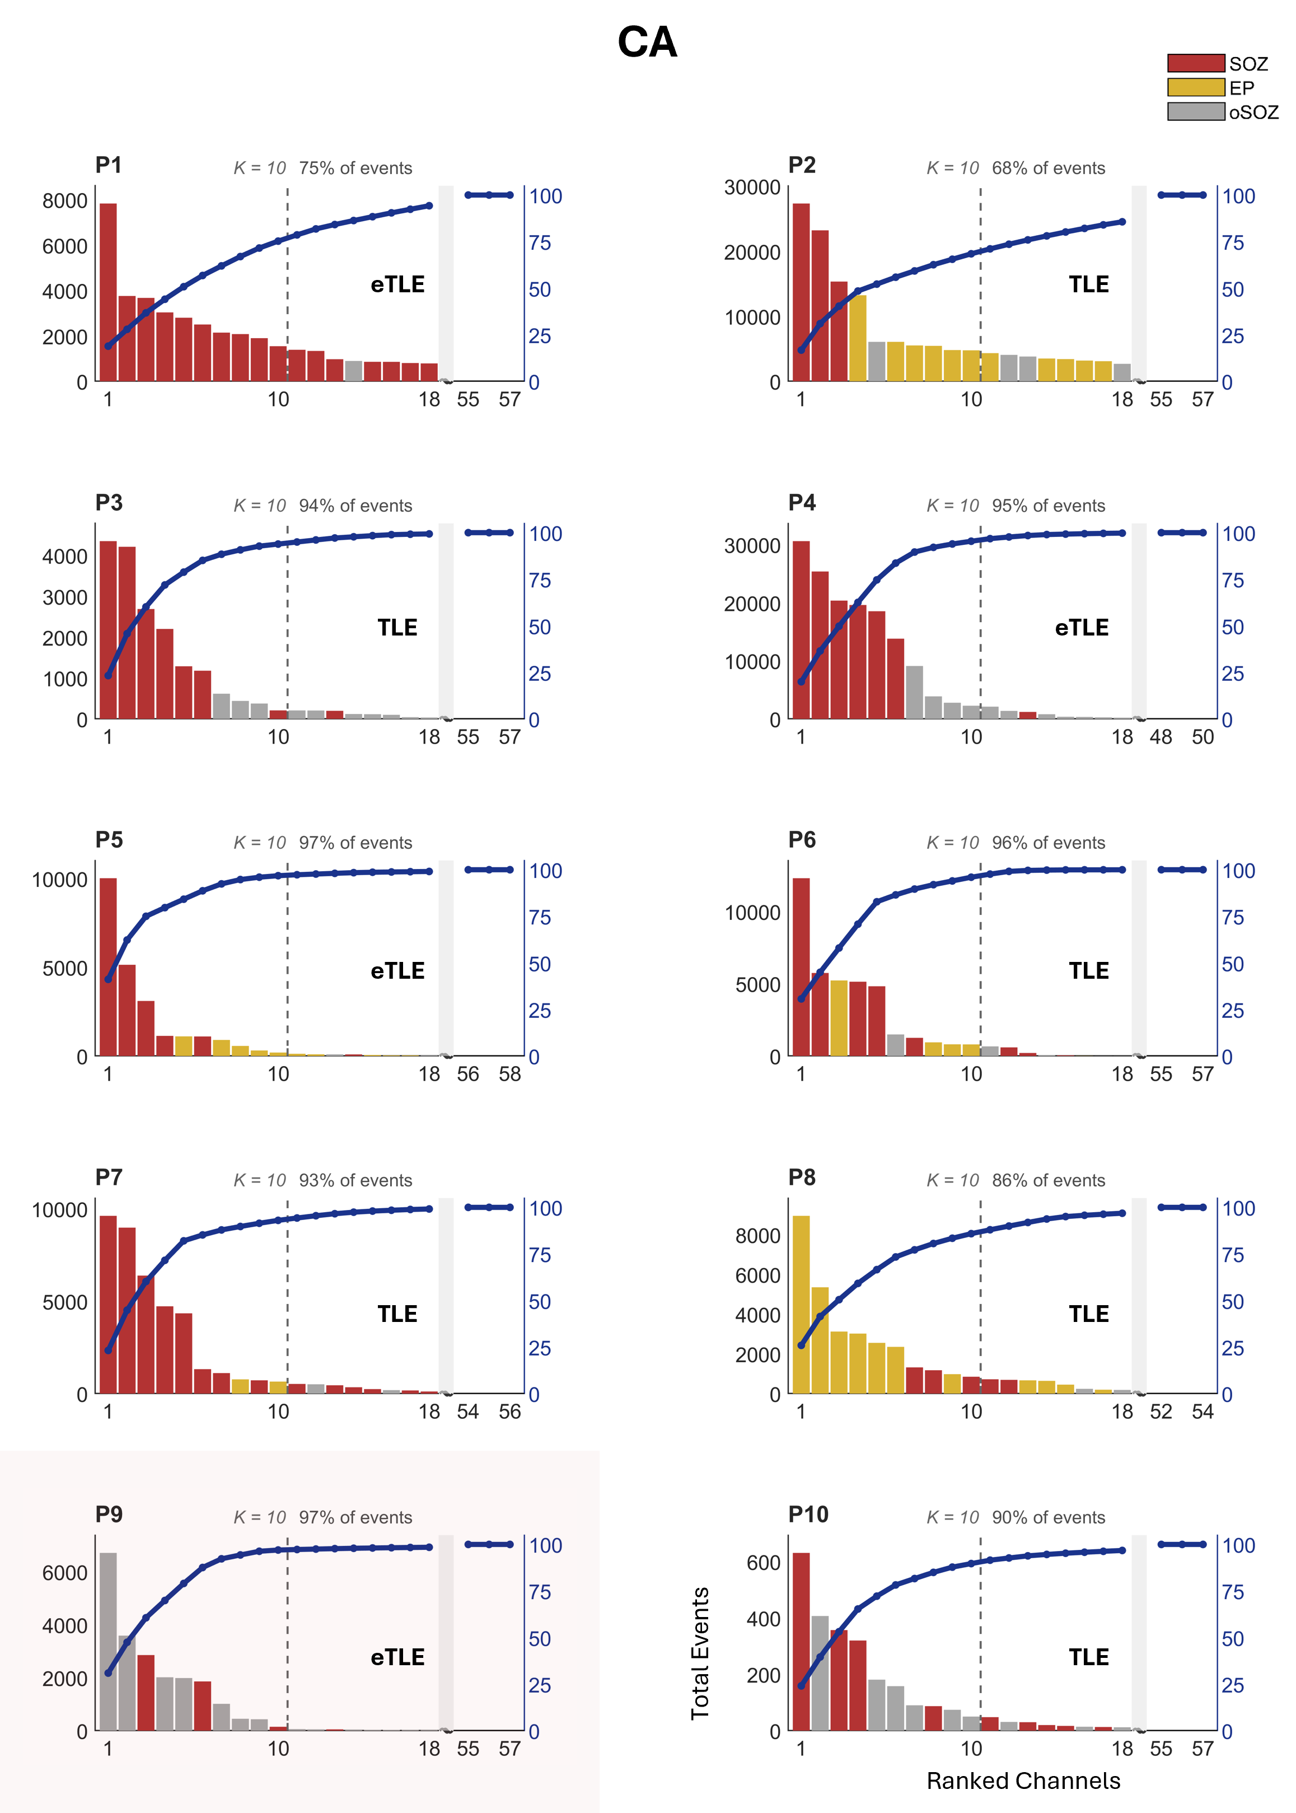
Supplementary Fig. S7 Channel-wise total event counts ranked by HFO — CA recordings. Bar plots show the total number of detected events over 24 hours for each channel, ranked from highest to lowest rate, for all 10 subjects (P1–P10) recorded with the CA (Natus Quantum) system. Bars are color-coded by anatomical category: SOZ contacts in red, EP contacts in yellow, and oSOZ contacts in gray. The dashed vertical line at K = 10 indicates the cutoff. The top-ranked channels are consistently dominated by SOZ and EP contacts across subjects (except P9, which was uncertain-localization case), supporting the spatial concordance between rHFO-rich channels and clinically defined epileptogenic regions. Panel labels (P1–P10) identify individual subjects.

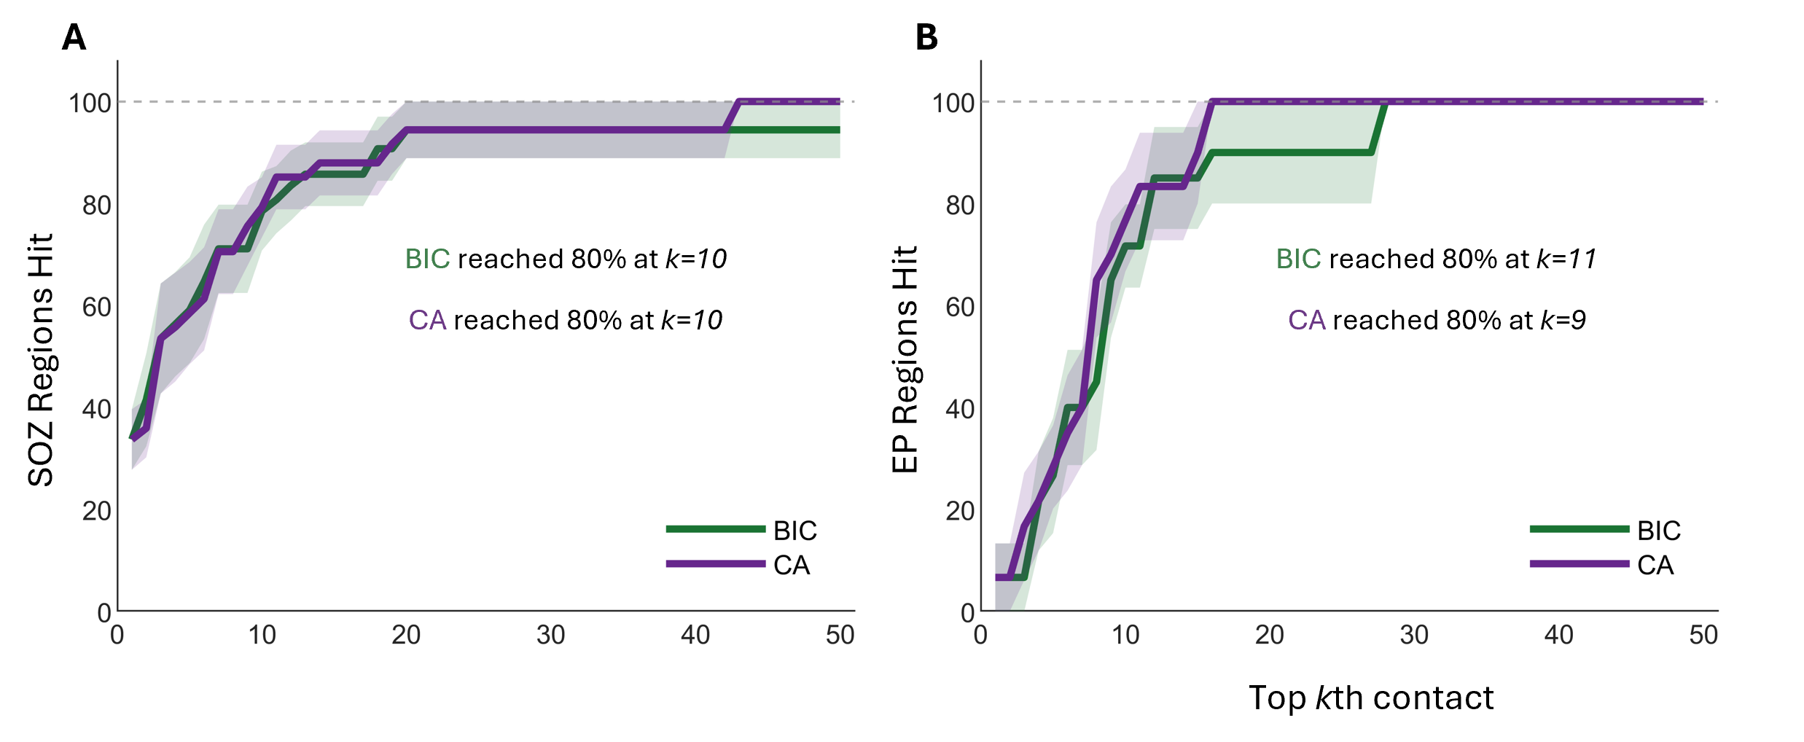
Supplementary Fig. S8. Coverage of SOZ and EP regions using channels ranked by HFO rate. (A) Percentage of SOZ regions identified as a function of the top-ranked contacts, sorted by descending HFO rate, for the Brain Interchange system (BIC, green) and the clinical amplifier (CA, purple). Both systems reached 80% SOZ coverage using the top k = 10 contacts. (B) Percentage of EP regions identified using the same ranking. The CA reached 80% EP coverage at k = 9 contacts, while the BIC reached the same coverage at k = 11 contacts. Shaded regions indicate variability across subjects.

