Environmental Monitoring and Assessment
Electronic Supplementary Material — Online Resource 3
Supplementary Figures S3–S15.
Article: When Does Model Complexity Pay? Multi-Horizon NO₂ Forecasting in the Sparse Monitoring Network of the City of Buenos Aires

Author: Javier Aira — Independent Researcher, City of Buenos Aires, Argentina. Corresponding author: jj.aira@outlook.com. ORCID: 0000-0003-0879-1380.

This Online Resource groups Supplementary Figures S3–S15, one per page, in the order in which they are first cited in the main text. Figs. S1 (photographs of the stations) and S2 (schematic of the workflow) are included in Online Resource 1; the supplementary tables are in Online Resource 2.

Abbreviations
APRA, Environmental Protection Agency of the City of Buenos Aires; CABA, Autonomous City of Buenos Aires; CI, confidence interval; CO, carbon monoxide; EU, European Union — the official designations of legal instruments retain their published form, e.g. Directive (EU) 2024/2881; FN, false negatives; FP, false positives; NO, nitrogen monoxide; NO₂, nitrogen dioxide; PM10, particulate matter with an aerodynamic diameter ≤ 10 µm; RMSE, root mean squared error; ΔRMSE, difference in RMSE between two models; SARIMAX, seasonal autoregressive integrated moving average with exogenous regressors; SHAP, Shapley additive explanations; TN, true negatives; TP, true positives; TROPOMI, TROPOspheric Monitoring Instrument; WHO, World Health Organization — the form used in the author–year citations and in the labels embedded in Fig. S4, which is not edited; XGBoost, extreme gradient boosting.

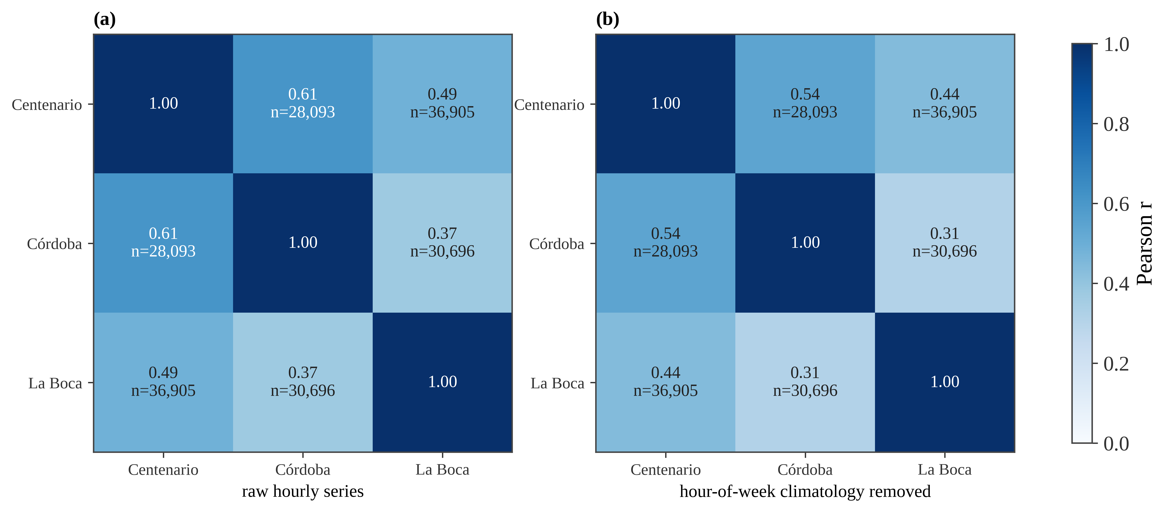
Fig. S3 Hourly NO₂ correlation matrix between the three stations (2019–2025), on complete observation pairs (n per cell). (a) Raw hourly series: 0.37–0.61. (b) Deseasonalised series (hour-of-week cycle removed): 0.31–0.54

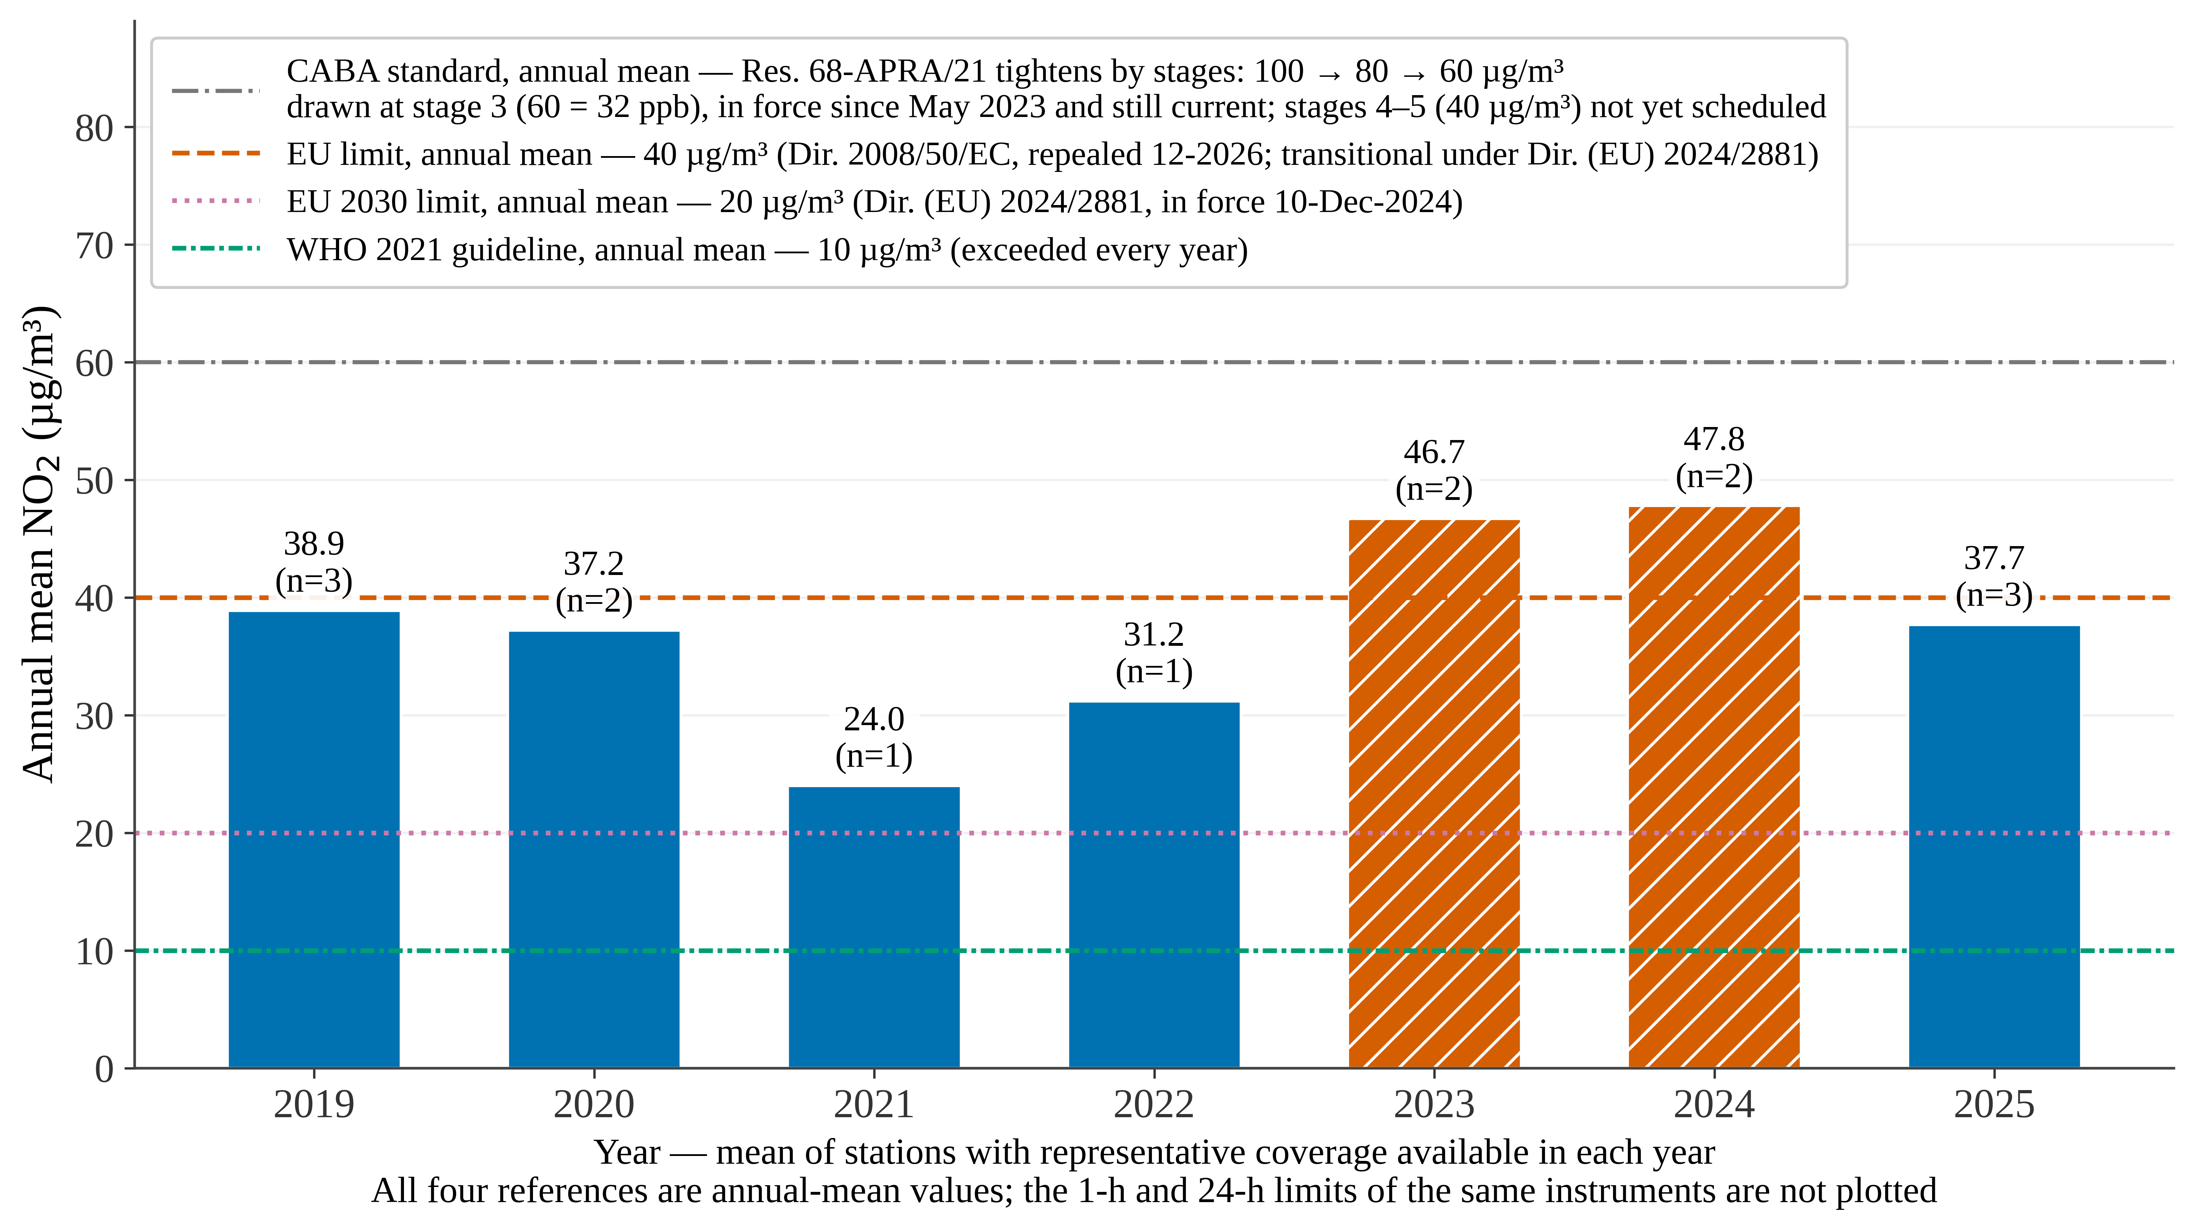
Fig. S4 Annual mean NO₂ of the network against the reference guidelines and standards, all expressed as annual means and plotted only as comparative context: the 2021 WHO guideline (10 µg/m³; World Health Organization [WHO], 2021), the 2030 EU annual limit value (20 µg/m³; European Union, 2024), the transitional EU annual limit value (40 µg/m³; European Union, 2008) and the CABA standard at its stage in force (Resolución 68-APRA/21, Annex I; APRA, 2021), the only reference that varies within the period. Only stations with representative annual coverage (≥75%) are considered, and their number varies between years: the bars must not be interpreted as a trend over a fixed composition of the network or as a formal determination of regulatory compliance. In red, the years whose network mean exceeds the transitional EU limit value (2023–2024). The complete regulatory framework — the stage schedule of Resolución 68-APRA/21, the pre-existing standard of Ley N° 1356 (2004), the pending timetable and the short-term values, which are not plotted because they correspond to other averaging periods — and the coverage caveats are in Online Resource 4, §§1–2

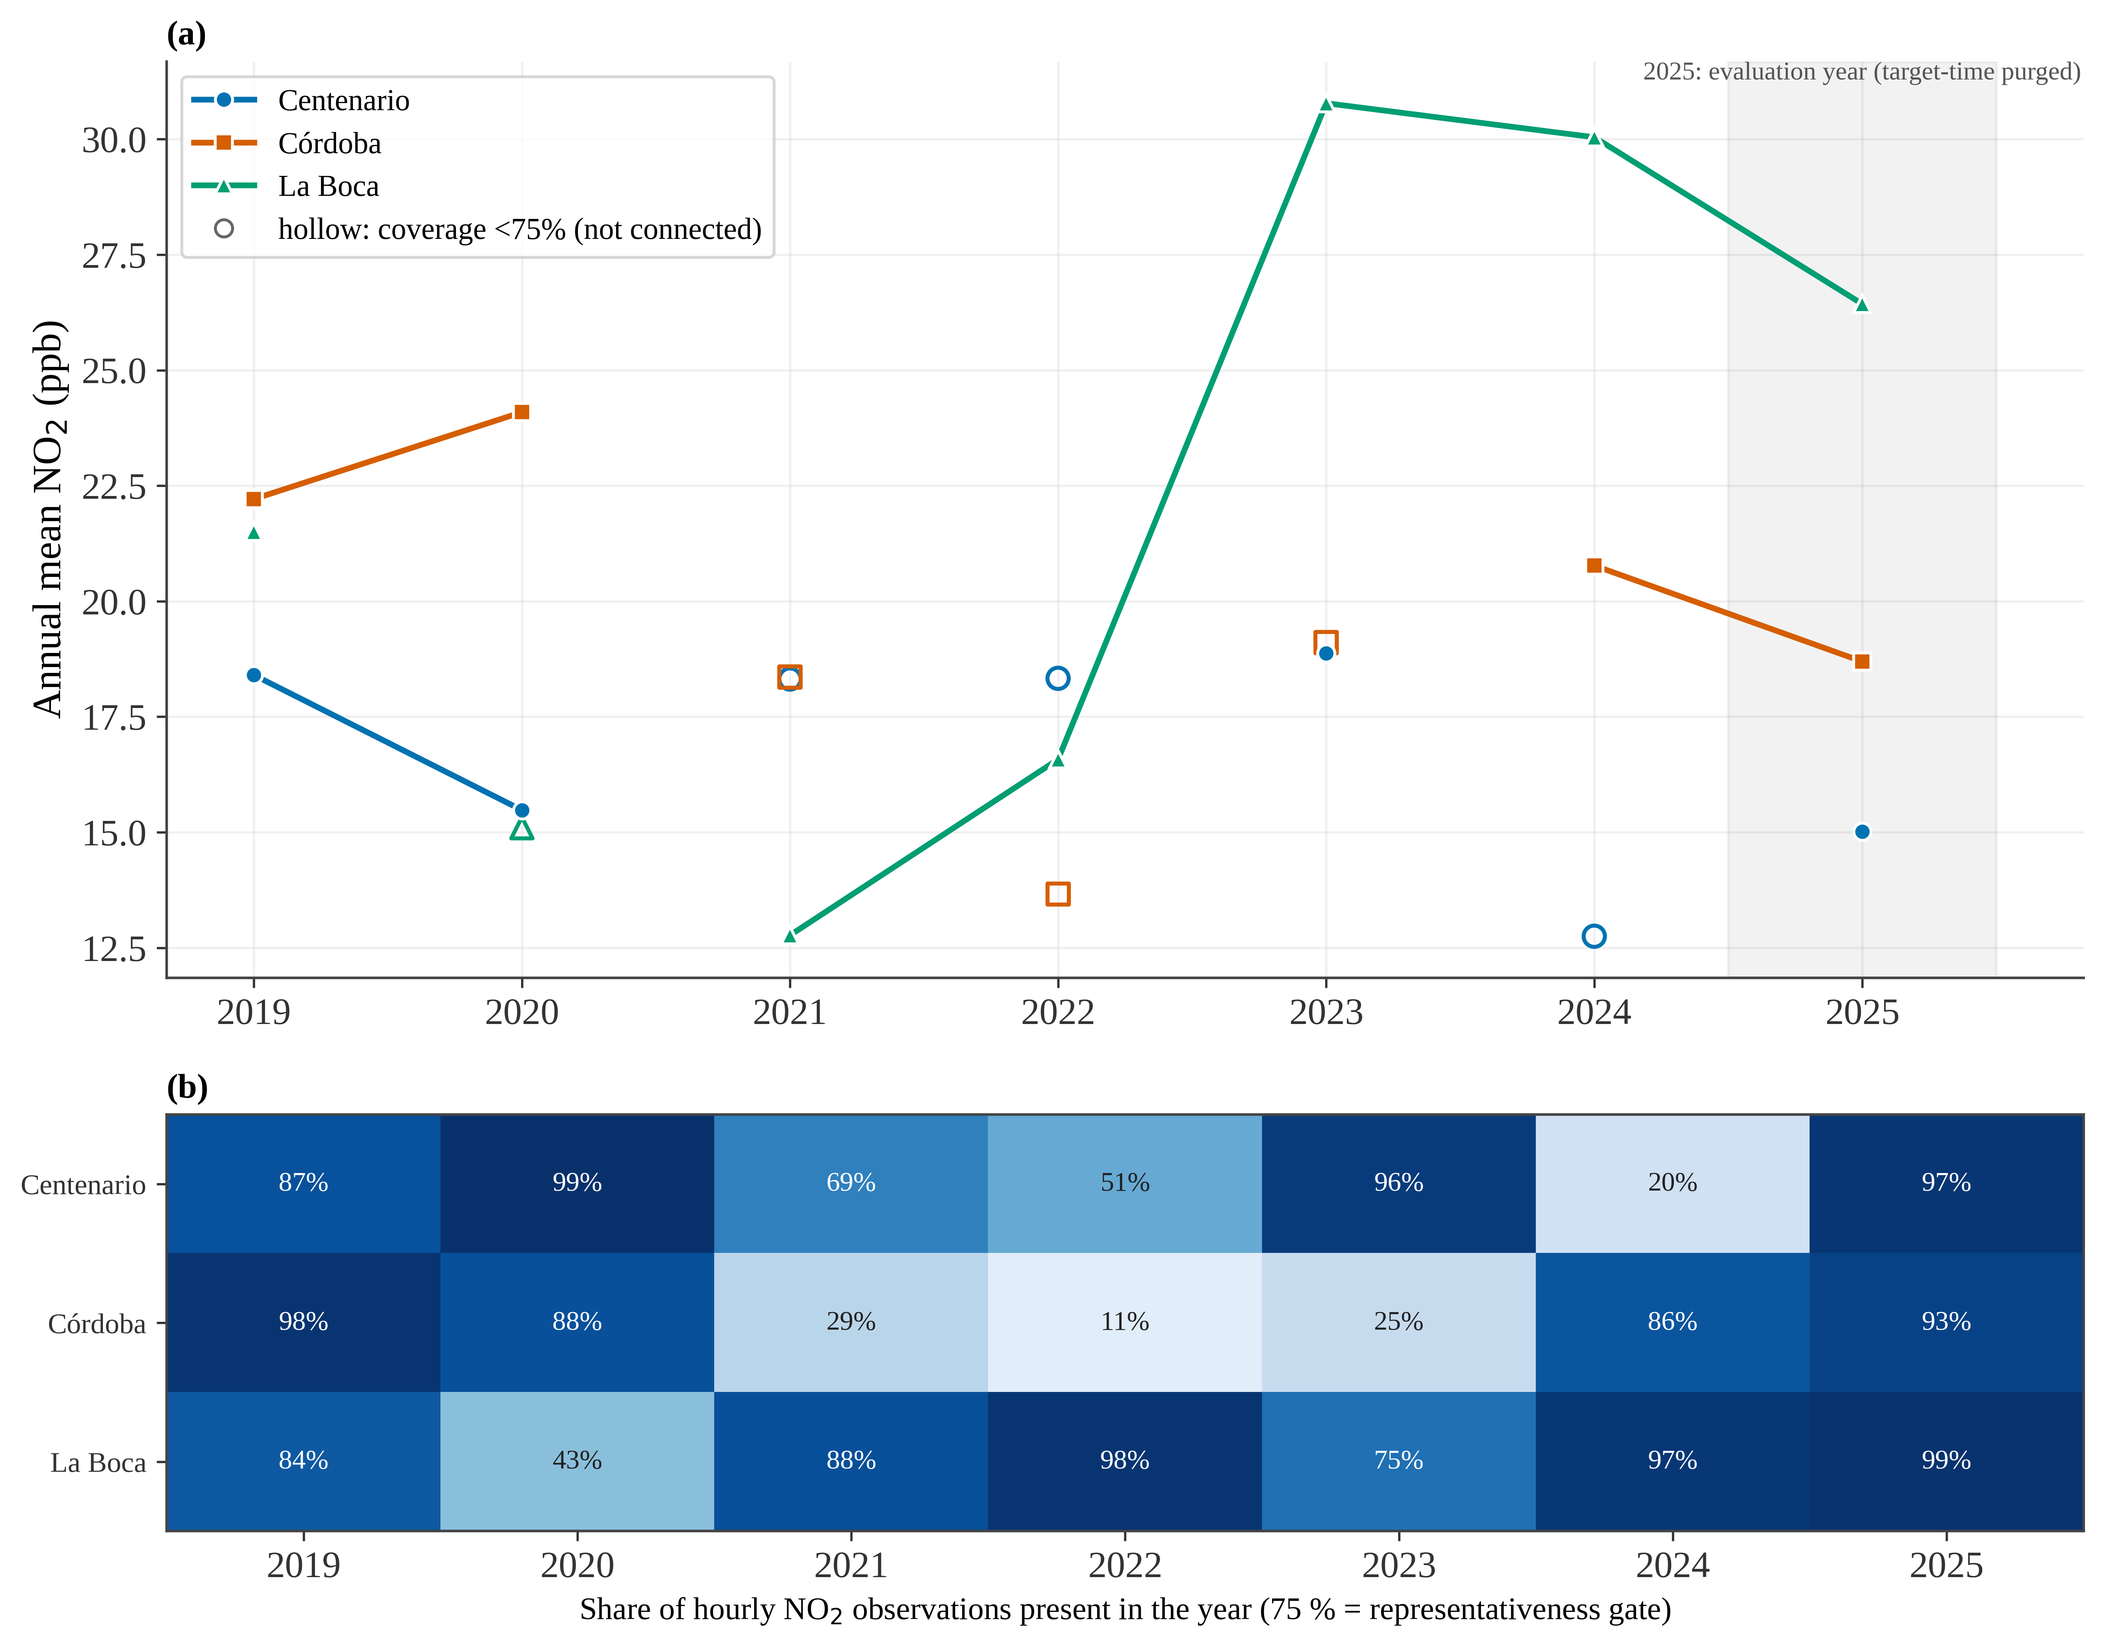
Fig. S5 (a) Evolution of the annual mean NO₂ concentration by station (2019–2025); years with coverage below 75% are shown with hollow, unconnected symbols (not representative) and the shading marks the 2025 evaluation year. (b) NO₂ data coverage (percentage of hours in the year with a valid measurement) by station and year

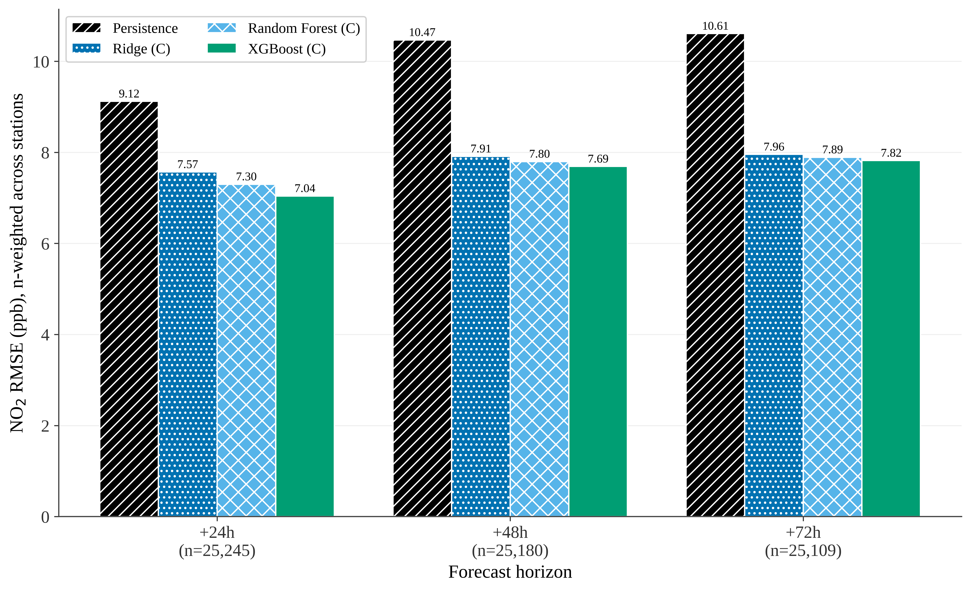
Fig. S6 RMSE in the 2025 evaluation year, by horizon, for the full configuration C (n per horizon on the axis). Training on the 2019–2024 series; evaluation on all valid hourly rows of 2025

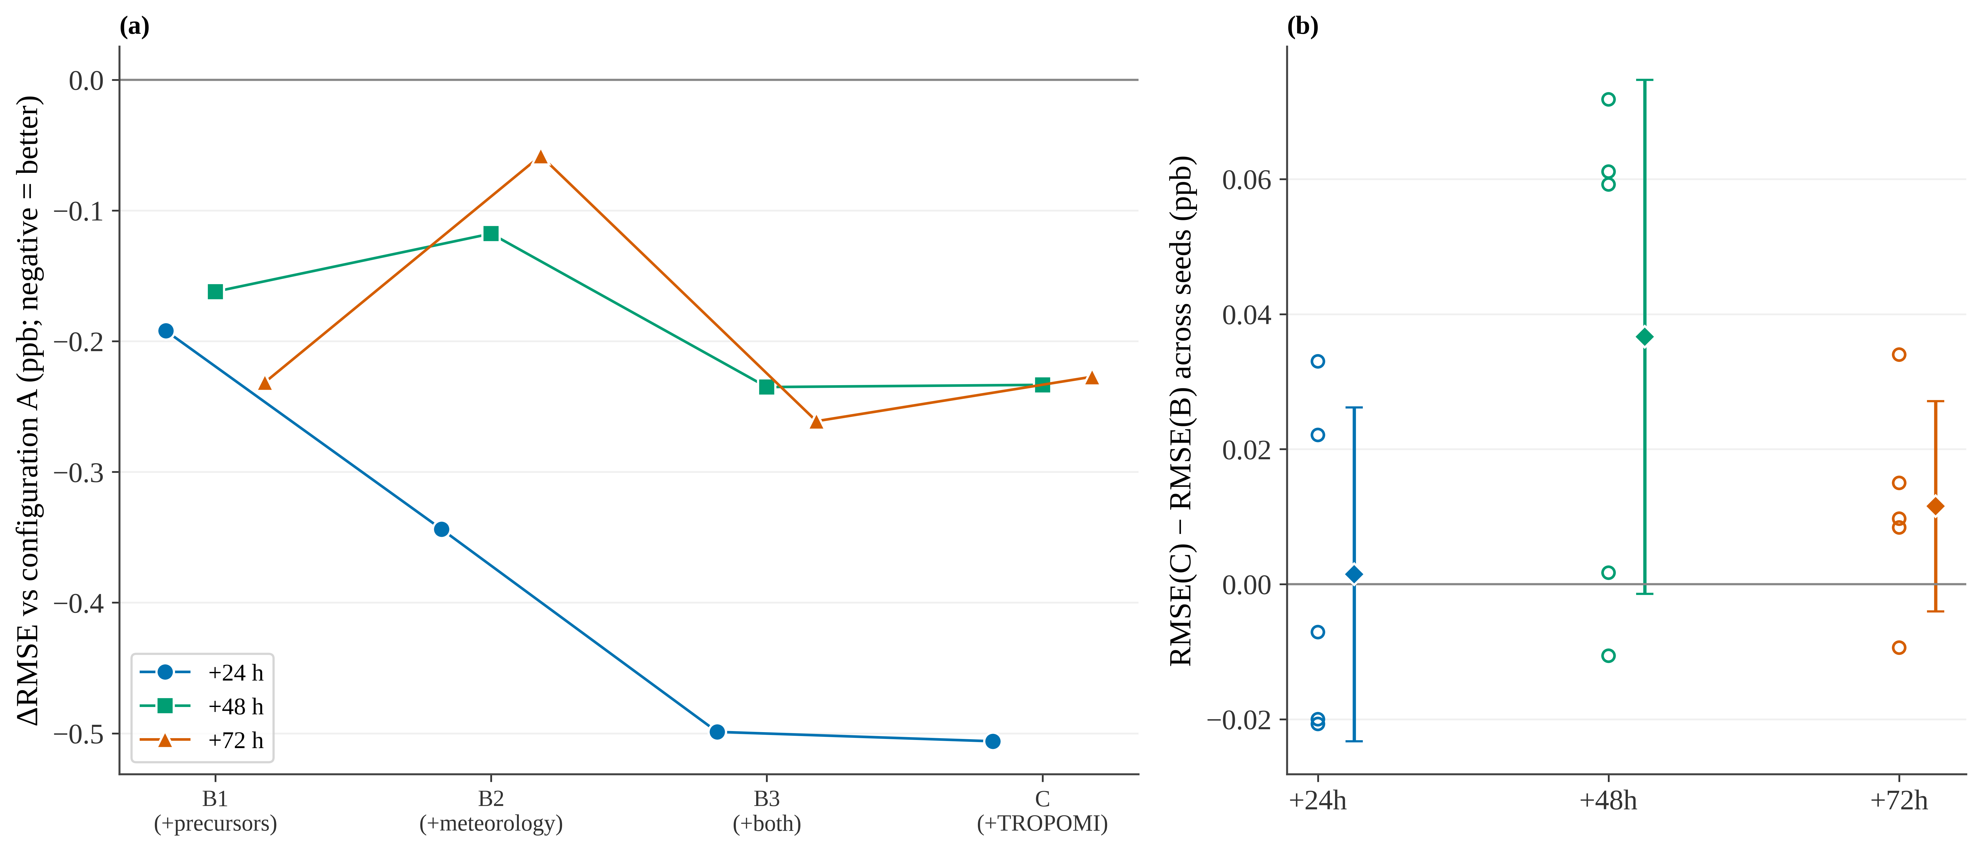
Fig. S7 Fine-grained ablation of the marginal contribution by source in the 2025 evaluation year (XGBoost). Nested configurations: A (NO₂ + calendar), B1 (+ precursors), B2 (+ meteorology), B3 (+ both), C (+ TROPOMI). (a) ΔRMSE relative to A (single run, seed 42). (b) RMSE(C) − RMSE(B) across five seeds: individual points and mean ± standard deviation

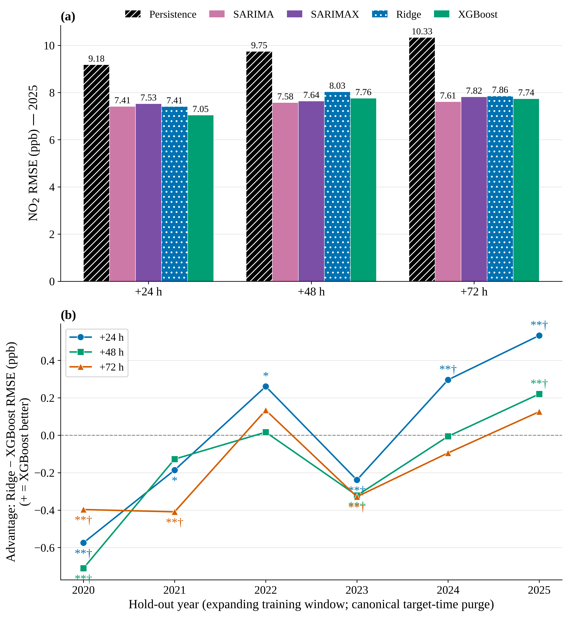
Fig. S8 (a) SARIMAX against the model families on common daily issue times (issued at 00 h; 2025 evaluation year). (b) Advantage ΔRMSE = Ridge − XGBoost by hold-out year in an expanding window 2020–2025 (* p<0.05 and ** p<0.01 nominal, Diebold–Mariano; † survives the global Benjamini–Hochberg correction)

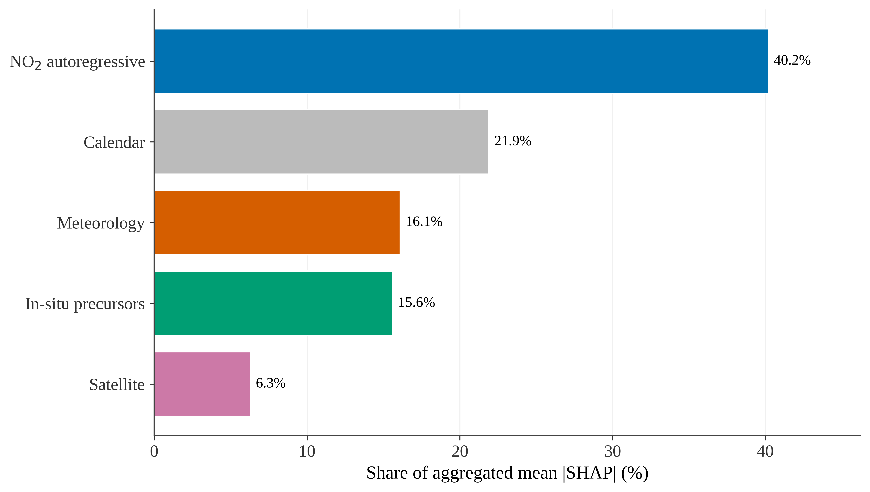
Fig. S9 Relative contribution of each data source according to aggregated SHAP values (XGBoost, configuration C, +24 h). Colours follow the source categories of Fig. S11

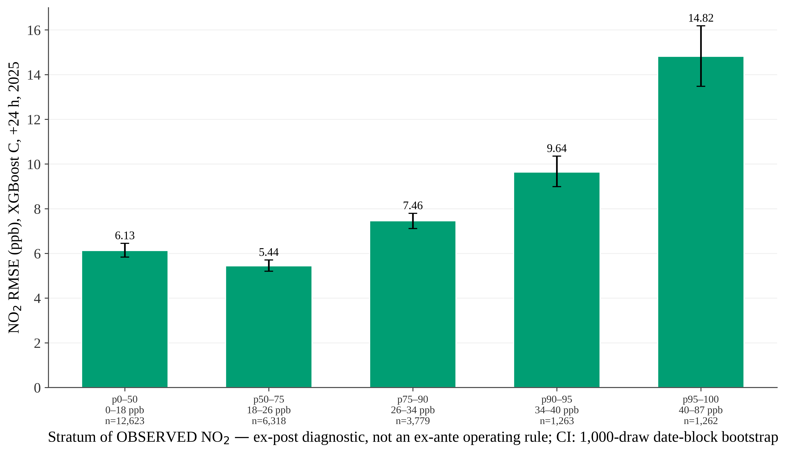
Fig. S10 NO₂ RMSE by stratum of observed NO₂ (percentiles p0–50 to p95–100) in the 2025 evaluation year (XGBoost, configuration C, +24 h), with n per stratum and a date-block bootstrap CI

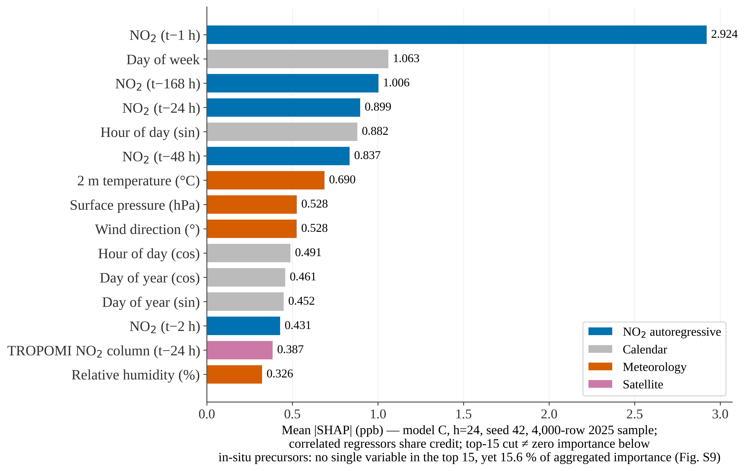
Fig. S11 Fifteen most influential features by |SHAP| value (XGBoost, configuration C, +24 h); the aggregation by source category is shown in Fig. S9. No precursor (NO, CO, PM10) appears among the top 15

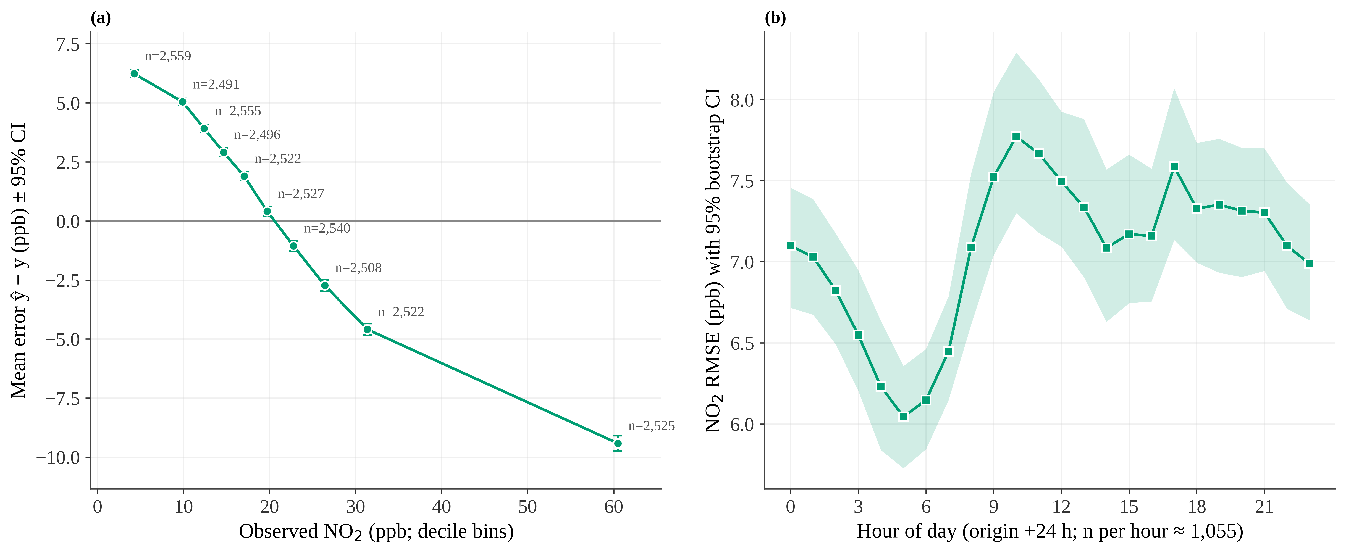
Fig. S12 Error structure in the 2025 evaluation year (XGBoost, configuration C, +24 h). (a) Mean error ŷ − y by decile of observed NO₂ (± 95% CI; n per bin). (b) RMSE by hour of the day with a 95% bootstrap CI

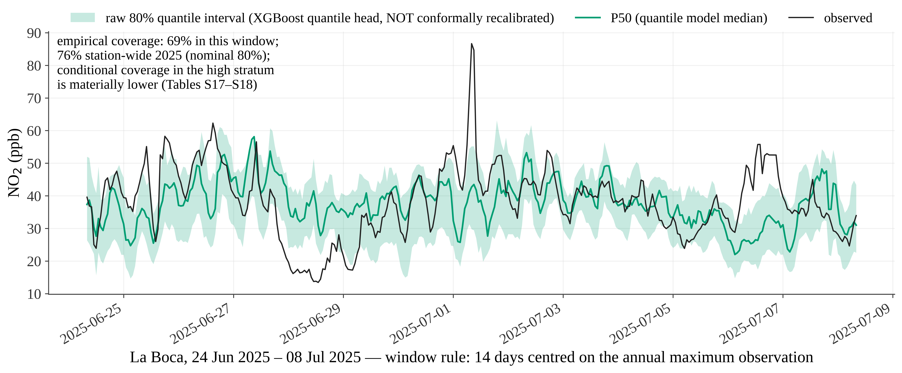
Fig. S13 Observed NO₂ against the +24 h forecast with an 80% prediction interval (quantile regression, without recalibration) at La Boca; 14-day window centred on the observed annual maximum of 2025. Conditional coverage in the high stratum is substantially lower (Online Resource 2, Tables S17–S18)

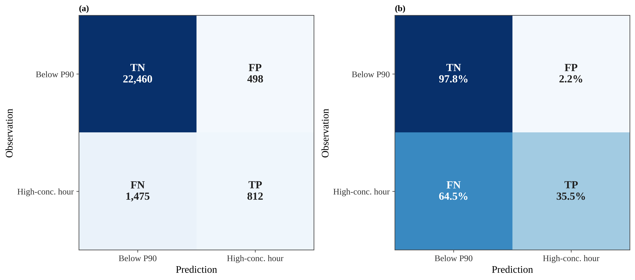
Fig. S14 Hourly confusion matrix of the high-concentration-hour classifier (threshold frozen at 35.03 ppb, the 90th percentile of the 2019–2024 training data) at +24 h in the 2025 evaluation year. (a) Counts; (b) normalised by row (by observed class). TN/FP/FN/TP: true and false negatives/positives. Operational metrics in Online Resource 2, Table S19

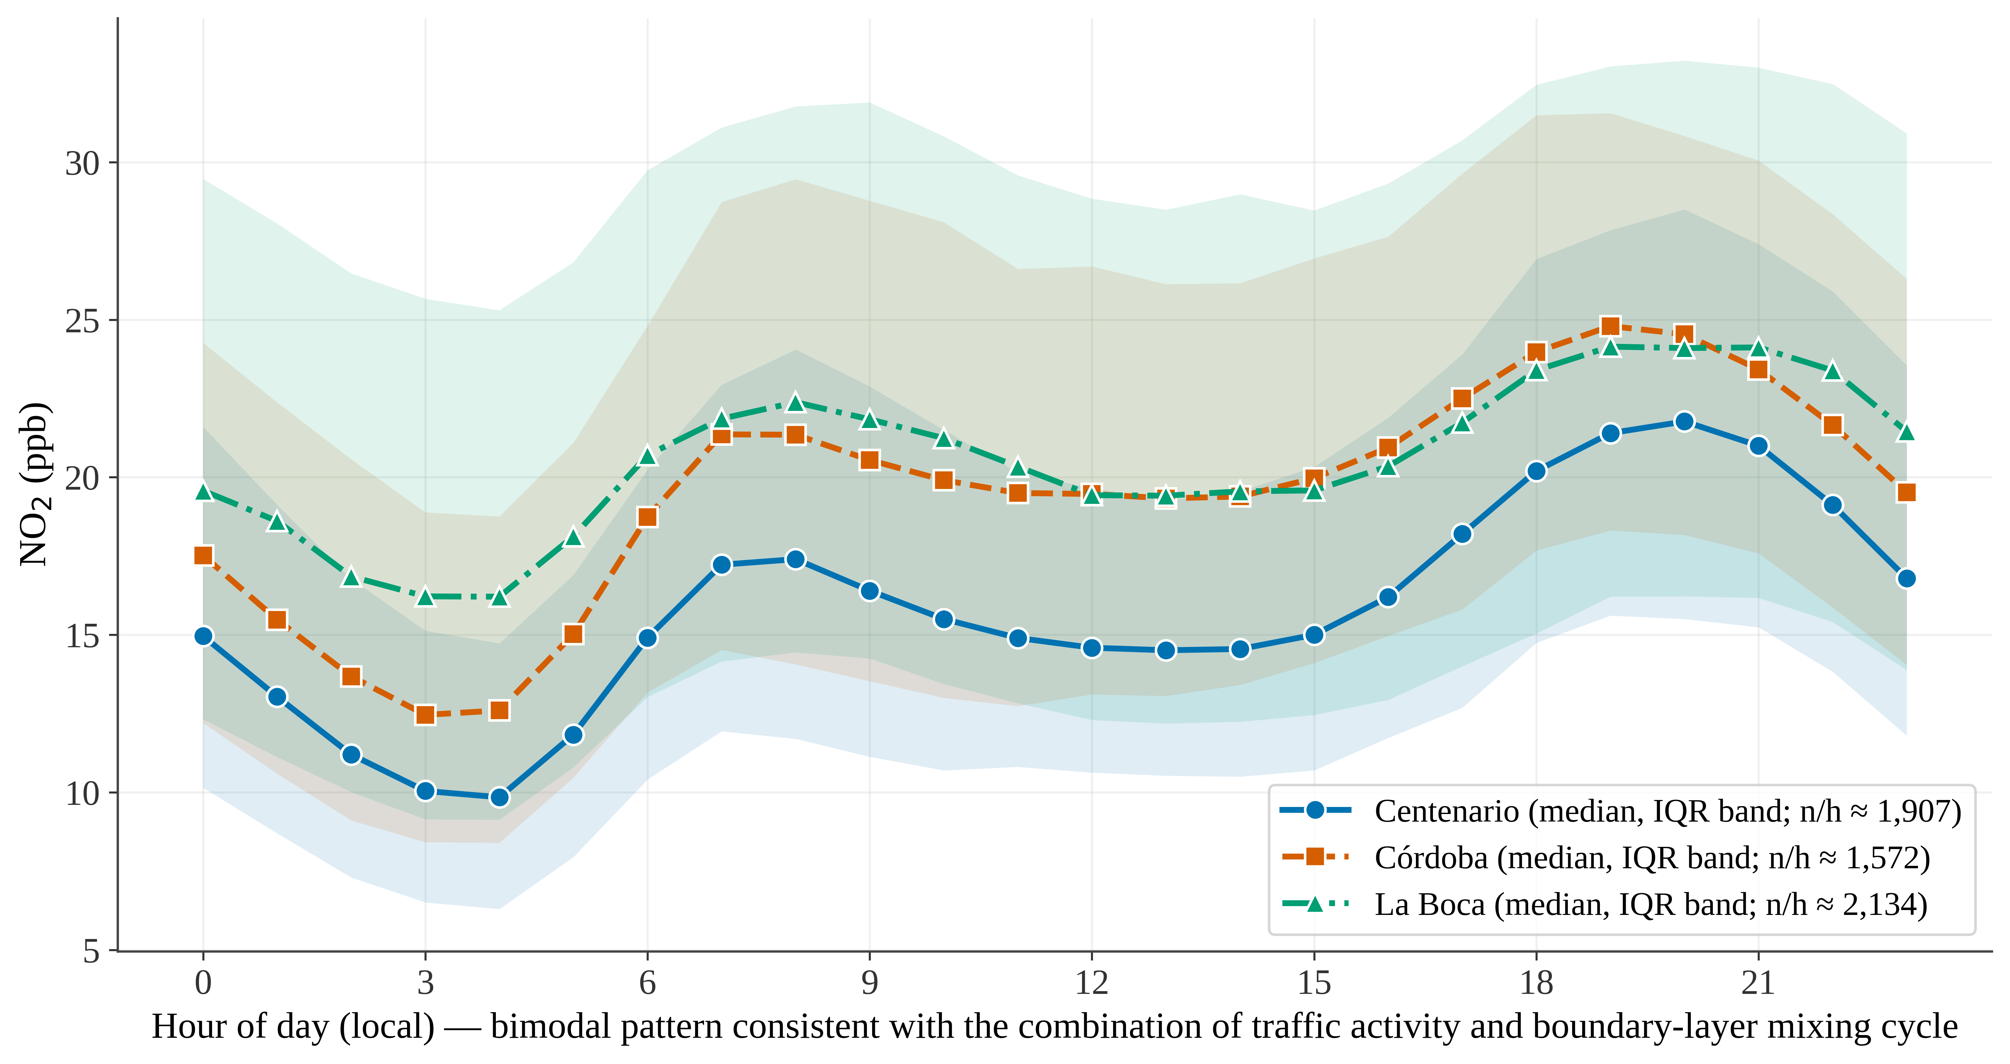
Fig. S15 Diurnal cycle of NO₂ by station (2019–2025): hourly median and interquartile band (percentiles 25–75)

References
Agencia de Protección Ambiental (APRA). (2021). Resolución N° 68-APRA/21: Estándares de calidad de aire y cronograma de adecuación progresiva [Resolution No. 68-APRA/21: Air quality standards and progressive compliance schedule]. Gobierno de la Ciudad Autónoma de Buenos Aires. Boletín Oficial de la Ciudad Autónoma de Buenos Aires, N° 6112, 29 de abril de 2021. Anexo I: Estándares de calidad de aire [Annex I: Air quality standards] (Informe N° 12564371-GCABA-APRA/21). https://documentosboletinoficial.buenosaires.gob.ar/publico/PE-RES-SECA-APRA-68-21-ANX.pdf
European Union. (2008). Directive 2008/50/EC of the European Parliament and of the Council of 21 May 2008 on ambient air quality and cleaner air for Europe. Official Journal of the European Union, L 152, 1–44.
European Union. (2024). Directive (EU) 2024/2881 of the European Parliament and of the Council of 23 October 2024 on ambient air quality and cleaner air for Europe (recast). Official Journal of the European Union, L, 2024/2881, 20 November 2024.
Ley N° 1356. (2004). Preservación del recurso aire y prevención y control de la contaminación atmosférica [Preservation of the air resource and prevention and control of atmospheric pollution]. Legislatura de la Ciudad Autónoma de Buenos Aires. Boletín Oficial de la Ciudad Autónoma de Buenos Aires, N° 2000, 10 de agosto de 2004 (republicada en el N° 2006, 19 de agosto de 2004, por fe de erratas en los artículos 35 y 66). Anexo I: Estándares de calidad de aire ambiente (Tabla A) [Annex I: Ambient air quality standards (Table A)]. https://boletinoficial.buenosaires.gob.ar/normativaba/norma/59418
World Health Organization. (2021). WHO global air quality guidelines: Particulate matter (PM2.5 and PM10), ozone, nitrogen dioxide, sulfur dioxide and carbon monoxide. World Health Organization. https://www.who.int/publications/i/item/9789240034228

