Implementing HUGO™ RAS for Radical Prostatectomy – a retrospective monocentric comparison to the da Vinci Xi® system
Supplementary Material

Supplement Table1: For each outcome, a separate propensity score model was specified using clinically relevant preoperative covariates. Overlap weighting was subsequently applied based on the estimated propensity scores.
Outcome | Covariates included in the propensity score model | Clinical Rationale
Operative duration | Surgeon, ASA score, BMI, Planned nerve-sparing | Surgical complexity and patient factors
Length of hospital stay | Surgeon, Age, ASA score | Recovery and perioperative risk
Anastomotic integrity at first cystogram | Surgeon, Age, BMI, Planned nerve-sparing, D’Amico risk group, Prostate volume | Anastomotic complexity and oncological extent
Positive surgical margins | Surgeon, BMI, D’Amico risk group, Prostate volume | Tumor biology and surgical difficulty
Lymph node yield | Surgeon, BMI, Age, ASA score, D’Amico risk group | Extent of pelvic lymph node dissection
Complications | Surgeon, ASA score, Planned nerve-sparing, Prostate volume, D’Amico risk group | Patient frailty and operative complexity
Achieved nerve sparing | Surgeon, D’Amico risk group, Prostate volume, Planned nerve-sparing | Surgical complexity

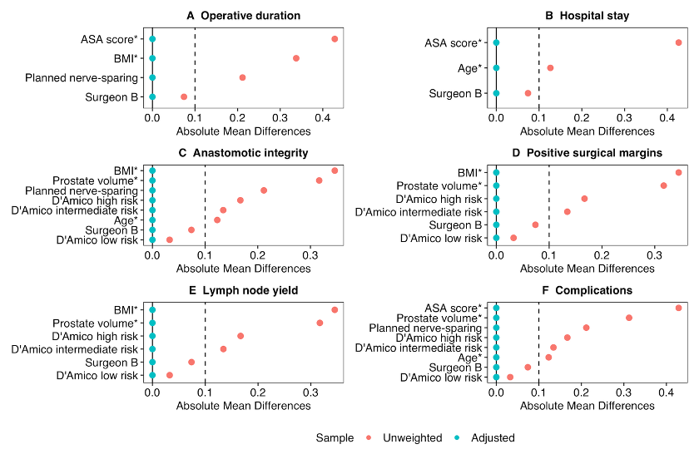
Supplementary Figure S1: Outcome-specific Love plots before and after overlap weighting

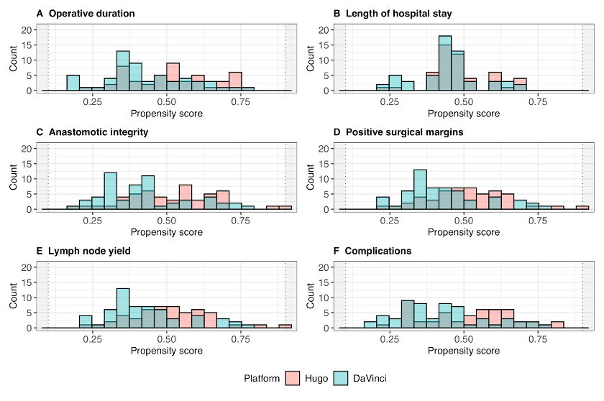
Supplementary Figure S2: Outcome-specific propensity score distributions by robotic platform

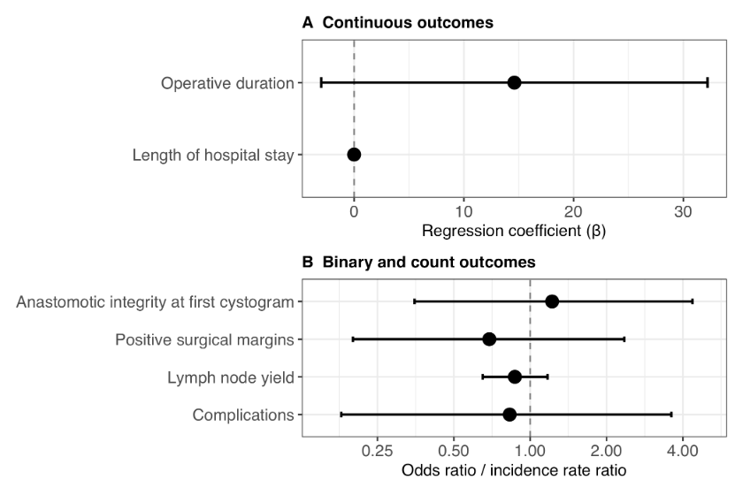
Supplementary Figure S3: Adjusted treatment effects with unadjusted 95%-confidence intervals indicating precision from outcome-specific overlap-weighted regression models
Supplementary Table S2. Estimated platform and surgeon effects across all outcome-specific regression models.
Outcome | Platform effect | Surgeon effect
Operative duration | β = +14.6 (-3.0 to 32.2), p=0.104 | β = -7.0 (-25.9 to 11.8), p=0.460
Length of hospital stay | β = -0.003 (-0.022 to 0.015), p=0.720 | β = -0.000 (-0.019 to 0.019), p=0.969
Anastomotic integrity | OR = 1.22 (0.35 to 4.36), p=0.755 | OR = 1.20 (0.30 to 5.00), p=0.793
Positive surgical margins | OR = 0.69 (0.20 to 2.35), p=0.555 | OR = 0.56 (0.15 to 1.97), p=0.374
Lymph node yield | IRR = 0.87 (0.65 to 1.17), p=0.359 | IRR = 1.50 (1.11 to 2.04), p=0.008
Complications | OR = 0.83 (0.18 to 3.60), p=0.803 | OR = 1.05 (0.20 to 5.19), p=0.956
Values represent adjusted effect estimates obtained from the final overlap-weighted outcome models. Platform and surgeon effects were estimated simultaneously within the same multivariable outcome models. β = regression coefficient; OR = odds ratio; IRR = incidence rate ratio; CI = confidence interval.

