Philadelphia’s Got Talent! A novel, naturalistic paradigm for inducing socio-affective prediction errors

Online Resource 1

Contents
Supplemental Text
Appendix S1: Practice Tasks
Appendix S2: Task Presentation Information
Appendix S3: Follow-up Question Likert Labels
Supplemental Tables
Table S1. Participant Demographics
Table S2. PE Descriptives
Supplemental Figures
Figure S1. Task Prompt Overview
Figure S2. Post-Task Emotion Survey
Figure S3. Individual-Level Prediction Error Scores

Appendix S1: Practice Tasks
Study 1
Session 1: Talent Show Practice Task
Before beginning the PGT, participants completed a brief practice to ensure they understood the procedures. The practice included two example trials — one with a low degree of freedom and one with a high degree of freedom — presented with shortened timing (5 seconds for performance and 10 seconds for preparation).
Session 2: SSOO Practice Task
Before beginning the SSOO task, participants completed four example trials to confirm they understood the procedures and properly used the continuous rating scale. This practice phase presented a condensed version of the SSOO task, using the same continuous rating format and follow-up questions. Participants viewed two induction trials and two fish trials. The induction videos consisted of two 30-second clips from YouTube — one of a person singing and one of a person dancing. To preserve the surprise nature of the task, participants were not told they would see themselves and another subject in the actual task. A video of a man dancing and another man singing were used in the practice. Participants were told to use whatever information they needed about the agents in the video upon which to base their ratings. Instead of blue “Self” and orange “Other” cues, a purple circle reading “Dance” with a 500Hz tone and a yellow circle reading “Song” with a 700Hz tone were used to further preserve the surprise in the actual task.
Study 2
Session 1: Talent Show Practice Task
Before beginning the Talent Show, participants completed a brief practice task to familiarize themselves with the procedures. During practice, the experimenter walked participants through two abbreviated example trials — one singing trial (Happy by Pharrell Williams) and one storytelling trial (Beauty and the Beast) — while present in the room. Participants experienced the full trial structure, including the cue, preparation period, and performance period, without completing actual performances. This practice was conducted with the experimenter present so that participants could ask questions before beginning the real Talent Show, during which the experimenter would not be in the room.
Session 2: SSOO Practice Task
This session began with a practice task designed to help participants respond more quickly to the follow-up questions, which were each presented within a fixed 4-second response window. During the practice phase, participants were informed that the actual task would involve viewing videos of themselves and another person; however, during practice they watched unrelated performance videos that did not feature themselves or other participants. This allowed them to become familiar with the interface, practice using the continuous rating scale, and respond to the follow-up questions. The experimenter remained in the testing room throughout the practice to ensure understanding.
Appendix S2: Task Presentation Information
The PGT and SSOO were coded in JavaScript using the jsPsych library, which offered an optimal solution for presenting video stimuli and collecting participant ratings. The CoRVid.js package was used for continuous video rating capture. Both tasks were presented from an Apple MacBook, which wirelessly projected the display to a Sharp commercial 60-inch LCD screen (60 5/64” diagonal) via Apple TV. Participants used the MacBook’s keyboard to enter all responses.
Appendix S3: Follow-up Question Likert Labels
Study 1
In Session 1 (Talent Show), participants answered two questions after each performance. The question “How would you rate your performance overall?” was rated on a 7-point scale (1 = Very Bad; 2 = Moderately Bad; 3 = Somewhat Bad; 4 = Neutral or Average; 5 = Somewhat Good; 6 = Moderately Good; 7 = Very Good). The question “How much would you expect someone else to like your performance?” was rated on a separate 7-point scale (1 = Very Much Dislike; 2 = Moderately Dislike; 3 = Somewhat Dislike; 4 = Neither Like Nor Dislike; 5 = Somewhat Like; 6 = Moderately Like; 7 = Very Much Like).
In Session 2 (SSOO), participants completed the question “Overall, was the video better or worse than you expected?” using a 7-point scale (1 = Much Worse; 2 = Moderately Worse; 3 = Somewhat Worse; 4 = Neither Better Nor Worse; 5 = Somewhat Better; 6 = Moderately Better; 7 = Much Better). The question “How would you rate that performance overall?” used the same 7-point performance rating scale as in Session 1. Following self trials, participants also answered “How much would you expect someone else to like your performance?”, whereas, following other trials they answered “How much did you like the performance?” and both questions used the same 7-point social ratings scale as in Session 1.
Study 2
In Session 1 (Talent Show), participants answered two questions after each performance. The question “How would you rate your performance overall?” was rated on a 5-point scale (1 = Very Bad; 3 = Neutral or Average; 5 = Very Good). The question “How would you expect another person to rate your performance?” was rated using the same 5-point performance rating scale.
In Session 2 (SSOO), participants completed the question “Overall, was the video better or worse than you expected?” using a 5-point scale (1 = Much Worse; 3 = Neither Better Nor Worse; 5 = Much Better). The question “How would you rate that performance overall?” and “How would you expect another person to rate your performance?” used the same 5-point performance rating scale as Session 1.

Table S1
Participant Demographics
Characteristic | Study 1 (n = 12) | Study 2 (n = 20)
Age
Age, M (SD) [range] | 24.2 (6.1), 18–35 | 20.6 (2.7), 18–28
Sex
Female | 9 (75%) | 14 (70%)
Male | 3 (25%) | 6 (30%)
Gender
Female | 9 (75%) | 11 (55%)
Male | 2 (16.7%) | 6 (30%)
Non-binary | 1 (8.3%) | 2 (10%)
Race/Ethnicity
White or Caucasians | 5 (41.7%) | 7 (35%)
Black or African American | 4 (33.3%) | 6 (30%)
Asian | 1 (8.3%) | 4 (20%)
Multiracial/Mixed | 1 (8.3%) | 3 (15%)
Prefer not to say | 1 (8.3%) | 0 (0%)
Household Income
Between $15,000 and $29,999 | 2 (16.7%) | 2 (10%)
Between $30,000 and $49,999 | 4 (33.3%) | 5 (25%)
Between $50,000 and $74,999 | 1 (8.3%) | 3 (15%)
Between $75,000 and $99,999 | 1 (8.3%) | 3 (15%)
Between $100,000 and $150,000 | 2 (16.7%) | 2 (10%)
Over $150,000 | 2 (16.7%) | 4 (20%)

Table S2
Prediction error (PE) descriptive statistics by hypothesis and question across Study 1 and Study 2. M = mean PE score averaged across subjects. SD = standard deviation. Min and Max refer to the range of subject-level average PE scores. % Hypothesized Direction = percentage of subjects whose average PE score was in the predicted direction (positive for H1 and H3; negative for H2)

Supplemental Figures
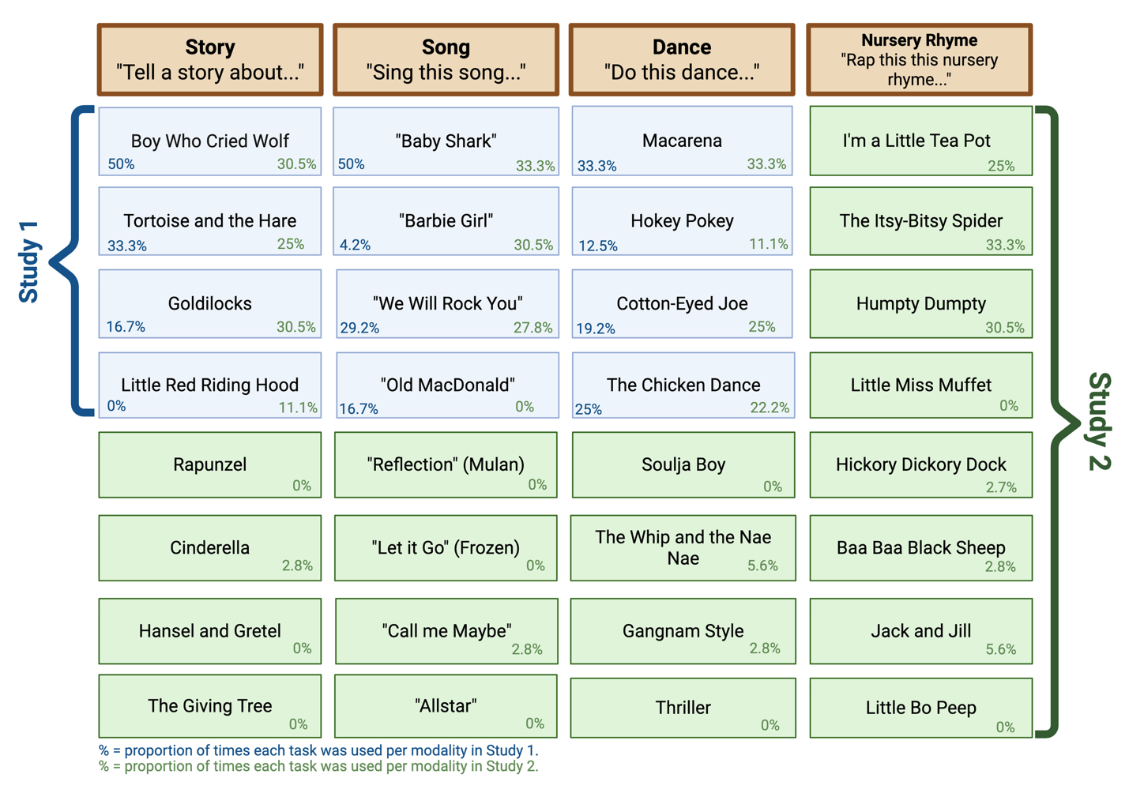
Figure S1. Overview of performance task prompts available across modalities in Study 1 and Study 2. Each cell displays the task prompt along with two percentages — the left percentage reflects the proportion of participants assigned that prompt in Study 1, and the right percentage reflects the proportion in Study 2. Blue cells indicate prompts used in Study 1, while green cells indicate prompts used exclusively in Study 2.

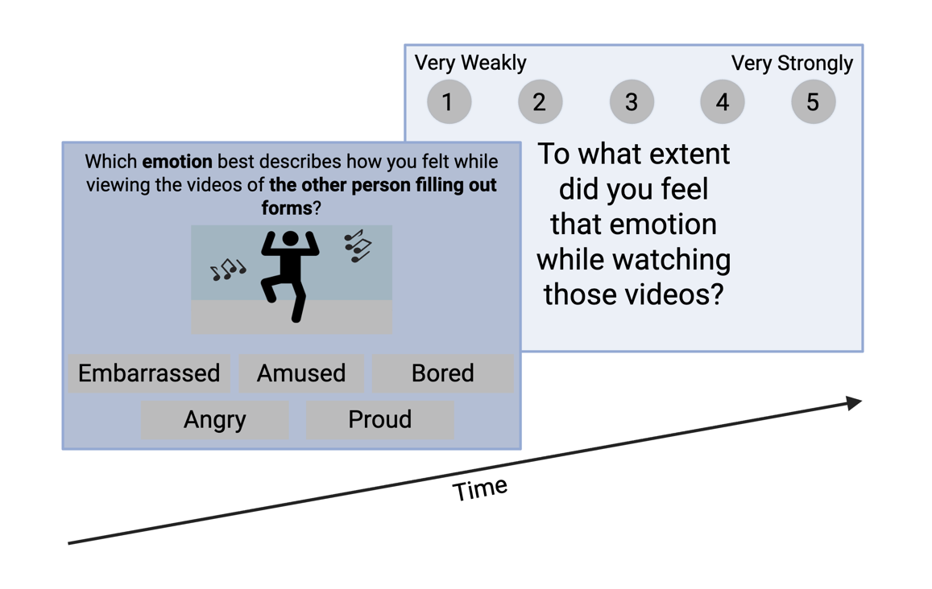
Figure S2. Post-task emotion survey administered following the SSOO in Study 2. Participants first selected the emotion that best described their experience while viewing the videos (embarrassed, amused, bored, angry, or proud), and then rated the intensity of the selected emotion on a 5-point scale ranging from 1 (very weakly) to 5 (very strongly).

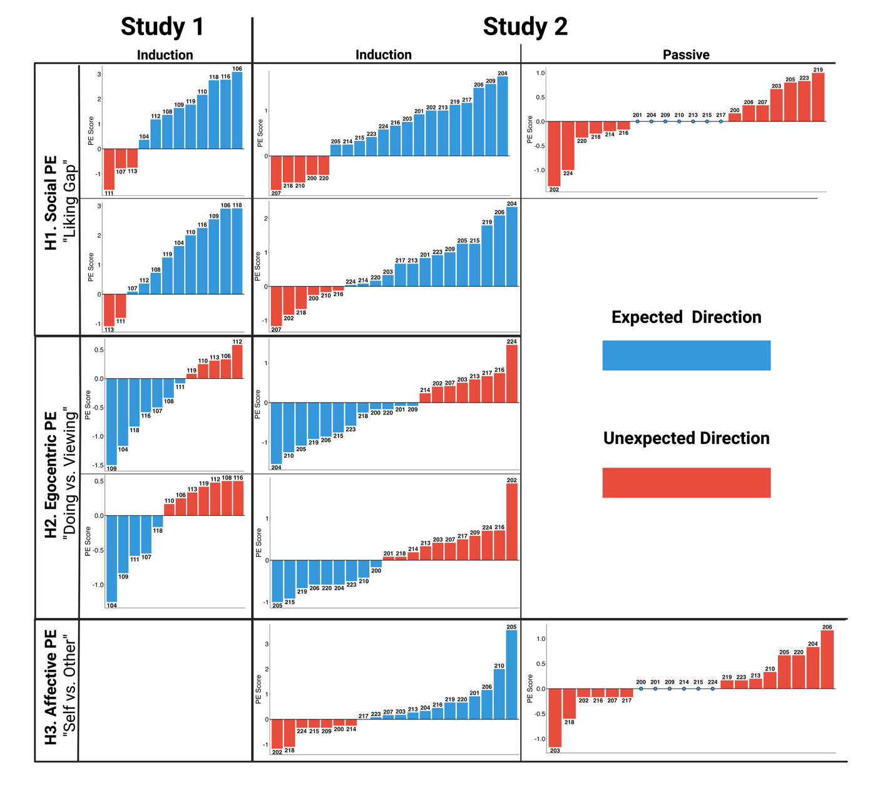
Figure S3. Individual-level prediction error (PE) scores for each question across Studies 1 and 2, organized by hypothesis and study/trial type. Each bar represents one participant’s average PE score for a given question, computed by averaging that participant’s trial-level PE values within the relevant condition. Participant IDs are displayed above each bar, and bars are ordered from smallest to largest PE score within each panel. Blue bars indicate PE scores in the hypothesized direction, whereas red bars indicate PE scores in the non-hypothesized direction. Study 1 included induction trials only. Study 2 included both induction and passive control trials. Empty cells indicate questions not applicable to that study or trial type.

