Supplementary Material for
A Flux-to-AI Discovery Framework Reveals Carbon-Regulated Intermittent Non-Canonical Nitrification in Achromobacter xylosoxidans
Gabriela Canto-Encalada¹, Hamza Hajama¹, Alexis Saldivar¹, Ademikanra Adekunle¹, Gregory Willkeen¹, Anca M. Segall¹, Cristal Zuniga^{1,2}*
*Corresponding author: Cristal Zuniga
Email: czuniga2@sdsu.edu

Supplementary Text

Results

Approach and expansion of the genomics repertoire of Achromobacter xylosoxidans
Several studies have confirmed the ability of Ax to perform heterotrophic nitrification (1,2). This process involves simultaneously generating energy from an organic carbon source while oxidizing ammonium. However, little is known about the enzymes involved in this process for heterotrophic nitrifiers. Most of the 133 genomes of Ax strains contained the genes that encode for the enzymes that catalyze the oxidation of NH₄⁺ to hydroxylamine (Ammonia monooxygenase, Amo) and the oxidation of nitrite to nitrate (Nitrate reductase, Nap) (Fig. 2F). Nonetheless, there is limited information on the enzymes responsible for oxidizing hydroxylamine (NH₂OH) to nitrite. A previous study proposed a nitrification pathway for the heterotrophic nitrifier Alcaligenes mmonioxydans sp (3). The genera Alcaligenes and Achromobacter are closely related, with multiple species historically reassigned between the two (4,5). Therefore, Alcaligenes ammonioxydans sp. can potentially share metabolic capabilities with A. xylosoxidans. Wu MR and colleagues (3) suggested that A. ammonioxydans condensates hydroxylamine (ham) to pyruvic oxime spontaneously, followed by the oxidation of ham to nitrite via pyruvic oxime dioxygenase (Pod) (Fig. 4A). Therefore, through BLASTp, we first identified in A. xylosoxidans G1401 (strain used for iGC1310 reconstruction) a homolog of the Pod enzyme from A. ammonioxydans (Table S8). This sequence was then used as a query to detect Pod across the Ax pangenome. Fig. 2F shows that 132 of 133 Ax strains encode Pod. The presence of all proteins involved in heterotrophic nitrification (Amo, Pod, and Nap) in nearly all strains suggests that this pathway has been evolutionarily conserved.

Enhancing the predictability capabilities of the GEM using experimentally determined data of the biomass objective function and high-throughput phenotyping
The Biomass Objective Function (BOF) is a stoichiometric reaction that represents Ax biomass composition, including proteins, carbohydrates, lipids, nucleic acids, and other macromolecules (6). The stoichiometric value of each metabolite is defined as millimoles per gram dry weight (mmol/gDW) of biomass.
Initially, the BOF was imported from the iML1515 template model and was further adapted to Ax traits. The total mass fractions of DNA, carbohydrates, lipids, and proteins in Ax biomass were calculated experimentally, accounting for 75.31% of the total dry cell weight (3.8%, 4.9%, 13.27%, and 53.34%, respectively) (Fig. 3A). These values are consistent with previous reports for E. coli, supporting iML1515 as a suitable template (7).
Remaining macromolecules, such as RNA, cofactors, murein, lipopolysaccharides (LPS), and inorganic ions, were normalized to the residual 24.69% of the biomass, while maintaining the relative proportions among them as defined in the E. coli model (iML1515) (Fig. 3A). Amino acid and fatty acid profiles were determined experimentally. In contrast, nucleic acid profiles were derived from the Ax genome. Growth-Associated Maintenance energy (GAM, 75.38 mmol/gDW ATP) and Non-Growth-Associated Maintenance energy (NGAM, 6.86 mmol/gDW ATP) were imported from iML1515. The updated BOF was set as the objective function for all the simulations mentioned in this study.
To our knowledge, this BOF remains the only characterization of Ax biomass composition available.

Genomic and metabolic modeling analyses reveal a persistent nitrification pathway in Achromobacter xylosoxidans regulated by carbon availability
In order to understand the conditions that involve the activation/deactivation of heterotrophic nitrification in Ax, we manually added to the iGC13101 model all the biochemical reactions associated with the nitrifying enzymes. The proposed pathway of heterotrophic nitrification in A. xylosoxidans is described in Fig. 4A.
To elucidate how Ax activates the nitrification pathway, we performed robustness analysis simulations using low and high succinate uptake rates (0-4 mmol/g DW/h), which can be correlated with low and high concentrations (Fig. 4A). The iGC1310 model was constrained in minimal medium with NH₄⁺ uptake rate fixed at 1 mmol/g DW/h. Fig. 4A shows that at low succinate uptake rates (~0.5 - ~2.5 mmol/gDW/h), the nitrifying enzymes are active. Ammonium is consumed and oxidized to hydroxylamine (NH₂OH) by the catalysis of Amo, followed by a spontaneous condensation reaction between hydroxylamine and pyruvate, which produces pyruvic oxime. Subsequently, pyruvic oxime is oxidized to nitrite through Pod, which is further oxidized to nitrate by Nap. The ubiquinol (QH₂) generated during the nitrification is used by the cytochrome bc1 complex (complex III) to reduce a molecule of cytochrome c that is further utilized by the terminal oxidase (cytochrome c oxidase, COX) to reduce oxygen (final electron acceptor) to water. This process generates a proton gradient between the cytoplasm and the periplasm, which induces the production of ATP by ATP synthase.
However, under higher succinate uptake rates (~2.5-4 mmol/g DW/h), the simulations predicted that the nitrification pathway is completely deactivated. The succinate dehydrogenase, which is coupled with the TCA cycle, produces all the ubiquinol required by complex III and COX. The activity of these last two reactions generates the proton motive force required for ATP synthesis.
Therefore, we experimentally measured nitrification activity in the Ax strains isolated from CF patients, G1401 (the strain used for iGC1310 modeling), G1324, and G1394. All these strains contained the enzymes involved in nitrification. We cultured the isolates in minimal media supplemented with ammonium chloride (1 g/L) and succinate (2.81 g/L). Triplicate cultures of Ax (200 mL each, initial OD600 of 0.1) were incubated at 37°C and shaken at 80 rpm for 181 hrs. Samples were taken every 18 h, and OD600, as well as ammonium nitrogen, nitrite, and protein concentrations, were determined.
As shown in Fig. 5A and Fig. S2, all Ax strains consumed NH₄⁺ during the first 24 hours, which coincides with an increase in both cell density (OD₆₀₀) and protein concentration. After 24 hours, cell density and protein production plateau, indicating the onset of the stationary phase. Notably, nitrite, a key metabolite in the nitrification process, begins accumulating after 24 hours. These organisms were able to initiate nitrite production (and therefore the nitrification process) just after the exponential phase. Since the stationary phase is usually related to the lack of a carbon source (8), we suggest that nitrification is active when the concentration of succinate is limited, which agrees with the simulation results (Fig. 4A). Hence, we were able to link the nitrification with the availability of carbon in the culture medium. The simulation results may indicate a shift to an alternative energy production method via nitrification. This process allows the cell to maintain redox balance and generate ATP under carbon-limited conditions.
Metabolic phenotype predicted by iGC1310 using acetoacetate as the sole carbon source
We simulated growth using the iGC1310 model in minimal medium with ammonium as the nitrogen source and a fixed carbon (succinate or acetoacetate) uptake (5 mmol/gDW/h). When the model consumed acetoacetate instead of succinate, fluxes through ketone-body utilization reactions (acetoacetyl-CoA transferase and Acetyl-CoA C-acetyltransferase) and the glyoxylate shunt (isocitrate lyase and malate synthase) increased (Fig. S3). In this pathway, acetoacetate (a C4 ketone body) is first converted to acetoacetyl-CoA, which is then split into two acetyl-CoA molecules (C2 unit). Since acetyl-CoA is now utilized as the carbon source, the glyoxylate shunt must be activated to prevent the complete oxidation of acetyl-CoA to CO₂ in the TCA cycle. In this way, Ax can conserve carbon skeletons for biosynthetic needs and effectively exploit the acetoacetate generated by microbiome biofilms.

Figures
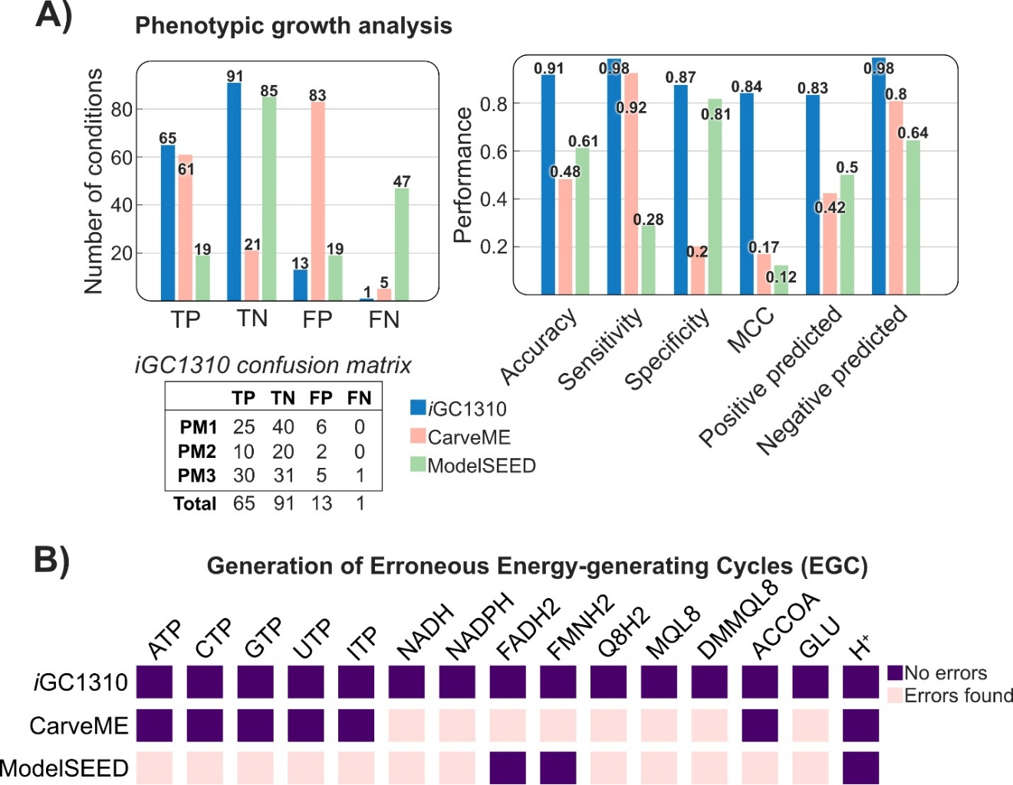

Fig. S1. Comparative analysis of properties for the Ax models.
CarveME and ModelSEED models were reconstructed using the gap-filling and M9 medium options to ensure growth on minimal medium. A) Benchmarking of phenotypic growth simulations by all Ax models, showing exceptional performance of iGC1310 over automatically reconstructed models. B) Identification of energy-generating cycles (EGCs) for key energy metabolites (ATP, CTP, GTP, UTP, ITP, NADH, NADPH, flavin adenine dinucleotide (FADH₂), flavin mononucleotide (ACCOA), L-glutamate (GLU), and proton exchange between periplasm and cytosol (H⁺)) in Ax models. Dissipation reactions for each metabolite were added to all models, and EGC formation was assessed following the protocol of Fritzemeier and colleagues (2017) (30). Purple indicates the absence of EGCs for a specific metabolite, while pink indicates the presence of EGC generation.
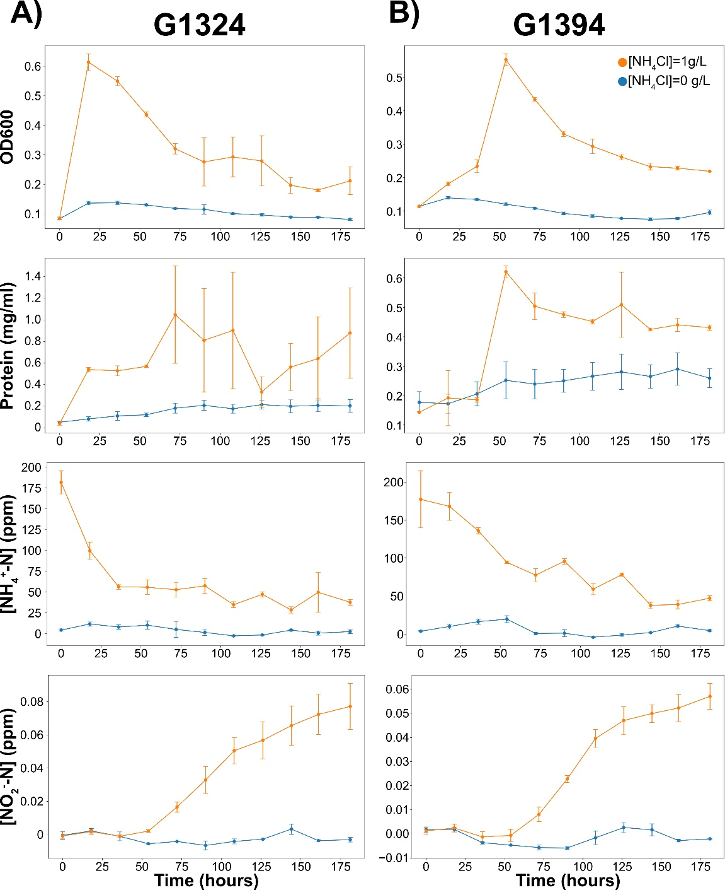

Fig. S2. Kinetic curves of A. xylosoxidans strains. A) Kinetic curves of G1324 strain. (B) Kinetic curves of G1394 strains. Both strains were cultured in minimal media supplemented with ammonium chloride (NH4Cl) and succinate.
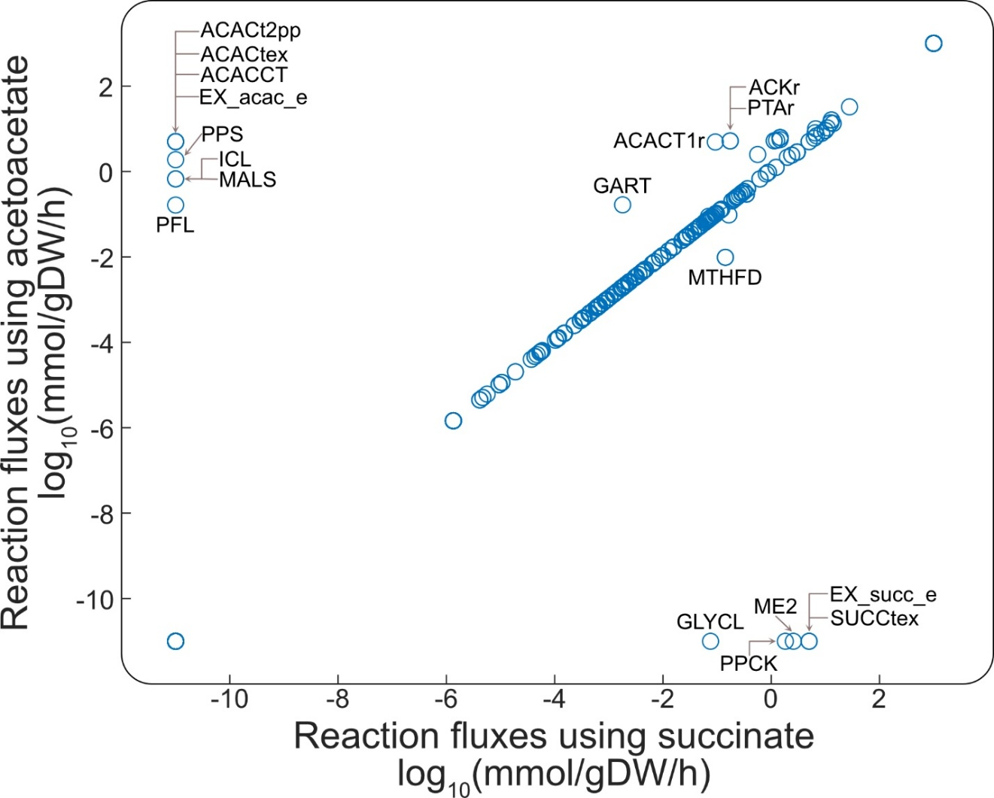
Fig. S3. Distribution of metabolic fluxes using acetoacetate or succinate as carbon sources. Ammonium was used as a nitrogen source for both simulations. Uptake fluxes for both the carbon and nitrogen sources were set at 5 mmol/gDW/h. Abbreviations: ACAC2pp, acetoacetate transport via proton symport (periplasm); ACACtex, Acetoacetate transport via diffusion (extracellular to periplasm), ACACCT, Acetyl-CoA:acetoacetyl-CoA transferase; EX_acac_e, Acetoacetate exchange; PPS, Phosphoenolpyruvate synthase; ICL, Isocitrate lyase; MALS, Malate synthase; PFL, Pyruvate formate lyase; GART, N1-(5-phospho-beta-D-ribosyl)glycinamide ligase (ADP-forming); ACACT1r, Acetyl-CoA C-acetyltransferase; PTAr, Phosphotransacetylase; ACKr; Acetate kinase; MTHFD, Methylenetetrahydrofolate dehydrogenase (NADP); GLYCL, Glycine Cleavage System; ME2, Malic enzyme (NADP); PPCK, Phosphoenolpyruvate carboxykinase; EX_succ_e, Succinate exchange; SUCCtex, Succinate transport via diffusion (extracellular to periplasm)

Tables

Table S1. Diseases associated with Achromobacter xylosoxidans in humans
Disease | Context | Reference
Cystic Fibrosis respiratory infections | Chronic colonization and persistent infection in the lungs of CF patients. Associated with lung function decline. | (9–11)
Pneumonia | Coarse bilateral crackles. Chronic infection. | (12,13)
Meningitis | Rare CNS infection, often post-trauma or catheter-related; high morbidity and mortality | (14–16)
Endocarditis | Associated with heart native and prosthetic valves or devices. High crude mortality (>50%) | (17,18)
Urinary Tract Infections | Very rare infection, usually in patients with urological abnormalities, malignancy, diabetes, renal failure, or transplant | (19–21)
Peritonitis | Notably, in patients on peritoneal dialysis. Often presents with abdominal pain, cloudy dialysate, or septic shock. High risk of relapse and treatment failure due to multidrug resistance and biofilm formation on catheters | (22–24)
Osteomyelitis | Post-traumatic or post-surgical cases are described. Cases reported in diabetic and immunocompetent patients. Often chronic. Treatment usually involves surgical debridement or amputation plus prolonged antibiotics | (25,26)
Ocular infections | Infection associated with contact lens wear, prior corneal surgery (LASIK, keratoplasty), or steroid use. Usually indolent, recurrent, and drug-resistant. Severe cases may require keratoplasty | (27–29)
Otitis | Ax was first identified in ear discharge from patients with chronic otitis media. Often, multidrug-resistant strains. Occurs in both immunocompromised and immunocompetent patients | (30–32)

Table S2. Model constraints for carbon utilization simulations
Reaction ID | Reaction name | Reaction Formula | Metabolite | Lower bound | Upper bound
EX_pi_e | Phosphate exchange | pi_e <=> | pi_e | -1000 | 1000
EX_co2_e | CO2 exchange | co2_e <=> | co2_e | -1000 | 1000
EX_fe3_e | Fe3+ exchange | fe3_e <=> | fe3_e | -1000 | 1000
EX_h_e | H+ exchange | h_e <=> | h_e | -1000 | 1000
EX_mn2_e | Mn2+ exchange | mn2_e <=> | mn2_e | -1000 | 1000
EX_succ_e | Succinate exchange | succ_e <=> | succ_e | 0 | 1000
EX_fe2_e | Fe2+ exchange | fe2_e <=> | fe2_e | -1000 | 1000
EX_zn2_e | Zinc exchange | zn2_e <=> | zn2_e | -1000 | 1000
EX_mg2_e | Mg exchange | mg2_e <=> | mg2_e | -1000 | 1000
EX_ca2_e | Calcium exchange | ca2_e <=> | ca2_e | -1000 | 1000
EX_ni2_e | Ni2+ exchange | ni2_e <=> | ni2_e | -1000 | 1000
EX_cu2_e | Cu2+ exchange | cu2_e <=> | cu2_e | -1000 | 1000
EX_sel_e | Selenate exchange | sel_e <=> | sel_e | -1000 | 1000
EX_cobalt2_e | Co2+ exchange | cobalt2_e <=> | cobalt2_e | -1000 | 1000
EX_h2o_e | H2O exchange | h2o_e <=> | h2o_e | -1000 | 1000
EX_mobd_e | Molybdate exchange | mobd_e <=> | mobd_e | -1000 | 1000
EX_so4_e | Sulfate exchange | so4_e <=> | so4_e | -1000 | 1000
EX_nh4_e | Ammonia exchange | nh4_e <=> | nh4_e | -5 | 1000
EX_k_e | K+ exchange | k_e <=> | k_e | -1000 | 1000
EX_na1_e | Sodium exchange | na1_e <=> | na1_e | -1000 | 1000
EX_cl_e | Chloride exchange | cl_e <=> | cl_e | -1000 | 1000
EX_o2_e | O2 exchange | o2_e <=> | o2_e | -1000 | 1000
EX_tungs_e | Tungstate exchange | tungs_e <=> | tungs_e | -1000 | 1000
EX_slnt_e | Selenite exchange | slnt_e <=> | slnt_e | -1000 | 1000

Table S3. Model constraints for nitrogen utilization simulations
Reaction ID | Reaction name | Reaction Formula | Metabolite | Lower bound | Upper bound
EX_pi_e | Phosphate exchange | pi_e <=> | pi_e | -1000 | 1000
EX_co2_e | CO2 exchange | co2_e <=> | co2_e | -1000 | 1000
EX_fe3_e | Fe3+ exchange | fe3_e <=> | fe3_e | -1000 | 1000
EX_h_e | H+ exchange | h_e <=> | h_e | -1000 | 1000
EX_mn2_e | Mn2+ exchange | mn2_e <=> | mn2_e | -1000 | 1000
EX_succ_e | Succinate exchange | succ_e <=> | succ_e | -5 | 1000
EX_fe2_e | Fe2+ exchange | fe2_e <=> | fe2_e | -1000 | 1000
EX_zn2_e | Zinc exchange | zn2_e <=> | zn2_e | -1000 | 1000
EX_mg2_e | Mg exchange | mg2_e <=> | mg2_e | -1000 | 1000
EX_ca2_e | Calcium exchange | ca2_e <=> | ca2_e | -1000 | 1000
EX_ni2_e | Ni2+ exchange | ni2_e <=> | ni2_e | -1000 | 1000
EX_cu2_e | Cu2+ exchange | cu2_e <=> | cu2_e | -1000 | 1000
EX_sel_e | Selenate exchange | sel_e <=> | sel_e | -1000 | 1000
EX_cobalt2_e | Co2+ exchange | cobalt2_e <=> | cobalt2_e | -1000 | 1000
EX_h2o_e | H2O exchange | h2o_e <=> | h2o_e | -1000 | 1000
EX_mobd_e | Molybdate exchange | mobd_e <=> | mobd_e | -1000 | 1000
EX_so4_e | Sulfate exchange | so4_e <=> | so4_e | -1000 | 1000
EX_nh4_e | Ammonia exchange | nh4_e <=> | nh4_e | 0 | 1000
EX_k_e | K+ exchange | k_e <=> | k_e | -1000 | 1000
EX_na1_e | Sodium exchange | na1_e <=> | na1_e | -1000 | 1000
EX_cl_e | Chloride exchange | cl_e <=> | cl_e | -1000 | 1000
EX_o2_e | O2 exchange | o2_e <=> | o2_e | -1000 | 1000
EX_tungs_e | Tungstate exchange | tungs_e <=> | tungs_e | -1000 | 1000
EX_slnt_e | Selenite exchange | slnt_e <=> | slnt_e | -1000 | 1000

Table S4. Model constraints for simulations of nitrification analysis
Reaction ID | Reaction name | Reaction Formula | Metabolite | Lower bound (mmol/gDW/h) | Upper bound (mmol/gDW/h)
EX_pi_e | Phosphate exchange | pi_e <=> | pi_e | -1000 | 1000
EX_co2_e | CO2 exchange | co2_e <=> | co2_e | -1000 | 1000
EX_fe3_e | Fe3+ exchange | fe3_e <=> | fe3_e | -1000 | 1000
EX_h_e | H+ exchange | h_e <=> | h_e | -1000 | 1000
EX_mn2_e | Mn2+ exchange | mn2_e <=> | mn2_e | -1000 | 1000
EX_succ_e | Succinate exchange | succ_e <=> | succ_e | [0-4] | 1000
EX_fe2_e | Fe2+ exchange | fe2_e <=> | fe2_e | -1000 | 1000
EX_zn2_e | Zinc exchange | zn2_e <=> | zn2_e | -1000 | 1000
EX_mg2_e | Mg exchange | mg2_e <=> | mg2_e | -1000 | 1000
EX_ca2_e | Calcium exchange | ca2_e <=> | ca2_e | -1000 | 1000
EX_ni2_e | Ni2+ exchange | ni2_e <=> | ni2_e | -1000 | 1000
EX_cu2_e | Cu2+ exchange | cu2_e <=> | cu2_e | -1000 | 1000
EX_sel_e | Selenate exchange | sel_e <=> | sel_e | -1000 | 1000
EX_cobalt2_e | Co2+ exchange | cobalt2_e <=> | cobalt2_e | -1000 | 1000
EX_h2o_e | H2O exchange | h2o_e <=> | h2o_e | -1000 | 1000
EX_mobd_e | Molybdate exchange | mobd_e <=> | mobd_e | -1000 | 1000
EX_so4_e | Sulfate exchange | so4_e <=> | so4_e | -1000 | 1000
EX_nh4_e | Ammonia exchange | nh4_e <=> | nh4_e | -1 | 1000
EX_k_e | K+ exchange | k_e <=> | k_e | -1000 | 1000
EX_na1_e | Sodium exchange | na1_e <=> | na1_e | -1000 | 1000
EX_cl_e | Chloride exchange | cl_e <=> | cl_e | -1000 | 1000
EX_o2_e | O2 exchange | o2_e <=> | o2_e | -1000 | 1000
EX_tungs_e | Tungstate exchange | tungs_e <=> | tungs_e | -1000 | 1000
EX_slnt_e | Selenite exchange | slnt_e <=> | slnt_e | -1000 | 1000

Table S5. Presence or absence of denitrification enzymes in Ax strains obtained from clinical isolates of patients with cystic fibrosis
Compound | Formula | Concentration (g/L)
Ferrous sulfate heptahydrate | FeSO₄ · 7H₂O | 9.13
Calcium chloride dehydrate | CaCl₂ · 2H₂O | 7.33
Manganese(II) chloride tetrahydrate | MnCl₂·4H₂O | 7.95
Zinc sulfate heptahydrate | ZnSO₄ · 7H₂O | 39.17
Copper(II) sulfate | CuSO₄ | 1.57
Cobalt(II) chloride hexahydrate | CoCl₂·6H₂O | 2.95
Ammonium molybdate(IV) tetrahydrate | (NH₄)₆Mo₇O₂₄ · 4H₂O | 1.16

Table S6. Details of isolated Ax strains obtained from patients with cystic fibrosis.
Strain number | Sample location | Sequencing method
G1318 | San Diego CA | Short read / Illumina
G1323 | San Diego CA | Short read / Illumina
G1324 | San Diego CA | Long read/ ONT*
G1325 | San Diego CA | Short read / Illumina
G1387 | Rhode Island | Long read/ ONT
G1388 | Rhode Island | Short read / Illumina
G1394 | San Diego CA | Hybrid
G1401 | Rhode Island | Long read/ ONT
G1407 | Atlanta GA | Short read / Illumina
G1408 | Atlanta GA | Short read / Illumina
G1409 | Atlanta GA | Short read / Illumina
G1410 | Atlanta GA | Short read / Illumina
G1412 | South Carolina | Long read/ ONT
G1413 | South Carolina | Long read/ ONT
G1414 | South Carolina | Long read/ ONT
G1417 | Rhode Island | Hybrid
G1418 | Rhode Island | Hybrid
G1423 | Rhode Island | Long read/ ONT

Table S7. Results of BUSCO analysis in genomes of isolates obtained from clinical isolates of patients with cystic fibrosis
Isolate | Completeness | Single | Duplicated | Fragmented | Missing | GenomeSize(pb)
G1410 | 99.2 | 98.5 | 0.7 | 0.4 | 0.4 | 6324016
G1432 | 77.7 | 77.6 | 0.1 | 15 | 7.3 | 6749065
G1413 | 74.4 | 73.8 | 0.6 | 16 | 9.6 | 6206895
G1388 | 98.6 | 98 | 0.6 | 0.4 | 1 | 6284599
G1408 | 99.2 | 98.5 | 0.7 | 0.4 | 0.4 | 6321513
G1407 | 99.2 | 98.5 | 0.7 | 0.4 | 0.4 | 6319065
G1409 | 99.2 | 98.5 | 0.7 | 0.4 | 0.4 | 6334465
G1418 | 99.3 | 98.7 | 0.6 | 0.3 | 0.4 | 6290280
G1414 | 85 | 84 | 1 | 9.6 | 5.4 | 6207369
G1325 | 98.5 | 98.1 | 0.4 | 0.6 | 0.9 | 6449526
G1412 | 76.3 | 76 | 0.3 | 13.5 | 10.2 | 6206928
G1401 | 93.8 | 93.2 | 0.6 | 3.9 | 2.3 | 6293570
G1324 | 66.8 | 66.7 | 0.1 | 20.9 | 12.3 | 6414488
G1323 | 98.7 | 97.8 | 0.9 | 0 | 1.3 | 6625099
G1387 | 98.6 | 98 | 0.6 | 0.6 | 0.8 | 6227005
G1433 | 78 | 77.9 | 0.1 | 14.8 | 7.2 | 6749792
G1434 | 74.5 | 74.4 | 0.1 | 17.6 | 7.9 | 6748899
G1394 | 98.7 | 98.4 | 0.3 | 0.6 | 0.7 | 6513437
G1417 | 99 | 98.4 | 0.6 | 0.4 | 0.6 | 6289541
G1423 | 79.2 | 78.6 | 0.6 | 13.5 | 7.3 | 6277991
G1318 | 98.7 | 98.3 | 0.4 | 0.7 | 0.6 | 6465045

Table S8. Nitrifying reactions in iGC1310 with their associated genes.Table S2. Details of isolated Ax strains obtained from patients with cystic fibrosis.
Reaction ID in model | Reaction name | Reaction abbreviation in Figure 4 | Reaction formula | Gene
AMO | Ammonia monooxygenase | AMO | 2 h_c + nh4_p + q8h2_c + o2_p -> h2o_p + 3 h_p + q8_c + ham_p | 222.273.peg.6062
PYROXIMA | Pyruvate oximation | PYROXIMA | pyr_p + h_p + ham_p -> h2o_p + pyrox_p | Spontaneous
POD | Pyruvic oxime dioxygenase | POD | o2_p + pyrox_p -> pyr_p + 2 h_p + no2_p | 222.273.peg.2420
NO3R1bpp | Respiratory nitrate reductase | NAP_ABDE | h2o_p + no2_p + q8_c <=> q8h2_c + no3_p | 222.273.peg.2781 and 222.273.peg.2782 and 222.273.peg.2783 and 222.273.peg.2784
NADH16pp | NADH dehydrogenase | nadh16pp | 4 h_c + q8_c + nadh_c -> 3 h_p + nad_c + q8h2_c | 222.273.peg.1441
SUCDi | Succinate dehydrogenase | SUCDi | q8_c + succ_c -> q8h2_c + fum_c | 222.273.peg.1484 and 222.273.peg.1485 and 222.273.peg.1482 and 222.273.peg.1483 and 222.273.peg.1486 and 222.273.peg.5623
bc1com | Cytochrome bc1 complex III | bc1com | 2 h_c + q8h2_c + 2 cytcoxi_p -> 4 h_p + q8_c + 2 cytcred_p | 222.273.peg.202 and 222.273.peg.203 and 222.273.peg.204
CytCOX | Cytochrome c oxidase terminal oxidase | COX | 4 h_c + 0.5 o2_c + 2 cytcred_p -> 2 h_p + h2o_c + 2 cytcoxi_p | 222.273.peg.255 and 222.273.peg.256 and 222.273.peg.259 or ((222.273.peg.4597 or 222.273.peg.4416) and (222.273.peg.4417 or 222.273.peg.4596) and (222.273.peg.4418 or 222.273.peg.4595) and (222.273.peg.4419 or 222.273.peg.4594))

Table S9. Summary of studies linking nitrification and denitrification activity to succinate as a carbon source
Organism/system | Biochemical process | Succinate role | Key finding | Reference
Achromobacter spiritinus HS2 | Nitrification and denitrification | Sodium succinate was the optimal carbon source for growth and nitrogen removal | With succinate, A. spiritinusHS2 achieved up to 99.1% ammonium removal and 95.5% total nitrogen removal at 8 °C via heterotrophic nitrification-aerobic denitrification, without nitrite accumulation or N₂O emissions. | (33)
Glutamicibacter arilaitensis EM-H8 | Denitrification | Tested as a sole carbon source. Identified as optimal for nitrate (NO₃⁻-N) removal, reaching 95.8–97.6% efficiency | Succinate enabled efficient aerobic denitrification | (34)
Achromobacter xylosoxidans CF-S36 | Nitrification | Succinate was the most preferred carbon source for nitrification (highest NH₄⁺ removal rate, 6.3 mg/L/h). It also supported efficient nitrate and nitrite denitrification | A. xylosoxidans CF-S36 achieved ~98% NH₄⁺ removal within 36 h using succinate; ~100% NO₃⁻ removal within 36 h , and ~76% NO₂⁻ removal within 36 h | (1)
Pseudomonas putida NP5 | Nitrification and denitrification | Succinate was identified as the optimal carbon source for heterotrophic nitrification-aerobic denitrification and simultaneous nitrogen-phosphorus removal | With succinate, P. putida NP5 achieved ~96% NH₄⁺ removal and ~90% PO₄³⁻ removal within 24 h; nearly complete NO₂⁻ (99.4%) and NO₃⁻ (99.6%) removal within 24 h during aerobic denitrification. Negligible NO₂⁻ or N₂O accumulation occurred. | (35)
Paracoccus denitrificans (NCIB 8944) | Denitrification | Succinate was used as the carbon source during anaerobic growth with nitrate as electron acceptor. It fueled the respiratory chain linked to denitrification. | Cells reduced nitrate → nitrite → nitrous oxide → N₂ without accumulation of intermediates. Electron flow from succinate supported complete denitrification | (36)
Paracoccus denitrificans PD1222 | Denitrification | Succinate was supplied as the sole carbon source (30 mM) during anaerobic denitrification assays. | With succinate, Paracoccus denitrificans PD1222 carried out complete denitrification (NO₃⁻ → NO₂⁻ → NO → N₂O → N₂) without accumulation of gaseous intermediates. | (37)
Mixed microbial community (biofilms in PBS-packed reactors). Microbial analysis showed dominance of Azoarcus, Simplicispira, Acidovorax, Comamonas, Paracoccus, Labrenzia, all linked to heterotrophic denitrification. | Denitrification | Poly(butylene succinate) (PBS) acted as both solid carbon source and biofilm carrier for denitrifiers. Succinate was released gradually during polymer degradation and used as electron donor for denitrification | Stable denitrification achieved with real RAS (recirculating aquaculture system) wastewater: denitrification rates up to 0.53-0.66 kg NO₃⁻-N m⁻³ d⁻¹, with nitrite kept below 1 mg/L. | (38)
Mixed microbial biofilm (groundwater bioreactor). The major phyla were Proteobacteria, specifically Betaproteobacteria, Burkholderiales, and Comamonadaceae  the major phyla | Denitrification | Poly(butylene succinate) (PBS) acted as solid carbon source and biofilm carrier. Succinate fueled denitrifiers | Continuous operation for ~2 years achieved 88–97% nitrate removal, effluent nitrate 3.3–8.8 mg/L. Denitrification rates: 0.25–0.35 g N L⁻¹ d⁻¹ (20–29 °C), dropping to 0.12 g N L⁻¹ d⁻¹ (10–18 °C). | (39)

Table S10. Presence or absence of denitrification enzymes in Ax strains obtained from clinical isolates of patients with cystic fibrosis
Strain | Nitrate reductase | Nitrite reductase | Nitric oxide reductase | Nitrous oxide reductase
G1401 | + | - | - | -
G1407 | + | - | - | -
G1408 | + | - | - | -
G1409 | + | - | - | -
G1410 | + | - | - | -
G1412 | + | - | - | -
G1413 | + | - | - | -
G1414 | + | - | - | -
G1324 | + | + | + | +
G1394 | + | + | + | +
G1325 | + | + | + | +
G1323 | + | + | + | -
G1318 | + | + | + | +
G1434 | + | + | + | +
G1433 | + | + | + | +
G1434 | + | + | + | +
G1387 | + | - | - | -
G1388 | + | - | - | -
G1417 | + | - | - | -
G1418 | + | - | - | -
G1423 | + | - | - | -

Additional file 1 (.xlsx). Results of phenotypic growth experiments compared with predictions from iGC1310, CarveME, and ModelSEED models.
Additional file 2 (.csv). Binarized growth rates of all Ax strains from human and non-human sources using several carbon sources
Additional file 3 (.xlsx). List of Ax strains from NCBI and CF clinical isolates with isolation sources
Additional file 4 (.csv). Persistent genes obtained from pan-genome analysis
Additional file 5 (.csv). Shell genes identified during pan-genome analysis
Additional file 6 (.csv). Cloud genes identified during pan-genome analysis
Additional file 7 (.xlsx). Properties of Ax multi-strain scale metabolic models
Additional file 8 (.xlsx). Genes and their amino acid sequences per GEM in the Ax multi-strain network
Additional file 9 (.csv). Genomic location of denitrifying genes across soil- and water-derived Ax strains
Additional file 10 (.csv). GC content of denitrifying genes across soil- and water-derived Ax strains

References

1. Padhi SK, Maiti NK. Molecular insight into the dynamic central metabolic pathways of Achromobacter xylosoxidans CF-S36 during heterotrophic nitrogen removal processes. Journal of Bioscience and Bioengineering. 2017 Jan 1;123(1):46–55. doi:10.1016/j.jbiosc.2016.07.012
2. Kundu P, Pramanik A, Mitra S, Choudhury JD, Mukherjee J, Mukherjee S. Heterotrophic nitrification by Achromobacter xylosoxidans S18 isolated from a small-scale slaughterhouse wastewater. Bioprocess Biosyst Eng. 2012 Jun 1;35(5):721–8. doi:10.1007/s00449-011-0652-6
3. Wu MR, Hou TT, Liu Y, Miao LL, Ai GM, Ma L, et al. Novel Alcaligenes ammonioxydans sp. nov. from wastewater treatment sludge oxidizes ammonia to N2 with a previously unknown pathway. Environ Microbiol. 2021 Nov;23(11):6965–80. doi:10.1111/1462-2920.15751 PubMed PMID: 34581470.
4. Yabuuchi E, Kawamura Y, Kosako Y, Ezaki T. Emendation of Genus Achromobacter and Achromobacter xylosoxidans (Yabuuchi and Yano) and Proposal of Achromobacter ruhlandii (Packer and Vishniac) Comb. Nov., Achromobacter piechaudii (Kiredjian et al.) Comb. Nov., and Achromobacter xylosoxidans Subsp. denitrificans (Rüger and Tan) Comb. Nov. Microbiology and Immunology. 1998;42(6):429–38. doi:10.1111/j.1348-0421.1998.tb02306.x
5. Gomila M, Prince-Manzano C, Svensson-Stadler L, Busquets A, Erhard M, Martínez DL, et al. Genotypic and Phenotypic Applications for the Differentiation and Species-Level Identification of Achromobacter for Clinical Diagnoses. PLOS ONE. 2014 Dec 4;9(12):e114356. doi:10.1371/journal.pone.0114356
6. Feist AM, Palsson BO. The biomass objective function. Current Opinion in Microbiology. 2010 Jun 1;Ecology and industrial microbiology • Special section: Systems biology13(3):344–9. doi:10.1016/j.mib.2010.03.003
7. Simensen V, Schulz C, Karlsen E, Bråtelund S, Burgos I, Thorfinnsdottir LB, et al. Experimental determination of Escherichia coli biomass composition for constraint-based metabolic modeling. PLOS ONE. 2022 Jan 27;17(1):e0262450. doi:10.1371/journal.pone.0262450
8. Chubukov V, Sauer U. Environmental Dependence of Stationary-Phase Metabolism in Bacillus subtilis and Escherichia coli. Applied and Environmental Microbiology. 2014 May;80(9):2901–9. doi:10.1128/AEM.00061-14
9. Bhowmik N, Stubbendieck RM. Achromobacter spp.: Emerging pathogens in the cystic fibrosis lung. PLOS Pathogens. 2025 Apr 22;21(4):e1013067. doi:10.1371/journal.ppat.1013067
10. Gabrielaite M, Bartell JA, Nørskov-Lauritsen N, Pressler T, Nielsen FC, Johansen HK, et al. Transmission and Antibiotic Resistance of Achromobacter in Cystic Fibrosis. Journal of Clinical Microbiology. 2021 Mar 19;59(4):10.1128/jcm.02911-20. doi:10.1128/jcm.02911-20
11. Somayaji R, Stanojevic S, Tullis DE, Stephenson AL, Ratjen F, Waters V. Clinical Outcomes Associated with Achromobacter Species Infection in Patients with Cystic Fibrosis. Annals ATS. 2017 Sep;14(9):1412–8. doi:10.1513/AnnalsATS.201701-071OC
12. Awadh H, Mansour M, Aqtash O, Shweihat Y. Pneumonia due to a Rare Pathogen: Achromobacter xylosoxidans, Subspecies denitrificans. Case Reports in Infectious Diseases. 2017;2017(1):3969682. doi:10.1155/2017/3969682
13. Kotani T, Inazaki T, Kasai H, Rakuman S, Suzuki K, Urushibara T. Pneumonia due to Achromobacter xylosoxidans with a chronic course resembling non-tuberculous mycobacterial infection. Respirology Case Reports. 2024;12(2):e01287. doi:10.1002/rcr2.1287
14. Nair A, Lucarelli V, Hoyt A. Rare case of resistant Achromobacter xylosoxidans-associated meningitis due to intrathecal catheter. Surg Neurol Int. 2024 Nov 15;15:424. doi:10.25259/SNI_764_2024 PubMed PMID: 39640325; PubMed Central PMCID: PMC11618729.
15. Manckoundia P, Mazen E, Coste AS, Somana S, Marilier S, Duez JM, et al. A case of meningitis due to Achromobacter xylosoxidans denitrificans 60 years after a cranial trauma. Med Sci Monit. 2011 Jun 1;17(6):CS63–5. doi:10.12659/MSM.881796 PubMed PMID: 21629191; PubMed Central PMCID: PMC3539539.
16. D’Amato RF, Salemi M, Mathews A, Cleri DJ, Reddy G. Achromobacter xylosoxidans (Alcaligenes xylosoxidans subsp. xylosoxidans) meningitis associated with a gunshot wound. J Clin Microbiol. 1988 Nov;26(11):2425–6. doi:10.1128/jcm.26.11.2425-2426.1988 PubMed PMID: 3235669; PubMed Central PMCID: PMC266906.
17. Derber C, Elam K, Forbes BA, Bearman G. Achromobacter species endocarditis: A case report and literature review. Can J Infect Dis Med Microbiol. 2011;22(3):e17–20. doi:10.1155/2011/527412 PubMed PMID: 22942890; PubMed Central PMCID: PMC3200376.
18. Rodrigues CG, Rays J, Kanegae MY. Native-valve endocarditis caused by Achromobacter xylosoxidans: a case report and review of literature. Autops Case Rep. 2017 Sep 30;7(3):50–5. doi:10.4322/acr.2017.029 PubMed PMID: 29043211; PubMed Central PMCID: PMC5634435.
19. Lee JH, Lee SY, Park IY, Park SY, Lee JS, Kang G, et al. A Case of Septic Shock caused by Achromobacter xylosoxidans in an Immunocompetent Female Patient after Extracorporeal Shock Wave Lithotripsy for a Ureteral Stone. Infect Chemother. 2016 Mar;48(1):47–50. doi:10.3947/ic.2016.48.1.47 PubMed PMID: 27104016; PubMed Central PMCID: PMC4835435.
20. Tena D, González-Praetorius A, Pérez-Balsalobre M, Sancho O, Bisquert J. Urinary tract infection due to Achromobacter xylosoxidans: report of 9 cases. Scand J Infect Dis. 2008;40(2):84–7. doi:10.1080/00365540701558714 PubMed PMID: 17852927.
21. Sarı S, Yeşilyurt E, Yılmaz N, Gürel A, Gürtan E, Şanal L. Achromobacter xylosoxidans infection in urinary tract in a secondary kidney stone patient: Case Report. Journal of Surgery and Medicine. 2018 Sep 1;2(3):406–7. doi:10.28982/josam.437945
22. Donderski R, Grajewska M, Mikucka A, Sulikowska B, Gospodarek-Komkowska E, Manitius J. Achromobacter xylosoxidans Relapsing Peritonitis and Streptococcus suis Peritonitis in Peritoneal Dialysis Patients: A Report of Two Cases. Case Rep Nephrol. 2018 Jul 30;2018:9454520. doi:10.1155/2018/9454520 PubMed PMID: 30155325; PubMed Central PMCID: PMC6091324.
23. Oh TG, Baek JH, Jeong SJ, Chae YT, Ku NS, Chin BS, et al. Continuous ambulatory peritoneal dialysis-associated peritonitis caused by achromobacter xylosoxidans: A case report and comprehensive literature review. Infection and Chemotherapy. 2011 Jun;43(3):275–8. doi:10.3947/ic.2011.43.3.275
24. Tawhari I, Saggese S, Alshahrani SS, Asiri G, Alshahrani SA, Summan S, et al. Peritoneal Dialysis-Associated Peritonitis Caused by Achromobacter xylosoxidans: A Case Report and Literature Review. J Investig Med High Impact Case Rep. 2024 Jan 2;12:23247096231220467. doi:10.1177/23247096231220467 PubMed PMID: 38164897; PubMed Central PMCID: PMC10762871.
25. Imani S, Wijetunga A, Shumborski S, O’Leary E. Chronic osteomyelitis caused by Achromobacter xylosoxidans following orthopaedic trauma: A case report and review of the literature. IDCases. 2021 Jun 29;25:e01211. doi:10.1016/j.idcr.2021.e01211 PubMed PMID: 34277350; PubMed Central PMCID: PMC8267561.
26. Shinha T, Oguagha IC. Osteomyelitis caused by Achromobacter xylosoxidans. IDCases. 2015 Jan 1;2(1):11–2. doi:10.1016/j.idcr.2015.01.001
27. Lee B, Cai CX, Srikumaran D, Woreta FA. Severe Achromobacter xylosoxidans keratitis with deep corneal involvement. Am J Ophthalmol Case Rep. 2018 Jun 20;11:128–30. doi:10.1016/j.ajoc.2018.06.006 PubMed PMID: 29984332; PubMed Central PMCID: PMC6031244.
28. Park JH, Song NH, Koh JW. Achromobacter xylosoxidans Keratitis after Contact Lens Usage. Korean J Ophthalmol. 2012 Feb;26(1):49–53. doi:10.3341/kjo.2012.26.1.49 PubMed PMID: 22323886; PubMed Central PMCID: PMC3268169.
29. Sahawneh HF, Franco J, Abusamak M, Bartley J, Sahawneh HF, Franco J, et al. Recurrent Indolent Keratitis Caused by Achromobacter xylosoxidans: A Case Report and Literature Review. Cureus. 2024 Dec 10;16(12). doi:10.7759/cureus.75472
30. Yabuuchi E, Ohyama A. Achromobacter xylosoxidans n. sp. from Human Ear Discharge. Japanese Journal of Microbiology. 1971;15(5):477–81. doi:10.1111/j.1348-0421.1971.tb00607.x
31. Curry S, Richman E, Hatch J. Chronic otomastoiditis and otitis externa caused by Achromobacter xylosoxidans. Otolaryngology Case Reports. 2020 Nov 1;17:100234. doi:10.1016/j.xocr.2020.100234
32. Grau-van Laak C, Ruiz-García C, Lassaletta L, Morales-Puebla JM. Chronic otorrhea and osteomyelitis of the external auditory canal by Achromobacter xylosoxidans: an uncommon diagnosis. Eur Arch Otorhinolaryngol. 2024 Apr;281(4):2031–5. doi:10.1007/s00405-024-08465-8 PubMed PMID: 38367073; PubMed Central PMCID: PMC10942891.
33. Gao YJ, Zhang T, Hu LK, Liu SY, Li CC, Jin YS, et al. Denitrification Characteristics of the Low-Temperature Tolerant Denitrification Strain Achromobacter spiritinus HS2 and Its Application. Microorganisms. 2024 Feb 23;12(3):451. doi:10.3390/microorganisms12030451 PubMed PMID: 38543502; PubMed Central PMCID: PMC10971896.
34. Chen M, He T, Wu Q, Zhang M, He K. Enhanced heterotrophic nitrification and aerobic denitrification performance of Glutamicibacter arilaitensis EM-H8 with different carbon sources. Chemosphere. 2023 May 1;323:138266. doi:10.1016/j.chemosphere.2023.138266
35. Yang L, Wang XH, Cui S, Ren YX, Yu J, Chen N, et al. Simultaneous removal of nitrogen and phosphorous by heterotrophic nitrification-aerobic denitrification of a metal resistant bacterium Pseudomonas putida strain NP5. Bioresour Technol. 2019 Aug;285:121360. doi:10.1016/j.biortech.2019.121360 PubMed PMID: 31015182.
36. Alefounder PR, Greenfield AJ, McCarthy JEG, Ferguson SJ. Selection and organisation of denitrifying electron-transfer pathways in Paracoccus denitrificans. Biochimica et Biophysica Acta (BBA) - Bioenergetics. 1983 Jul 29;724(1):20–39. doi:10.1016/0005-2728(83)90022-1
37. Olaya-Abril A, Hidalgo-Carrillo J, Luque-Almagro VM, Fuentes-Almagro C, Urbano FJ, Moreno-Vivián C, et al. Exploring the Denitrification Proteome of Paracoccus denitrificans PD1222. Front Microbiol. 2018;9:1137. doi:10.3389/fmicb.2018.01137 PubMed PMID: 29896187; PubMed Central PMCID: PMC5987163.
38. Zhu SM, Deng YL, Ruan YJ, Guo XS, Shi MM, Shen JZ. Biological denitrification using poly(butylene succinate) as carbon source and biofilm carrier for recirculating aquaculture system effluent treatment. Bioresource Technology. 2015 Sep 1;192:603–10. doi:10.1016/j.biortech.2015.06.021
39. Chu L, Wang J. Denitrification of groundwater using a biodegradable polymer as a carbon source: long-term performance and microbial diversity. RSC Adv. 2017 Nov 16;7(84):53454–62. doi:10.1039/C7RA11151G

