Figure S1. Primary pooled-normalised SHRI results: (a) five-class city-area composition and (b) high and very-high proportions on a logarithmic scale.
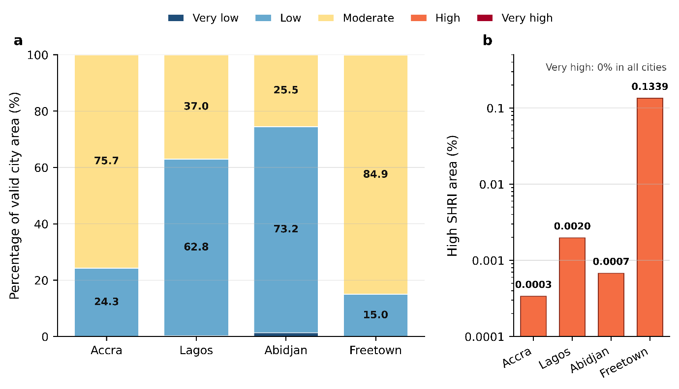

Figure S2. Sensitivity of high and very-high SHRI proportions to three weighting scenarios and fixed-interval versus pooled-quantile classification.
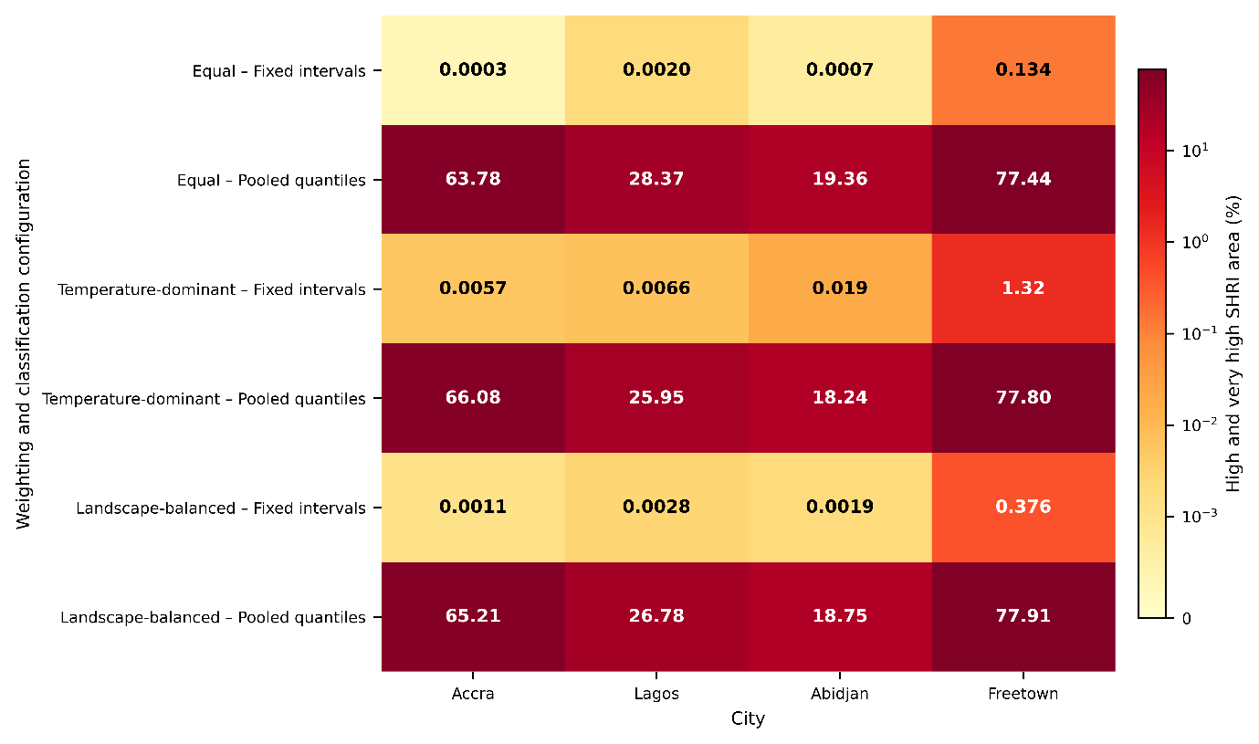

Table S1. Temporal coverage and quality-control statistics for the 2024 satellite observations
City | Sensor | Jan–Mar scenes | Apr–Jun scenes | Jul–Sep scenes | Oct–Dec scenes | Total scenes | Mean UTC time | Mean local-solar time | Valid area (km²) | Valid pixels (%) | Cloud threshold (%)
Accra | Landsat 8/9 | 15 | 13 | 8 | 16 | 52 | 10:12 | 10:13 | 3698.62 | 99.56 | 60
Accra | Sentinel-2 | 71 | 37 | 27 | 71 | 206 | 10:33 | 10:33 | 3698.92 | 99.57 | 60
Lagos | Landsat 8/9 | 22 | 13 | 6 | 27 | 68 | 10:00 | 10:14 | 3783.79 | 99.55 | 60
Lagos | Sentinel-2 | 39 | 19 | 1 | 45 | 104 | 10:19 | 10:33 | 3784.38 | 99.57 | 60
Abidjan | Landsat 8/9 | 25 | 13 | 2 | 23 | 63 | 10:30 | 10:13 | 2106.87 | 99.54 | 60
Abidjan | Sentinel-2 | 49 | 19 | 14 | 40 | 122 | 10:49 | 10:33 | 2107.45 | 99.56 | 60
Freetown | Landsat 8/9 | 10 | 5 | 1 | 8 | 24 | 11:10 | 10:17 | 81.92 | 98.65 | 60
Freetown | Sentinel-2 | 18 | 9 | 4 | 11 | 42 | 11:29 | 10:36 | 82.69 | 99.58 | 60
Note: All collections covered 1 January–31 December 2024. Scene counts refer to images retained after spatial, temporal and scene-level cloud filtering. Valid area and valid-pixel coverage were calculated after applying the complete sensor-specific quality mask. Acquisition times were converted from decimal hours and rounded to the nearest minute.

Table S2. Pooled normalisation ranges and classification thresholds used in the SHRI analysis
A. Common pooled normalisation ranges
Variable | Pooled minimum | Pooled maximum
LST (°C) | 17.111640 | 59.983864
NDVI | −0.881750 | 0.998969
NDBI | −0.716933 | 0.843759
B. Weighting scenarios and classification thresholds
Weighting scenario | LST/NDBI/VD weights | Classification | Threshold 1 | Threshold 2 | Threshold 3 | Threshold 4
Equal weighting | 0.333/0.333/0.333 | Fixed intervals | 0.2000 | 0.4000 | 0.6000 | 0.8000
Equal weighting | 0.333/0.333/0.333 | Pooled quantiles | 0.2754 | 0.3652 | 0.4238 | 0.4707
Temperature-dominant | 0.500/0.250/0.250 | Fixed intervals | 0.2000 | 0.4000 | 0.6000 | 0.8000
Temperature-dominant | 0.500/0.250/0.250 | Pooled quantiles | 0.2988 | 0.3730 | 0.4356 | 0.4863
Landscape-balanced | 0.400/0.300/0.300 | Fixed intervals | 0.2000 | 0.4000 | 0.6000 | 0.8000
Landscape-balanced | 0.400/0.300/0.300 | Pooled quantiles | 0.2832 | 0.3691 | 0.4277 | 0.4746
Note: VD denotes vegetation deficiency, calculated as $1-{NDVI}_{norm}$. Pooled-quantile thresholds were calculated from the combined four-city distribution and applied uniformly to all cities.
Table S3. Complete city-level SHRI sensitivity results under alternative weighting and classification configurations
A. Equal weighting
Classification | City | Valid area (km²) | Coverage (%) | VL (%) | L (%) | M (%) | H (%) | VH (%) | H + VH (%) | H + VH area (km²) | Rank
Fixed intervals | Accra | 3698.62 | 99.56 | <0.01 | 24.29 | 75.70 | <0.01 | 0.00 | <0.01 | 0.01 | 4
Fixed intervals | Lagos | 3783.79 | 99.55 | 0.19 | 62.80 | 37.01 | <0.01 | 0.00 | <0.01 | 0.07 | 2
Fixed intervals | Abidjan | 2106.87 | 99.54 | 1.36 | 73.16 | 25.48 | <0.01 | 0.00 | <0.01 | 0.01 | 3
Fixed intervals | Freetown | 81.92 | 98.65 | 0.00 | 14.98 | 84.89 | 0.13 | 0.00 | 0.13 | 0.11 | 1
Pooled quantiles | Accra | 3698.62 | 99.56 | 2.20 | 11.71 | 22.31 | 34.18 | 29.60 | 63.78 | 2358.97 | 2
Pooled quantiles | Lagos | 3783.79 | 99.55 | 25.83 | 26.05 | 19.75 | 14.22 | 14.15 | 28.37 | 1073.38 | 3
Pooled quantiles | Abidjan | 2106.87 | 99.54 | 40.71 | 24.22 | 15.71 | 8.99 | 10.37 | 19.36 | 407.88 | 4
Pooled quantiles | Freetown | 81.92 | 98.65 | 2.32 | 6.70 | 13.54 | 25.60 | 51.84 | 77.44 | 63.44 | 1

B. Temperature-dominant weighting
Classification | City | Valid area (km²) | Coverage (%) | VL (%) | L (%) | M (%) | H (%) | VH (%) | H + VH (%) | H + VH area (km²) | Rank
Fixed intervals | Accra | 3698.62 | 99.56 | 0.00 | 19.05 | 80.94 | <0.01 | 0.00 | <0.01 | 0.21 | 4
Fixed intervals | Lagos | 3783.79 | 99.55 | <0.01 | 65.43 | 34.56 | <0.01 | 0.00 | <0.01 | 0.25 | 3
Fixed intervals | Abidjan | 2106.87 | 99.54 | 0.19 | 73.80 | 26.00 | 0.02 | 0.00 | 0.02 | 0.40 | 2
Fixed intervals | Freetown | 81.92 | 98.65 | 0.00 | 12.43 | 86.25 | 1.32 | 0.00 | 1.32 | 1.08 | 1
Pooled quantiles | Accra | 3698.62 | 99.56 | 2.24 | 9.98 | 21.69 | 35.51 | 30.57 | 66.08 | 2444.23 | 2
Pooled quantiles | Lagos | 3783.79 | 99.55 | 27.02 | 28.44 | 18.58 | 13.13 | 12.83 | 25.95 | 982.05 | 3
Pooled quantiles | Abidjan | 2106.87 | 99.54 | 40.46 | 24.22 | 17.08 | 8.63 | 9.61 | 18.24 | 384.27 | 4
Pooled quantiles | Freetown | 81.92 | 98.65 | 2.75 | 5.55 | 13.89 | 24.91 | 52.89 | 77.80 | 63.74 | 1

C. Landscape-balanced weighting
Classification | City | Valid area (km²) | Coverage (%) | VL (%) | L (%) | M (%) | H (%) | VH (%) | H + VH (%) | H + VH area (km²) | Rank
Fixed intervals | Accra | 3698.62 | 99.56 | <0.01 | 21.90 | 78.10 | <0.01 | 0.00 | <0.01 | 0.04 | 4
Fixed intervals | Lagos | 3783.79 | 99.55 | 0.03 | 64.02 | 35.95 | <0.01 | 0.00 | <0.01 | 0.11 | 2
Fixed intervals | Abidjan | 2106.87 | 99.54 | 0.44 | 73.91 | 25.66 | <0.01 | 0.00 | <0.01 | 0.04 | 3
Fixed intervals | Freetown | 81.92 | 98.65 | 0.00 | 13.76 | 85.87 | 0.38 | 0.00 | 0.38 | 0.31 | 1
Pooled quantiles | Accra | 3698.62 | 99.56 | 2.11 | 11.17 | 21.52 | 33.53 | 31.68 | 65.21 | 2411.69 | 2
Pooled quantiles | Lagos | 3783.79 | 99.55 | 25.68 | 27.20 | 20.35 | 12.60 | 14.18 | 26.78 | 1013.24 | 3
Pooled quantiles | Abidjan | 2106.87 | 99.54 | 40.04 | 24.81 | 16.40 | 8.37 | 10.38 | 18.75 | 395.08 | 4
Pooled quantiles | Freetown | 81.92 | 98.65 | 2.37 | 6.39 | 13.33 | 24.00 | 53.90 | 77.91 | 63.82 | 1
Note: VL = very low; L = low; M = moderate; H = high; VH = very high. Coverage is the percentage of the city boundary represented by valid SHRI pixels. “<0.01” indicates a positive value below 0.01%. Rank 1 represents the largest combined high and very-high proportion within each weighting-classification configuration. Percentages may not sum to exactly 100% because of rounding.

