Supplementary Materials for

High speed time-multiplexing enabled multi-dimensional silicon photonic parallel computing

Huifu Xiao, Haorong Peng, Shuai Meng, Yongheng Jiang, Xudong Zhou, Pu Zhang, Yingjie Hong, Mingyang Wang, Jiajun He, Zhiqi Zhu, Jianhong Yang & Yonghui Tian*.

School of Physical Science and Technology, Lanzhou University, Lanzhou 730000, Gansu, China.

*Corresponding author. Email: tianyh@lzu.edu.cn

This PDF file includes:

Supplementary Note 1: Basic elements for the photonic tensor computing chip
Supplementary Note 2: Static Measurements
Supplementary Note 3: Dynamic Measurements
Supplementary Note 4: Parallel Computing Principles of One High-speed Microring Modulator
Supplementary Note 5: Details of Positive and Negative Value Calculations and Corresponding Computational Coding Methods
Supplementary Note 6: Details of the MNIST Handwritten Digit Recognition and Iris Recognition Applications
Supplementary Note 7: Parallel Computing Principles of Multidimensional High-speed Microring Modulators
Supplementary Note 8: Details of the Edge Detection Application
Supplementary Note 9: Details of the Fingerprint Recognition Application
Supplementary Note 10: Detailed Specifications of Each Performance Indicator

Supplementary Note 1: Basic elements for the photonic tensor computing chip

The proposed photonic computing device is fabricated on a silicon-on-insulator (SOI) platform comprising a 220-nm-thick top silicon layer and a 2-μm buried oxide layer. Here, we use rib waveguide with rib-height of 150 nm. To achieve optimal optical performance and manufacturing viability, the architecture design waveguide bends with 10-μm radius to minimize bending losses while maintaining efficient light confinement, alongside a layout that reduces electrical signal attenuation while ensuring precise alignment with corresponding contact pads. Each microring resonator implements a dual-modulation scheme, integrating both a microheater for quasi-static thermal wavelength tuning and a PN junction operating on the carrier-depletion principle for high-speed electro-optic modulation. This hybrid configuration enables independent control of operating wavelength and dynamic signal modulation, significantly enhancing logical function reconfigurability. The co-integration of these complementary tuning methods within individual microrings improves functional versatility while maintaining a compact footprint. Fabrication utilized standard 180-nm CMOS-compatible processes, with 70-nm shallow etching for grating coupler.
Figure S1 shows the structure diagram of the two main components: four modes (de)multiplexer and microring resonator. For the four modes (de)multiplexer, the single TE mode condition waveguide width is chosen to be w₀ = 0.4 μm, the corresponding widths of the multimode waveguides carrying TE₁, TE₂ and TE₃ modes are w₁ = 0.929 μm , w₂ = 1.469 μm and w₃ = 2.019 μm.On the other side, the coupling length for TE₀-to-TE₁, TE₀-to-TE₂ and TE₀-to-TE₃ mode conversions are L₁= 13.5 μm, L₂ = 17 μm and L₃ = 21 μm with the coupling gap g₁ = 0.3 μm. Note that all of the cure waveguides have 90 degrees bending angle with a 10 μm radius. For the design of MRR, the radius R = 20 μm, the coupling length L₄ = 2 μm, and the coupling gap g₂ = 0.43 μm.
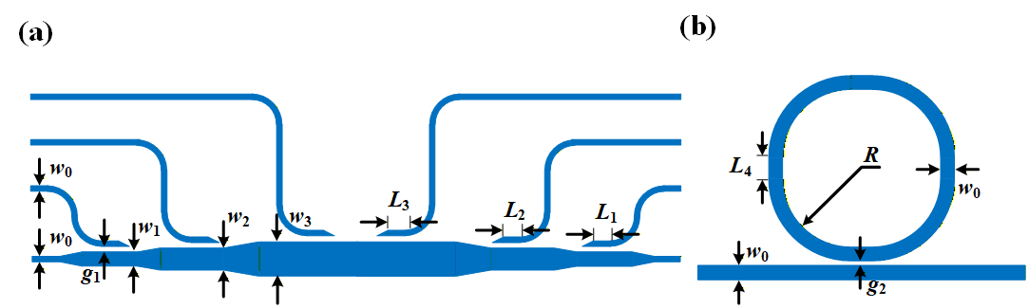
Figure S1 Schematic of the fabricated device. Schematic diagrams of (a) four modes (de)multiplexer and (b) MRR with marked structural parameters.

Supplementary Note 2: Static measurements

As shown in Fig. S2(a)-(d) are the performance characteristics of different channels of the four-mode (de)multiplexer, the optical mode multiplexer/demultiplexer (MUXer/deMUXer) can multiplex/demultiplex four quasi-transverse electric modes TE₀/TE₁/TE₂/TE₃ with insertion loss smaller than 1.196 dB, 2.363 dB, 1.437 dB, 2.252 dB, and crosstalk lower than -24.47 dB, -20.638 dB, -23.358 dB, and -17.599 dB, respectively. In addition, Figs. S2(e)-(h) present the static spectra of different mode channels of the microring modulator under four operating wavelengths and four modes. Specifically, the operating wavelengths corresponding to the TE₀-TE₀, TE₁-TE₁, TE₂-TE₂, and TE₃-TE₃ modes are 1553.8 nm, 1554.8 nm, 1555.8 nm, and 1556.8 nm, respectively, while the other curves correspond to the crosstalk induced by other mode channels. Figs. S2(i)-(l) present the tunable spectra under four operating wavelengths and four modes. Specifically, (i) corresponds to the TE₀-TE₀ channel, with an extinction ratio of 18.177 dB for the microring; (j) denotes the TE₁-TE₁ channel, where the microring exhibits an extinction ratio of 19.956 dB; (k) represents the TE₂-TE₂ channel, with the microring’s extinction ratio being 18.141 dB; and (l) is the TE₃-TE₃ channel, with an extinction ratio of 17.975 dB for the microring. The insertion loss is relatively low under the fundamental mode, approximately 1.8 dB, while it is higher under other modes (around 2.3 dB). Moreover, the extinction ratios of the resonant peaks of the microring at different operating wavelengths under the same mode show good consistency. In contrast, the difference in the resonant peaks of the microring between different modes is small (within 2 dB), which can ensure good consistency of the computing system. Static measurement experiments setups of the fabricated device are shown in Fig. S3.

Figure S2 Transmission characteristics of MRRs at different modes and resonant wavelengths. (a)–(d): Four-mode (de)multiplexer; (e)–(h): Microring resonators for TE₀–TE₃ modes; (i)–(l): Microring resonators operating at different wavelengths for TE₀–TE₃ modes.
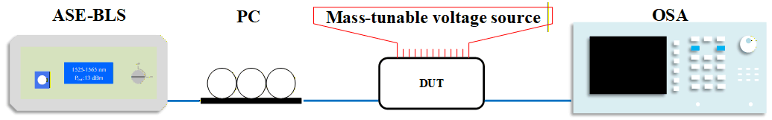
Figure S3 Diagram of static measurement experiments setups. (ASE-BLS, ASE Broadband Light Source; PC, polarization controller; OSC, high-speed oscilloscope)

Supplementary Note 3: Dynamic measurements.

Fig. S4(a) illustrates the eye diagrams of non-return-to-zero (NRZ) and four-level pulse amplitude modulation (PAM4) signals for the microring modulator at different baud rates. Specifically, for the NRZ signal, tests were conducted at 40 Gbaud, 60 Gbaud, 80 Gbaud, 100 Gbaud, and 120 Gbaud, with the corresponding extinction ratios (Ext. Ratio) measured as 2.755 dB, 1.957 dB, 1.389 dB, 1.057 dB, and 1.238 dB, respectively.
Fig. S4(b)–(c) present the test link diagrams under dynamic testing conditions, where Fig. S4(b) depicts the experimental link for eye diagram testing, and Fig. S4(c) shows the experimental test link diagram for implementing applications including edge extraction, handwritten numerical recognition, iris recognition, and fingerprint recognition. In the figures, blue denotes optical connect, while red represents electrical connect.
During the eye diagram measurement, a Keysight M8199B Arbitrary Waveform Generator (AWG) was employed to generate encoded electrical signals (NRZ/PAM4), which were then applied to the Device Under Test (DUT). A Radio Frequency Power Amplifier (RFPA, SHF S807) was utilized to produce radio frequency (RF) signals and amplify them to meet the driving requirements of the silicon microring electro-optic modulator. A Tunable Voltage Source (TVS) supplied the operating voltage for both the RFPA and the DUT. In the optical link, a Tunable Laser (TL) delivered a single-wavelength optical source. A Polarization Controller (PC) was adopted to adjust the polarization state of the light beam. The silicon microring electro-optic modulator embedded in the DUT imposed the NRZ/PAM4 electrical signals onto the optical carrier. An Erbium-Doped Fiber Amplifier (EDFA, Keopsys CEFA-C-PB-LP-SM-23-MSA1-B201-FA-FA) was used to boost the optical power, and signal filtering was performed by an Optical Tunable Filter (OTF, Santec OTF-350). Finally, the conditioned optical signal was fed into a Keysight DCA-X 86100D.
In contrast to the eye diagram test link, the application test link features a distinct configuration in the electrical path: the AWG outputs an additional signal channel to an external lithium niobate (LiNbO₃) electro-optic modulator (EOM), and the tunable voltage source (TVS) is employed to supply the bias voltage for this external EOM.
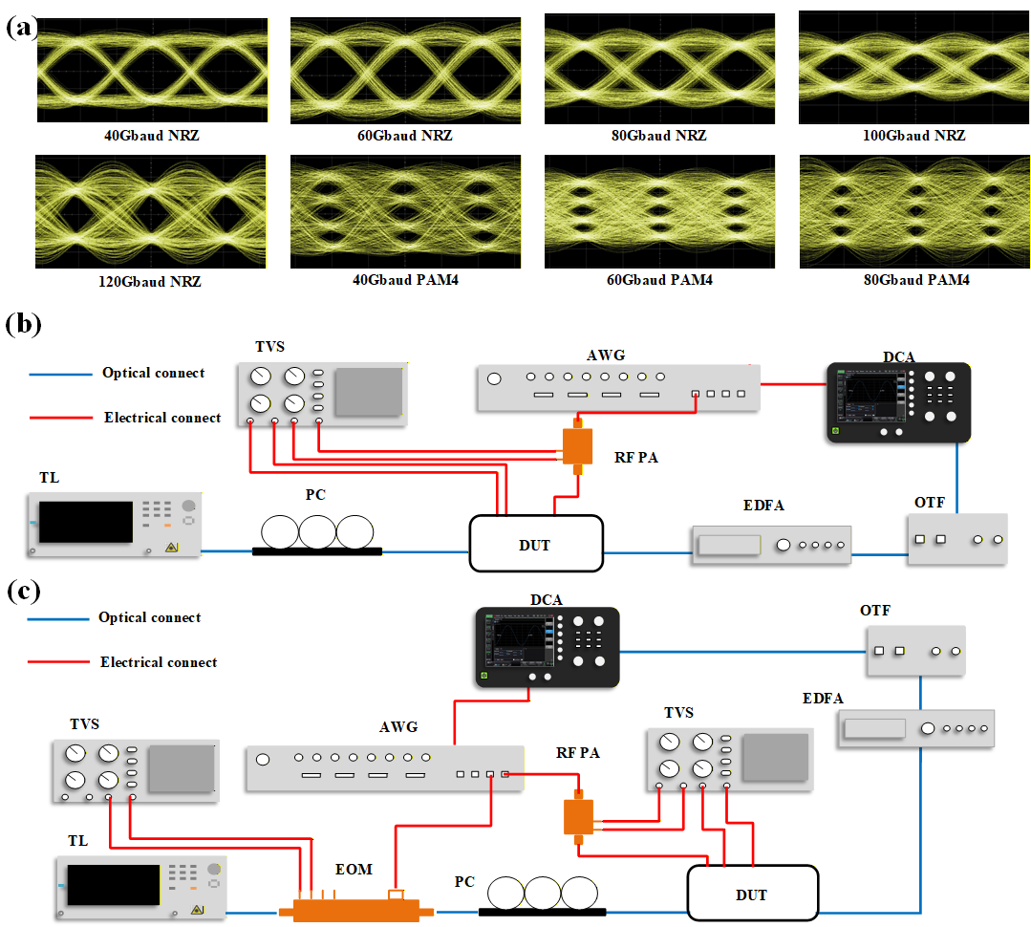
Figure S4 (a) Eye diagrams of NRZ and PAM4 signals at different data rates; (b) Schematic of the eye diagram measurement and (c) experimental setup. (TL: tunable laser; PC: polarization controller; DUT: device under test; AWG: arbitrary waveform generator; RF PA: radio-frequency power amplifier; EOM: electro-optic modulator; TVS: tunable voltage source; OTF: optical tunable filter; DCA: digital communication analyzer)

Supplementary Note 4: Parallel Computing Principles of One High-speed Microring Modulator

Dot-product parallel computing: dot-product parallel computing utilizes Time Division Multiplexing (TDM) to multiply multiple weight vectors with a specific data vector in the time sequence. Its physical architecture loads high-speed weight data by microring modulators and high-speed input data by external modulators, and then realizes parallel multiplication operations by synchronizing the timing of the two modules (as shown in Fig. S5).
Figure S5 Schematic diagram of parallel dot-product computing architecture
Let the high-speed input data vector loaded on the external modulator be X, which contains N elements. This data X needs to be multiplied with M groups of weight vectors each containing N weight elements simultaneously. Let the M×N weight matrix composed of M groups of weight vectors be W. The expression of the output result Y is as follows:
$$\begin{aligned}X^{T}×W={\left[\begin{matrix}x_{1} \\ ⋮ \\ x_{N}\end{matrix}\right]}^{T}×\left[\begin{matrix}w_{1,1} & ⋯ & w_{1,N} \\ ⋮ & ⋱ & ⋮ \\ w_{M,1} & ⋯ & w_{M,N}\end{matrix}\right]=\left[y_{1},…,y_{M}\right]=Y\#\left(\text{S1}\right)\end{aligned}$$
where the output result Y={y₁,…,y_{M}} has M elements corresponding to M groups of weight vectors, as shown in Fig. S5. When the input vector X is loaded on the external modulator in time sequence, the time-sequence expression of X is shown below:
$$\begin{aligned}X\left(t\right)=\sum_{j=1}^{N}{x_{j}\int_{0}^{∞}{δ\left(t-j/f_{s}\right)}dt}\#（\text{S}\text{2}）\end{aligned}$$
where t is time; N is the dimension of the input vector, i.e., the number of vector elements; j represents the j-th element of the input vector; δ is the Dirac delta function; fs is the baud rate of the external modulator.
Meanwhile, the M×N weight matrix W is flattened into a vector along the row direction, and the time-sequence expression of the weight matrix W can be expressed as:
$$\begin{aligned}W\left(t\right)=\sum_{j=1}^{N}{\sum_{i=1}^{M}{w_{i,j}\int_{0}^{∞}{δ\left(t-\frac{（j-1）N+i}{{Mf}_{s}}+∆T\right)}dt}}\#\left(\text{S}\text{3}\right)\end{aligned}$$
where M is the number of weight groups; i represents the i-th group of weight vectors; ΔT is the calibrated delay time to ensure precise multiplication between corresponding elements of weight vectors and input vectors; Mf_{s} is the baud rate of the microring modulator.
In this way, a single element in X(t) can be multiplied with M elements in W(t) in turn, so as to realize the dot product operation between the input vector and the weight vector. The operation relationship is:
$$\begin{aligned}Y_{i,j}=x_{j}w_{i,j}\#（\text{S}\text{4}）\end{aligned}$$
For each element in the output vector Y, the expression of the i-th element Y_{i} is shown below:
$$\begin{aligned}Y_{i}=\sum_{j=1}^{N}{x_{j}w_{i,j}}\#（\text{S5}）\end{aligned}$$
A simple computing system composed of a single microring modulator and an external modulator (Fig. S5) can equivalently realize the function of a single fully connected layer through multi-core parallel computing, benefiting from the highly flexible timing encoding capability of TDM. Taking a single fully connected layer with N input nodes and M output nodes as an example: each output node corresponds to N weight values, with a total of M weight groups. In a single computation with one data sample, the N-channel input data vector X remains unchanged for the M weight groups. The principle and data relationship are consistent with the above content, but there is more than one data sample in fully connected computation. For a single fully connected computation with L samples, the time-sequence expressions of the input data vector X and weight matrix W become:
$$\begin{aligned}X\left(t\right)=\sum_{k=1}^{L}{\sum_{j=1}^{N}{x_{（k-1）N+j}\int_{0}^{∞}{δ\left(t-\frac{（k-1）N+j}{f_{s}}\right)}dt}}\#（\text{S6}）\end{aligned}$$
$$\begin{aligned}W\left(t\right)=\sum_{k=1}^{L}{\sum_{j=1}^{N}{\sum_{i=1}^{M}{w_{i,j}\int_{0}^{∞}{δ\left(t-\frac{（k-1）NM+（j-1）N+i}{{Mf}_{s}}+∆T\right)}dt}}}\#（\text{S7}）\end{aligned}$$
The corresponding output vector Y={y₁,…,y_{M},y_{M+1},…,y_{LM}}.
This architecture can also use the same set of weights to complete parallel computation of multiple data samples. Its working principle is similar to the implementation of a fully connected layer, except that the number of parallel samples is M, there is only one group of weights with N weights, and the data baud rate of the external modulator is M times that of the microring modulator.
Supplementary Note 5: Details of positive and negative value calculations and corresponding computational coding methods

Since negative values are not present in the optical domain, we adopt a separate calculation scheme for positive and negative values to resolve the issue of negative arithmetic operations. The weight w is decomposed into its positive component w₊ and negative component w₋ . These two components are then encoded individually, followed by respective multiplication operations with the input data Data. Subsequently, the product of the positive component w₊ and Data is subtracted by the product of the negative component w− and Data, as expressed in the following equation:
$Y=w*Data=\left(w_{+}-w_{-}\right)*Data$ (S8)
Based on the aforementioned processing methods for positive and negative value calculations, we partition the weight data into positive weight sequences and negative weight sequences, as illustrated in Fig. S6(a). For both the Iris flower classification task and the handwritten digit recognition task, the encoding logic of weights and input data is analogous. The distinction lies in that, in the Iris flower application, each data bit of a single sample corresponds to the identical position of three weight kernels, whereas in the handwritten digit recognition application, two data samples correspond to the weights of one convolution kernel, as depicted in Figs. S6(b)–(c). The data length of a single sample for the Iris flower dataset is 9, while that for the handwritten digit recognition task is determined by the sliding times n (denoted as Slidetime) of the convolution kernel. With a stride of 1 for the convolution kernel sliding over the input image, the data encoding sequence is shown in Fig. S6(c) when Slidetime = 1, and the encoding of subsequent data follows the same pattern. Fig. S6(d) presents the data encoding rule for the edge detection application. The input image is divided into 9 regions (Data 1, …, Data 9) according to the areas swept by the convolution kernel at different positions, given that the convolution kernel size is 3×3. The data arrangement sequence adheres to the traversal order of the convolution kernel during its sliding process. Since four convolution kernels are employed to process the same input image, each data bit corresponds to four weight values. Taking the data encoding of Data 1 as an example, as illustrated in the lower part of Fig. S6(d), Data 1 corresponds to position w₁ of the convolution kernel, and the encoding of the remaining data follows the same rule. The encoding principle of the fingerprint recognition application is consistent with that of the edge detection application, except that the image samples in the fingerprint recognition task are divided into 25 regions.
Leveraging the above encoding principles and the processing methods for positive and negative value calculations, we split the encoded data into positive and negative components for separate computation in the experiments. The final computational results are subsequently obtained by subtracting the negative component from the positive component.
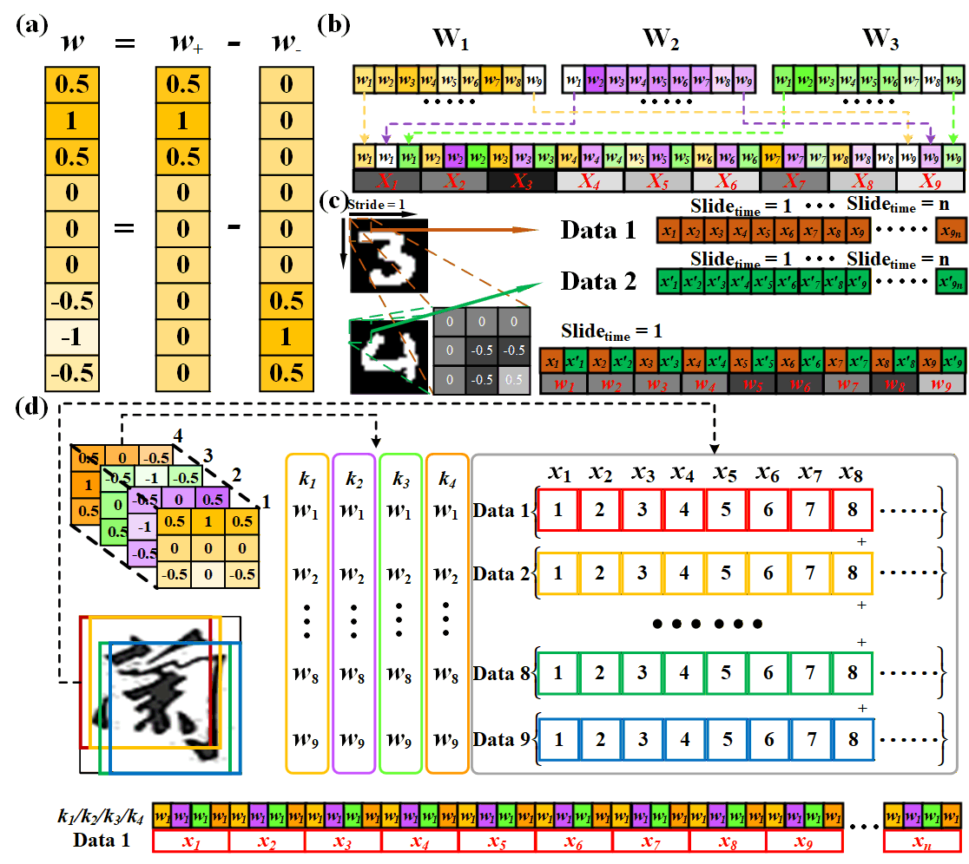
Figure S6 (a) Schematic diagram of the calculation method for positive and negative numbers; (b)–(d) Schematic diagrams of coding for iris recognition, handwritten digit recognition, and edge extraction applications, respectively.
Supplementary Note 6: Details of the MINST Handwritten Digit Recognition and Iris Recognition Applications

Based on the data encoding principles for handwritten digit recognition and Iris flower recognition applications elaborated in Supplementary Note 5, a microring modulator operating at wavelength λ₁ under the TE₀ mode was adopted in the experiment to load the encoded weight data, with an external LiNbO₃ modulator employed for sample data loading. The data of ten samples from the same class were grouped into one set, and the thirty sample data points were divided into three sets for separate experimental tests, where the encoded data length for a single set was 10×9×3=270. The test results were acquired via segmented sampling: the data processed by the same weight kernel were sampled sequentially and grouped into a single column, yielding three columns of calculation results corresponding to the three weight kernels. For each column, every nine data points were summed to derive the calculation result of each sample under the weight kernel for a specific class; subsequent processing with the softmax function was then conducted to obtain the final classification probabilities. For the ten samples of the first class, the classification probability derived from the processing result of the weight kernel for Class 1 (the first weight kernel) was the maximum, and the same principle applied to the other two classes. Implemented in a cyclic manner, this encoding and calculation method can achieve the functional performance of an entire fully connected layer. In the future, by integrating with modules such as FPGAs, operations including segmented sampling, nonlinear function calculation, data classification and aggregation, and summation can be programmed into FPGAs, thereby realizing an optoelectronic hybrid fully connected network system.
Iris flower recognition and MNIST handwritten digit recognition are the most classic applications in target recognition, which are widely used in the optical computing field for verifying chip performance. Python (version 3.12.4) and PyTorch (version 2.4.1 + CPU: 13th Gen Intel(R) Core(TM) i5-13600KF) were adopted for the training of these two applications on a 64-bit computer. The Iris flower fully connected network trained in this work comprised an input layer with 4 nodes, a hidden layer with 9 nodes, and an output layer with 3 nodes. A ReLU nonlinear function was applied between the input layer and the hidden layer for data processing. The stochastic gradient descent (SGD) algorithm was used as the optimization method with a learning rate of 0.02, and the cross-entropy loss function was adopted as the loss metric. Ultimately, the trained model achieved a 100% recognition accuracy for the 30 test samples.
For the handwritten digit recognition application, 100 MNIST handwritten digit images were tested in the experiment, with ten images for each digit from 0 to 9. Two images were encoded as one group, resulting in a total of 50 groups. Given the image size of 28×28 pixels, a 3×3 convolution kernel was slid with a stride of 1, leading to a total sliding number (n) of 676; thus, the encoded data length for a single group was 676×2×9=12168. The data processing method was similar to that for the Iris flower recognition application, with the key difference that each group of data was divided into two columns, and the processed data were fed into the subsequent network for recognition instead of being processed with the softmax function. The architecture of the training network for handwritten digit recognition is shown in Fig. S7, with the part implemented in this work indicated by the red box in the figure. The model was trained for 20 epochs with a batch size of 64 and a momentum of 0.5; the SGD algorithm was adopted for optimization with a learning rate of 0.01, and the cross-entropy loss function was used as the loss metric. After training, the model achieved a 92% training set accuracy at the 20th epoch, and a 96% recognition accuracy was obtained for the selected 100 test images when evaluated with the trained model.
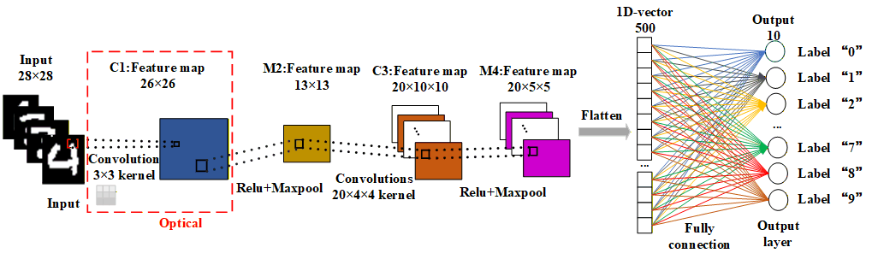
Figure S7 Schematic diagram of the network model for handwritten digit recognition application
Supplementary Note 7: Parallel Computing Principles of Multidimensional High-speed Microring Modulators

On the basis of dot-product parallel computing, Wavelength Division Multiplexing (WDM), Mode Division Multiplexing (MDM), and Space Division Multiplexing (SDM) are introduced. A single microring modulator is replaced by a wavelength/mode/space division multiplexed microring modulator array, and each microring modulator corresponds to an external modulator.
Figure S8 Schematic diagram of matrix parallel computing architecture
In this integrated photonic convolution computing system with four-dimensional multiplexing of time, wavelength, mode and time (as shown in Fig. S8), there are n×m×o microrings, where n represents the number of multiplexed wavelengths, m represents the number of multiplexed modes, and o represents the number of multiplexed spaces, thus forming an n×m×o weight tensor, and each microring represents a position of the weight tensor. For simplicity and clarity, in the following texts, we use the hybrid multiplexing of wavelength and mode to illustrate the calculation principle. The calculation principle is similar when adding a space dimension.
On this basis, TDM can realize the capability of parallel processing concurrently and loads M convolution kernels in parallel, thus forming a three-dimensional convolution computing system of n×m×M. Let the size of the image X to be convolved in the proposed computing system be k×l. Since the size of the convolution kernel is n×m, the matrix size traversed by each weight position of the convolution kernel is (k−n+1)×(l−m+1). Let (k−n+1)×(l−m+1)=K. The traversal matrix corresponding to the first position w_{1,1} of the convolution kernel is Data 1, the second position w_{1,2} corresponds to Data 2, and the traversal matrix positions are allocated in the order of the row direction of the convolution kernel. Finally, the traversal matrix corresponding to the N-th position w_{n,m} is Data N, where N=n×m.
Each traversal matrix is flattened into a vector and loaded on the external modulator, and the input data corresponding to the microring is loaded on each external modulator. Then the time-sequence expression of the vector $X_{n,m}^{(N)}$ of the traversal matrix Data N can be expressed as:
$$\begin{aligned}X_{n,m}^{\left(N\right)}=\sum_{j=1}^{K}{x_{j,n,m}\int_{0}^{∞}{δ\left(t-j/f_{s}\right)}dt}\#\left(\text{S9}\right)\end{aligned}$$
where K represents the number of times the convolution kernel traverses the image, and also represents the vector dimension after the traversal matrix Data N is flattened; n,m represent the microrings of the corresponding wavelength and mode; x_{j,n,m} represents the j-th element after the Data N matrix is flattened into a vector.
Since the number of loaded convolution kernels is M, the data rate loaded on the microring is M times the data encoding rate of the external modulator. The time-sequence expression of the weight data of the microring at the n-th wavelength and m-th mode can be expressed as:
$$\begin{aligned}W_{n,m}\left(t\right)=\sum_{i=1}^{K}{\sum_{j=1}^{M}{w_{n,m,j}\int_{0}^{∞}{δ\left(t-\frac{（i-1）M+j}{{Mf}_{s}}+∆T\right)}dt}}\#\left(\text{S10}\right)\end{aligned}$$
where w_{n,m,j} represents the weight at the n-th row and m-th column of the j-th convolution kernel, and n,m also represent the n-th wavelength and m-th mode; Mf_{s} is the rate of loading weights on the microring modulator.
It can be seen from Equations (S9) and (S10) that one element in the flattened vector of the Data N matrix corresponds to M weight values in time sequence. The multiplication between the microring weight at the n-th wavelength and m-th mode and the input data of the corresponding external modulator is the multiplication between the weight value and the data at the corresponding position in time sequence. The resulting vector Y_{n,m} can be expressed as:
$$\begin{aligned}{Y_{n,m}={\{y}_{1,1,n,m},…,y_{1,M,n,m},…,y_{2,M,n,m},…,y_{K,M,n,m}\}}^{T}\#\left(\text{S11}\right)\end{aligned}$$
Then the overall system result Y can be expressed as:
$$\begin{aligned}Y=\sum_{j=1}^{n}{\sum_{i=1}^{m}{Y_{i,j}}}=\{{y_{1,1},…,y_{1,M},…,y_{K,1},…,y_{K,M}\}}^{T}\#\left(\text{S12}\right)\end{aligned}$$
The data processed by the same convolution kernel is divided into M vectors, and then the vectors are converted into matrices of (k−n+1)×(l−m+1). Each result matrix is shown in the Output part at the bottom right of Fig. S8.

Supplementary Note 8: Details of the Edge Detection Application

Based on the data encoding principle for edge extraction elaborated in Supplementary Note 5, we performed edge extraction on the Chinese characters ‘蘭’, ‘州’, ‘大’ and ‘學’ using four convolution kernels for the top, left, bottom and right directions, respectively. In the experiment, the raw data were loaded onto an external LiNbO₃ electro-optic modulator, while the weight data were loaded onto microring modulators operating under distinct working conditions. Each piece of raw data was mapped to a microring modulator with a specific working state, where the employed operating wavelengths were λ₁ (1553.8 nm), λ₂ (1554.8 nm) and λ₃ (1555.8 nm), and the adopted operating modes were TE₀, TE₁ and TE₂. Specifically, Data 1–3 corresponded to the microring modulators operating at λ₁, λ₂ and λ₃ under the TE₀ mode; Data 4–6 to those at λ₁, λ₂ and λ₃ under the TE₁ mode; and Data 7–9 to those at λ₁, λ₂ and λ₃ under the TE₂ mode. Given that the size of each character image was 60×40 pixels, the encoding length for each of the nine data groups was calculated as 58×38×4 = 8816. The processing result of the Chinese character ‘蘭’ has been presented in the main text and will not be reiterated here. Figs. S9 (a)–(c) show the processing results of ‘州’, ‘大’ and ‘學’, respectively, where the extraction effect of each edge is prominent. Owing to the influence of environmental noise and the instability of manual operation, individual background signals exhibit slight deviations from those obtained via electronic processing. The performance is expected to be improved by introducing a power feedback system or incorporating specific denoising algorithms.
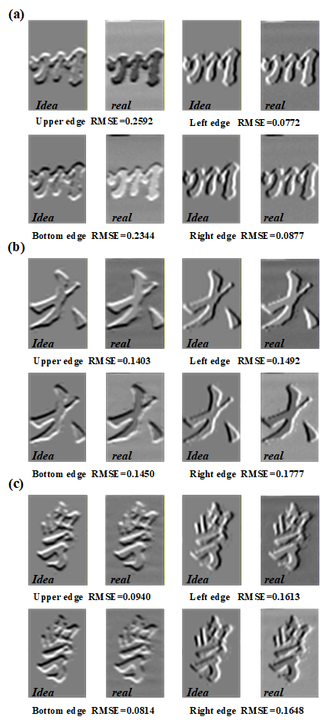
Figure S9 (a)–(c) Extraction results of the Upper, bottom, left and right edges, and root mean square error (RMSE) results for the Chinese characters‘州’, ‘大’ and ‘學’, respectively.
Supplementary Note 9: Details of the Fingerprint Recognition Application

For computer vision tasks, scale variation is a critical research focus. Currently, three mainstream solutions have been developed for convolutional neural networks (CNNs) to address this issue, namely image pyramid, feature pyramid network (FPN), and Trident Network^{[2]}. The Trident Network employs a three-branch architecture where each branch utilizes dilated convolution kernels with distinct dilation rates but maintains an identical number of parameters. Each branch provides a receptive field of different size, enabling more comprehensive extraction of feature information from images.
The Siamese Network is a special neural network architecture primarily designed to measure the similarity between two inputs. Composed of two sub-networks with shared weights, it quantifies the similarity of the two inputs by calculating the distance between their extracted feature vectors. This architecture supports few-shot/one-shot learning^{[3]} and is robust to interference from noisy samples^{[4]}, making it suitable for pattern recognition tasks with stringent fault tolerance requirements, such as face recognition, fingerprint recognition, and object tracking^{[5]-[6]}. In this work, we implement a Siamese Network integrated with the characteristics of the Trident Network for fingerprint recognition based on the proposed optoelectronic computing system, with its encoding rules being analogous to those of the edge extraction application elaborated in Supplementary Note 5. The dual high-speed computing capability of the proposed system can fully exploit its advantages of high degrees of freedom and parallelism, which is conducive to the implementation of the Trident Network and its parallel branch processing mechanism.
The code for implementing the fingerprint recognition application in this work is based on the open-source resource available at https://zhuanlan.zhihu.com/p/594381489, and the fingerprint dataset ^{[7]} is provided by the Center for Biometrics and Security Research, Chinese Academy of Sciences. In practical scenarios, captured fingerprint images are prone to rotation, translation or misalignment, which leads to the failure of feature point matching between different fingerprint images. To realize the fingerprint recognition application, preprocessing of the fingerprint dataset is required before network training, which involves the matching and alignment of fingerprint images. The Scale-Invariant Feature Transform (SIFT) algorithm is adopted for the alignment operation, which consists of two core steps: feature point detection and feature point description.
For network training, 5 fingerprint images with the same label and 34 fingerprint images with other labels were selected for the alignment process. The network was trained using TensorFlow (version 2.18.0) and Keras (version 3.10.0). Due to experimental constraints, all 39 images were cropped prior to training: the central 120×120 region was retained from the original 256×256 fingerprint images for subsequent training procedures. The Adaptive Moment Estimation (Adam) algorithm was used as the optimization method, with the contrastive loss function adopted as the loss metric. The evaluation metric was defined as follows: a Euclidean distance of less than 0.5 between a pair of images indicates matching fingerprints, while a distance greater than 0.5 indicates non-matching fingerprints. The training hyperparameters were set as follows: batch size = 1, training epochs = 40, and validation split = 0.2.
For experimental testing, 5 fingerprint images with the same label and another 5 with different labels were selected from the training dataset. The first three-branch layer of the network for these 10 test images was implemented based on the proposed optoelectronic computing system. The calculated results were paired and compared with the electronically processed data of the first fingerprint image. A Euclidean distance of less than 0.5 between a test pair was deemed a match, while a distance greater than 0.5 was deemed a mismatch. The recognition accuracy of the 10 test images was then determined by comparing the predicted matching results with the actual label information.

Supplementary Note 10: Detailed Specifications of Each Indicator

Average Computing Speed and Computing density: For the matrix-vector multiplication of a 1×a vector A and an a×b matrix B, the number of computing operations N performed per unit time is given by the following formula:
$N≈2abf$ (S13)
where f denotes the modulation rate with the unit of Gbaud. The Average Computing Speed (ACS) is defined as ACS=2f. Computing Density (OCD) refers to the number of computing operations per unit area per unit time, which is expressed as:
$OCD=N/S=(b×2a)×f/S=2abf/S$ (S14)
with the unit of OPS/mm², and S representing the chip area. For the proposed system, the modulation rate f is determined by the maximum modulation rate of the microring electro-optical modulators and the external LiNbO₃ modulators. For the edge extraction application, the microring electro-optical modulators achieve the maximum modulation rate (f₁ = 20 Gbaud), leading to an ACS of 2×f₁ =40 GOPS. For the iris recognition, handwritten digit recognition and fingerprint recognition applications, the maximum modulation rates are f₂ = 15 Gbaud, f₃ = 10 Gbaud and f₄ =15 Gbaud, corresponding to ACS values of 30 GOPS, 20 GOPS and 30 GOPS, respectively. The ACS of the proposed system is limited by the modulation rate of the microring electro-optical modulators, which can reach a maximum rate of 120 Gbaud for non-return-to-zero (NRZ) signals, leading to a theoretical maximum ACS of 240 GOPS. The area of a single microring modulator is S=0.045 mm×0.083 mm=0.003735 mm². For a single microring with a=b=1, the computing density is calculated as OCD=2× f/S=ACS/S=120 GOPS/0.003735 mm²≈32.128 TOPS/mm². For the entire system with a total area of S=1.643 mm× 1.456 mm = 2.392208 mm² and parameter values of a = 4, b = 5, the computing density is OCD=(2×4×5× f )/S=(2×4×5×120) GOPS/2.392208 mm² ≈ 2.007 TOPS/mm². Due to the relatively loose electrode arrangement for test requirements, a certain area is wasted; the computing density can be increased to 4.014 TOPS/mm² if the electrodes are arranged in a regular pattern with half of the area saved.
Calculation Deviation and Calculation Accuracy: The root mean square error (RMSE) is adopted to evaluate the calculation deviation of the system, which is calculated as:
$RMSE=\sqrt{\frac{1}{KMN}\sum_{k=1}^{K}{\sum_{i=1}^{M}{\sum_{j=1}^{N}{{e_{ij}^{\left(k\right)}}^{2}}}}}$ (S15)
where $e_{ij}^{\left(k\right)}=a_{ij}^{\left(k\right)}-b_{ij}^{\left(k\right)}$ is the pixel error, $a_{ij}^{\left(k\right)}$, $b_{ij}^{\left(k\right)}$ are the pixel values of the $i^{th}$ row and the $j^{th}$ column from the feature images (the convolution results) of the $k^{th}$ image with the experimental chip system and the digital computing, respectively, M and N are the number of rows and columns of the feature image respectively, and K are the number of image.
The ENOB (or bit precision) $N_{b}$ is calculated as follows:
$N_{b}=\log_{2}\left(\frac{μ_{max}-μ_{min}}{RMSE}\right)$ (S16)
where $μ_{max}$ and $μ_{min}$ are the maximum and minimum values of the output, respectively. As shown in Supplementary Note 6, the minimum RMSE of the system is calculated to be 0.0772. Since the output data of the system are normalized to the range of [1, -1], the bit precision Nb is approximately 5 bits according to Eq. (S16).
Computing Power Consumption: The Computing Power Consumption (CPC) is a key parameter to evaluate the operation efficiency of integrated photonic computing systems, defined as the energy consumed for a single computing operation. The power consumption of the proposed system mainly consists of two parts: the first is the power used to compensate for the resonance wavelength shift of microrings caused by the thermo-optical effect of the thermal electrodes fabricated on the chip during device operation, and the second is the power loss induced by the microwave signals loaded on the microring electro-optical modulators. The first part of the power consumption P1 is expressed as:
$P_{1}=nU^{2}/R$ (S17)
where n is the number of microrings involved in the computing operation, U is the average voltage required to maintain the resonance wavelength of microrings at the operating wavelength, and R is the resistance of the thermo-optical electrodes. For a single microring (n=1) with U=0.5 V and R=600 Ω, the power consumption P₁ is calculated to be approximately 0.4167 mW. According to Ref. [1], the total microwave energy consumption is estimated as 1.03 fJ/bit, leading to the second part of the power consumption for a single microring as P₂=120 Gbit/s×1.03 fJ/bit=0.1236 mW. Thus, the total power consumption of a single microring electro-optical modulator is P=P₁+P₂=0.5403 mW. The computing power consumption per operation for a single microring is derived from the following formula:
$CPC=P/2abf$ (S18)
and the calculated CPC is 2.25125 fJ/OP.

References
[1] Timurdogan, E., Sorace-Agaskar, C., Sun, J. et al. An ultralow power athermal silicon modulator. Nat Commun 5, 4008 (2014). https://doi.org/10.1038/ncomms5008
[2] Y. Li, Y. Chen, N. Wang and Z. -X. Zhang, "Scale-Aware Trident Networks for Object Detection," 2019 IEEE/CVF International Conference on Computer Vision (ICCV), Seoul, Korea (South), 2019, pp. 6053-6062, doi: 10.1109/ICCV.2019.00615.
[3] Koch, G., Zemel, R. and Salakhutdinov, R., 2015, July. Siamese neural networks for one-shot image recognition. In ICML deep learning workshop (Vol. 2).
[4] Chen, X., Yan, X., Zheng, F., Jiang, Y., Xia, S.T., Zhao, Y. and Ji, R., 2020. One-Shot Adversarial Attacks on Visual Tracking With Dual Attention. In Proceedings of the IEEE/CVF Conference on Computer Vision and Pattern Recognition (pp. 10176-10185).
[5] Chopra, S., Hadsell, R. and LeCun, Y., 2005, June. Learning a similarity metric discriminatively, with application to face verification. In 2005 IEEE Computer Society Conference on Computer Vision and Pattern Recognition (CVPR'05) (Vol. 1, pp. 539-546). IEEE.
[6] Bertinetto, L., Valmadre, J., Henriques, J.F., Vedaldi, A. and Torr, P.H., 2016, October. Fully-convolutional siamese networks for object tracking. In European conference on computer vision (pp. 850-865). Springer, Cham.
[7] https://hycasia.github.io/dataset/casia-irisv4/

