Supplementary Material
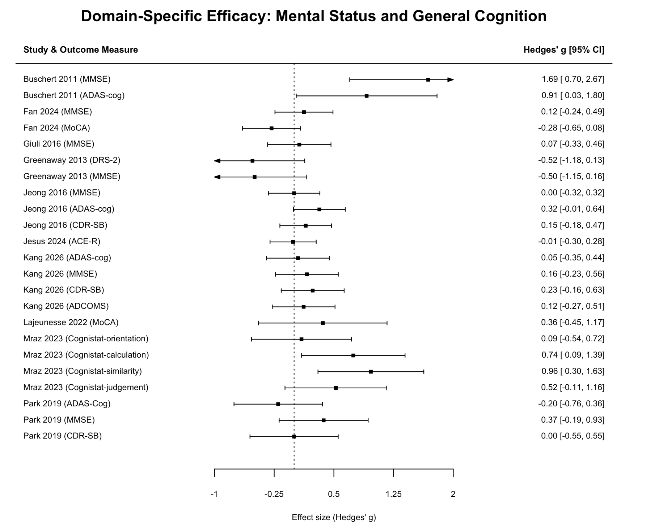
Figure S1. Forest plot of outcome-specific effect sizes within the mental status and general cognition domain.

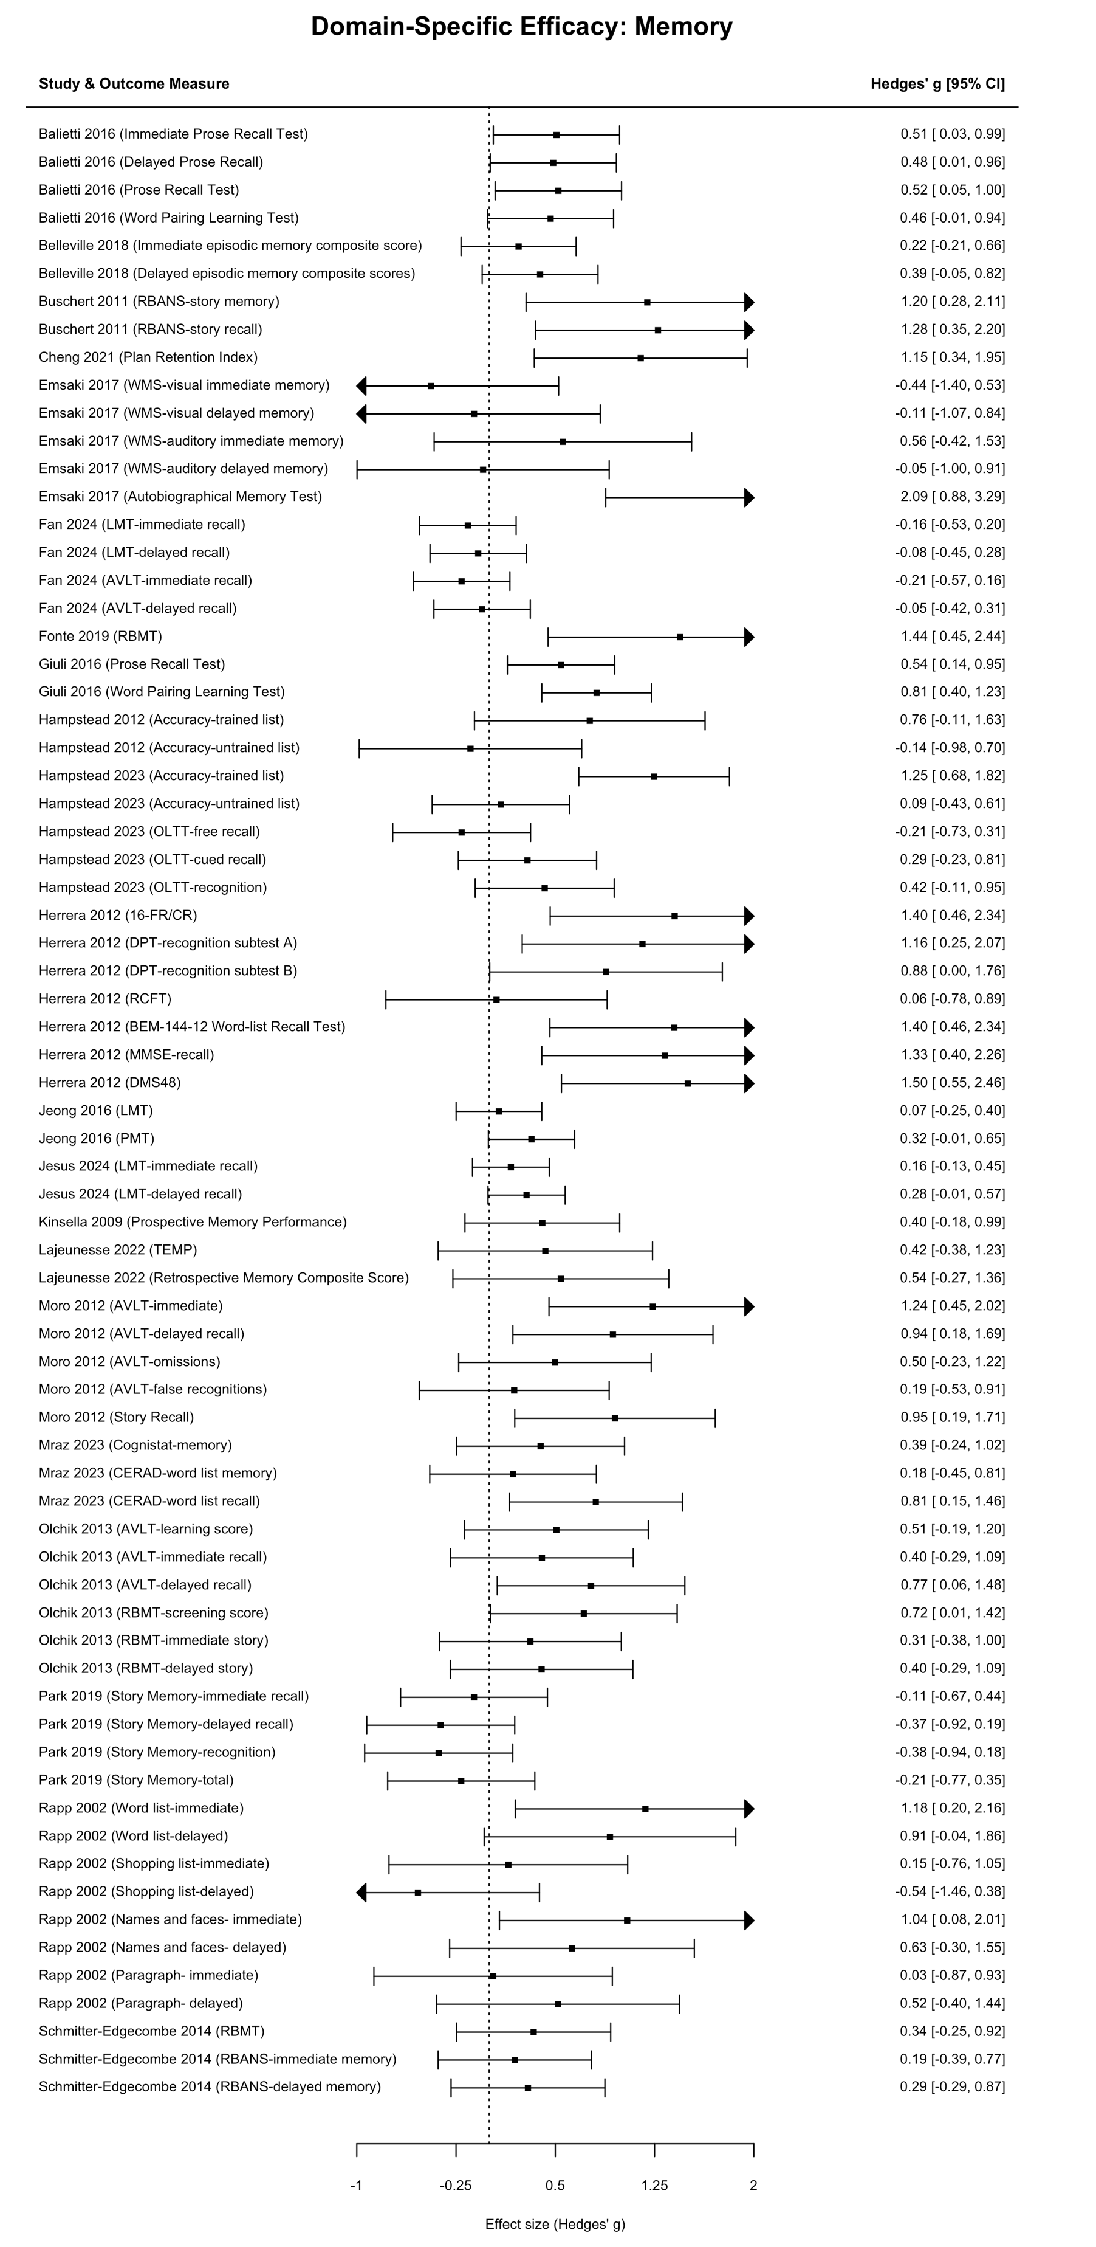
Figure S2. Forest plot of outcome-specific effect sizes within the memory domain.
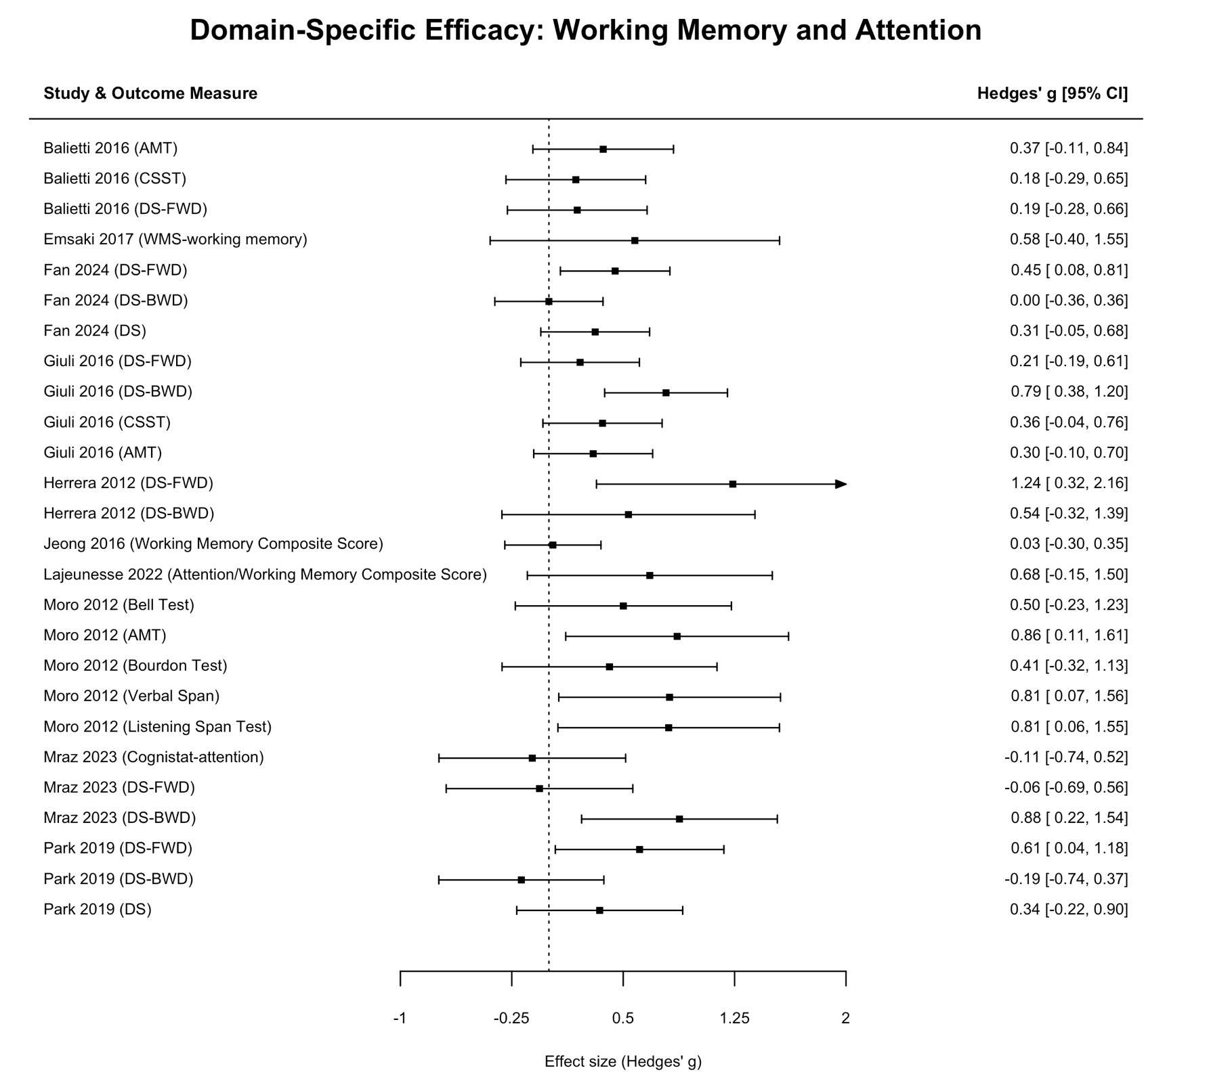
Figure S3. Forest plot of outcome-specific effect sizes within the working memory and attention domain.

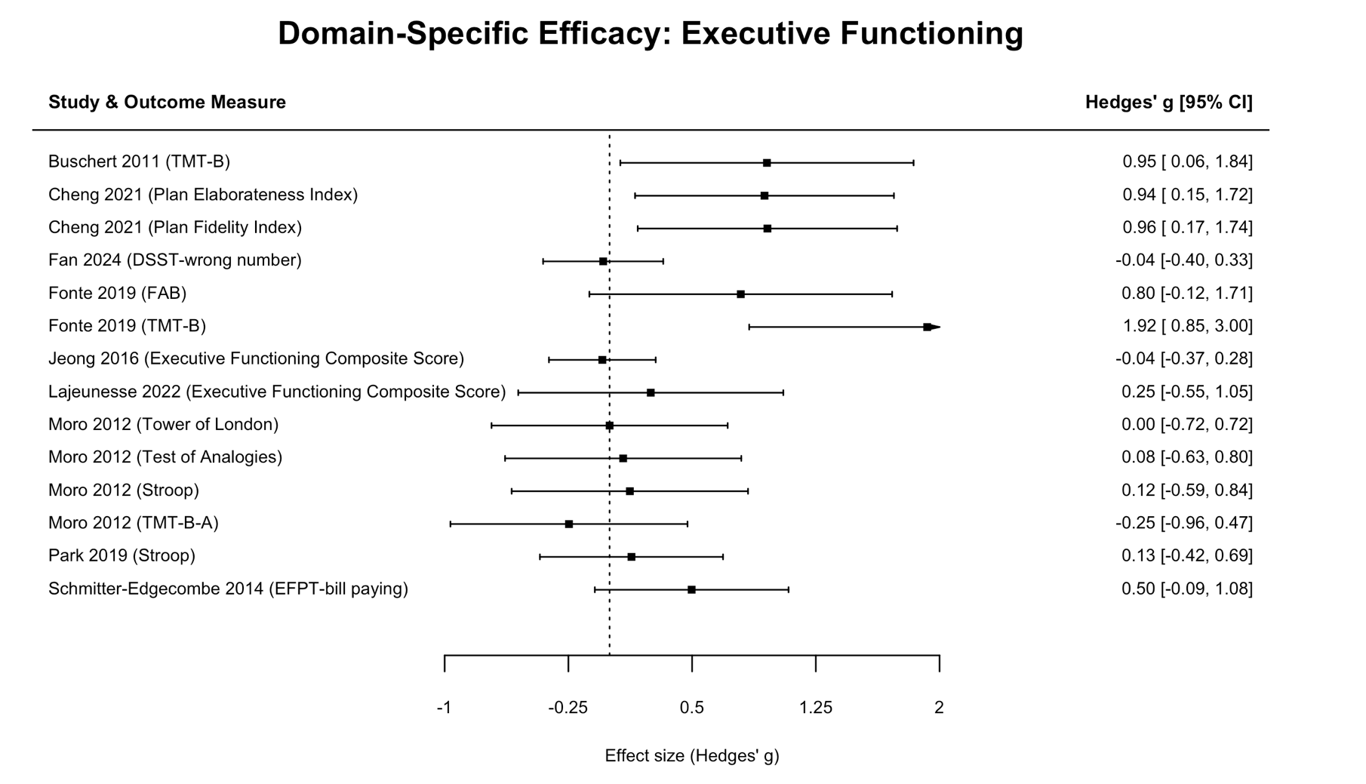
Figure S4. Forest plot of outcome-specific effect sizes within the executive functioning domain.

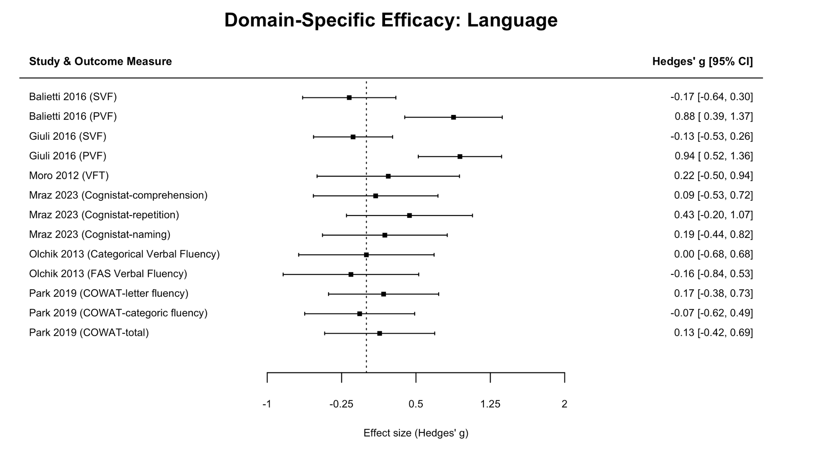
Figure S5. Forest plot of outcome-specific effect sizes within the working memory and attention domain.

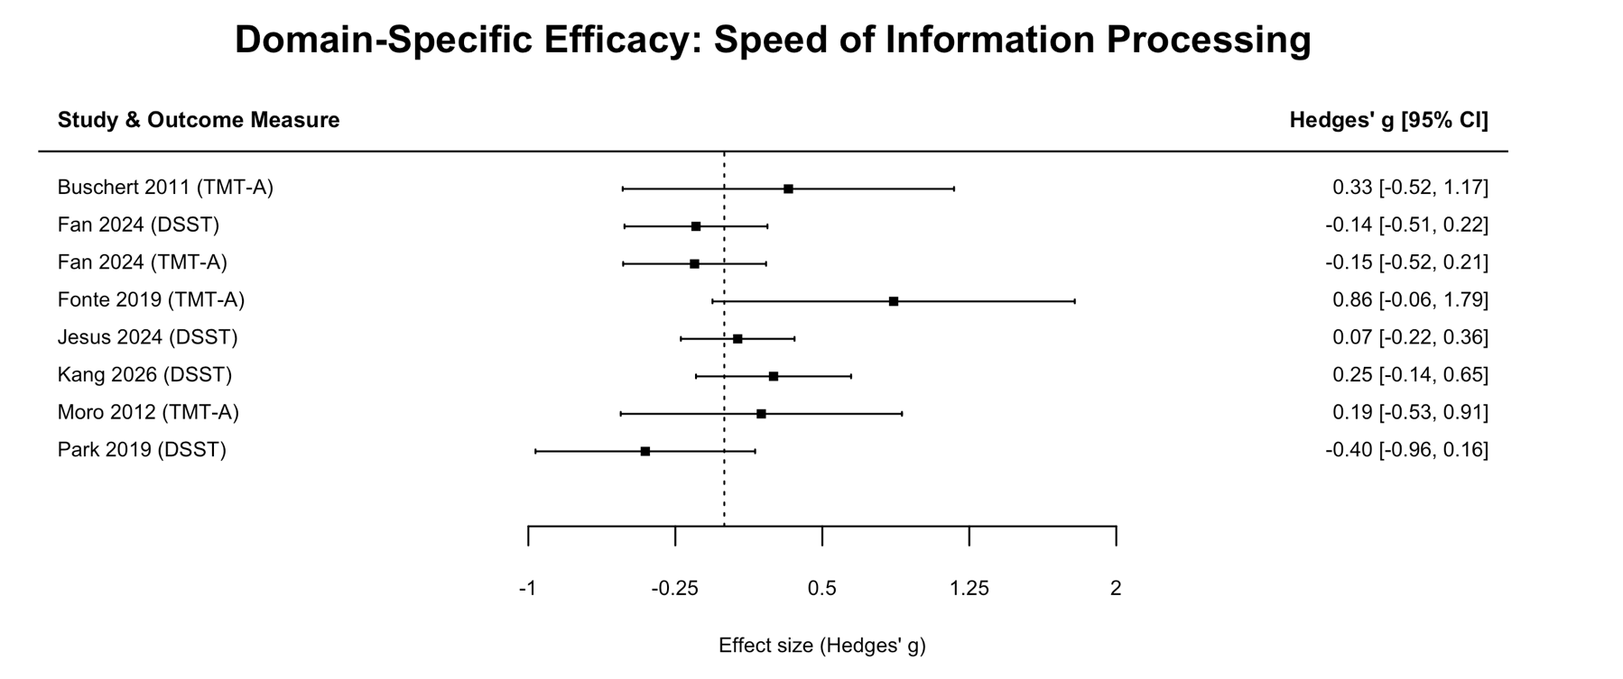
Figure S6. Forest plot of outcome-specific effect sizes within the working memory and attention domain.

