Supplementary Material
Automated Versus Manual Oxygen Control in Preterm Babies on Respiratory Support: A Randomized Crossover Trial (NCT06622161)
Supplementary Methods
Room-air identification. SpO₂ reflects the FiO₂ delivered approximately 15 seconds earlier (circulation and pulse-oximeter averaging delay). On a uniform 1-Hz time grid we therefore classified every second as supplemental oxygen (set FiO₂ > 21%) or room air (set FiO₂ = 21%) using the set FiO₂ lagged by 15 seconds; hyperoxia bands (SpO₂ > 94% and ≥ 98%) were credited as hyperoxia only during supplemental oxygen. Sensitivity analyses repeated this with 10- and 20-second lags (Supplementary Table S5).
Crossover modelling. In addition to paired Wilcoxon tests, the primary and key secondary endpoints were analysed with a linear mixed-effects model (fixed effects: treatment, period; random intercept per infant). Sequence (carry-over) and period effects were assessed with standard 2×2 crossover tests (Supplementary Table S4).
Supplementary Table S1. Per-infant treatment sequence, arm start times, and FiO₂ setpoint-change counts (≥1% increments).
Infant | Sequence | Automated start | Manual start | FiO₂ changes (Auto) | FiO₂ changes (Manual)
1 | ManualFirst | 2024-10-04 02:00 | 2024-10-03 14:00 | 5139 | 128
2 | ManualFirst | 2024-10-05 12:00 | 2024-10-05 00:00 | 2239 | 959
3 | AutoFirst | 2024-10-07 22:00 | 2024-10-08 10:00 | 3441 | 125
4 | ManualFirst | 2024-10-17 07:00 | 2024-10-16 19:00 | 275 | 7
5 | AutoFirst | 2024-10-17 16:00 | 2024-10-18 04:00 | 3976 | 107
6 | AutoFirst | 2024-10-23 18:00 | 2024-10-24 06:00 | 1500 | 121
7 | AutoFirst | 2024-10-23 18:00 | 2024-10-24 06:00 | 2231 | 134
8 | AutoFirst | 2024-10-27 00:00 | 2024-10-27 12:00 | 2850 | 110
9 | ManualFirst | 2024-11-05 06:00 | 2024-11-04 18:00 | 6546 | 151
10 | AutoFirst | 2024-11-05 00:00 | 2024-11-05 12:00 | 5873 | 145
11 | ManualFirst | 2024-11-07 04:00 | 2024-11-06 16:00 | 1116 | 117
12 | ManualFirst | 2024-11-11 10:00 | 2024-11-10 22:00 | 514 | 87
13 | AutoFirst | 2024-11-12 12:00 | 2024-11-13 00:00 | 2963 | 181
15 | ManualFirst | 2024-11-19 09:00 | 2024-11-18 21:00 | 4018 | 137
16 | AutoFirst | 2024-11-22 12:00 | 2024-11-23 00:00 | 693 | 24
17 | ManualFirst | 2024-11-23 22:00 | 2024-11-23 10:00 | 2865 | 270
18 | ManualFirst | 2024-11-24 12:00 | 2024-11-24 00:00 | 7623 | 154
19 | AutoFirst | 2024-11-26 02:00 | 2024-11-26 14:00 | 2990 | 139
20 | ManualFirst | 2024-11-28 05:00 | 2024-11-27 17:00 | 249 | 62
21 | ManualFirst | 2024-11-30 12:00 | 2024-11-30 00:00 | 88 | 90
22 | AutoFirst | 2024-12-01 00:00 | 2024-12-01 12:00 | 2925 | 832
23 | ManualFirst | 2024-12-02 01:00 | 2024-12-01 13:00 | 6 | 83
24 | AutoFirst | 2024-12-03 00:00 | 2024-12-03 12:00 | 3648 | 648
25 | ManualFirst | 2024-12-05 04:25 | 2024-12-04 16:25 | 357 | 162
26 | AutoFirst | 2024-12-17 04:00 | 2024-12-17 16:00 | 477 | 4
Start clock-times were set by time of enrolment and varied across infants. The two 12-hour periods ran consecutively with no washout. FiO₂ setpoint changes in the automated arm represent frequent small algorithmic updates, not clinician-initiated titrations.

Supplementary Table S2. Exploratory medication subgroup analysis (automated arm).
Drug | Outcome (Automated arm) | With, n | With, median (IQR) | Without, n | Without, median (IQR) | Mann-Whitney p
Morphine (sedation) | SpO₂ 90–94% | 6 | 68.1 (59.0–80.0) | 19 | 51.7 (12.8–70.1) | 0.092
Morphine (sedation) | Clinically-adjusted target range | 6 | 86.8 (74.9–92.1) | 19 | 89.0 (87.4–95.8) | 0.246
Caffeine (stimulant) | SpO₂ 90–94% | 17 | 64.7 (38.9–82.9) | 8 | 47.0 (31.0–57.5) | 0.175
Caffeine (stimulant) | Clinically-adjusted target range | 17 | 89.2 (86.0–95.5) | 8 | 88.0 (84.3–91.7) | 0.475
Median (IQR) percent of valid SpO₂ time; p from Mann–Whitney U test. Clinically-adjusted target range = SpO₂ 90–94% or >94% in room air.
Supplementary Table S3. Subgroup analysis by ventilatory support (invasive vs non-invasive).
Outcome | Subgroup | n | Automated median (IQR) | Manual median (IQR) | Within-infant diff median (IQR) | Within-subgroup Wilcoxon p
SpO₂ 90–94% (primary) | Invasive | 20 | 61.6 (48.8–82.5) | 39.1 (28.4–51.0) | 22.1 (0.0–33.2) | 0.002
SpO₂ 90–94% (primary) | Non-invasive | 5 | 39.6 (2.2–42.3) | 36.8 (12.6–40.4) | -5.9 (-8.9–5.5) | 0.812
SpO₂ 90–94% (primary) | Interaction (invasive vs non-invasive) | 25 |  |  |  | MW p=0.035
Clinically-adjusted target range | Invasive | 20 | 88.8 (84.6–94.0) | 62.7 (42.7–74.2) | 26.6 (10.4–39.5) | <0.001
Clinically-adjusted target range | Non-invasive | 5 | 91.0 (88.0–99.3) | 92.8 (88.5–95.4) | 4.6 (-4.7–10.8) | 0.812
Clinically-adjusted target range | Interaction (invasive vs non-invasive) | 25 |  |  |  | MW p=0.097
SpO₂ <90% | Invasive | 20 | 6.7 (3.8–10.5) | 13.6 (6.7–20.0) | -4.8 (-15.0–0.9) | 0.019
SpO₂ <90% | Non-invasive | 5 | 4.4 (0.3–7.7) | 5.0 (4.2–11.5) | -4.2 (-7.7–2.7) | 0.625
SpO₂ <90% | Interaction (invasive vs non-invasive) | 25 |  |  |  | MW p=0.488
SpO₂ <80% | Invasive | 20 | 0.7 (0.1–1.2) | 2.3 (0.1–4.2) | -1.5 (-3.7–0.0) | 0.021
SpO₂ <80% | Non-invasive | 5 | 0.0 (0.0–0.0) | 0.0 (0.0–0.0) | -0.0 (-0.0–0.0) | 0.625
SpO₂ <80% | Interaction (invasive vs non-invasive) | 25 |  |  |  | MW p=0.408
SpO₂ >94% on supplemental oxygen | Invasive | 20 | 3.4 (1.5–7.4) | 18.7 (5.5–31.1) | -12.6 (-21.1–-3.7) | <0.001
SpO₂ >94% on supplemental oxygen | Non-invasive | 5 | 0.7 (0.3–4.3) | 0.4 (0.0–2.3) | 0.3 (-0.4–0.7) | 1.000
SpO₂ >94% on supplemental oxygen | Interaction (invasive vs non-invasive) | 25 |  |  |  | MW p=0.216
Median (IQR) percent of valid SpO₂ time per arm; within-infant diff = automated − manual. Within-subgroup p, Wilcoxon signed-rank test; INTERACTION row tests whether the treatment difference differs between invasive and non-invasive infants (Mann–Whitney U). Exploratory; non-invasive n=5.
Supplementary Table S4. Sequence (carry-over) and period effects: standard 2×2 crossover tests.
Outcome | n, automated first | n, manual first | Carry-over p | Period p
SpO₂ 90–94% (primary) | 12 | 13 | 0.201 | 0.087
Clinically-adjusted target range | 12 | 13 | 0.849 | 0.849
SpO₂ <90% | 12 | 13 | 0.087 | 0.013
SpO₂ <80% | 12 | 13 | 0.201 | 0.369
Carry-over assessed by comparing within-infant period sums between sequence groups; period effect by comparing within-infant differences (Mann–Whitney U). No significant carry-over or period effect for the primary outcome.
Supplementary Table S5. Sensitivity of room-air-dependent outcomes to the FiO₂-to-SpO₂ lag (10, 15, 20 seconds).
Outcome (% of valid SpO₂ time) | FiO₂ lag (s) | Automated, median | Manual, median | Median difference | p
Clinically-adjusted target range (SpO₂ 90–94% or >94% in room air) | 10 | 89.13 | 67.91 | 21.05 | <0.001
 | 15 | 88.96 | 67.82 | 20.98 | <0.001
 | 20 | 88.78 | 67.74 | 20.95 | <0.001
SpO₂ >94% on supplemental oxygen | 10 | 2.97 | 15.97 | -8.83 | <0.001
 | 15 | 3.07 | 16.06 | -8.82 | <0.001
 | 20 | 3.13 | 16.14 | -8.80 | <0.001
SpO₂ >94% in room air | 10 | 33.52 | 8.46 | 2.04 | 0.020
 | 15 | 33.31 | 8.37 | 2.03 | 0.020
 | 20 | 33.26 | 8.29 | 2.00 | 0.022
SpO₂ ≥98% on supplemental oxygen | 10 | 0.31 | 1.04 | -0.59 | 0.006
 | 15 | 0.36 | 1.04 | -0.64 | 0.008
 | 20 | 0.44 | 0.97 | -0.68 | 0.011
SpO₂ ≥98% in room air | 10 | 4.83 | 0.49 | 1.06 | 0.022
 | 15 | 4.77 | 0.43 | 0.97 | 0.022
 | 20 | 4.75 | 0.38 | 0.90 | 0.026
Median values per arm and median paired difference (automated − manual); p from Wilcoxon signed-rank test. Conclusions are unchanged across the lag values tested.

Supplementary Table S6. Linear mixed-effects model: treatment effect adjusted for period (random intercept per infant).
Outcome | Infants | Treatment effect (Auto−Manual) | 95% CI | Treatment p | Period effect | Period p | Method
SpO₂ 90–94% (primary) | 25 | 14.68 | 7.07 to 22.3 | <0.001 | -4.96 | 0.202 | MixedLM(lbfgs)
Clinically-adjusted target range | 25 | 22.77 | 14.73 to 30.82 | <0.001 | 0.75 | 0.855 | MixedLM(powell)
SpO₂ <90% | 25 | -8.48 | -13.29 to -3.68 | <0.001 | 7.89 | 0.001 | MixedLM(lbfgs)
SpO₂ <80% | 25 | -2.5 | -4.51 to -0.5 | 0.014 | 1.53 | 0.133 | MixedLM(powell)
Treatment effect = automated − manual (percentage points) from a model with fixed effects for treatment and period and a random intercept per infant. Where the between-infant variance approached zero, an OLS model with infant-clustered standard errors was used (noted in Method).

Supplementary Table S7. Full effect-size table for all outcomes (paired, n=25).
Outcome | N | Auto median | Manual median | Mean diff | Mean diff 95% CI | Hodges-Lehmann | Cohen dz | Wilcoxon p
SpO₂ 90–94% (primary) | 25 | 55.93 | 37.76 | 14.49 | 7.1 to 21.74 | 14.4 | 0.74 | 0.007
Clinically-adjusted target range (SpO₂ 90–94% or >94% in room air) | 25 | 88.96 | 67.82 | 22.8 | 15.24 to 30.54 | 22.94 | 1.13 | <0.001
SpO₂ <90% | 25 | 6.65 | 11.5 | -8.17 | -14.14 to -3.18 | -5.37 | -0.57 | 0.015
SpO₂ <80% | 25 | 0.26 | 1.07 | -2.44 | -4.77 to -0.68 | -1.53 | -0.47 | 0.019
SpO₂ >94% on supplemental oxygen | 25 | 3.07 | 16.06 | -14.63 | -21.76 to -7.66 | -11.49 | -0.79 | <0.001
SpO₂ >94% in air | 25 | 33.31 | 8.37 | 8.32 | 2.11 to 14.95 | 5.84 | 0.49 | 0.020
SpO₂ ≥98% on supplemental oxygen | 25 | 0.36 | 1.04 | -6.11 | -10.14 to -2.72 | -3.56 | -0.62 | 0.008
SpO₂ ≥98% in room air | 25 | 4.77 | 0.43 | 7.1 | 1.91 to 13.15 | 4.89 | 0.48 | 0.022
Severe desaturation, SpO₂ <80% ≥10 s (episodes/12 h) | 25 | 4.0 | 8.0 | -8.24 | -15.68 to -1.84 | -6.0 | -0.47 | 0.048
Hyperoxaemia, SpO₂ ≥98% on oxygen ≥10 s (episodes/12 h) | 25 | 5.0 | 7.0 | -32.24 | -57.04 to -11.52 | -12.0 | -0.54 | 0.016
Median FiO₂ per infant (%) | 25 | 21.5 | 25.0 | -2.08 | -4.98 to 1.2 | -2.0 | -0.27 | 0.047
Mean FiO₂ per infant (%) | 25 | 23.67 | 25.61 | -1.39 | -3.58 to 0.81 | -1.21 | -0.25 | 0.615
Set-FiO₂ changes ≥1% (n/12 h) | 25 | 2850.0 | 128.0 | 2385.0 | 1588.08 to 3187.34 | 2140.0 | 1.13 | <0.001
AUC burden outside 90–94% (%·s/h) | 25 | 5195.4 | 7261.15 | -2661.9 | -4748.99 to -757.62 | -2096.43 | -0.51 | 0.026
AUC burden below 90% (%·s/h) | 25 | 829.23 | 1960.26 | -2272.19 | -4182.8 to -750.17 | -1317.44 | -0.51 | 0.020
AUC burden below 80% (%·s/h) | 25 | 51.82 | 301.0 | -607.02 | -1143.75 to -119.81 | -410.81 | -0.46 | 0.016
Mean diff = mean within-infant difference (automated − manual) with bootstrap 95% CI; Hodges–Lehmann = non-parametric paired location estimate; Cohen dz = paired standardized mean difference; p from Wilcoxon signed-rank test.

Supplementary Figures

Supplementary Figure S1.
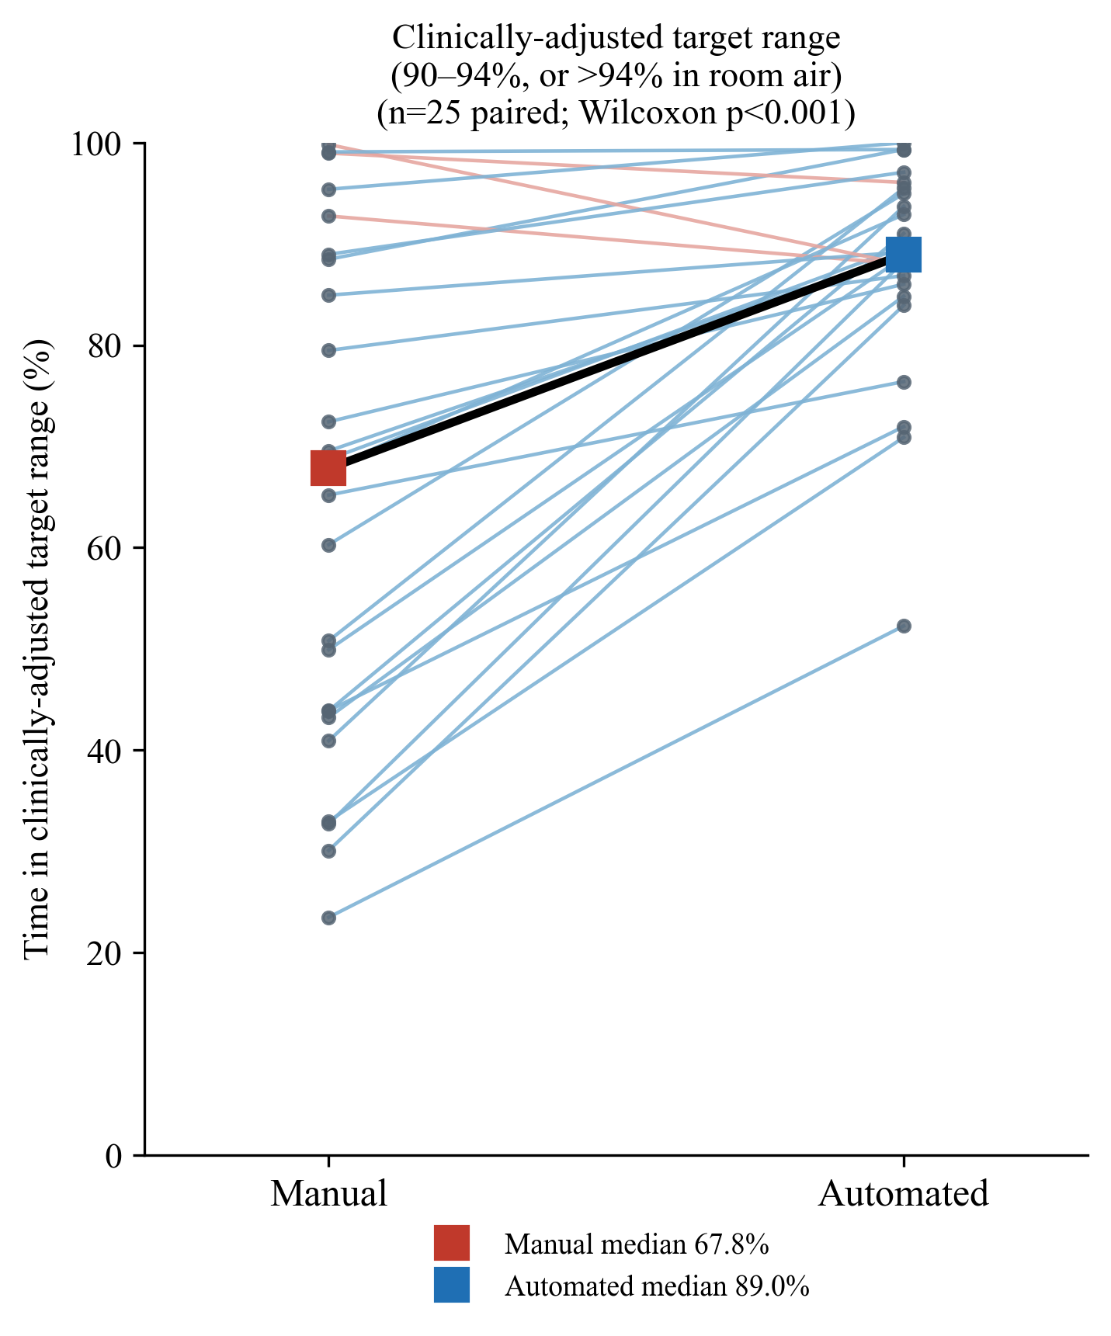
Individual paired responses for the clinically-adjusted target range (SpO₂ 90-94%, or above 94% while breathing room air). Each thin line connects one infant's manual and automated period; blue lines indicate infants in whom time in range increased with automated control and red lines those in whom it decreased. Coloured squares and the bold line mark the group medians.

Supplementary Figure S2.
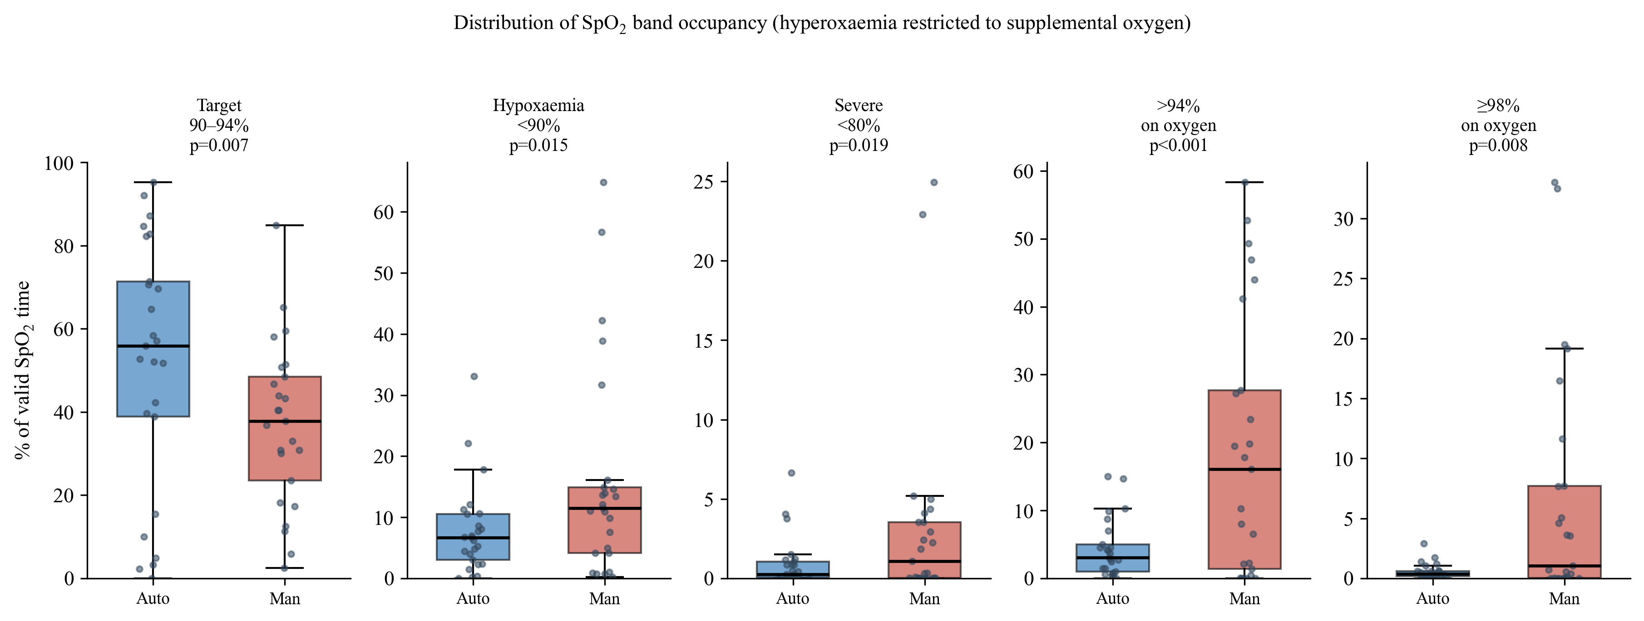
Distribution of SpO₂ band occupancy during automated and manual control. Boxes show the median and interquartile range across the 25 infants, whiskers extend to 1.5 times the interquartile range, and points show individual infants. Hyperoxaemia bands are restricted to periods of supplemental oxygen, identified second-by-second from the set FiO₂ lagged by 15 seconds. p values are from Wilcoxon signed-rank tests.

Supplementary Figure S3.
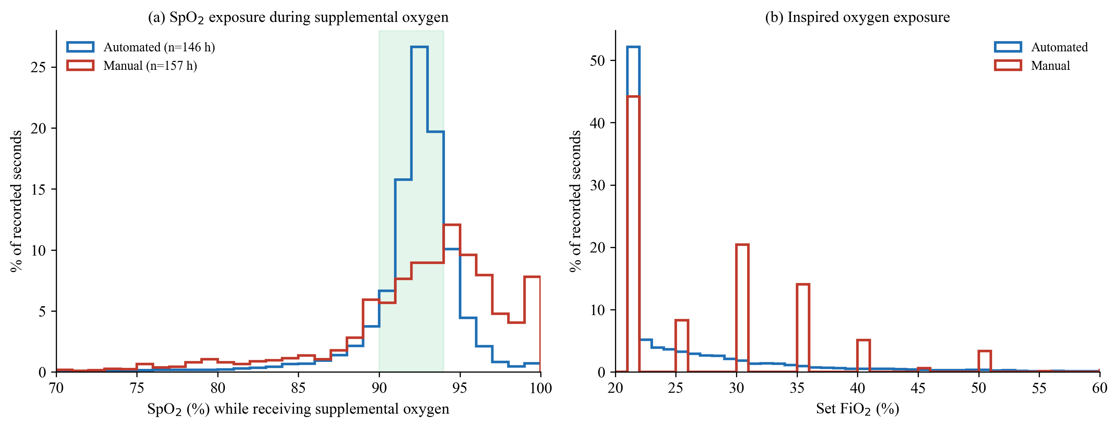
Pooled second-by-second exposure histograms for the two arms (automated, blue; manual, red). (a) Distribution of SpO₂ during periods of supplemental oxygen only; the shaded band marks the 90-94% target range. The automated distribution is narrower and centred within the target band (median 92%, IQR 91-93), whereas the manual distribution is wider and shifted upwards (median 93%, IQR 90-95). (b) Distribution of set FiO₂, truncated at 60% for clarity. Manual settings cluster at round 5% increments whereas the controller occupies a continuous range. Both panels are expressed as the percentage of all recorded seconds in that arm.

