Supplementary figures

Supplementary Figure 1. Bar plots showing the percentage of institutions answering “Yes” to the question: do you have an executive board where health research strategy is set? Dark colour corresponds to the institution’s answer in the FOI response, middle dark colour corresponds to our interpretation of the institution’s answer based on what they said in the FOI response, and light colour corresponds to the information extracted for the internet search (higher education institution only). Navy blue corresponds to universities, teal blue to NHS trusts, orange corresponds to integrated care boards (ICB), and green to funders.

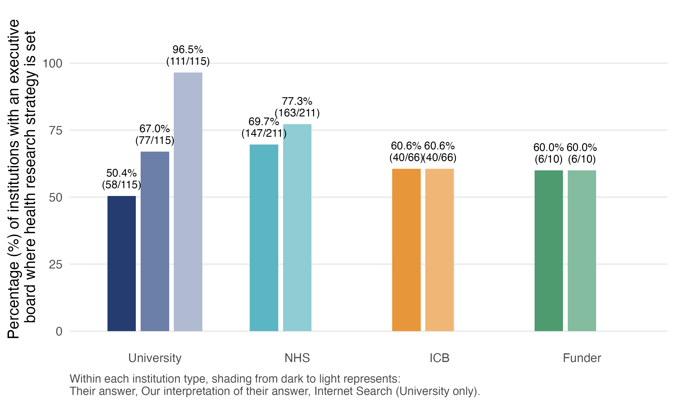

Supplementary Figure 2.
Bar plots showing the primary outcome (top), i.e., percentage of institutions with executive boards or committees that have a member with an explicitly defined PPI role, and the percentage of institutions with a separate PPI board that feeds into their governance structure (secondary outcome, bottom), by institution type. The data is based on our interpretation of their answer to the FOI request. Navy blue corresponds to universities, teal blue to NHS trusts, orange corresponds to integrated care boards (ICB), and green to funders.
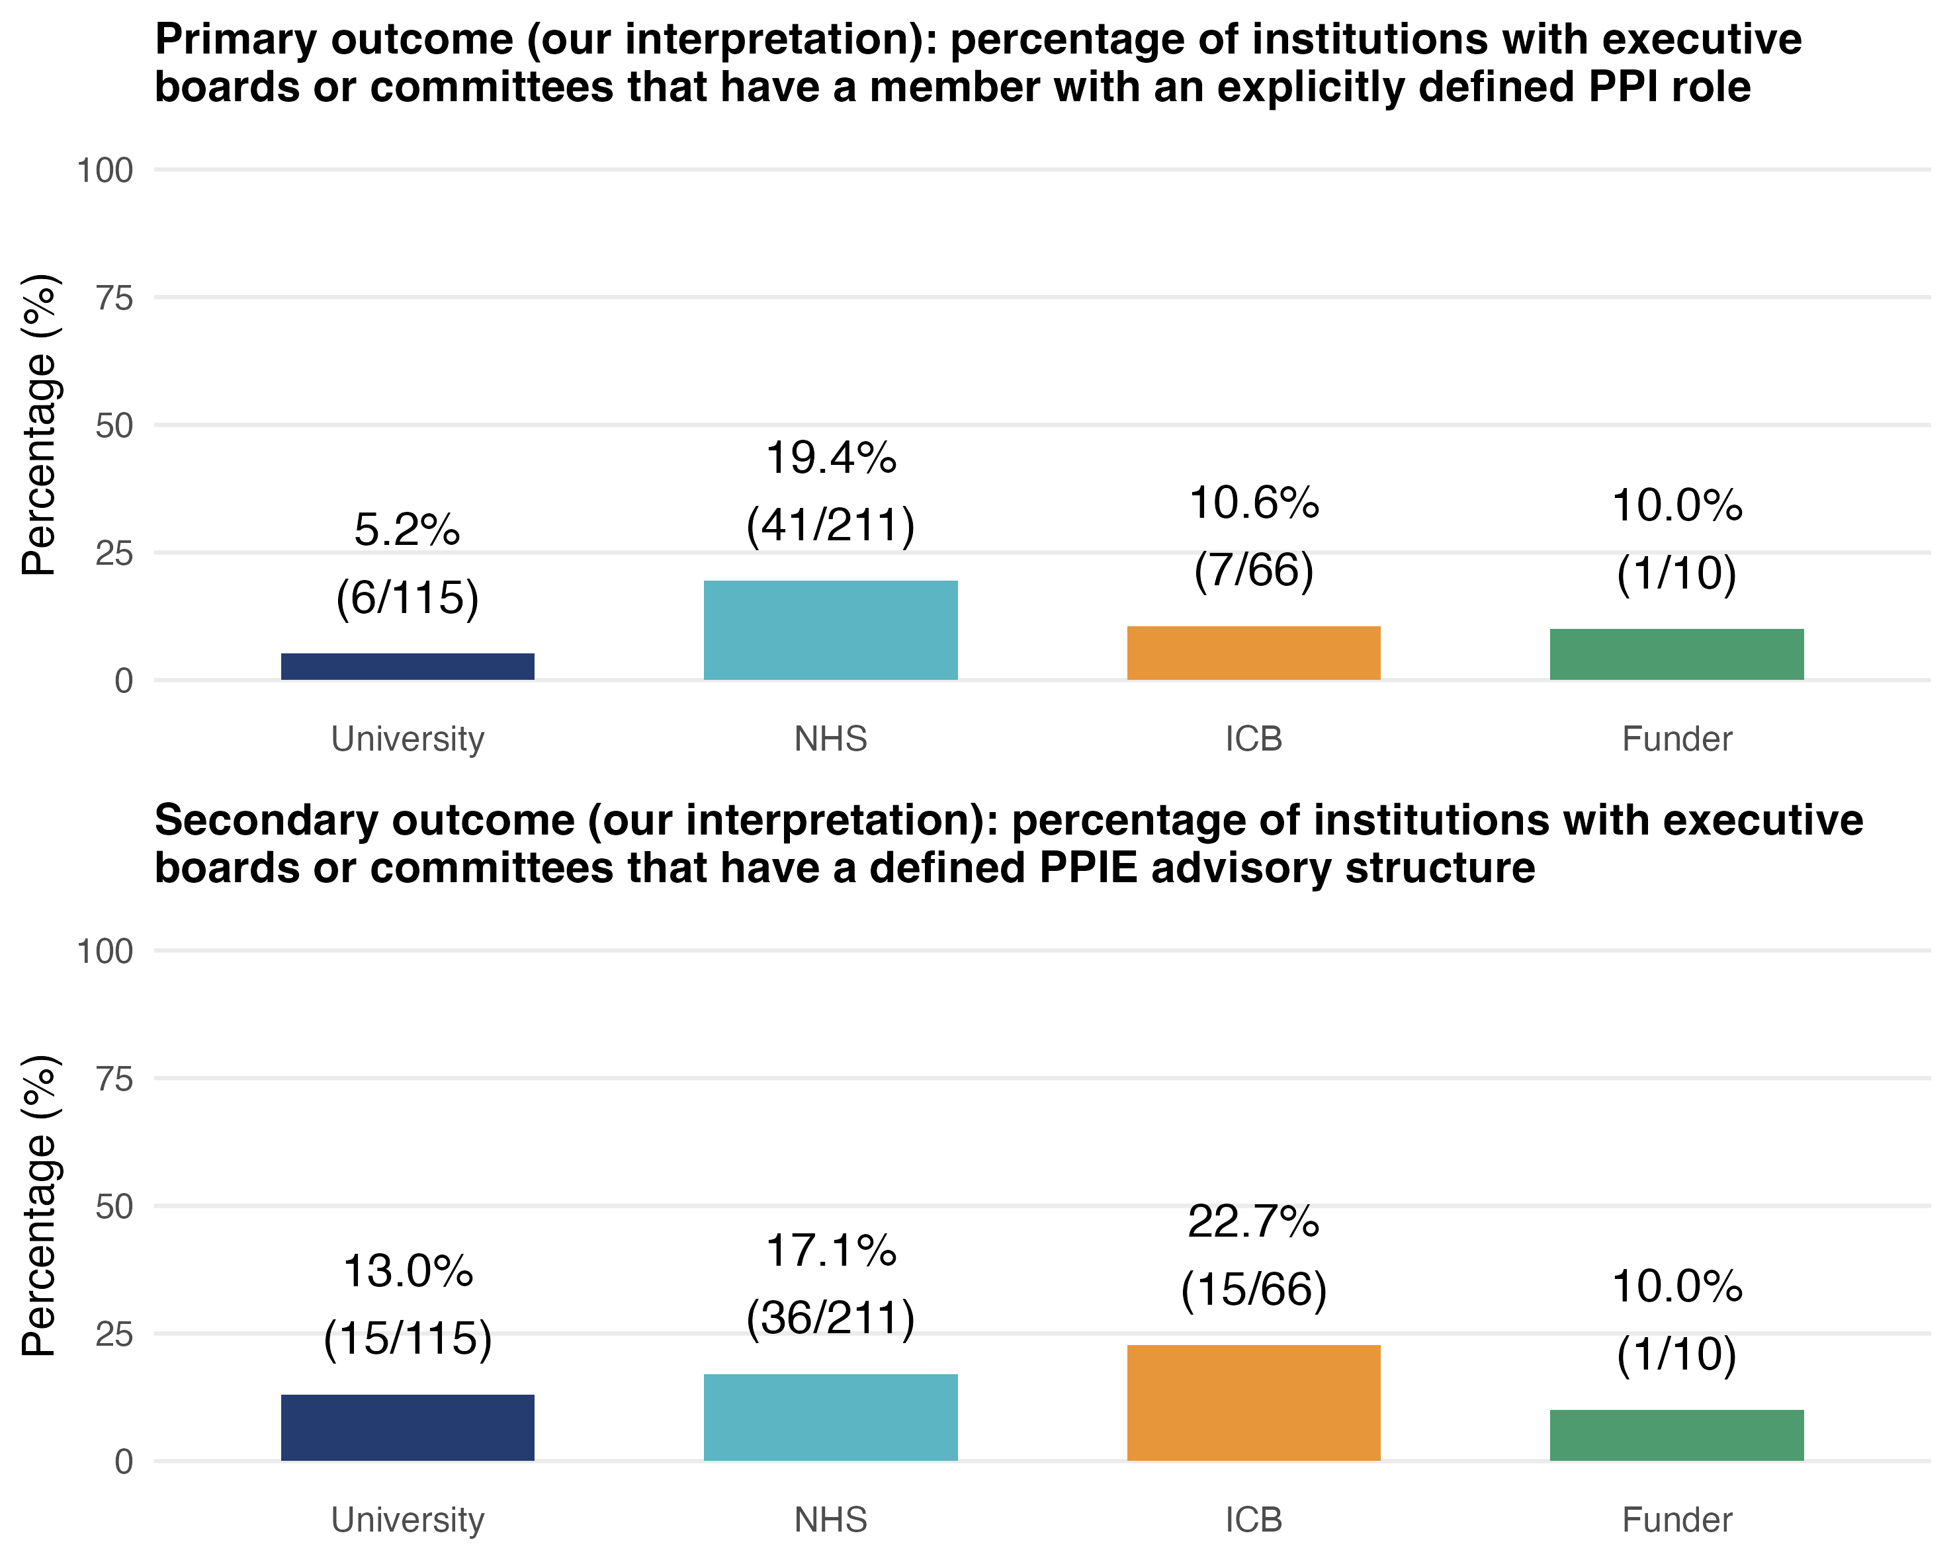

Supplementary Figure 3.
Bar plot showing the percentage of institutions with remuneration (dark shading) and mandatory training (light shading) for PPI representatives, by institution type. This is computed among institutions that have PPI representation or a PPI advisory structure at executive level. Navy blue corresponds to universities, teal blue to NHS trusts, orange corresponds to integrated care boards (ICB), and green to funders.

