Supplementary Material

Supplementary Table S1. Six-month weight outcomes by indication
Indication | n (6-mo) | Weight loss (kg) | %TWL | BMI change | p-value
GERD | 5,327 | 13.3 ± 8.3 | 12.7 ± 7.0 | 4.9 ± 3.0 | <0.001
Recurrent weight gain | 2,160 | 16.8 ± 8.7 | 14.2 ± 6.6 | 6.1 ± 3.1
Suboptimal clinical response | 836 | 15.8 ± 8.4 | 13.3 ± 6.4 | 5.8 ± 3.0
Other | 474 | 14.1 ± 9.9 | 12.7 ± 7.4 | 5.1 ± 3.5
%TWL = percent total weight loss; BMI = body mass index; 6-mo = six-month. Data are presented as mean ± SD. P-value from one-way ANOVA across indication groups. Excluded out-of-range weight-loss values: 61; final 6-month weight-loss cohort: 8,797.

Supplementary Figure S1. Six-month intervention rate after SG-to-RYGB conversion
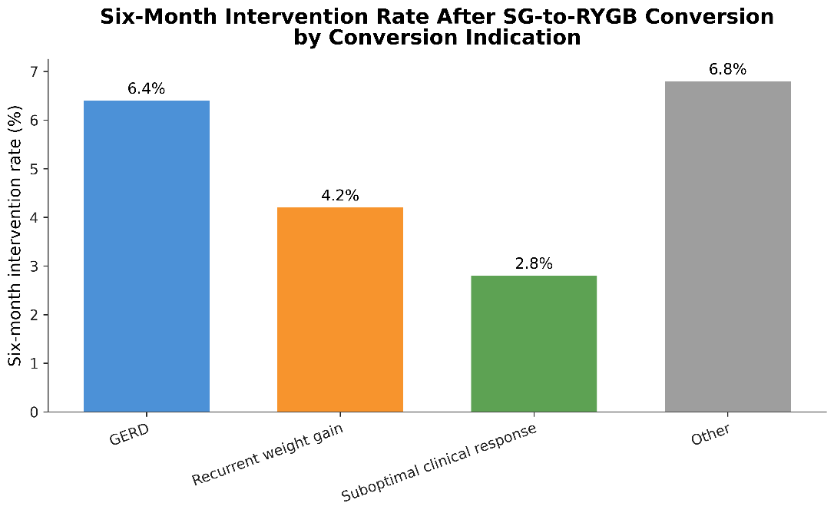

Supplementary Figure S2. Six-month %TWL after SG-to-RYGB conversion
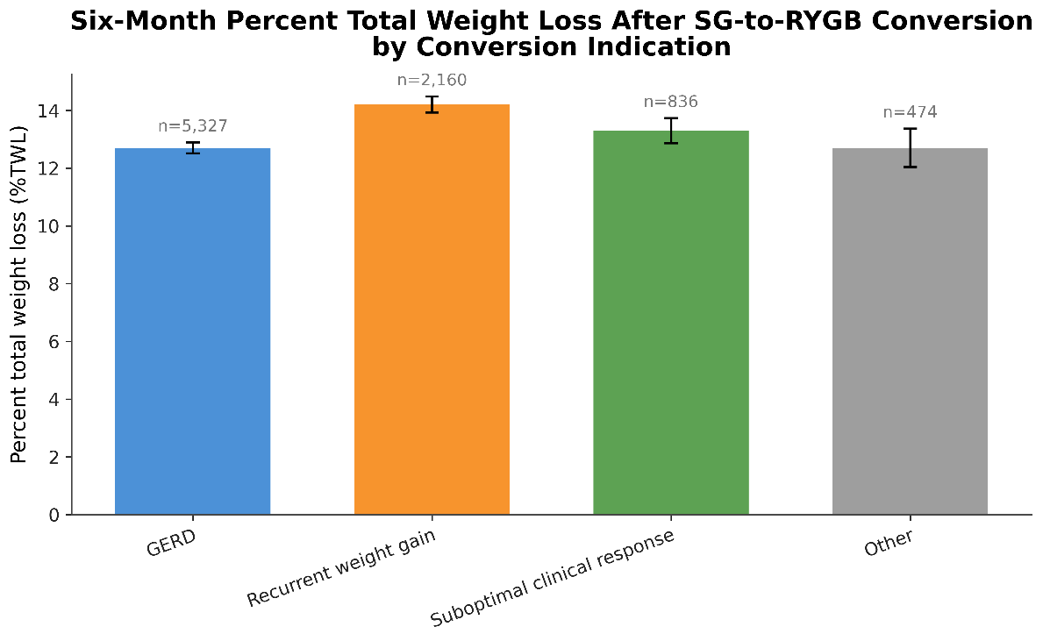

Supplementary Figure S3. Six-month weight loss after SG-to-RYGB conversion
