Supplementary materials for
A CPP-Functionalized LNP Platform for Oral Baculovirus DNA Delivery Enables Precision Control of Invasive Pests

This file contains:
Table S1. Primers used in this study.
Figure S1. Flow cytometric analysis of cell cycle distribution in Sf9 cells treated with stress-exposed MAT formulations.

And legends for:
Data S1. Image-based cell counting algorithm for S2 cells.
Data S2. Image-based cell counting algorithm for Sf9 cells.

Table S1. Primers used in this study.
Gene | Forward Primer sequence | Reverse Primer sequence
polyhedron | AAACCTGGACCCGCTTT | AGTTGGTGTATTCGCTGT
pe38 | ATGTCTAACAGATATCATCCGT | TTTTGTCTTCAATCATCATGTC
RPL13 | GTTAGCTACACAGCTCCGTGG | GCAGCAGTTGGGGCTTTAGT
EF-1α | ATGAAATCTCTGTGACCGGGG | GCGGTGGTATCGACAAACGT
pe38 | ACGCGGTATGTTCATGGTGT | CTTGTGCTGTGTGCTTGGAC
polh | GGTCATTAACCTGCGTCCCA | GCGGTACTCGTTGTTCATGC
ie1 | TGGTTTCGTTGAAAACGGGC | TTCAACACTGCCACCGAGTT
lef8 | ATGGTCGAAGCGTGCACTAA | AGCGAGTCGACTTGTTGGTT
p10 | CCAATTCGGTCAATTGCGCT | ACAAATTTTGACCGCCGTGC
vp39 | AAACTGGCTTGGTGGCTACA | ATTTGCAAACGATTGGGGCG

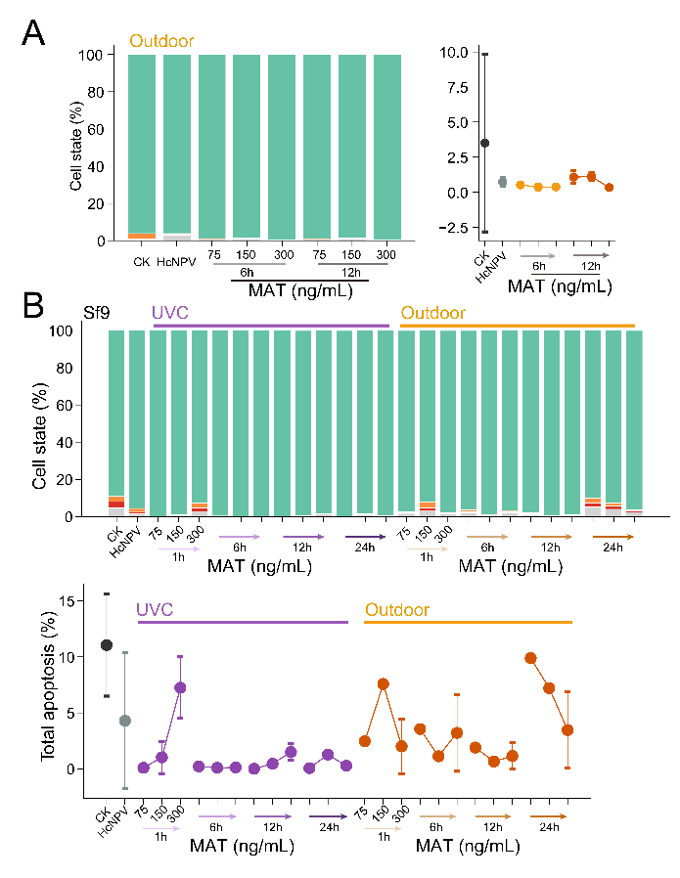
Figure S1. Flow cytometric analysis of cell cycle distribution in Sf9 cells treated with stress-exposed MAT formulations. Cell cycle phases are color-coded as in Figure 4.

