Supplementary Tables

Table S1: Summary of survival models. p-values derived from likelihood ratio tests (LRT); pseudo-R² following Nakagawa et al. 2017; prior size = height for seedlings, DBH for saplings; main effects from additive models shown in parentheses when the
treatment × year interaction was significant, indicating a different shape of the survival trend across treatments over time. ICC = interclass-correlation coefficient; * = p<0.05. No NR indicates that the sample size was insufficient to include the natural regeneration treatment.

 | LRT of covariates |  |  |  | Random  effects |  |  | Pseudo-R²
Survival response | Treatment × year | Treatment | Year | Prior size |  | Effect | ICC |  | Marginal | Conditional
Early-successional seedlings | 0.048* | (0.006)* | (<0.001)* | <0.001* |  | species | 0.09 |  | 0.11 | 0.18
Mid-successional seedlings | 0.007* | (<0.001)* | (<0.001)* | <0.001* |  | species | 0.07 |  | 0.14 | 0.19
Late- successional seedlings (no NR) | 0.328 | <0.001* | <0.001* | <0.001* |  | species site | 0.08  0.07 |  | 0.11 | 0.23
Early-successional saplings | 0.044* | (<0.001)* | (<0.001)* | <0.001* |  | species | 0.19 |  | 0.22 | 0.43
Mid-succ. saplings (no NR) | 0.001* | (0.383) | (<0.001)* | 0.122 |  | species site | 0.16  0.11 |  | 0.19 | 0.36
Late-succ. saplings (no NR) | 0.021* | (0.453) | (<0.001)* | 0.194 |  | site | 0.07 |  | 0.10 | 0.16

Table S2: Summary of annual seedling-to-sapling transition models. p-values derived from likelihood ratio tests (LRT); pseudo-R² following Nakagawa et al. 2017; main effects from additive models shown in parentheses when the treatment × year interaction was significant, indicating a different shape of the survival trend across treatments over time. ICC = interclass-correlation coefficient; * = p < 0.05. No NR indicates that the sample size was insufficient to include the natural regeneration treatment.

 | LRT of covariates |  |  |  |  |  | Random Pseudo-R²  effect
Response | Treatment × year | Treatment | Year | Prior height |  | Effect |  | ICC | Marginal |  | Conditional
Early-successional | 0.506 | <0.001* | <0.001* | <0.001* |  | species |  | 0.17 | 0.39 |  | 0.50
Mid-successsional | <0.001* | (0.789) | (<0.001)* | <0.001* |  | species |  | 0.19 | 0.35 |  | 0.47
Late-succ. (no NR) | 0.685 | 0.012* | <0.001* | <0.001* |  | species |  | 0.49 | 0.55 |  | 0.77

Table S3: Summary of sapling growth models. p-values derived from likelihood ratio tests (LRT); pseudo-R² following Nakagawa et al. 2017; main effects from additive models shown in parentheses when the treatment × year interaction was significant, indicating a different shape of the survival trend across treatments over time. ICC = interclass-correlation coefficient; * = p < 0.05. No NR indicates that the sample size was insufficient to include the natural regeneration treatment.

 | LRT of covariates |  |  |  | Random  effects |  |  | Pseudo-R²
Growth model | Treatment × year | Treatment | Year | Initial DBH |  | Effect | ICC |  | Marginal |  | Conditional
Early-successional | <0.001* | (<0.001)* | (<0.001)* | <0.001* |  | plant ID | 0.45 |  | 0.32 |  | 0.67
Mid-succ. (no NR) | 0.004* | (<0.001)* | (<0.001)* | <0.001* |  | plant ID | 0.24 |  | 0.17 |  | 0.43
Late-succ. (no NR) | 0.451 | 0.089 | <0.001* | <0.001* |  | plant ID  species | 0.14  0.17 |  | 0.17 |  | 0.45

Table S4. IUCN Red List species recorded. Species are listed by ascending order of IUCN category (NT = Near Threatened, VU = Vulnerable, EN = Endangered, CR = Critically Endangered). Dispersal mode codes: ZOO = animal-dispersed, WIND = wind-dispersed, GRAV = gravity-dispersed. Treatments in which each species was recorded: NR = natural regeneration, AN = applied nucleation, PL = plantation, RF = reference forest. All species are categorized as late successional except for Verbesina tapantiana, which is early-successional.

Species | Authority | Family | Disp. mode | Seed width (mm) | IUCN Category | Treatment
Amphitecna isthmica | (A.H. Gentry) A.H. Gentry | Bignoniaceae | ZOO | 10-15 | NT | NR, AN, PL, RF
Inga skutchii | Standl. | Fabaceae | ZOO | 5-10 | NT | NR, AN, PL, RF
Ocotea lentii | W.C. Burger | Lauraceae | ZOO | 10-15 | NT | AN, PL, RF
Mortoniodendron abelianum | Al. Rodr. | Malvaceae | GRAV | 5-10 | NT | RF
Virola chrysocarpa | D. Santam. & Aguilar | Myristicaceae | ZOO | >15 | NT | AN, PL
Desmopsis oerstedii | Saff. | Annonaceae | ZOO | 5-10 | VU | RF
Persea silvatica | van der Werff | Lauraceae | ZOO | 10-15 | VU | PL
Cedrela odorata | L. | Meliaceae | WIND | 5-10 | VU | NR, PL
Verbesina tapantiana | Poveda & Hammel | Asteraceae | WIND | <5 | EN | RF
Sapium allenii | Huft | Euphorbiaceae | ZOO | <5 | EN | AN, PL
Quercus insignis | M. Martens & Galeotti | Fagaceae | ZOO | >15 | EN | AN
Eugenia grayumii | Barrie | Myrtaceae | ZOO | 10-15 | EN | NR, AN, PL, RF
Ardisia dunlapiana | P.H. Allen | Primulaceae | ZOO | <5 | EN | RF
Ardisia furfuracea | Standl. | Primulaceae | ZOO | 5-10 | EN | AN, RF
Quararibea aurantiocalyx | W.S. Alverson | Malvaceae | ZOO | >15 | CR | RF

Table S5. Pairwise PERMANOVA comparing sapling communities by restoration treatment in 2025. Overall PERMANOVA results: R² = 0.12 pseudo-F = 1.49, p = 0.05. P-values were calculated based on 999 permutations and adjusted using the Bonferroni method.

Comparison | Sum of Squares | F | R² | P | P-adjusted
AN vs NR | 0.384 | 1.193 | 0.079 | 0.250 | 0.750
AN vs PL | 0.441 | 1.424 | 0.087 | 0.130 | 0.390
NR vs PL | 0.603 | 1.878 | 0.126 | 0.016* | 0.048*

Supplementary Figures

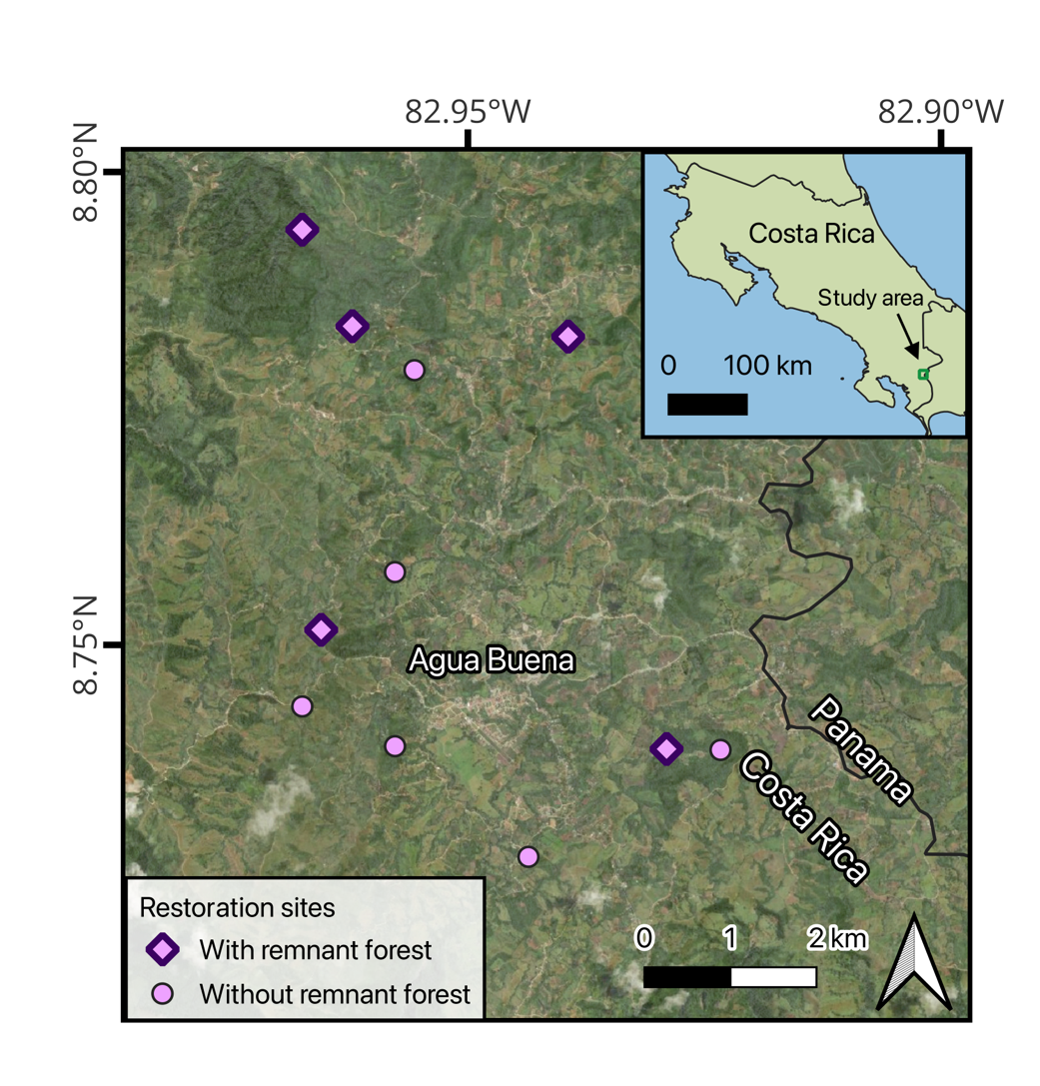
Fig. S1. Map of the 11 study sites in southern Costa Rica.

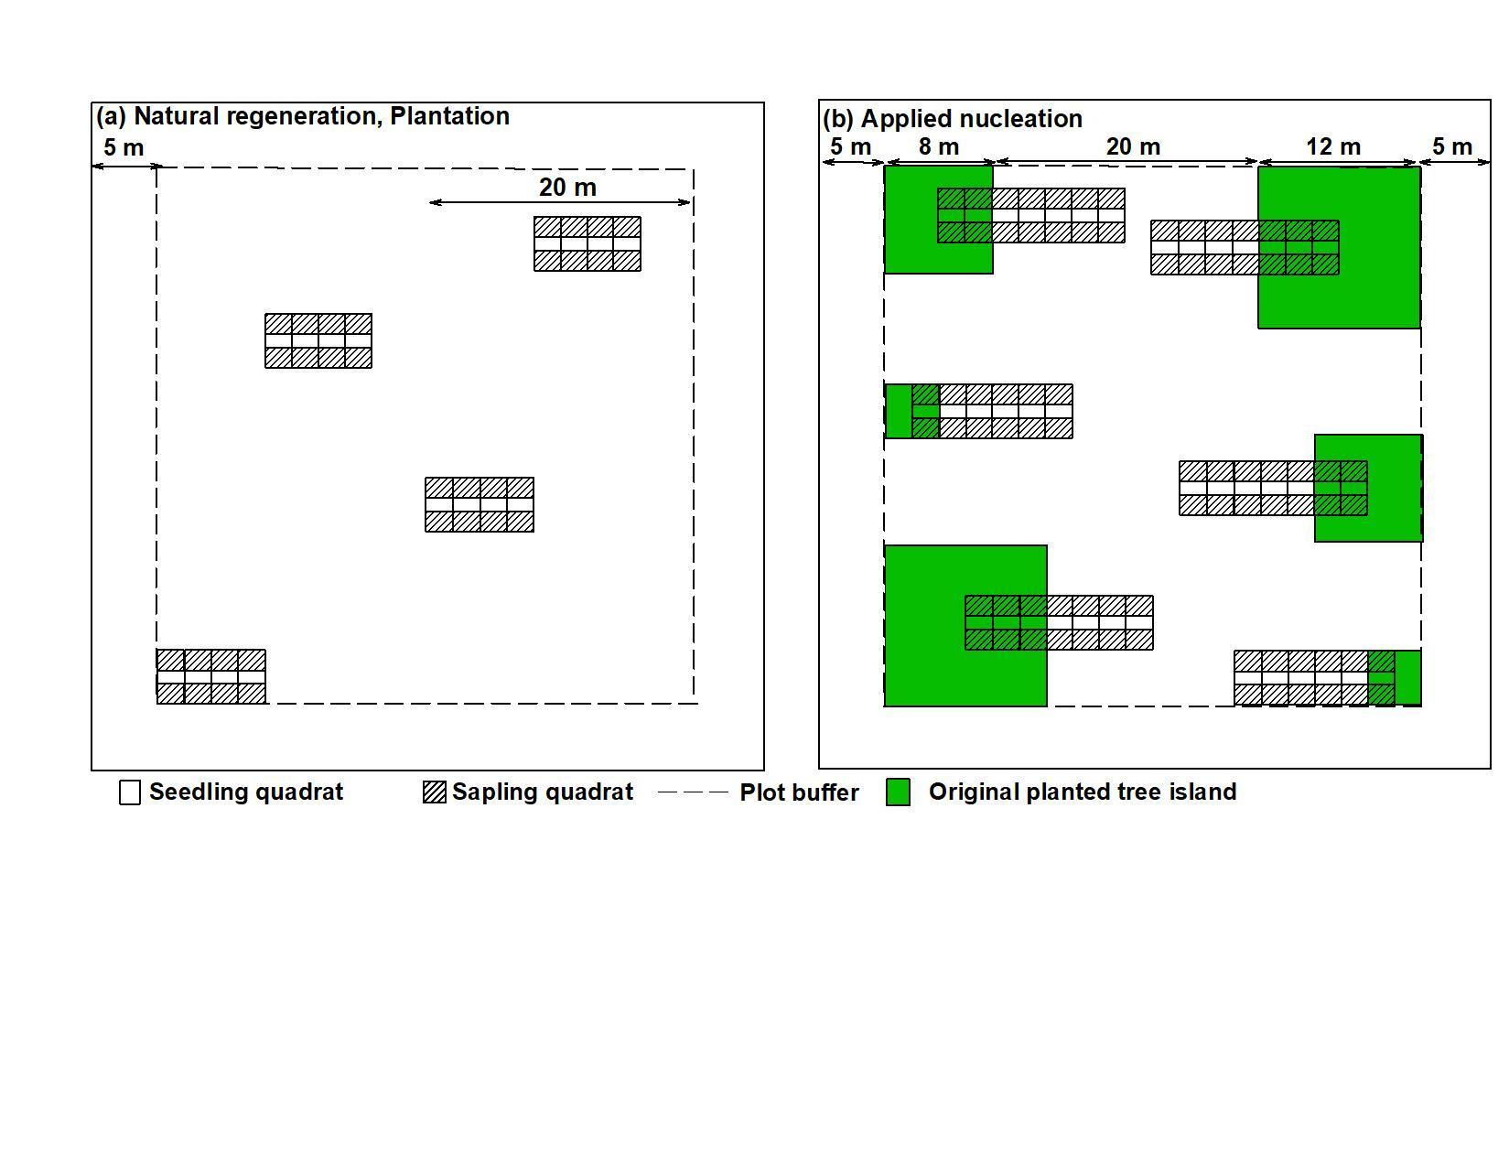

Fig. S2. Sampling design in natural regeneration and plantation (a) and applied nucleation (b) plots. Because we sampled a larger area for seedlings and saplings in applied nucleation plots compared to the other treatments, recruit abundances were adjusted for area prior to calculating community dissimilarity by multiplying by scaling factors: 8/15 for seedlings and 2/5 for saplings.
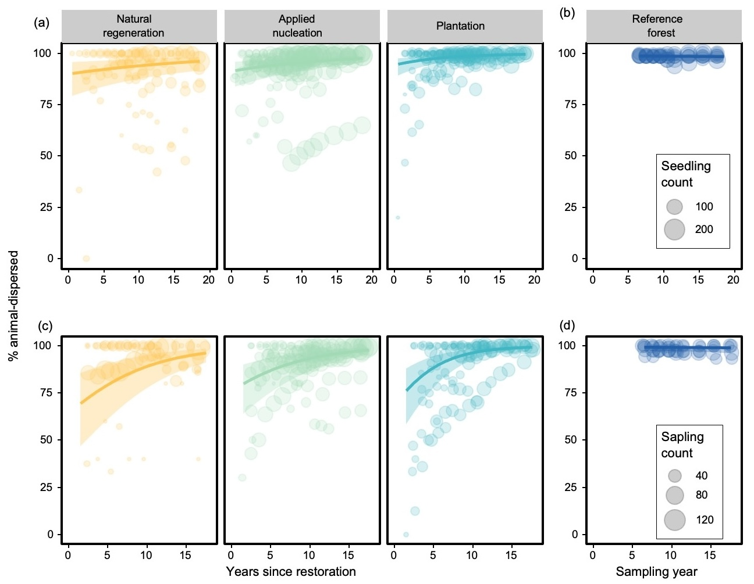
Fig. S3. Percentage of recruits belonging to species that are animal-dispersed for over time for seedlings (a,b) and saplings (c,d) in restoration plots and reference forest, respectively. Lines and shaded areas represent model predictions and 95% confidence intervals. Circles represent individual assemblages with 5 or more recruits (n = 420 seedling assemblages; n = 362 sapling assemblages), with symbol size scaled by the number of individuals sampled in the plot.
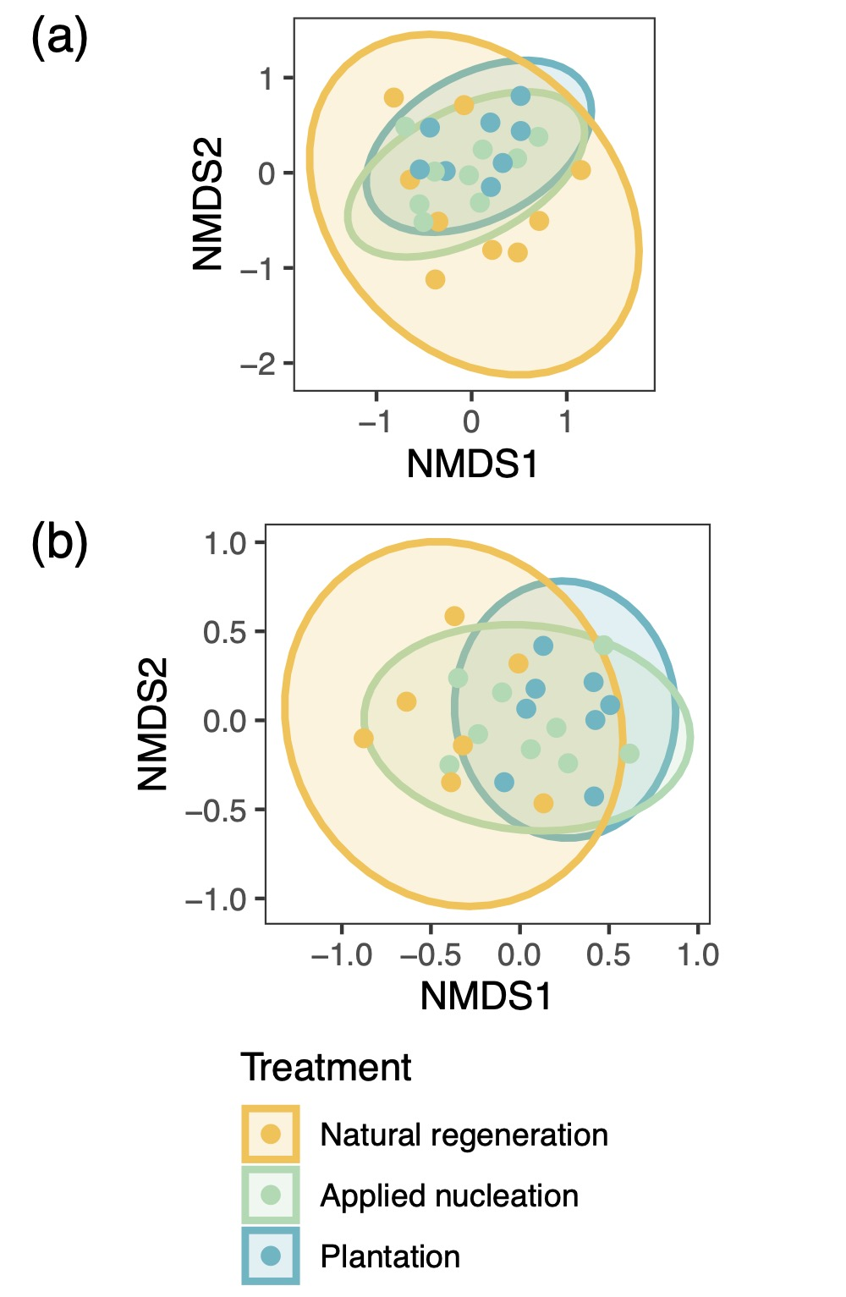

Fig. S4. Compositional similarity among recruit communities in restoration treatments in the final sampling year. NMDS of seedling (a) and sapling (b) assemblages in restoration plots in the last sampled year (2025). Shaded ellipses represent 95% CIs of within group-variance. Stress = 0.22 and 0.23, respectively. See Table S5 for pairwise PERMANOVA results among treatments.

