Appendix
A1. Additional dataset details
Inclusion criteria for the in-house cohort included: (i) adult patients (18 years), (ii) histopathologically confirmed glioma, (iii) availability of preoperative multi-sequence MRI (T1, T1C, T2, FLAIR), and (iv) complete molecular and/or survival data. Exclusion criteria included: (i) poor image quality, (ii) missing key MRI sequences, and (iii) prior treatment before imaging. Data were collected retrospectively between 2010-2025. Missing values (NA) in clinical and molecular variables were handled using complete-case analysis for each downstream task. No imputation was performed; models were trained only on samples with available labels for the specific endpoint.
A2. Additional training details
Models were trained using AdamW optimizer (weight decay=1e-4, 1=0.9, 2=0.999) with a learning rate of 1e-5 and batch size of 2. Training was performed for 100 epochs with early stopping based on validation loss (patience=20). Experiments were conducted on an NVIDIA A6000 GPU (48 GB VRAM), with total training time of approximately 52 hours. Convergence was assessed via stabilization of validation loss and embedding consistency metrics.

Dataset | N
BraTS-GLI-Pre | 1,443
BraTS-GLI-Post | 1,809
BraTS-MEN | 1,141
BraTS-MET | 1,475
BraTS-PED | 351
LUMIERE | 599
MU-Glioma-Post | 596
Total | 7,414
Supplementary Table 1: Training Dataset Composition and Sample Size

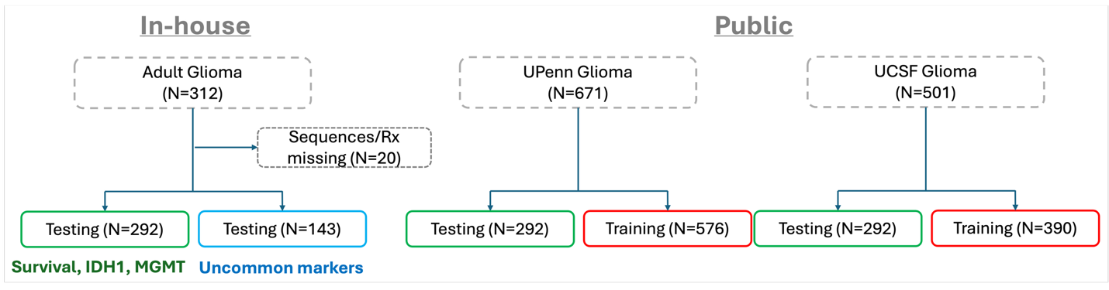
Supplementary Figure 1: Overview of the study cohorts.

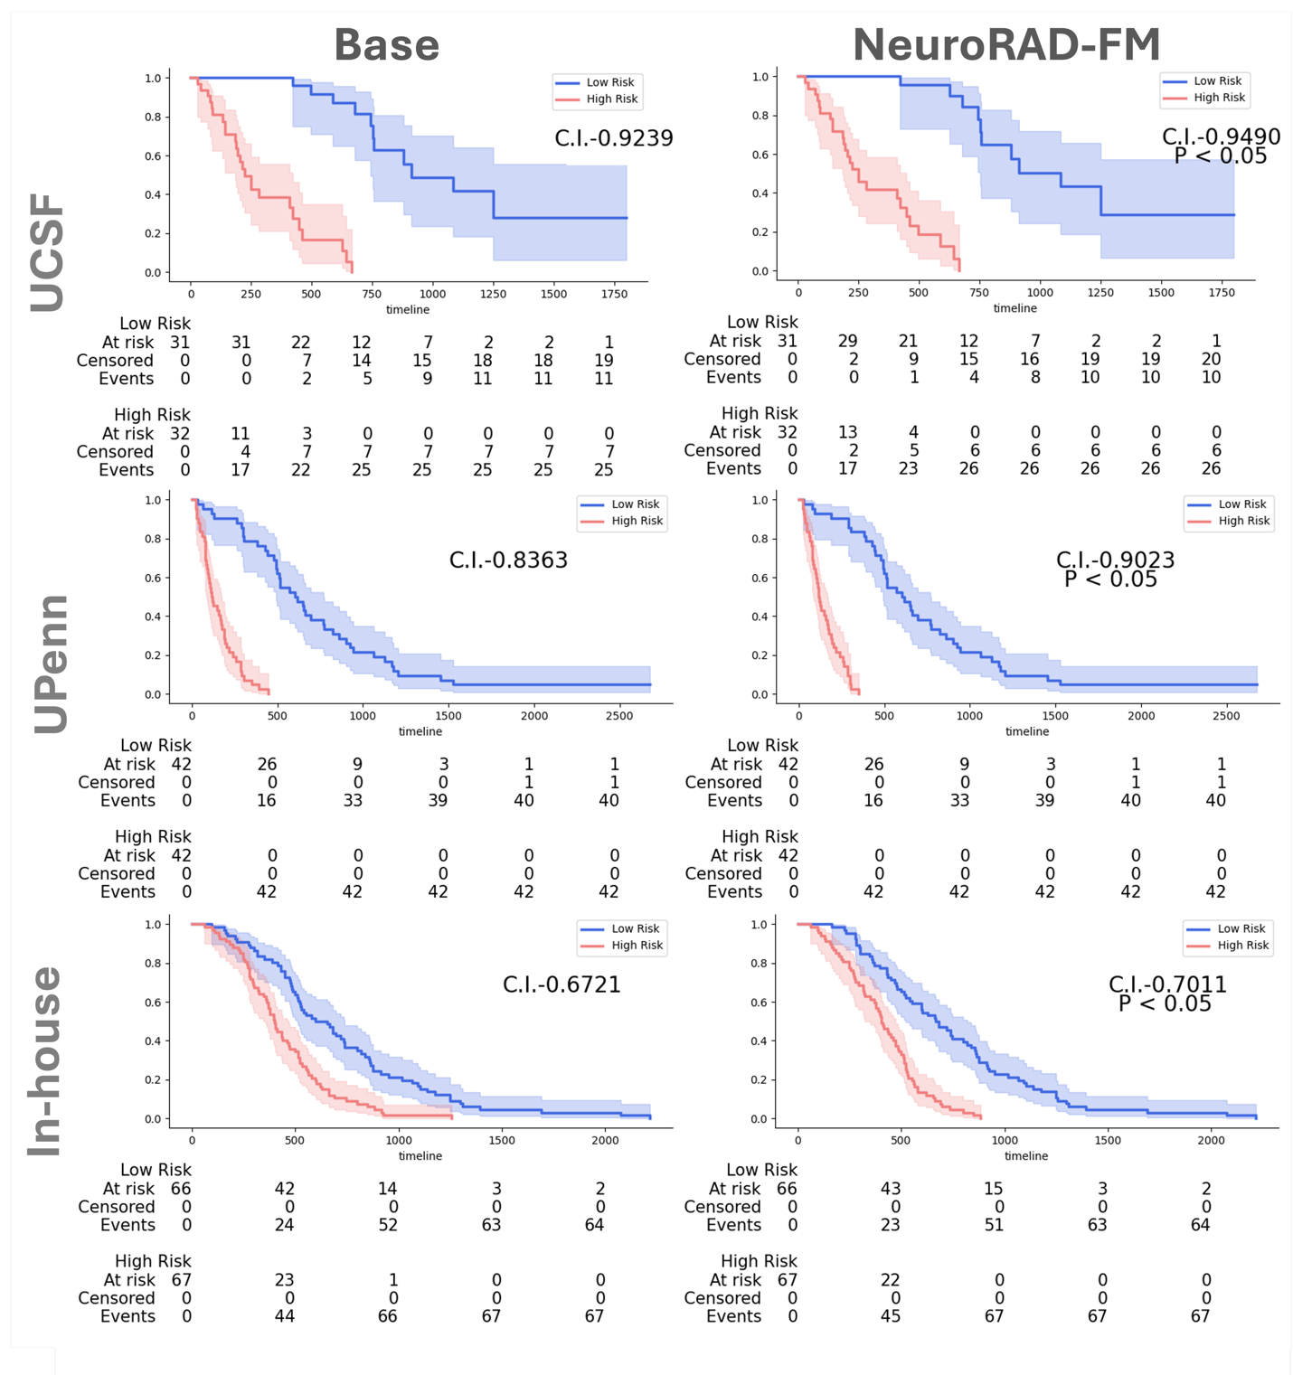
Supplementary Figure 2: Comparison high- and low-risk patients of base SSL method and NeuroRAD-FM for UCSF, UPenn and In-house cohorts.

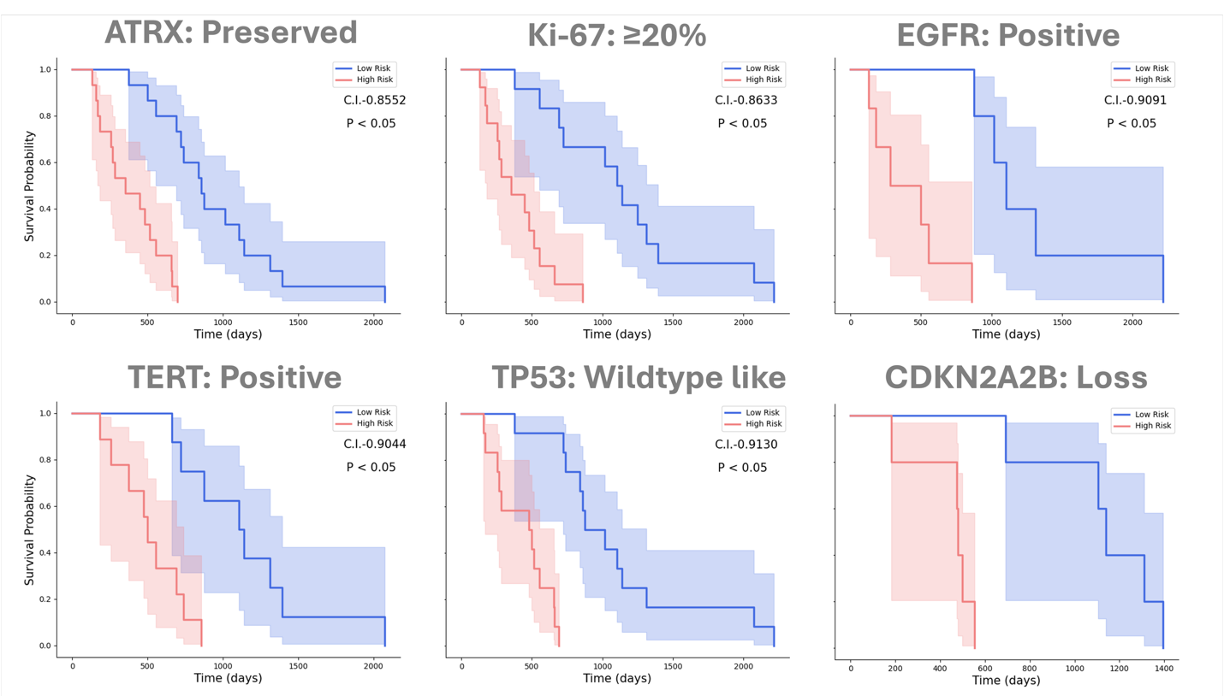
Supplementary Figure 3: Stratification of high- and low-risk patients for different uncommon mutation types.

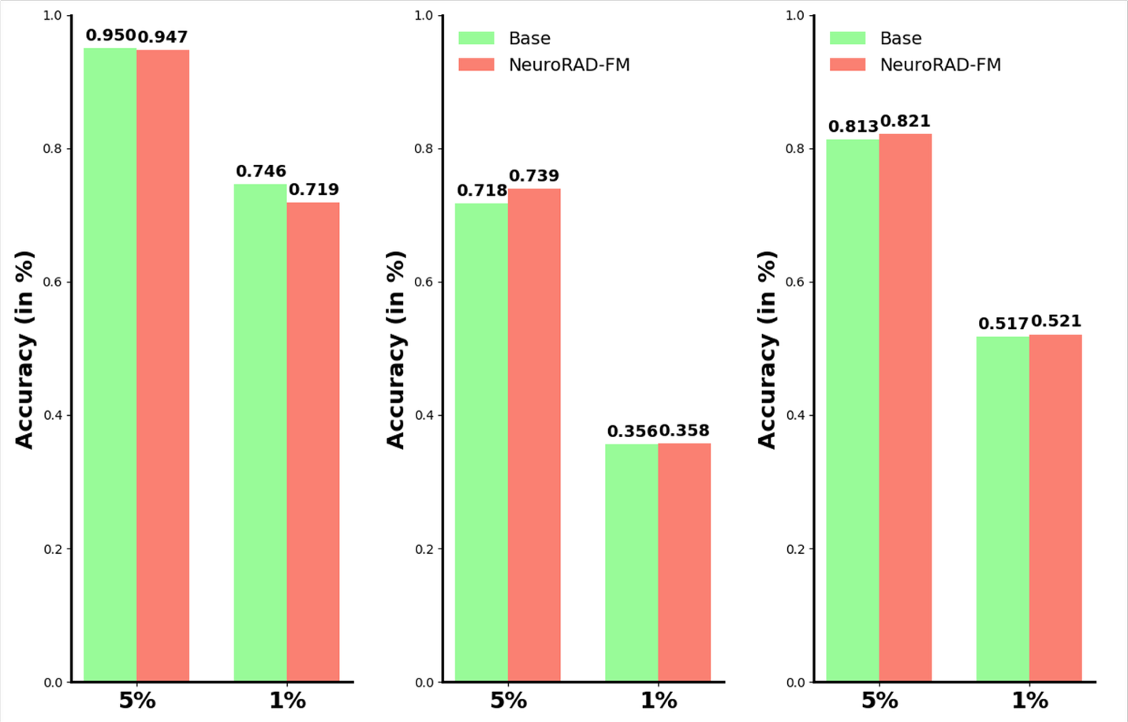
Supplementary Figure 4: Percentage of attention center regions (derived using 5% and 1% Grad-CAM thresholds) that overlap with the tumor region.
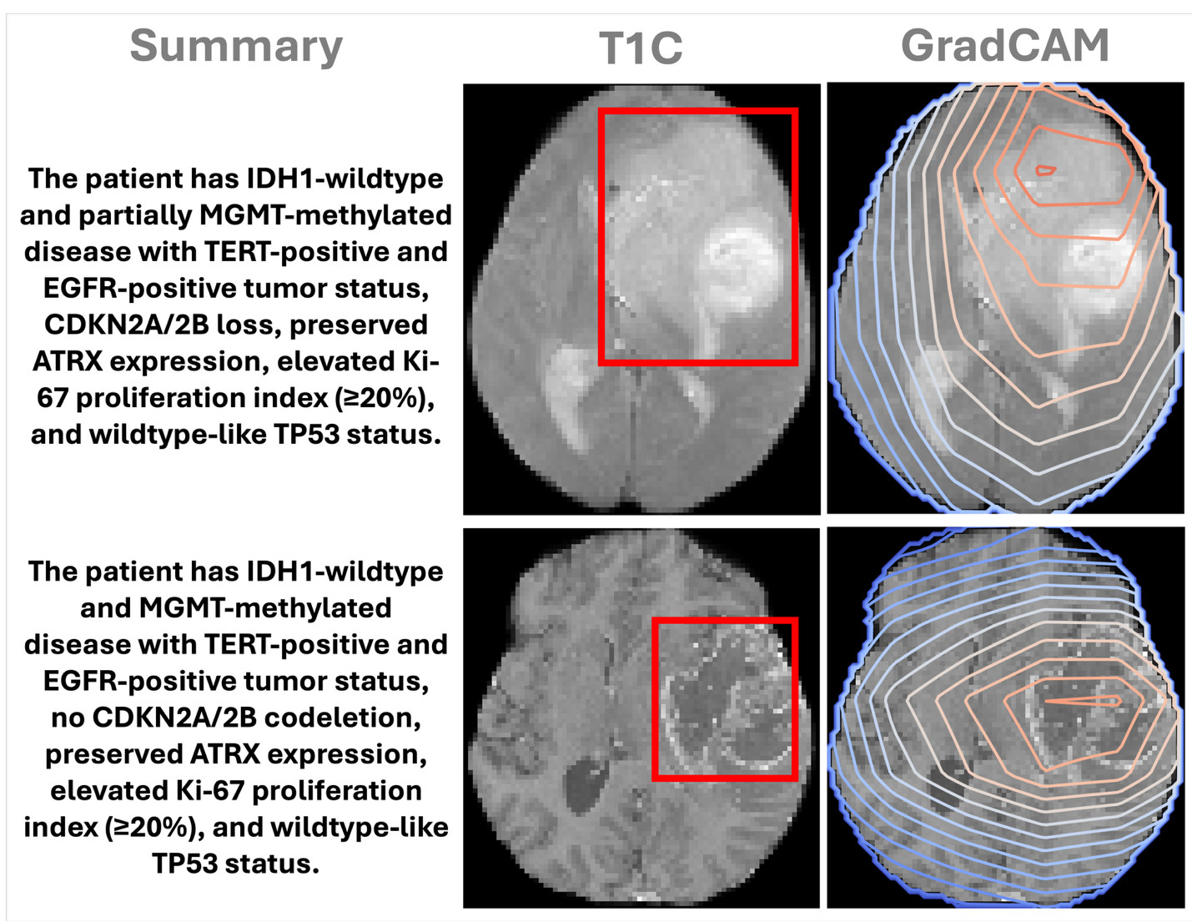
Supplementary Figure 5: Additional Grad-CAM visualizations along with the disease summary.

