A cost-effectiveness and value of information analysis to inform future research of tranexamic acid for older adults experiencing mild traumatic brain injury.
Supplementary information

Appendix Figure 1: Markov Model structure
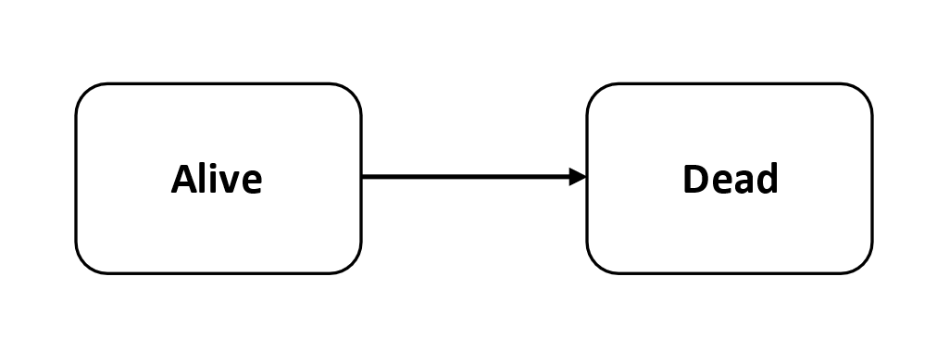

Appendix Table 1: Adverse event probabilities, tranexamic acid risk ratios and costs per event
Event | Probability (No tranexamic acid) | Probability Distribution | Tranexamic acid - Risk ratio | Risk ratio Distribution | Cost
Pulmonary embolism | 0.40% | Beta(α=5, β=1247) | 0.978 | Lognormal (95% CI: 0.509-1.877) | £494.06
Deep vein thrombosis | 0.08% | Beta(α=1, β=1251) | 1.222 | Lognormal (95% CI: 0.573-2.608) | £92.41
Stroke | 0.16% | Beta(α=2, β=1250) | 1.233 | Lognormal (95% CI: 0.714-2.128) | £731.99
Myocardial infarction | 0.32% | Beta(α=4, β=1248) | 0.733 | Lognormal (95% CI: 0.309-1.739) | £1,296.30
Renal failure | 0.56% | Beta(α=7, β=1246) | 1.275 | Lognormal (95% CI: 0.902-1.802) | £464.40
Sepsis | 2.40% | Beta(α=30, β=1222) | 1.037 | Lognormal (95% CI: 0.885-1.215) | £386.67
Seizure | 1.20% | Beta(α=15, β=1237) | 1.211 | Lognormal (95% CI: 0.939-1.561) | £556.07
Gastrointestinal bleeding | 0.48% | Beta(α=6, β=1246) | 0.711 | Lognormal (95% CI: 0.374-1.352) | £363.26
Source: The probability of adverse events in the control arm (placebo) was derived from mild TBI patients in the CRASH-3 study. The risk ratio of adverse events was derived from all patients in the CRASH-3 trial. The cost of each adverse event were derived from NHS reference costs.^{1,2}
Appendix Table 2: Deterministic cost-effectiveness results, by mean age
Analysis | Treatment | Costs | QALYs | ICER (QALY)
60 years old | No tranexamic acid | 30048 | 9.158
 | Tranexamic acid | 30191 | 9.203 | £3,205
70 years old | No tranexamic acid | £23,144 | 5.983
 | Tranexamic acid | £23,253 | 6.012 | £3,751
90 years old | No tranexamic acid | £10,467 | 1.167
 | Tranexamic acid | £10,515 | 1.173 | £8,366

Appendix Table 3: Deterministic, univariate threshold analysis of potential treatment effects required for tranexamic acid to be cost-effective. For each treatment effect considered, the other potential treatment effects were not included (i.e. the parameters were the same for tranexamic acid and no tranexamic acid)
 | Treatment effect for tranexamic acid to be cost-effective at £20,000/QALY willingness to pay threshold
Age | Tranexamic acid mortality risk ratio | Utility increment for tranexamic acid versus no tranexamic acid (applied for 1 month only)* | Mean reduction in length of stay (days)* | Neurosurgery risk ratio*
60 | 0.997 | 0.00417 | 0.021 | 0.974
70 | 0.996 | 0.00417 | 0.021 | 0.974
80 (base case) | 0.991 | 0.00417 | 0.021 | 0.974
90 | 0.972 | 0.00417 | 0.021 | 0.974
*The starting age of the cohort only influenced the tranexamic acid mortality risk ratio treatment effect required.

Appendix Figure 2: A threshold analysis of the risk ratio treatment effect required for tranexamic avid to be cost-effectiveness across a range of mortality risks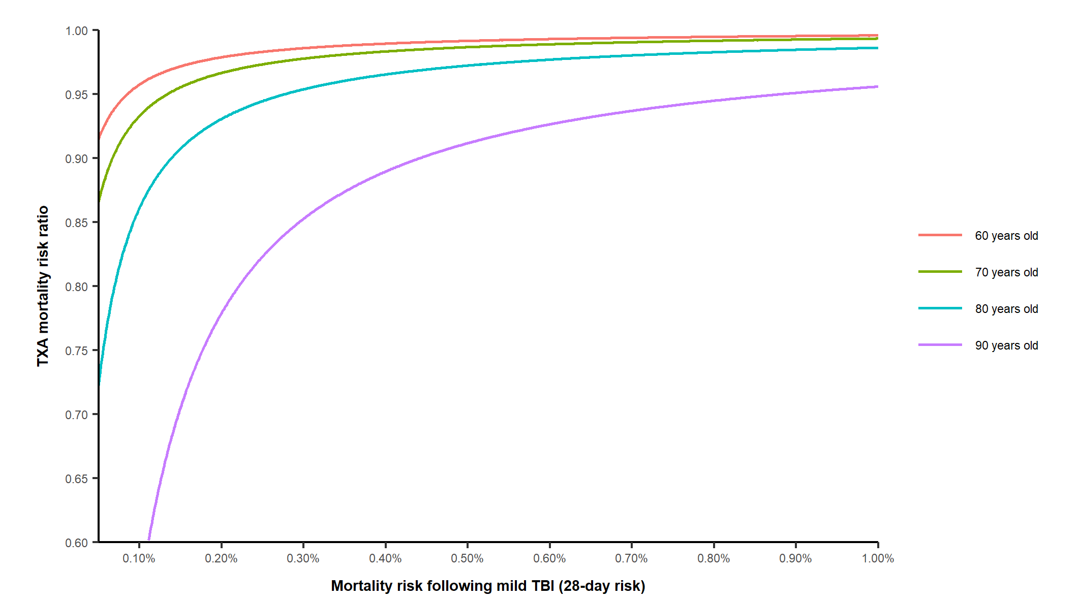

Appendix Figure 3: Cost-effectiveness acceptability curves for tranexamic acid across a range of risk ratio treatment effects. The sensitivity analysis assumes the same variance around the risk ratio as used in the base case analysis.
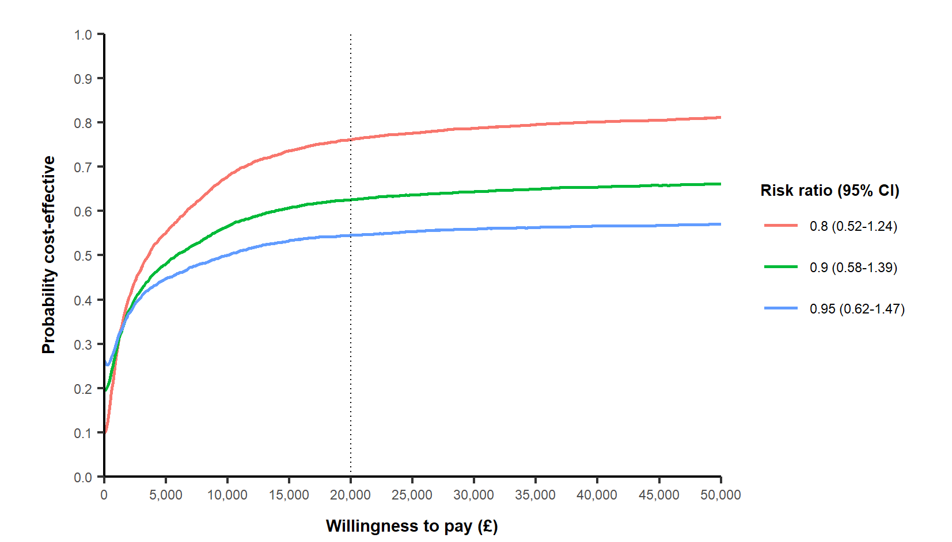

Appendix Table 4: Expected value of perfect information across different time horizons
Time Horizon (years) | Expected value of perfect information
5 | £3,707,239
10 | £7,108,928
20 (base case) | £13,210,773
30 | £18,052,063

Appendix Figure 4: Expected value of partial perfect information (EVPPI) for groups of parameters
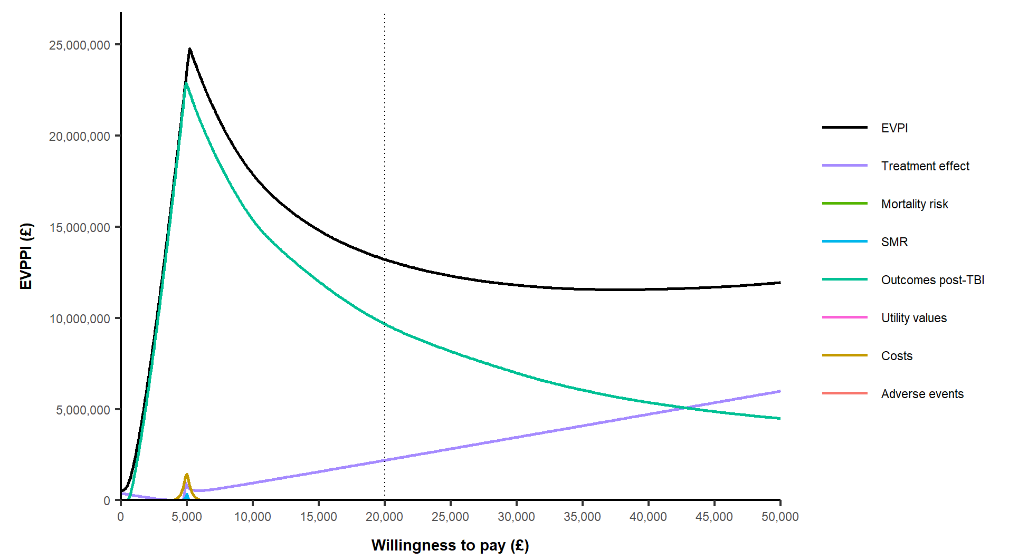

References

1. The CRASH-3 trial collaborators. Effects of tranexamic acid on death, disability, vascular occlusive events and other morbidities in patients with acute traumatic brain injury (CRASH-3): a randomised, placebo-controlled trial. Lancet. 2019;394:1713-23.
2. NHS. National schedule of reference costs 2017-18. 2018.

