Supplementary Figures:
Supplementary Figure S1. Principal component analysis of the 48 RNA-seq libraries (all genes, log2), colored by tissue and shaped by embryo-production group (IVP/MOET). PC1 separates tissues, indicating tissue is the dominant source of expression variance.
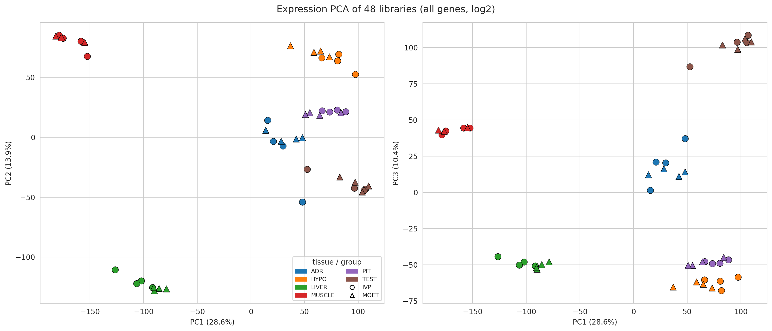
Supplementary Figure S2. Sample-sample expression correlation with hierarchical clustering of the 48 libraries. Samples cluster primarily by tissue, confirming expected biological structure and absence of major outliers.
