Supplementary Materials

Participants
Participants were excluded based on the following exclusion criteria: 1) no functional or structural images; 2) no handedness information; 3) no full-scale intelligence quotient score, or a full-scale intelligence quotient score lower than 70 (Lukito et al., 2020); 4) different scanning parameters (e.g., eyes open or closed, repetition time, total time points, slice number, or image matrix size) from those of other participants acquired at the same site; 5) severe artifacts or signal loss in fMRI data on visual inspection by two authors; 6) head motion > 3 mm or 3°; 7) poor spatial normalization (visual inspection by two authors); and 8) scanning coverage of less than 90% of the whole brain mask. Furthermore, several participants were excluded to match the individuals with ASD and TDCs from each site for sex (p > 0.05, chi-squared test), handedness (p > 0.05, chi-squared test), and age (p > 0.05, two-sample t-test).

Moreover, the following sites with < 20 participants were excluded: CALTECH, CMU_a, CMU_b, MAX_MUN_a, MAX_MUN_b MAX_MUN_c, MAX_MUN_d, SBL, and UCLA_2 of ABIDE I. Furthermore, the OHSU and IU sites were excluded because the scanning duration was shorter than 5 minutes and the time repetition was shorter than 700 ms, respectively.

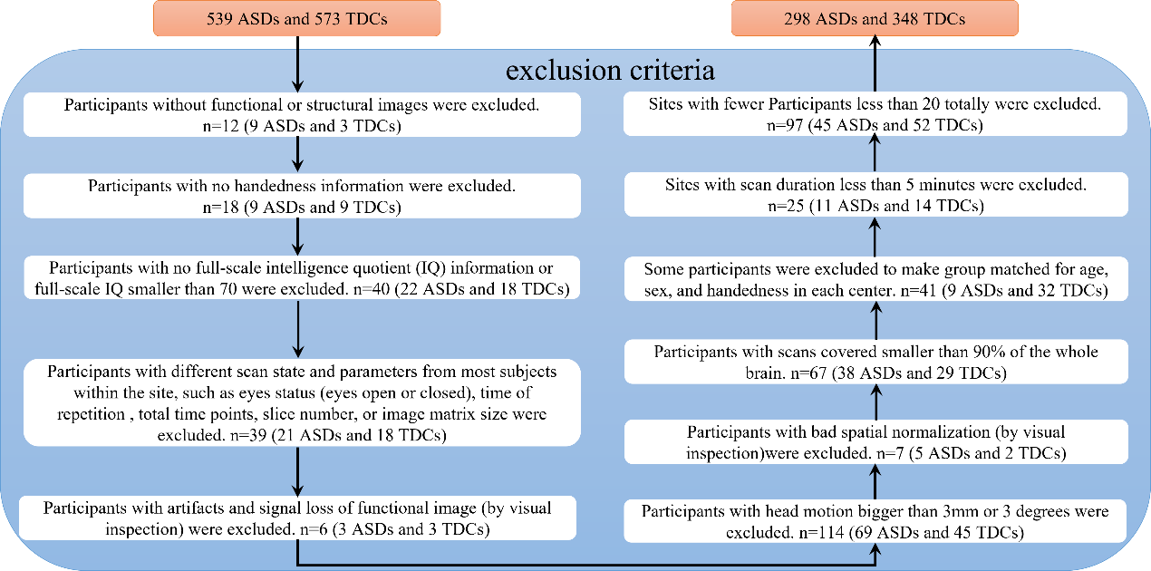
Figure S1. Exclusion criteria for participants. ASD: autism spectrum disorder; TDC: typically developing control.

Table S1. The basic demographic information of all included participants.
 | ASD (N = 298) |  |  | TDC (N = 348) |  |  | Statistics
Sex (male/female) | 262 | 36 |  | 304 | 44 |  | χ² = 0.05 | p = 0.829
Handedness (right/left/mixed) | 262 | 32 | 4 | 319 | 27 | 2 | χ² = 2.83 | p = 0.243
Age (mean ± SD) | 15.9 | 6.1 |  | 16.1 | 5.6 |  | t = -0.32 | p = 0.747
FIQ (mean ± SD)** | 106.37 | 16.54 |  | 111.21 | 12.66 |  | t = -4.20 | p < 0.001
mFD (mean ± SD)** | 0.11 | 0.07 |  | 0.09 | 0.06 |  | t = 3.73 | p < 0.001
ASD: the autism spectrum disorder; TDC: typically developing control; **: p <0.001; FIQ: full-scale intelligence quotient; mFD: mean framewise displacement; SD: standard deviation.

Spatial character of the individualized potential superficial targets
Using the watershed segmentation algorithm, the potential superficial targets were spread over a smaller area in the DLPFC than when they were generated from anatomical atlases (Figure S2). Similar to the DLPFC, the potential superficial targets generated from anatomical atlases were scattered over a larger area in the IPL and fell into two different clusters (Figure S2).

There were no significant differences in the MNI coordinates (including X, Y, and Z directions) of these potential targets within the DLPFC between individuals with ASD and TDCs (Figure S3). Compared with the individualized stimulation target MNI coordinates of TDCs within the IPL, those of individuals with ASD had a more scattered distribution over X, Y, and Z directions (Figure S4); however, only targets in the right IPL on the Y direction were significantly different (t = 2.10, p = 0.04, Figure S4).

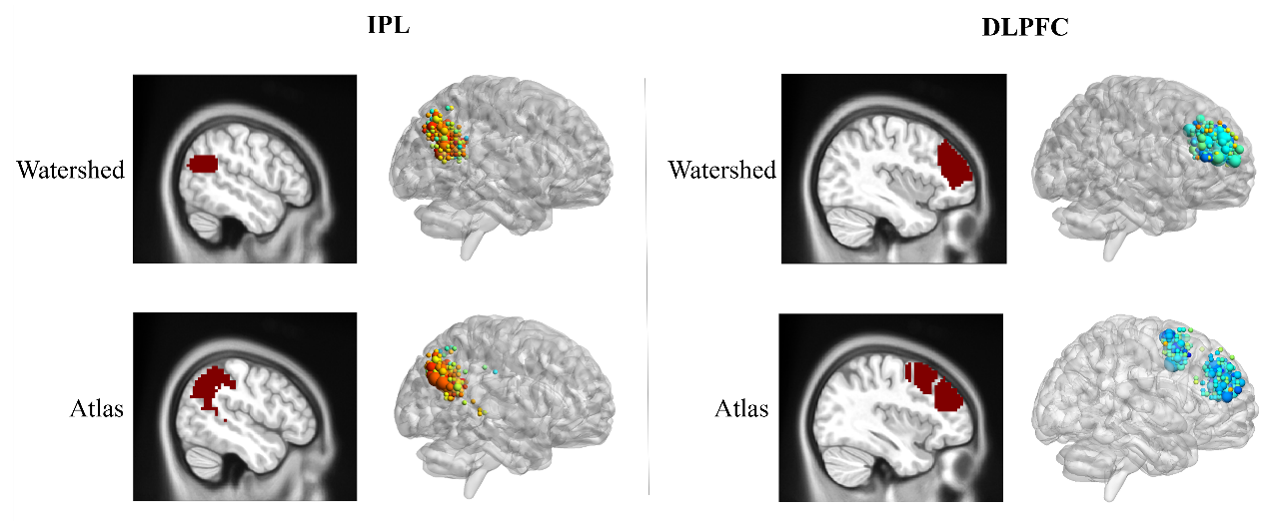
Figure S2. Individualized potential target distribution within the IPL and DLPFC, as defined using the watershed algorithm and anatomical atlases. IPL: inferior parietal lobule; DLPFC: dorsolateral prefrontal cortex.

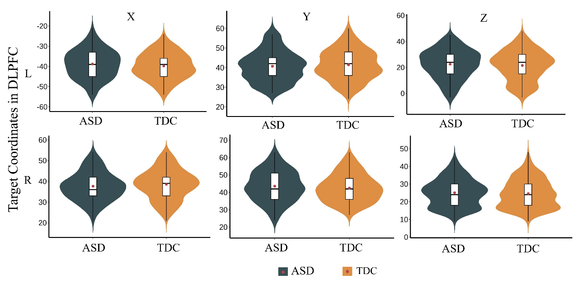
Figure S3. MNI coordinates (X, Y, and Z) differences of individualized stimulation targets on the DLPFC between individuals with ASD and TDCs. ASD: autism spectrum disorder; TDCs: typically developing controls; DLPFC: dorsolateral prefrontal cortex; MNI: Montreal Neurological Institute; L: left hemisphere; R: right hemisphere.

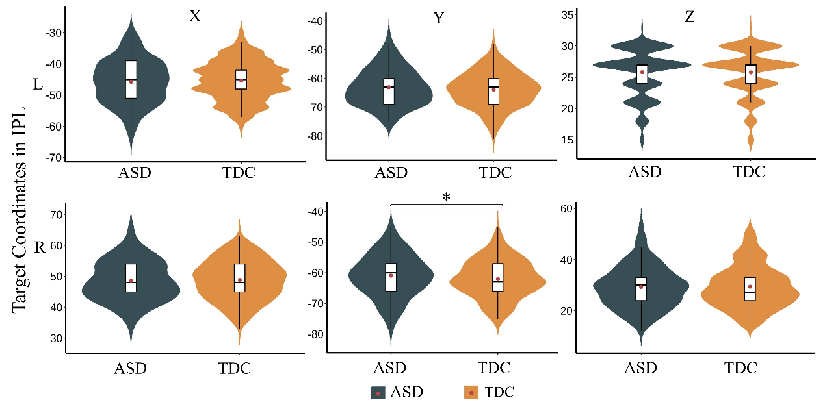
Figure S4. MNI coordinates (X, Y, and Z) differences of individualized stimulation targets on the IPL between individuals with ASD and TDCs. IPL: inferior parietal lobule; ASD: autism spectrum disorder; TDC: typically developing controls; MNI: Montreal Neurological Institute; L: the left hemisphere; R: the right hemisphere. *: p < 0.05.

Table S2. The mean reduction in subscale of CARS after TMS treatment.
Subscale | Function | Pre (mean) | Post (mean) | Reduction Percentage
CARS1 | Relating | 2.2 | 1.8 | 15
CARS2 | Imitation | 1.2 | 1.2 | 0
CARS3 | Emotional Response | 2.4 | 1.8 | 28
CARS4 | Body Use | 1.8 | 1.5 | 18
CARS5 | Object Use | 2.0 | 1.8 | 13
CARS6 | Adaptation to Change | 1.9 | 1.8 | 9
CARS7 | Visual Response | 1.3 | 1.3 | 0
CARS8 | Listening Response | 1.8 | 1.4 | 19
CARS9 | Taste/Smell/Touch Response | 2.3 | 2.0 | 11
CARS10 | Fear/ Anxiety | 2.3 | 1.8 | 19
CARS11 | Verbal Communication | 1.8 | 1.6 | 14
CARS12 | Nonverbal Communication | 1.4 | 1.3 | 6
CARS13 | Activity Level | 2.0 | 1.8 | 8
CARS14 | Intellectual Response | 1.8 | 1.7 | 9
CARS15 | General Impression | 2.2 | 2.2 | 0

Table S3. CARS changes after PCC-rIPL-FC guided iTBS treatment for all participants.
Subject_ID | Pre | Post | Reduction (%)
ASD_sub01 | 31 | 23.5 | 24
ASD_sub02 | 26 | 21.5 | 17
ASD_sub03 | 29 | 26.5 | 9
ASD_sub04 | 28 | 27 | 4
ASD_sub05 | 25 | 23 | 8
ASD_sub06 | 30 | 27.5 | 8
Mean (SD) | 28.2 (2.3) | 24.8 (2.5) | 12 (8)

References

Cash, R. F. H., Weigand, A., Zalesky, A., Siddiqi, S. H., Downar, J., Fitzgerald, P. B., & Fox, M. D. 2020. Using Brain Imaging to Improve Spatial Targeting of Transcranial Magnetic Stimulation for Depression. Biol Psychiatry. https://doi.org/10.1016/j.biopsych.2020.05.033
Fox, M. D., Buckner, R. L., White, M. P., Greicius, M. D., & Pascual-Leone, A. 2012. Efficacy of transcranial magnetic stimulation targets for depression is related to intrinsic functional connectivity with the subgenual cingulate. Biol Psychiatry, 72(7), 595-603. https://doi.org/10.1016/j.biopsych.2012.04.028
Igelström, K. M., & Graziano, M. S. A. 2017. The inferior parietal lobule and temporoparietal junction: A network perspective. Neuropsychologia, 105, 70-83. https://doi.org/10.1016/j.neuropsychologia.2017.01.001
Lukito, S., Norman, L., Carlisi, C., Radua, J., Hart, H., Simonoff, E., & Rubia, K. 2020. Comparative meta-analyses of brain structural and functional abnormalities during cognitive control in attention-deficit/hyperactivity disorder and autism spectrum disorder. Psychol Med, 50(6), 894-919. https://doi.org/10.1017/s0033291720000574
Zhao, N., Yue, J., Feng, Z. J., Qiao, Y., Ge, Q., Yuan, L. X., Wang, J., Xiang, Y. T., & Zang, Y. F. 2022. The Location Reliability of the Resting-State fMRI FC of Emotional Regions Towards rTMS Therapy. Neuroinformatics, 20(4), 1055-1064. https://doi.org/10.1007/s12021-022-09585-4

