Supplementary Information
This PDF file includes:
Symbols
Supplementary Methods
Supplementary Results I to Ⅵ
Figs. S1 to S20
Tables S1 to S6
Legends for supplementary figures S1 to S20
Legends for supplementary tables S1 to S6

Symbol | Definition
Occurrence probability of Kármán gait observation window for each experimental case | P_{KG}
Body length | BL
Bluff-body width | W
Mean flow velocity | U
Percentage of time exhibiting Kármán gait within a specific wake zone | P_{KG,z}
Normalized lateral displacement of the tip of the head | L_{h}
Normalized lateral displacement of the tip of the tail | L_{t}
Normalized lateral displacement of the body center | L_{c}
tail-beat frequency | f_{tb}
body wavelength | λ_{b}
Body wave velocity | v_{b}
vortex shedding frequency | f_{s}
wake wavelength | λ_{w}
vortex convection velocity | U_{c}
The dominant period of L_{h}, L_{t}, and L_{c} | T
angular frequency | ω_{s}
natural angular frequency | ω_{n}
damping ratio | β

Summary: This Supplementary Information provides additional methodological details, validation analyses and supporting results for the interpretation of Kármán gait as a wake-forced phase-locked state. Supplementary Methods describe the experimental setup, kinematic extraction, PIV measurements, CFD reconstruction, dynamic mode decomposition and passive bionic-fish experiments. Supplementary Results I–V provide supporting evidence for the parameter window of Kármán gait, robustness of the incident vortex streets, validation of the computational framework, distinction between Kármán gait and active undulatory swimming, live–dead comparisons and phase-dependent hydrodynamic mechanisms.

Supplementary Methods (Figures S1–S4)
Figures S1–S4 provide methodological details for the experimental and analytical framework. These include the field locations and fish species used for cross-species observations (Fig. S1), the recirculating flume, wake visualization and kinematic extraction procedures (Fig. S2), the time-resolved PIV setup for wake measurements (Fig. S3), and the Dynamic Mode Decomposition workflow used to identify coherent flow structures (Fig. S4). These supplementary methods document the experimental basis and flow-analysis pipeline supporting the main results.

Experimental design and animal subjects
We used a comparative experimental design to examine Kármán gait across diverse fish species and to separate active neuromuscular control from passive body–wake interaction. In total, 65 experimental cases were conducted across 20 fish species, with characteristic body length ranging from 5 to 22 cm (Table S1). Squalidus argentatus was selected as the primary model species because it provided the largest number of repeated trials and allowed detailed comparisons among active undulatory swimming, live-fish Kármán gait and passive dead-fish responses. The remaining species were used to assess the breadth of Kármán-gait occurrence across morphologically diverse fishes and were not used for species-level statistical inference.
Fish were acclimated in laboratory holding tanks before experiments. Water temperature was maintained between 16.0 and 20.0 °C across experimental cases. Body length, flow velocity, obstacle width, recording duration and Kármán-gait occurrence range were recorded for each case.
For passive-body controls, selected S. argentatus specimens with body length of approximately 12 cm were deeply anaesthetized and euthanized using an overdose of MS-222. Experiments were conducted after cessation of opercular movement and visible neuromotor activity. These trials were used to isolate passive body–wake mechanics from active neural control. Where passive-body stiffness was examined, dead-fish specimens were kept hydrated and tested within a fixed post-mortem time window. Effective bending stiffness was estimated from a small-deflection bending test, and passive Kármán-gait responses were compared across stiffness ranges to assess whether body compliance constrained access to the wake-forced Kármán-gait branch. Detailed stiffness procedures are provided in the Supplementary Methods.
All experimental procedures were approved by the Institutional Animal Care and Use Committee of Sichuan University (IACUC number: SCU44-2512-04).

Flow-tank setup and gait classification
Experiments were conducted in a speed-controlled recirculating swimming respirometer with a transparent rectangular test section of 0.6 m × 0.2 m × 0.2 m. Four bluff-body cross-sectional geometries were used to generate Kármán vortex streets: D-shaped cylinder, triangular, circular and rhomboid cylinders. The characteristic bluff-body width W ranged from 3 to 7 cm. Free-stream velocity U was varied from 0.1 to 1.5 m/s. Additional flow-regime tests were conducted for the four bluff-body geometries with widths of 3, 4 and 5 cm over 0.1–0.6 m/s. Fish–vortex interaction trials were conducted under representative conditions using a D-shaped cylinder and triangular bluff bodies, with W=5 cm and U=0.4 m/s.
Wake structures were visualized using potassium permanganate solution to provide sufficient image contrast for wake visualization and image processing. For active undulatory swimming, fish swam in the absence of an upstream bluff body. For Kármán gait, fish were recorded while holding station in the vortex street downstream of the bluff body.
A swimming bout was classified as Kármán gait when it satisfied three criteria: periodic slaloming of the body center between alternating vortices, tail-beat frequency f_{tb}​ is significantly lower than that during active swimming, and maintenance of the synchronized slaloming pattern for at least three consecutive vortex-shedding cycles ^{1, 2, 3}. The temporal probability of Kármán gait occurrence was calculated as:
$P_{t}=\frac{\sum_{i}{t_{i}}}{T_{\text{obs}}}×100\%$ (1)
where $t_{i}$​ is the duration of the i-th qualifying Kármán-gait bout and $T_{\text{obs}}$ is the total valid observation time.
Passive silicone bionic-fish experiments
Passive bionic fish were fabricated using two-component food-grade silicone. Components A and B were mixed at a mass ratio of 1:1 and cured in a fish-shaped mould. All bionic fish had the same external dimensions of 120 mm × 15 mm × 2.5 mm, so that differences among treatments mainly reflected changes in stiffness or density rather than body geometry.
Body stiffness was controlled using silicone materials with different Shore A hardness values: 5, 10, 20 and 30. An additional high-stiffness group was produced by embedding a 0.05-mm-thick PET strip inside the body before curing, which made its apparent stiffness higher than that of the Shore A 30 silicone group. Body density was adjusted by embedding 3-mm-diameter steel beads to increase density or 3-mm-diameter foam beads to decrease density. The unweighted silicone body had a density close to that of water and was used as the density-matched reference condition, for which ($ω_{s}/ω_{n}=1$).
Bionic-fish experiments were conducted downstream of the D-shaped cylinder under the same representative wake condition used for live-fish Kármán-gait analysis. Kármán-gait occurrence was quantified using the same temporal-probability criterion as in the live-fish experiments. Segments showing sustained lateral slaloming, frequency locking with vortex shedding and synchronization for at least three consecutive vortex-shedding cycles were classified as Kármán gait. The occurrence probability was calculated as ($P_{\text{KG}}=\sum_{i}{t_{\text{KG},i}}/T_{\text{valid}}$).

Kinematic and phase analysis
Fish motion was recorded from above using a high-speed camera operating at 60–180 frames s⁻¹, depending on the flow condition and recording duration. Fish silhouettes were extracted from each frame using image binarization, and the instantaneous body midline was obtained using a custom midline-extraction algorithm. The algorithm extracted a continuous centerline from the binarized fish silhouette; detailed implementation is not included in the main text but can be made available upon reasonable request.
The head tip, body center and tail tip were identified along the extracted midline. Their normalized lateral displacements were denoted as L_{h} ​, L_{c} ​and L_{t} ​, respectively. All displacements were normalized by body length. Tail-beat frequency f_{tb}​ was calculated from the time series of tail-tip lateral displacement L_{t}(t).
Body-wave propagation was quantified by tracking the downstream movement of lateral-displacement peaks along the extracted midline. For each oscillation cycle, wave-crest positions were identified along the body axis, and body-wave velocity v_{b}​ was calculated from the slope of crest position versus time.
The BC–tail phase difference was calculated using a peak-timing method. For each stable oscillatory bout, local maxima of L_{c}(t) and L_{t}(t) were identified over consecutive cycles. The time lag between corresponding body-center and tail peaks was converted to phase difference as:
$φ=2π\frac{Δt}{T}$​ (2)
where Δt is the peak-time difference and T is the dominant oscillation period. The sign of φ was assigned according to the convention
$φ=φ_{\text{tail}}-φ_{\text{BC}}$​ (3)
where $φ_{\text{tail}}​$ and $φ_{\text{BC}}$ are the phases of tail and body-center motion, respectively. Positive values correspond to the active-swimming branch, whereas negative values correspond to the Kármán-gait branch.

PIV measurements and wake characterization
Time-resolved particle image velocimetry was used to quantify wake structure and fish–wake interaction. The flow was seeded with 100-mesh water-insoluble polystyrene tracer particles. The primary locomotion plane was illuminated using a planar light sheet generated by synchronized lasers. Flow images were recorded at 2000 frames s⁻¹.
For each PIV case, 500 consecutive frames were selected for velocity-field reconstruction. The physical processing window was approximately 0.01 m. Velocity fields were calculated using multipass cross-correlation in PIVlab. Spurious vectors were removed using local-median validation and replaced by interpolation. The out-of-plane vorticity was calculated as:
$ω_{z}=\frac{∂v}{∂x}-\frac{∂u}{∂y}$​ (4)
where u and v are the streamwise and lateral velocity components.
The vortex-shedding frequency f_{s} was obtained from the Fourier spectrum of the PIV-derived vorticity time series at representative downstream locations in the wake. The dominant spectral peak was taken as f_{s}​. Vortex convection velocity U_{c}​ was estimated by tracking the displacement of identified vortex cores between consecutive PIV frames and dividing the downstream displacement by the corresponding time interval. Mean U_{c}​ was calculated over multiple vortex-passage events. These quantities were used to assess frequency matching between f_{tb}​ and f_{s}​, and velocity matching between v_{b} ​and U_{c}​.
CFD simulation and hydrodynamic force reconstruction
CFD simulations were performed using ANSYS Fluent 2021 R1. The incompressible Navier–Stokes equations were solved using a transient Large Eddy Simulation framework. The computational mesh contained approximately 8.0×10⁴ cells. Two 15-s simulation cases were conducted at an inlet velocity of U=0.4 m/s.
Two numerical simulation cases were conducted. Case 1 was a static-mesh D-shaped cylinder wake simulation (W=5) cm, inlet velocity U=0.4 m/s, simulation time t=15s, which was used to validate the CFD framework against PIV measurements. Validation was performed by comparing wake topology, vortex spacing, time-averaged flow structure and vortex-shedding frequency. Case 2 used a dynamic fish-body mesh (BL=10) cm, inlet velocity U=0.4 m/s, simulation time t=15s with body-center lateral displacement disabled. Only the Kármán-gait-derived tail motion was prescribed, allowing the tail-induced hydrodynamic force to be isolated. This simulation was used to reconstruct pressure fields and estimate the relationship between tail-tip amplitude, ($L_{t}$), and the tail-induced lateral force coefficient, ($C_{L,t}$).
Hydrodynamic forces acting on the fish body were obtained directly from the force-report function in ANSYS Fluent, which integrates pressure and viscous shear contributions over the selected body surface. The streamwise and lateral force components were denoted as F_{x}(t) and F_{y}​(t), respectively. When required, the corresponding force coefficients were calculated as:
$C_{D}\left(t\right)=\frac{F_{x}\left(t\right)}{0.5ρU^{2}S_{\text{ref}}}$​ (5)
$C_{L}\left(t\right)=\frac{F_{y}\left(t\right)}{0.5ρU^{2}S_{\text{ref}}}$​ (6)
where ρ is water density, U is inlet velocity and $S_{\text{ref}}​$ is the reference area used in Fluent force-coefficient calculation. Details of boundary conditions, time-step selection and mesh settings are provided in the Supplementary Methods.

DMD and mode-removal analysis
Dynamic mode decomposition was applied to CFD-reconstructed pressure fields to identify dominant hydrodynamic pressure modes during Kármán gait ⁴. Sequential pressure snapshots were arranged into two time-shifted matrices,
$X=\left[p_{1},p_{2},…,p_{m-1}\right]$ (7)
$X^{'}=\left[p_{2},p_{3},…,p_{m}\right]$ (8)
where p_{i} denotes the pressure field at time step iii. DMD modes, modal frequencies and modal amplitudes were obtained through singular value decomposition and eigendecomposition of the reduced linear operator. The first three energy-dominant modes were retained for mechanistic interpretation.
The leading pressure modes were interpreted by comparing their spatial pressure-gradient signatures, temporal frequencies and associated fish kinematics. Mode 1 was associated with the low-pressure restoring corridor, Mode 2 with periodic lateral forcing F_{y}(ω), and Mode 3 with streamwise forcing F_{x}(2ω) and body-wave propagation. In the Supplementary Information, vorticity-field analyses were also performed to characterize the periodic wake structure and to confirm consistency between vortex-street organization and pressure-mode dynamics.
To assess the sensitivity of reconstructed midline responses to individual modes, a mode-removal analysis was performed. The contribution associated with each leading mode was selectively removed, and the predicted midline response was reconstructed. The resulting changes in body-center slaloming, tail oscillation, lateral confinement and body-wave propagation were summarized qualitatively. This analysis was used to support the functional assignment of the leading hydrodynamic modes, rather than as a direct experimental removal of flow structures.

Tail-induced lateral force and Fourier analysis
To evaluate whether tail oscillation can generate a lateral hydrodynamic force capable of regulating body-center motion, we performed an additional CFD analysis in which the fish body center was fixed and only tail oscillation was prescribed. Under this configuration, the net lateral hydrodynamic force acting on the full fish body arises from tail-driven deformation and its interaction with the surrounding flow. This force was obtained directly from the Fluent force-report function and was defined as the tail-induced lateral force F_{t} ​. The corresponding nondimensional coefficient was denoted as C_{L,t} .
Tail amplitude L_{t​} was extracted from the prescribed tail-tip motion and normalized by body length. The relationship between C_{L,t} and L_{t} was evaluated using least-squares regression. The fitted relationship was
$C_{L,t}=2119.2L_{t}$ (9)
with
R²=0.944 (10)
This analysis was used to support the representation of F_{t} as a kinematically constrained tail-induced regulatory force in the wake-forced oscillator model.
Fourier spectra were calculated to characterize the frequency-domain structure of fish-body kinematics and hydrodynamic force coefficients during Kármán gait. All time series were detrended and mean-subtracted before analysis. One-sided Fourier amplitude spectra were obtained using the fast Fourier transform and normalized by their maximum amplitude. Frequencies were normalized by the vortex-shedding frequency, $f_{s}$, such that $f/f_{s}=1$ represents the fundamental wake-forcing frequency, $ω$, and $f/f_{s}=2$ represents the second harmonic, $2ω$. Dominant spectral peaks in the lateral and streamwise force components were used to identify the $F_{y}\left(ω\right)-F_{x}\left(2ω\right)$ wake-force architecture during Kármán gait.

Reduced-order modelling
To interpret the lateral body-center dynamics during Kármán gait, we constructed a wake-forced oscillator model motivated by vortex-induced vibration and forced-damped oscillator frameworks for swimming and fluid–structure interaction ^{5, 6, 7}. The body-center displacement L_{c}​ was represented as a damped oscillator driven by the net lateral forcing generated by incident vortex forcing and tail-induced regulation:
$m_{\text{eff}}\ddot{L_{c}}+c_{\text{eff}}\dot{L_{c}}+k_{\text{eff}}L_{c}=F_{y}\left(t\right)-F_{t}\left(t\right)$ (11)
where m_{eff}​, c_{eff} and k_{eff} denote effective inertia, damping and restoring stiffness, respectively. Fy​(t) represents periodic lateral forcing from the incident vortex street, whereas F_{t}(t) represents the effective tail-induced regulatory force.
After normalization by effective mass, the model can be written as:
$\ddot{L_{c}}+2β\dot{L_{c}}+ω_{0}^{2}L_{c}=f_{0}\cos\left(ωt\right)$ (12)
where $β=c_{\text{eff}}/\left(2m_{\text{eff}}\right)$, $ω_{0}=\sqrt{k_{\text{eff}}/m_{\text{eff}}}$​​, and f₀​ is the effective net forcing amplitude. The steady-state response was written as:
$L_{c}=A_{c}\left(ω\right)\cos\left[ωt-φ_{c}\left(ω\right)\right]$ (13)
where φ_{c} is the phase lag between lateral vortex forcing and body-center response. This phase lag is distinct from the BC–tail phase difference φ. The model was used to explain the near-0.5π forcing–response phase lag and amplitude regulation observed during Kármán gait.

Statistics and reproducibility
Data are reported as mean ± s.d. unless otherwise stated. Sample sizes refer to independent swimming bouts, individual fish, experimental cases or reconstructed flow fields, as specified in the figure captions and supplementary tables. When multiple cycles or bouts were obtained from the same individual, values were first averaged within each individual before group-level comparisons unless otherwise stated. For time-series analyses such as force–amplitude regression or Fourier spectra, sample size refers to sampled time points or reconstructed cases and was not interpreted as independent biological replication.
Normality was assessed using the Shapiro–Wilk test, and homogeneity of variance was assessed using Levene’s test. Differences among locomotor states or bluff-body geometries were tested using one-way ANOVA followed by Tukey’s post hoc test when assumptions of normality and homogeneity of variance were satisfied. Otherwise, Kruskal–Wallis tests followed by Dunn’s post hoc comparisons were used. Significance was set at P<0.05.
Frequency matching between f_{tb} and f_{s}​ was evaluated using paired comparisons within the same Kármán-gait bouts. Body-wave velocity v_{b}​ and vortex convection velocity U_{c}​ were compared in the same way. When paired differences were normally distributed, paired t-tests were used; otherwise, Wilcoxon signed-rank tests were used.
Linear relationships, including the relationship between L_{t} and C_{L,t} ​, were evaluated using least-squares regression and reported with fitted slope, R² and P-value. Frequency-domain analyses were interpreted based on dominant spectral peaks unless multiple independent trials were available for statistical comparison. All statistical analyses were performed using MATLAB. All tests were two-sided unless otherwise stated.

Supplementary Results I. Parameter window and wake robustness of Kármán gait (Figures S5–S9)
To examine whether Kármán gait depends on a narrow set of experimental conditions or on a specific bluff-body geometry, we first quantified the occurrence window of successful Kármán-gait cases and characterized the wakes generated by different obstacle shapes. Successful cases were concentrated within an intermediate fish-to-obstacle size range: (BL/W = 2.0-2.5) accounted for 50.8% of all successful cases, followed by (BL/W = 2.5-3.0) and (BL/W = 3.0-4.0), which accounted for 23.1% and 16.9%, respectively (Fig. S5a). Thus, more than 90% of successful cases occurred within (BL/W = 2.0-4.0), whereas smaller (BL/W = 1.5-2.0) and larger (BL/W = 4.0-4.5) size ratios were much less frequent. Successful cases were also concentrated within moderate incoming velocities, especially 0.3–0.6 m/s, which together accounted for approximately 70% of the observed Kármán-gait conditions (Fig. S5b). The highest proportion occurred at 0.4 m/s, suggesting that Kármán gait is favored by an intermediate velocity range rather than by either very weak or very strong incoming flow.
We then examined whether this parameter window was specific to one obstacle geometry. Dye visualization showed that D-shaped, triangular, circular and prism-shaped bluff bodies all generated organized alternating vortex streets across the tested obstacle widths and flow velocities (Figs. S6–S9). Although local wake details differed among shapes, PIV-based vorticity fields and modal decomposition revealed a consistent leading modal structure across all four geometries: a stationary base-flow component (f = 0), a fundamental vortex-shedding mode (f = f_{s}), and a higher-frequency harmonic component (f = 2f_{s}). This shared modal organization indicates that the hydrodynamic forcing relevant to Kármán gait is not unique to one bluff-body shape. Instead, the tested obstacles produced a common vortex-street forcing template that could support wake-induced slaloming when body size and flow velocity fell within a favorable range.

Supplementary Results II. Validation of the computational flow framework (Figure S10)
Because the pressure field and modal force architecture were derived from CFD-based flow reconstruction, we validated the numerical framework against experimental PIV measurements before using it for hydrodynamic analysis. The simulated vorticity field reproduced the main spatial organization of the measured wake, including the alternating vortices shed downstream of the bluff body and the associated velocity-vector pattern (Fig. S10a). Dynamic mode decomposition further showed that the leading simulated modes corresponded closely to those extracted from PIV: a stationary base-flow mode (f = 0), a fundamental vortex-shedding mode (f = f_{s}), and a first harmonic component (f = 2f_{s}). Although small differences in local vortex strength and spatial extent were present, the dominant modal structure and characteristic shedding frequencies were consistent between experiment and simulation.
Additional comparisons supported the reliability of the flow reconstruction. The simulated streamline pattern reproduced the large-scale wake trajectory observed in dye visualization, including the alternating deflection of the wake downstream of the obstacle (Fig. S10b). The time-averaged velocity field also captured the main momentum deficit and the low-velocity wake region behind the bluff body (Fig. S10c). Quantitatively, vortex-shedding frequencies estimated from CFD agreed closely with those measured from PIV across the tested conditions, with a fitted relationship of (y = 1.0058x) and (R² = 0.9997) (Fig. S10d). Together, these comparisons support the use of the CFD framework for reconstructing pressure fields and hydrodynamic force components during Kármán gait.

Supplementary Results III. Distinction between Kármán gait and normal undulatory swimming (Figures S11–S14)
To distinguish Kármán gait from normal active undulatory swimming, we compared whole-body midline kinematics and body-center–tail phase relationships across the same 20 fish species under wake-forced and uniform-flow conditions. During Kármán gait, the midline envelopes showed large-amplitude lateral slaloming combined with posterior body-wave propagation across diverse taxa (Fig. S11). Although species-specific differences in body shape and detailed deformation were present, the overall kinematic pattern was broadly conserved: the body center followed a wake-induced lateral trajectory, while the posterior body and tail developed coordinated wave-like motion. In contrast, baseline undulatory swimming in uniform flow showed smaller-amplitude body deformation and a more typical tail-beating pattern, with motion concentrated toward the posterior body and tail (Fig. S12). This difference in spatial organization indicates that Kármán gait is not simply an amplified or weakened form of normal swimming, but involves a distinct whole-body response to the incident vortex street.
The phase analyses further supported this distinction. During Kármán gait, the relationship between body-center motion, (Lc), and tail-tip oscillation, (Lt), clustered around a half-cycle phase offset across species, indicating consistent phase locking between wake-induced body-center slaloming and tail motion (Fig. S13). By contrast, during baseline undulatory swimming, (Lc) and (Lt) showed a different phase organization, closer to the coordination expected for active tail beating in uniform flow (Fig. S14). Together, the cross-species midline envelopes and phase relationships show that Kármán gait represents a wake-forced phase-locked locomotor state, rather than a direct extension of normal undulatory swimming.

Supplementary Results IV. Passive-dominated organization revealed by live–post-mortem comparisons (Figures S15–S17)
To distinguish passive body–wake mechanics from active neuromuscular control, we compared live-fish Kármán gait with post-mortem passive responses in the same vortex-street environment. Midline decomposition showed that the global Kármán-gait motion could be separated into two main components: periodic body-center motion (Lc) and posterior body-wave propagation (Fig. S15a). Both components were retained in post-mortem fish, indicating that the large-scale slaloming and posterior wave-like deformation do not require continuous active propulsion. Phase comparisons further showed that the body-center–tail phase relationship was broadly similar between live and post-mortem fish, whereas the head phase differed more strongly (Fig. S15b). This suggests that the dominant body-wave organization is largely maintained by passive body–wake interaction, while live fish retain active control mainly in the anterior body.
Visual comparisons across representative species and obstacle geometries further supported this interpretation. Live and post-mortem fish both displayed slaloming trajectories through successive vortex pairs in wakes generated by D-shaped and triangular cylinders (Fig. S16). Although detailed posture and local head orientation differed between live and post-mortem conditions, the gross wake-following trajectory and posterior body-wave pattern were preserved. Spatiotemporal alignment analysis confirmed that both live and post-mortem fish occupied comparable positions relative to successive vortices during the slaloming cycle (Fig. S17a). Regional amplitude comparisons showed that body-center and tail motions followed broadly similar temporal patterns between live and post-mortem fish, whereas the largest live–post-mortem difference occurred in the head region (Fig. S17b). Together, these results support a passive-dominated but actively stabilized interpretation of Kármán gait: the vortex street organizes the global body–tail motion, while active control in live fish appears to contribute primarily to anterior stabilization and orientation.

Supplementary Results V. Phase-dependent hydrodynamics and force generation (Figures S18–S20)
To examine how phase-dependent wake interaction and modal force components contribute to Kármán-gait dynamics, we combined hydrodynamic mapping, mode-removal reconstruction and isolated tail-oscillation simulations. First, phase-dependent hydrodynamic analysis showed that live fish tended to route the head through inter-vortex gaps, whereas the body center followed a slaloming trajectory within the wake corridor (Fig. S18). Live and post-mortem fish experienced broadly similar hydrodynamic environments along the body-center trajectory, supporting the interpretation that the gross body-center motion is largely organized by passive body–wake interaction. Across prescribed phase relationships, pressure, velocity, vorticity and turbulent kinetic energy varied strongly with phase. The Kármán-gait-like phase relationship near ($=0.5π$) was associated with elevated hydrodynamic loading compared with the ($=0$) and ($=π$) reference conditions, indicating stronger wake–body interaction and suggesting enhanced wake-mediated forcing during phase-locked slaloming.
Mode-removal analysis further identified how the leading wake modes contribute to the reconstructed body motion (Fig. S19). The full reconstruction reproduced coordinated body-center oscillation, tail motion and downstream body-wave propagation. Removing Mode 1 disrupted lateral confinement, indicating that this mode contributes to the restoring corridor that keeps the fish within the wake-defined slaloming path. Removing Mode 2 suppressed body-center oscillation, showing that this mode provides the dominant lateral excitation for body-center slaloming. Removing Mode 3 suppressed tail motion and body-wave propagation, indicating that this mode contributes primarily to posterior body deformation and tail-amplitude development. These results support the functional assignment of Mode 1 as confinement, Mode 2 as lateral excitation and Mode 3 as body-wave propagation.
Finally, isolated tail-oscillation simulations were used to evaluate whether tail-amplitude variation can generate a corresponding lateral force component (Fig. S20). After removing body-center lateral displacement and prescribing only the Kármán-gait-derived tail motion, the tail-induced lateral force coefficient, ($C_{L,t}$), varied approximately linearly with tail-tip amplitude, ($L_{t}$), with ($C_{L,t}=2119.2L_{t}$) and ($R^{2}=0.944$). This relationship supports the representation of $F_{t}$ as a tail-mediated force component linked to tail-amplitude variation in the wake-forced oscillator model. Together, these supplementary analyses connect phase-dependent wake loading, modal organization and tail-mediated force generation, providing mechanistic support for the ($F_{y}\left(ω\right)-F_{x}\left(2ω\right)$) force architecture and amplitude-regulation mechanism proposed in the main text.

Supplementary Results Ⅵ. Estimation of the relative tail-mediated force from live–dead Kármán-gait amplitude differences
To estimate the relative magnitude of the tail-mediated force, we used the amplitude difference between live-fish and dead-fish Kármán-gait responses. At resonance, the lateral response amplitude of the body center can be approximated as
$A=\frac{f_{\text{eff}}}{2βω_{0}}$,
where ($f_{\text{eff}}$) is the mass-normalized effective forcing amplitude, ($β$) is the effective damping coefficient, and ($ω_{0}$) is the effective resonance frequency of the coupled body–wake system.
For live fish, the tail-mediated force acts opposite to the lateral vortex forcing. Therefore, the regulated live-fish amplitude can be written as
$$A_{L}=\frac{f_{y}-f_{t}}{2βω_{0}},$$
where
$f_{y}=\frac{F_{y}}{m_{\text{eff}}}$,
and
$f_{t}=\frac{F_{t}}{m_{\text{eff}}}$.
Here, ($f_{y}$) is the mass-normalized lateral vortex forcing, ($f_{t}$) is the mass-normalized tail-mediated force, and ($m_{\text{eff}}$) is the effective inertia of the coupled fish–fluid system.
For dead fish, the tail amplitude increases relative to live fish. Assuming that the tail-mediated force scales with tail amplitude,
$F_{t}∝L_{t}$,
the dead-fish tail-mediated force can be estimated as
$f_{t,D}=1.26f_{t}$,
because the tail amplitude in dead-fish Kármán gait is approximately 26% higher than that in live-fish Kármán gait.
The body-center amplitude of dead fish is approximately (23%) lower than that of live fish. Therefore,
$A_{D}=0.77A_{L}$.
Under the same effective damping and resonance condition, the dead-fish response amplitude is
$A_{D}=\frac{f_{y}-f_{t,D}}{2βω_{0}}$.
Substituting $f_{t,D}=1.26f_{t}$ gives
$A_{D}=\frac{f_{y}-1.26f_{t}}{2βω_{0}}$.
Thus, the ratio between dead-fish and live-fish amplitudes becomes
$$\frac{A_{D}}{A_{L}}=\frac{f_{y}-1.26f_{t}}{f_{y}-f_{t}}=0.77$$

Let
$r=\frac{f_{t}}{f_{y}}$.
Then
$\frac{1-1.26r}{1-r}=0.77$.
Solving for (r),
$$1-1.26r=0.77-0.77r$$
$1-0.77=1.26r-0.77r$,
$0.23=0.49r$,
$r=\frac{0.23}{0.49}$,
$r≈0.47$.
Therefore,
$\frac{f_{t}}{f_{y}}≈0.47$.
Because ($f_{y}$) and ($f_{t}$) are both normalized by the same effective mass ($m_{\text{eff}}$), their ratio is equal to the ratio of the corresponding dimensional forces:
$$\frac{f_{t}}{f_{y}}=\frac{F_{t}/m_{\text{eff}}}{F_{y}/m_{\text{eff}}}=\frac{F_{t}}{F_{y}}$$
Thus,
$\frac{F_{t}}{F_{y}}≈0.47$.
Using this ratio, the observed live-fish regulated amplitude is
$A_{1}=\frac{f_{y}-f_{t}}{2βω_{0}}$.
Substituting ($f_{t}=rf_{y}$), we obtain
$A_{1}=\frac{f_{y}\left(1-r\right)}{2βω_{0}}$.
This value was normalized to (100%).
If the tail-mediated force is removed, the amplitude becomes
$A_{2}=\frac{f_{y}}{2βω_{0}}$.
The relative amplitude is therefore
$\frac{A_{2}}{A_{1}}=\frac{f_{y}}{f_{y}\left(1-r\right)}=\frac{1}{1-r}.$]
Using (r=0.47),
$$\frac{A_{2}}{A_{1}}=\frac{1}{1-0.47}$$
$\frac{A_{2}}{A_{1}}≈1.89$.
Thus,
$$A_{2}≈189\%A_{1},$$
corresponding to a (+89%) increase relative to the observed regulated condition.
If the tail-mediated force acts in the same direction as the lateral vortex forcing, the effective amplitude becomes
$A_{3}=\frac{f_{y}+f_{t}}{2βω_{0}}$.
Substituting ($f_{t}=rf_{y}$), we obtain
$A_{3}=\frac{f_{y}\left(1+r\right)}{2βω_{0}}$.
The relative amplitude is
$$\frac{A_{3}}{A_{1}}=\frac{f_{y}\left(1+r\right)}{f_{y}\left(1-r\right)}=\frac{1+r}{1-r}$$
Using (r=0.47),
$$\frac{A_{3}}{A_{1}}=\frac{1+0.47}{1-0.47}$$
$\frac{A_{3}}{A_{1}}≈2.77$.
Thus,
$A_{3}≈277\%A_{1}$,
corresponding to a (+177%) increase relative to the observed regulated condition.
This derivation shows that the tail-mediated force is not a small correction to the vortex forcing. Instead, with
$\frac{F_{t}}{F_{y}}≈0.47$,
the tail-mediated force substantially reduces the effective lateral forcing and thereby limits the resonant body-center amplitude during live-fish Kármán gait.

Supplementary Figures
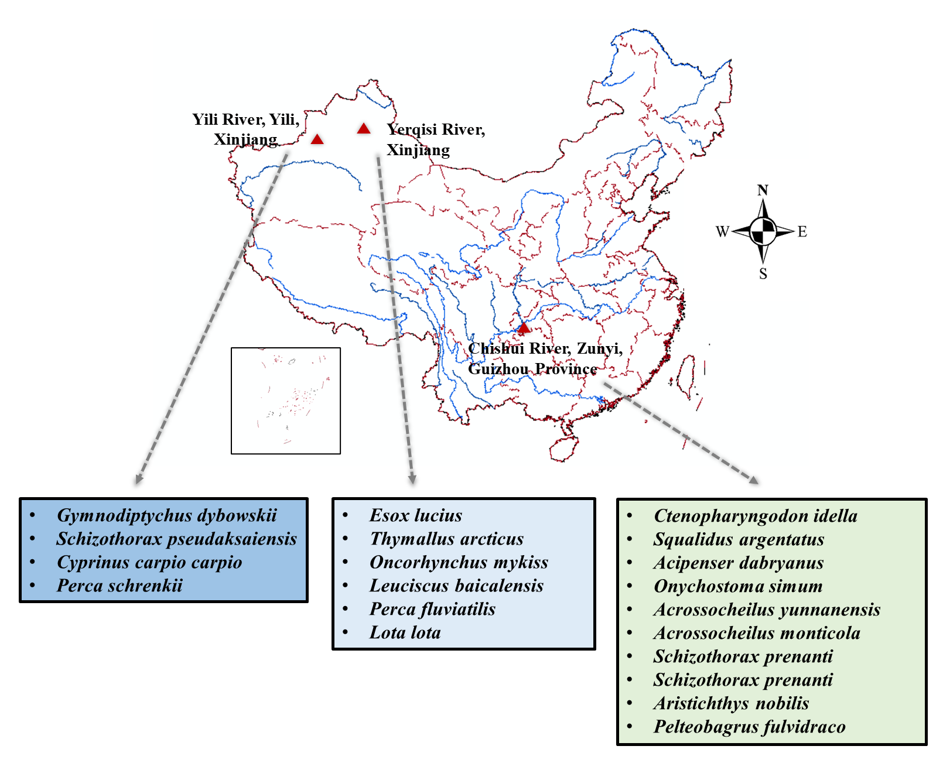
- Experimental settings and biological subjects. Experiments were conducted using fish collected from field sites in Guizhou and Xinjiang, China, covering diverse hydrodynamic and ecological contexts. The dataset included 20 fish species, with 10 species from Guizhou and 10 species from Xinjiang. These species differed in body morphology and were used to examine the occurrence and kinematic characteristics of Kármán gait across diverse biological subjects.

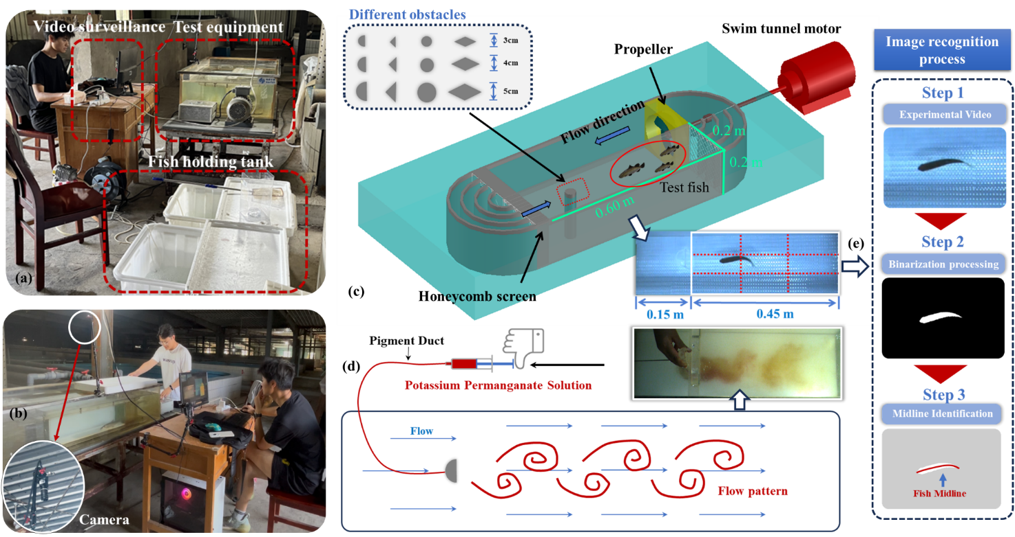
- Details of the experimental flume, flow visualization, and kinematic extraction. (a) Top-view photograph of the experimental apparatus. (b) Arrangement of the overhead camera used for kinematic recording. (c) Schematic of the experimental setup. Experiments were conducted in a recirculating swimming respirometer (Haixing Co., Ltd.) that generated a stable incoming flow. A cylindrical bluff body was mounted vertically in the test section to induce periodic vortex shedding and form an organized Kármán vortex street. (d) Flow-visualization and kinematic-processing pipeline. Potassium permanganate ($\text{KMn}{\text{O}}_{\text{4}}$) solution was introduced upstream of the obstacle to visualize coherent wake structures and fish slaloming behaviour. Raw videos were processed using image binarization to isolate the fish silhouette, from which instantaneous body midlines were extracted for kinematic analysis.

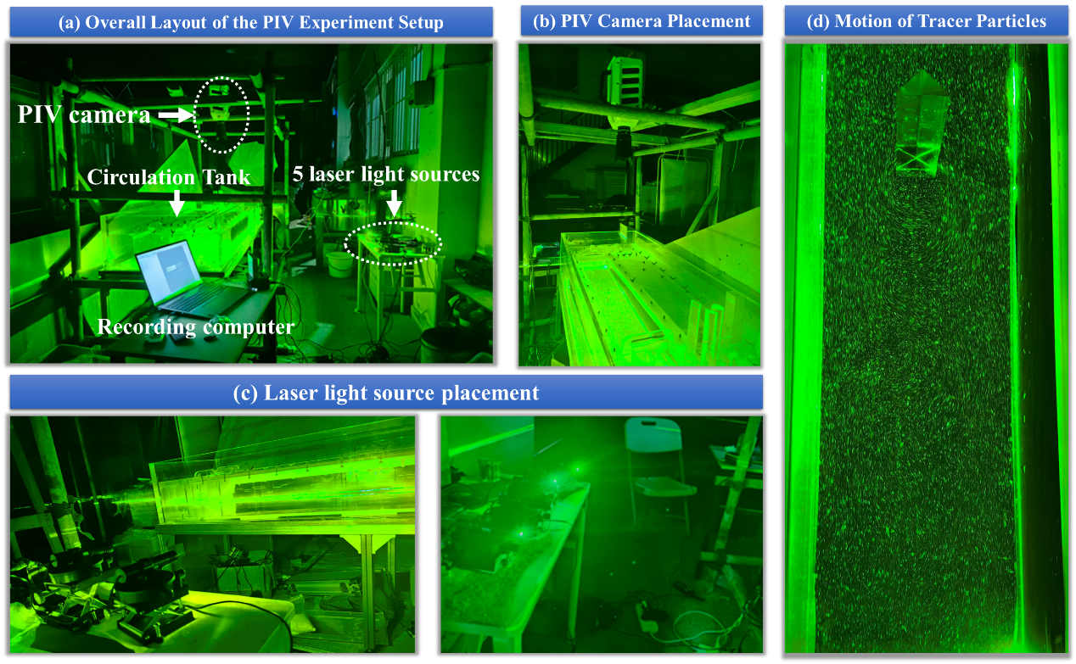
- Experimental arrangement for the time-resolved PIV measurements. The wake behind the bluff body was characterized using time-resolved particle image velocimetry (PIV). To resolve the flow structures directly interacting with the fish during Kármán gait, the measurement plane was aligned with the fish’s primary locomotion plane, approximately 5–7 cm above the bottom of the test section. Flow images were recorded at 2000 frames s⁻¹ using a high-speed camera (Qianlida Co., Ltd.). The flow was seeded with 100-mesh white, water-insoluble polystyrene particles, and the measurement plane was illuminated by a planar light sheet generated by five synchronized laser sources.
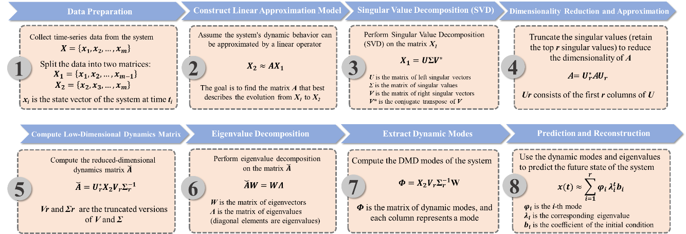
- Schematic overview of the Dynamic Mode Decomposition framework. Dynamic Mode Decomposition (DMD) was used to identify coherent spatiotemporal structures from sequential flow-field snapshots. The snapshots were organized into two time-shifted matrices, reduced using singular value decomposition and projected onto a low-dimensional linear evolution operator. Eigendecomposition of this operator yielded DMD modes with associated eigenvalues, which describe the spatial structure, oscillation frequency and temporal growth or decay of each mode.

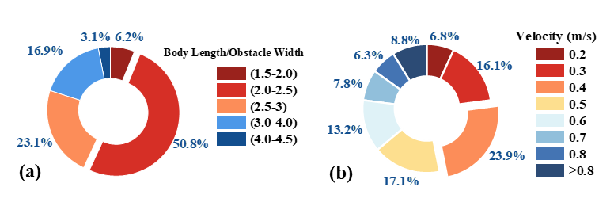
- Distribution of successful Kármán-gait occurrence conditions. Successful occurrence conditions were defined as experimental settings in which Kármán gait was visually confirmed at least once. The distributions summarize the proportion of successful cases grouped by (a) relative fish-to-bluff-body size ratio (BL/W) and (b) incoming flow velocity.
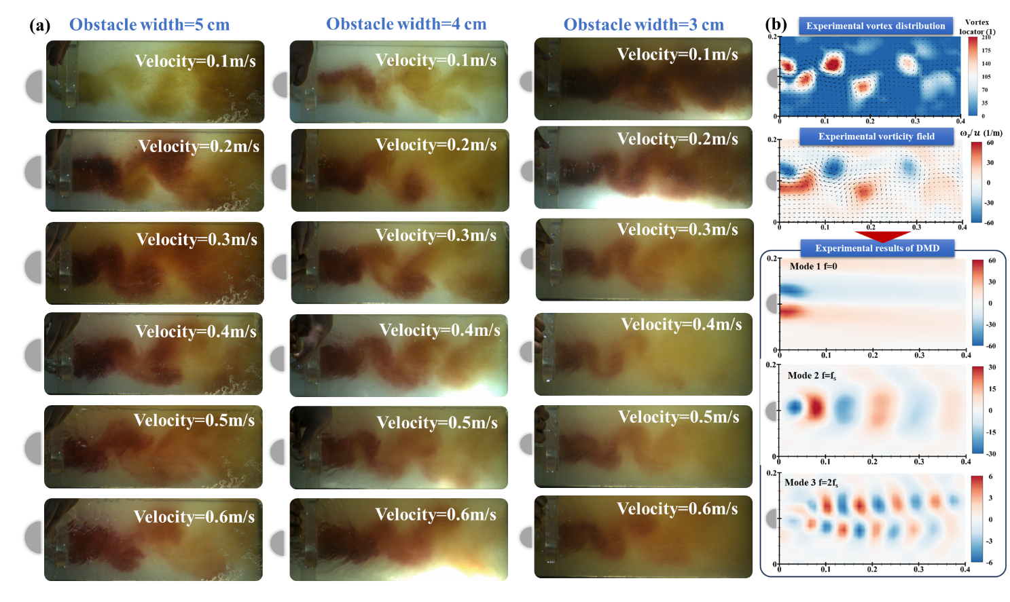
- Kinematic characterization and modal decomposition of the D-shaped-cylinder wake. (a) Dye-based flow visualization showing that the wake topology generated by the D-shaped cylinder remains broadly consistent across the tested cylinder sizes and freestream velocities. (b) PIV-based characterization of the wake and modal decomposition of the spatiotemporal vorticity field. The wake exhibits organized periodic vortex shedding, from which three leading coherent structures were identified. Mode 1 represents the stationary base flow (f=0), capturing the time-averaged background vorticity. Mode 2 corresponds to the fundamental vortex-shedding mode (f=f_{s}), associated with alternating vortex formation and streamwise periodicity. Mode 3 corresponds to the first harmonic (f=2f_{s}), showing an antisymmetric spatial structure across the wake centerline and periodic streamwise fluctuations.
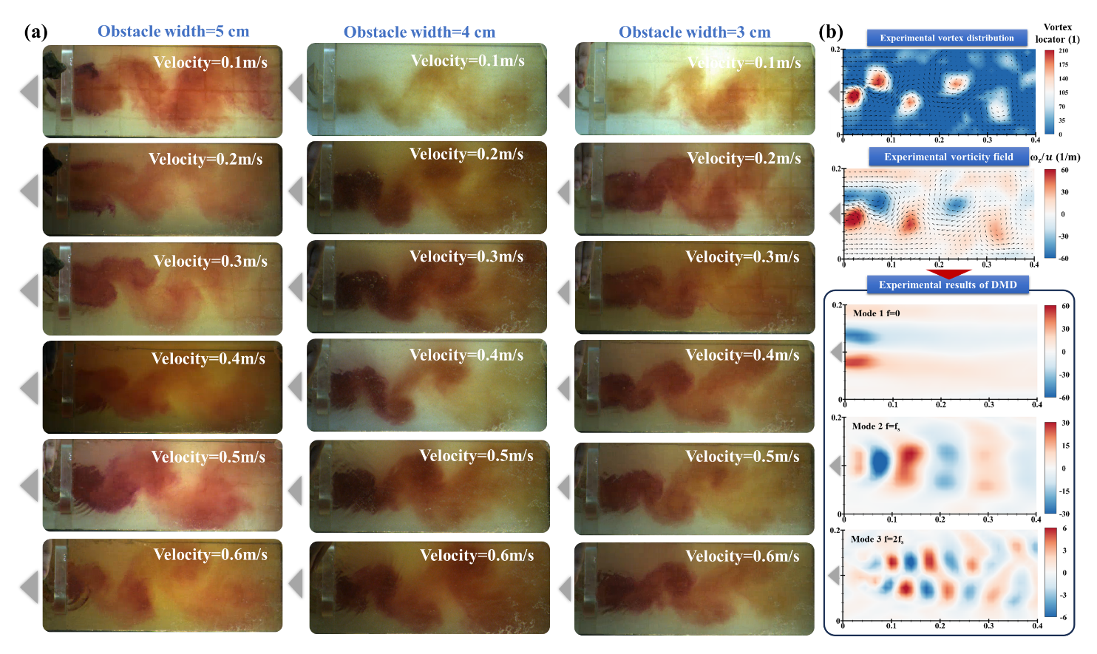
- Wake characterization and modal decomposition behind the triangular cylinder. (a) Dye-based flow visualization showing organized vortex shedding behind the triangular cylinder across the tested cylinder sizes and freestream velocities. (b) PIV-based characterization of the wake and modal decomposition of the spatiotemporal vorticity field. The triangular cylinder generated a coherent vortex street with leading modal structures comparable to those observed behind the D-shaped cylinder, including a stationary base-flow component, a fundamental shedding mode and a higher-frequency harmonic component.
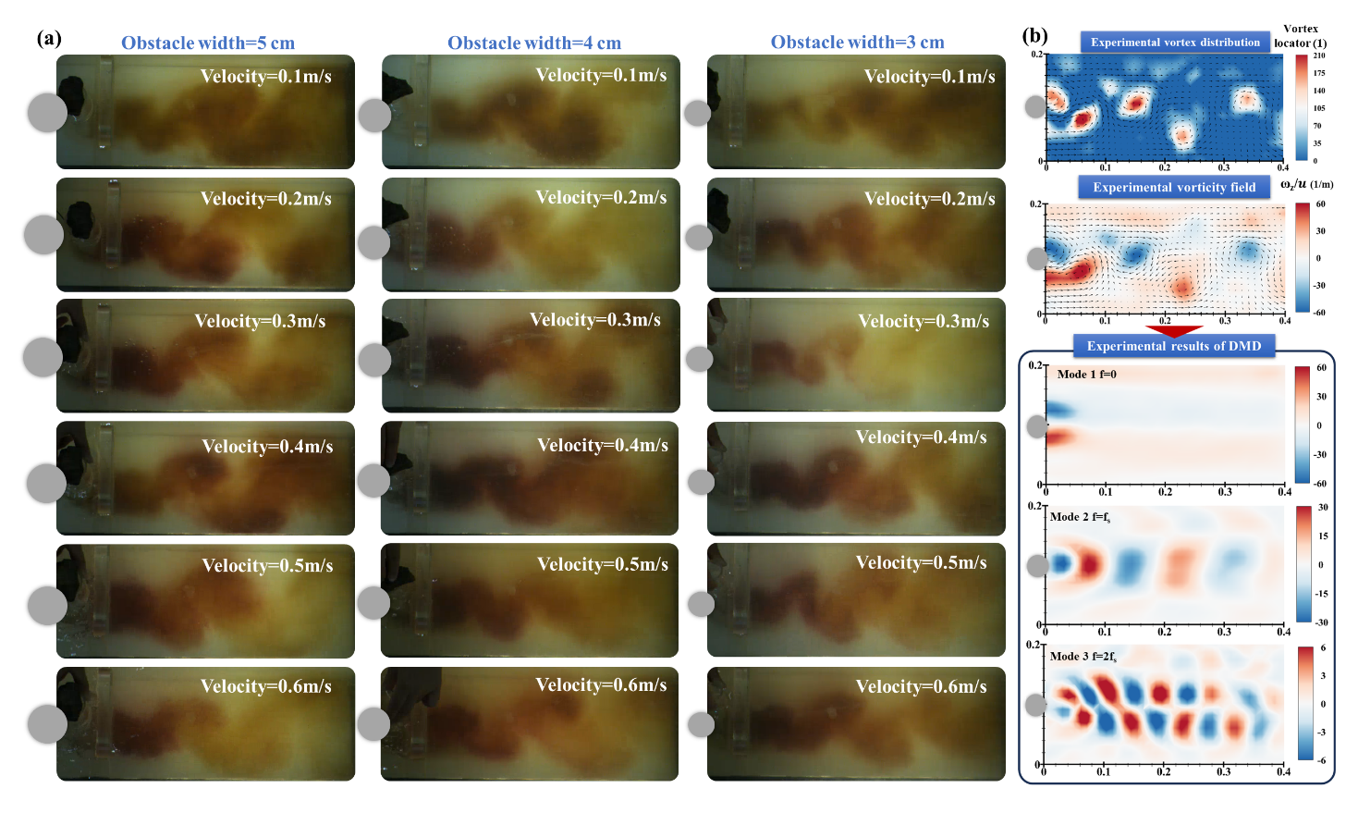
- Wake characterization and modal decomposition behind the circular cylinder. (a) Dye-based flow visualization showing organized vortex shedding behind the circular cylinder across the tested cylinder sizes and freestream velocities. (b) PIV-based characterization of the wake and modal decomposition of the spatiotemporal vorticity field. The circular cylinder produced a periodic wake with leading coherent structures corresponding to the time-averaged wake, the fundamental vortex-shedding mode and the first harmonic component.

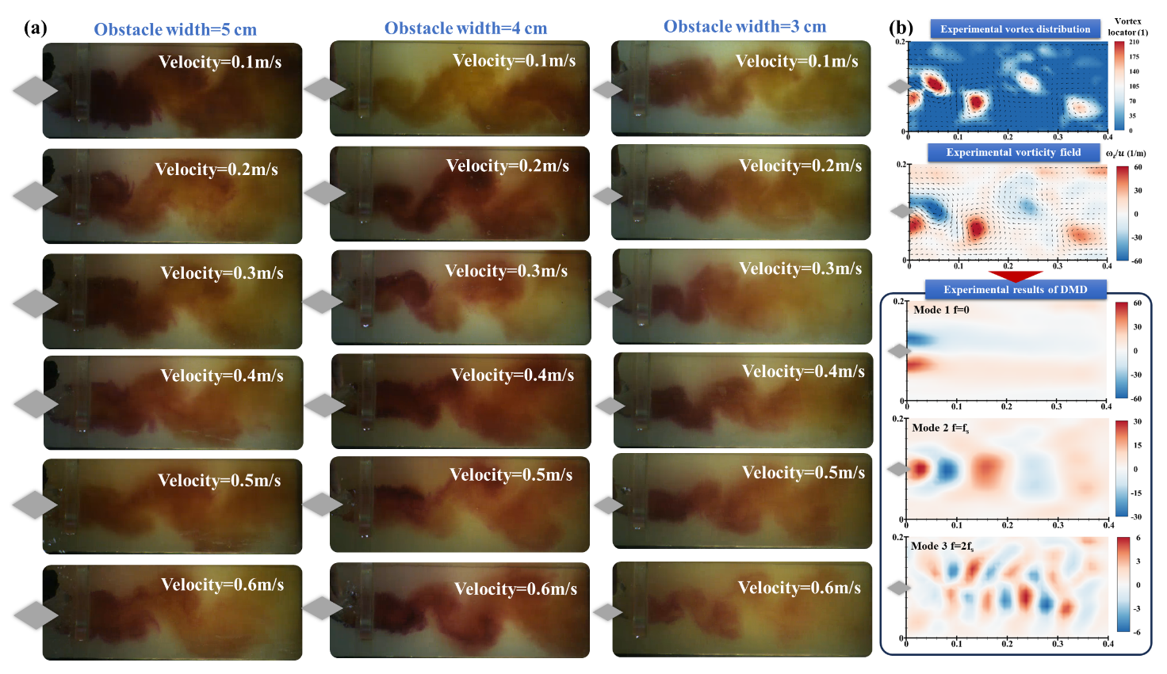
- Wake characterization and modal decomposition behind the rhombus cylinder. (a) Dye-based flow visualization showing organized vortex shedding behind the rhombus cylinder across the tested cylinder sizes and freestream velocities. (b) PIV-based characterization of the wake and modal decomposition of the spatiotemporal vorticity field. The rhombus-cylinder wake showed leading coherent structures similar to those identified for the D-shaped, triangular and circular cylinders. Across the four bluff-body geometries, the dominant wake organization was broadly conserved, with a stationary base-flow component, a fundamental shedding mode and a harmonic component. This similarity in wake structure provides a hydrodynamic basis for comparing Kármán-gait responses across different obstacle shapes and is consistent with the observed lack of a significant difference in Kármán-gait occurrence among the tested bluff bodies.
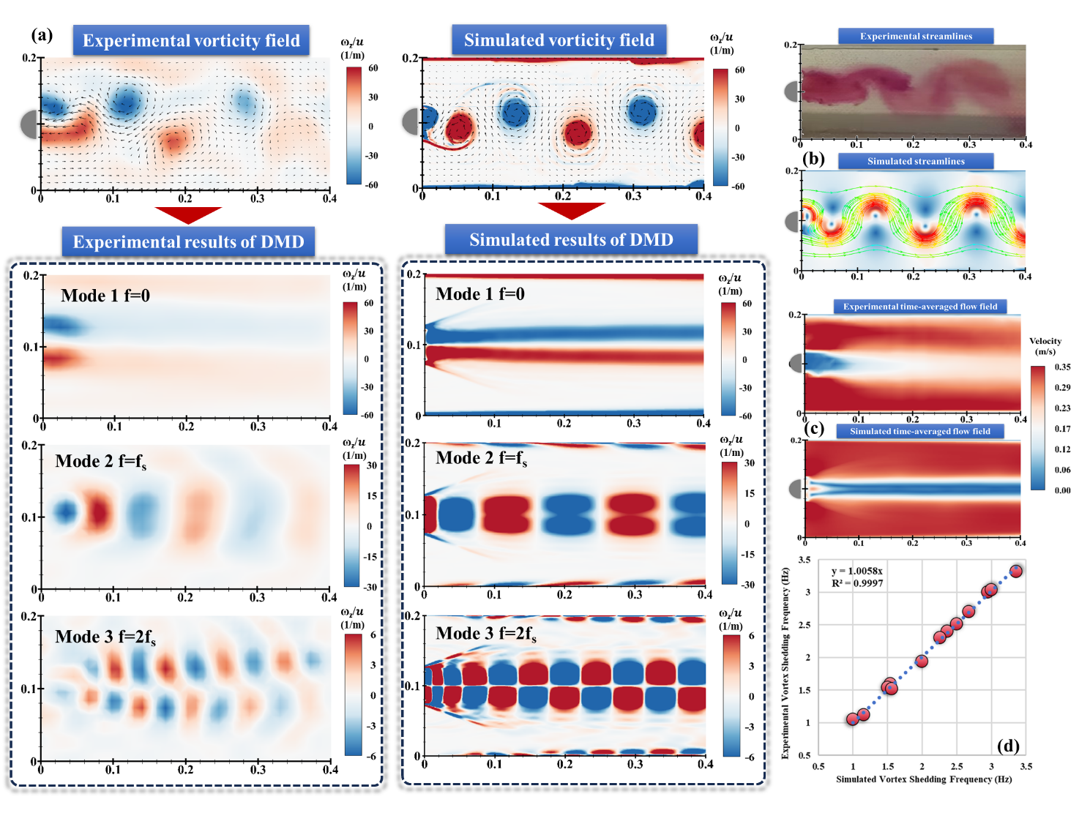
- Qualitative and quantitative validation of the CFD model against PIV measurements. The computational fluid dynamics (CFD) model was validated by comparing simulated wake dynamics with particle image velocimetry (PIV) measurements. (a) Measured and simulated spatiotemporal vorticity fields and their modal decompositions. The CFD model reproduced the main wake topology and the three leading coherent structures identified from PIV. (b) Measured and simulated streamline patterns, showing consistent large-scale wake organization. (c) Time-averaged velocity fields from PIV and CFD, indicate that the model captured the wake momentum deficit and the low-velocity recirculation region downstream of the bluff body. (d) Vortex-shedding frequencies estimated from PIV and CFD, showing close agreement across the tested cases ($R^{2}≈1.0$). These validation results support the use of the CFD model for pressure-field reconstruction and subsequent hydrodynamic force analysis.

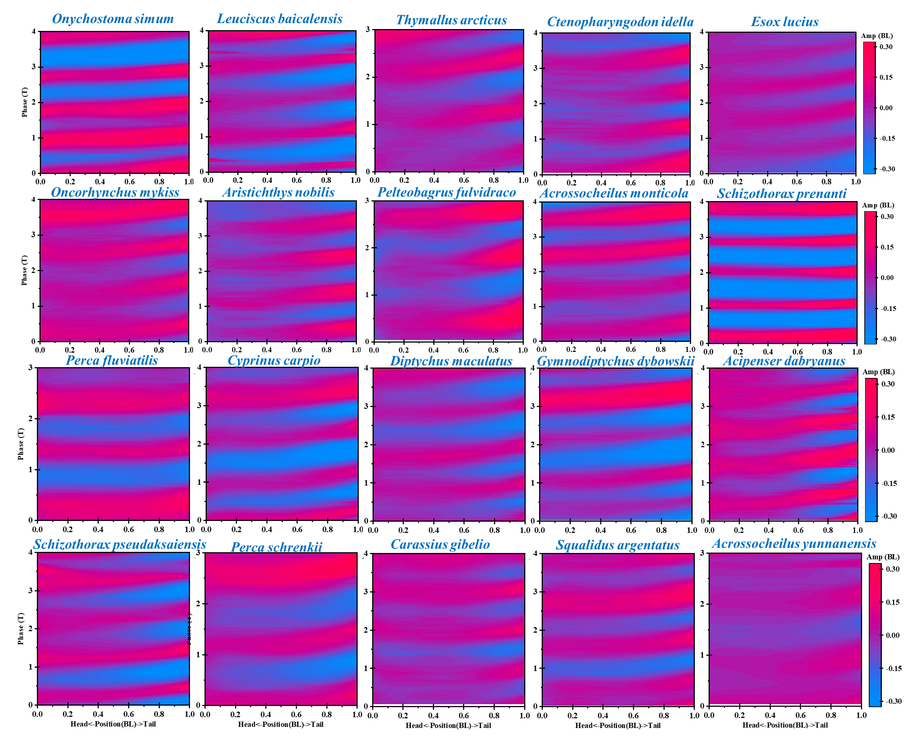
- Kinematic envelopes of 20 fish species during Kármán gait. Body deformation profiles were quantified across 20 taxonomically and morphologically diverse fish species during Kármán gait. Despite interspecific differences in body shape and size, the fish exhibited broadly similar slaloming envelopes and posterior body-wave patterns when interacting with the vortex street. This cross-species consistency supports the interpretation that Kármán gait is organized by a common body–wake interaction mechanism, while allowing for species-specific variation in detailed kinematics.
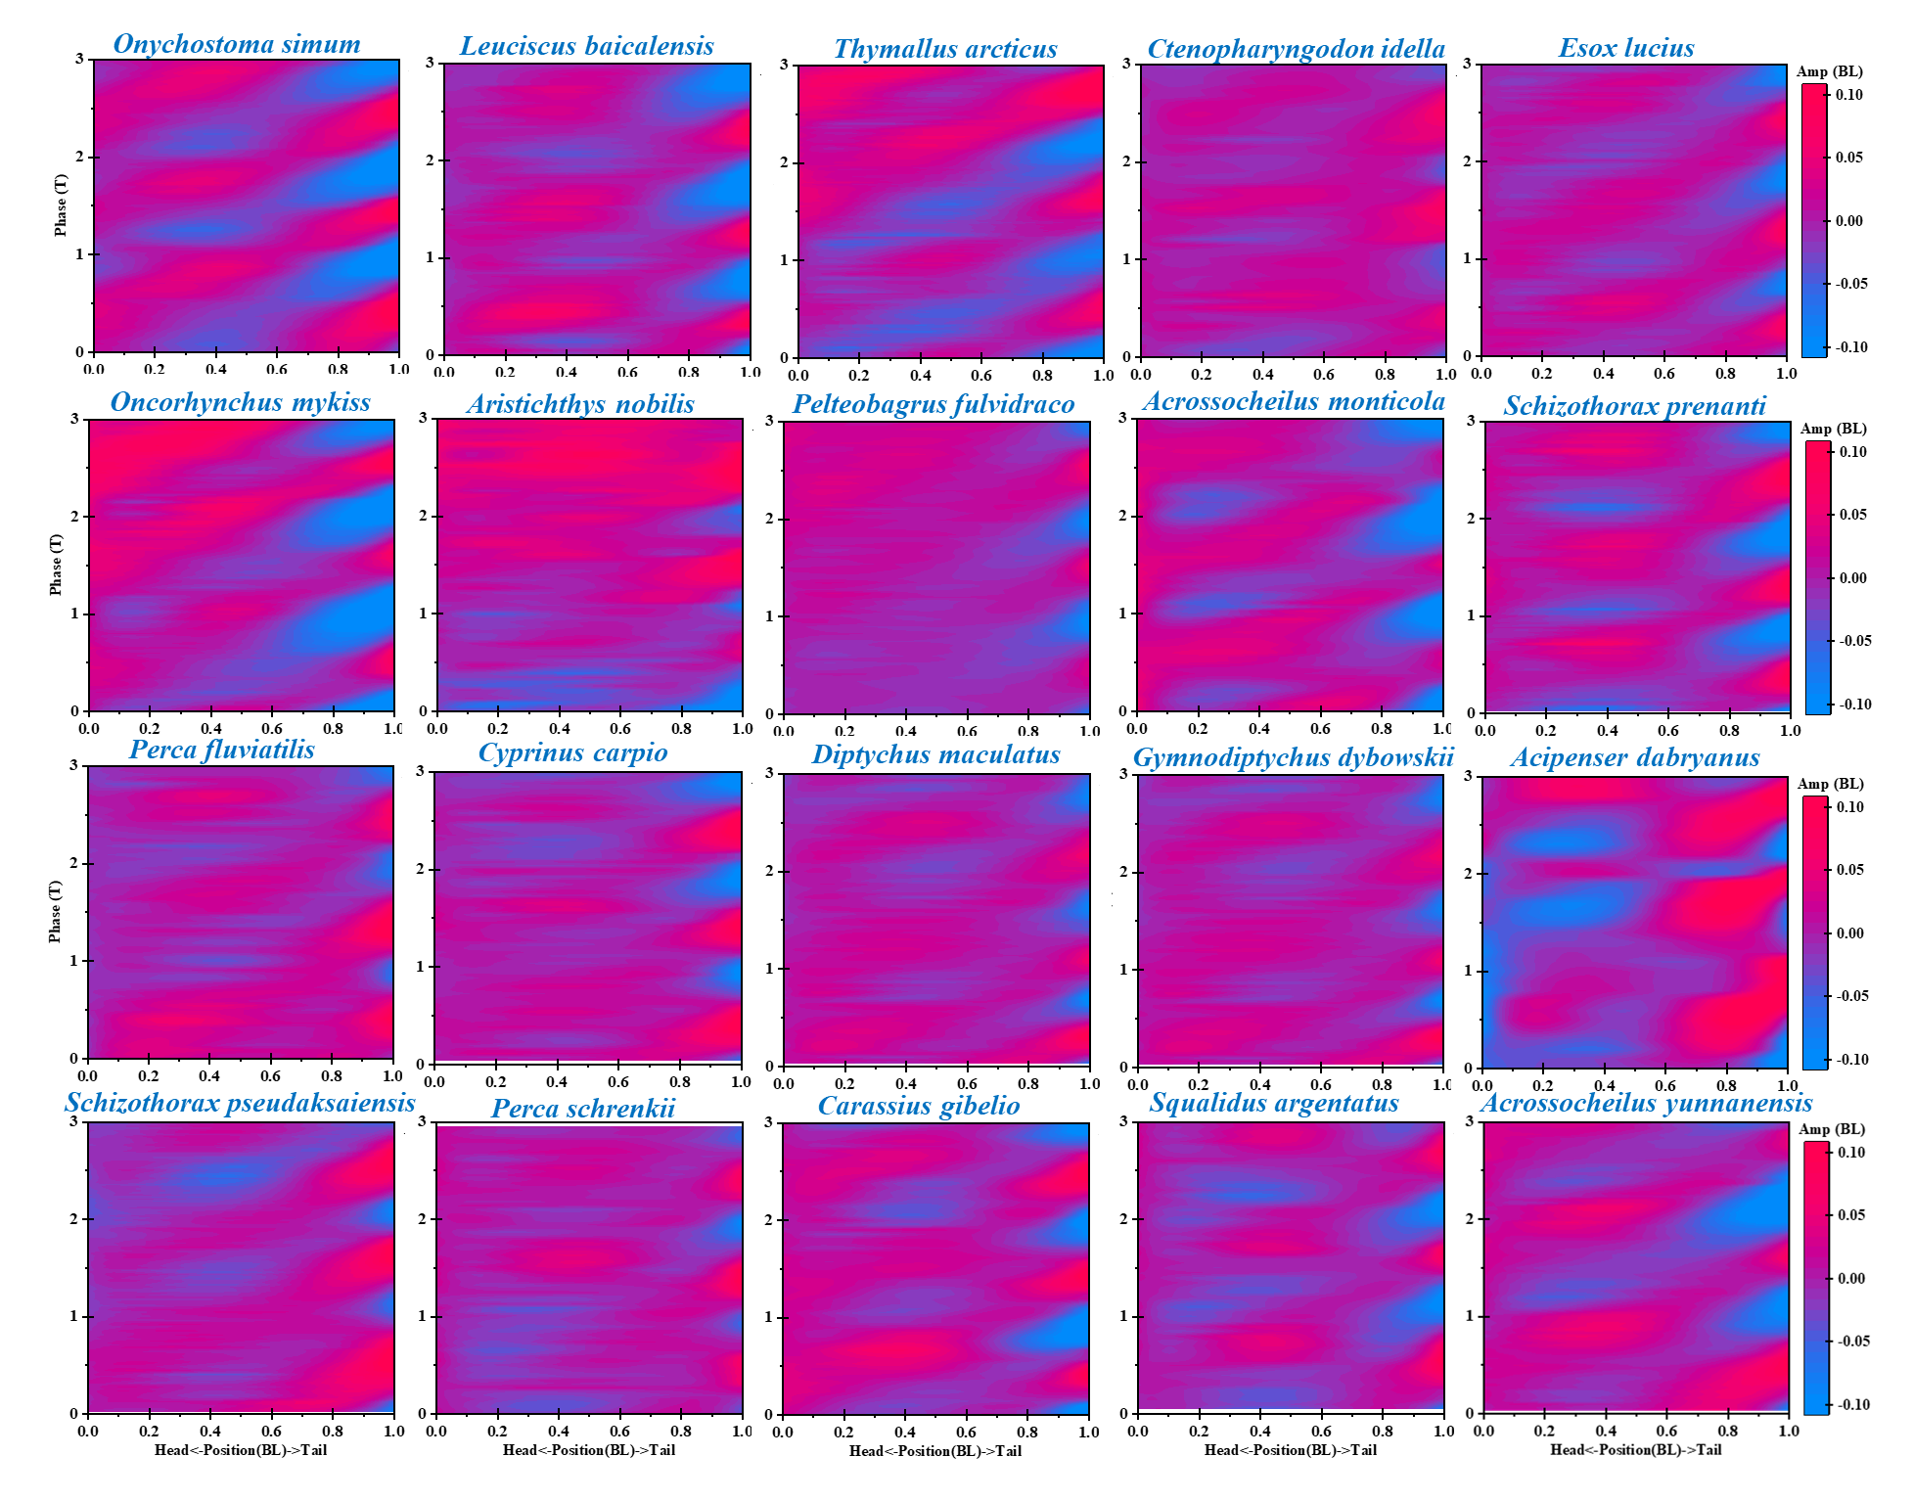
- Baseline midline kinematics during undulatory swimming across fish taxa. Steady free-stream swimming kinematics were quantified across the same 20 fish species as a control for the Kármán-gait analyses. Body deformation profiles during baseline undulatory swimming showed broadly comparable tail-beating patterns across taxa, while differing from the wake-induced slaloming envelopes observed during Kármán gait (Fig. S11). This comparison provides a baseline for distinguishing normal active undulatory swimming from the wake-organized kinematics of Kármán gait.

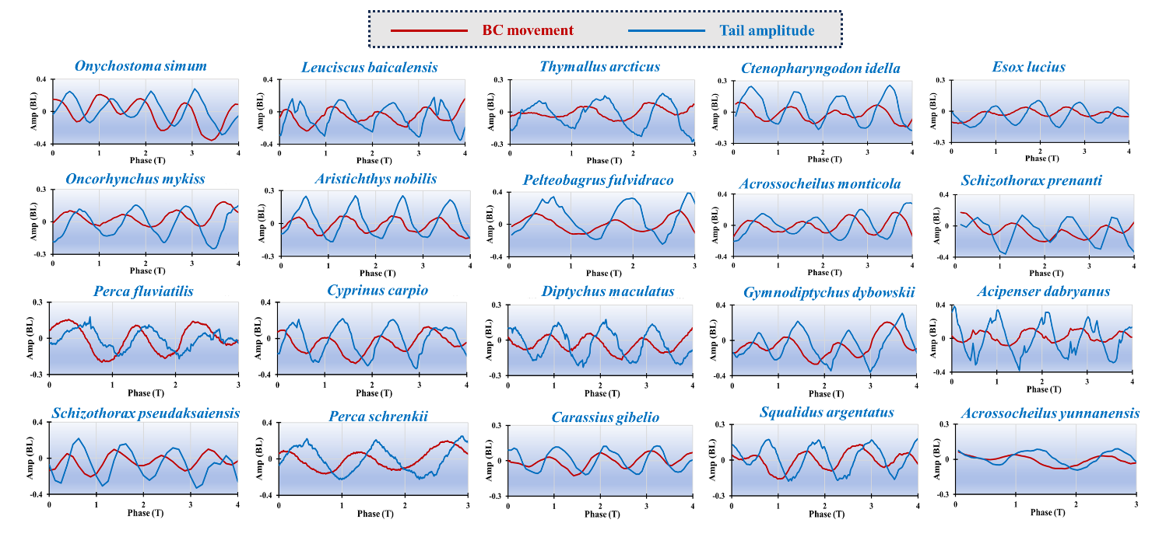
- Cross-species phase locking during Kármán gait. Kinematic phase relationships were quantified across 20 taxonomically and morphologically diverse fish species during Kármán gait. The phase difference between body-center motion (L_{c}) and tail-tip oscillation (L_{t}) clustered near (-0.5π) across species, indicating a consistent body-center–tail phase relationship during wake-induced slaloming. Together with the phase-dependent hydrodynamic loading analysis (Fig. S18), this result supports the interpretation that Kármán gait is a wake-forced phase-locked state shaped by passive body–wake interaction and active stabilization, rather than a simple variant of normal undulatory swimming.
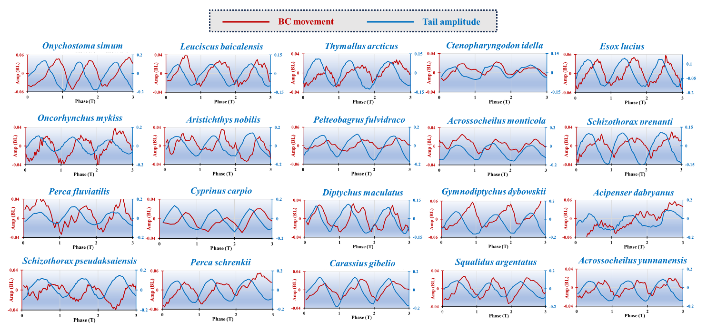
- Baseline phase relationship during steady undulatory swimming across 20 fish species. Kinematic phase relationships during steady free-stream swimming were quantified across the same 20 fish species used for the Kármán-gait analysis. During baseline undulatory swimming, the phase difference between body-center motion (L_{c}) and tail-tip oscillation (L_{t}) clustered near (+0.5π), indicating a near in-phase relationship between body-center and tail motion during active tail beating. This baseline phase organization differs from the half-cycle phase offset observed during Kármán gait (Fig. S13), supporting the interpretation that Kármán gait is a distinct wake-forced phase-locked state rather than a direct extension of normal undulatory swimming.

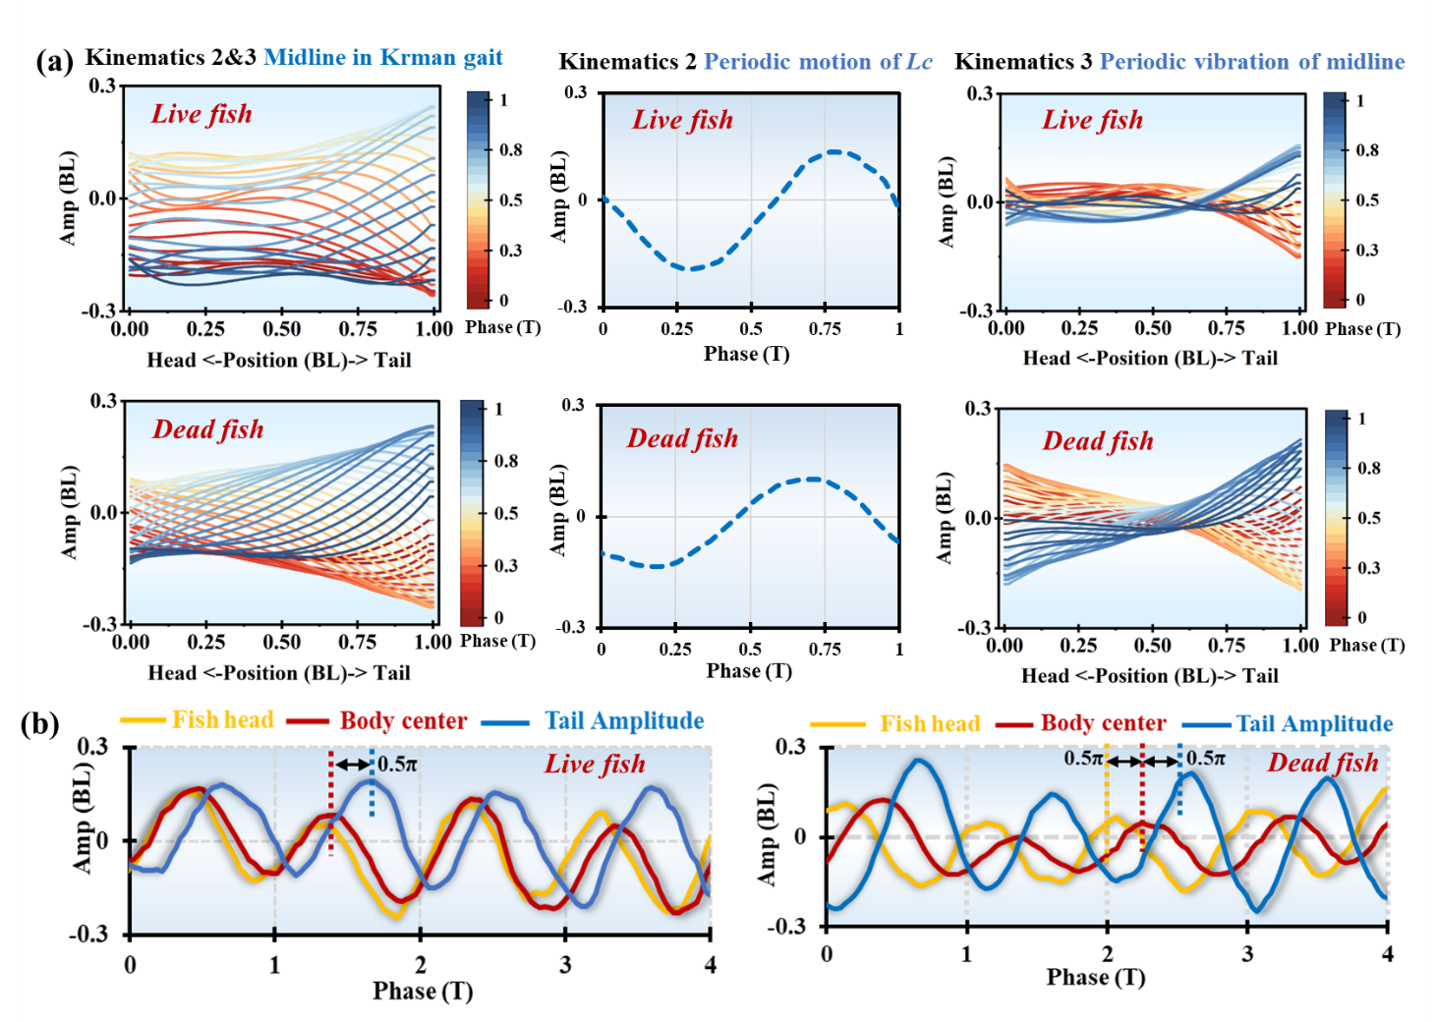
- Comparison of kinematic mode composition in live and dead fish during Kármán gait. (a) Decomposition of live- and dead-fish kinematics into two components: periodic body-center motion and body-wave propagation. The similar decomposition observed in both live and dead fish indicates that the global motion of Kármán gait can be represented as the superposition of a body-center oscillation mode and a body-wave mode. (b) Phase relationships among head, body center and tail motion. The body-center–tail phase structure is similar in live and dead fish, whereas the head phase differs more strongly. This supports the interpretation that the dominant body-wave organization of Kármán gait is largely maintained by passive body–wake interaction, while active control is retained mainly in the head region.

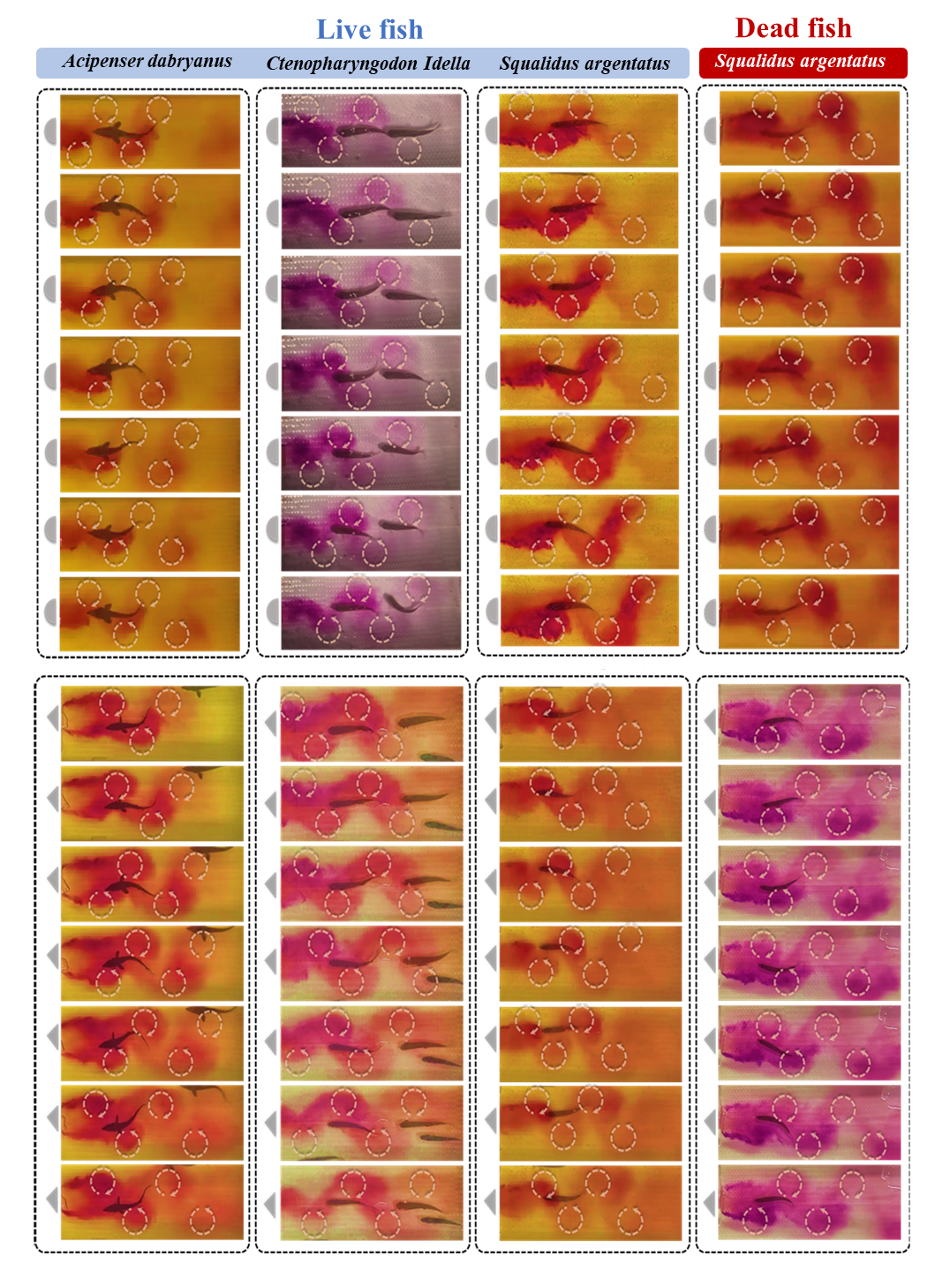
- Live and post-mortem fish responses in representative vortex streets. Representative live and post-mortem fish were compared in wakes generated by D-shaped and triangular cylinders to examine whether the gross Kármán-gait pattern persists without active swimming. Across the tested species and wake geometries, both live and post-mortem fish exhibited broadly similar vortex-slaloming trajectories and posterior body-wave patterns. These observations support the interpretation that the global organization of Kármán gait is strongly shaped by passive body–wake interaction, while allowing for active modulation in live fish.
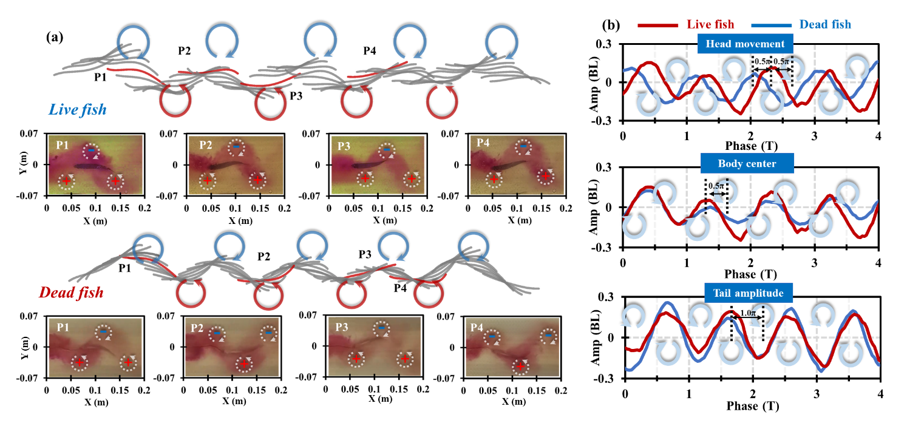
- Spatiotemporal alignment and regional amplitudes of live and post-mortem fish during Kármán gait. (a) Representative snapshots and schematics showing the relative alignment between the fish body and successive vortices during Kármán gait. Key phases, P1–P4, indicate characteristic positions of the fish body within the vortex street over one cycle. (b) Time series of lateral displacement or oscillation amplitude at the head, body center and tail in live and post-mortem fish. Body-center and tail motions show broadly similar temporal patterns between live and post-mortem conditions, whereas the head region exhibits larger live–dead differences. These results support a passive-dominated body–wake organization of Kármán gait, with active stabilization concentrated mainly in the anterior body.
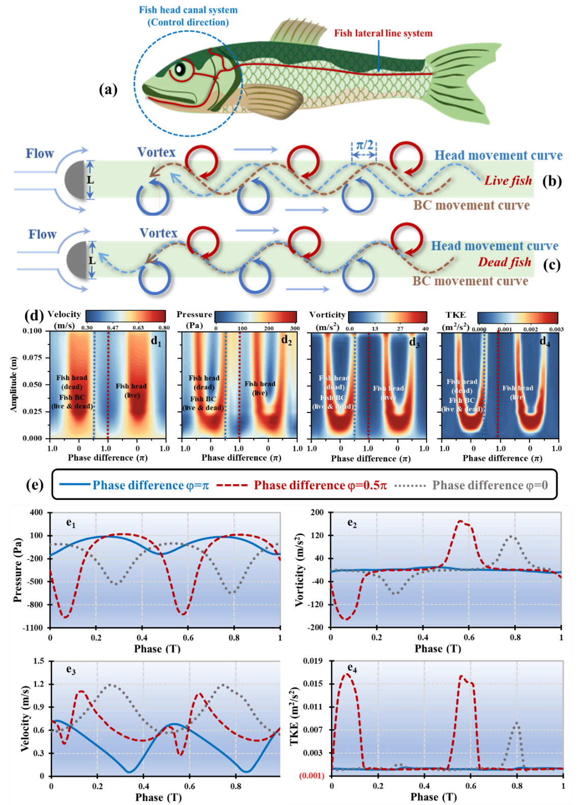
- Phase-dependent hydrodynamic loading during wake synchronization. (a) Schematic representation of the head canal system, lateral-line system and body locations used for phase-dependent hydrodynamic analysis. (b, c) Representative trajectories of the head and body center during wake synchronization in live and post-mortem fish. Live fish tend to route the head through inter-vortex gaps, whereas the body center follows a slaloming trajectory through the wake corridor. (d) Hydrodynamic loading mapped across prescribed phase relationships and lateral amplitudes, showing the spatial distribution of pressure, velocity, vorticity and turbulent kinetic energy experienced by the body trajectory. (e) Time series of hydrodynamic quantities along representative phase relationships. The ($=0.5π$) condition shows elevated pressure variation, vorticity, velocity and turbulent kinetic energy compared with the ($=0$) and ($=π$) reference conditions, indicating stronger wake–body interaction near the Kármán-gait phase relationship. These results are consistent with enhanced wake-mediated forcing and energy transfer during phase-locked Kármán gait.
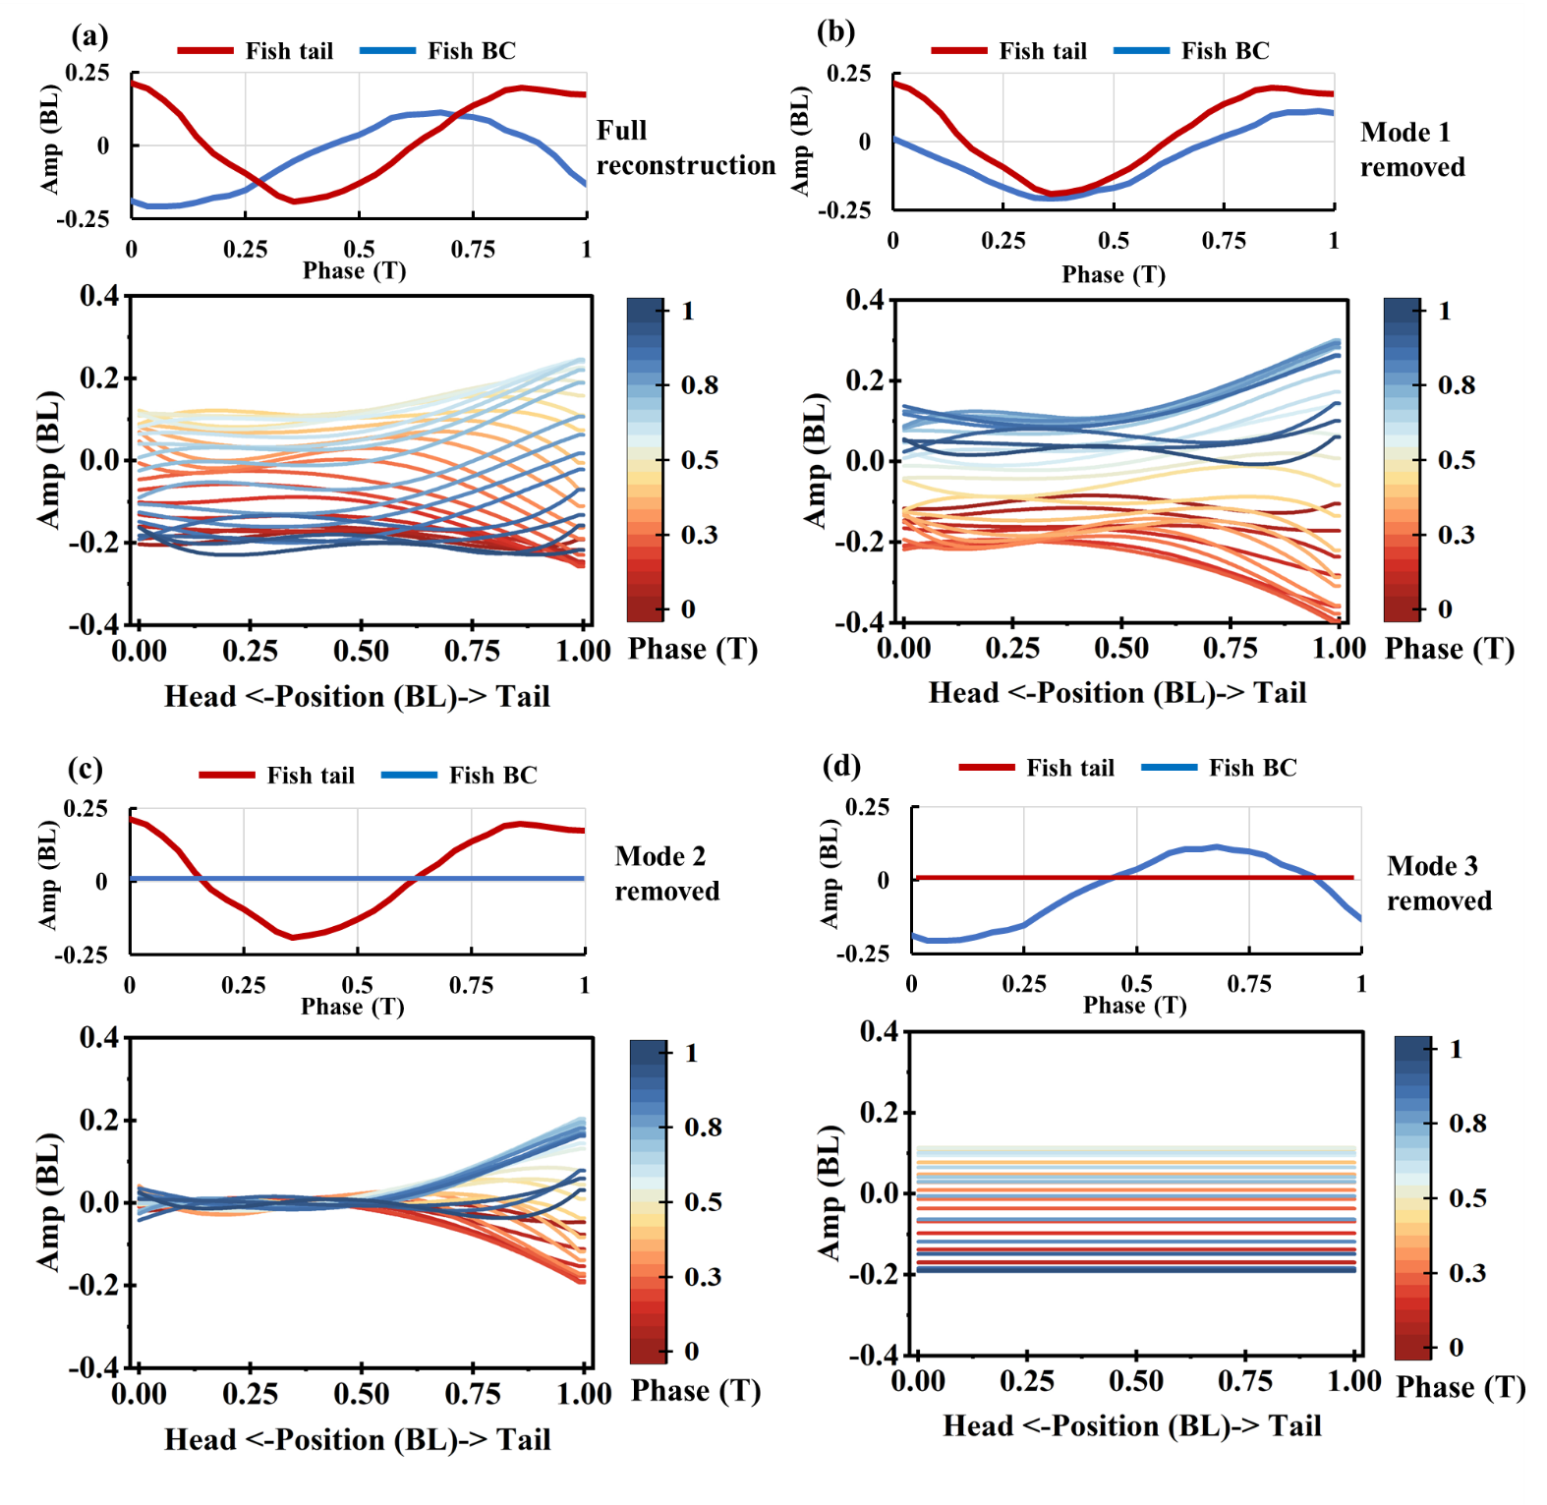
- Mode-dependence analysis of reconstructed Kármán-gait body motion. (a) Full reconstruction of the fish-body response, showing coordinated body-center oscillation, tail motion and body-wave propagation over one cycle. (b) Removing Mode 1 disrupts lateral confinement of the reconstructed body profiles, indicating that Mode 1 contributes to the restoring corridor that confines the fish body within the vortex street. (c) Removing Mode 2 strongly suppresses body-center oscillation while partially preserving posterior deformation, indicating that Mode 2 drives periodic body-center slaloming. (d) Removing Mode 3 suppresses tail motion and downstream body-wave propagation while partially retaining body-center motion, indicating that Mode 3 contributes primarily to tail-amplitude development and body-wave propagation. Red and blue curves denote tail-tip and body-center displacements, respectively. Body profiles are coloured by normalized phase within one oscillation cycle.
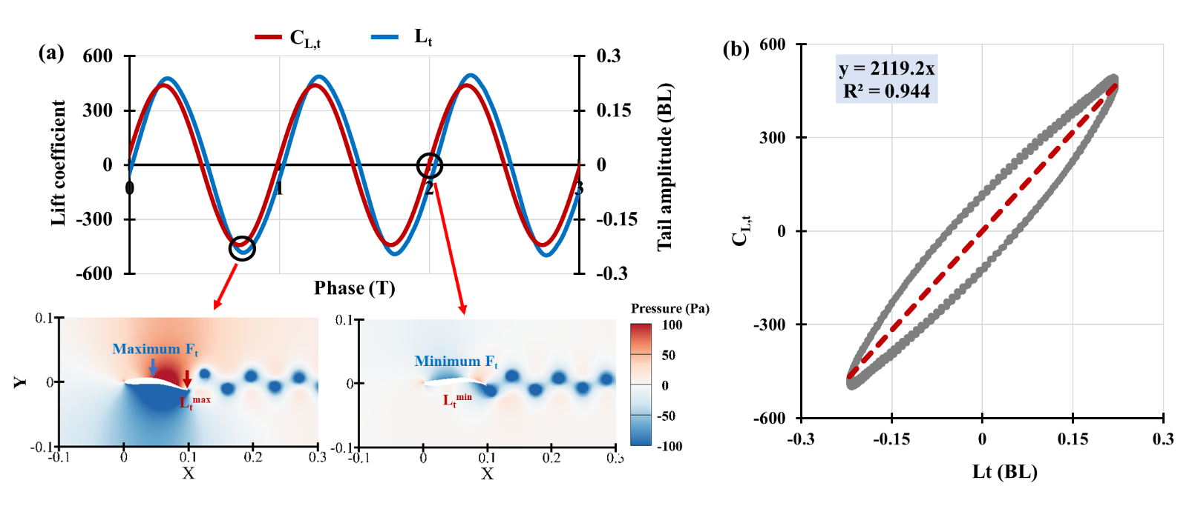
- Relationship between tail amplitude and tail-induced lateral force. (a) Time series of the tail-induced lateral force coefficient ($C_{L,t}$) and normalized tail-tip amplitude (L_{t}) obtained after removing body-center lateral displacement and prescribing only the Kármán-gait-derived tail motion. Pressure-field snapshots show the flow structures associated with the maximum and minimum tail-induced force (F_{t}). (b) $C_{L,t}$ scales approximately linearly with L_{t}, with $C_{L,t}=2119.2L_{t}$ and $R^{2}=0.944$. This relationship supports the representation of F_{t} as a tail-mediated force component linked to tail-amplitude variation in the wake-forced oscillator model.

Supplementary Tables
Summary: The supplementary tables provide detailed information on the experimental conditions, flow measurements, numerical simulations and modal interpretation supporting the main results. Table S1 summarizes the cross-species experimental cases used to identify Kármán-gait occurrence across bluff-body geometries, flow velocities and fish body sizes. Tables S2 and S3 document the PIV and flow-regime characterization cases used to verify the wake structures generated by different obstacles. Table S4 lists the representative fish–vortex interaction experiments used for live–post-mortem comparisons. Table S5 summarizes the numerical simulation cases used for CFD validation and tail-induced force reconstruction. Table S6 provides a qualitative summary of the mode-removal analysis and links each dominant wake mode to its primary kinematic function. Together, these tables support the repeatability of the experiments, the validation of the computational framework and the functional interpretation of the wake modes.

Table S1 Experimental cases used for cross-species Kármán-gait observations.
Bluff-bodyshape | Cases | Species | W (cm) | BL (cm) | Velocity range (m/s) | Kármán gait range (m/s) | Time (min) | Temp (°C)
Semicircle | 1 | Onychostoma simum | 3 | 12 | 0-1.3 | 1.0-1.2 | 65 | 20
Semicircle | 2 | Onychostoma simum | 4 | 12 | 0.4-0.8 | 0.5-0.6 | 16 | 20
Semicircle | 3 | Onychostoma simum | 5 | 12 | 0-0.6 | 0.4-0.6 | 30 | 20
Semicircle | 4 | Onychostoma simum | 5 | 18 | 0-0.6 | 0.2-0.6 | 28 | 20
Semicircle | 5 | Squalidus argentatus | 3 | 9 | 0-0.5 | 0.3-0.5 | 25 | 18
Semicircle | 6 | Squalidus argentatus | 4 | 9.5 | 0-0.6 | 0.2-0.4 | 30 | 18
Semicircle | 7 | Squalidus argentatus | 5 | 10.6 | 0-0.6 | 0.3-0.6 | 30 | 18
Semicircle | 8 | Squalidus argentatus | 5 | 9 | 0-0.6 | 0.2-0.4 | 26 | 18
Semicircle | 9 | Squalidus argentatus | 4 | 9 | 0-0.5 | 0.2-0.4 | 24 | 18
Semicircle | 10 | Squalidus argentatus | 3 | 9 | 0-0.6 | 0.3-0.6 | 29 | 18
Semicircle | 11 | Esox lucius | 7 | 22 | 0-0.7 | 0.5-0.7 | 35 | 19
Semicircle | 12 | Leuciscus baicalensis | 7 | 16 | 0-1.0 | 0.4,1.0 | 60 | 18
Semicircle | 13 | Thymallus arcticus | 7 | 16 | 0-0.4 | 0.3 | 18 | 18
Semicircle | 14 | Carassius gibelio | 7 | 14 | 0-0.5 | 0.2-0.5 | 23 | 19
Semicircle | 15 | Perca schrenkii | 7 | 14 | 0-0.5 | 0.2-0.5 | 23 | 17
Semicircle | 16 | Perca schrenkii | 5 | 14 | 0-1.1 | 0.7 | 55 | 17
Semicircle | 17 | Perca fluviatilis | 5 | 13 | 0-0.4 | 0.2-0.4 | 18 | 17
Semicircle | 18 | Perca fluviatilis | 7 | 14 | 0-0.4 | 0.2-0.4 | 17 | 17
Semicircle | 19 | Oncorhynchus mykiss | 3 | 9 | 0-0.9 | 0.4,0.8,0.9 | 55 | 18
Semicircle | 20 | Oncorhynchus mykiss | 5 | 10.5 | 0-0.8 | 0.3-0.8 | 38 | 18
Semicircle | 21 | Cyprinus carpio | 7 | 16 | 0-0.8 | 0.3-0.8 | 40 | 19
Semicircle | 22 | Diptychus maculatus | 7 | 17 | 0-0.5 | 0.3-0.5 | 22 | 19
Semicircle | 23 | Gymnodiptychus dybowskii | 7 | 15 | 0.6-0.7 | 0.6-0.7 | 51 | 17
Semicircle | 24 | Schizothorax pseudaksaiensis | 7 | 16 | 0-1.0 | 0.2-1.0 | 48 | 18
Semicircle | 25 | Acrossocheilus monticola | 5 | 12 | 0-0.6 | 0.4-0.6 | 27.5 | 18
Semicircle | 26 | Acrossocheilus monticola | 5 | 12 | 0-0.6 | 0.4-0.6 | 27 | 18
Semicircle | 27 | Acrossocheilus yunnanensis | 5 | 10 | 0.4-0.6 | 0.4 | 15 | 18
Semicircle | 28 | Acrossocheilus yunnanensis | 3 | 8 | 0-0.6 | 0.4 | 28 | 18
Semicircle | 29 | Acrossocheilus yunnanensis | 4 | 10 | 0-0.6 | 0.4 | 28 | 18
Semicircle | 30 | Acrossocheilus yunnanensis | 5 | 10 | 0-0.6 | 0.4-0.5 | 28 | 18
Semicircle | 31 | Acrossocheilus yunnanensis | 3 | 5 | 0-0.6 | 0.4 | 31 | 18
Semicircle | 32 | Acipenser dabryanus | 4 | 14.5 | 0.3-0.4 | 0.3-0.4 | 30 | 17
Triangle | 33 | Onychostoma simum | 3 | 12 | 0-1.5 | 0.7-1.5 | 65 | 20
Triangle | 34 | Onychostoma simum | 5 | 18 | 0.6-0.8 | 0.6-0.8 | 17 | 20
Triangle | 35 | Onychostoma simum | 5 | 18 | 0.6-0.8 | 0.6-0.8 | 12 | 20
Triangle | 36 | Onychostoma simum | 4 | 13 | 0-0.8 | 0.6-0.7 | 39 | 20
Triangle | 37 | Onychostoma simum | 4 | 15 | 0-1.0 | 0.7-1.0 | 51 | 20
Triangle | 38 | Acrossocheilus monticola | 5 | 12 | 0.5-1.0 | 0.5-1.0 | 25 | 17
Triangle | 39 | Acrossocheilus monticola | 5 | 12 | 0-0.5 | 0.4-0.5 | 25 | 17
Triangle | 40 | Squalidus argentatus | 5 | 12 | 0.5-1.0 | 0.5-1.1 | 22.5 | 19
Triangle | 41 | Squalidus argentatus | 5 | 12 | 0-0.5 | 0.4 | 23 | 19
Triangle | 42 | Squalidus argentatus | 4 | 9 | 0-0.4 | 0.3 | 19.5 | 19
Triangle | 43 | Squalidus argentatus | 5 | 11 | 0-0.6 | 0.3-0.6 | 29.5 | 19
Triangle | 44 | Squalidus argentatus | 4 | 11 | 0-0.5 | 0.2-0.5 | 36.75 | 19
Triangle | 45 | Squalidus argentatus | 3 | 9 | 0-0.6 | 0.3-0.6 | 29 | 19
Triangle | 46 | Squalidus argentatus | 4 | 9 | 0-0.5 | 0.2-0.5 | 21.5 | 19
Triangle | 47 | Squalidus argentatus | 5 | 9 | 0-0.6 | 0.3-0.6 | 32 | 19
Triangle | 48 | Acipenser dabryanus | 4 | 14.5 | 0.3-0.4 | 0.3-0.4 | 30 | 18
Triangle | 49 | Ctenopharyngodon idella | 4 | 11 | 0.3-0.4 | 0.3-0.4 | 40 | 19
Circle | 50 | Schizothorax prenanti | 5 | 10 | 0-1.0 | 0.5-0.8 | 58 | 20
Circle | 51 | Onychostoma simum | 4 | 12 | 0-0.8 | 0.4-0.8 | 39 | 18
Circle | 52 | Onychostoma simum | 5 | 12 | 0-0.8 | 0.4-0.7 | 40 | 18
Circle | 53 | Squalidus argentatus | 5 | 10 | 0-0.6 | 0.3-0.4 | 28 | 19
Circle | 54 | Squalidus argentatus | 5 | 9 | 0.4 | 0.4 | 5 | 19
Circle | 55 | Squalidus argentatus | 4 | 9 | 0-0.6 | 0.3-0.6 | 29 | 19
Circle | 56 | Squalidus argentatus | 3 | 9 | 0-0.6 | 0.3-0.6 | 30 | 19
Circle | 57 | Squalidus argentatus | 5 | 11 | 0-0.6 | 0.2-0.6 | 29.5 | 18
Circle | 58 | Aristichthys nobilis | 5 | 11 | 0-1.0 | 0.4-0.6 | 50 | 17
Circle | 59 | Aristichthys nobilis | 3 | 10 | 0-1.0 | 0.4-0.6 | 52.5 | 17
Circle | 60 | Ctenopharyngodon idella | 3 | 11 | 0-1.2 | 0.5 | 64 | 19
Rhombus | 61 | Acipenser dabryanus | 4 | 14.5 | 0.3-0.4 | 0.3-0.4 | 10 | 16
Rhombus | 62 | Ctenopharyngodon idella | 4 | 11 | 0.3-0.4 | 0.3-0.4 | 10 | 16
Rhombus | 63 | Squalidus argentatus | 4 | 11 | 0.3-0.4 | 0.3-0.4 | 12 | 16
Rhombus | 64 | Aristichthys nobilis | 5 | 11 | 0-0.6 | 0.2-0.5 | 30 | 16
Rhombus | 65 | Pelteobagrus fulvidraco | 5 | 14 | 0-0.5 | 0.2-0.4 | 25 | 16

Table S2 Experimental conditions for PIV wake measurements.
Bluff-body shape | Cases | Species & Body length | W (cm) | Velocity range (m/s) | Time（s） | Temp (°C)
Semicircle | 1 | No fish | 5 | 0.2-0.5 | 60 | 18
Triangle | 2 | No fish | 5 | 0.2-0.5 | 60 | 18
Circle | 3 | No fish | 5 | 0.2-0.5 | 60 | 18
Rhombus | 4 | No fish | 5 | 0.2-0.5 | 60 | 18
Semicircle | 5 | Squalidus argentatus, 12 cm | 5 | 0.4 | 15 | 18
Table S3 Flow-regime characterization across bluff-body geometries and obstacle widths.
Bluff-body shape | Cases | W (cm) | Velocity range (m/s) | Time (min) | Temp (°C)
Semicircle | 1 | 3 | 0.1-0.6 | 19 | 18
 | 2 | 4 | 0.1-0.6 | 18 | 18
 | 3 | 5 | 0.1-0.6 | 15 | 18
Triangle | 4 | 3 | 0.1-0.6 | 15 | 18
 | 5 | 4 | 0.1-0.6 | 21 | 18
 | 6 | 5 | 0.1-0.6 | 23 | 18
Circle | 7 | 3 | 0.1-0.6 | 13 | 18
 | 8 | 4 | 0.1-0.6 | 19 | 18
 | 9 | 5 | 0.1-0.6 | 19 | 18
Rhombus | 10 | 3 | 0.1-0.6 | 22 | 18
 | 11 | 4 | 0.1-0.6 | 30 | 18
 | 12 | 5 | 0.1-0.6 | 18 | 18
Table S4 Experimental cases for fish–vortex interaction and live–dead comparisons.
Bluff-body shape | Cases | Species | BL (cm) | W (cm) | Velocity (m/s) | Time (s) | Temp (°C)
Semicircle | 1 | Acipenser dabryanus | 14 | 5 | 0.4 | 10 | 18
Semicircle | 2 | Ctenopharyngodon idella | 12 | 5 | 0.4 | 10 | 18
Semicircle | 3 | Squalidus argentatus | 12 | 5 | 0.4 | 10 | 18
Semicircle | 4 | Squalidus argentatus (dead) | 12 | 5 | 0.4 | 10 | 18
Triangle | 5 | Acipenser dabryanus | 14 | 5 | 0.4 | 10 | 18
Triangle | 6 | Ctenopharyngodon idella | 12 | 5 | 0.4 | 10 | 18
Triangle | 7 | Squalidus argentatus | 12 | 5 | 0.4 | 10 | 18
Triangle | 8 | Squalidus argentatus (dead) | 12 | 5 | 0.4 | 10 | 18
Table S5 CFD validation and tail-induced force reconstruction.
Cases | Bluff-body shape | W (cm) | BL (cm) | Velocity inlet (m/s) | Simulation time(s) | Mesh Type
1 | Semicircle | 5 | NA | 0.4 | 15 | Static
2 | Kármán gait (lateral displacement disabled) | NA | 10 | 0.4 | 15 | Dynamic
Table S6 Functional consequences of removing individual wake modes from reconstructed Kármán-gait kinematics.
Condition | BC slaloming | Tail oscillation | Lateral confinement | Body-wave propagation | Main functional loss
Full reconstruction | Preserved | Preserved | Preserved | Preserved | None
Mode 1 removed | Preserved | Preserved | Lost | Preserved | Loss of restoring confinement
Mode 2 removed | Lost | Partially retained | Weakened | Partially retained | Suppressed BC slaloming
Mode 3 removed | Partially retained | Lost | Partially retained | Lost | Suppressed tail/body-wave propagation

References
1. Akanyeti O, Liao JC. The effect of flow speed and body size on Karman gait kinematics in rainbow trout. J Exp Biol 2013, 216(Pt 18): 3442-3449.
2. Akanyeti O, Liao JC. A kinematic model of Karman gaiting in rainbow trout. J Exp Biol 2013, 216(Pt 24): 4666-4677.
3. Liao JC, Beal DN, Lauder GV, Triantafyllou MS. The Karman gait: novel body kinematics of rainbow trout swimming in a vortex street. J Exp Biol 2003, 206(Pt 6): 1059-1073.
4. Schmid PJ. Dynamic mode decomposition of numerical and experimental data. J Fluid Mech 2010, 656: 5-28.
5. Hoover AP, Xu NW, Gemmell BJ, Colin SP, Costello JH, Dabiri JO, et al. Neuromechanical wave resonance in jellyfish swimming. Proceedings of the National Academy of Sciences of the United States of America 2021, 118(11).
6. Bhalla AP, Griffith BE, Patankar NA. A forced damped oscillation framework for undulatory swimming provides new insights into how propulsion arises in active and passive swimming. PLoS Comput Biol 2013, 9(6): e1003097.
7. Williamson CHK, Govardhan R. Vortex-induced vibrations. Annu Rev Fluid Mech 2004, 36: 413-455.

