Supplementary Material
Table of Contents
Table S1. Demographic and clinical characteristics of participants 2
Figure S1. Within- and between-person associations between linguistic features and suicidal ideation severity 3
Table S2. Full configuration grid: out-of-fold AUC (mean ± SD) 4
Figure S2. Confusion matrices for the selected configurations 8
Table S3. Bias-corrected (BBC-CV) discrimination with 95% percentile confidence intervals 9
Table S4. Component ablation: out-of-fold AUC (fold-mean) with 95% patient-cluster bootstrap CI 11

Table S1. Demographic and clinical characteristics of participants.
Characteristic | All participants  (n = 99) | Longitudinal analysis cohort (n = 84)
Age, years, mean (SD) | 30.3 (10.3) | 29.9 (9.5)
Female, n (%) | 78 (78.8) | 66 (78.6)
Education, years, mean (SD) | 14.1 (2.1) | 14.1 (2.1)
Marital status, n (%)
Never married | 73 (73.7) | 63 (75.0)
Married | 21 (21.2) | 17 (20.2)
Separated, divorced or widowed | 5 (5.1) | 4 (4.8)
Self-rated socioeconomic status, n (%)
Lowest | 3 (3.0) | 2 (2.4)
Low | 19 (19.2) | 17 (20.2)
Middle | 50 (50.5) | 42 (50.0)
High | 14 (14.1) | 13 (15.5)
Highest | 13 (13.1) | 10 (11.9)
Monthly household income, 10,000 KRW, mean (SD) | 434.8 (534.4) | 436.7 (562.2)
Urban residence, n (%) | 89 (89.9) | 76 (90.5)
Body mass index, mean (SD) | 24.6 (5.0) | 25.1 (4.9)
Bipolar I or II, n (%) | 74 (74.7) | 60 (71.4)
Bipolar disorder not otherwise specified, n (%) | 13 (13.1) | 13 (15.5)
Major depressive disorder, n (%) | 12 (12.1) | 11 (13.1)
Prior suicide attempt, n (%) | 12 (12.1) | 11 (13.1)
Family history of suicide, n (%) | 24 (24.2) | 20 (23.8)
Scale for Suicide Ideation, mean (SD) | 18.5 (9.4) | 18.1 (9.6)
Hamilton Depression Rating Scale, mean (SD) | 17.0 (4.8) | 16.8 (5.1)
Patient Health Questionnaire, mean (SD) | 15.5 (6.7) | 15.3 (6.9)
Beck Anxiety Inventory, mean (SD) | 23.6 (16.5) | 22.5 (16.3)
Antipsychotic dose, mean (SD) | 11.8 (15.5) | 12.4 (16.2)
Sessions contributed, mean (SD) | 3.4 (1.4) | 3.8 (1.1)
Values are mean (SD) or n (%), measured at the baseline session. The 15 patients who contributed a single session could not form a consecutive session pair and were therefore excluded from the longitudinal analyses.

Figure S1. Within- and between-person associations between linguistic features and suicidal ideation severity.
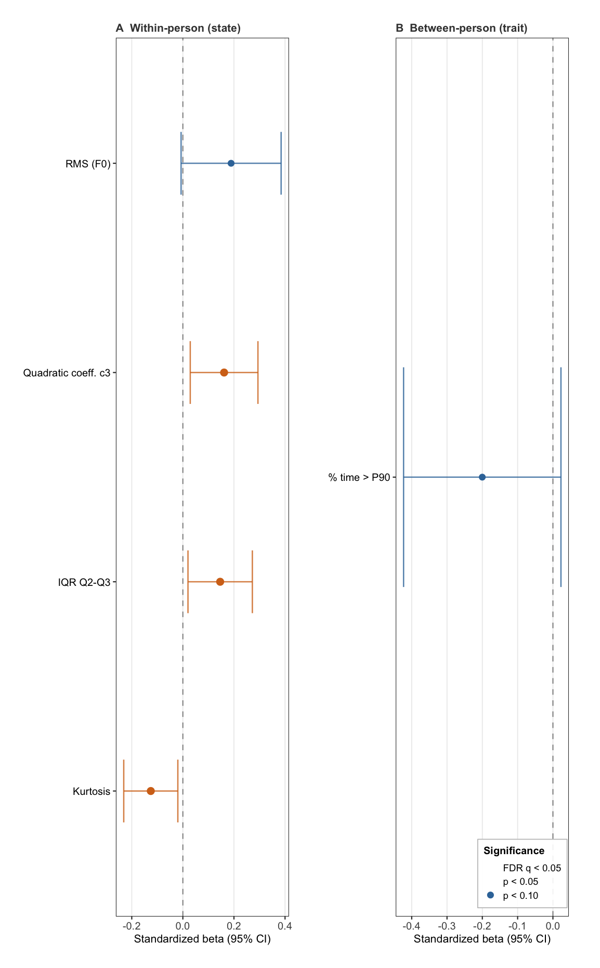

None of the 30 F0 descriptors survived FDR correction for either the within-person or the between-person association with SSI severity. The nominal within-person associations were observed for qregc3 (${\hat{β}}_{W}=0.1610$, $SE=0.068$, $p=0.018$, $q=0.240$), pitch kurtosis (${\hat{β}}_{W}=-0.126$, $SE=0.054$, $p=0.021$, $q=0.240$), and the interquartile range of the upper pitch register (IQR Q2–Q3; ${\hat{β}}_{W}=0.146$, $SE=0.064$, $p=0.024$, $q=0.240$).
Table S2. Full configuration grid: out-of-fold AUC (mean ± SD).
Feature block | Feature engineering | Classifier | AUC (mean ± SD)
Between-person (cross-sectional) (21 configurations)
F0 + LIWC + clinical | Raw | Focal LightGBM | 0.704 ± 0.064
F0 + LIWC + clinical | Raw | Balanced LightGBM | 0.702 ± 0.061
LIWC + clinical | Raw | Balanced LightGBM | 0.690 ± 0.037
LIWC + clinical | Raw | XGBoost | 0.690 ± 0.045
F0 + LIWC + clinical | Raw | XGBoost | 0.690 ± 0.061
LIWC + clinical | Raw | Focal LightGBM | 0.684 ± 0.052
F0 + LIWC | Raw | XGBoost | 0.682 ± 0.037
F0 + LIWC | Raw | Balanced LightGBM | 0.674 ± 0.049
LIWC only | Raw | Focal LightGBM | 0.673 ± 0.030
LIWC only | Raw | Balanced LightGBM | 0.661 ± 0.026
F0 + LIWC | Raw | Focal LightGBM | 0.659 ± 0.057
LIWC only | Raw | XGBoost | 0.658 ± 0.046
F0 + clinical | Raw | Balanced LightGBM | 0.624 ± 0.090
F0 + clinical | Raw | Focal LightGBM | 0.608 ± 0.108
Demographics only | Raw | Balanced LightGBM | 0.607 ± 0.069
Demographics only | Raw | Focal LightGBM | 0.604 ± 0.058
F0 + clinical | Raw | XGBoost | 0.597 ± 0.103
F0 only | Raw | Balanced LightGBM | 0.588 ± 0.109
F0 only | Raw | Focal LightGBM | 0.579 ± 0.098
F0 only | Raw | XGBoost | 0.566 ± 0.101
Demographics only | Raw | XGBoost | 0.564 ± 0.073
Within-person (binary) (60 configurations)
LIWC + clinical | Add current | Focal LightGBM | 0.760 ± 0.051
F0 + LIWC + clinical | Signal-shift | Balanced LightGBM | 0.755 ± 0.078
F0 + LIWC + clinical | Signal-shift | Focal LightGBM | 0.753 ± 0.079
LIWC + clinical | Add current | Balanced LightGBM | 0.750 ± 0.062
LIWC + clinical | Signal-shift | Focal LightGBM | 0.740 ± 0.072
LIWC + clinical | Add current | XGBoost | 0.730 ± 0.076
LIWC + clinical | Signal-shift | Balanced LightGBM | 0.723 ± 0.086
F0 + LIWC | Signal-shift | Focal LightGBM | 0.718 ± 0.062
F0 + LIWC + clinical | Add current | Focal LightGBM | 0.717 ± 0.069
F0 + LIWC + clinical | Add current | Balanced LightGBM | 0.709 ± 0.080
LIWC only | Signal-shift | Focal LightGBM | 0.708 ± 0.079
LIWC + clinical | Signal-shift | XGBoost | 0.706 ± 0.088
LIWC only | Add current | Balanced LightGBM | 0.701 ± 0.081
F0 + LIWC | Signal-shift | Balanced LightGBM | 0.700 ± 0.080
F0 + LIWC | Add current | Focal LightGBM | 0.696 ± 0.072
LIWC only | Add current | Focal LightGBM | 0.694 ± 0.094
LIWC only | Signal-shift | Balanced LightGBM | 0.692 ± 0.066
F0 + LIWC + clinical | Add current | XGBoost | 0.689 ± 0.076
F0 + LIWC | Add current | Balanced LightGBM | 0.687 ± 0.095
LIWC only | Rate only | Focal LightGBM | 0.685 ± 0.095
F0 + LIWC + clinical | Signal-shift | XGBoost | 0.683 ± 0.087
F0 + LIWC | Signal-shift | XGBoost | 0.681 ± 0.088
LIWC + clinical | Rate only | Focal LightGBM | 0.677 ± 0.069
LIWC only | Signal-shift | XGBoost | 0.676 ± 0.084
LIWC only | Add current | XGBoost | 0.671 ± 0.106
LIWC + clinical | Rate only | Balanced LightGBM | 0.670 ± 0.077
LIWC + clinical | Rate only | XGBoost | 0.666 ± 0.081
F0 + LIWC | Add current | XGBoost | 0.662 ± 0.096
F0 + LIWC + clinical | Rate only | Balanced LightGBM | 0.659 ± 0.082
LIWC only | Rate only | XGBoost | 0.655 ± 0.091
LIWC only | Rate only | Balanced LightGBM | 0.653 ± 0.089
F0 + LIWC + clinical | Rate only | XGBoost | 0.643 ± 0.082
F0 + LIWC + clinical | Rate only | Focal LightGBM | 0.631 ± 0.053
F0 + LIWC | Rate only | XGBoost | 0.631 ± 0.068
F0 + LIWC | Rate only | Focal LightGBM | 0.629 ± 0.068
F0 + LIWC | Rate only | Balanced LightGBM | 0.625 ± 0.085
F0 + clinical | Rate only | Balanced LightGBM | 0.609 ± 0.108
F0 + clinical | Rate only | XGBoost | 0.609 ± 0.122
F0 + clinical | Rate only | Focal LightGBM | 0.594 ± 0.116
Demographics only | Rate only | XGBoost | 0.590 ± 0.168
Demographics only | Add current | XGBoost | 0.590 ± 0.168
F0 + clinical | Signal-shift | XGBoost | 0.584 ± 0.070
F0 + clinical | Signal-shift | Balanced LightGBM | 0.582 ± 0.084
F0 + clinical | Add current | Focal LightGBM | 0.579 ± 0.124
F0 + clinical | Signal-shift | Focal LightGBM | 0.575 ± 0.099
F0 + clinical | Add current | Balanced LightGBM | 0.574 ± 0.123
F0 only | Rate only | XGBoost | 0.570 ± 0.109
F0 + clinical | Add current | XGBoost | 0.569 ± 0.087
Demographics only | Rate only | Focal LightGBM | 0.567 ± 0.144
Demographics only | Add current | Focal LightGBM | 0.567 ± 0.144
Demographics only | Rate only | Balanced LightGBM | 0.553 ± 0.143
Demographics only | Add current | Balanced LightGBM | 0.553 ± 0.143
F0 only | Signal-shift | XGBoost | 0.541 ± 0.066
F0 only | Add current | XGBoost | 0.538 ± 0.098
F0 only | Signal-shift | Balanced LightGBM | 0.534 ± 0.076
F0 only | Rate only | Balanced LightGBM | 0.525 ± 0.105
F0 only | Rate only | Focal LightGBM | 0.521 ± 0.130
F0 only | Add current | Balanced LightGBM | 0.518 ± 0.107
F0 only | Signal-shift | Focal LightGBM | 0.511 ± 0.084
F0 only | Add current | Focal LightGBM | 0.503 ± 0.103
Within-person (three-class, macro one-vs-rest) (60 configurations)
F0 + LIWC | Signal-shift | XGBoost | 0.705 ± 0.084
LIWC + clinical | Signal-shift | Focal LightGBM | 0.701 ± 0.101
LIWC + clinical | Signal-shift | Balanced LightGBM | 0.700 ± 0.103
LIWC only | Signal-shift | Balanced LightGBM | 0.699 ± 0.097
F0 + LIWC | Signal-shift | Balanced LightGBM | 0.697 ± 0.073
LIWC only | Signal-shift | Focal LightGBM | 0.690 ± 0.093
F0 + LIWC | Signal-shift | Focal LightGBM | 0.690 ± 0.079
F0 + LIWC + clinical | Signal-shift | XGBoost | 0.689 ± 0.085
LIWC + clinical | Signal-shift | XGBoost | 0.689 ± 0.096
LIWC only | Signal-shift | XGBoost | 0.682 ± 0.095
F0 + LIWC + clinical | Signal-shift | Balanced LightGBM | 0.681 ± 0.080
F0 + LIWC + clinical | Signal-shift | Focal LightGBM | 0.675 ± 0.089
F0 + LIWC + clinical | Add current | Focal LightGBM | 0.664 ± 0.115
F0 + LIWC + clinical | Add current | Balanced LightGBM | 0.658 ± 0.086
F0 + LIWC + clinical | Rate only | Focal LightGBM | 0.649 ± 0.067
F0 + LIWC + clinical | Rate only | Balanced LightGBM | 0.646 ± 0.054
F0 + LIWC | Add current | Balanced LightGBM | 0.644 ± 0.101
F0 only | Signal-shift | XGBoost | 0.642 ± 0.050
F0 + LIWC + clinical | Add current | XGBoost | 0.640 ± 0.090
LIWC + clinical | Rate only | Balanced LightGBM | 0.637 ± 0.072
LIWC + clinical | Add current | Balanced LightGBM | 0.636 ± 0.088
F0 + LIWC + clinical | Rate only | XGBoost | 0.636 ± 0.057
LIWC + clinical | Rate only | Focal LightGBM | 0.635 ± 0.074
LIWC + clinical | Add current | Focal LightGBM | 0.632 ± 0.071
F0 + LIWC | Rate only | Focal LightGBM | 0.631 ± 0.051
LIWC + clinical | Add current | XGBoost | 0.630 ± 0.078
F0 + clinical | Signal-shift | XGBoost | 0.629 ± 0.067
F0 + LIWC | Add current | Focal LightGBM | 0.625 ± 0.100
F0 only | Signal-shift | Balanced LightGBM | 0.621 ± 0.076
F0 + LIWC | Add current | XGBoost | 0.619 ± 0.081
F0 + LIWC | Rate only | Balanced LightGBM | 0.619 ± 0.057
LIWC only | Add current | Focal LightGBM | 0.613 ± 0.085
F0 + clinical | Signal-shift | Focal LightGBM | 0.609 ± 0.078
F0 + clinical | Signal-shift | Balanced LightGBM | 0.607 ± 0.071
F0 only | Signal-shift | Focal LightGBM | 0.607 ± 0.079
LIWC only | Add current | Balanced LightGBM | 0.607 ± 0.077
F0 + clinical | Add current | XGBoost | 0.604 ± 0.079
F0 + clinical | Rate only | XGBoost | 0.604 ± 0.073
LIWC + clinical | Rate only | XGBoost | 0.600 ± 0.023
F0 + clinical | Add current | Balanced LightGBM | 0.597 ± 0.057
LIWC only | Rate only | Focal LightGBM | 0.590 ± 0.064
F0 + clinical | Rate only | Focal LightGBM | 0.589 ± 0.047
LIWC only | Add current | XGBoost | 0.588 ± 0.050
F0 + clinical | Add current | Focal LightGBM | 0.587 ± 0.065
F0 + LIWC | Rate only | XGBoost | 0.587 ± 0.036
F0 only | Rate only | XGBoost | 0.587 ± 0.076
F0 + clinical | Rate only | Balanced LightGBM | 0.582 ± 0.034
LIWC only | Rate only | Balanced LightGBM | 0.579 ± 0.054
F0 only | Add current | Balanced LightGBM | 0.561 ± 0.041
F0 only | Rate only | Balanced LightGBM | 0.556 ± 0.047
LIWC only | Rate only | XGBoost | 0.553 ± 0.054
F0 only | Add current | Focal LightGBM | 0.544 ± 0.040
F0 only | Rate only | Focal LightGBM | 0.540 ± 0.065
F0 only | Add current | XGBoost | 0.539 ± 0.057
Demographics only | Rate only | XGBoost | 0.494 ± 0.058
Demographics only | Add current | XGBoost | 0.494 ± 0.058
Demographics only | Rate only | Balanced LightGBM | 0.469 ± 0.097
Demographics only | Add current | Balanced LightGBM | 0.469 ± 0.097
Demographics only | Rate only | Focal LightGBM | 0.462 ± 0.100
Demographics only | Add current | Focal LightGBM | 0.462 ± 0.100
Out-of-fold AUC (mean ± SD across the five patient-grouped folds) for every feature block × feature-engineering scheme × classifier configuration, sorted by AUC within each task. Clinical denotes demographics, baseline SSI and prior suicide-attempt history; baseline SSI is excluded from the between-person task because its label thresholds the concurrent SSI. The signal-shift scheme requires current-session speech features and is undefined for the demographics-only block, so those three cells are absent from the longitudinal grids.

Figure S2. Confusion matrices for the selected configurations.

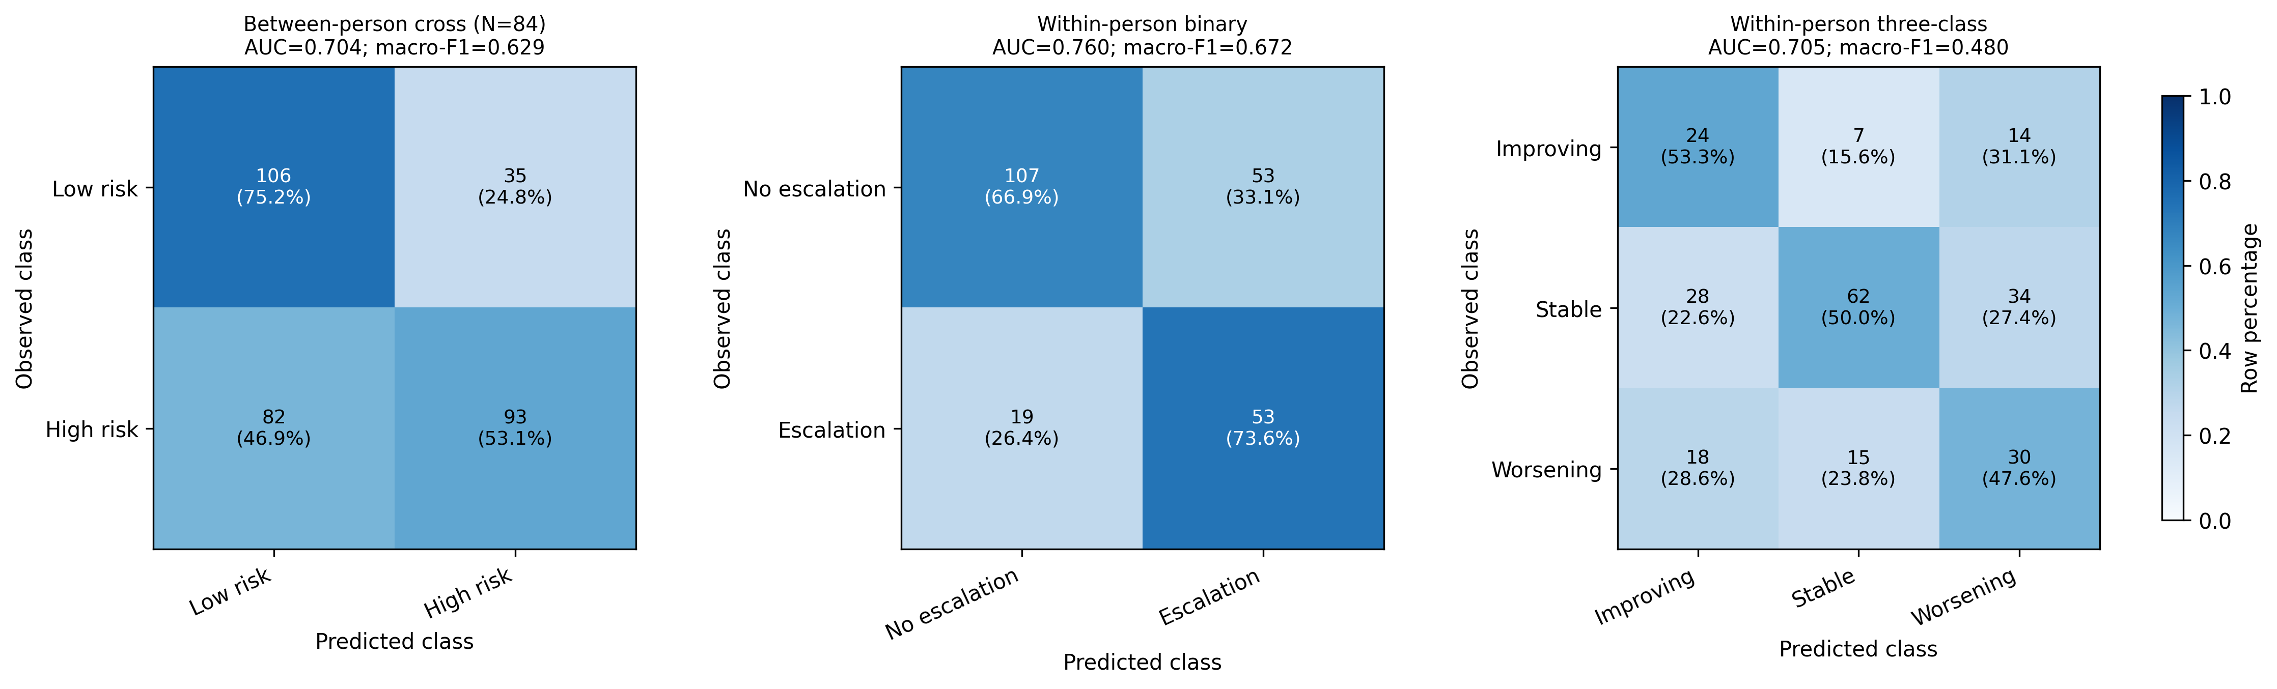
Figure S2 reports thresholded predictions from the same saved out-of-fold probabilities used to calculate the CV-best AUCs. No model was retrained. The binary within-person and cross-sectional configurations used a fixed positive-class probability threshold maximizing Youden’s J (0.802 and 0.152, respectively); the three-class configuration divided each class probability by that class’s Youden threshold (0.075, 0.816, 0.150) before taking the maximum. Counts are accompanied by percentages normalized within each observed class.

Table S3. Bias-corrected (BBC-CV) discrimination with 95% percentile confidence intervals.
Task | Axis | Level | BBC-CV AUC (95% CI)
Between-person  (binary) | Available feature types | Demographics only | 0.607 (0.476–0.737)
Between-person  (binary) | Available feature types | F0 only | 0.572 (0.470–0.674)
Between-person  (binary) | Available feature types | LIWC only | 0.644 (0.552–0.740)
Between-person  (binary) | Available feature types | F0 + clinical | 0.581 (0.469–0.698)
Between-person  (binary) | Available feature types | LIWC + clinical | 0.655 (0.515–0.765)
Between-person  (binary) | Available feature types | F0 + LIWC | 0.635 (0.540–0.735)
Between-person  (binary) | Available feature types | F0 + LIWC + clinical | 0.659 (0.547–0.760)
Between-person  (binary) | Classifier | Focal LightGBM | 0.668 (0.564–0.772)
Between-person  (binary) |  | Balanced LightGBM | 0.662 (0.552–0.765)
 |  | XGBoost | 0.644 (0.544–0.747)
Within-person (binary) | Available feature types | Demographics only | 0.526 (0.385–0.665)
Within-person (binary) | Available feature types | F0 only | 0.552 (0.432–0.663)
Within-person (binary) | Available feature types | LIWC only | 0.688 (0.573–0.798)
Within-person (binary) | Available feature types | F0 + clinical | 0.523 (0.384–0.643)
Within-person (binary) | Available feature types | LIWC + clinical | 0.738 (0.632–0.829)
Within-person (binary) | Available feature types | F0 + LIWC | 0.687 (0.577–0.783)
Within-person (binary) | Available feature types | F0 + LIWC + clinical | 0.729 (0.635–0.809)
 | Feature engineering | Rate only | 0.664 (0.522–0.784)
 | Feature engineering | Add current | 0.740 (0.632–0.829)
 | Feature engineering | Signal-shift | 0.737 (0.641–0.817)
 | Classifier | Focal LightGBM | 0.735 (0.649–0.813)
 |  | Balanced LightGBM | 0.732 (0.635–0.811)
 |  | XGBoost | 0.720 (0.614–0.816)
Within-person (three-class) | Available feature types | Demographics only | 0.449 (0.359–0.544)
Within-person (three-class) | Available feature types | F0 only | 0.633 (0.533–0.717)
Within-person (three-class) | Available feature types | LIWC only | 0.656 (0.563–0.745)
Within-person (three-class) | Available feature types | F0 + clinical | 0.633 (0.533–0.717)
Within-person (three-class) | Available feature types | LIWC + clinical | 0.652 (0.560–0.741)
 | Available feature types | F0 + LIWC | 0.660 (0.565–0.750)
 | Available feature types | F0 + LIWC + clinical | 0.656 (0.559–0.745)
 | Feature engineering | Rate only | 0.563 (0.482–0.640)
 | Feature engineering | Add current | 0.595 (0.494–0.681)
 | Feature engineering | Signal-shift | 0.657 (0.563–0.745)
 | Classifier | Focal LightGBM | 0.642 (0.557–0.726)
 |  | Balanced LightGBM | 0.658 (0.569–0.743)
 |  | XGBoost | 0.664 (0.559–0.752)

Each row is one bar of Figure 2: the level named in the third column is held fixed and the remaining design axes are searched, so the estimate is the outcome of the same bias-corrected selection procedure applied to a smaller candidate pool rather than the performance of a single fitted model. For the feature-type axis the pools are nested — making a feature type available keeps every block that can be built from it — so the F0 + LIWC + clinical row spans the entire grid and equals the primary estimate in Table 2.

Table S4. Component ablation: out-of-fold AUC (fold-mean) with 95% patient-cluster bootstrap CI.

Task with ablated feature set | AUC | 95% CI | Δ vs. full (95% CI)
Within-person (binary)
Full (LIWC + demographics + baseline SSI + prior history) | 0.760 | 0.685–0.835
$-$ Prior suicide history | 0.726 | 0.649–0.806 | +0.034  (-0.010 to +0.081)
$-$ Baseline SSI | 0.700 | 0.609–0.791 | +0.057*  (+0.002 to +0.115)
$-$ Demographics | 0.726 | 0.647–0.803 | +0.034  (-0.010 to +0.079)
$-$ LIWC | 0.560 | 0.466–0.647 | +0.204*  (+0.085 to +0.322)
$-$ Clinical (demographics + baseline SSI + prior history) | 0.694 | 0.613–0.781 | +0.061  (-0.001 to +0.119)
Between-person (cross-sectional)
Full (F0 + LIWC + demographics + prior history) | 0.704 | 0.624–0.772
$-$ F0 (acoustic) | 0.684 | 0.599–0.755 | +0.019  (-0.021 to +0.063)
$-$ LIWC | 0.608 | 0.523–0.688 | +0.092*  (+0.016 to +0.161)
$-$ Demographics | 0.675 | 0.591–0.743 | +0.030  (-0.011 to +0.073)
$-$ Prior suicide history | 0.689 | 0.604–0.754 | +0.015  (-0.011 to +0.040)
$-$ Speech (F0 + LIWC) | 0.578 | 0.464–0.689 | +0.118*  (+0.006 to +0.228)
Bold = anchor (held-fixed level).
Demographics = age, sex; clinical = Demographics = age + sex; Clinical = demographics + baseline SSI + prior suicide history; F0 = openSMILE pitch features; AUC = fold-mean out-of-fold AUC with a 95% patient-cluster bootstrap CI (1000 resamples of the 84 patients); $Δ$ = paired loss relative to the full model, * marking intervals that exclude zero.

