Supplementary Information

Table 1 Main instruments and equipment
Instrument | Model/Specification
High-performance liquid chromatography system | Shimadzu LC-2050³D with PDA detector
Chromatographic column | ShimNex CS C18 (5 μm, 4.6 mm × 150 mm)
Incubator | 37°C
Constant-temperature shaking incubator | 37°C, 250 rpm
Electronic balance | 0.1 mg / 1 mg precision
Pipettes | 0.5–1000 μL
Biological safety cabinet | Thermo Fisher Scientific (USA), model 1379
Table 2 Main reagents
Reagent | Purity/Specification
Sterile PBS buffer | 0.01 mol/L, pH 7.2–7.4
Acetonitrile | HPLC grade
Phosphate buffer | 0.05 mol/L, pH 3.0
Vancomycin standard | ≥98% purity

Figure.1 Standard curves for different antibiotic-loaded cement formulations.

Figure.2 Vancomycin concentrations at different time points for each cement formulation
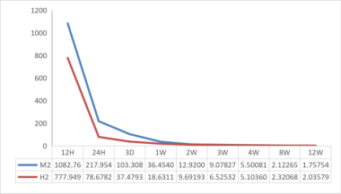 | 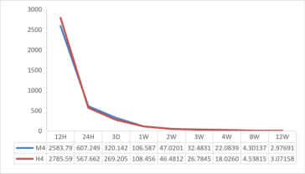 | 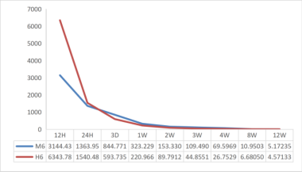
2g | 4g | 6g

Figure.3 Inhibition rates of different antibiotic-loaded cement formulations at 12 weeks.

Figure.4.Representative agar plates from the antibacterial inhibition assay at 12 weeks for each antibiotic-loaded cement formulation
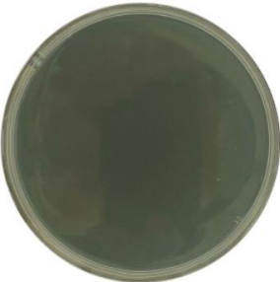 | 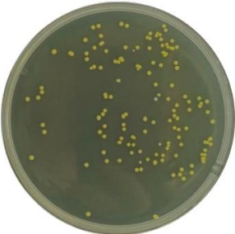 | 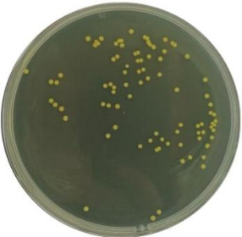 | 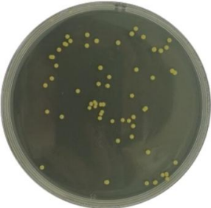
SC | H2 | H4 | H6
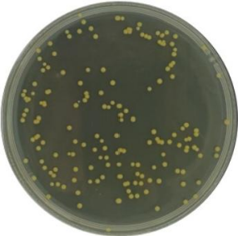 | 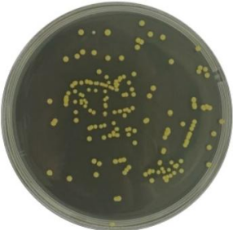 | 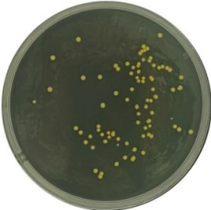 | 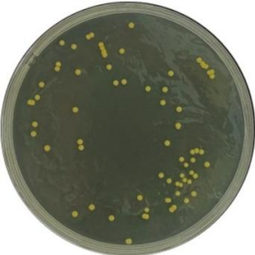
NC | M2 | M4 | M6
Note: SC, sterile control (PBS only); NC, negative control (cement without antibiotic); M2–M6, medium-viscosity groups with 2, 4, and 6 g vancomycin per 40 g cement, respectively; H2–H6, medium-high-viscosity groups with 2, 4, and 6 g vancomycin per 40 g cement, respectively.
Figure 5 Scanning electron microscopy (SEM) images of antibiotic-loaded cement specimens at 12 weeks for each formulation (magnification ×50,000).
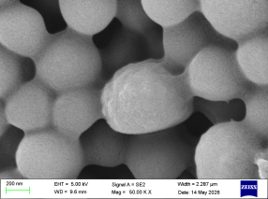 | 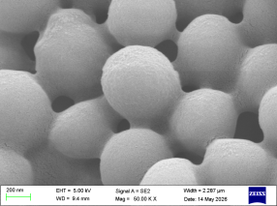 | 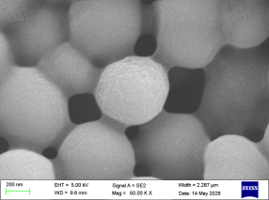
H2 | H4 | H6
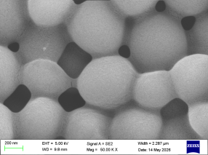 | 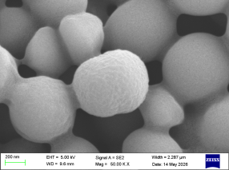 | 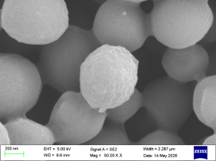
M2 | M4 | M6
Note: At 50,000× magnification, specimens loaded with 2 g to 6 g vancomycin showed progressively reduced MRSA bacterial adhesion. Bacteria appeared as clustered aggregates, and the amount of extracellular matrix-like substance gradually decreased with increasing vancomycin load, irrespective of cement viscosity.
Table.3 Results of repeated-measures ANOVA for cumulative vancomycin release concentration
variation |  | SS | df | MS | FF | PP | Partial η²
Between-subjects | Viscosity | 156.23 | 1 | 156.23 | 0.87 | 0.387 | 0.127
Between-subjects | Dose | 66892.45 | 2 | 33446.23 | 186.34 | <0.001 | 0.969
Between-subjects | V × D | 234.56 | 2 | 117.28 | 0.65 | 0.554 | 0.098
Between-subjects | Error between | 2153.88† | 12 | 179.49 | — | — | —
Within-subjects | Time | 125893.21 | 2.41‡ | 52237.43 | 452.67 | <0.001 | 0.987
Within-subjects | T × V | 156.78 | 2.41‡ | 65.05 | 0.56 | 0.621 | 0.086
Within-subjects | T × D | 15678.92 | 4.82‡ | 3253.72 | 28.15 | <0.001 | 0.824
Within-subjects | T × V × D | 234.89 | 4.82‡ | 48.73 | 0.42 | 0.829 | 0.065
Within-subjects | Error within | 3341.71†† | 28.92‡ | 115.55 | — | — | —
† Between-subjects error SS was derived by pooling the error SS from each factor; †† Within-subjects error SS was estimated after sphericity correction;
‡ Degrees of freedom were corrected using the Greenhouse–Geisser method (Mauchly's test of sphericity, P < 0.001).

Table.4 Pairwise comparisons of vancomycin release concentration among different antibiotic-loaded groups
Comparison group | Mean Difference | SE | P | 95%CI
4 g vs 2 g | 89.56 | 6.32 | <0.001 | (74.28, 104.84)
6 g vs 2 g | 156.78 | 6.32 | <0.001 | (141.50, 172.06)
6 g vs 4 g | 67.22 | 6.32 | <0.001 | (51.94, 82.50)

