Supplementary information

Article title: Climate-associated nutritional variability of maize across agroecological zones in Cameroon: implications for food security
Journal: Agriculture and Food Security
Shey Ndogmi Yoniwo^{1,}*, Alec Forsyth¹, Naeem Syed¹ and Joseph Hubert Yamdeu Galani¹
¹Section of Natural and Applied Sciences, School of Sciences, Psychology, Arts & Humanities, Computing, Engineering, and Sports (SPACES), Canterbury Christ Church University, Kent, UK
*Corresponding author: sheyyoniwo@gmail.com

Supplementary Methods S1. Detailed Maize Sampling Protocol
Maize samples were obtained either from mature cobs collected from fields and barns holding unshelled cobs, or from already-shelled grain found in drying yards and storage containers, depending on what was available at the time of the household visit.
Field and barn sampling. A total of three maize cobs were collected per household, before, during, or after harvesting. On standing field crops, one cob each was taken from three distinct areas on different rows, at the edges and at the centre of the plot, to capture intra-field variability. Where maize had already been harvested and heaped, one cob each was collected from three distinct locations within the heap. In barns holding unshelled cobs, one cob was sampled from the centre and two from peripheral points equidistant from the centre. After de-husking and shelling, the grains from the three cobs were thoroughly mixed in a plastic basin, and approximately 250 g of this composite was transferred into a sealed, labelled paper bag pending milling.
Sampling shelled grain. Where only shelled grain was available, approximately 250 g was sampled from drying yards or storage containers by randomly drawing five 50 g portions from different sections. For grain stored in bags, a grain spear or probe was used to collect the same quantity from different depths. In both cases, the portions were pooled, mixed, and transferred to labelled bags following the same procedure as for cob-derived samples. An overview of the full sampling procedure is provided in Supplementary Figure S1.
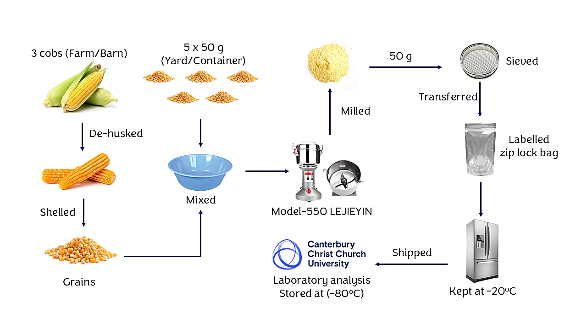
Supplementary Figure S1. Overview of maize sampling and post-sampling handling

Supplementary Table S1. Shapiro-Wilk normality test for assay variables
Assay | statistic | p-value | Sig. | Interpretation
ABTS antioxidant activity | 0.976 | 0.000 | *** | Highly Non-Normal
Calcium (Ca) | 0.994 | 0.365 | ns | Normal Distribution
Copper (Cu) | 0.680 | 0.000 | *** | Highly Non-Normal
DPPH antioxidant activity | 0.988 | 0.036 | * | Non-Normal
FRAP antioxidant activity | 0.986 | 0.012 | * | Non-Normal
Iron (Fe) | 0.838 | 0.000 | *** | Highly Non-Normal
Fructose | 0.752 | 0.000 | *** | Highly Non-Normal
Glucose | 0.599 | 0.000 | *** | Highly Non-Normal
Potassium (K) | 0.997 | 0.885 | ns | Normal Distribution
Maltose | 0.862 | 0.000 | *** | Highly Non-Normal
Magnesium (Mg) | 0.996 | 0.849 | ns | Normal Distribution
Manganese (Mn) | 0.983 | 0.005 | * | Non-Normal
Phosphorus (P) | 0.964 | 0.000 | *** | Highly Non-Normal
Phytate | 0.964 | 0.000 | *** | Highly Non-Normal
Sucrose | 0.868 | 0.000 | *** | Highly Non-Normal
Sugar | 0.893 | 0.000 | *** | Highly Non-Normal
Total phenolics (TPC) | 0.908 | 0.000 | *** | Highly Non-Normal
Xylose | 0.771 | 0.000 | *** | Highly Non-Normal
Zinc (Zn) | 0.987 | 0.018 | * | Non-Normal
Note: *** = Highly significant, * = Significant, ns = Not significant

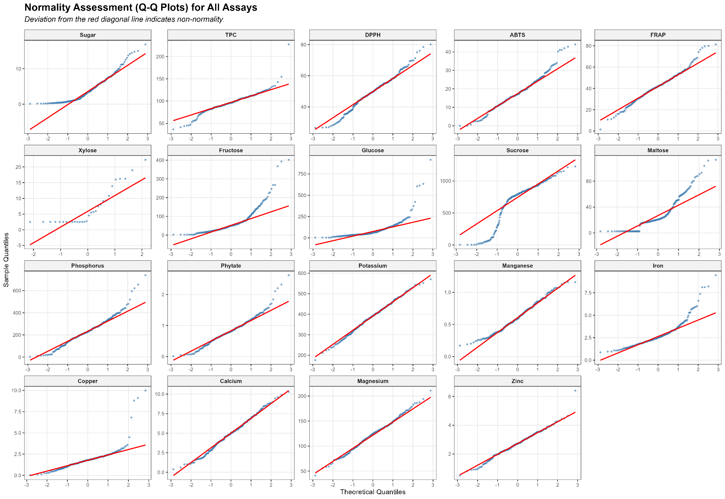
Note: Deviation from the red diagonal line indicates non-normality
Supplementary Figure S2. Normality assessment (Q-Q plots) for all assays

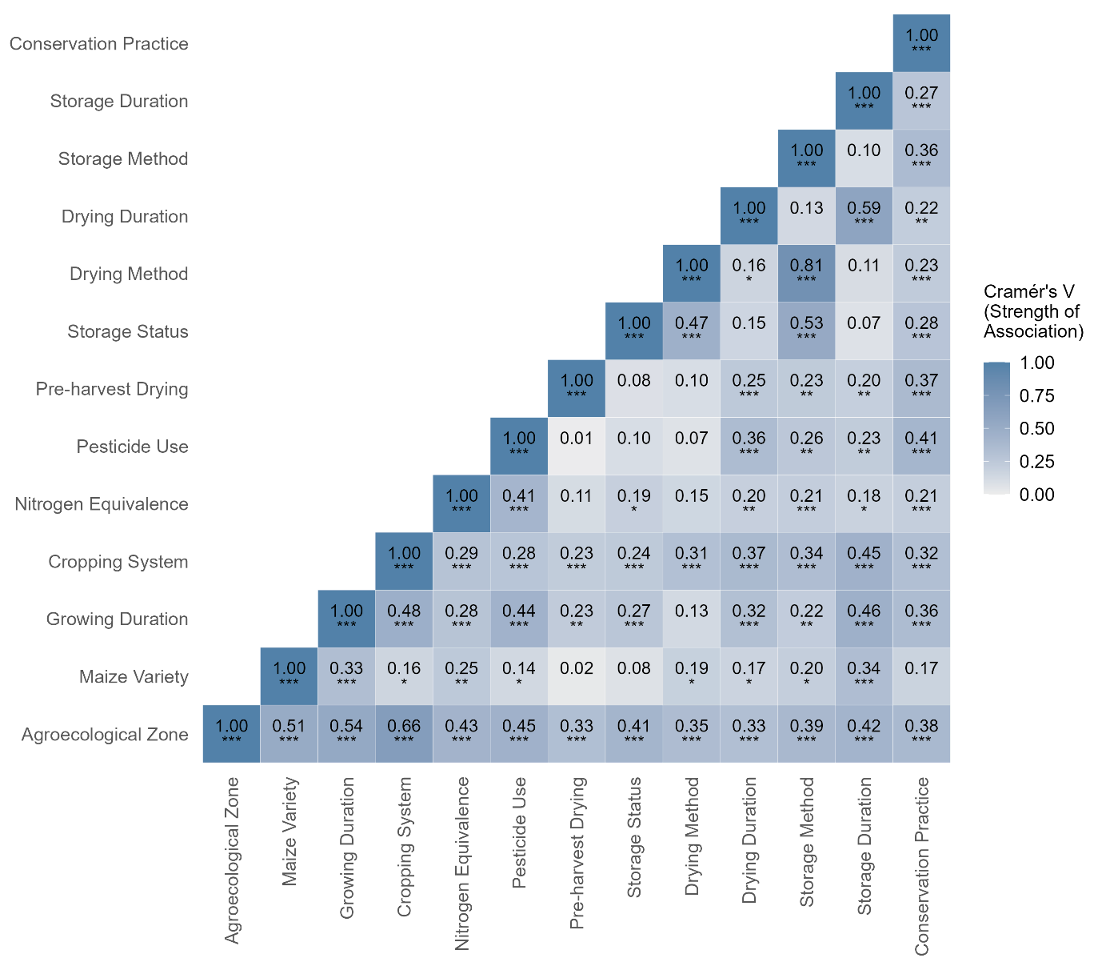
Note: ***, **, * are significant correlation at p < 0.001, 0.01, 0.05 respectively
Supplementary Figure S2. Heatmap showing Cramer’s V correlation between categorical variables, including farm management practices and agroecological zones
Supplementary Table S2. Variance Inflation Factor (VIF) values for explanatory variables in the regression model
Explanatory variable | VIF
Agroecological zone | 1.62
Maize variety | 1.26
Growing duration | 1.42
Cropping system | 1.52
Nitrogen equivalence | 1.20
Pesticide use | 1.36
Preharvest drying | 1.28
Storage status | 1.27
Drying duration: | 1.51
Storage duration | 1.73
Conservation practice | 1.23
Postharvest system | 1.19
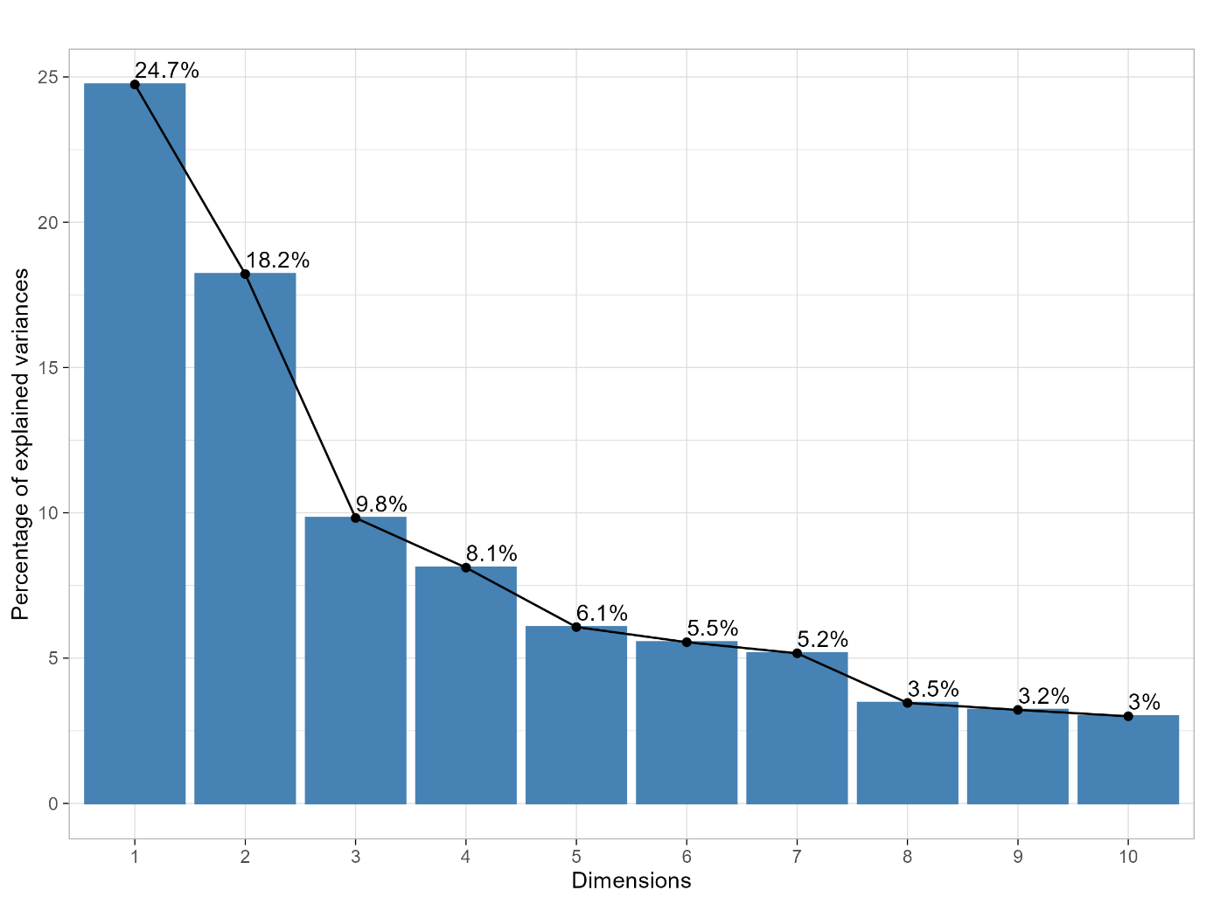
Note: Bar heights represent the percentage of total variance explained by each successive principal component; the cumulative curve (line) helps determine how many principal components (Dim) to retain.
Supplementary Figure S4. Scree plot of variance in maize nutritional and biochemical composition explained by principal components
Supplementary Table S3. Contribution (%) of nutrient assays for PCA components
Assay | Dim.1 | Dim.2 | Dim.3 | Cumulative
Reducing sugar | 7.50 | 0.00 | 12.36 | 19.86
Total phenolic content | 2.79 | 0.13 | 27.86 | 30.78
DPPH antioxidant activity | 18.29 | 0.19 | 1.28 | 19.76
ABTS antioxidant activity | 13.86 | 0.31 | 4.18 | 18.34
FRAP antioxidant activity | 14.83 | 0.00 | 6.11 | 20.94
Xylose | 10.29 | 0.15 | 0.55 | 10.99
Fructose | 3.22 | 2.04 | 5.41 | 10.67
Glucose | 5.31 | 1.29 | 0.14 | 6.75
Sucrose | 12.21 | 0.10 | 2.90 | 15.22
Maltose | 8.02 | 0.12 | 15.61 | 23.76
Phosphorus/Phytate | 1.86 | 6.69 | 18.04 | 26.59
Potassium (K) | 0.15 | 19.71 | 0.07 | 19.93
Manganese (Mn) | 0.98 | 14.16 | 1.33 | 16.47
Iron (Fe) | 0.05 | 5.12 | 0.16 | 5.33
Copper (Cu) | 0.36 | 2.08 | 0.15 | 2.59
Calcium (Ca) | 0.26 | 3.44 | 0.53 | 4.24
Magnesium (Mg) | 0.00 | 24.74 | 0.05 | 24.78
Zinc (Zn) | 0.01 | 19.73 | 3.28 | 23.01

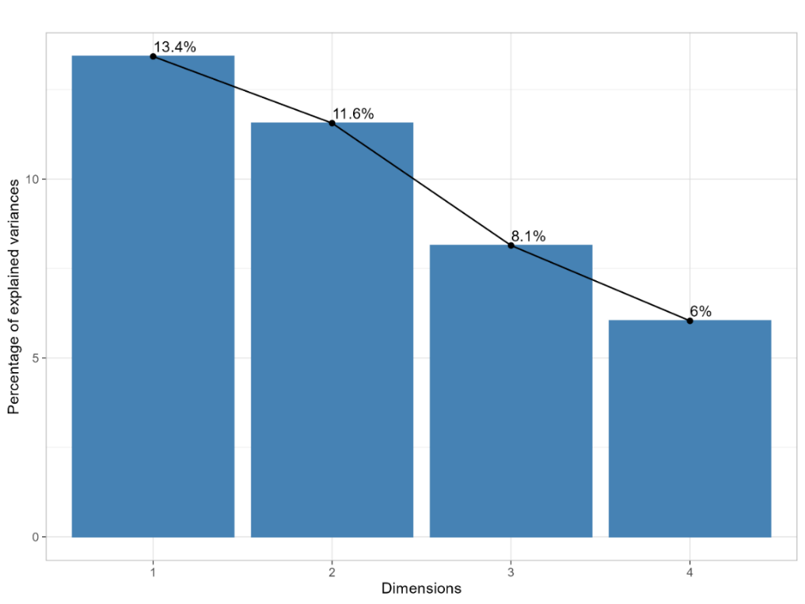
Note: Bar heights represent the percentage of total variance explained by each successive dimensions; the cumulative curve (line) helps determine how many FAMD components to consider.
Supplementary Figure S4. Scree plot of variance explained by FAMD components
Supplementary Table S4. Contribution (%) of assays and explanatory variables to the FAMD components
Variables | Dim1 | Dim2 | Dim3 | Cumulative
Assay variables
Sugar | 5.58 | 0.87 | 1.98 | 8.44
Total phenolic content | 1.11 | 0.31 | 2.66 | 4.08
DPPH antioxidant activity | 13.46 | 0.22 | 0.12 | 13.80
ABTS antioxidant activity | 9.11 | 0.01 | 0.45 | 9.57
FRAP antioxidant activity | 9.25 | 0.10 | 1.37 | 10.72
Xylose | 6.62 | 0.14 | 7.15 | 13.91
Fructose | 3.00 | 0.21 | 1.26 | 4.47
Glucose | 4.48 | 0.20 | 0.12 | 4.81
Sucrose | 9.04 | 0.02 | 0.22 | 9.27
Maltose | 7.54 | 0.02 | 2.12 | 9.69
Phosphorus/Phytate | 0.84 | 5.97 | 0.85 | 7.65
Potassium (K) | 0.01 | 3.88 | 7.61 | 11.50
Manganese (Mn) | 0.24 | 5.29 | 7.32 | 12.84
Iron (Fe) | 0.01 | 1.15 | 2.31 | 3.46
Copper (Cu) | 0.02 | 0.80 | 0.75 | 1.58
Calcium (Ca) | 0.06 | 2.66 | 0.01 | 2.73
Magnesium (Mg) | 0.41 | 8.93 | 2.78 | 12.13
Zinc (Zn) | 0.36 | 5.86 | 10.29 | 16.51
Explanatory variables
Agroecological zone (AEZ) | 6.52 | 13.26 | 12.51 | 32.29
Maize variety | 0.06 | 4.43 | 3.56 | 8.06
Growing duration | 1.71 | 8.49 | 2.69 | 12.89
Cropping system | 0.43 | 7.17 | 3.00 | 10.59
Nitrogen equivalence | 1.87 | 6.76 | 0.84 | 9.47
Pesticide use | 0.03 | 3.20 | 3.72 | 6.94
Pre-harvest drying | 3.10 | 0.03 | 0.00 | 3.13
Storage status | 3.01 | 0.79 | 2.58 | 6.38
Drying duration | 1.72 | 7.02 | 4.28 | 13.01
Storage duration | 3.72 | 7.38 | 5.34 | 16.43
Conservation practice | 3.58 | 3.44 | 5.66 | 12.69
Postharvest system | 3.12 | 1.40 | 6.44 | 10.95

