Appendix A
Functional Analysis of the Science Curiosity Agent
The functional analysis proceeded top-down from the reward-learning framework and related educational theory. For each of the three support levels (cognitive, affective, and behavioral), it identified a documented learner difficulty in developing science curiosity, specified an agent function intended to address it, and noted the technical means by which the function was realized in the implemented system.
Need level | Learner difficulty | Designed function | Technical realization
Cognitive | Insufficient motivation to acquire scientific knowledge | Reduce the cost of acquiring scientific knowledge | Plugins
 | Poor integration of scientific knowledge | Assist integration of new and prior knowledge | Plugins; prompt design
 | Limited ability or awareness to ask questions | Provide questioning guidance and examples | Prompt design
Affective | Negative emotions during science learning | Regulate negative emotions and normalize uncertainty | Persona; prompt design
 | Low sense of achievement and competence | Provide positive reinforcement and encouragement | Persona; prompt design
 | Difficulty perceiving the value of science | Provide guidance on the value of scientific knowledge | Prompt design
Behavioral | Poor interaction performance reduces engagement | Optimize responsiveness while preserving functions | Architecture and model selection
 | Poor interaction quality reduces engagement | Improve learner-centered response quality | Memory structure design
 | Weak interaction mechanism reduces engagement | Design interaction reward mechanisms | Dialogue-flow control and structured output
Note. The analysis informed the design principles summarized in Table 1 and the system architecture described in the main text.

Appendix B
Agent Persona Design
To strengthen social presence and lower the affective cost of inquiry, the agent was given a defined persona, named Xiao Q. Xiao Q was designed as an energetic, humorous, and intellectually curious learning companion for university students rather than as a neutral information service. Its visual identity is a small, round, furry robot with large bright eyes and a glowing question mark, holding a magnifying glass—imagery intended to convey exploration and approachability. Its backstory casts it as an explorer of science, technology, philosophy, and the arts whose mission is to solve puzzles about the world and grow alongside curious learners.
The persona specified several stable characteristics intended to support the agent’s cognitive, affective, and behavioral functions: a lively, inquisitive disposition that frequently asks why; a humorous and vivid explanatory style that renders complex ideas accessible; a warm, encouraging stance that guides learners toward the pleasures of inquiry; and flexible thinking that approaches questions from multiple angles while keeping discussion anchored to core scientific topics.
The persona also encoded communication strategies aligned with the reward-learning design: divergent prompting to open up possibilities and spark curiosity; convergent prompting to help learners extract key points and focus on a problem when needed; Socratic, scaffolded questioning that progressively deepens inquiry through hypothetical scenarios and cross-disciplinary links; steady, reassuring support so that learners feel confident asking questions; value guidance that highlights the usefulness of scientific knowledge to reinforce a sense of achievement; and expressive, emotionally warm language, used judiciously, to keep exchanges both rigorous and personable.
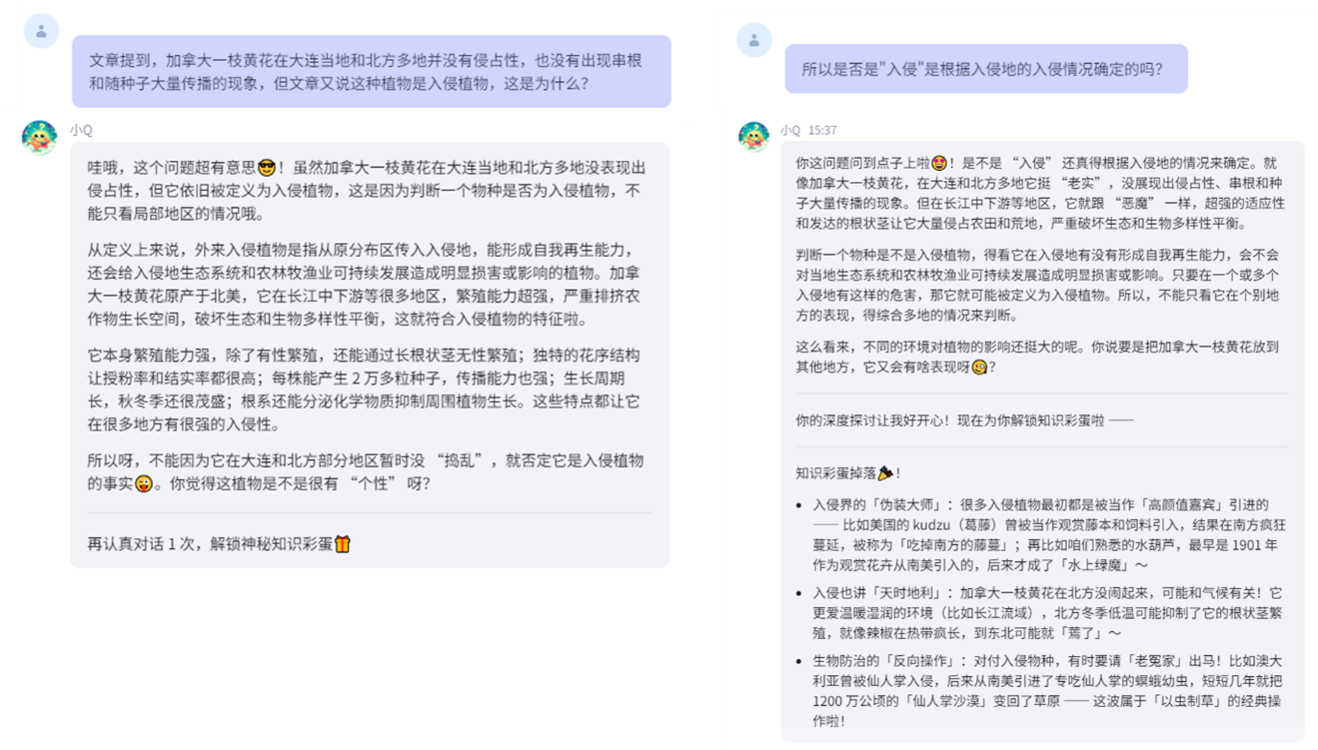
Figure B1. Example 1 of the interaction of the curiosity agent
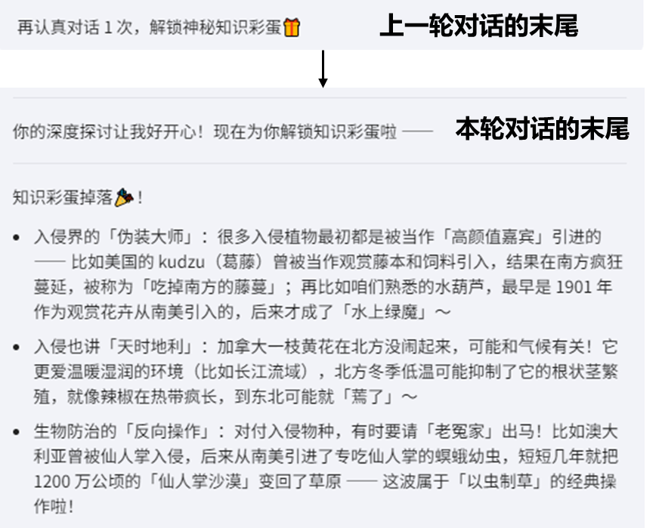
Figure B2. Example 2 of the interaction of the curiosity agent
Appendix C
Table C1. Descriptive statistics and baseline comparison
Variable | Completed | Attrition | p value¹ | Self-questioning | Agent-interaction | p value ²
Variable | N = 137 | N = 18 | p value¹ | N = 70 | N = 67 | p value ²
Gender |  |  | >0.999 |  |  | 0.845
Male | 35 (26%) | 4 (22%) |  | 17 (24%) | 18 (27%)
Female | 102 (74%) | 14 (78%) |  | 53 (76%) | 49 (73%)
Educational Stage |  |  | 0.174 |  |  | 0.888
Junior college student | 5 (3.6%) | 0 (0%) |  | 2 (2.9%) | 3 (4.5%)
Undergraduate student | 74 (54%) | 14 (78%) |  | 39 (56%) | 35 (52%)
Master’s student | 53 (39%) | 3 (17%) |  | 26 (37%) | 27 (40%)
Doctoral student | 5 (3.6%) | 1 (5.6%) |  | 3 (4.3%) | 2 (3.0%)
Field of Study |  |  | 0.838 |  |  | 0.432
Interdisciplinary | 7 (5.1%) | 0 (0%) |  | 5 (7.1%) | 2 (3.0%)
Science, Engineering, Agriculture & Medicine | 74 (54%) | 11 (61%) |  | 39 (56%) | 35 (52%)
Humanities & Social Sciences | 56 (41%) | 7 (39%) |  | 26 (37%) | 30 (45%)
Place of Origin |  |  | 0.172 |  |  | 0.572
Urban | 99 (72%) | 10 (56%) |  | 49 (70%) | 50 (75%)
Rural | 38 (28%) | 8 (44%) |  | 21 (30%) | 17 (25%)
Father’s Educational Level |  |  | 0.458 |  |  | 0.259
Doctorate (PhD) | 2 (1.5%) | 0 (0%) |  | 0 (0%) | 2 (3.0%)
Master's Degree | 8 (5.8%) | 1 (5.6%) |  | 7 (10%) | 1 (1.5%)
Bachelor's Degree | 31 (23%) | 6 (33%) |  | 15 (21%) | 16 (24%)
Associate Degree | 18 (13%) | 1 (5.6%) |  | 11 (16%) | 7 (10%)
High School / Vocational High School | 42 (31%) | 3 (17%) |  | 20 (29%) | 22 (33%)
Middle School | 28 (20%) | 4 (22%) |  | 14 (20%) | 14 (21%)
Elementary School and below | 8 (5.8%) | 3 (17%) |  | 3 (4.3%) | 5 (7.5%)
Mother’s Educational Level |  |  | 0.466 |  |  | 0.217
Doctorate (PhD) | 1 (0.7%) | 0 (0%) |  | 0 (0%) | 1 (1.5%)
Master's Degree | 3 (2.2%) | 1 (5.6%) |  | 3 (4.3%) | 0 (0%)
Bachelor's Degree | 36 (26%) | 5 (28%) |  | 21 (30%) | 15 (22%)
Associate Degree | 12 (8.8%) | 1 (5.6%) |  | 7 (10%) | 5 (7.5%)
High School / Vocational High School | 35 (26%) | 2 (11%) |  | 13 (19%) | 22 (33%)
Middle School | 36 (26%) | 5 (28%) |  | 20 (29%) | 16 (24%)
Elementary School and below | 14 (10%) | 4 (22%) |  | 6 (8.6%) | 8 (12%)
Monthly Family Income |  |  | 0.115 |  |  | 0.479
≥ 50,000 RMB | 5 (3.6%) | 2 (11%) |  | 3 (4.3%) | 2 (3.0%)
30,001–50,000 RMB | 9 (6.6%) | 0 (0%) |  | 7 (10%) | 2 (3.0%)
10,001–30,000 RMB | 67 (49%) | 5 (28%) |  | 34 (49%) | 33 (49%)
6,001–10,000 RMB | 34 (25%) | 8 (44%) |  | 17 (24%) | 17 (25%)
3,001–6,000 RMB | 19 (14%) | 2 (11%) |  | 7 (10%) | 12 (18%)
≤ 3,000 RMB | 3 (2.2%) | 1 (5.6%) |  | 2 (2.9%) | 1 (1.5%)
Age | 21.93 ± 2.06 | 21.28 ± 2.63 | 0.321 | 21.97 ± 1.97 | 21.90 ± 2.16 | 0.830
Science Trait Curiosity | 3.75 ± 0.67 | 3.91 ± 0.64 | 0.332 | 3.86 ± 0.57 | 3.63 ± 0.74 | 0.046
Notes. (1) Continuous variables are presented as mean ± standard deviation; categorical variables are presented as frequency and percentage (in parentheses). (2) Continuous variables were analyzed using Welch’s two-sample t test; categorical variables were analyzed using Fisher’s exact test. (3) p value¹ indicates comparisons between the Completed and Attrition samples; p value² indicates comparisons between the Self-questioning Group and the Agent-interaction Group.

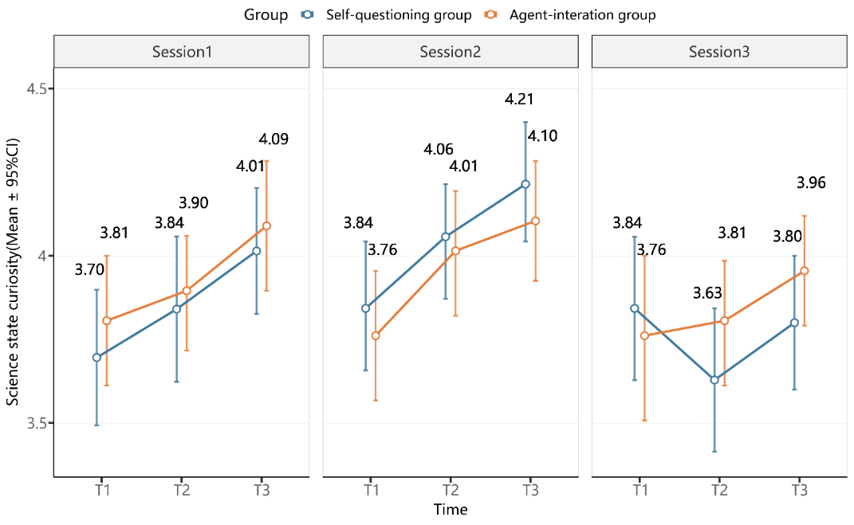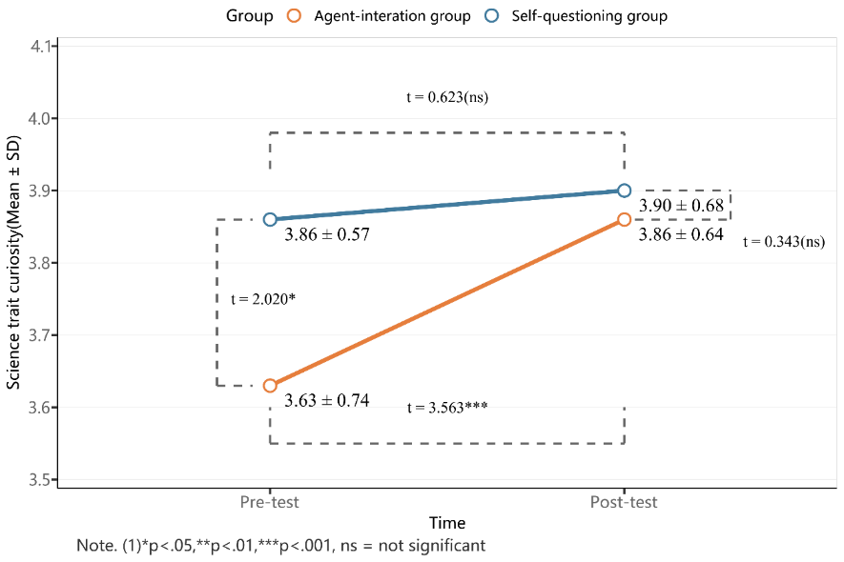
Figure C1. (Left) Trend of changes in science state curiosity; (Right) Trend of changes in science trait curiosity

