PHENOLOGY OF GRASSLAND PLANTS RESPONDS TO URBANIZATION

Supplementary material

Supplementary 1: Adaptation of the BBCH code phenological stages for the five monitored plant species.
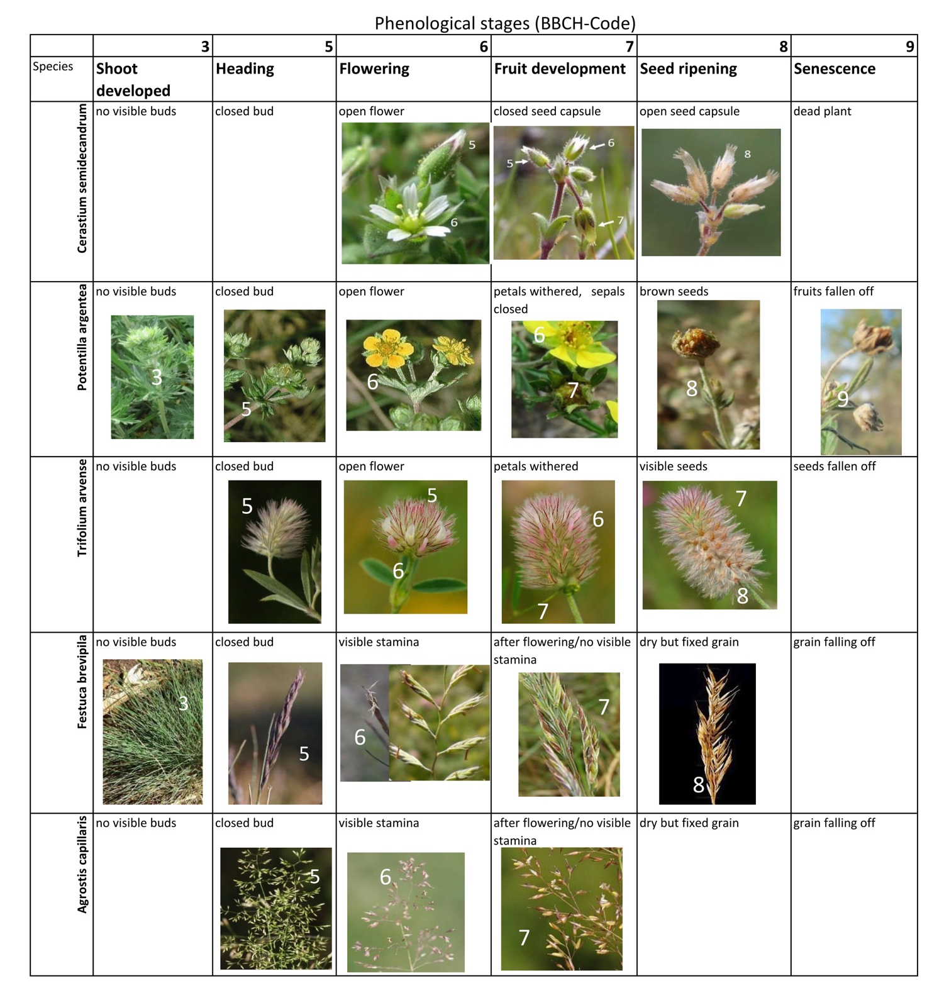

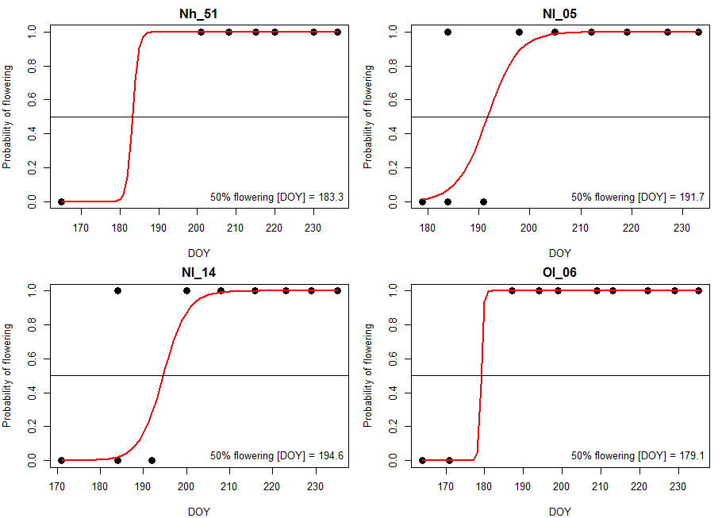
Supplementary 2: logistic modelling of 50% flowering onset dates, as exemplified for one site (Nl_05) for T. arvense. Black dots represent sample dates at which flowering had either occurred (1) or not occurred (0). Red line represents the binomial model and the intersection of the black horizontal 50% line with the binomial model is the 50% flowering date.

Supplementary 3: Slopes of regression models for impacts of air temperature variables of the preceding month and preceding week onto flowering and seed maturation onset dates of the 5 species, only models of p<0.1 shown. Combinations of p<0.5 in bold.
Temperature variable |  | DOY of 50% flowering |  |  |  |  | DOY of 50% seed maturation
 |  | Cer | Fes | Pot | Agr | Tri | Cer | Fes | Pot | Agr | Tri
 | Calendar month//week prior to median of DOY | 3//15 | 4//19 |  | 5//25 | 5//27 |  | 5//21 | 7//27 | 6//27
monthly value | day sums |  |  |  |  | 0.002
monthly value | avg max |  |  |  |  |  |  |  | -5.07
weekly value | sums | -0.01 |  |  | 0.07 |  |  |  |  | 0.06
weekly value | sums day | -0.02 | 0.00 |  |  |  |  | 0.00 | -0.06
weekly value | avg | -1.58 |  |  | 12.25 |  |  |  |  | 10.61
weekly value | avg day | -1.64 | 1.909 |  |  |  |  |  | -7.73
weekly value | avg night | -0.86 |  |  |  |  |  |  |  | 5.39
weekly value | avg max |  | 0.69 |  |  |  |  |  | -3.83
weekly value | avg min | -0.73 |  |  |  |  |  |  |  | 6.13

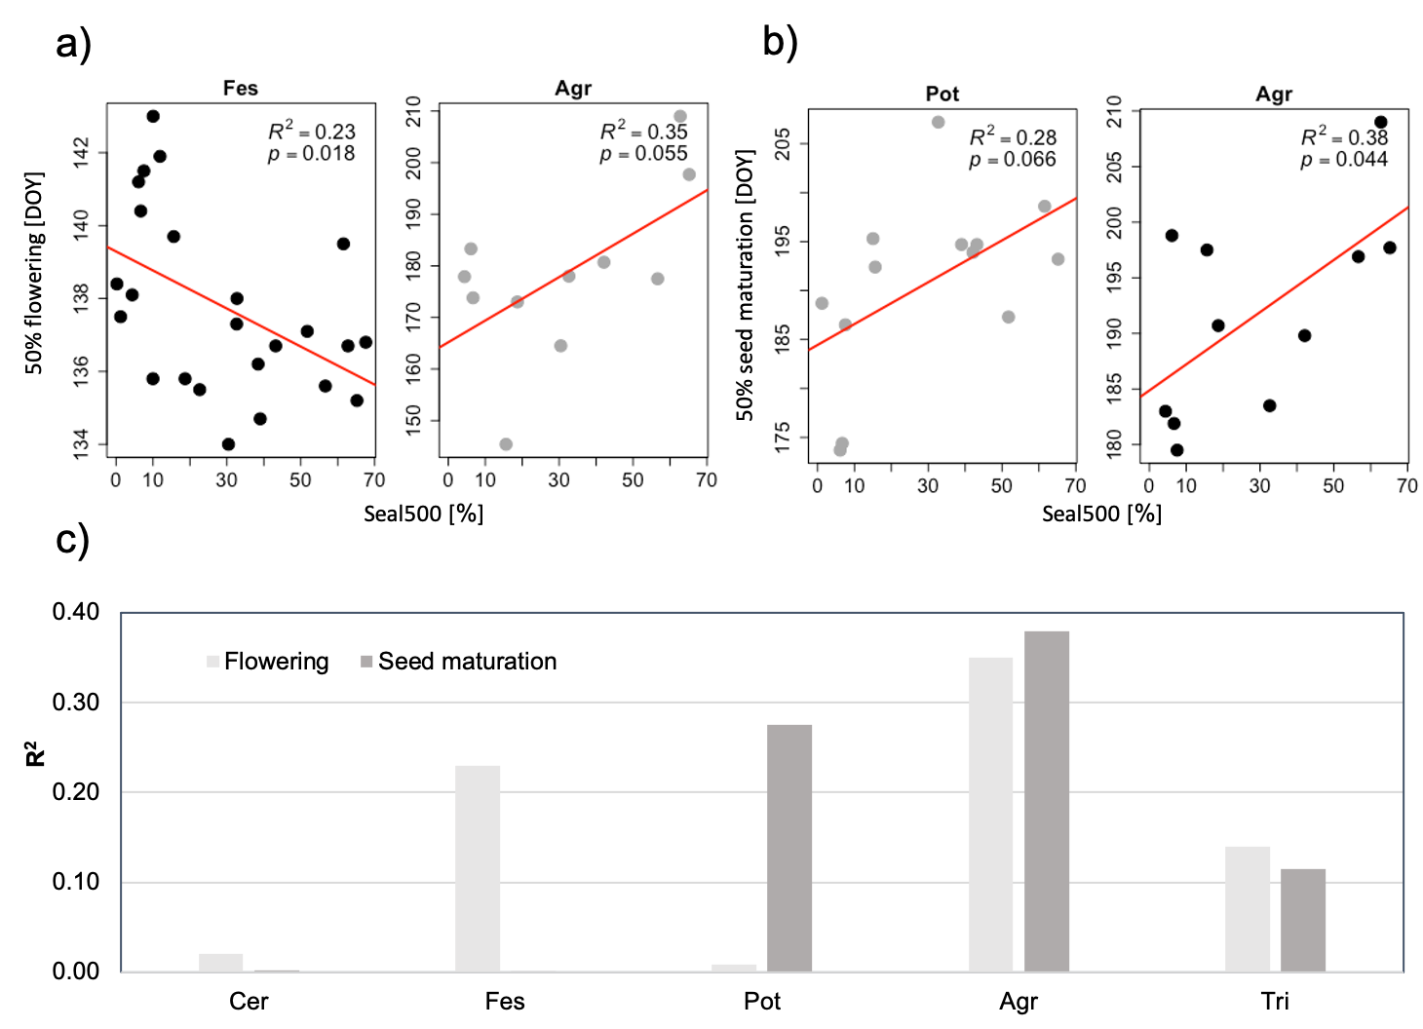
Supplementary 4: Relationships between urbanization and phenology. a) Significant (black dots) or nearly significant (grey dots) linear regression models for influence of impervious surface in a 500m radius (Seal500) on flowering, b) same as a) but for seed maturation c) Explained variance (R²) of models of influence of impervious surfaces (Seal500) on 50% flowering day and 50% seed maturation day for all species (species ordered by the median of 50 % flowering onset ).

